3 Sensitivity Analysis (Leave-one-out Analysis)
For sensitivity analysis, we conducted a leave-one-out (LOO) analysis by sequentially refitting the linear mixed-effects model while excluding one subject at a time. To evaluate the stability of our estimates, we visualized the distribution of model estimates using box plots and summarized the distribution of p-values across iterations. This approach allowed us to assess the influence of individual subjects on the model results and determine whether the findings were driven by any specific data points. The consistency of the estimates across LOO iterations supports the robustness of our model conclusions.

3.1 Aortic Valve Annulus

3.1.1 Primary Analysis
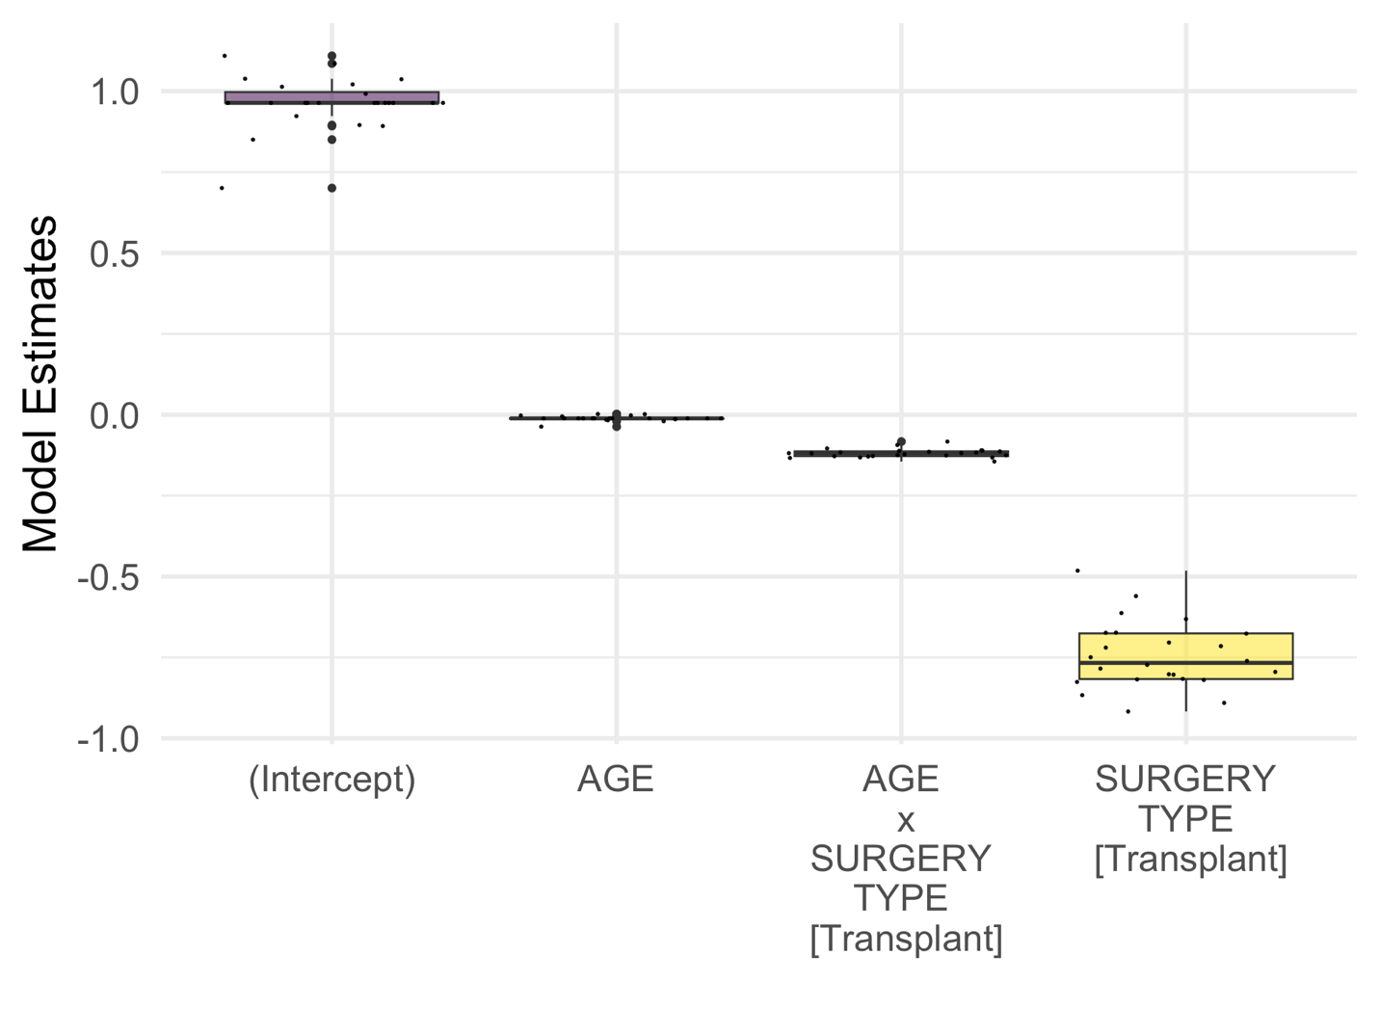

 | Min. | 1st Qu. | Median | Mean | 3rd Qu. | Max.
(Intercept) | 0.007 | 0.016 | 0.018 | 0.020 | 0.019 | 0.054
AGE | 0.161 | 0.658 | 0.672 | 0.680 | 0.673 | 0.946
SURGERY_TYPE [Transplant] | 0.097 | 0.152 | 0.179 | 0.190 | 0.225 | 0.326
AGE x SURGERY_TYPE [Transplant] | 0.003 | 0.007 | 0.012 | 0.016 | 0.018 | 0.074

3.1.2 Secondary Analysis (Subgroup Analysis for VSD Control)
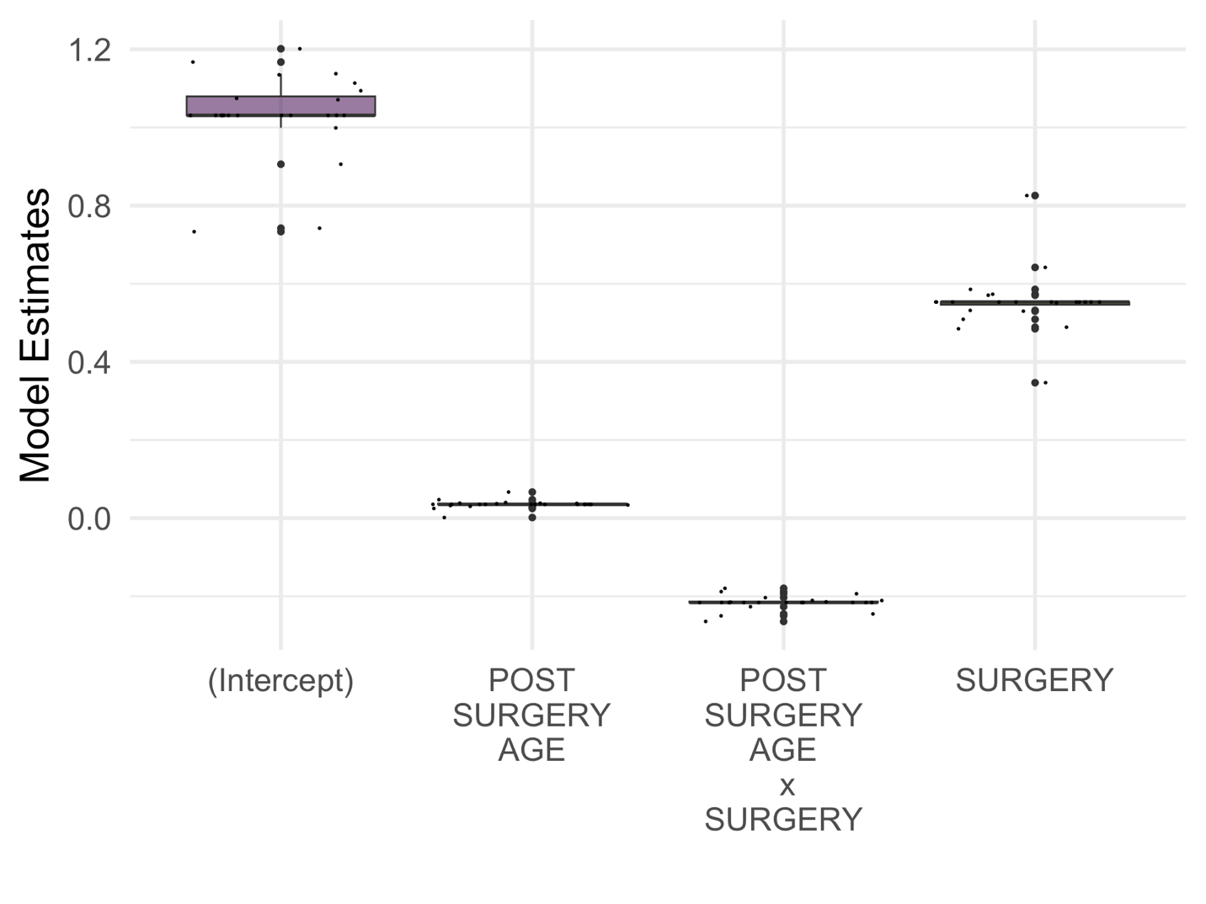
 | Min. | 1st Qu. | Median | Mean | 3rd Qu. | Max.
(Intercept) | 0.020 | 0.037 | 0.037 | 0.045 | 0.045 | 0.109
POST_SURGERY_AGE | 0.115 | 0.331 | 0.341 | 0.365 | 0.341 | 0.966
SURGERY | 0.011 | 0.070 | 0.070 | 0.084 | 0.082 | 0.280
POST_SURGERY_AGE x SURGERY | 0.000 | 0.003 | 0.003 | 0.004 | 0.004 | 0.011

3.2 Pulmonary Valve Annulus

3.2.1 Primary Analysis
CODE
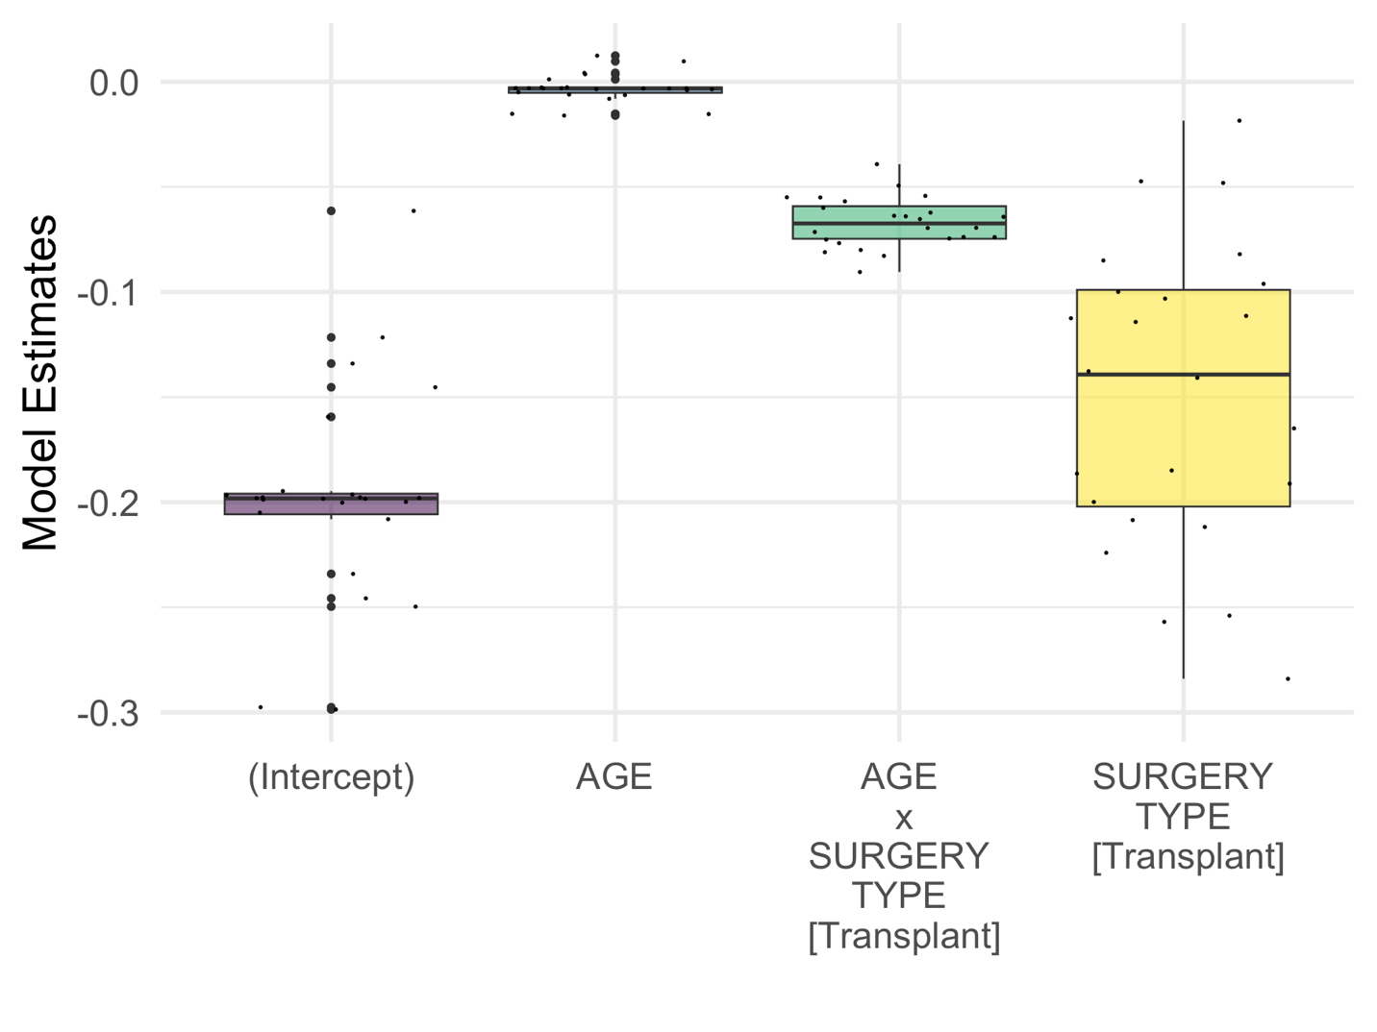

 | Min. | 1st Qu. | Median | Mean | 3rd Qu. | Max.
(Intercept) | 0.150 | 0.312 | 0.322 | 0.343 | 0.328 | 0.757
AGE | 0.546 | 0.806 | 0.892 | 0.827 | 0.904 | 0.963
SURGERY_TYPE [Transplant] | 0.315 | 0.477 | 0.640 | 0.621 | 0.734 | 0.949
AGE x SURGERY_TYPE [Transplant] | 0.049 | 0.107 | 0.149 | 0.161 | 0.209 | 0.385

3.2.2 Secondary Analysis (Subgroup Analysis for VSD Control)
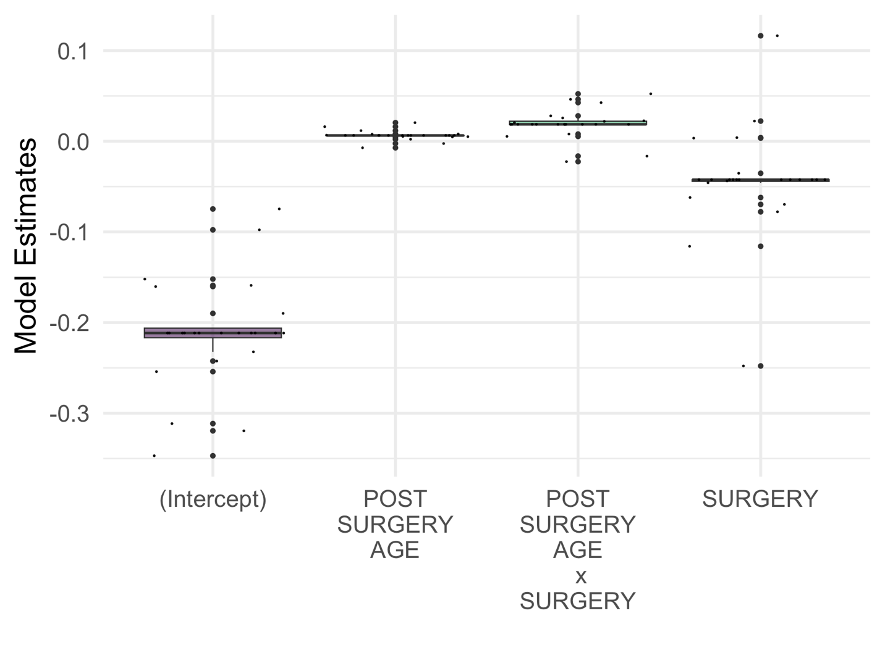

 | Min. | 1st Qu. | Median | Mean | 3rd Qu. | Max.
(Intercept) | 0.154 | 0.351 | 0.354 | 0.381 | 0.377 | 0.731
POST_SURGERY_AGE | 0.534 | 0.813 | 0.821 | 0.806 | 0.821 | 0.944
SURGERY | 0.368 | 0.846 | 0.861 | 0.827 | 0.861 | 0.989
POST_SURGERY_AGE x SURGERY | 0.432 | 0.701 | 0.741 | 0.706 | 0.741 | 0.930

