SUPPLEMENTARY DOCUMENT

Vacuum and sonication treatment enables efficient transient gene expression in various monocot and eudicot plant seedlings

Eugene Li^{1,2}, Yuan Geng^{1,2}, Tuyako R. Khristoforova², Yunqing Wang³, Jolie W. Jones², Gozde S. Demirer^{2,#}

¹Authors contributed equally
²Chemistry and Chemical Engineering Division, California Institute of Technology, Pasadena, CA, USA
³Biology and Biological Engineering Division, California Institute of Technology (Caltech), Pasadena,
California, USA 91125

#corresponding author: gdemirer@caltech.edu

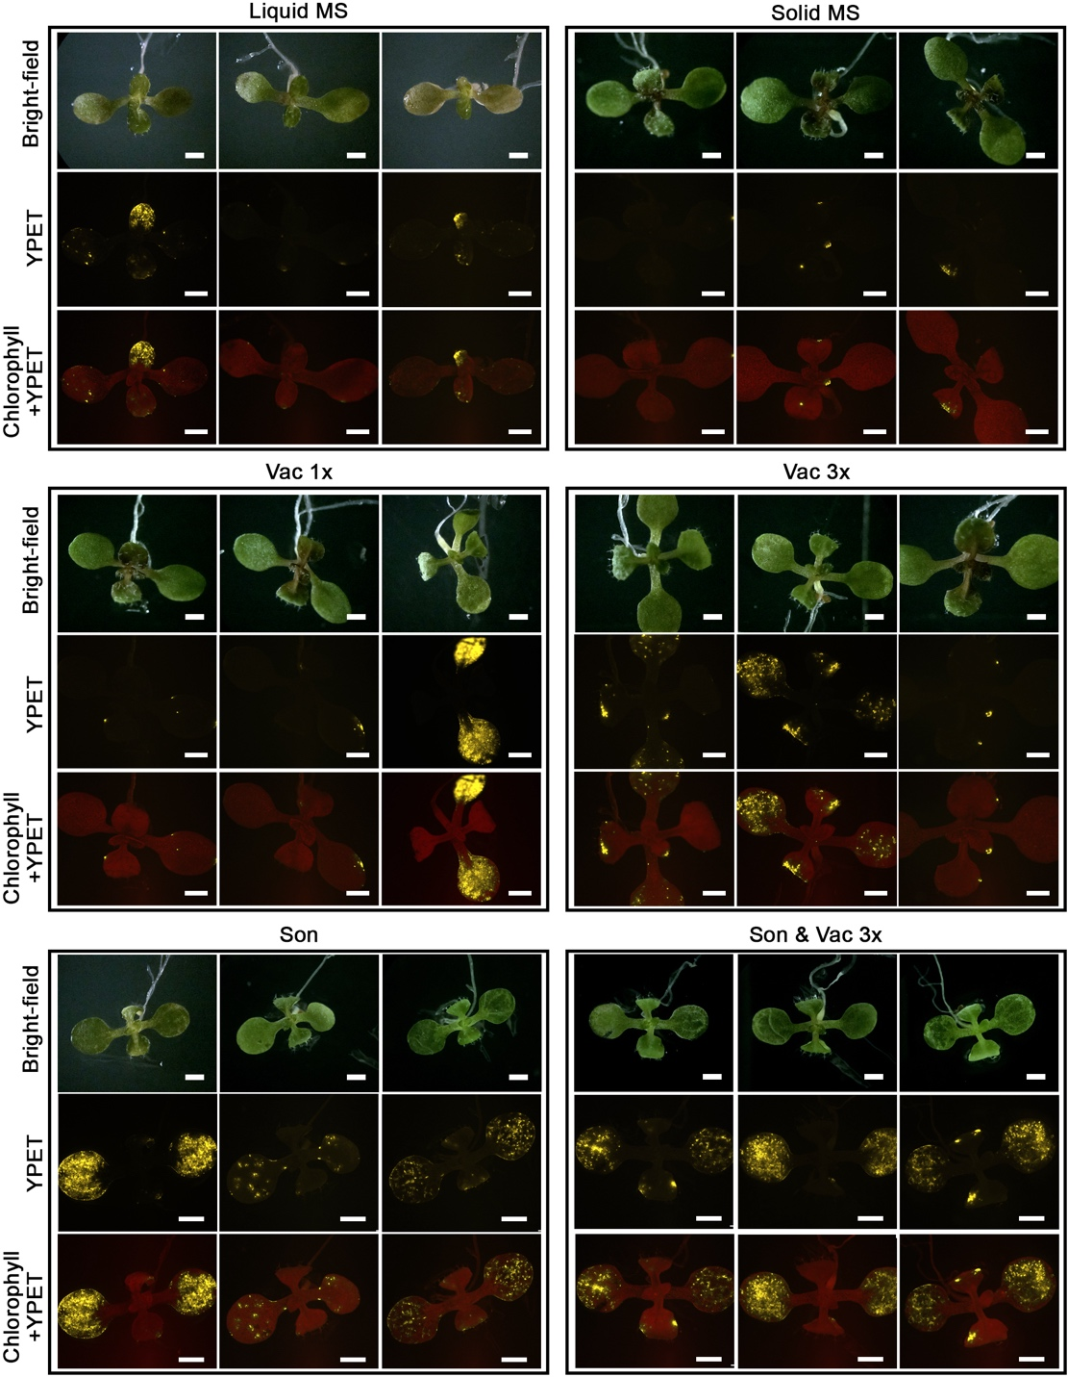
Supplementary Figure 1. Fluorescence microscopy images of Arabidopsis thaliana seedlings after different treatments. Vac 1x: Vacuum once; Vac 3x: Vacuum 3 times; Son: Sonication 20s; Son & Vac 3x: combination of sonication 20s and vacuum 3 times. Channels: Bright-field, YPET (yellow), and Chlorophyll (red) overlaid with YPET. All scale bars: 1 mm.
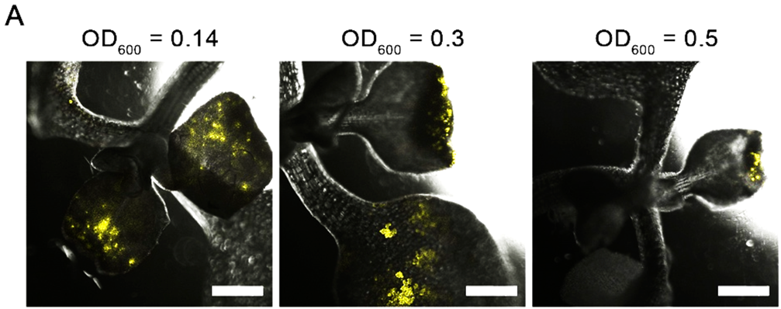
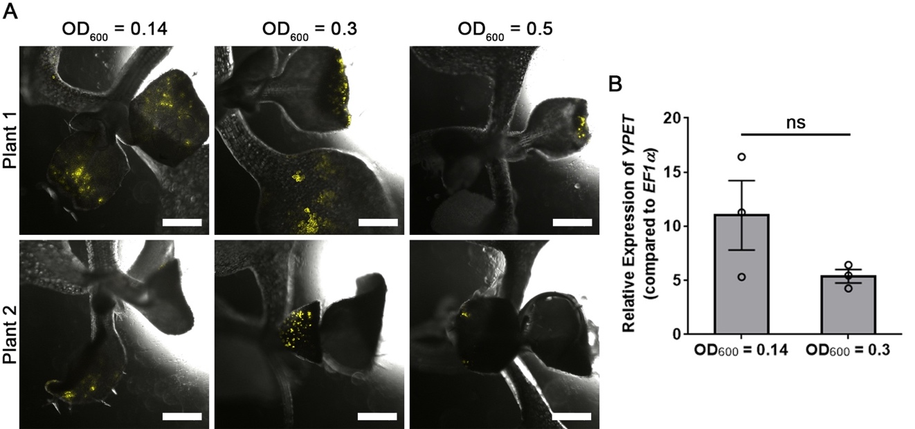

Supplementary Figure 2. Effect of A. tumefaciens concentration on transient expression efficiency in Arabidopsis thaliana. (A) Representative 4-dpi fluorescence microscopy images of A. thaliana seedlings infected with A. tumefaciens concentration of OD₆₀₀ = 0.14, 0.3, or 0.5. All scale bars: 500 µm. (B) Relative expression of YPET via qPCR in 4-dpi seedlings infected with A. tumefaciens at OD₆₀₀ = 0.14 or 0.3. N = 3 biological replicates (each with 5 seedlings). The experiment was independently repeated three times with similar results. Error bars denote standard error of mean. Statistical analysis was performed using a student’s t-test. ns, not significant with p-value 0.1605.

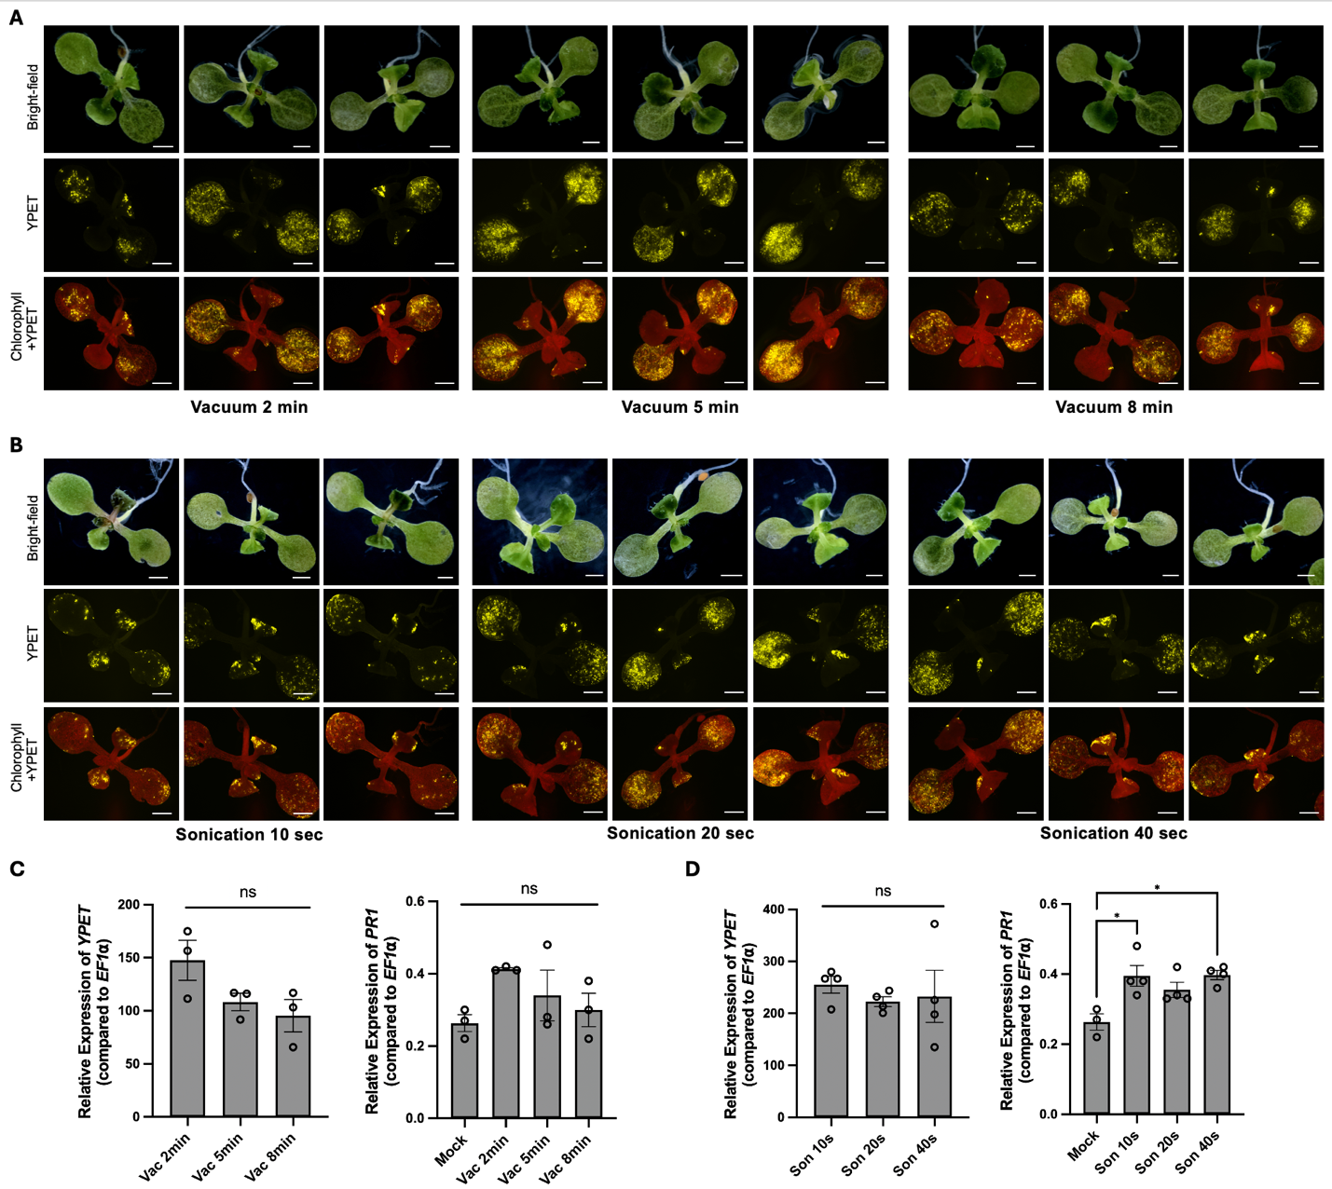
Supplementary Figure 3. Optimization of vacuum and sonication parameters for VAST-mediated transformation efficiency and stress response in Arabidopsis. (A, B) Representative confocal images showing YPET fluorescence in Arabidopsis seedlings subjected to different vacuum infiltration durations (2, 5, and 8 minutes) (A) and sonication times (10, 20, and 40 seconds) (B). Top to bottom rows show bright-field, YPET fluorescence, and merged YPET + chlorophyll channels. Scale bars = 1 mm. (C, D) qPCR analysis of YPET (left) and PR1 (right) gene expression following vacuum (C) and sonication (D) treatments. Data are normalized to the housekeeping gene EF1α. Bars represent mean ± standard error from 3 biological replicates (each with 5 seedlings) from a representative experiment. The experiment was independently repeated three times with similar results. Statistical outliers were identified and excluded using Grubbs’s test. One-way ANOVA followed by Tukey’s test was used for statistical analysis. Significance levels: *p < 0.0332; ns, not significant.

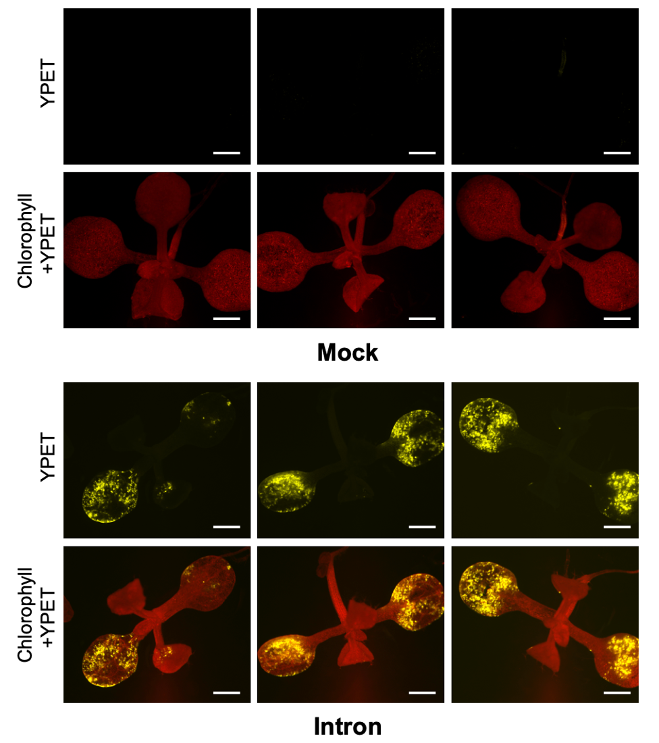
Supplementary Figure 4. Validation of plant-specific expression of YPET. Arabidopsis seedlings were transformed with a YPET construct containing the second intron of the ST-LS1 gene from potato to ensure expression originates from plant cells. Strong YPET fluorescence was observed in the Intron group but not in the mock-treated control, confirming plant-specific expression. Images show YPET fluorescence (top) and merged YPET + chlorophyll (bottom). Scale bars = 1 mm.

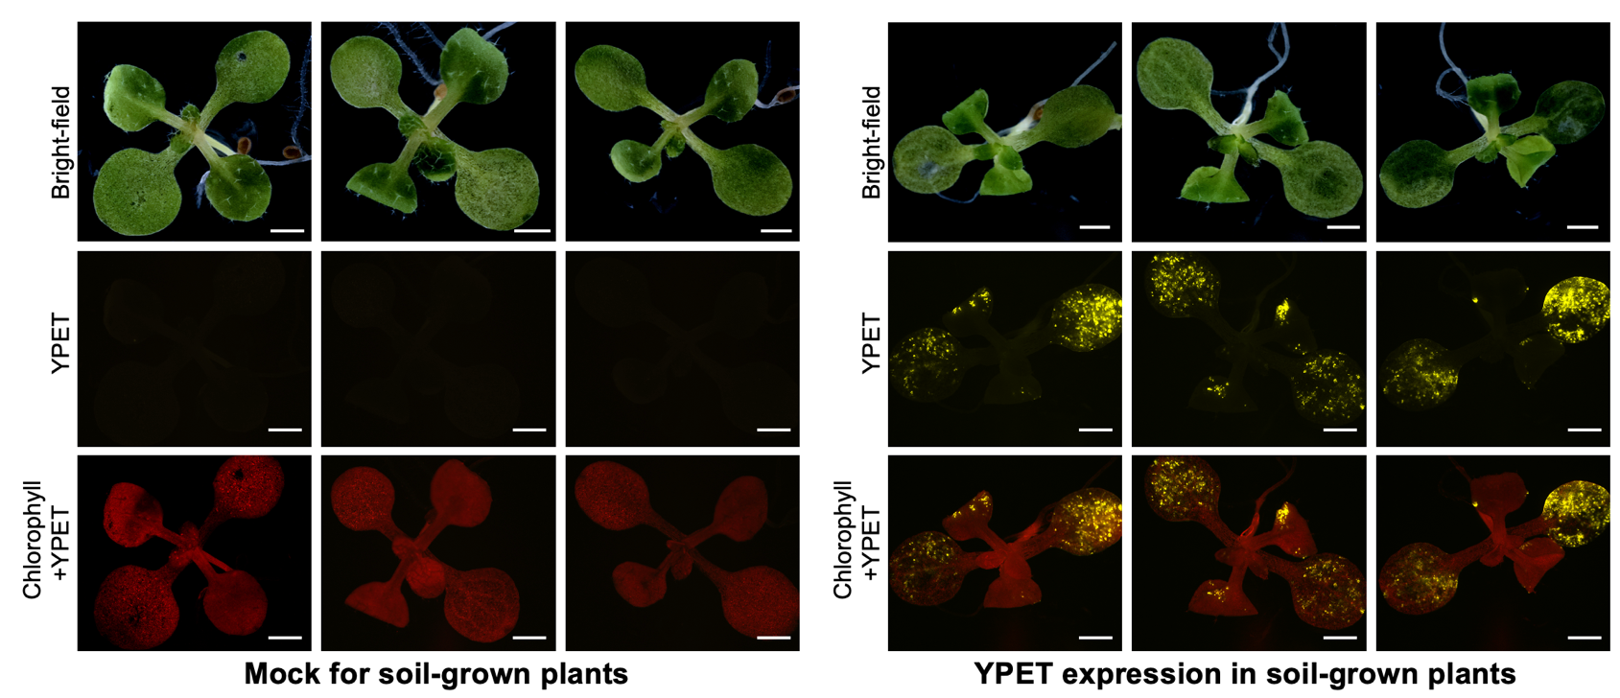
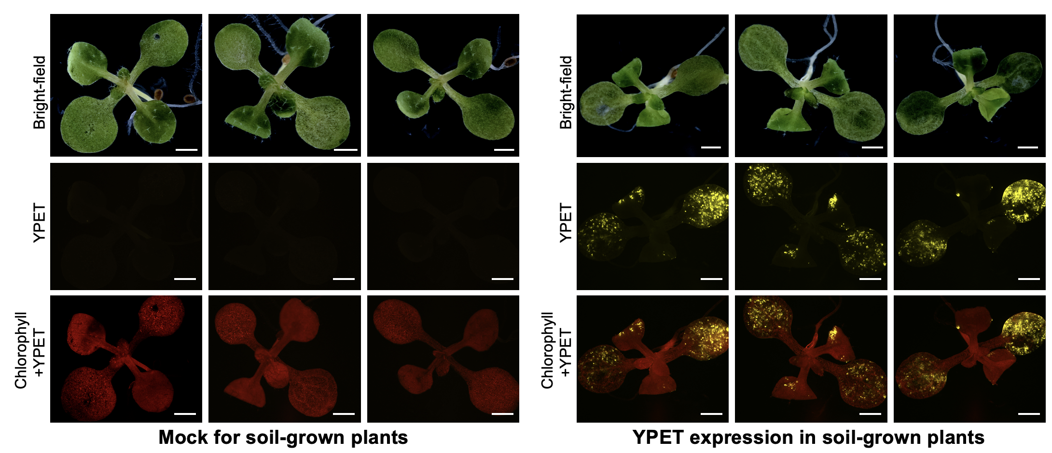

Supplementary Figure 5. VAST enables transformation in soil-grown Arabidopsis plants. YPET fluorescence was observed in soil-grown plants following VAST treatment, while no signal was detected in mock-treated controls. Images show bright-field (top), YPET fluorescence (middle), and merged YPET + chlorophyll (bottom). Scale bars = 1 mm.

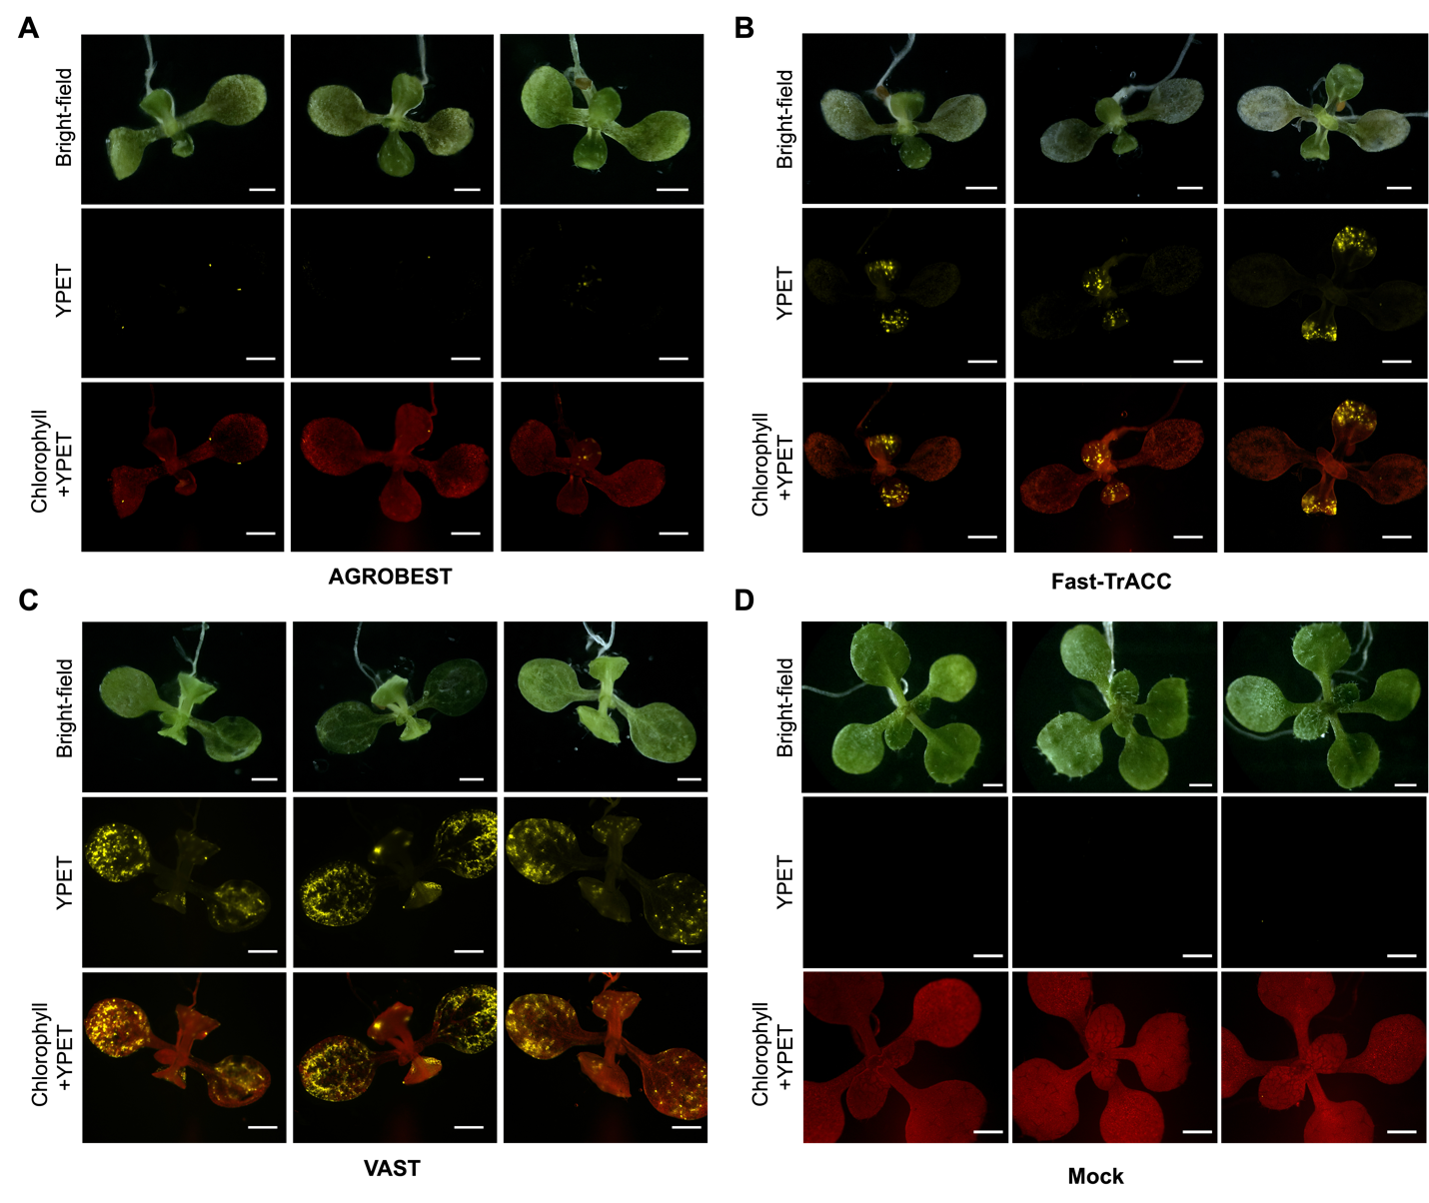
Supplementary Figure 6. Representative fluorescence microscopy image sets of A. thaliana seedlings at 4dpi using (A) AGROBEST, (B) Fast-TrACC, (C) VAST, and (D) mock treatment without A. tumefaciens infection (negative control). All scale bars: 1 mm. Channels: Bright-field, YPET fluorescence (yellow), and Chlorophyll (red) overlaid with YPET.

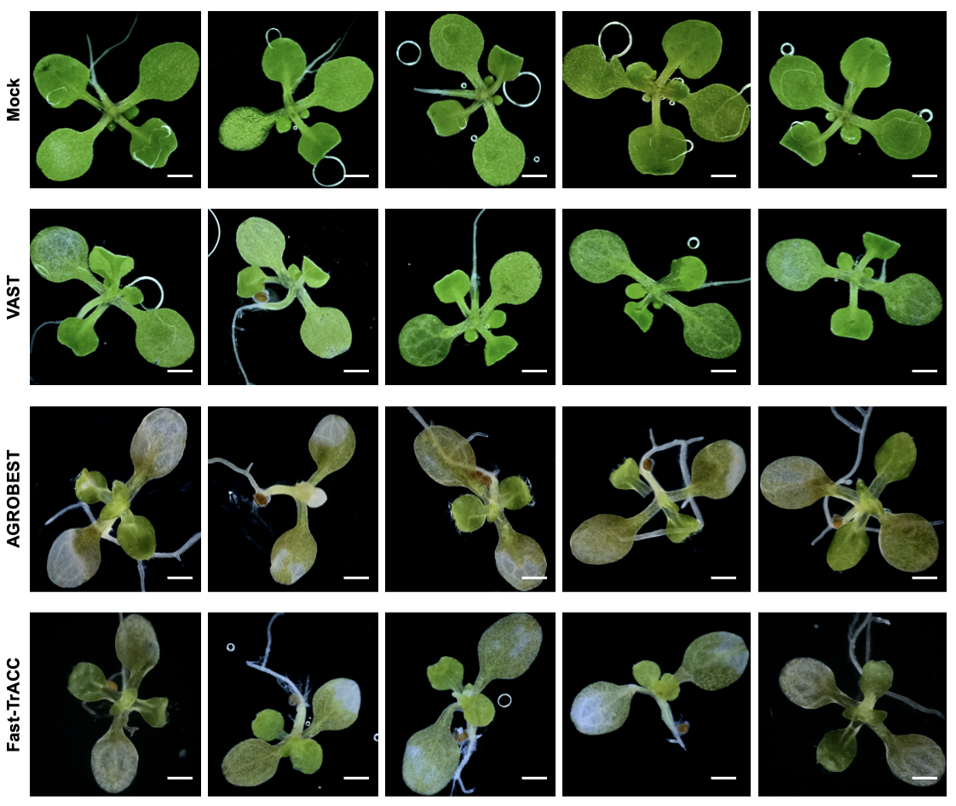
Supplementary Figure 7. Bright-field images showing leaf tissue condition following transformation with different methods of Mock, VAST, AGROBEST, and Fast-TrACC. Five representative seedlings are shown for each condition. Scale bars = 1 mm.

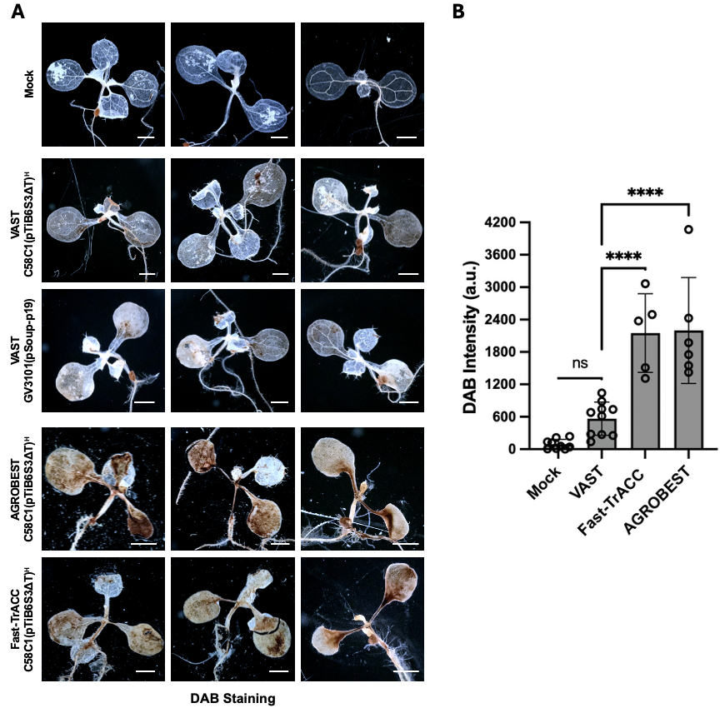 Supplementary Figure 8. Assessment of oxidative stress levels in transformed seedlings via DAB staining. (A) Representative images of Arabidopsis seedlings stained with DAB (3,3′-diaminobenzidine) to visualize hydrogen peroxide (H₂O₂) accumulation as an indicator of oxidative stress after transformation with Mock, VAST, AGROBEST, and Fast-TrACC. Brown precipitate indicates localized H₂O₂ accumulation. Scale bars = 1 mm. (B) Quantification of DAB staining intensity. Bars represent mean ± standard deviation from at least 6 biological replicates. Statistical analysis was performed using one-way ANOVA with Tukey’s post hoc test. Significance levels: ****p < 0.0001; ns = not significant.

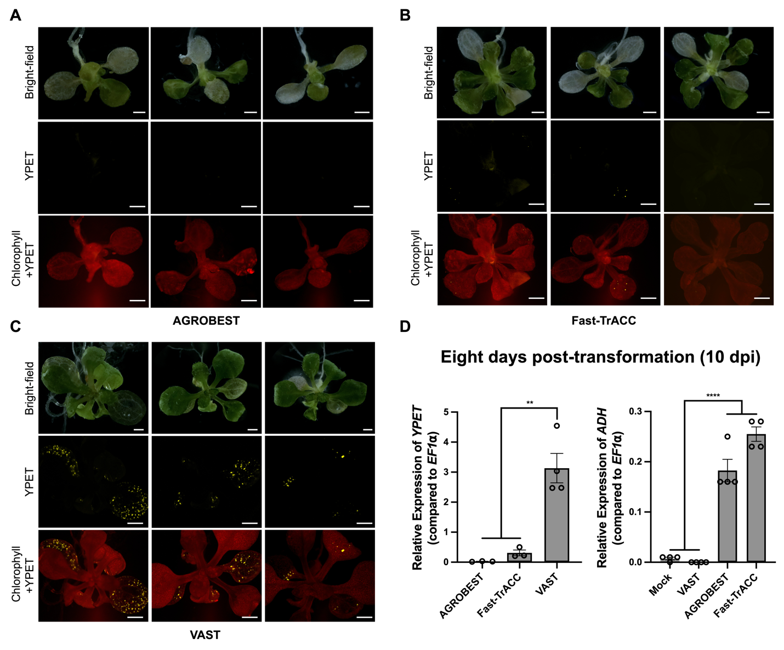
Supplementary Figure 9. Representative fluorescence microscopy image sets of A. thaliana seedlings at 10-dpi using (A) AGROBEST, (B) Fast-TrACC, and (C) VAST. All scale bars: 1 mm. Channels: Bright-field, YPET fluorescence (yellow), and Chlorophyll (red) overlaid with YPET. (D) qPCR analysis of YPET and ADH expression at 10-dpi for AGROBEST, Fast-TrACC, and VAST, normalized to the housekeeping gene EF1α. Data represent mean ± standard error from 4 biological replicates with 5 seedlings per replicate. The experiment was independently repeated three times with similar results. Statistical outliers were identified and excluded using Grubbs' test. One-way ANOVA with Tukey’s test was used for analysis, with significance indicated as ****p < 0.0001, ***p < 0.0002, **p < 0.0021, *p < 0.0332.

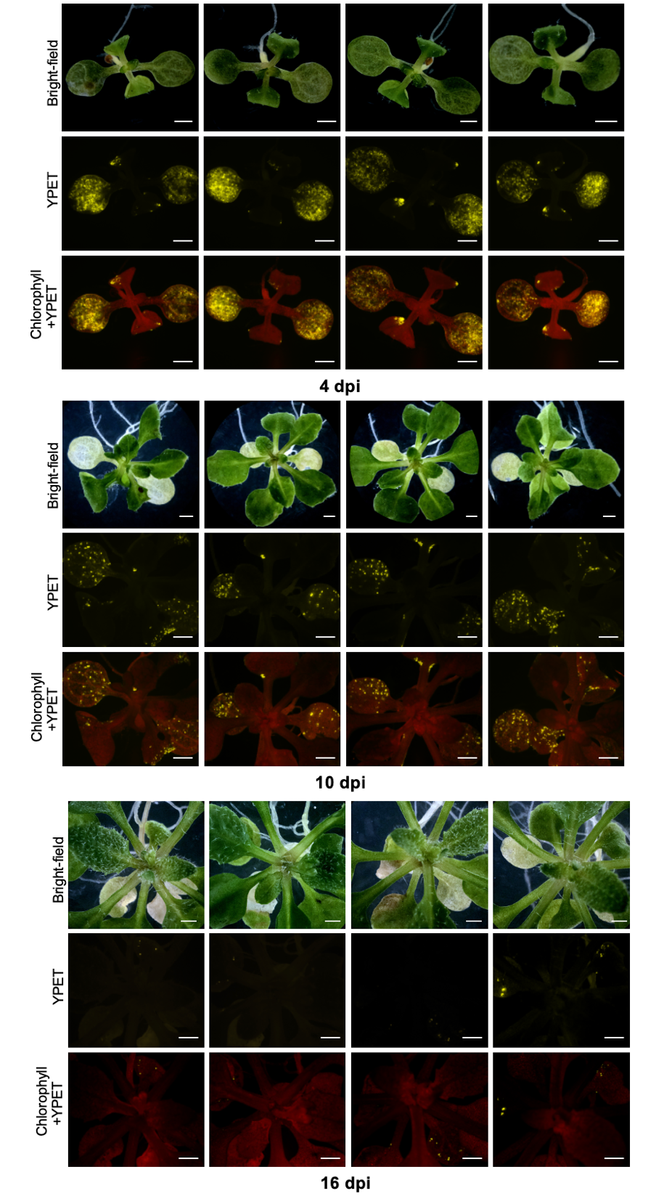
Supplementary Figure 10. Time-course of VAST-mediated YPET expression in Arabidopsis thaliana. Strong, widespread fluorescence is observed at 4 dpi, remains detectable but sparser at 10 dpi, and becomes faint by 16 dpi due to leaf expansion and emergence of new tissue. Images show bright-field, YPET, and merged YPET + chlorophyll channels. Scale bars = 1 mm.

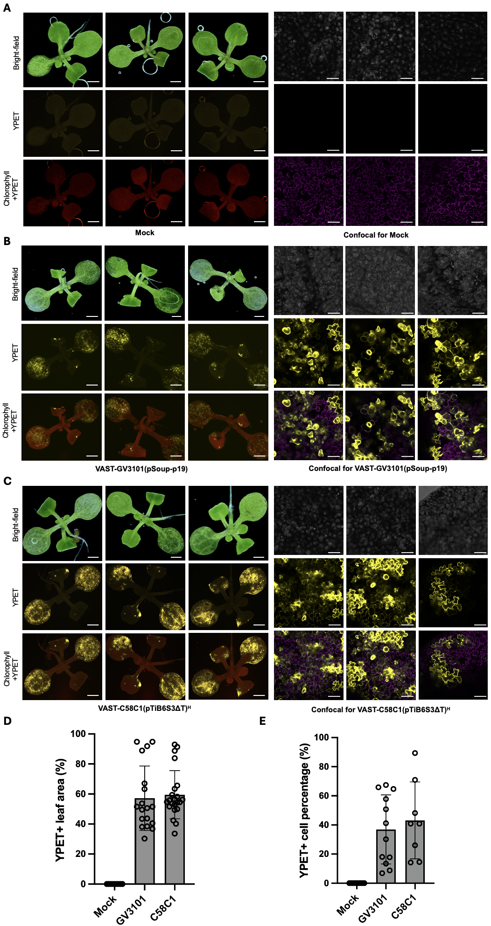
Supplementary Figure 11. Spatial characterization and single-cell quantification of VAST-mediated expression in Arabidopsis thaliana. (A-C) Representative bright-field, YPET fluorescence, and merged chlorophyll + YPET images (left) and confocal microscopy images (right) of A. thaliana leaves transformed with mock, VAST-GV3101(pSoup-p19), or VAST-C58C1(pTiB6S3ΔT)^{H}. (D) Quantification of YPET-positive leaf area (%), and (E) YPET-positive cells as a percentage of total cells, quantified from confocal images. Data represent mean ± standard deviation from at least 8 biological replicates (individual seedlings). Scale bars = 1 mm (widefield) and 100 µm (confocal).

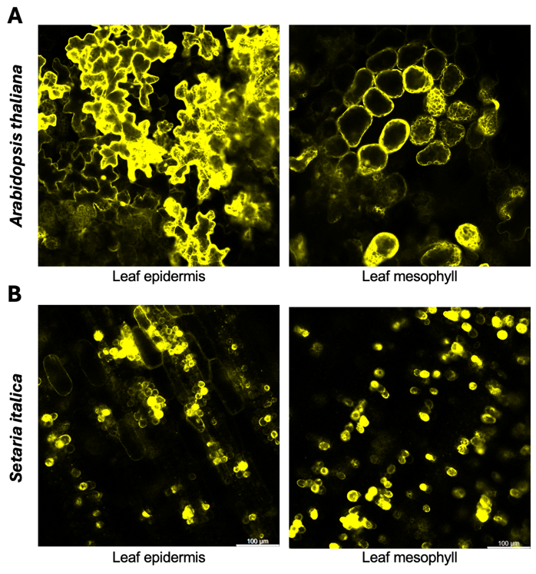
Supplementary Figure 12. Representative confocal microscopy images showing YPET expression in the epidermal and mesophyll layers of transformed Arabidopsis thaliana (A) and Setaria italica (B) leaves. Scale bars = 100 µm.

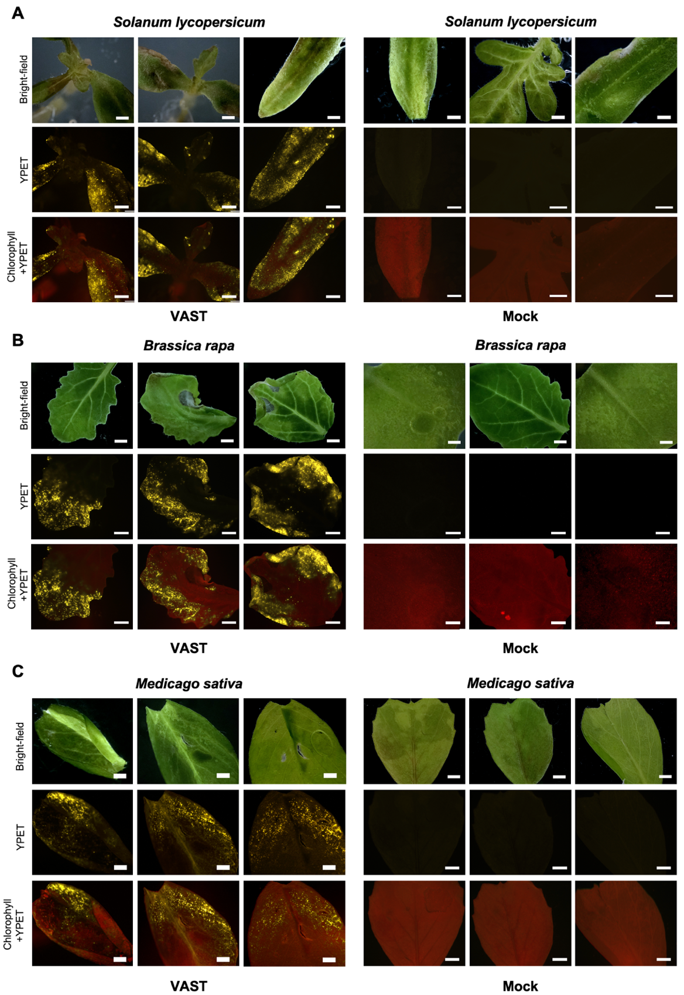

Supplementary Figure 13. Representative fluorescence microscopy image sets of (A) Solanum lycopersicum, (B) Brassica rapa, and (C) Medicago sativa seedlings at 4-5 dpi. The leftmost sample in (B) was treated with 3x vacuum (lacking sonication), whereas all other samples were transformed using the optimized VAST method (see Supplementary Table 2). All scale bars: 1 mm. Channels: Bright-field, YPET fluorescence (yellow), and Chlorophyll (red) overlaid with YPET.
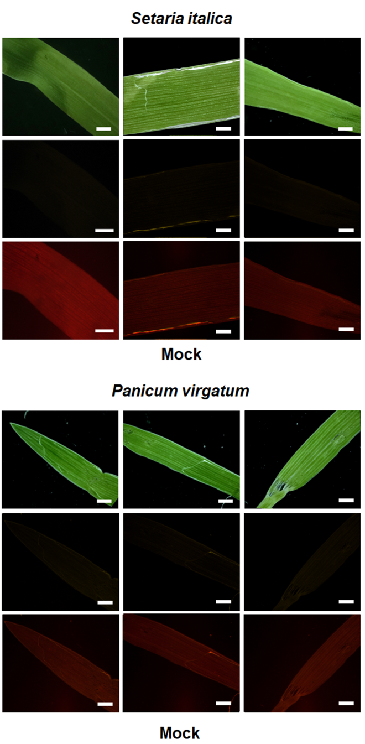
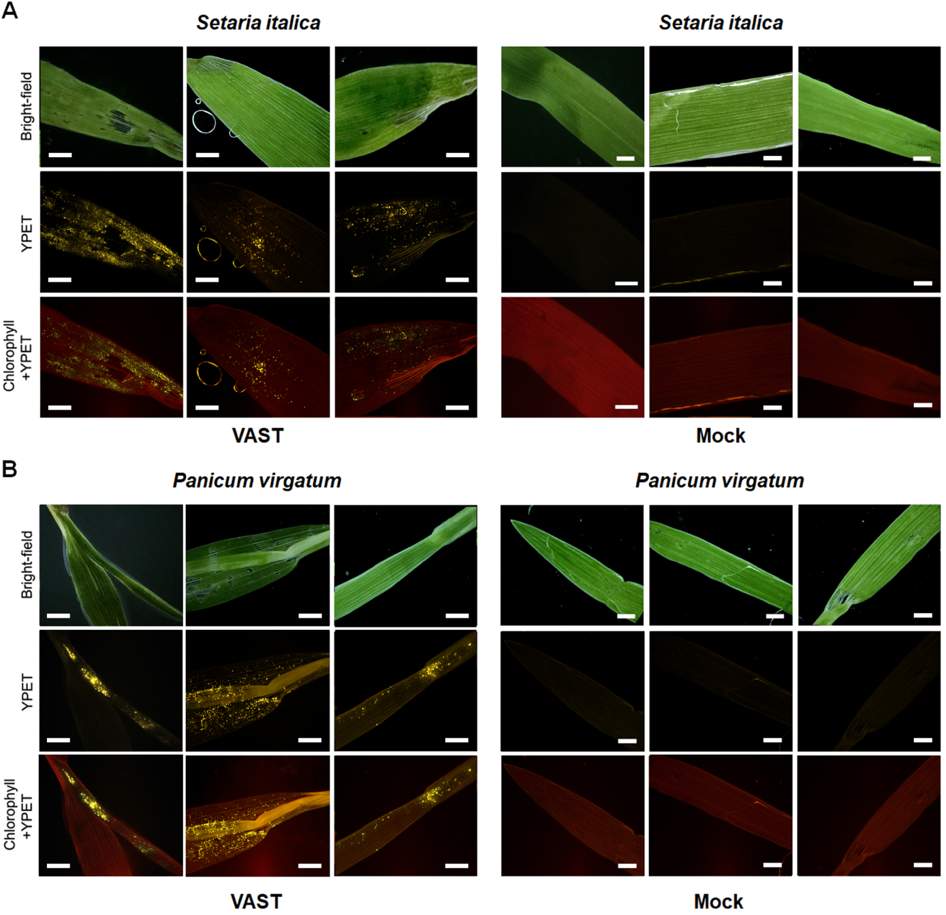

Supplementary Figure 14. Mock fluorescence microscopy image sets of (A) Setaria italica, and (B) Panicum virgatum at 4-dpi. All scale bars: 1 mm. Channels: Bright-field, YPET fluorescence (yellow), and Chlorophyll (red) overlaid with YPET.

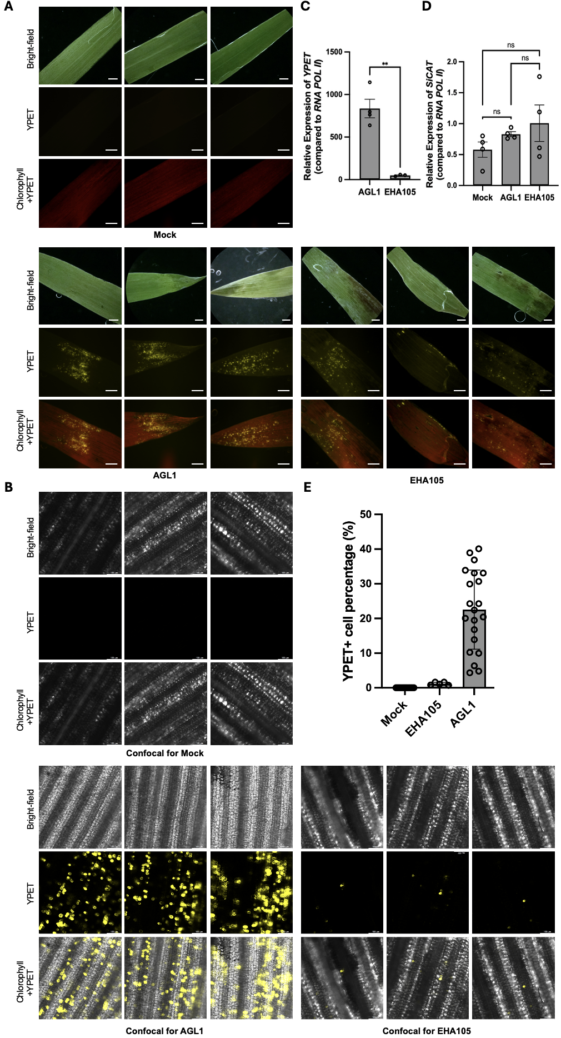
Supplementary Figure 15. Comparison of Agrobacterium tumefaciens strains AGL1 and EHA105 for VAST-mediated transformation in Setaria italica. (A) Representative bright-field, YPET fluorescence, and merged YPET + chlorophyll images of S. italica leaves infiltrated with mock, AGL1, or EHA105. (B) Representative confocal microscopy images of epidermal and mesophyll layers in AGL1-transformed leaves compared to EHA105 and mock controls. (C) qPCR analysis of YPET expression at 4 dpi in AGL1-treated samples compared to EHA105. (D) qPCR analysis of the oxidative stress marker gene catalase in Mock, AGL1, and EHA105-treated samples. For qPCR (C–D), gene expression is compared to the housekeeping gene RNA POL II and data represent mean ± standard error from 4 biological replicates (each with 5 pooled seedlings). (E) Quantification of % YPET-positive cells from confocal images in 22 biological replicates (individual seedlings). Data represent mean ± standard deviation. Each dot represents one seedling. Statistical analysis was performed using one-way ANOVA with Tukey’s post hoc test. Significance levels: *p < 0.0021; p < 0.0332; ns, not significant. Scale bars = 1 mm (widefield) and 100 µm (confocal).

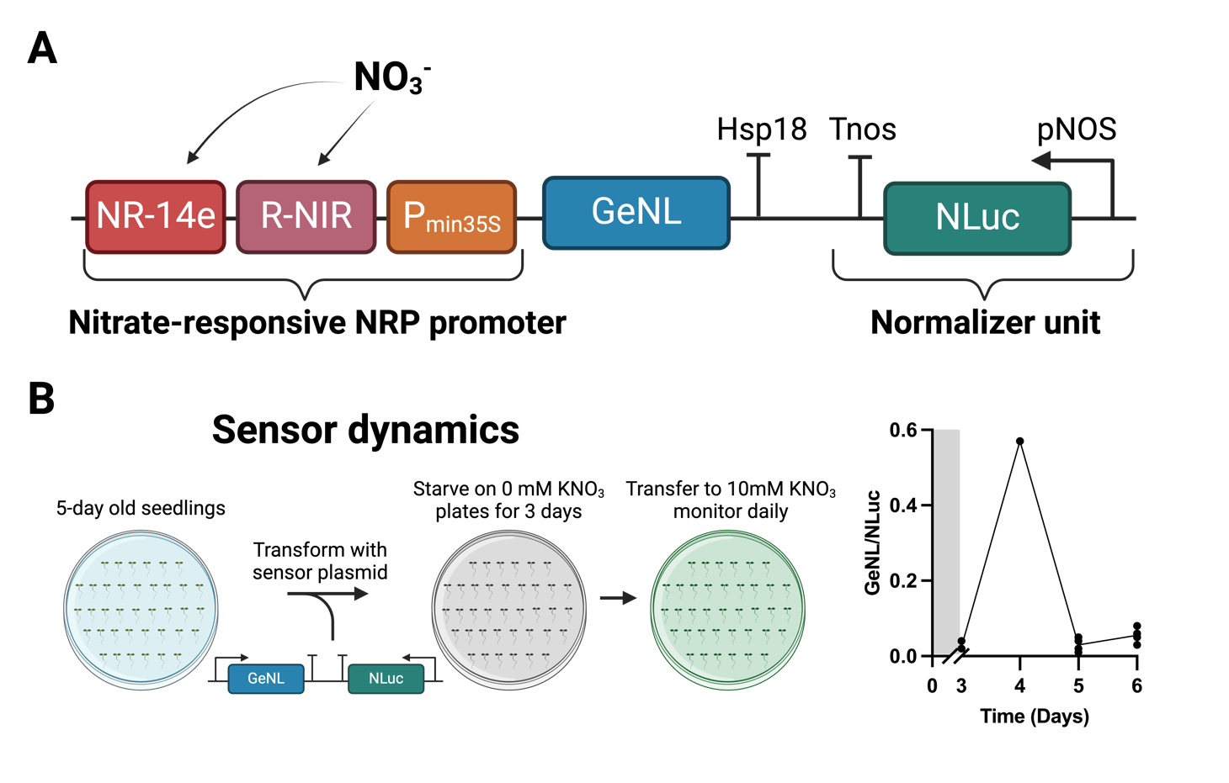
Supplementary Figure 16. Functional analysis of the Nitrate-Regulated Promoter (NRP) in S. italica. (A) Schematic representation of the construct used. GeNL (Green Enhanced Nano-lantern), NLuc (NanoLuc luciferase), pNOS (nopaline synthase promoter), Tnos (nopaline synthase terminator), and Hsp18 (Arabidopsis heat shock protein 18.2 terminator). (B) Workflow schematic for testing sensor dynamics and daily luminescence activity of NRP. Each dot represents a biological replicate (4 biological replicates with 5 seedlings per replicate), and the line represents the mean of the replicates. The gray-shaded area indicates the nitrogen starvation period on nitrogen-free plates, used to bring NRP activity to baseline.

