Supplementary figures
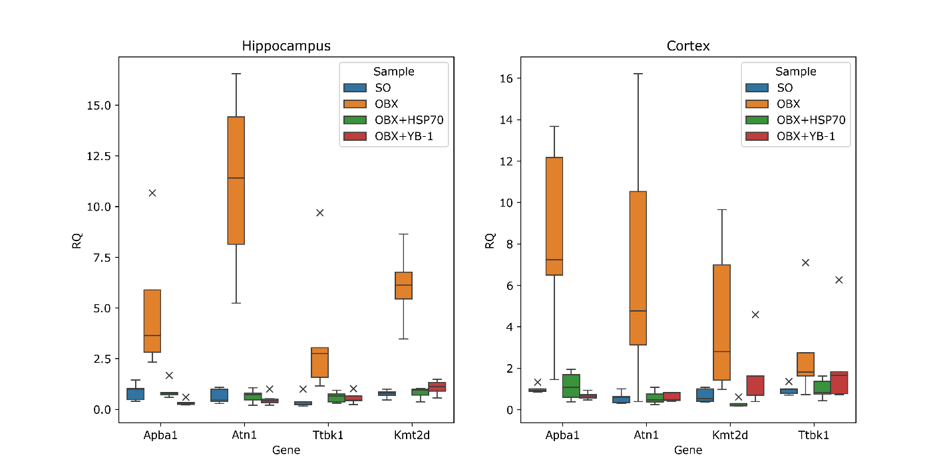
Figure S1. Validation results of transcriptome analysis by qRT-PCR of four differentially expressed genes (with up regulation in OBX) in two brain regions of sham operated (SO), OBX, OBX+recHSP70 and OBX+recYB-1 mice.
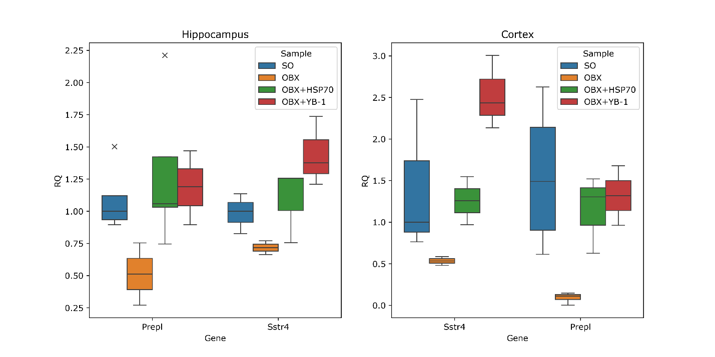
Figure S2. Validation results of transcriptome analysis by qRT-PCR of two differentially expressed genes (with down regulation in OBX) in two brain regions of sham operated (SO), OBX, OBX+recHSP70 and OBX+recYB-1 mice.
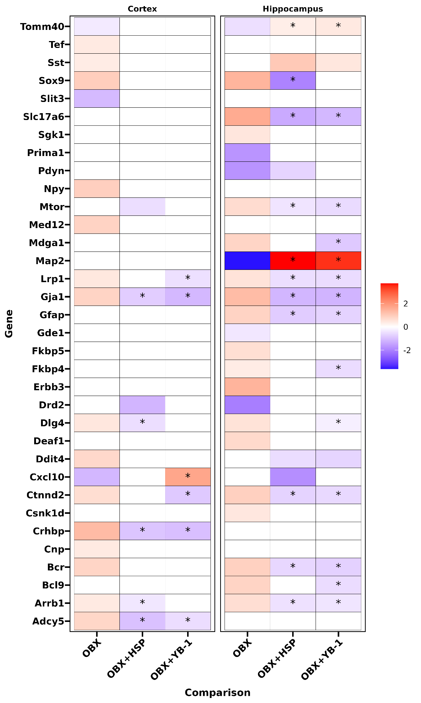
Figure S3. The effect of recombinant Hsp70 and YB-1 administration on the expression of genes involved in major depression in OBX mice. Log2FC values of genes (p<0.05) are shown on heatmap, upregulated are colored as red, and downregulated – as blue. Genes with compensation coefficient 80-120% labeled *

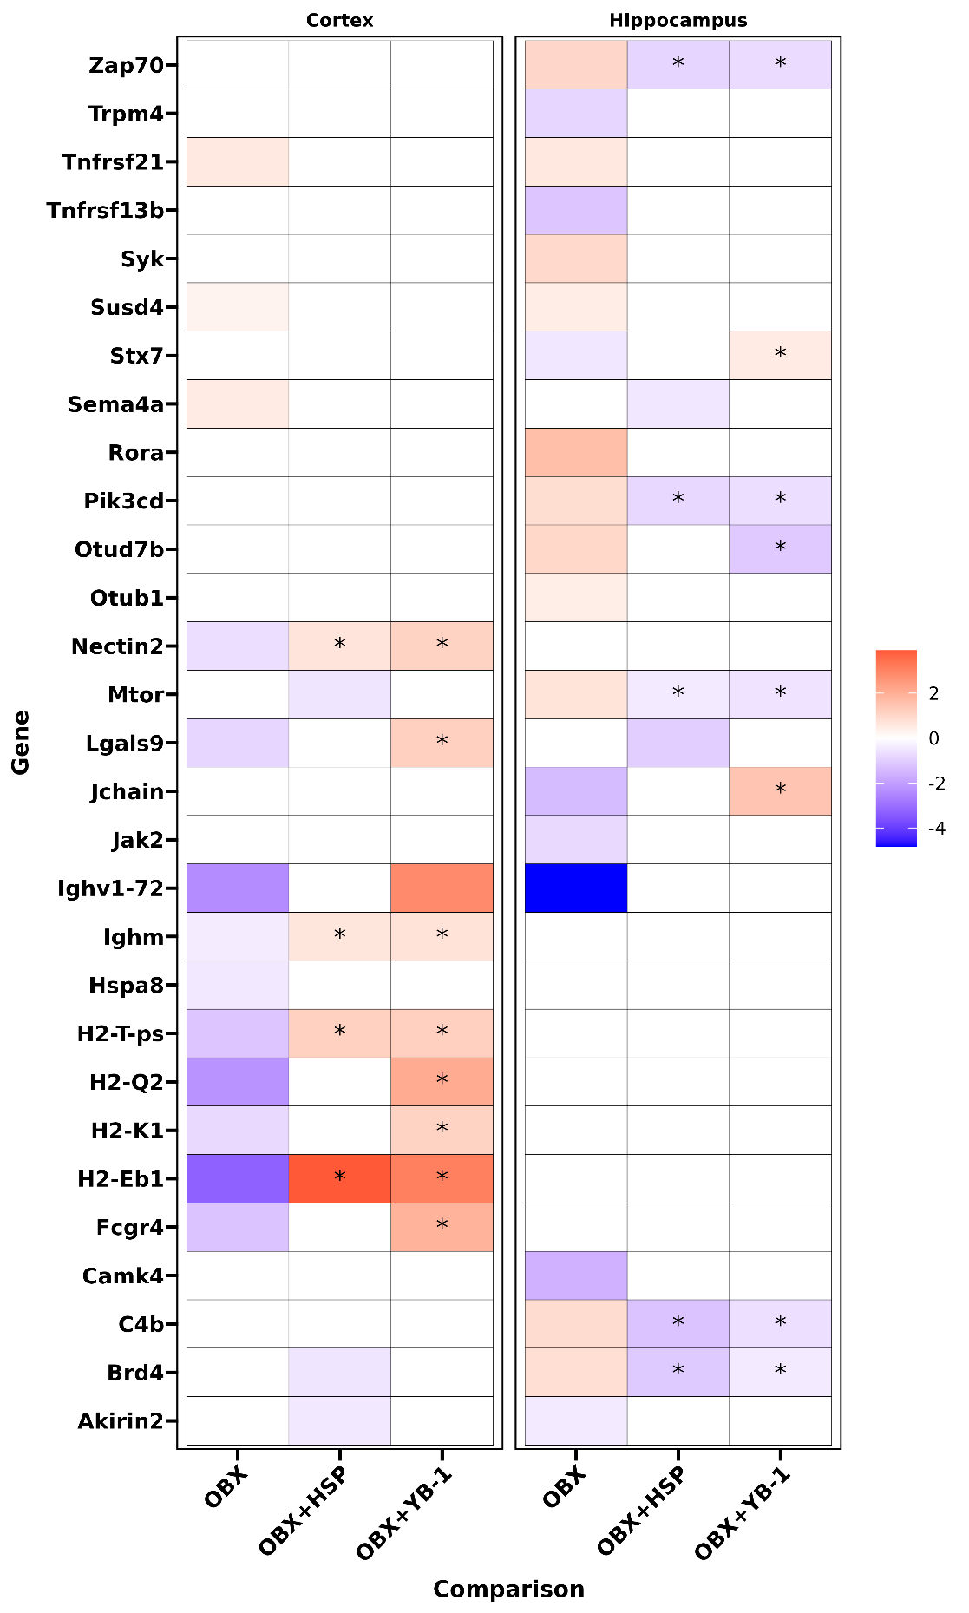
Figure S4. The effect of recombinant Hsp70 and YB-1 administration on the expression of genes involved in immune response in OBX mice. Log2FC values of genes (p<0.05) are shown on heatmap, upregulated are colored as red, and downregulated – as blue. Genes with compensation coefficient 80-120 labeled *.

