Supplementary Material
Exploring the Association between Hypothyroidism and Circadian Syndrome: Insights from NHANES 2007-2012
Ahmed Arabi ¹, Humam Emad Rajha ¹, Osama Alkeilani ¹, Ahmad Hamdan ¹, Dima Nasrallah ¹, Giridhara R. Babu ^{2,*}

¹ College of Medicine, QU Health, Qatar University, Doha P.O. Box 2713, Qatar
² Department of Population Medicine, College of Medicine, QU Health, Qatar University, Doha P.O. Box 2713, Qatar
* Corresponding author. E-mail address: gbabu@qu.edu.qa (G.R. Babu)

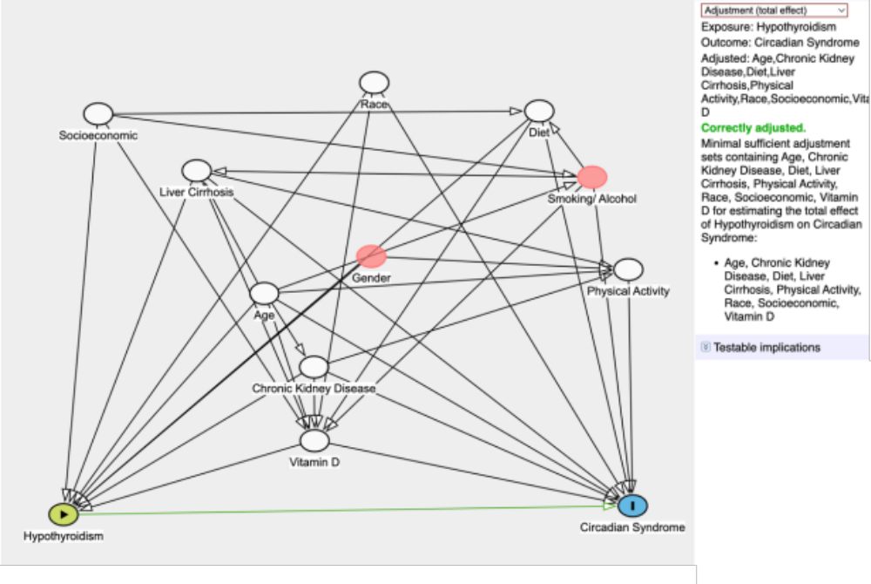

Figure S1. Directed Acyclic Graph (DAG) showing the association between hypothyroidism status with circadian syndrome and different covariates.

Table S1. Unadjusted association between hypothyroidism status and CircS status (n = 5,974) ¹.
Exposure | Categories | CircS OR | p-Value | 95% CI
Hypothyroidism Status
 | No Hypothyroidism | 1
 | Hypothyroidism | 2.04 | <0.001 | 1.69–2.45
¹ Included cohort for the unadjusted association includes adults (aged 18 and above) with complete data on hypothyroidism status and CircS status.
Table S2. Unadjusted association between hypothyroidism status and MetS status (n = 5,935) ¹.
Exposure | Categories | MetS OR | p-Value | 95% CI
Hypothyroidism Status
 | No Hypothyroidism | 1
 | Hypothyroidism | 1.88 | <0.001 | 1.65–2.15
¹ Included cohort for the unadjusted association includes adults (aged 18 and above) with complete data on hypothyroidism status and CircS status.

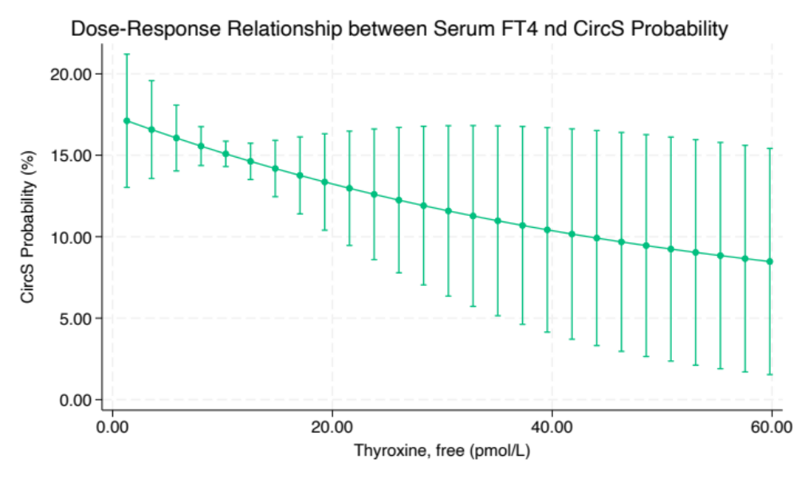

Figure S2. Dose-response Curve demonstrating the unadjusted association between serum FT4 and CircS probability (n= 5,763).¹
¹ Included cohort for the unadjusted dose-response analysis includes adults (aged 18 and above) with complete data on serum FT4 and CircS status.

