A new village-level panel reveals hidden scale of drought-driven agricultural job losses across rural India

Here we provide additional information on the empirical data used in the main article and present the results of additional statistical analyses. Section 1 provides summary statistics for the primary variables used in the main analyses presented in the article. Section 2 provides state-specific drought effects on male agricultural labor participation, similar to the all-India coefficients shown in Table 1 of the main article. Section 3 contains additional empirical analyses that support the robustness of our results. Section 4 is dedicated to a validation of the SPEI drought index used in this paper. Section 5 is about the CMIP6 drought projection analyses and outcomes for India.

Section 1: Summary statistics
Table S1 present summary statistics for the variables used in the empirical analyses reported in Tables 1–2 of the article.

Table S1. Summary statistics
Variable | N | Mean | Std. Dev. | Min. | 25th % | Median | 75th % | Max.
Agricultural workforce data
(16 states, all villages)
Share male agr workers, % | 905,232 | 75.66 | 22.77 | 0 | 64.86 | 82.89 | 93.02 | 100
N male agr workers, log | 905,232 | 4.798 | 1.274 | 0 | 4.14 | 4.963 | 5.656 | 9.038
Drought data (all villages)

Drought index t−1 | 905,232 | 0.2 | 0.25 | 0 | 0 | 0.2 | 0.4 | 1
Drought index t−2 | 905,232 | 0.21 | 0.28 | 0 | 0 | 0 | 0.4 | 1
Drought index t−3 | 905,232 | 0.1 | 0.19 | 0 | 0 | 0 | 0.2 | 1
Drought index t−4 | 905,232 | 0.12 | 0.25 | 0 | 0 | 0 | 0 | 1
Drought index t−5 | 905,232 | 0.14 | 0.22 | 0 | 0 | 0 | 0.2 | 1
Severe drought index t−1 | 905,232 | 0.09 | 0.15 | 0 | 0 | 0 | 0.2 | 0.8
Severe drought index t−2 | 905,232 | 0.05 | 0.13 | 0 | 0 | 0 | 0 | 1
Severe drought index t−3 | 905,232 | 0.02 | 0.06 | 0 | 0 | 0 | 0 | 0.8
Severe drought index t−4 | 905,232 | 0.03 | 0.12 | 0 | 0 | 0 | 0 | 1
Severe drought index t−5 | 905,232 | 0.05 | 0.12 | 0 | 0 | 0 | 0 | 0.8
5yr Avg drought index | 905,232 | 0.15 | 0.00 | 0 | 0.08 | 0.12 | 0.24 | 0.6
5yr Avg severe drought index | 905,232 | 0.05 | 0.06 | 0 | 0 | 0 | 0.08 | 0.32

Section 2: State-specific drought impact on male agricultural labor participation.
Tables S2 and S3 present the predicted impact of an additional month of drought (Table S2) and severe drought (S3) disaggregated by state.

Table S2. Predicted effect of an additional month of drought on the male populations working in agriculture by state, at one-year lag (t-1)
Lagged drought  variable (t-1) |  | Estimate | Std. Error | 95% CI Lower | 95% CI Upper
1 | Andhra Pradesh | 1.438* | 2.247 | 0.698 | 2.179
2 | Bihar | -0.805* | 2.085 | -1.492 | -0.117
3 | Chhattisgarh | -0.461 | 1.422 | -0.929 | 0.008
4 | Gujarat | -4.005* | 4.533 | -5.499 | -2.511
5 | Haryana | 0.893 | 2.863 | -0.050 | 1.837
6 | Jharkhand | -2.126* | 2.623 | -2.991 | -1.262
7 | Karnataka | 0.669 | 2.451 | -0.139 | 1.477
8 | Kerala | 1.848* | 3.348 | 0.745 | 2.952
9 | Madhya Pradesh | -0.638* | 1.586 | -1.161 | -0.115
10 | Maharashtra | -2.196* | 2.268 | -2.943 | -1.449
11 | Odisha | -0.486 | 1.684 | -1.041 | 0.069
12 | Punjab | -0.540* | 1.516 | -1.040 | -0.040
13 | Rajasthan | 0.175 | 2.255 | -0.568 | 0.918
14 | Tamil Nadu | 1.733 | 7.282 | -0.667 | 4.134
15 | Uttar Pradesh | -0.438 | 1.676 | -0.990 | 0.115
16 | West Bengal | 0.111 | 2.253 | -0.631 | 0.854
Notes: * denotes statistical significance at the 90% confidence level.

Table S3. Predicted effect of an additional month of severe drought on the male populations working in agriculture by state, at one-year lag (t-1)
Lagged drought  variable (t-1) |  | Estimate | Std. Error | 95% CI Lower | 95% CI Upper
1 | Andhra Pradesh | 0.346 | 2.535 | -0.490 | 1.182
2 | Bihar | -1.595* | 4.442 | -3.059 | -0.131
3 | Chhattisgarh | -0.613* | 1.622 | -1.147 | -0.078
4 | Gujarat | -5.858* | 2.993 | -6.845 | -4.872
5 | Haryana | 0.378 | 4.050 | -0.957 | 1.713
6 | Jharkhand | -4.252* | 2.757 | -5.160 | -3.343
7 | Karnataka | 0.719 | 3.033 | -0.281 | 1.719
8 | Kerala | 1.391 | 9.415 | -1.712 | 4.494
9 | Madhya Pradesh | -1.114* | 2.829 | -2.046 | -0.181
10 | Maharashtra | -2.188* | 2.332 | -2.957 | -1.420
11 | Odisha | 0.556 | 2.483 | -0.262 | 1.374
12 | Punjab | -0.990* | 2.172 | -1.705 | -0.274
13 | Rajasthan | 0.221 | 3.985 | -1.093 | 1.534
14 | Tamil Nadu | 4.071* | 9.540 | 0.926 | 7.215
15 | Uttar Pradesh | -1.904* | 2.626 | -2.770 | -1.039
16 | West Bengal | -0.528 | 2.388 | -1.315 | 0.259
Notes: * denotes statistical significance at the 90% confidence level.

Section 3: Sensitivity analysis
In this section, we present and briefly discuss the results of the sensitivity analysis. To begin with, we examine the sensitivity of the article’s conclusions to different specifications of the standard errors. First, we replicate Model 1 in the article, but cluster the standard error at the sub-district level, instead of the district level. While the average number of villages per district in the primary sample is 1,906, the average number of villages per sub-district is much smaller, averaging 189. Yet, our conclusions, reported in Table S4, are not affected, with the standard generally becoming smaller when clustering them at the sub-district level. The primary consequence is that the rebound effects in subsequent years after the initial drop in male agricultural labor now appears more clearly.
Second, we evaluate whether the results are sensitive to the spatial specification of the standard errors. Table S5 reproduces Table 1 of the main article but uses spatial- Heteroskedasticity and Autocorrelation Consistent (spatial-HAC) errors (see Conley 1999, 2008). To do so, we use a Bartlett kernel with a cut-off distance of 50 kilometres. Because of the extremely large number of units (villages), calculating these errors for the entire sample of 452,616 is not practical from a computational perspective. Instead, we generate a new dataset comprising a random 10% of the original number of villages and stratified this sample by state to maintain the dataset structure. The new random sample comprises 45,261 villages. Models 1–4 of Table S5 reproduce Table 1 of the main article using clustered standard errors at the district level, demonstrating that the conclusions are not meaningfully impacted by the new sample. Models 5–8 then use the spatial-HAC errors. As shown, the use of spatial-HAC error with a 50km cut-off does not appear to alter the results in any substantial way. In fact, the standard errors are now smaller.
Third, in Table S6, we again replicate Table 1 from the main article, this time using a different specification of the fixed effects: interacting year fixed effects with state fixed effects to control for the potential influence of state-specific policies, such as the Mahatma Gandhi National Rural Employment Guarantee Act (MGNREGA). Although MGNREGA is a national-level policy, its implementation is decentralized and varies in speed across states. The program was rolled out in 2006, with states such as Rajasthan, Andhra Pradesh, Tamil Nadu, and Kerala known for effective implementation, whereas Uttar Pradesh, Bihar, and Jharkhand have struggled with poor execution.
The results again indicate that male agricultural labor participation declines in the year following a drought, particularly in the case of severe drought. However, the five-year average effect is no longer statistically significant at conventional levels, suggesting that state-specific policies may influence the speed of agricultural labor recovery after a drought.
Fourth, in Table S7, we expand the number of lags of the drought index to include the previous 10 years before the 2001 and 2011 censuses. The results for the immediate impact of a drought remain robust to this specification (see Models 1–2 of Table S7). That said, we note a departure from the results reported in Table 1 of the main article for the variable that measures the average number of drought-month over the past 10 years (see Models 3–4 of Table S7). For both Models, the coefficients become positive, though it is only significant for the severe drought index. While we remain cautious in our interpretation of this results, given that the variable weights a drought 10 years prior to the census equivalently to a drought in the year immediately before, it suggests that drought condition when averaging over the past 10 years may not be associated with reductions in male agricultural labor participation.

Table S4. Standard errors clustered at the sub-district level
 | Dependent variable: Share of male agricultural workers
 | drought | severe drought | drought | severe drought
 | (Model 1) | (Model 2) | (Model 3) | (Model 4)
Drought index t−1 | -5.036** | -5.995**
 | (0.438) | (0.610)
Drought index t−2 | 1.056** | -0.586
 | (0.313) | (0.507)
Drought index t−3 | 2.906** | 3.408**
 | (0.396) | (0.961)
Drought index t−4 | -0.570+ | -3.638**
 | (0.321) | (0.711)
Drought index t−5 | -1.579** | 0.391
 | (0.337) | (0.631)
5yr Avg drought index |  |  | -5.340** | -11.107**
 |  |  | (0.579) | (1.184)
Village FE | Yes | Yes | Yes | Yes
Year FE | Yes | Yes | Yes | Yes
Adjusted R² | 0.584 | 0.583 | 0.582 | 0.582
N Observations | 905,232 | 905,232 | 905,232 | 905,232
N State | 16 | 16 | 16 | 16
N District | 475 | 475 | 475 | 475
Note: | + p<0.1; * p<0.05; ** p<0.01. Standard errors clustered at the sub-district level.

Table S5. Conley standard errors
 | Dependent variable: Share of male agricultural workers
 | Clustered standard errors — District |  |  |  | Spatial-HAC error — 50 km cutoff with Bartlett kernel
 | drought | severe drought | drought | severe drought | drought | severe drought | drought | severe drought
 | (Model 1) | (Model 2) | (Model 3) | (Model 4) | (Model 1) | (Model 2) | (Model 3) | (Model 4)
Drought index t−1 | -5.534* | -11.594** |  |  | -5.534** | -11.594**
 | (2.338) | (3.849) |  |  | (0.886) | (1.409)
Drought index t−2 | -3.430* | -5.012 |  |  | -3.430** | -5.012**
 | (1.436) | (3.283) |  |  | (0.532) | (1.281)
Drought index t−3 | -0.168 | -6.195 |  |  | -0.168 | -6.195**
 | (1.888) | (5.061) |  |  | (0.788) | (2.172)
Drought index t−4 | 1.160 | 5.732* |  |  | 1.160+ | 5.732**
 | (1.534) | (2.647) |  |  | (0.616) | (1.105)
Drought index t−5 | -1.566 | 4.379 |  |  | -1.566 | 4.379**
 | (2.690) | (3.527) |  |  | (1.014) | (1.519)
5yr Avg drought index |  |  | -10.237** | -17.855* |  |  | -10.237** | -17.855**
 |  |  | (3.427) | (7.441) |  |  | (1.428) | (2.933)
Village FE | Yes | Yes | Yes | Yes | Yes | Yes | Yes | Yes
Year FE | Yes | Yes | Yes | Yes | Yes | Yes | Yes | Yes
Adjusted R² | 0.584 | 0.583 | 0.582 | 0.582 | 0.584 | 0.583 | 0.582 | 0.582
N Observations | 90,522 | 90,522 | 90,522 | 90,522 | 90,522 | 90,522 | 90,522 | 90,522
N State | 16 | 16 | 16 | 16 | 16 | 16 | 16 | 16
N District | 475 | 475 | 475 | 475 | 475 | 475 | 475 | 475
Note: | + p<0.1; * p<0.05; ** p<0.01.

 | Dependent variable: Share of male agricultural workers
 | drought | severe drought | drought | severe drought
 | (Model 1) | (Model 2) | (Model 3) | (Model 4)
Drought index t−1 | -2.133** | -4.220**
 | -0.741 | -1.108
Drought index t−2 | 0.779 | 0.794
 | -0.499 | -0.857
Drought index t−3 | 0.691 | 1.693
 | -0.596 | -1.278
Drought index t−4 | 2.148** | 2.016⁺
 | -0.611 | -1.211
Drought index t−5 | -2.138** | 0.173
 | -0.618 | -1.028
5yr Avg drought index |  |  | -0.093 | -1.435
 |  |  | -1.139 | -2.282
Village FE | Yes | Yes | Yes | Yes
Year x state FE | Yes | Yes | Yes | Yes
Adjusted R² | 0.593 | 0.593 | 0.593 | 0.593
N Observations | 905,232 | 905,232 | 905,232 | 905,232
N State | 16 | 16 | 16 | 16
N District | 475 | 475 | 475 | 475
Note: | + p<0.1; * p<0.05; ** p<0.01. Standard errors clustered at the sub-district level.
Table S6. State-by-Time fixed-effects

 | Dependent variable: Share of male agricultural workers
 | drought | severe drought | drought | severe drought
 | (Model 1) | (Model 2) | (Model 3) | (Model 4)
Drought index t−1 | -4.114** | -4.737**
 | (1.037) | (1.243)
Drought index t−2 | 2.180** | 1.126
 | (0.591) | (0.888)
Drought index t−3 | 3.244** | 4.258*
 | (0.848) | (1.836)
Drought index t−4 | -0.873 | -2.405*
 | (0.574) | (1.167)
Drought index t−5 | -1.709* | 0.673
 | (0.699) | (1.221)
Drought index t−6 | 0.616 | 2.224*
 | (0.599) | (1.096)
Drought index t−7 | -0.622 | -1.564
 | (0.587) | (1.220)
Drought index t−8 | 2.474** | 5.207**
 | (0.577) | (1.213)
Drought index t−9 | 1.140* | 1.825**
 | (0.540) | (0.533)
Drought index t−10 | 0.824 | -1.085
 | (0.586) | (0.853)
10yr Avg drought index |  |  | 2.426 | 9.927**
 |  |  | (1.542) | (2.847)
Village FE | Yes | Yes | Yes | Yes
Year x state FE | Yes | Yes | Yes | Yes
Adjusted R² | 0.586 | 0.586 | 0.586 | 0.586
N Observations | 905,232 | 905,232 | 905,232 | 905,232
N State | 16 | 16 | 16 | 16
N District | 475 | 475 | 475 | 475
Note: | + p<0.1; * p<0.05; ** p<0.01. Standard errors clustered at the sub-district level.
Table S7. 10-years lags

Section 4: Drought indicator technical validation

Figure S1 – S6. Technical validation of our high-resolution SPEI (0.05 degree) against Climatic Research Unit (CRU) TS 4.03 SPEI dataset (0.5 degree)
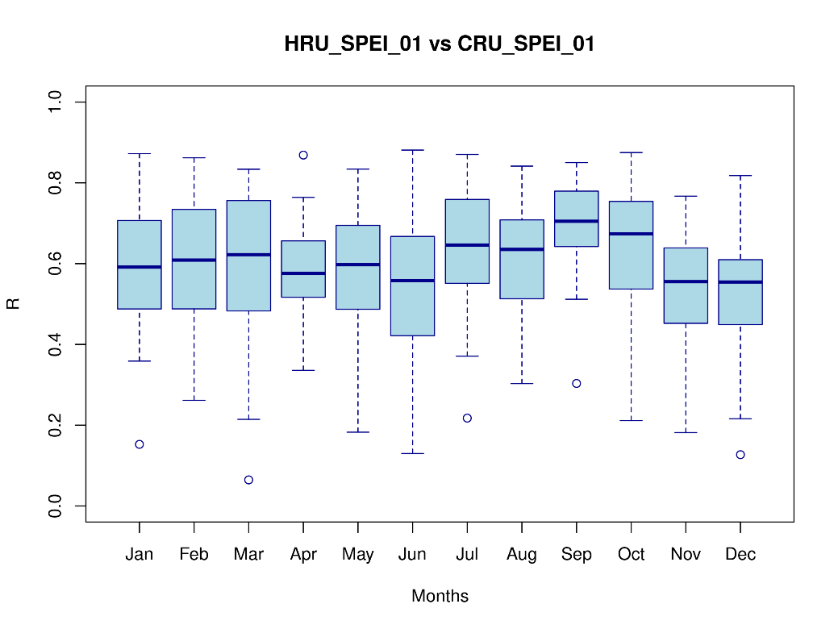

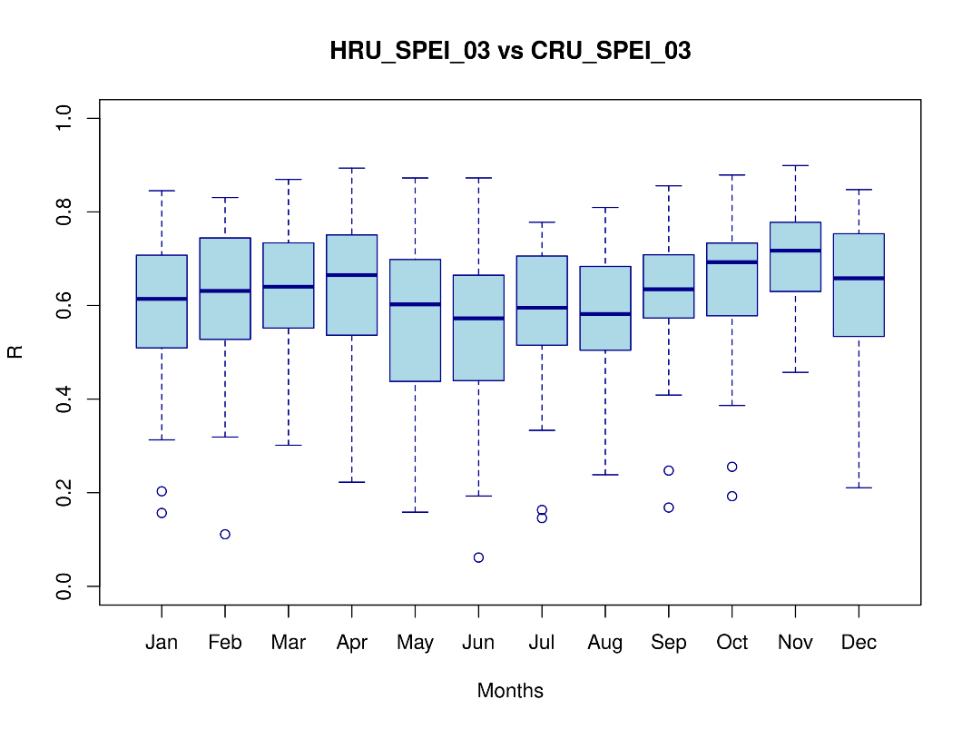

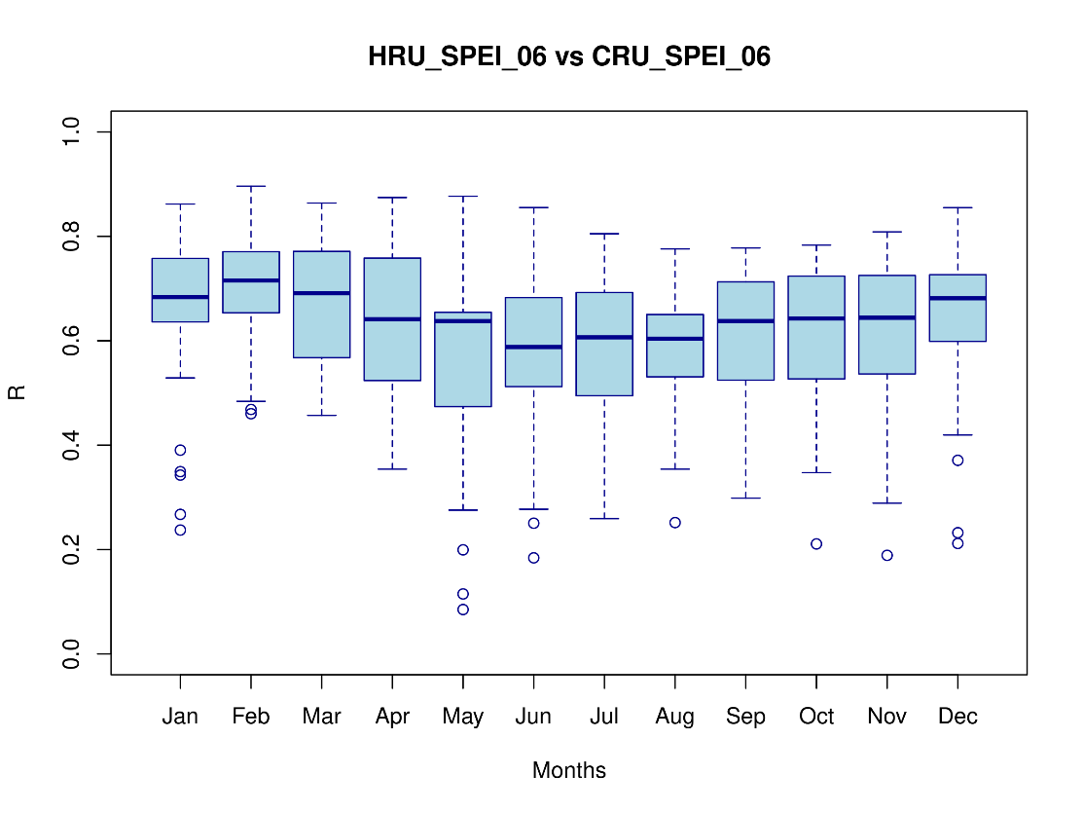

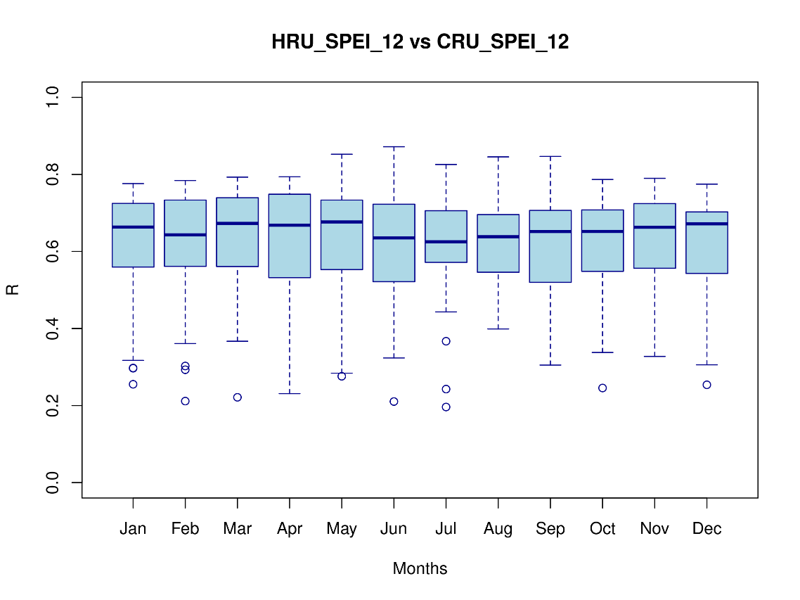

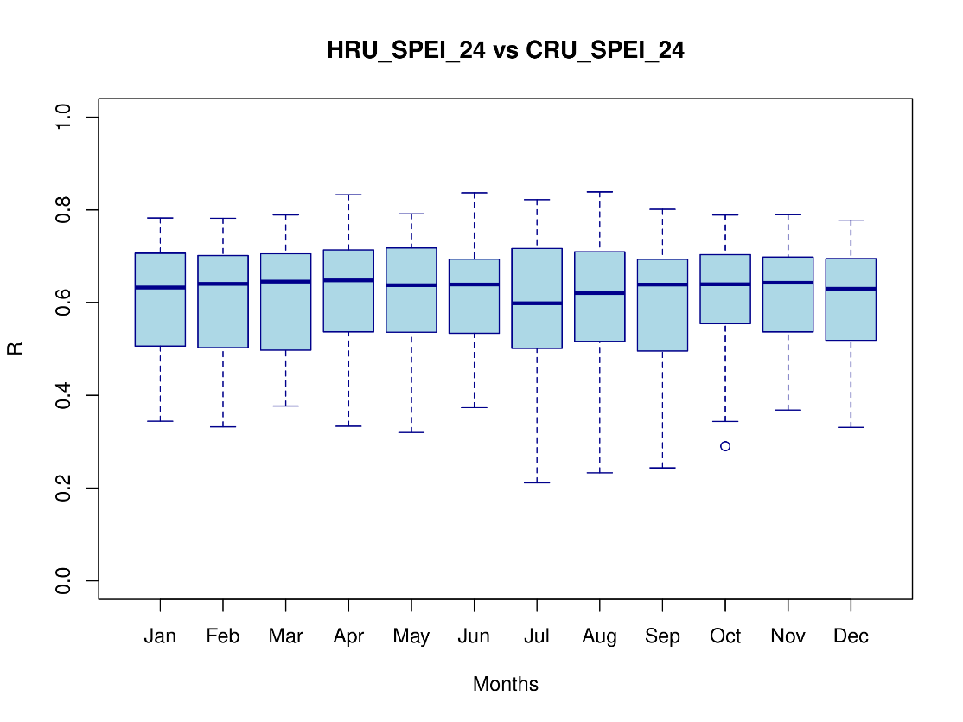

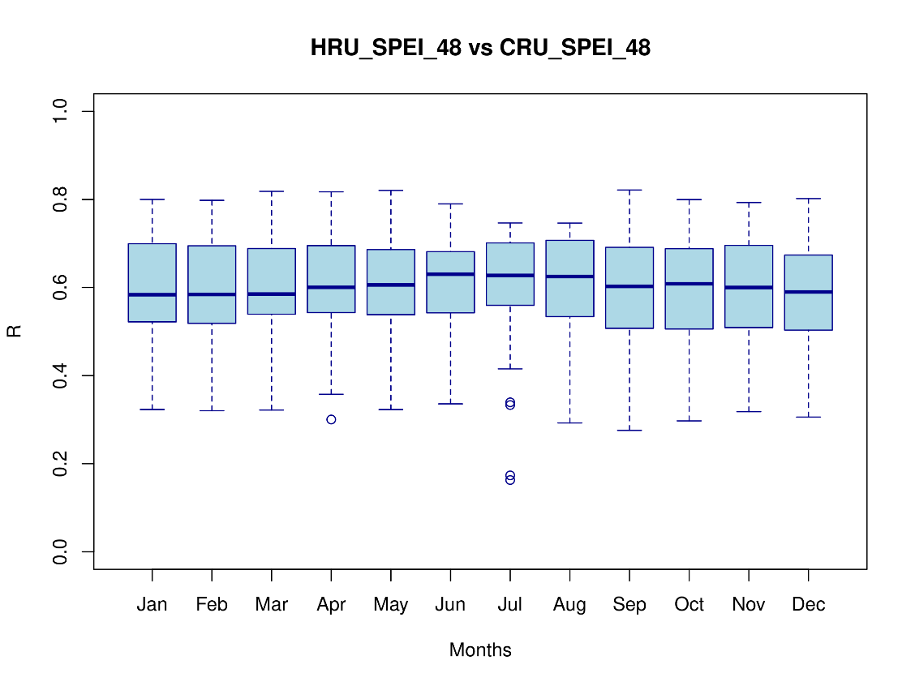

Section 5: CMIP6 climate projections

Figure S8: projected change in agricultural labor participation in 2050 (compared to weather condition in 2011)

References
Conley, T.G. 1999. GMM Estimation with Cross Sectional Dependence. Journal of Econometrics 92(1), 1-45
Conley, T.G. 2008. Spatial Econometrics. New Palgrave Dictionary of Economics, ed. Durlauf, S. N., Blume, L.E. 2nd Edition. Palgrave Macmillan.
Düben, C., Bluhm, R., Calderon, L., Christensen, D., Conley, T., Fetzer, T., Heldring, L. and Düben, M.C., 2022. Package ‘conleyreg’. R

We use the R Conleyreg package (Düben et al. 2022).

