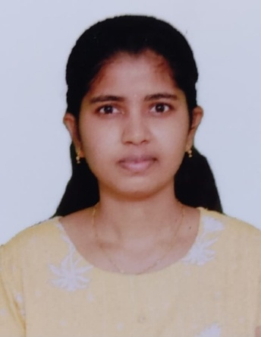
Mandala Pranitha is currently pursuing the MTech in Telecommunication at National Institute of Technology Calicut. She completed her BTech in Electronics and Communication Engineering from TKR College of Engineering and Technology, Hyderabad. Her research focuses on Free Space Optical Communication (FSO). Her areas of interest include wireless communication, optical wireless systems.
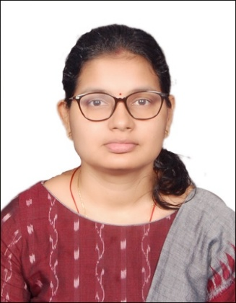
Madhuli Madhusmita Das is Currently pursuing a Ph.D. degree in the Department of Electronics and Communication Engineering at the National Institute of Technology Patna, India. Research interests include Free Space Optical (FSO) communication and underwater communication systems.

Dr. Jagadeesh V. K is presently working as Assistant Professor in National Institute of Technology Calicut, Kozhikode. He has done his Ph.D. from Dept. Electronics and Communication Engineering at National Institute of Technology, Tiruchirappalli in 2016. His areas of interest include Free Space optics, RF/FSO, Visible Light Communication, Wireless Communication.

