Supplementary material for: Identification of Nanog-Helper Genes in Early Mouse Embryo Differentiation Using Differential Entropy and Network Inference

Francisco Prista von Bonhorst^{1,*}, Olivier Gandrillon², Ulysse Herbach⁵, Corentin Robert^{1,3}, Claire Chazaud⁴ , Yannick De Decker³, Didier Gonze¹ and Geneviève Dupont¹

¹ Université libre de Bruxelles (ULB), Unit of Theoretical Chronobiology, Belgium
² Univ Lyon, CNRS, ENS de Lyon, INSERM, UMR5239, U1210, LBMC, 69364 Lyon, France
³Université libre de Bruxelles (ULB), Non-linear Physical Chemistry Unit, Belgium
⁴Université Clermont Auvergne, CNRS, INSERM, GReD Institute, France
⁵Université de Lorraine, CNRS, Inria, IECL, F-54000 Nancy, France
*Corresponding author: fpristas@ulb.be

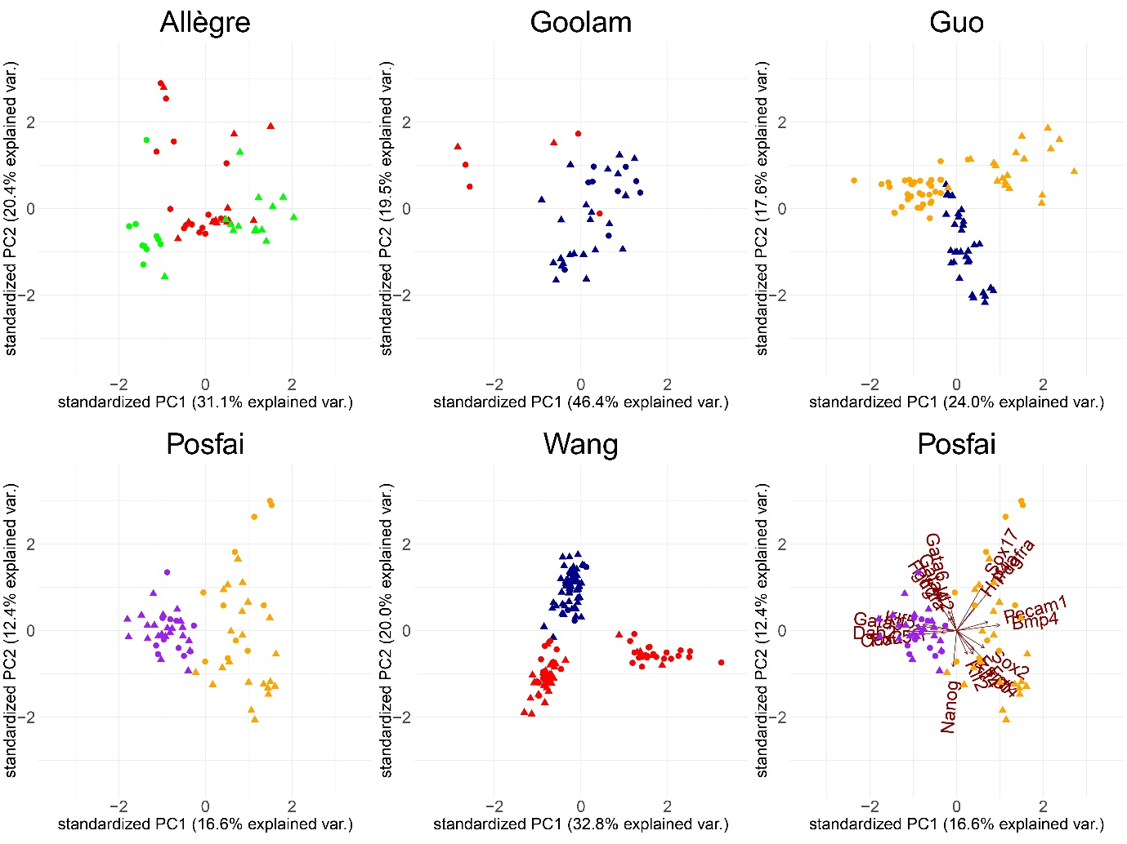

Supplementary Figure 1: PCA graphs of the two main components for all datasets, considering the initial and end stages of each dataset, for the 21 genes common to all datasets. Triangles represent Fgf4 expressing cells and circles are Fgf4 non-expressing cells. The two sub-populations are the latest developmental stage in both Allègre, Guo and Wang’s dataset are very clear, but are not as clear in Goolam (lack of cells at the 32C stage) or Posfai’s dataset, although there are hints of these two subpopulations arising. Right bottom panel shows the sets of vectors, when considering the initial and end stage of Posfai’s dataset. In comparison to Figure 2 of the manuscript, the sets of vectors are now less clear, although we still see that Nanog, Sox2, Fgf4 (Epi markers) point towards a different direction to Sox17, Pdgfra and Hnf4a (PrE markers).

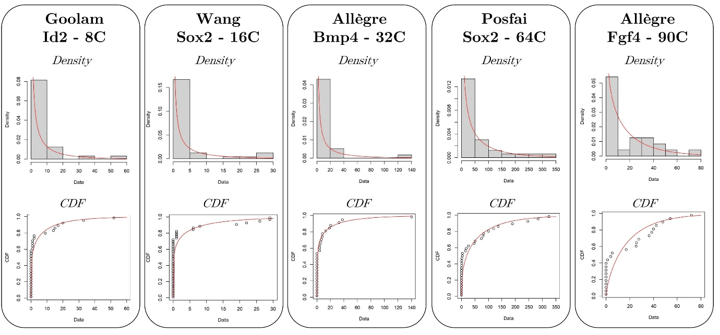

Supplementary Figure 2: Representative examples of histograms and fits to Γ distributions of the mRNA counts when the KS statistics are larger, and the p-values are small. As shown in the lower panels, the theoretical cumulative distribution functions are further to the empirical ones, explaining the larger KS statistics and smaller p-values, but the fits themselves reproduce the behavior of the mRNA distribution.

Genes in common in all datasets
Bmp4, Cdx2, Dab2, Esrrb, Fgf4, Fgfr2, Gata3, Gata4, Gata6, Hnf4a, Id2, Klf2, Klf4, Klf5, Nanog, Pdgfa, Pdgfra, Pecam1, Pou5f1, Sox17, Sox2

Supplementary Table 1: List of the 21 genes in common in all datasets. Note that Cdx2,
Hnf4a, Klf2, Klf4, Klf5 and Pdgfa were not measured at the 16C stage in Allegre’s
dataset.

Gene | Model with all genes | Simultaneous? | At 32C  stage? |  | Model with main genes + 1 | Simultaneous? | At 32C  stage?
Bmp4 | Yes | Yes | No |  | Yes | Yes | Yes
Cdx2 | No | No | No |  | No | No | No
Dab2 | No | No | No |  | No | No | No
Esrrb | Yes | No | No |  | No | No | No
Fgf4 | Yes | No | No |  | Yes | No | No
Fgfr2 | No | No | No |  | No | No | No
Gata3 | No | No | No |  | No | No | No
Gata4 | No | No | No |  | No | No | No
Gata6 | No | No | No |  | No | No | No
Hnf4a | Yes | Yes | Yes |  | Yes | Yes | Yes
Id2 | Yes | Yes | No |  | Yes | Yes | No
Klf2 | Yes | No | No |  | Yes | Yes | Yes
Klf4 | No | No | No |  | No | No | No
Klf5 | No | No | No |  | No | No | No
Pdgfa | Yes | No | No |  | Yes | No | No
Pdgfra | No | No | No |  | Yes | No | No
Pecam1 | Yes | Yes | Yes |  | Yes | Yes | Yes
Pou5f1 | Yes | Yes | Yes |  | No | No | No
Sox17 | No | No | No |  | No | No | No
Sox2 | Yes | Yes | Yes |  | Yes | Yes | Yes

Supplementary Table 2: Comparison of the timings at which the common genes have a reciprocal activation loop with Nanog (if any), when considering all genes simultaneously (left) or the main genes Nanog, Gata6, Fgfr2, Fgf4 and one additional gene (right). Only Hnf4a, Pecam1 and Sox2 exhibit the reciprocal activation with Nanog at the 32C stage, regardless of how many genes are used for the inference with CARDAMOM.

