Supplementary materials for
Lineage-specific head development in the coffin-headed cricket Loxoblemmus equestris links concentrated insect metamorphosis with novel trait evolution

Mizuho Yoneda¹, Shinichi Morita^{2,3}, Teruyuki Niimi^{2,3}, Takaaki Daimon¹, Takahiro Ohde^{1*}
1 Department of Applied Biosciences, Graduate School of Agriculture, Kyoto University, Kitashirakawa Oiwakecho, Sakyo-ku, Kyoto 606-8502, Japan.
2 Division of Evolutionary Developmental Biology, National Institute for Basic Biology, 38 Nishigonaka Myodaiji, Okazaki 444-8585, Japan.
3 Basic Biology Program, Graduate Institute for Advanced Studies, The Graduate University for Advanced Studies, SOKENDAI, 38 Nishigonaka Myodaiji, Okazaki 444-8585, Japan.
*Corresponding author: ohde.takahiro.4n@kyoto-u.ac.jp
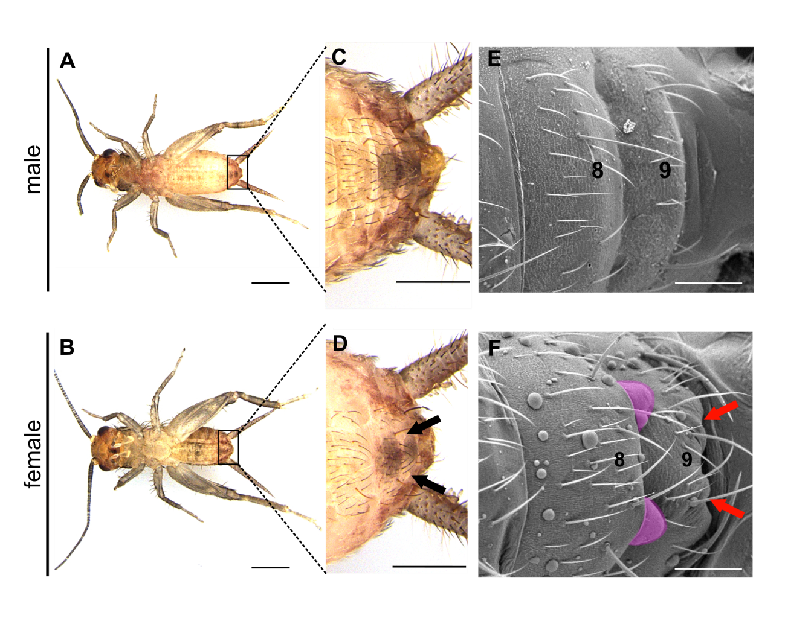
Fig. S1 Nymphal sexing of L. equestris. (A–F) The ventral sides of fourth nymphal instars in males and females. In females, protruding primordia of the ovipositor are formed at the end of the eighth segment (D, black arrows; F, filled with magenta), and the shape of the end of the ninth segment also changes (F, red arrowhead). Scale bars are 1mm (A,D) and 100µm (B, C, E, F).

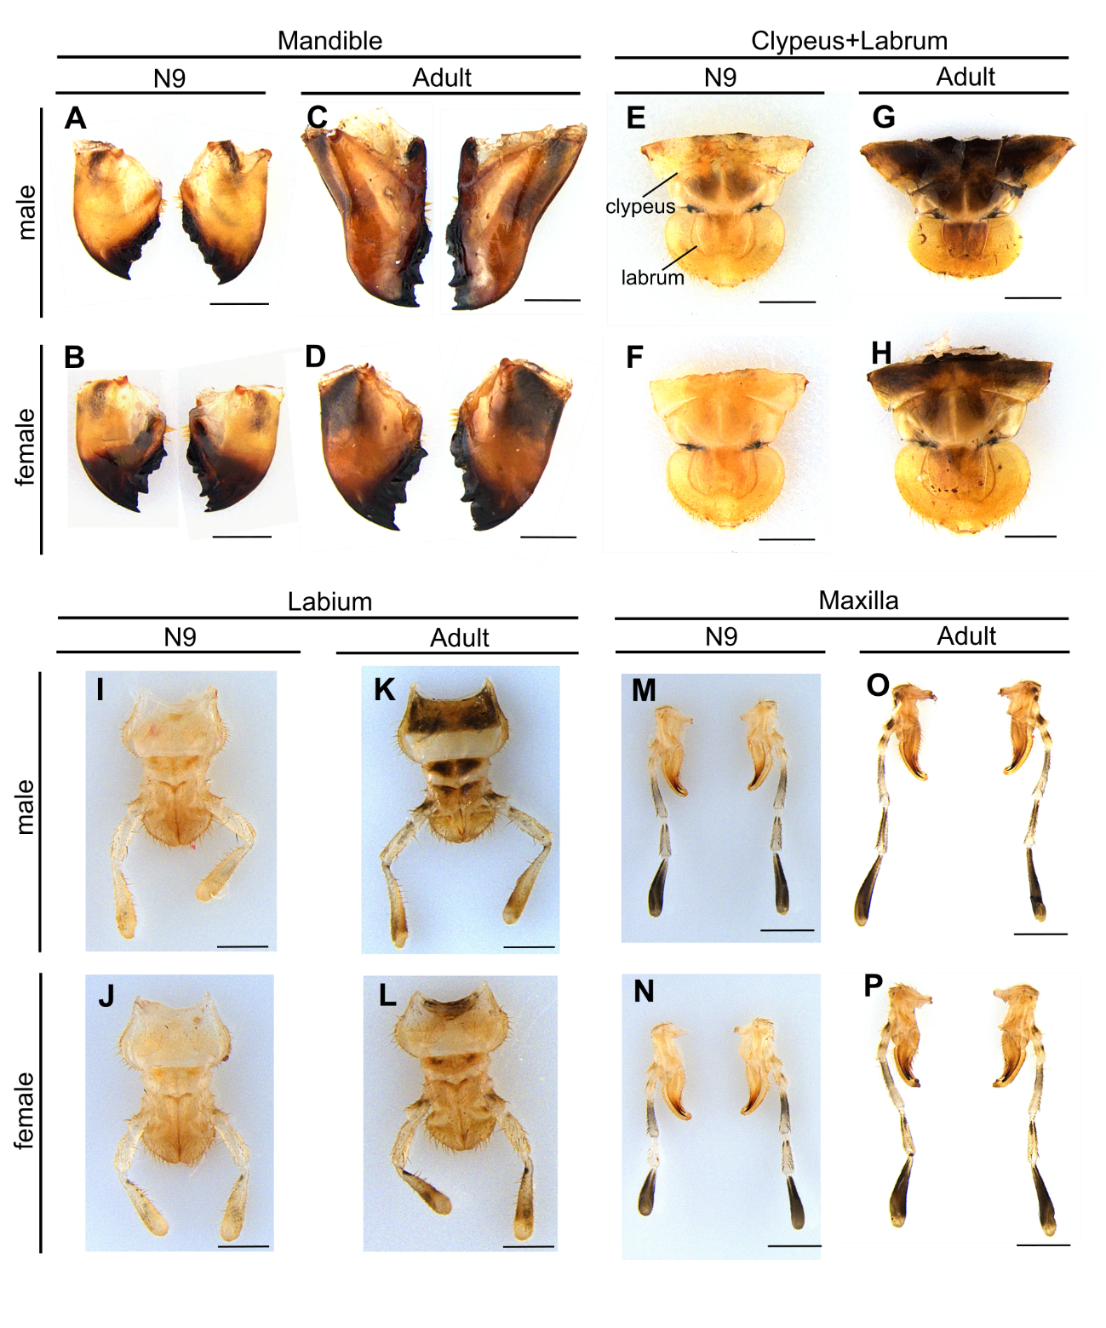
Fig. S2 The mouthparts sexual dimorphism in Loxoblemmus equestris. The mouthparts in N9 and adult. Scale bars are1mm.

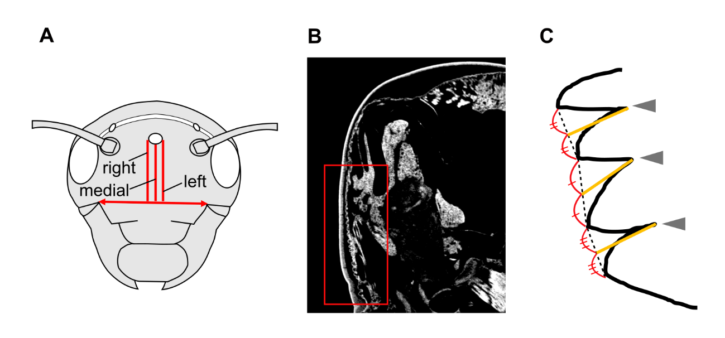
Fig. S3 Quantification of epidermal folding patterns. (A) Sagittal section planes used for furrow analysis. Sections were vertically captured from the ventral edges of the median ocellus to the epistomal suture (red lines), obtained from three-dimensional CT images. Sagittal sections at the most lateral sides of the median ocellus were defined as right and left sections, and a section at the equal distance from two lateral sections was analyzed as a medial section. Distance between the anterior mandibular articulations (red arrow) was used as a proxy of head size to normalize furrow depth. (B) An example of measured area in a CT image. The number of epidermal furrows and their depth were measured in the red square. (C) A furrow was defined as an epidermal fold comprising two crests and a groove (grey arrowheads). Furrow depth was measured as distance between the bottom of a groove and the midpoint between peaks of adjacent two crests (yellow lines). Furrows with depths of 5 µm or more were counted and used for comparing depths between sexes.
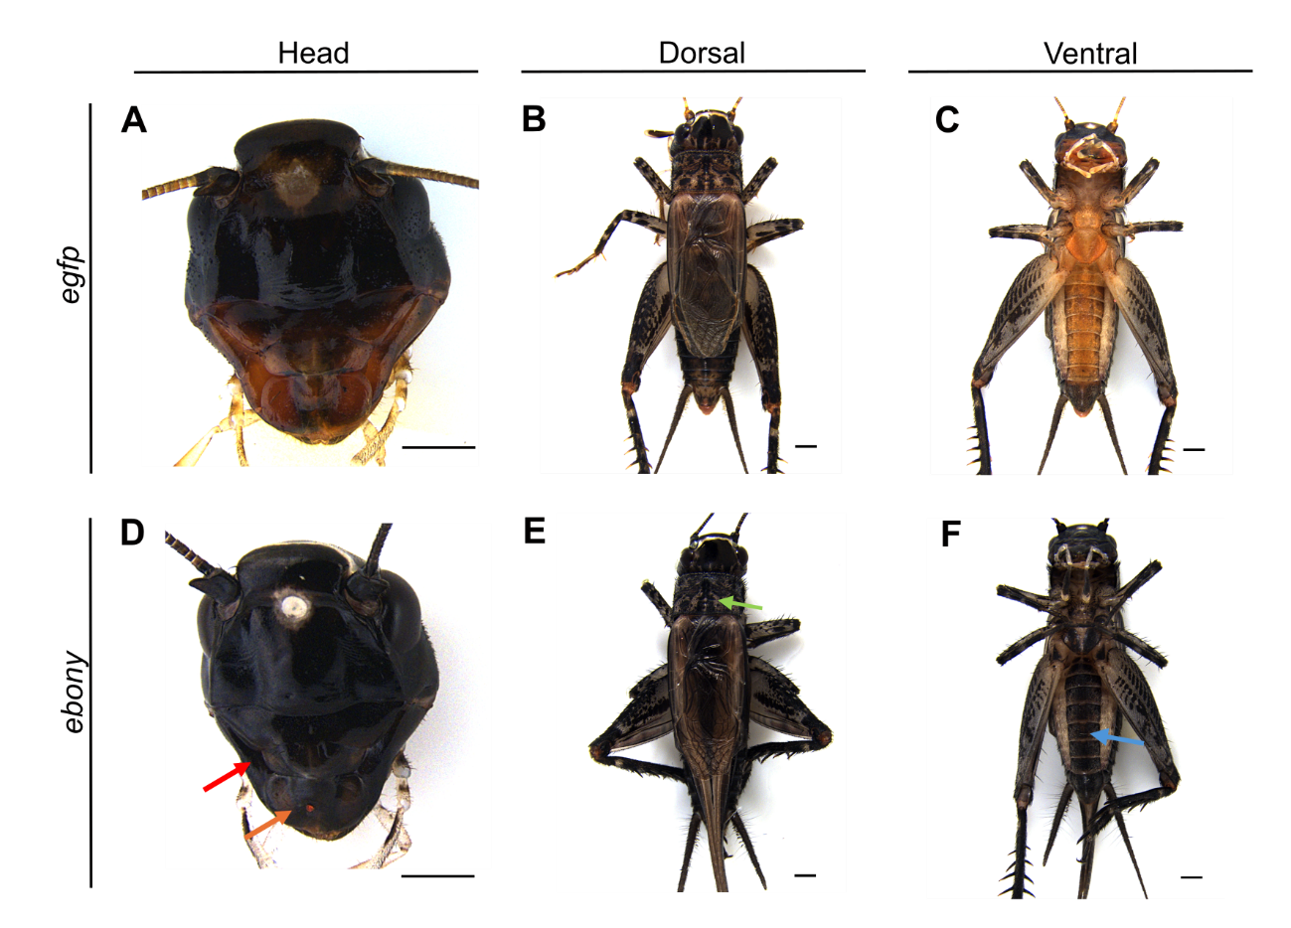
Fig. S4 Dark-colored phenotypes obtained by the ebony gene knockdown in L. equestris. Male adult phenotypes after injecting dsRNAs targeting egfp (A–C) or ebony (D–F). Color of Mandibles and the labrum (D, red and orange arrowheads), the pronotum (E, green arrowhead), and abdominal segments (F, blue arrowhead) are severely changed comparing to controls (A–C). Scale bars indicate 1mm.

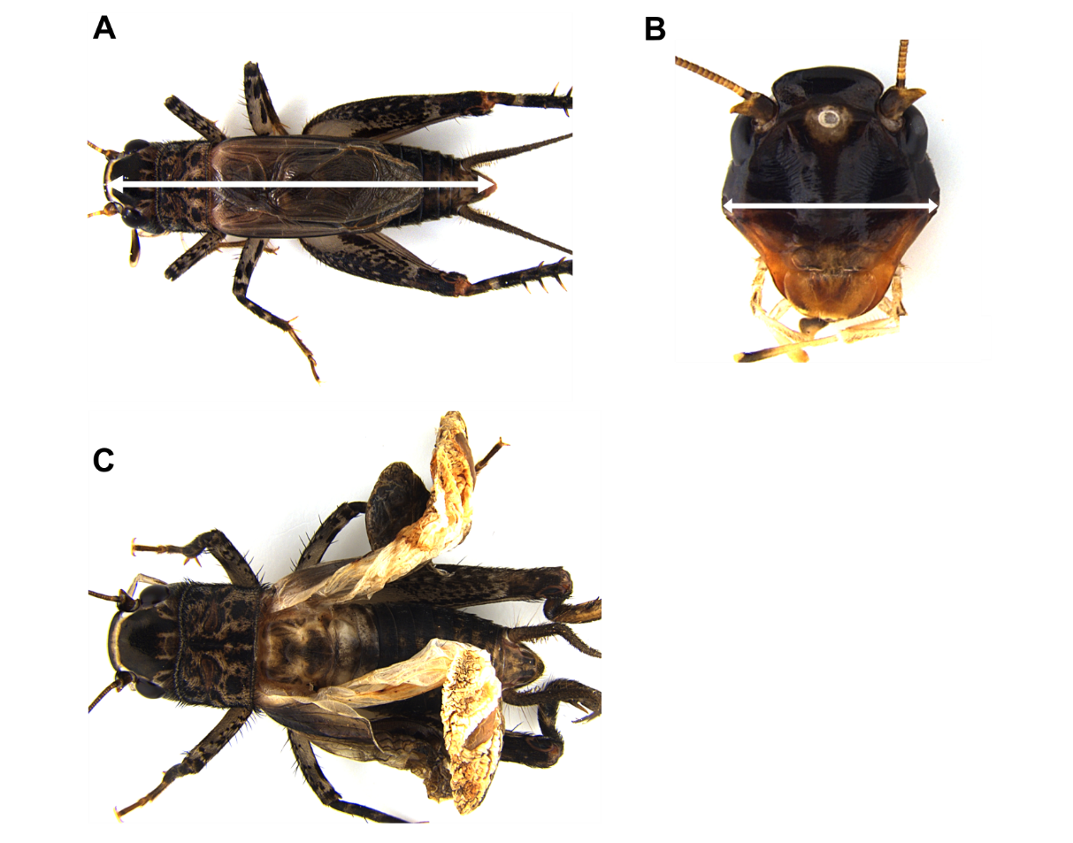
Fig. S5. Adult body and head size measurement in L. equestris. (A, B) Body size was measured from the anterior head to the anus (A, white arrow). Head width was measured at its widest part (B, white arrow). (C) An example of E93 RNAi adults after supernumerary nymphal molts, showing the failure to unfold wings.

Table S1. Primer sequences used for qPCR.
primer name | primer sequence
Lequ_RpL32_F | 5'-TCTGATCGACAGTTGCTGGG-3'
Lequ_RpL32_R | 5'-GGTGTTAATGATGCAGAACCGT-3'
Lequ_E93_qPCR_F | 5'-ACCTGCAATGGTGATGTCGT-3'
Lequ_E93_qPCR_R | 5'-GCCTGCACTGTTGTCAACTG-3'
Lequ_Kr-h1_qPCR_F | 5'-CAGATGTCGCACGTGTAGGG-3'
Lequ_Kr-h1_qPCR_R | 5'-AAAGCCCTACGTGTGCAAGA-3'
Lequ_br_qPCR_F | 5'-GCTCTTGCAACTTCCAATCGT-3'
Lequ_br_qPCR_R | 5'-GCTAGGTTGGACTGGGTGTT-3'

Table S2. Primer sequences used for the dsRNA template fragment amplifications.
primer name | primer sequence
Lequ_ebony_T7_F | 5'-taatacgactcactatagggACGCAAAAGAGACGGAACCA-3'
Lequ_ebony_T7_R | 5'-taatacgactcactatagggCCTCACCTTCGTGGACTCTG-3'
Lequ_E93_T7_F | 5'-taatacgactcactatagggACAGAGTCACAACAGCTCGG-3'
Lequ_E93_T7_R | 5'-taatacgactcactatagggCCCTCCTCTTCTACCGTGGA-3'
Lequ_Kr-h1_T7_F | 5'-taatacgactcactatagggTCTTGCACACGTAGGGCTTT-3'
Lequ_Kr-h1_T7_R | 5'-taatacgactcactatagggCCCTACAAGTGCGAGGTGTG-3'
Lequ_br_T7_F | 5'-taatacgactcactatagggCGATGATCGAGATGAGTTCCC-3'
Lequ_br_T7_R | 5'-taatacgactcactatagggACAGTAGCACCACCTGAGGT-3'

Table S3. Summary of nymphal RNAi targeting ebony in L. equestris.
Target gene | No. of injections | Injected dsRNA amount (µg) | Injected stage* | No. of survived adults  (survival rate) | No. of adults with dark body color phenotype
egfp | 13 | 15 | N8 | 13 (100%) | 0
ebony | 13 | 15 | N8 | 12 (92.3%) | 12
*All nymphs were injected within 24 hours after ecdysis.

Table S4. Summary of nymphal RNAi targeting E93, Kr-h1 and br in L. equestris.
Target gene | No. of injections | Injected dsRNA amount (µg) | Injected stage* | No. of survived adults  (survival rate) | Final nymphal instar  (phenotype/survived adults)
 |  |  |  |  | N7 | N8 | N9 | N10 | N11
egfp | 20 | 12 | N8 | 19 (95.0%) | 0 (0%) | 0 (0%) | 19 (100%) | 0 (0%) | 0 (0%)
E93 | 18 | 12 | N8 | 15 (83.3%) | 0 (0%) | 0 (0%) | 0 (0%) | 7 (46.6%) | 8 (53.3%)
egfp | 20 | 6 | N4 | 20 (100%) | 0 (0%) | 0 (0%) | 20 (100%) | 0 (0%) | 0 (0%)
Kr-h1 | 26 | 6 | N4 | 18 (69.2%) | 1  (5.5%) | 3 (16.6%) | 14 (77.7%) | 0 (0%) | 0 (0%)
br | 25 | 6 | N4 | 23 (92.0%) | 2  (8.7%) | 2  (8.7%) | 18 (78.3%) | 0 (0%) | 0 (0%)
*All nymphs were injected within 24 hours after ecdysis.

