Overview Tables and Figures

SUPPLEMENTARY MATERIAL
Table S1. Dietary patterns (number of servings during 7 days)
Table S2. Gastrointestinal symptoms (GSRS) and stool form and consistency (Bristol Stool Scale; BSS) before and 7 weeks after sweetener intake
Table S3. Baseline characteristic of volunteers stratified by pre-diabetic status
Table S4. Sweetener effect on glycaemic-related parameters before and 7 weeks after sweetener intake in prediabetic and normoglycaemic subjects
Table S5. O-PLS models showing the effect of covariates on: A) the plasma metabolome, B) the urinary metabolome, C) on gut microbiota composition before treatment
Figure S1. Flow Diagram
Figure S2. Effect of covariate adjustment on correlation between the metabolome and the gut microbiota with plasma fructosamine
Figure S3. Metabolome and gut microbiota profiles in response to sweetener intake
Figure S4. Differences in the effect of 7-week consumption of erythritol and xylitol on glycaemic parameters in participants stratified by pre-diabetic status

SUPPLEMENTARY MATERIAL

Table S1: Dietary patterns (number of servings during 7 days)
Food category | Before treatment | Week 3 | After 7 weeks | Before vs. 7 weeks (P-value)
Vegetables
Control | 9.1 ± 3.4 | 9.7 ± 6.6 | 8.3 ± 3.9 | NS
Erythritol | 8.3 ± 4.4 | 8.3 ± 4.8 | 9.2 ± 5.0 | NS
Xylitol | 10.1 ± 4.8 | 9.5 ± 5.0 | 8.5 ± 5.8 | NS
Between treatments P-value | NS | NA | NS
Fruits
Control | 8.9 ± 5.4 | 6.8 ± 6.6 | 5.1 ± 7.0 | P = 0.003
Erythritol | 9.2 ± 6.1 | 9.5 ± 6.4 | 6.8 ± 4.7 | P = 0.054
Xylitol | 7.5 ± 5.9 | 5.6 ± 4.4 | 4.4 ± 3.2 | P = 0.027
Between treatments P-value | NS | NA | NS
Cereals
Control | 13.9 ± 9.9 | 13.0 ± 7.0 | 13.3 ± 7.9 | NS
Erythritol | 18.3 ± 16.4 | 15.0 ± 9.6 | 13.8 ± 8.7 | NS
Xylitol | 22.3 ± 15.4 | 20.1 ± 13.2 | 17.0 ± 9.9 | NS
Between treatments P-value | Control vs. Erythritol:  P = 0.072 | NA | NS
Carbohydrates
Control | 9.1 ± 4.9 | 8.1 ± 3.3 | 7.0 ± 1.9 | NS
Erythritol | 9.1 ± 4.8 | 7.4 ± 3.3 | 7.8 ± 2.6 | NS
Xylitol | 9.6 ± 3.8 | 7.7 ± 2.7 | 8.7 ± 4.7 | NS
Between treatments P-value | NS | NA | NS
Meat / Fish
Control | 14.4 ± 5.5 | 12.6 ± 5.1 | 14.7 ± 5.4 | NS
Erythritol | 16.0 ± 8.4 | 15.1 ± 6.7 | 13.6 ± 5.6 | NS
Xylitol | 16.6 ± 6.0 | 13.9 ± 5.8 | 14.2 ± 7.0 | NS
Between treatments P-value | NS | NA | NS
Milk
Control | 11.3 ± 5.2 | 8.8 ± 3.5 | 9.6 ± 4.9 | NS
Erythritol | 15.5 ± 8.6 | 12.5 ± 7.5 | 12.3 ± 6.7 | NS
Xylitol | 14.8 ± 5.5 | 13.0 ± 8.5 | 12.4 ± 8.1 | NS
Between treatments P-value | NS | NA | NS
Fat
Control | 3.4 ± 1.9 | 3.4 ± 2.9 | 3.8 ± 2.6 | NS
Erythritol | 8.6 ± 6.0 | 5.6 ± 5.3 | 5.7 ± 4.1 | P = 0.047
Xylitol | 6.1 ± 4.4 | 4.8 ± 4.1 | 6.1 ± 4.9 | NS
Between treatments P-value | Control vs. Erythritol  P = 0.0005 | NA | NS
Beverages with added sugar
Control | 7.1 ± 10.2 | 5.9 ± 9.4 | 5.0 ± 7.0 | NS
Erythritol | 5.7 ± 9.5 | 2.5 ± 5.5 | 2.0 ± 7.3 | P = 0.061
Xylitol | 6.7 ± 7.6 | 3.1 ± 5.7 | 3.6 ± 8.1 | NS
Between treatments P-value | NS | NA | NS
Beverages with sweeteners
Control | 0.3 ± 1.1 | 0.3 ± 1.2 | 0.3 ± 1.4 | NS
Erythritol | 0.7 ± 2.1 | 1.8 ± 5.5 | 0.7 ± 2.0 | NS
Xylitol | 1.4 ± 5.1 | 2.1 ± 5.9 | 1.4 ± 4.6 | NS
Between treatments P-value | NS | NA | NS
Sugar-sweetened beverages
Control | 4.9 ± 8.1 | 4.4 ± 8.6 | 1.7 ± 2.4 | NS
Erythritol | 4.5 ± 8.4 | 3.9 ± 6.4 | 3.9 ± 6.3 | NS
Xylitol | 6.0 ± 9.9 | 3.7 ± 6.8 | 3.9 ± 5.7 | NS
Between treatments P-value | NS | NA | NS
Sweets
Control | 8.9 ± 5.5 | 7.3 ± 5.0 | 7.8 ± 7.1 | NS
Erythritol | 10.8 ± 8.1 | 7.4 ± 7.9 | 8.6 ± 6.6 | NS
Xylitol | 12.7 ± 5.7 | 9.9 ± 4.5 | 9.9 ± 5.9 | NS
Between treatments P-value | NS | NA | NS

Table S1: Dietary patterns before and 7 weeks after sweetener intake
NS = non-significant. NA = Not applicable. Level of significance alpha = 0.05. Linear mixed effect models with Šidak post-hoc test; Beverages with added sugar: e.g., coffee sweetened with sugar; Beverages with sweeteners: e.g., soft drink with low-caloric sweetener; Sugar-sweetened beverages: soft drink containing sugar.
Table S2: Gastrointestinal symptoms (GSRS) and stool form and consistency (Bristol Stool Scale; BSS) before and 7 weeks after sweetener intake

Parameter | Before treatment | Week 3 | After 7 weeks | Before vs. 7 weeks (P-value)
Total Score
Control | 21.34 ± 6.79 | 23.18 ± 9.91 | 22.77 ± 8.49 | NS
Erythritol | 21.11 ± 5.08 | 28.92 ± 12.39 | 24.02 ± 6.81 | P = 0.081
Xylitol | 24.70 ± 8.99 | 25.45 ± 10.12 | 28.53 ± 10.82 | NS
Between treatments P-value | NS | NA | Control vs. Xylitol: P = 0.082
Pain
Control | 1.41 ± 0.66 | 1.44 ± 0.67 | 1.33 ± 0.47 | NS
Erythritol | 1.44 ± 0.75 | 1.78 ± 1.03 | 1.59 ± 0.70 | NS
Xylitol | 1.62 ± 0.77 | 1.77 ± 0.96 | 1.62 ± 0.64 | NS
Between treatments P-value | NS | NA | NS
Reflux
Control | 1.31 ± 0.56 | 1.41 ± 0.59 | 1.23 ± 0.43 | NS
Erythritol | 1.25 ± 0.53 | 1.75 ± 1.05 | 1.43 ± 0.85 | P = 0.031
Xylitol | 1.43 ± 0.61 | 1.34 ± 0.64 | 1.75 ± 1.12 | NS
Between treatments P-value | NS | NA | Control vs. Xylitol: P = 0.038
Indigestion
Control | 1.81 ± 0.82 | 1.85 ± 1.05 | 1.74 ± 0.86 | NS
Erythritol | 1.74 ± 0.55 | 2.25 ± 1.29 | 1.77 ± 0.76 | NS
Xylitol | 1.98 ± 0.96 | 1.97 ± 0.94 | 2.20 ± 1.06 | NS
Between treatments P-value | NS | NA | NS
Diarrhea
Control | 1.35 ± 0.60 | 1.45 ± 1.28 | 1.33 ± 0.54 | NS
Erythritol | 1.27 ± 0.41 | 2.37 ± 1.69 | 1.67 ± 1.08 | P = 0.070
Xylitol | 1.52 ± 0.75 | 2.00 ± 1.81 | 2.02 ± 1.21 | P = 0.070
Between treatments P-value | NS | NA | Control vs. Xylitol: P = 0.023
Constipation
Control | 1.37 ± 0. 66 | 1.42 ± 0.97 | 1.79 ± 1.57 | NS
Erythritol | 1.17 ± 0.45 | 1.32 ± 0.73 | 1.43 ± 0.71 | NS
Xylitol | 1.52 ± 0.66 | 1.20 ± 0.39 | 1.78 ± 1.59 | NS
Between treatments P-value | NS | NA | NS
BSS (Bristol Stool Scale)
Control | 3.5 ± 1.1 | - | 3.8 ± 1.2 | NS
Erythritol | 4.3 ± 1.5 | - | 4.0 ± 1.4 | NS
Xylitol | 3.8 ± 1.1 | - | 3.9 ± 1.4 | NS
Between treatments P-value | NS | - | NS

Table S2: Gastrointestinal symptoms (GSRS) and stool form and consistency (Bristol Stool Scale; BSS) before and 7 weeks after sweetener intake
Control: n= 22; Xylitol: n= 20; Erythritol: n= 22. GSRS “Pain”: mean from questions Q1, Q4, Q5; “Reflux”: mean from questions: Q2, Q3; “Indigestion”: mean from questions: Q6, Q7, Q8, Q9; “Diarrhea”: mean from questions: Q11, Q12, Q14; “Constipation”: mean from questions: Q10, Q13, Q15. NS = non-significant. NA = Not applicable. Level of significance alpha = 0.05. Linear mixed effect models with Šidak post-hoc test;

Table S3. Baseline characteristic of volunteers stratified by pre-diabetic status

Parameter | Control  (N = 21) | Erythritol  (N = 21) | Xylitol  (N=18) | p-value
Prediabetes (n; %) | 14/21 (66.7) | 11/21 (52.4) | 11/18 (61.1)
Sex (f; %) | 16/21 (71.4) | 15/21(71.4) | 10/18 (55.6) | NS
Normoglycemic | 5/7 (71.4) | 7/10 (70) | 6/7 (85.7) | NS
Prediabetic | 11/14 (78.5) | 8/11 (72.7) | 4/11 (36.3) | NS
Age (years) | 35.9 ± 1.7 | 33.5 ± 2.0 | 32.1 ± 2.3 | NS
Normoglycemic | 30 ± 7.8 | 33.2 ± 8.6 | 29 ± 9.2 | NS
Prediabetic | 38.6 ± 6.3 | 33.2 ± 10.1 | 34.1 ± 9.6 | NS
Height (m) | 1.66 ± 0.08 | 1.69 ± 0.08 | 1.73 ± 0.11 | NS
Normoglycemic | 1.69 ± 0.08 | 1.66 ± 0.09 | 1.71 ± 0.11 | NS
Prediabetic | 1.65 ± 0.08 | 1.70 ± 0.07 | 1.74 ± 0.11 | 0.04
Weight (kg) | 104.3 ± 19.7 | 110.4 ± 25.4 | 115.0 ± 22.8 | NS
Normoglycemic | 103.9 ± 15.80 | 106.5 ± 11.42 | 109.1 ± 20.99 | NS
Prediabetic | 104.5 ± 21.99 | 113.9 ± 18.09 | 118.8 ± 24.08 | NS
BMI (kg/m²) | 37.5 ± 5.8 | 38.9 ± 4.7 | 38.3 ± 5,7 | NS
Normoglycemic | 36.5 ± 4.8 | 38.7 ± 4.4 | 37.0 ± 4.2 | NS
Prediabetic | 38.0 ± 6.3 | 39.0 ± 5.3 | 39.0 ± 6.5 | NS
Abd. circumference (cm) | 117.2 ± 16.8 | 122.0 ± 11.3 | 120.6 ± 15.6 | NS
Normoglycemic | 115.1 ± 18.0 | 116.62 ± 9.6 | 113.6 ± 14.7 | NS
Prediabetic | 118.3 ± 16.9 | 126.0 ± 10.7 | 125.0 ± 15.1 | NS
Systolic BP (mmHg) | 123.7 ± 13.5 | 122.2 ± 16.3 | 129.1 ± 12.4 | NS
Normoglycemic | 120.6 ± 16.97 | 118.1 ± 8.45 | 127.4 ± 14.79 | NS
Prediabetic | 125.2 ± 11.84 | 126 ± 20.91 | 130.2 ± 11.35 | NS
Diastolic BP (mmHg) | 83.7 ± 13.2 | 82.2 ± 11.4 | 81.8 ± 9.71 | NS
Normoglycemic | 81.6 ± 13.1 | 79.2 ± 6.8 | 81.1 ± 9.71 | NS
Prediabetic | 84.7 ± 13.4 | 85.0 ± 14.2 | 82.3 ± 10.2 | NS
Heart rate (beats/min) | 76.4 ± 7.0 | 74.0 ± 7.8 | 74.0 ± 10.1 | NS
Normoglycemic | 78 ± 10.7 | 73.9 ± 8.1 | 76 ± 7.7 | NS
Prediabetic | 75.6 ± 4.5 | 74.0 ± 7.9 | 72.7 ± 11.5 | NS
HbA1c (%) | 5.4 ± 0.3 | 5.4 ± 0.4 | 5.5 ± 0.4 | NS
Normoglycemic | 5.36 ± 0.4 | 5.31 ± 0.4 | 5.31± 0.4 | NS
Prediabetic | 5.45 ± 0.2 | 5.49 ± 0.4 | 5.55 ± 0.4 | NS
Fasting Glucose (mmol/L) | 5.8 ± 0.7 | 5.7 ± 0.6 | 5.6 ± 0.4 | NS
Normoglycemic | 5.2 ± 0.2 | 5.2 ± 0.2 | 5.2 ± 0.3 | NS
Prediabetic | 6.1 ± 0.7 | 6.1 ± 0.5 | 5.8 ± 0.1 | NS
Fasting Insulin (mIU/L) | 19.5 ± 12.7 | 18.0 ± 9.9 | 22.0 ± 10.7 | NS
Normoglycemic | 13.3 ± 7.06 | 15.8 ± 9.68 | 17.9 ± 9.35 | NS
Prediabetic | 22.7 ± 13.93 | 20.0 ± 10.17 | 24.6 ± 11.10 | NS
Tobacco consumption (cigarettes/d) | 1.7 ± 3.2 | 3.3 ± 6.1 | 6.3 ± 11.1 | NS
Normoglycemic | 2.1 ± 3.9 | 3.7 ± 5.6 | 2.0 ± 2.7 | NS
Prediabetic | 1.5 ± 3.0 | 3.0 ± 6.8 | 9.1 ± 13.6 | 0.02
Pack-years | 1.6 ± 5.5 | 0.6 ± 1.7 | 4.8 ± 9.8 | NS
Normoglycemic | 0.6 ± 1.0 | 0.7 ± 1.5 | 0.2 ± 0.4 | NS
Prediabetic | 2.2 ± 6.9 | 0.6 ± 1.9 | 7.1 ± 11.5 | NS
Alcohol (units/d) | 0.2 ± 0.34 | 0.2 ± 0.33 | 0.4 ± 0.58 | NS
Normoglycemic | 0.2 ± 0.4 | 0.31 ± 0.5 | 0.40 ± 0.9 | NS
Prediabetic | 0.1 ± 0.3 | 0.068 ± 0.2 | 0.320 ± 0.4 | NS

BMI: Body Mass Index; BP: Blood pressure; HbA1C: percentage glycated hemoglobin.

Table S4. Sweetener effect on glycaemic-related parameters before and 7 weeks after sweetener intake in prediabetic and normoglycaemic subjects

 | At baseline
 | Prediabetic |  | Normoglycaemic
 | p | pFDR | p | pFDR
HOMA-IR Index | 0.685 | 0.947 | 0.608 | 0.880
Fructosamine (umol/mL) | 0.994 | 0.994 | 0.108 | 0.323
oGTT: Glucose AUC 0-120min | 0.441 | 0.947 | 0.575 | 0.880
oGTT: Glucose AUC 30-120min | 0.592 | 0.947 | 0.880 | 0.880
oGTT: Insulin AUC 0-120min | 0.352 | 0.947 | 0.862 | 0.880
oGTT: Insulin AUC 30-120min | 0.790 | 0.947 | 0.102 | 0.323
 | 7 weeks post-treatment
 | Pre-diabetic |  | Normoglycaemic
 | p | pFDR | p | pFDR
HOMA-IR Index | 0.084 | 0.168 | 0.192 | 0.576
Fructosamine (umol/mL) | 0.020 | 0.072 | 0.054 | 0.323
oGTT: Glucose AUC 0-120min | 0.755 | 0.755 | 0.433 | 0.650
oGTT: Glucose AUC 30-120min | 0.024 | 0.072 | 0.298 | 0.596
oGTT: Insulin AUC 0-120min | 0.253 | 0.380 | 0.982 | 0.982
oGTT: Insulin AUC 30-120min | 0.385 | 0.462 | 0.672 | 0.807

Table S5. O-PLS models showing the effect of covariates on the A) plasma metabolome, B) urinary metabolome, and C) gut microbiota composition before treatment.

- Plasma Metabolome
 | HPOS |  |  | Lipids RPC
 | R²Y | Q²Y | pQ²Y | R²Y | Q²Y | pQ²Y
Age | 0.428 | 0.012 | 0.088 | 0.298 | -0.197 | 0.532
Sex | 0.743 | 0.247 | 0.002 | 0.316 | 0.0801 | 0.035
Country | 0.567 | 0.240 | 0.001 | 0.544 | 0.356 | 0.001
Prediabetic status | 0.399 | -0.059 | 0.188 | 0.271 | -0.216 | 0.581

- Urinary Metabolome
 | HPOS |  |  | RPC
 | R²Y | Q²Y | pQ²Y | R²Y | Q²Y | pQ²Y
Age | 0.438 | 0.044 | 0.04 | 0.609 | 0.336 | 0.001
Sex | 0.393 | 0.049 | 0.029 | 0.718 | 0.415 | 0.001
Country | 0.544 | 0.100 | 0.006 | 0.590 | 0.084 | 0.002
Prediabetic status | 0.494 | -0.099 | 0.272 | 0.494 | -0.099 | 0.260

- Gut Microbiota Composition
 | Phylum |  |  | Family |  |  | Genus
 | R²Y | Q²Y | pQ²Y | R²Y | Q²Y | pQ²Y | R²Y | Q²Y | pQ²Y
Age | 0.057 | -0.068 | 0.474 | 0.217 | -0.015 | 0.164 | 0.400 | 0.036 | 0.056
Sex | 0.084 | -0.206 | 0.943 | 0.24 | -0.056 | 0.284 | 0.338 | -0.162 | 0.471
Country | 0.168 | -0.097 | 0.364 | 0.372 | 0.036 | 0.008 | 0.479 | 0.024 | 0.052
Prediabetic status | 0.048 | -0.112 | 0.659 | 0.313 | -0.183 | 0.586 | 0.515 | -0.167 | 0.482

Figure S1: Flow Diagram
n= 68 randomized
Erythritol
Xylitol
Control

23 Allocated to intervention
23 Received allocated intervention
0 Did not receive allocated intervention
21 Allocated to intervention
21 Received allocated intervention
0 Did not receive allocated intervention
24 Allocated to intervention
24 Received allocated intervention
0 Did not receive allocated intervention

At 7 weeks post-treatment
2 Drop-out (2 received antibiotics), 1 freezer breakdown
22 Final analysis
(21 complete set of all parameters)
At 7 weeks post-treatment
1 Drop-out (1 received antibiotics), 1 freezer breakdown
22 Final analysis
(21 complete set of all parameters)

At 7 weeks post-treatment
1 Drop-out (1 hemolysis), 2 freezer breakdown
20 Final analysis
(18 complete set of all parameters)

Figure S2. Effect of covariate adjustment on correlation between the metabolome and the gut microbiota with plasma fructosamine

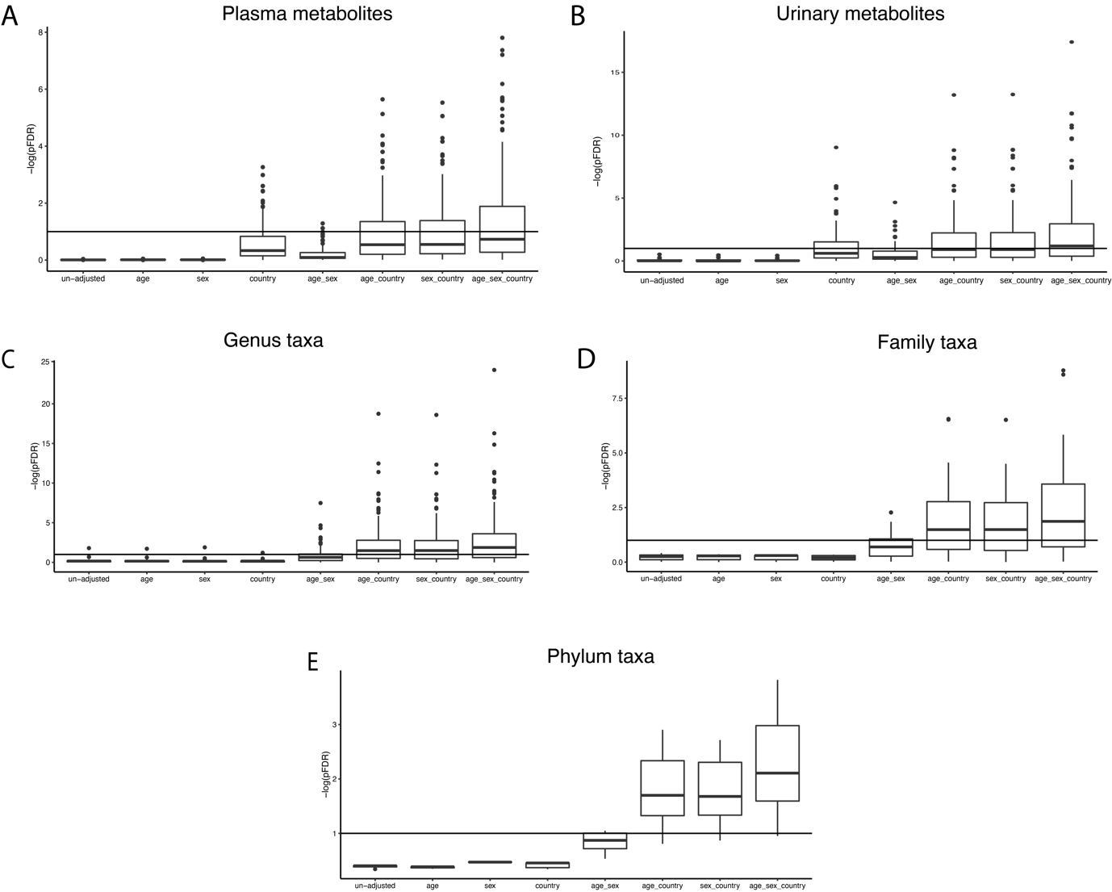
Figure S2. Effect of covariate adjustment on correlations between the metabolome and the gut microbiota with plasma fructosamine
Partial Spearman’s correlation between plasma fructosamine and A) plasma metabolome, B) urinary metabolome, C) gut microbiota at the genus level, D) gut microbiota at the family level, and E) gut microbiota at the phylum level. The x-axis represents the model covariate tested, and the y-axis the significant -log(pvalue) following adjustment by FDR. The line represents the cut-off for pFDR <0.1

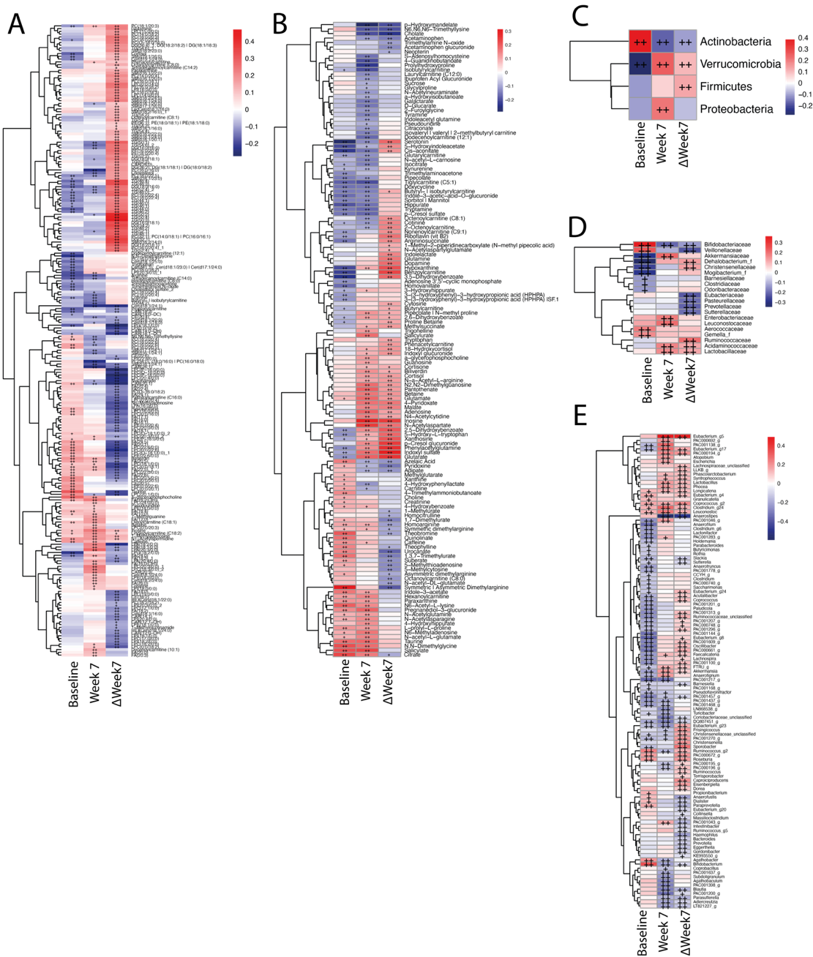
Figure S3. Metabolome and gut microbiota profiles in response to sweetener intake

Figure S3. Metabolome and gut microbiota profiles in response to sweetener intake
Heatmaps showing the significant features at pFDR < 0.1 of partial Mann-Kendall trend tests (trend order tested xylitol -> control -> erythritol ) adjusted by age, sex, and country at baseline, 7-week post-treatment and on the individualized response to sweetener intake for A) plasma metabolome features, B) urinary metabolome features, C) gut microbiota taxa at the phylum level, D) gut microbiota taxa at the family level, and E) gut microbiota taxa at the genus level.

Figure S4. Differences in the effect of 7-week consumption of erythritol and xylitol on glycaemic parameters in participants stratified by pre-diabetic status
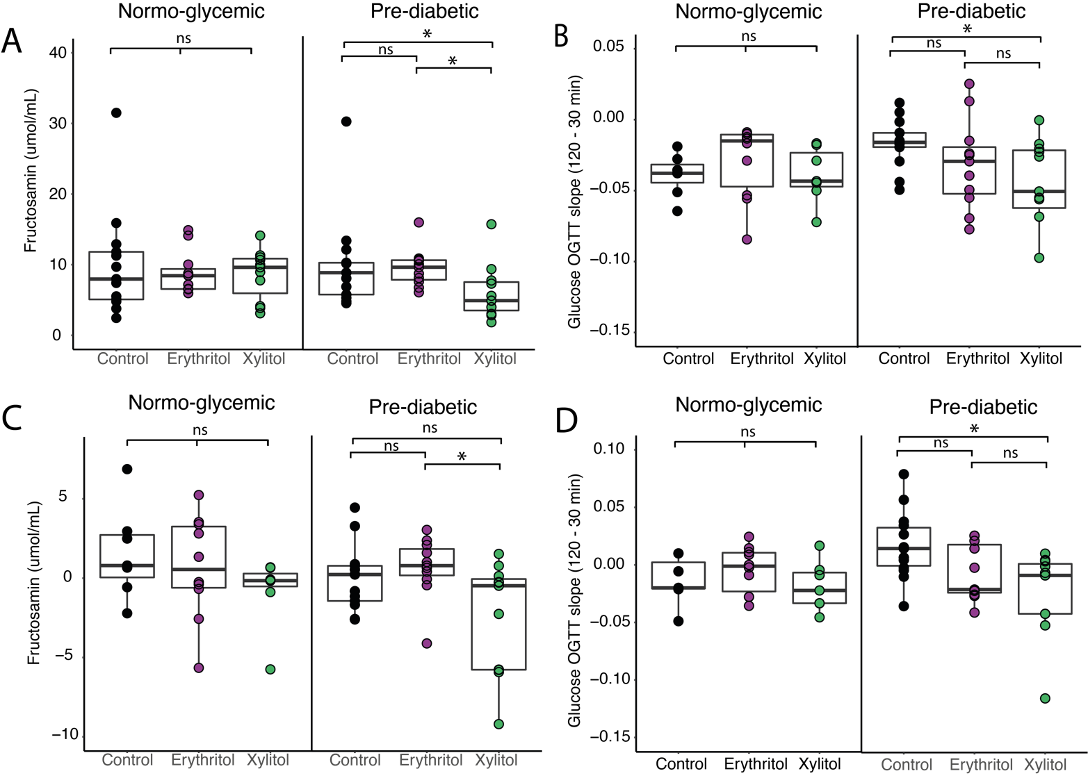

Figure S4. Differences in the effect of 7-week consumption of erythritol and xylitol on glycaemic parameters in participants stratified by pre-diabetic status
A) Plasma fructosamine levels in normoglycaemic (NG) and pre-diabetic (PD) participants at 7 weeks post-treatment, showing a significant reduction in the PD group for the xylitol group compared to the erythritol and control group. B) oGTT slope in NG and PD participants at 7 weeks post-treatment, showing a significant reduction in plasma glucose at the 120-minute time-point from the 30-minute time-point of the oGTT test in the xylitol group compared to the control group of the PD participants. C) Personalized response at 7 weeks post-treatment to plasma fructosamine levels in NG and PD participants, showing a significant reduction in the xylitol group compared to the erythritol group. D) Personalized response to the oGTT test at 7 weeks post-treatment in NG and PD participants, showing a significant reduction in plasma glucose at the 120-minute time-point from the 30-minute time-point of the oGTT test in the xylitol group compared to the control group of the PD participants. Kruskal-Wallis test with Dunn’s post-hoc analysis for multiple comparisons. * pFDR <0.05; *** pFDR <0.001

