Supporting Information
Chylomicron-biomimetic nanoparticles promote intestinal lymphatic transport by fast fusion with chylomicrons
Yawen Yao ^{a, b, †}, Cuihua Zhang ^{a, †}, Jieying Zhou ª, Shihao Xu ^{a, c}, Ying Li ª, Haiqiang Wu ^{a*}, Hua Yu ^{b, *}, Wei Xiong ^{a, *}
ª School of Pharmacy, Shenzhen University Medical School, Shenzhen University, Shenzhen 518055, China
^{b} Institute of Chinese Medical Sciences, State Key Laboratory of Quality Research in Chinese Medicine, University of Macau, Macao SAR, China
^{c} School of Chinese Pharmacy, Shenyang Pharmaceutical University, Shenyang, 110016, China.

† These authors contributed equally to this work.

Correspondence to:

Haiqiang Wu
School of Pharmacy, Shenzhen University Medical School, Shenzhen University, 1066 Xueyuan Avenue, Nanshan District, Shenzhen, 518055, China
E-mail: wuhq@szu.edu.cn

Hua Yu
Institute of Chinese Medical Sciences, State Key Laboratory of Quality Research in Chinese Medicine, University of Macau, Taipa, Macao SAR, China
E-mail: bcalecyu@um.edu.mo

Wei Xiong
School of Pharmacy, Shenzhen University Medical School, Shenzhen University, 1066 Xueyuan Avenue, Nanshan District, Shenzhen, 518055, China
E-mail: weixiong@szu.edu.cn

Supplementary figures
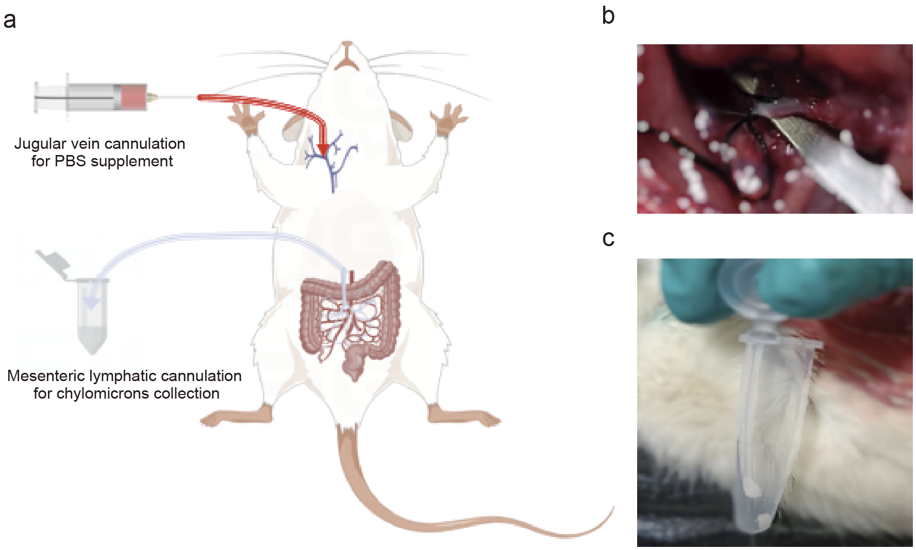
Supplementary Fig. 1 Natural chylomicrons (nCMs) collected from an overnight-fasted rat. a Schematic representation of lymphatic fluid collection by cannulation into the main mesenteric lymphatic duct. b Visualization of the main mesenteric lymphatic duct. c nCMs collected from a rat 1 hour after oral administration of olive oil.

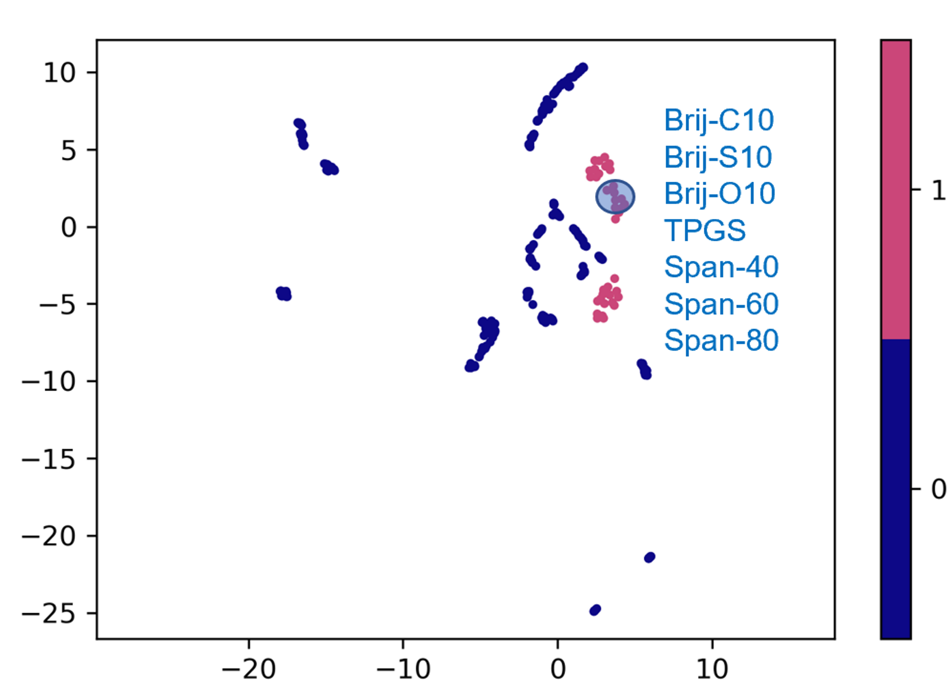
Supplementary Fig. 2 Screening of pharmaceutical excipients with high lipoprotein affinity using the cluster analysis method.
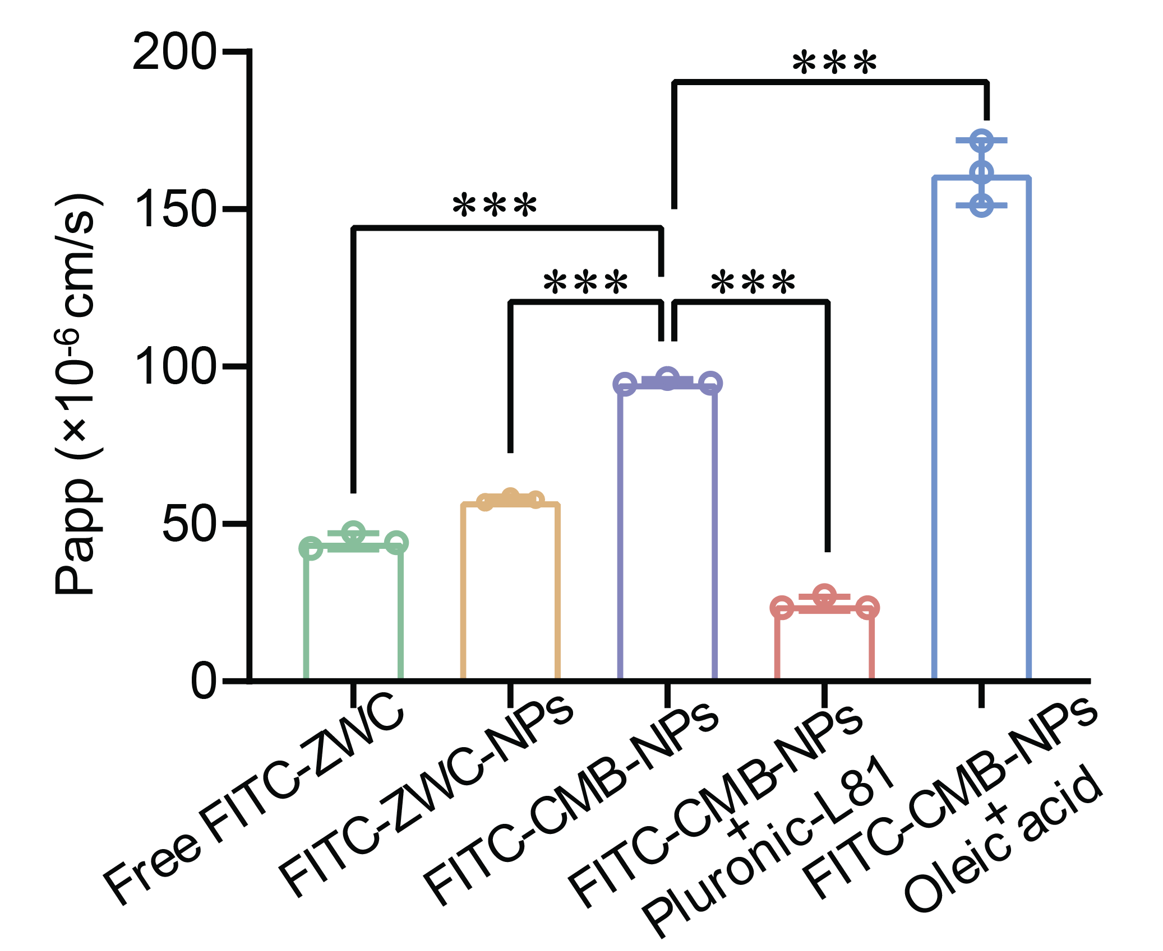
Supplementary Fig. 3 Apparent permeability of FITC-CMB-NPs in a Caco-2 cell monolayer in the presence of Pluronic-L81 or oleic acid.
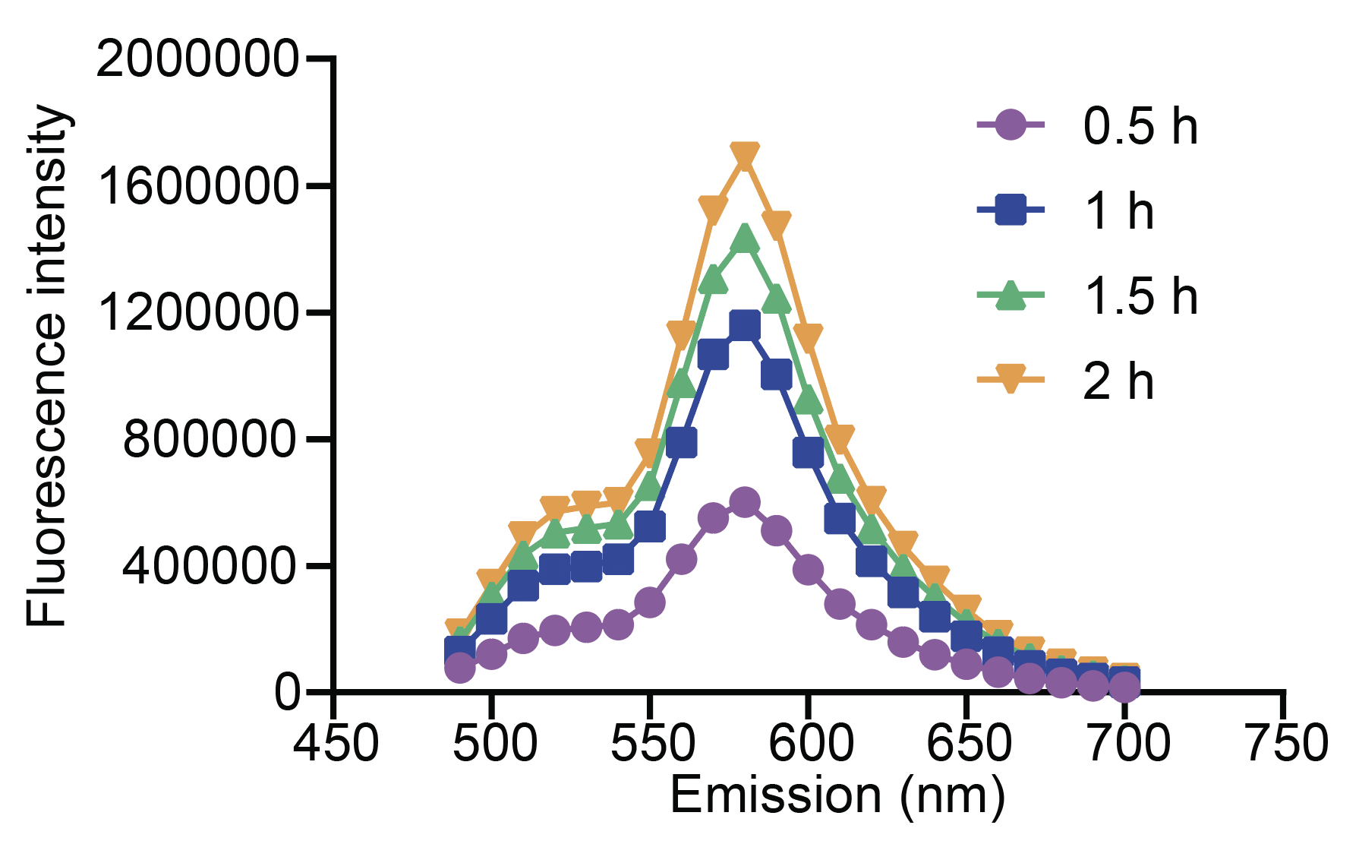
Supplementary Fig. 4 Emission spectra of FRET-CMB-NPs after crossing a Caco-2 cell monolayer over a 2-hour period.
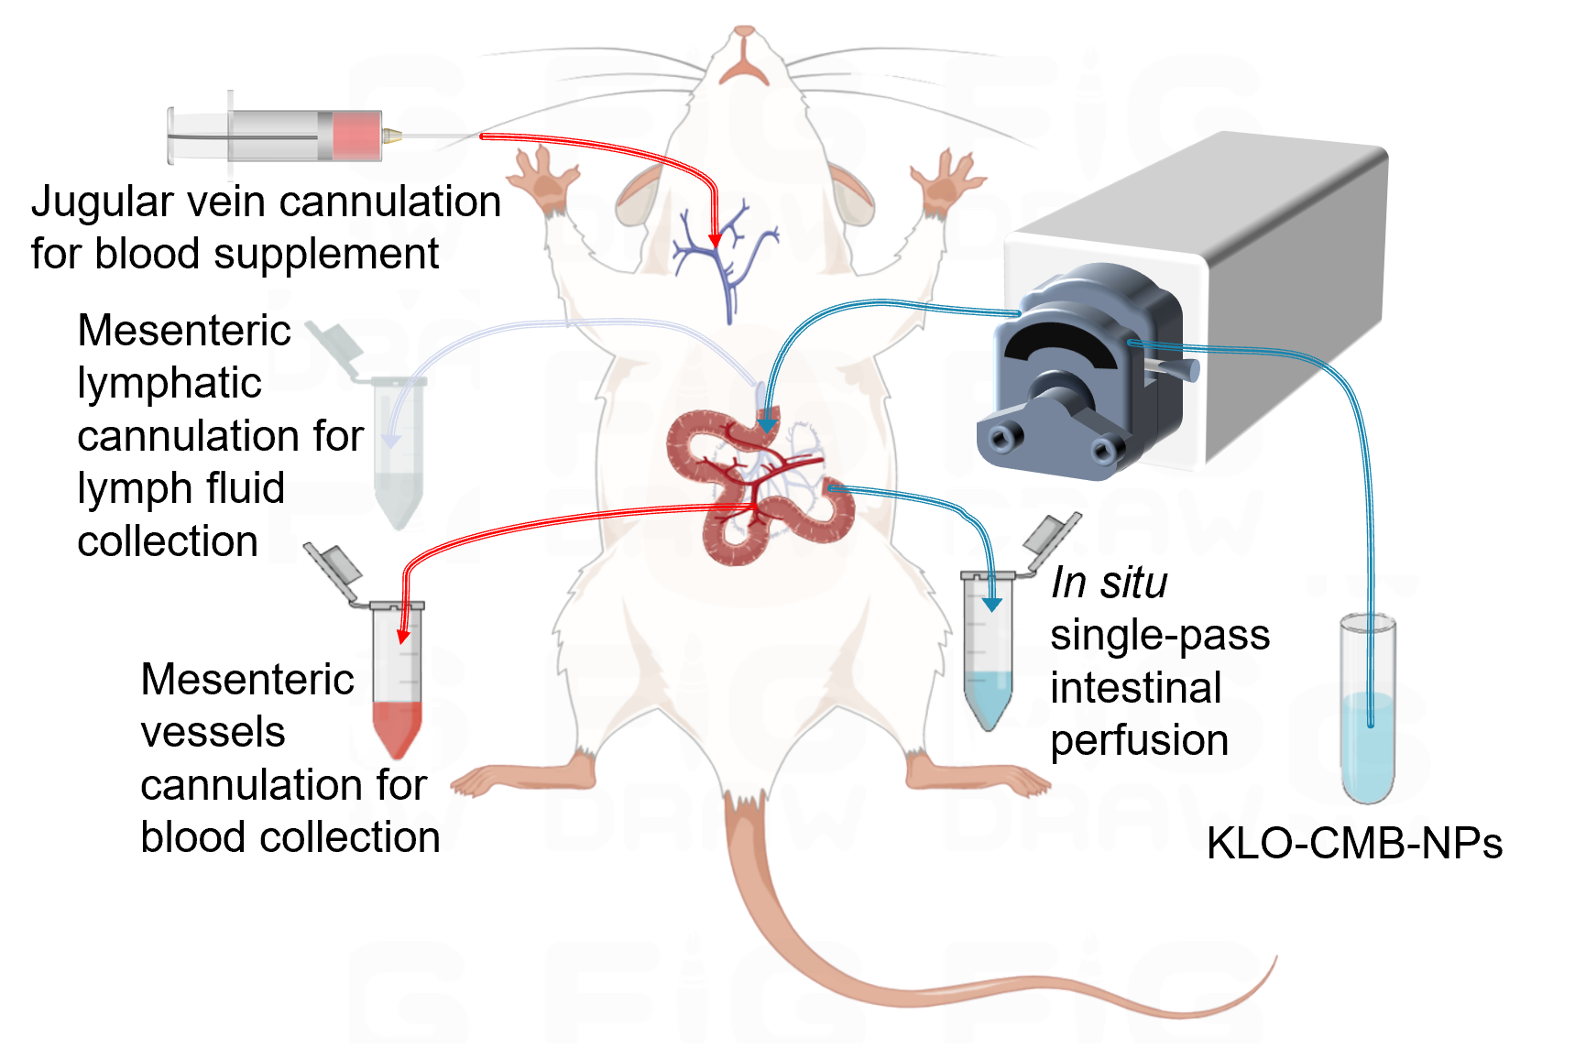
Supplementary Fig. 5 Schematic illustrating the determination of intestinal lymphatic transport of KLO-CMB-NPs through cannulation into the lymphatic duct and blood vessel of a rat.
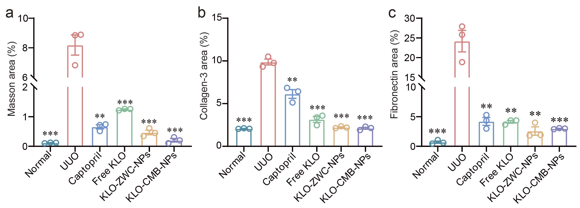
Supplementary Fig. 6 Quantitative analysis of the accumulation areas for (a) Masson's trichrome staining, (b) collagen-3, and (c) fibronectin. Data represent the means ± SD (n = 3), *p < 0.05, **p < 0.01, ***p < 0.001, versus the UUO group.
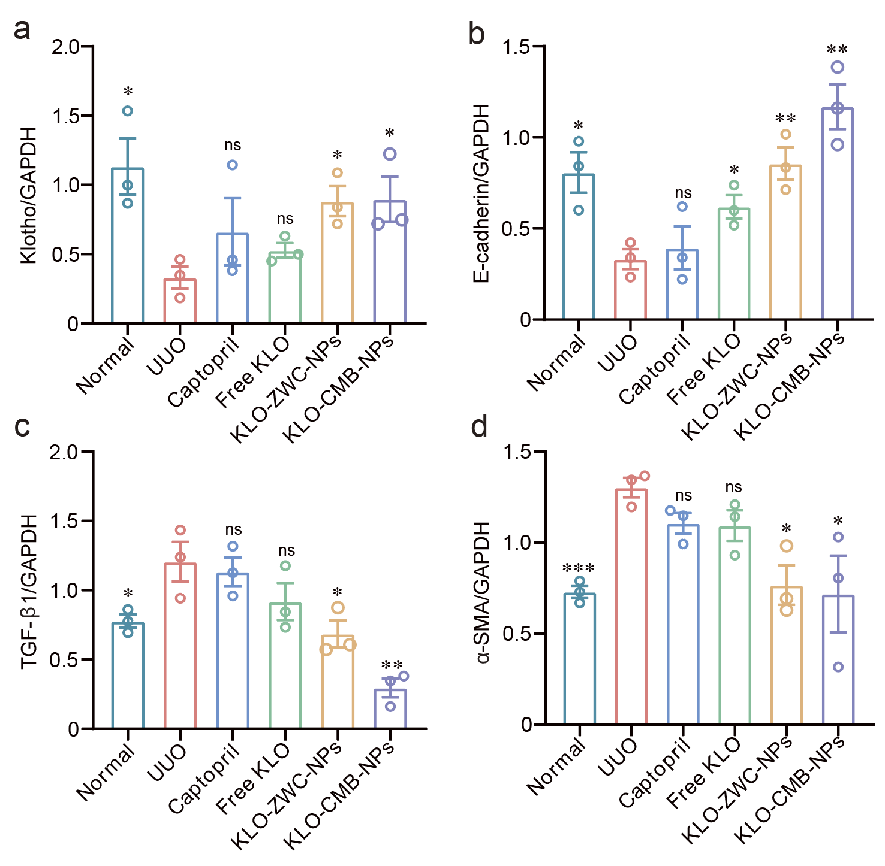
Supplementary Fig. 7 Quantitative analysis of renal fibrosis-related protein expression in the obstructed kidney of UUO mice. a klotho, b E-cadherin, c TGF-β-1, d α-SAM. Data represent the means ± SD (n = 3), *p < 0.05, **p < 0.01, ***p < 0.001, versus the UUO group.
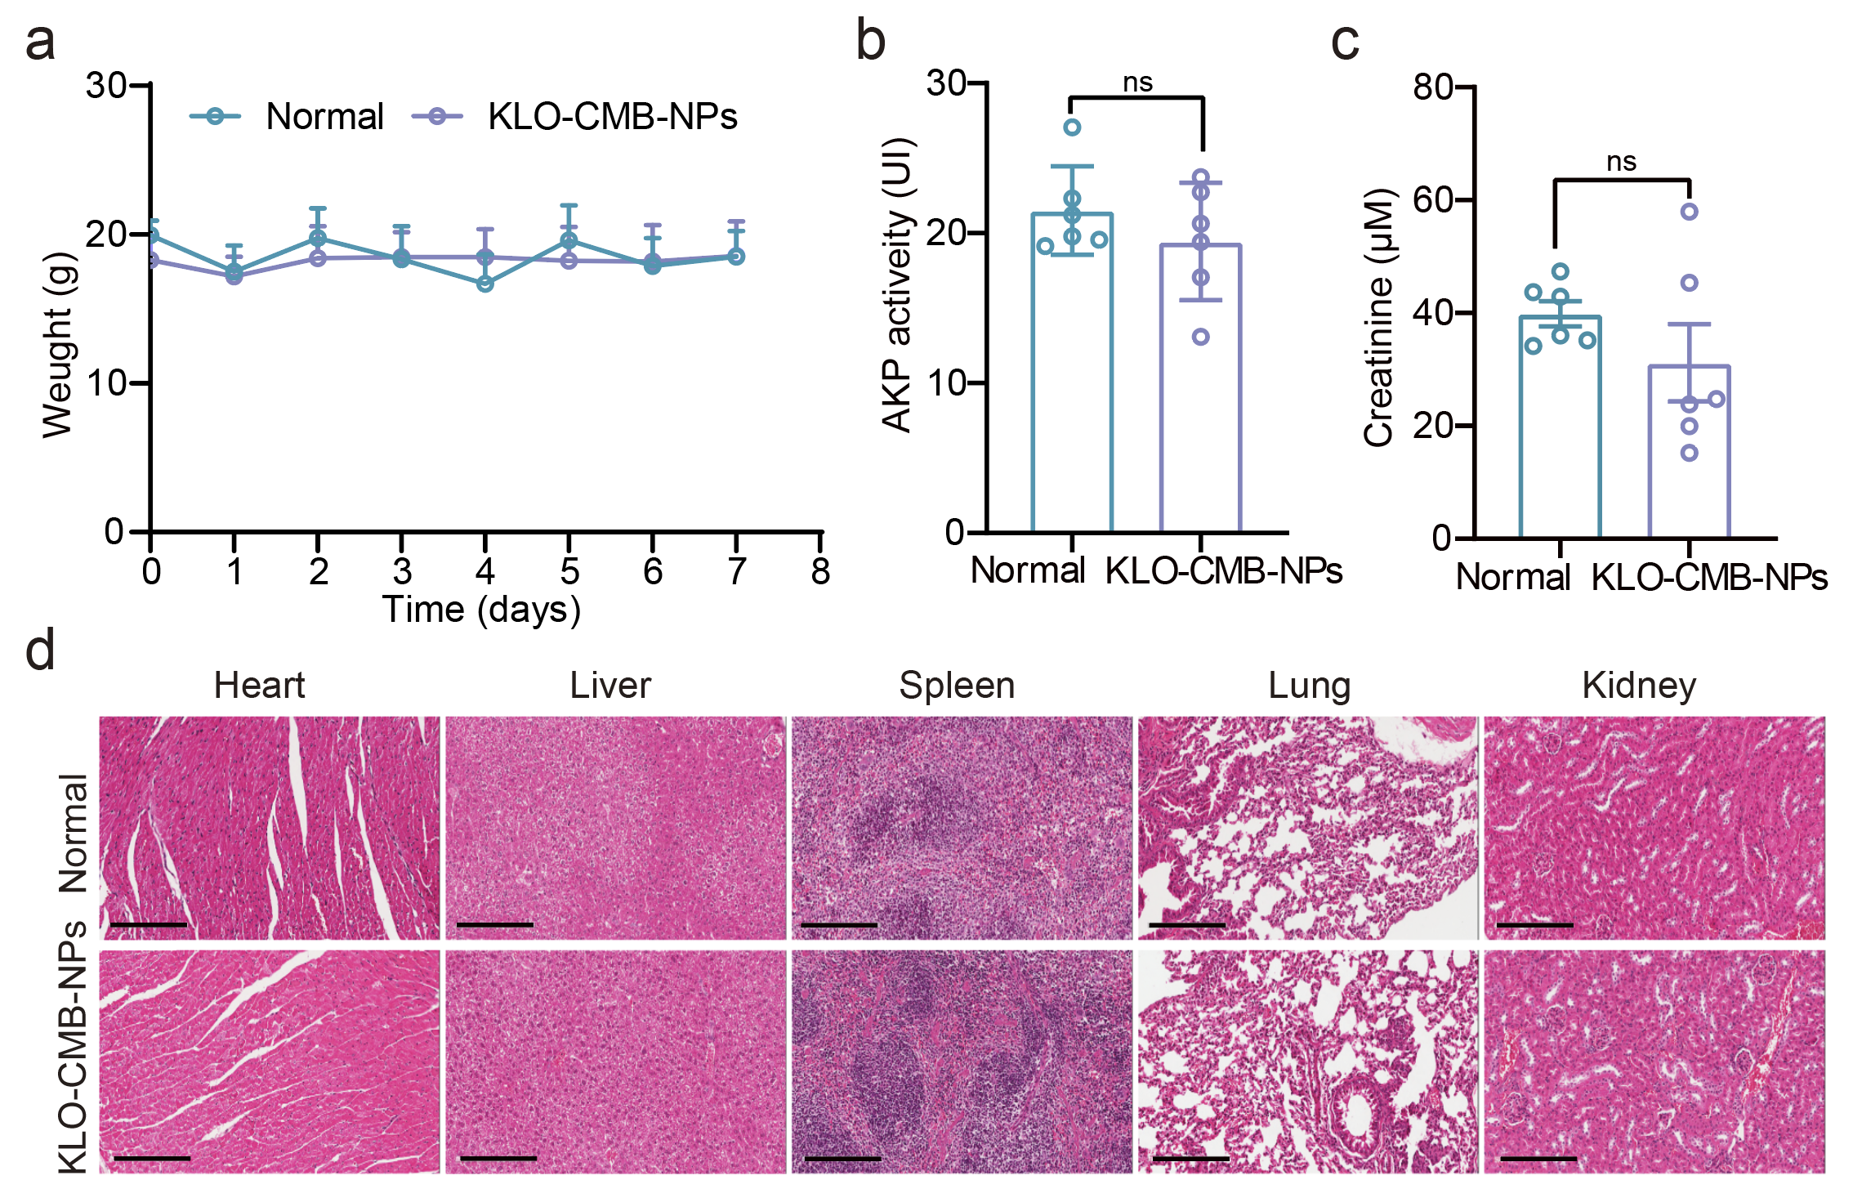
Supplementary Fig. 8 Safety and biocompatibility evaluation following 7-day consecutive oral administration of KLO-CMB-NPs (equivalent to KLO 80 μg/kg/day). a Body weight measurement. b Alkaline phosphatase (AKP) activity. c Serum creatinine. d H&E-stained sections of the heart, liver, spleen, lungs, and kidneys (scale bar: 200 μm). Data represent the means ± SD (n = 6), with no significant differences observed between the normal and KLO-CMB-NPs groups.

Supplementary tables

Supplementary Table 1 Comparison of different nanoparticle formulations in size, zeta potential (ZP), eencapsulation efficiency (EE) and loading capacity (LC). Data represent the means ± SD (n = 3).

Formulations | Size (nm) | ZP (mV) | EE (%) | LC (%)
KLO-CMB-NPs  BSA-CMB-NPs | 172.1 ± 0.6  165.1 ± 0.5 | -0.65 ± 0.61  0.23 ± 0.01 | 98.6 ± 1.8  97.1 ± 1.2 | 6.0 ± 0.2  5.9 ± 0.2
FITC-CMB-NPs | 166.4 ± 0.3 | 0.25 ± 0.07 | 97.9 ± 1.5 | 6.1 ± 0.3
FRET-CMB-NPs | 180.7 ± 0.5 | -0.79 ± 0.31 | - | -
FRET-ZWC-NPs | 178.3 ± 1.3 | 1.39 ± 0.79 | - | -

Supplementary Table 2 Pharmacokinetic parameters of KLO in rats after oral administration of KLO-CMB-NPs (1 μg/kg KLO) or intravenous injection of free KLO (0.1 μg/kg KLO). Data represent the means ± SD (n = 6).

Parameters | KLO-CMB-NPs | Free KLO
C_{max} (pg/mL) | 152.3 ± 25.5 | 101.5 ± 24.8
t_{max} (h) | 0.63 ± 0.1 | 0.25 ± 0
t_{1/2} (h) | 4.1 ± 1.6 | 1.5 ± 0.9
AUC_{0–t} (pg·h/mL) | 560.6 ± 163.2 | 210.5 ± 82.9
MRT_{0–t} (h) | 3.7 ± 0.8 | 1.5 ± 0.4
F abs (%) | 2.7%

