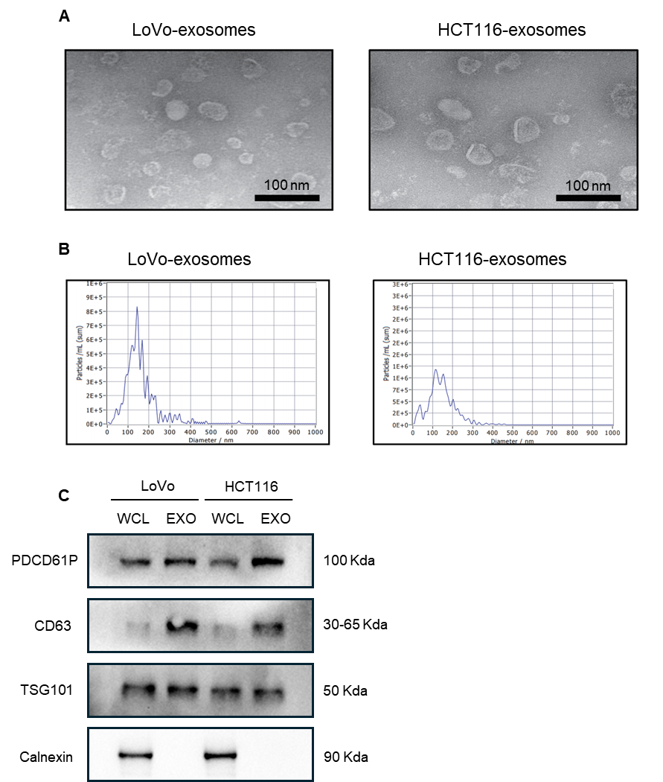
Figure S1 Identification of CRC exosomes
(A) Morphology of CRC-exosomes was visualized by TEM. scale bar:100nm. (B) Diameters distribution of CRC-exosomes was measured by NTA. (C) PDCD6IP, CD63, TSG101, Calnexin in LoVo and HCT116 derived exosomes (EXO) were detected by Western Blot, equal amount whole cell lysis (WCL) was used as control.

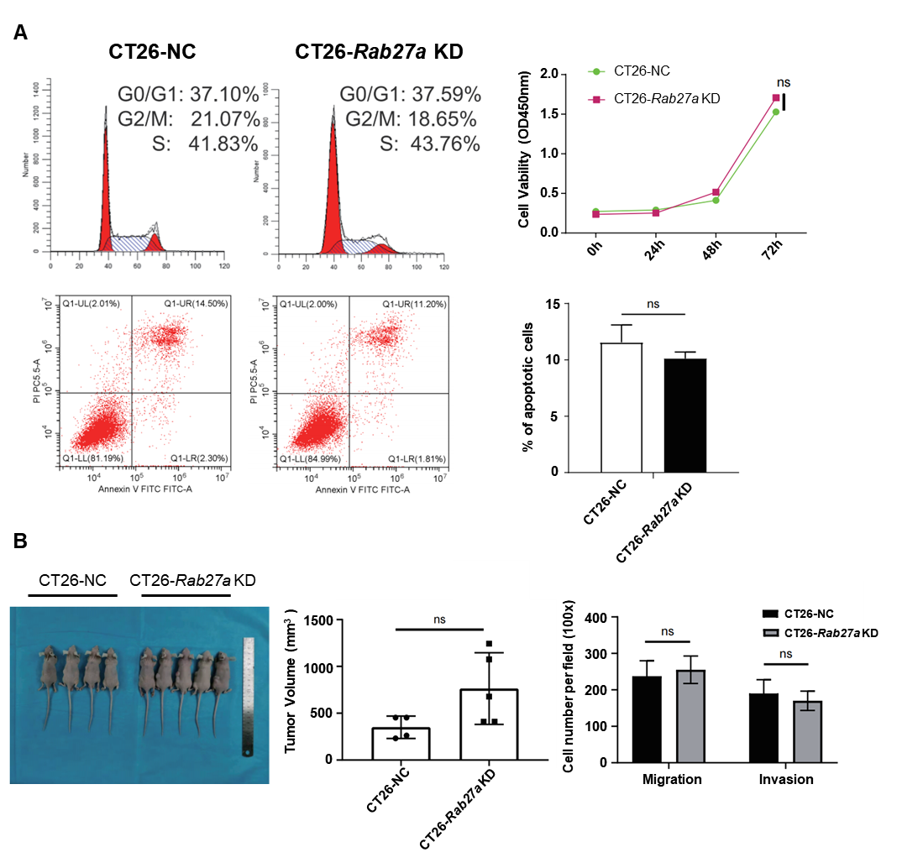
Figure S2 Rab27a downregulation did not significantly affect CT26 cell phenotype
(A) Upper panel: Cell cycle analysis of CT26 cells was tested by PI staining. Cell proliferation of CT26 cells was assessed by CCK8 assay. n=5 Lower panel: Apoptosis cell percentage of CT26 cells was detected by Annexin V+ PI staining. Bar chart of apoptotic cells percentage of CT26 cells. n=3 (B) Image of subcutaneous tumor model results. Bar chart of CT26-NC and CT26-Rab27a KD derived tumor volume in a subcutaneous tumor model. n=5 Bar chart of cell number in migration and invasion assay on CT26-NC and CT26-Rab27a KD cells. n=3-4 ns: no significance

