- Fabrication of PDMS mold for tensile specimen
Dog-bone-shaped hydrogel specimens were prepared following ASTM D638 (1st edition). The fabrication process followed the cross-sectional design shown in Figure S1(a). The master template of the tensile specimen was 3D-printed with a raised profile opposite to the ASTM standard. The master template was placed on a bare silicon wafer and aluminum foil was used to form a boundary along the edges, as shown in Figure S1(a). A prepolymer mixture(base: curing agent =10:1) of polydimethylsiloxane (PDMS) was poured into this setup. Thermal curing was performed at 80°C for 2 days. After curing, the master template was removed. This process created a PDMS mold for the hydrogel. The hydrogel precursor solution was introduced into this mold. UV curing was performed following the same polymerization method used for hydrogel synthesis. The final specimens were obtained as shown in figure 3(a).
To evaluate the mechanical properties of the synthesized hydrogels, stress-strain curves were obtained through uniaxial tensile testing. The hydrogel specimens were tested at a crosshead speed of 5 mm/min using a Universal Testing Machine (MINOS-005S).
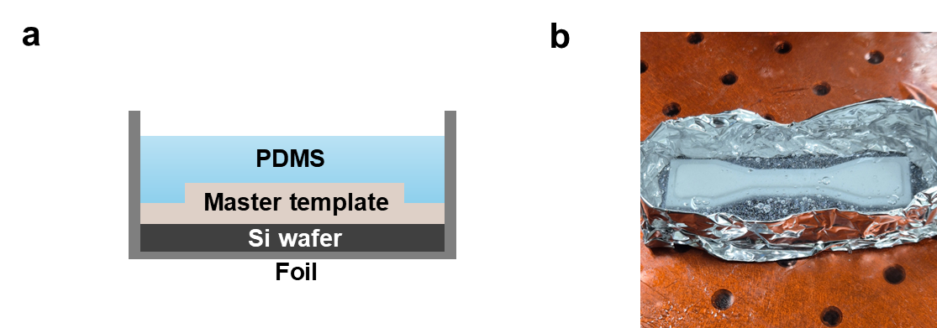
Figure S1. Fabrication process of hydrogel specimens for tensile test. (a) Schematic illustration of PDMS mold fabrication using a 3D-printed master template. (b) Photograph of the fabricated PDMS mold corresponding to (a).

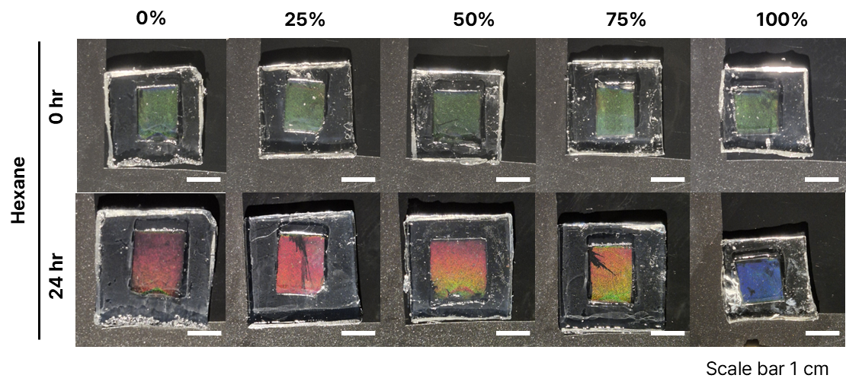
Figure S2. Structural color response of hydrogel immersed in hexane-water mixtures with various hexane concentrations.

