Supplementary Materials for
“Generalized Molecular Latent Representation via Graph Latent Diffusion Autoencoder”

Daiki Koge*¹, Naoaki Ono², Takashi Abe¹, Shigehiko Kanaya³
1. Department of Electrical and Information Engineering, Graduate School of Science and Technology, Niigata University
2. Data Science Center, Nara Institute of Science and Technology
3. Division of Information Science, Graduate School of Science and Technology, Nara Institute of Science and Technology
*Corresponding author e-mail : daiki-ko@ie.niigata-u.ac.jp

- Latent diffusion model
Table S1 summarizes the final selection of hyperparameters for the training of the latent diffusion model.

Table S1: Hyperparameters for the latent diffusion model.
Description | Models for ZINC-250k |  | Models for QM9
Description | Graph LDA | Graph LDA (stable) | Graph LDA | Graph LDA (stable)
- Time encoding function | Sinusoidal encoding [1] | Sinusoidal encoding | Sinusoidal encoding | Sinusoidal encoding
- Dimension of time embeddings | 256 | 256 | 256 | 256
- Number of time steps for diffusion | 200 | 1,000 | 100 | 500
- Dimension of hidden feature for noisy latent vectors $z_{t}$ | 256 | 256 | 256 | 256
- Number of layers | 3 | 3 | 3 | 3
- Learning rate | 0.0005 | 2nd stage in Algorithm 1: 0.0001,  3rd stage in Algorithm 1: 0.0001. | 0.0005 | 2nd stage in Algorithm 1 : 0.0005,  3rd stage in Algorithm 1 : 0.0001.

- Bayesian neural network for WAIC and WBIC evaluation (Section 3.3.1)
Bayesian neural networks are established to calculate the WAIC and WBIC values of the molecular property predictive models. Table S2 summarizes the final selection of hyperparameters for these networks.

Table S2: Hyperparameters for Bayesian neural networks.
Description | Pre-trained models by ZINC-250k | Pre-trained models by QM9
Dimension of hidden feature | 256 | 128
Number of layers | 3 | 3
Activation function | Tanh | Swish [2]

- kNN-rate and hyperparameters of UMAP (Section 4.2.1)
Figures S1 and S2 show the kNN-rate curves for different dimensions of the low-dimensional space of UMAP. The kneedle algorithm [3] detects the elbow point from the distance between the line ($y=ax+b$) connecting the start and end points of the curve and kNN-rate of each point. The green line in both figures represents the distance, and the elbow point corresponds to the maximum distance.
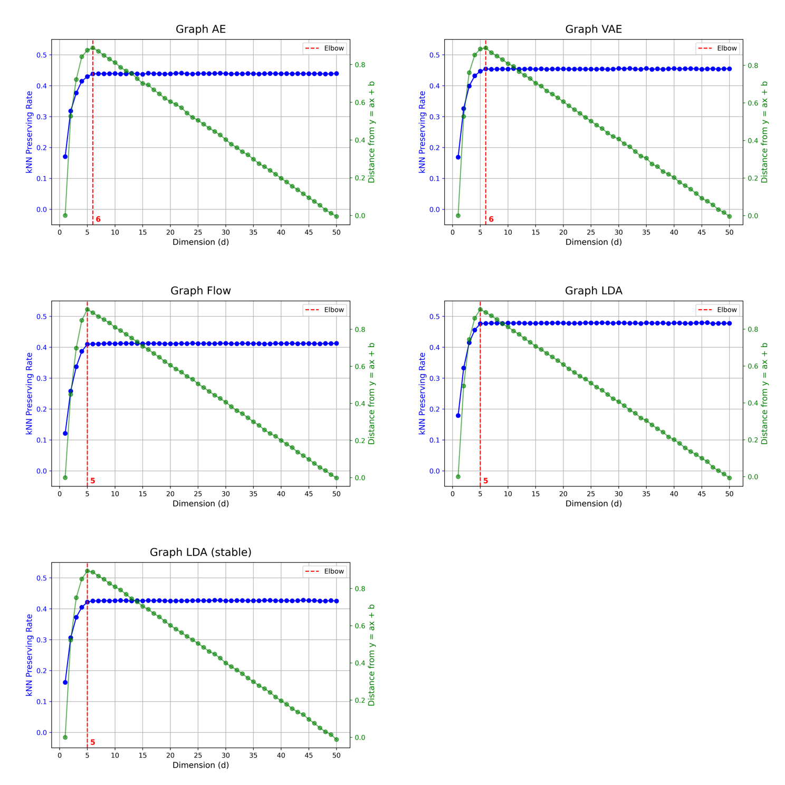
Figure S1: kNN-rate for each model on the ZINC-250k dataset.

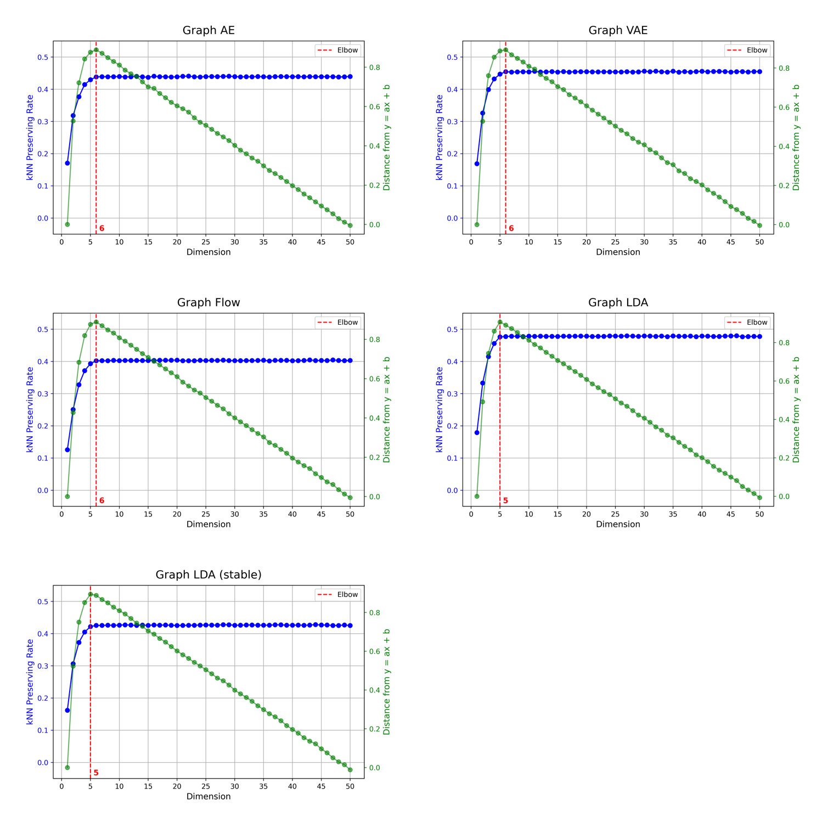
Figure S2: kNN-rate for each model on the QM9 dataset.

- Smoothness of molecular latent representations
Table S3 lists the smoothness values pertaining to the molecular latent representations for each model.
Table S3: Comparison of smoothness between the proposed and baseline models.
Molecular  Property | Models
 | Graph AE | Graph VAE | Graph Flow | Graph LDA | Graph LDA (Stable)
BACE (502) | 0.8266 | 1.6432 | 1.0107 | 0.9329 | 0.8000
CTSD (84) | 0.4689 | 0.7315 | 0.5970 | 0.5196 | 0.4865
MMP2 (1046) | 1.0401 | 2.0042 | 1.2032 | 1.1440 | 1.0203
Malaria (3019) | 1.2847 | 1.6487 | 1.3436 | 1.3372 | 1.2842
ESOL (1080) | 1.1205 | 2.0684 | 1.2020 | 1.3619 | 1.1161
Freesolv (642) | 2.1040 | 3.8106 | 2.0970 | 2.3131 | 2.1900
Lipo (1903) | 1.0372 | 1.4284 | 1.1504 | 1.1743 | 1.0313
LogP (100k) | 0.9086 | 1.6703 | 1.0990 | 1.0432 | 0.9312
HOMO (100k) | 1.5727$×{10}^{-2}$ | 1.5863$×{10}^{-2}$ | 1.6253$×{10}^{-2}$ | 1.6628$×{10}^{-2}$ | 1.5960$×{10}^{-2}$
LUMO (100k) | 3.2387$×{10}^{-2}$ | 3.1409$×{10}^{-2}$ | 3.1813$×{10}^{-2}$ | 3.5626$×{10}^{-2}$ | 3.0913$×{10}^{-2}$

- Computational details
OS: Red Hat Enterprise Linux release 8.4
CPU: Intel(R) Xeon(R) Gold 6230R CPU @ 2.10GHz
GPU: NVIDIA Corporation GA100 [A100 PCIe 40GB]
All experiments are conducted using Python 3.10.13. RDKit (version 2024.3.5.0) is used to treat the organic compound data, and PyTorch (version 2.4.0) and Pytorch Geometric (version 2.5.3) are used as the deep learning frameworks.

References
[1] Waswani A, Shazeer N, Parmar N, Uszkoreit J, Jones L, Gomez A, Kaiser L, Polosukhin I (2017) Attention is all you need. In: Nips
[2] Ramachandran, Prajit, Zoph B, Le QV (2017) ‘Searching for activation functions.’ arXiv preprint arXiv:1710.05941
[3] Satopaa V, Albrecht J, Irwin D, Raghavan B (2011) ‘Finding a’ kneedle in a haystack: Detecting knee points in system behavior." In: 31st international conference on distributed computing systems workshops. IEEE, p 166–171

