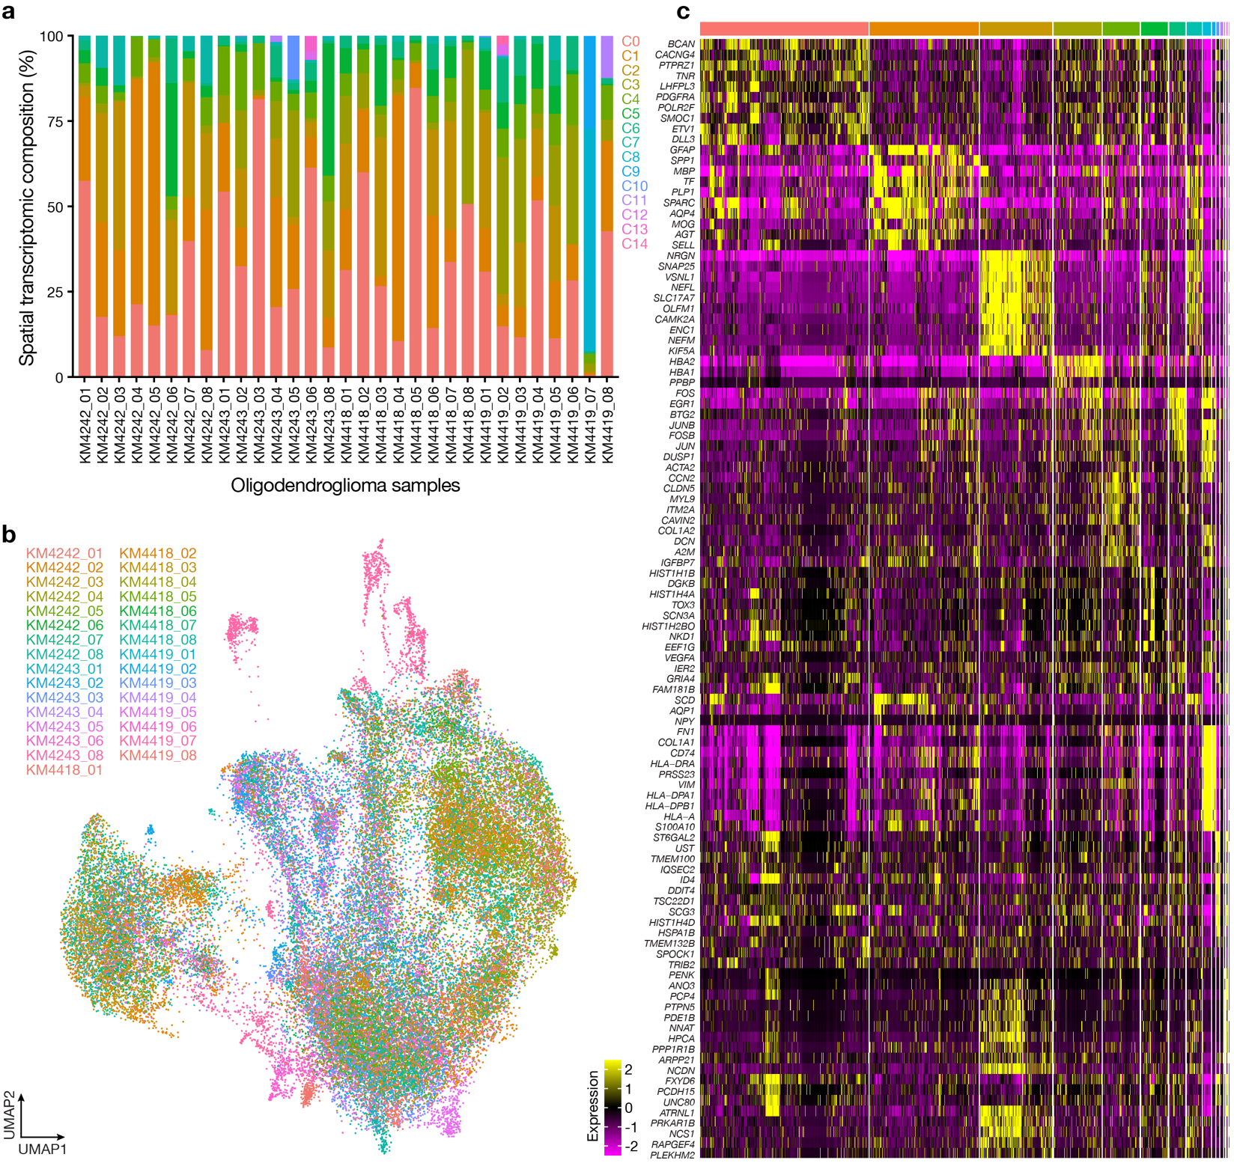Extended Data Fig. 1. Oligodendroglioma discovery cohort spatial transcriptomic sequencing. a, Stacked bar plots showing the distribution of spatial transcriptomic clusters across all oligodendroglioma samples. b, Uniform manifold approximation and projection (UMAP) of 55,737 batch-corrected oligodendroglioma spatial transcriptomes, shaded by sample of origin. c, Heatmap showing differentially expressed genes across spatial UMAP clusters from oligodendroglioma samples.
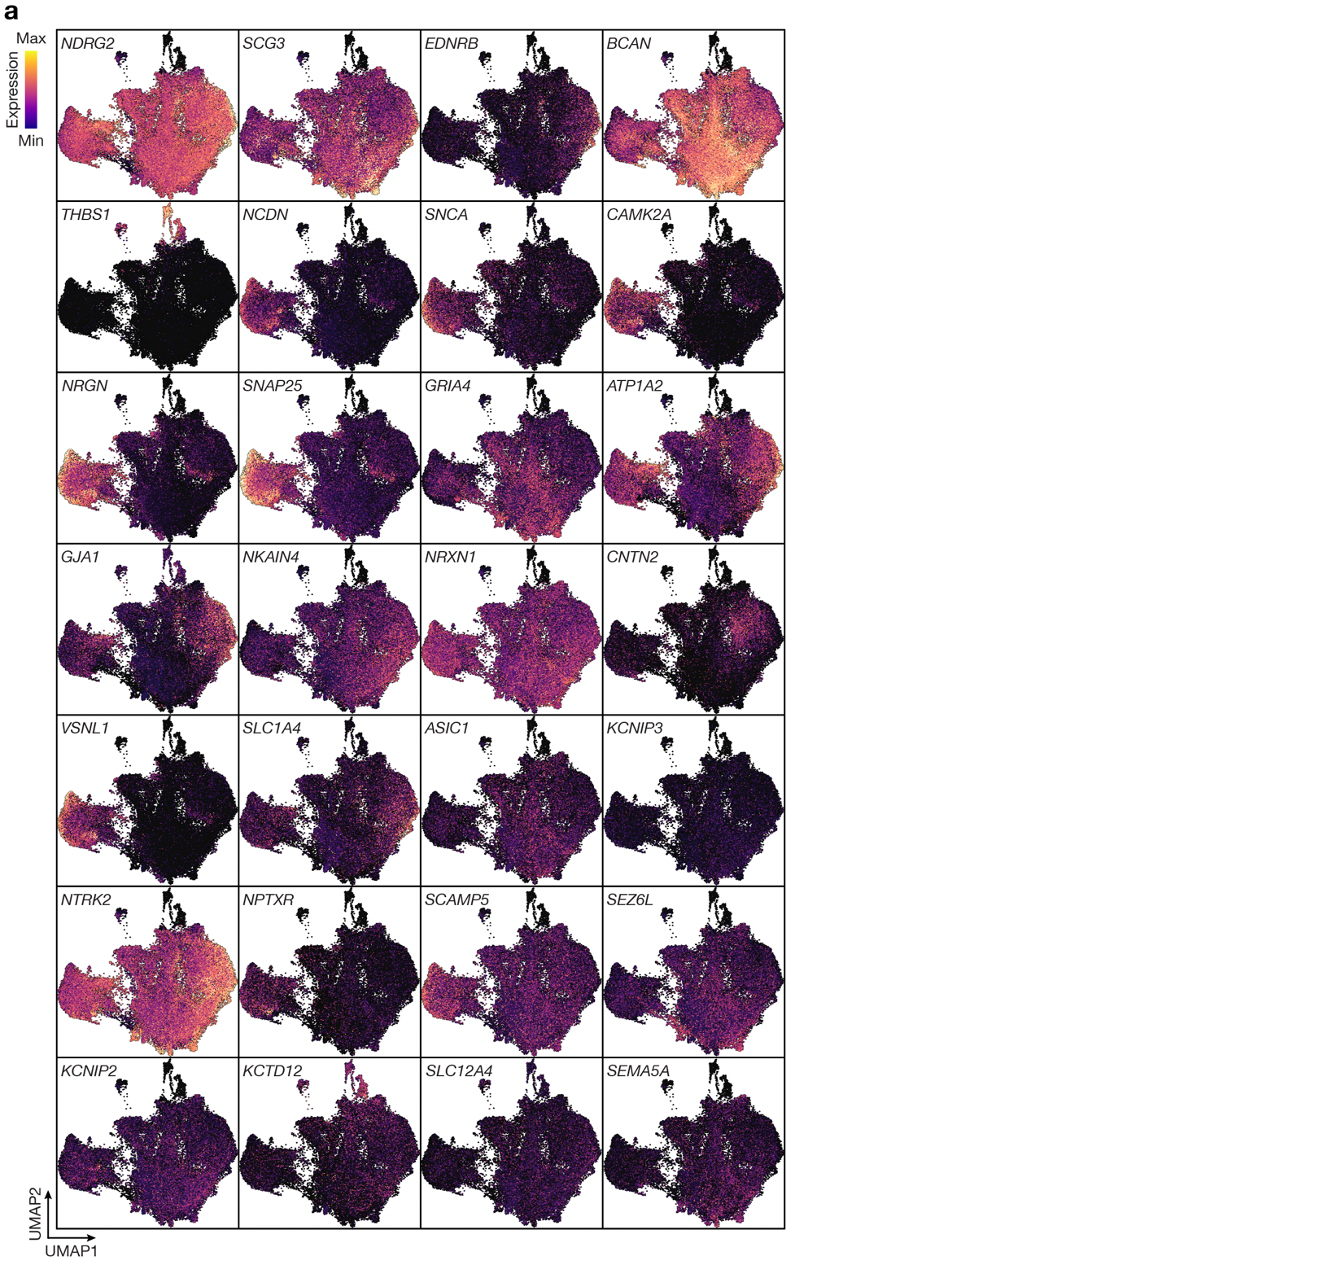Extended Data Fig. 2. Oligodendroglioma discovery cohort spatial transcriptomic cluster identities. a, Feature plots showing differentially expressed genes across spatial UMAP clusters from oligodendroglioma samples.
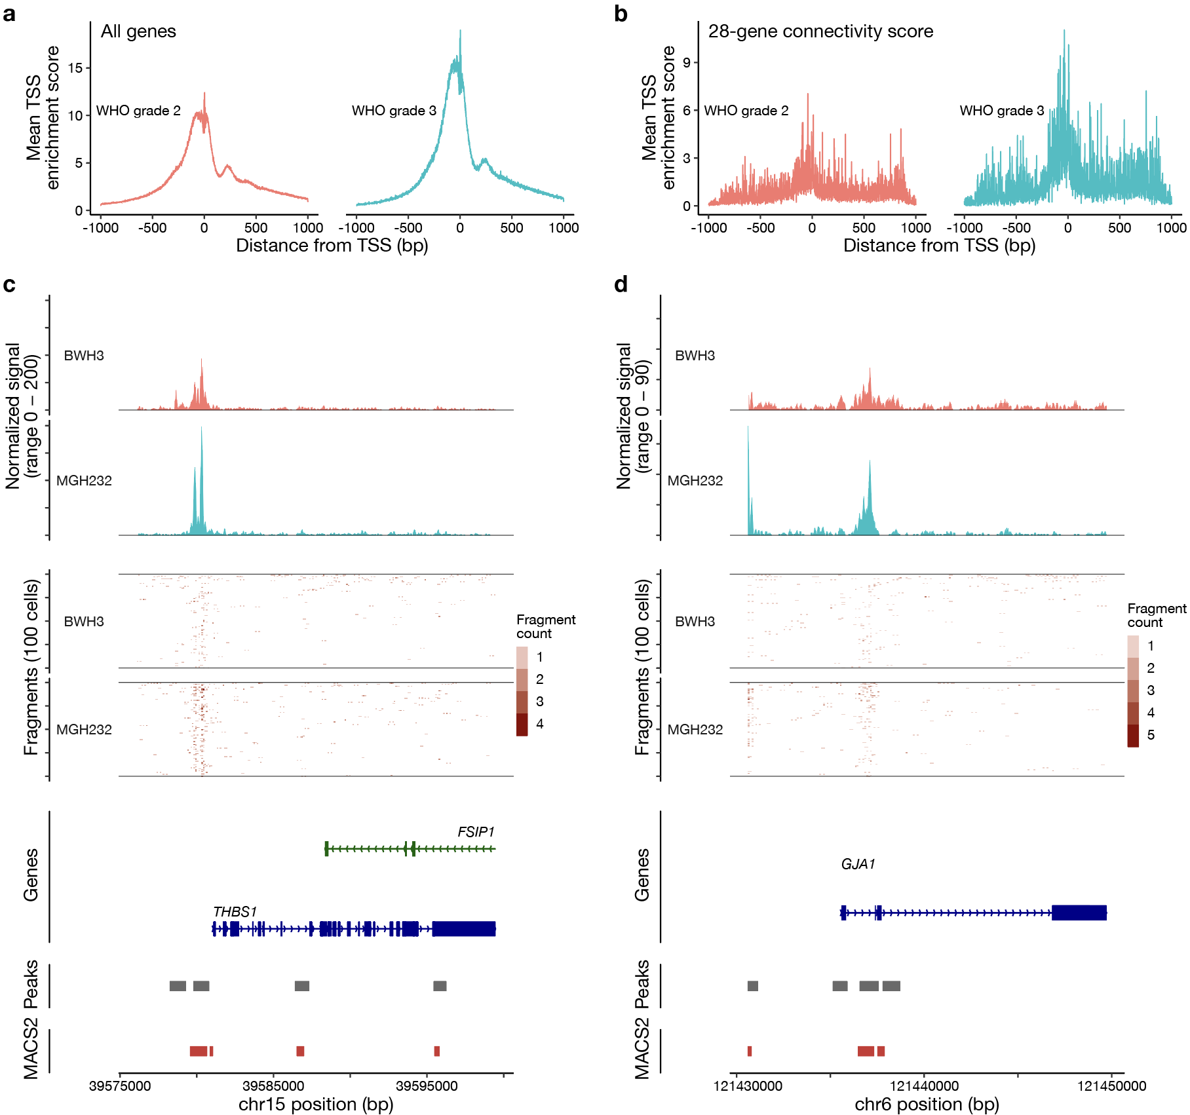Extended Data Fig. 3. Single cell chromatin accessibility in oligodendrogliomas. a, Transcription start site (TSS) enrichment score for all protein coding genes from all cells across CNS WHO grade 2 or 3 oligodendrogliomas. b, TSS enrichment score for all cells aggregated from 28 differentially expressed genes associated with synaptic connectivity across CNS WHO grade 2 or 3 oligodendrogliomas. c, Gene coverage plot, per-cell fragment abundance plot, gene annotation, and peak plots (from top to bottom) for THBS1 in representative CNS WHO grade 2 (BWH3) or grade 3 (MGH232) oligodendrogliomas. d, Gene coverage plot, per-cell fragment abundance plot, gene annotation, and peak plots (from top to bottom) for GJA1 in representative CNS WHO grade 2 (BWH3) or grade 3 (MGH232) oligodendrogliomas.
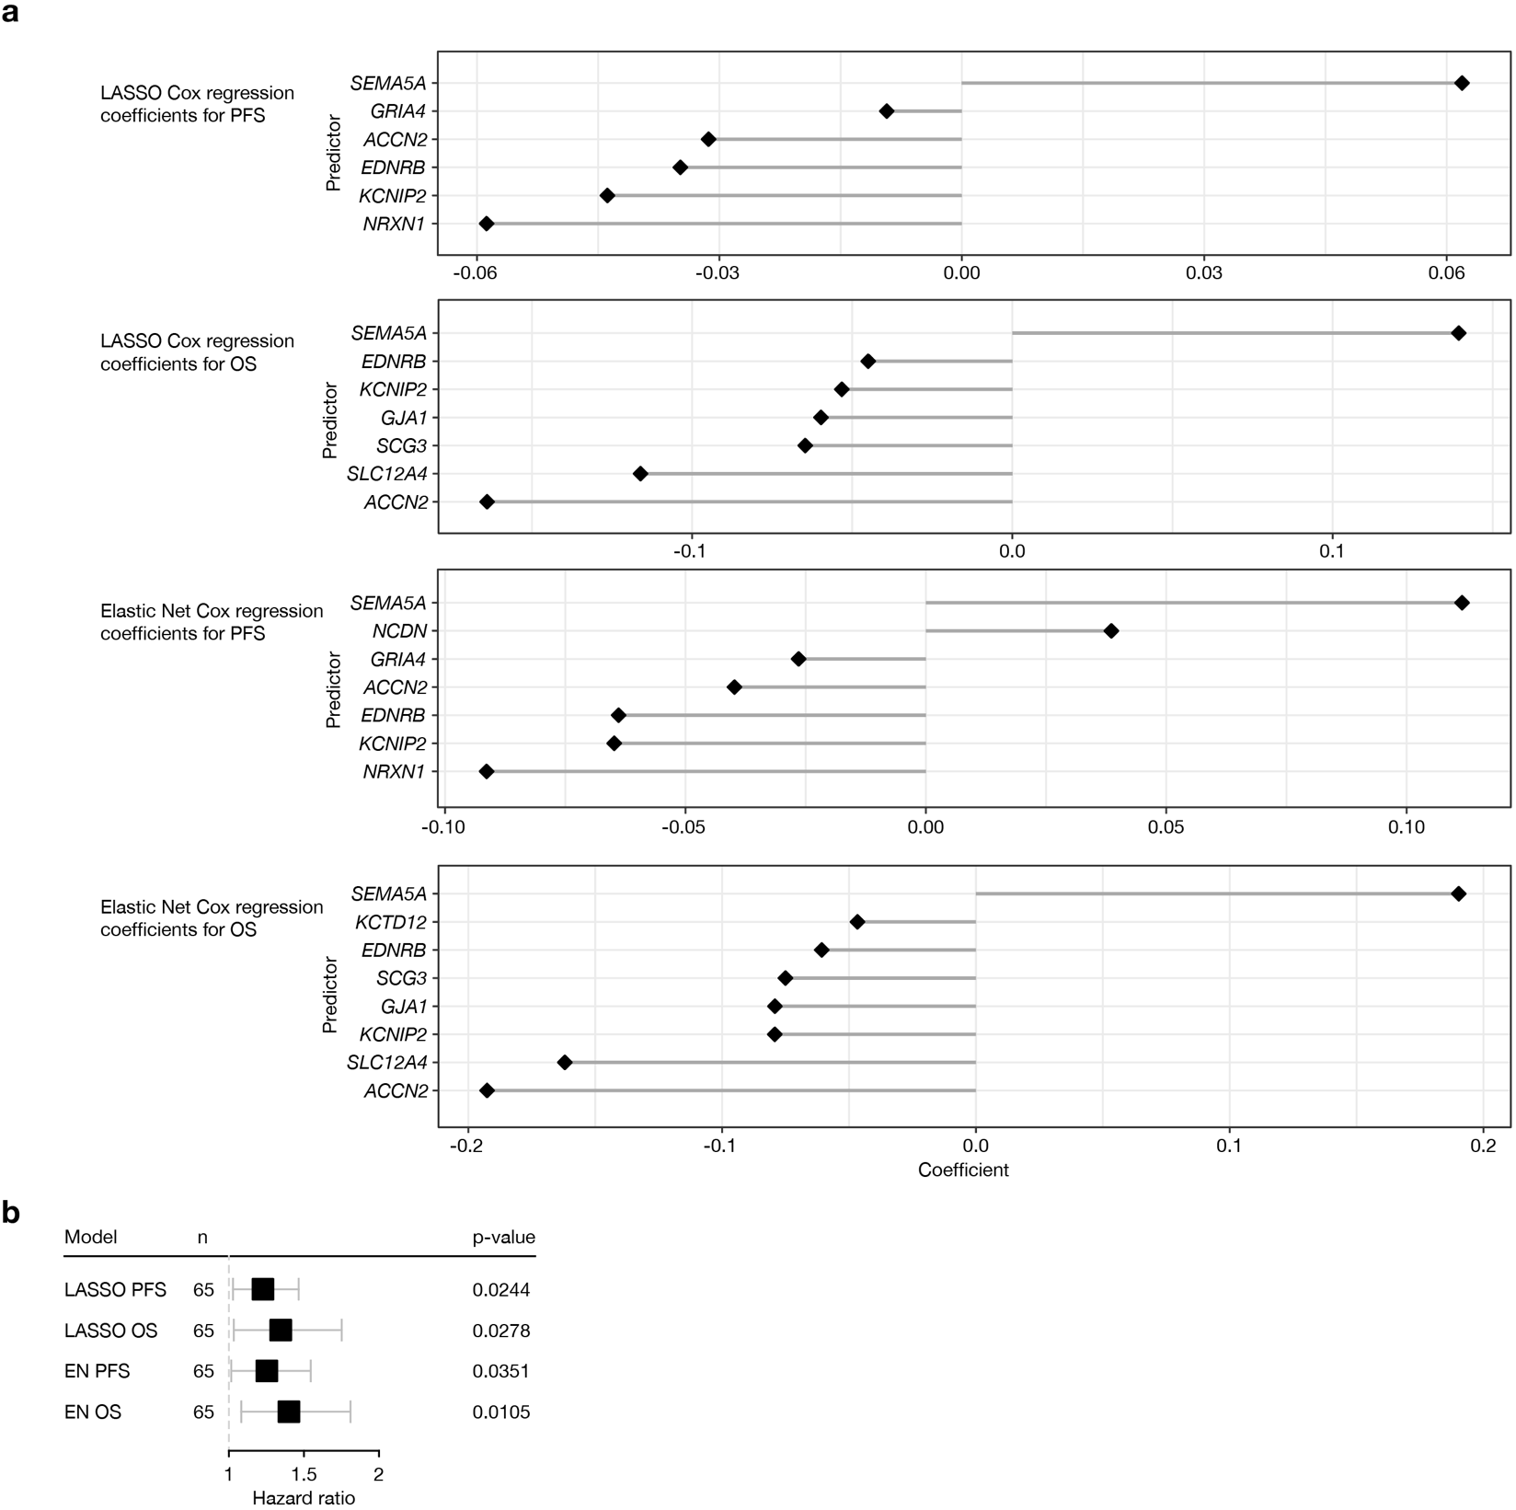Extended Data Fig. 4. Development of prognostic spatial connectivity gene signatures. a, Coefficient plots for LASSO or Elastic Net (EN) regularized Cox models using progression free survival (PFS) or overall survival (OS) as outcomes and the 28 genes from the spatial connectivity score as inputs in newly diagnosed IDH-mutant gliomas from The Cancer Genome Atlas (TCGA). b, LASSO or EN regularized Cox regression hazard ratios for PFS or OS per 0.1 increase in the spatial connectivity score in newly diagnosed astrocytomas from TCGA. Lines represent 95% confidence intervals.
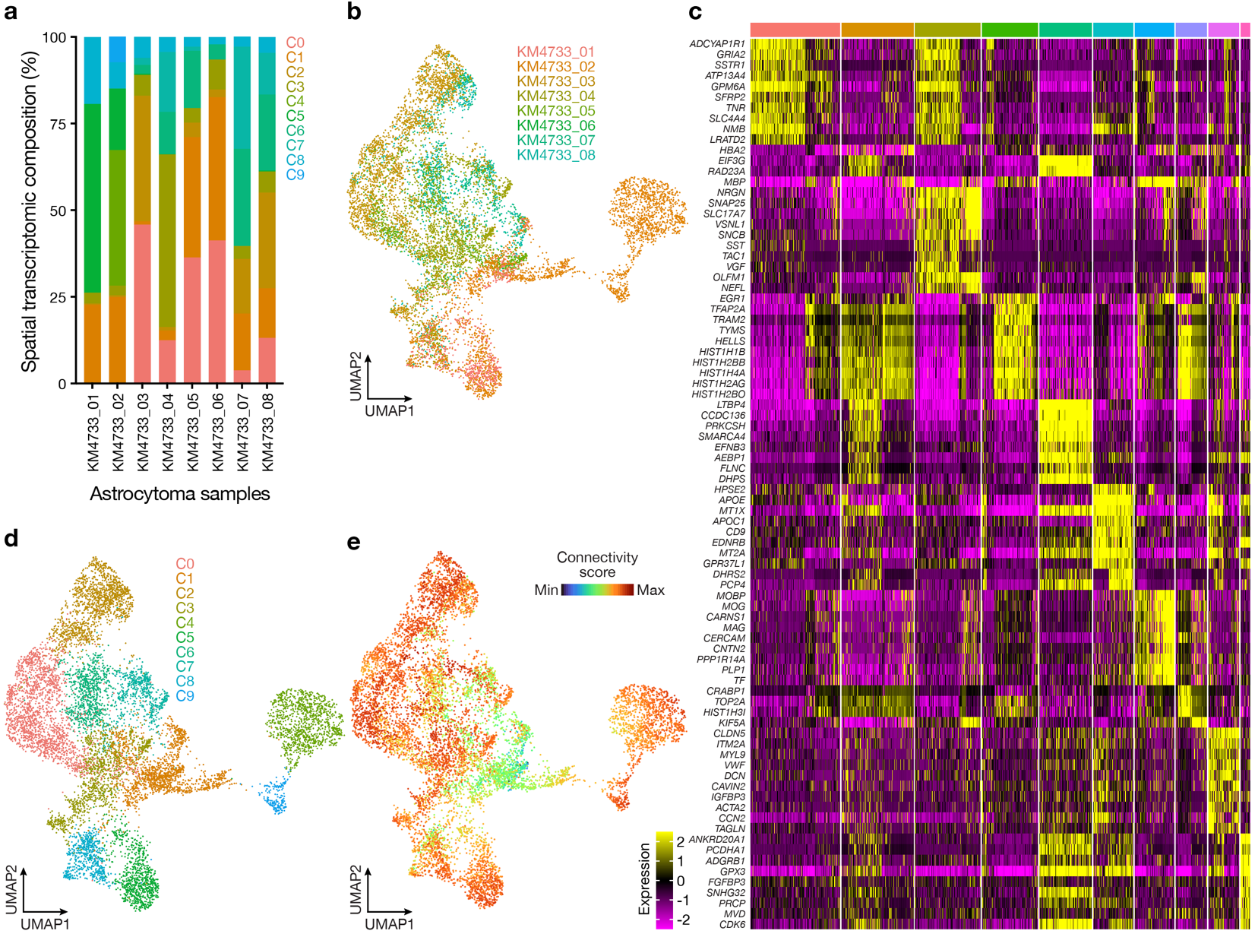Extended Data Fig. 5. Astrocytoma specificity cohort spatial transcriptomic sequencing. a, Stacked bar plots showing the distribution of spatial transcriptomic clusters sequencing clusters across 8 IDH-mutant astrocytoma samples. b, UMAP of 10,189 batch-corrected astrocytoma spatial transcriptomes, shaded by sample of origin. c, Heatmap showing differentially expressed genes across spatial UMAP clusters from 8 astrocytoma samples. d, UMAP showing spatial cluster assignment across all astrocytoma samples. e, UMAP showing connectivity score in astrocytoma samples. The connectivity score was derived from the average expression of 28 differentially expressed genes in recurrent oligodendroglioma spatial transcriptomes.
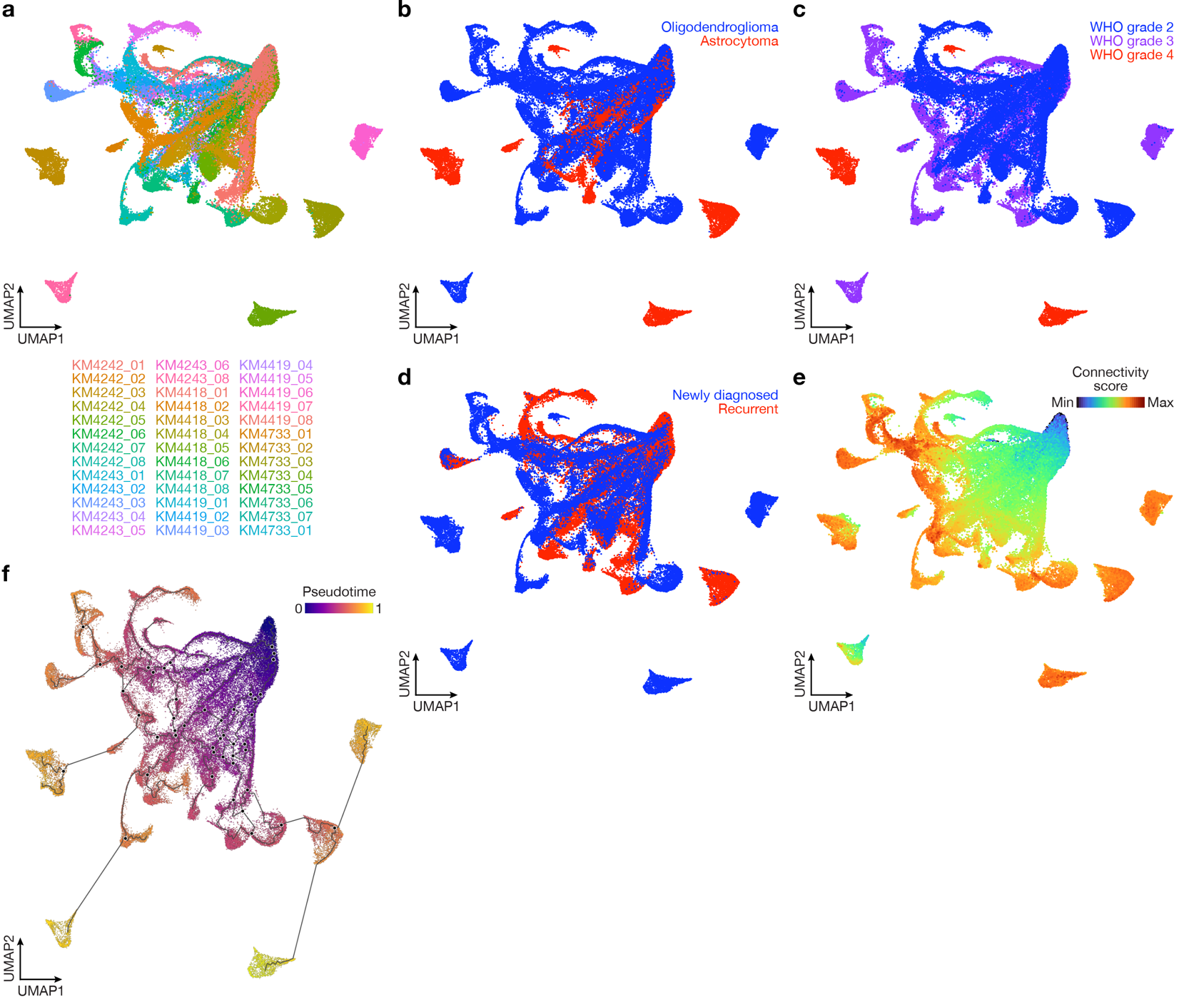Extended Data Fig. 6. Combined spatial transcriptomic analysis of 39 oligodendroglioma and astrocytoma samples. a, UMAP containing 65,956 spatial transcriptomes, shaded by sample of origin. b, UMAP shaded by tumor type. c, UMAP shaded by CNS WHO grade irrespective of tumor type. d, UMAP designating initial diagnosis or recurrence, irrespective of tumor type. e, UMAP showing connectivity score derived from averaged expression of 28 differentially expressed genes in recurrent oligodendroglioma spatial transcriptomes. f, Pseudotime trajectory analysis of all spatial transcriptomes suggesting that oligodendroglioma and astrocytoma connectivity evolves over the course of tumor progression.
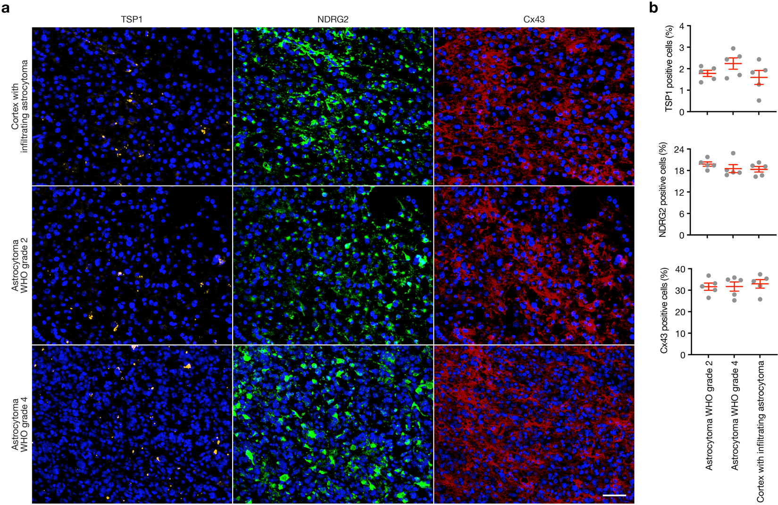Extended Data Fig. 7. Synaptic gene expression is independent of astrocytoma spatial location. a, Immunofluorescent staining of astrocytoma formalin fixed paraffin embedded tissue sections showing localization and distribution of TSP1 (THBS1), NDRG2, and Connexin 43 (GJA1). Scale bar, 100µm. b, Quantification of TSP1, NDRG2, and Connexin 43 immunofluorescence across astrocytoma CNS WHO grade 2, astrocytoma CNS WHO grade 3, and cortex with infiltrating astrocytoma tumor cells. Lines represent means and error bars represent the standard error of the means.

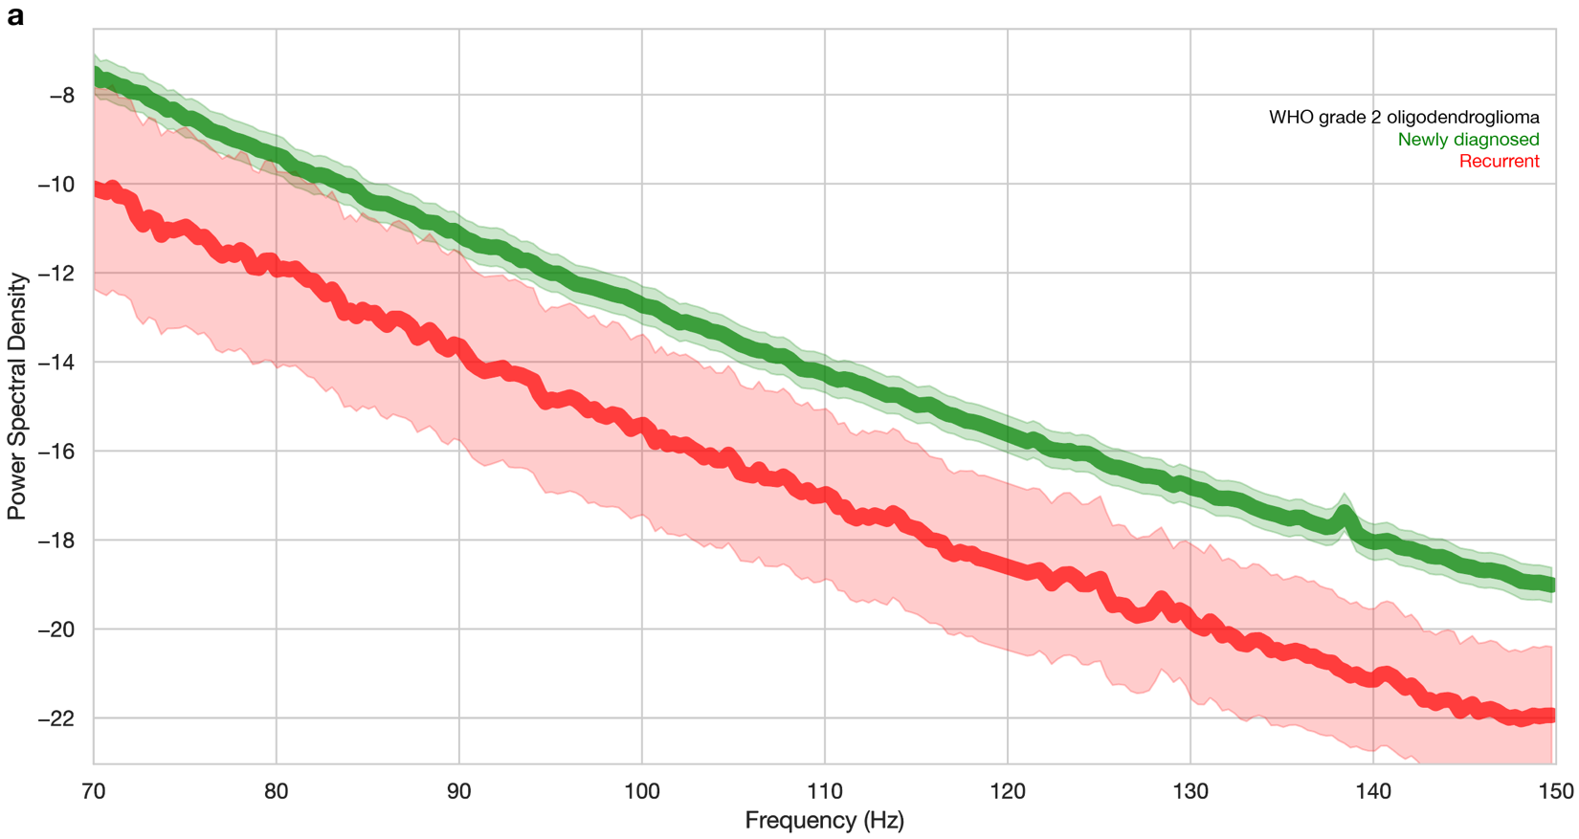Extended Data Fig. 8. Subdural electrode array relative connectivity from CNS WHO grade 2 oligodendrogliomas. a, High gamma (70-150 Hertz, Hz) power spectral density (PSD) of electrocorticography recordings from electrodes overlying newly diagnosed (green, n=8 patients, n=252 electrodes) or recurrent (red, 2 patients, 39 electrodes) CNS WHO grade 2 oligodendrogliomas. Shaded regions demonstrate 95% confidence intervals. The 118-122 Hz frequency range has been masked to remove 120 Hz artifact.
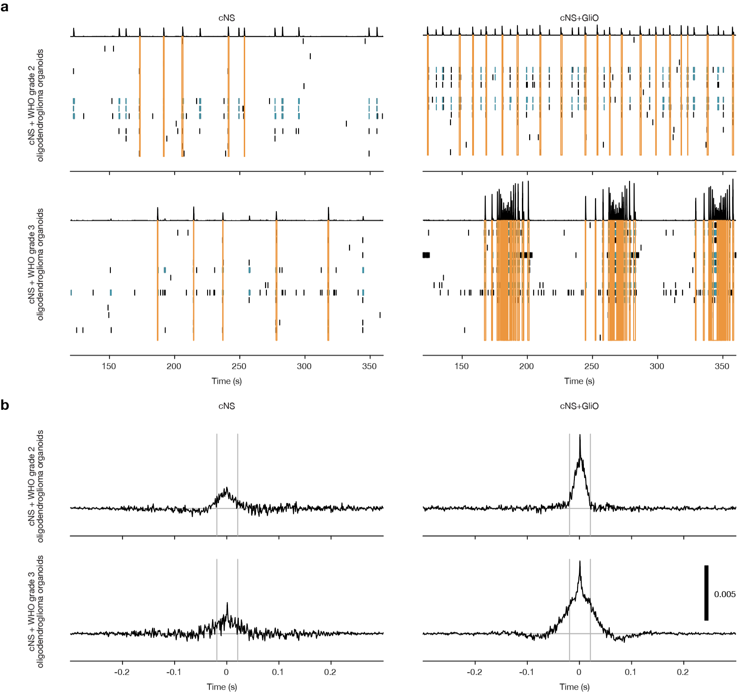Extended Data Fig. 9. Multielectrode array electrophysiology from oligodendroglioma organoid and cortical neurosphere co-cultures. a, Representative raster plots from multielectrode array analyses of cortical neurospheres (cNS) alone or in co-culture with CNS WHO grade 2 or 3 patient-derived oligodendroglioma organoids (GliO). Single action potentials (black tick marks), bursts of multiple action potentials (blue tick marks), and synchronous network activity (orange bars) are shown. b, Representative normalized pooled cross-correlograms across all unique pair-wise combinations of electrodes in a well of cNS alone or in co-culture with CNS WHO grade 2 or 3 patient-derived GliO. Action potentials occurring at similar times between all electrodes are shown by higher synchrony on the y-axis. Scale bar shows a unitless synchrony measure, with higher values indicating greater synchrony.
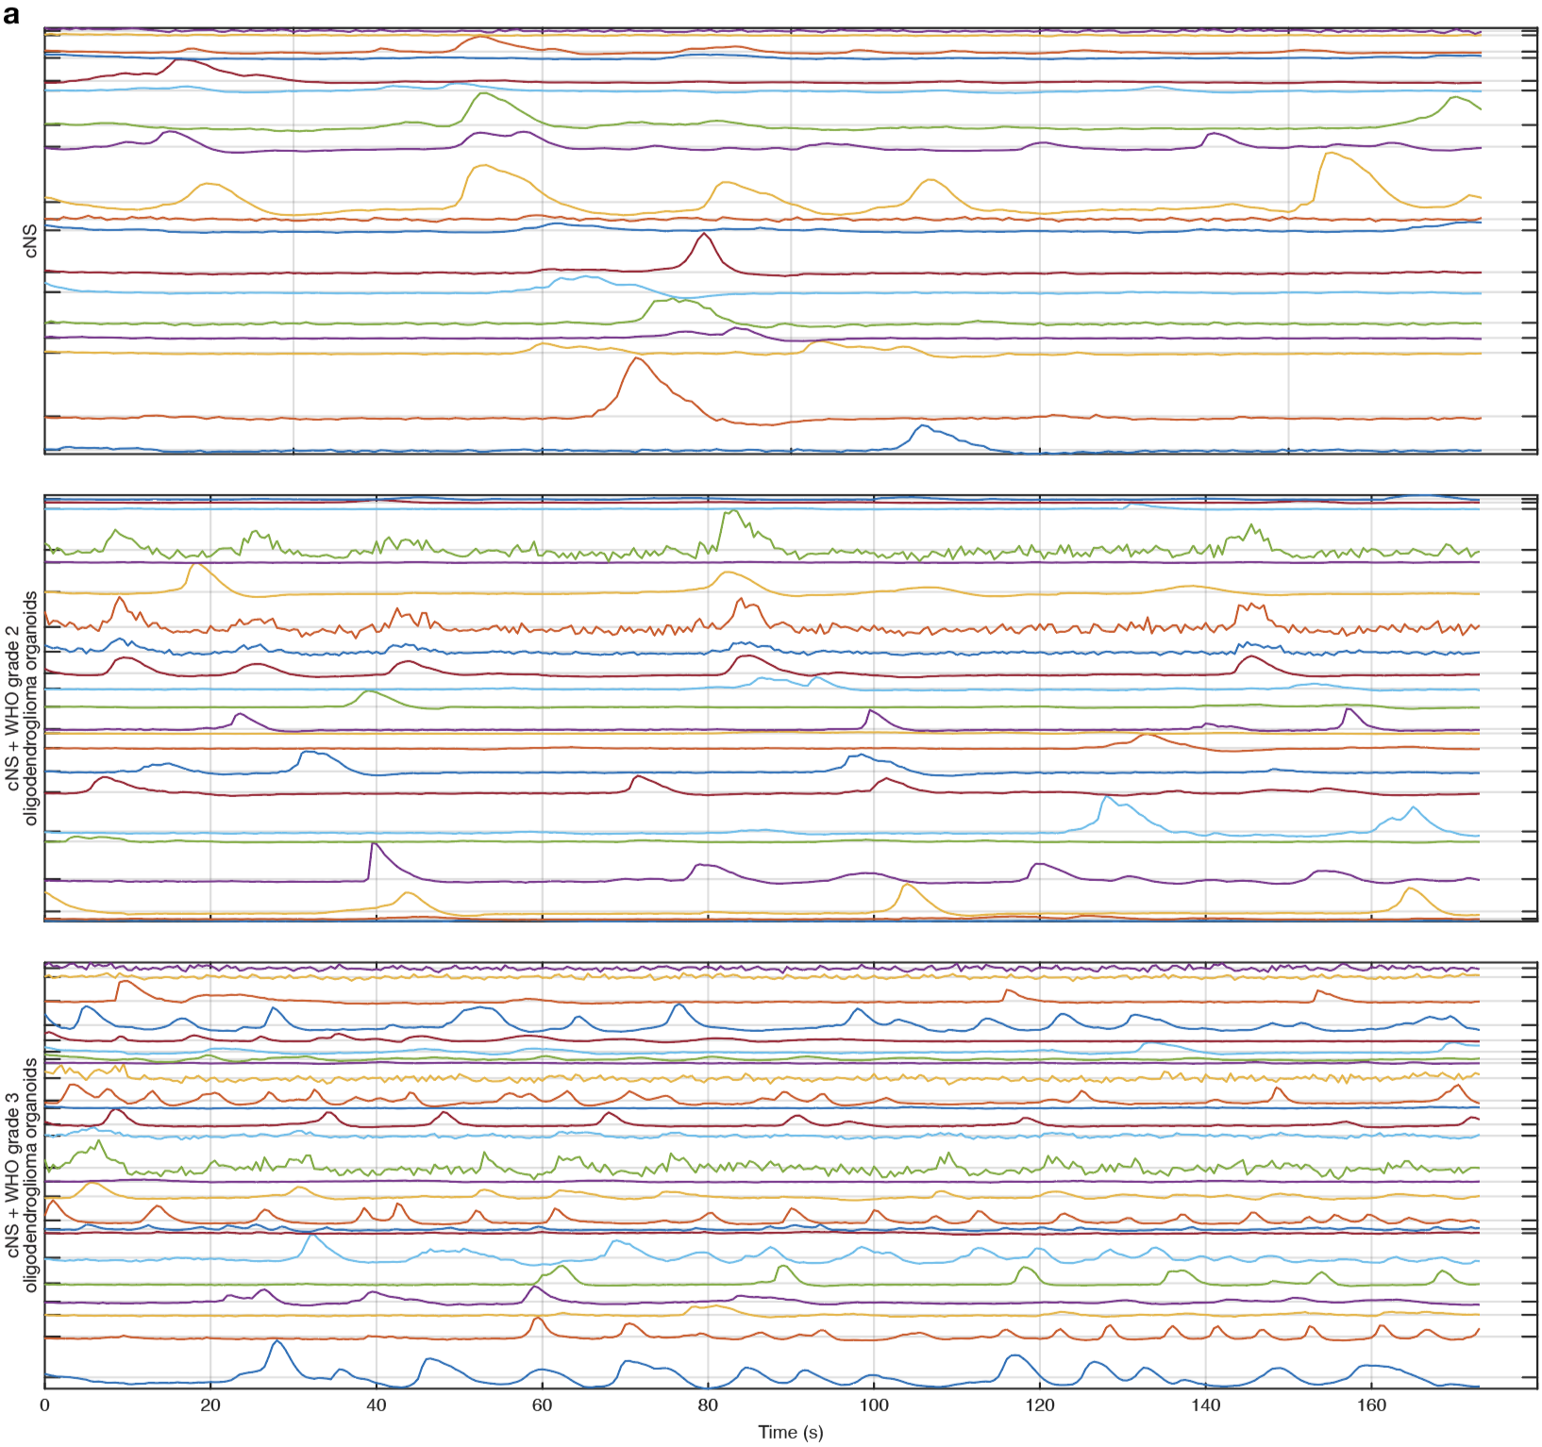Extended Data Fig. 10. Live-cell calcium imaging tracings from oligodendroglioma organoid and cortical neurosphere co-cultures. a, Example delta F/F₀ calcium traces of cortical neurospheres (cNS) alone or in co-culture with CNS WHO grade 2 or 3 patient-derived oligodendroglioma organoids (GliO) across 180 seconds. Each trace represents an individual cell.
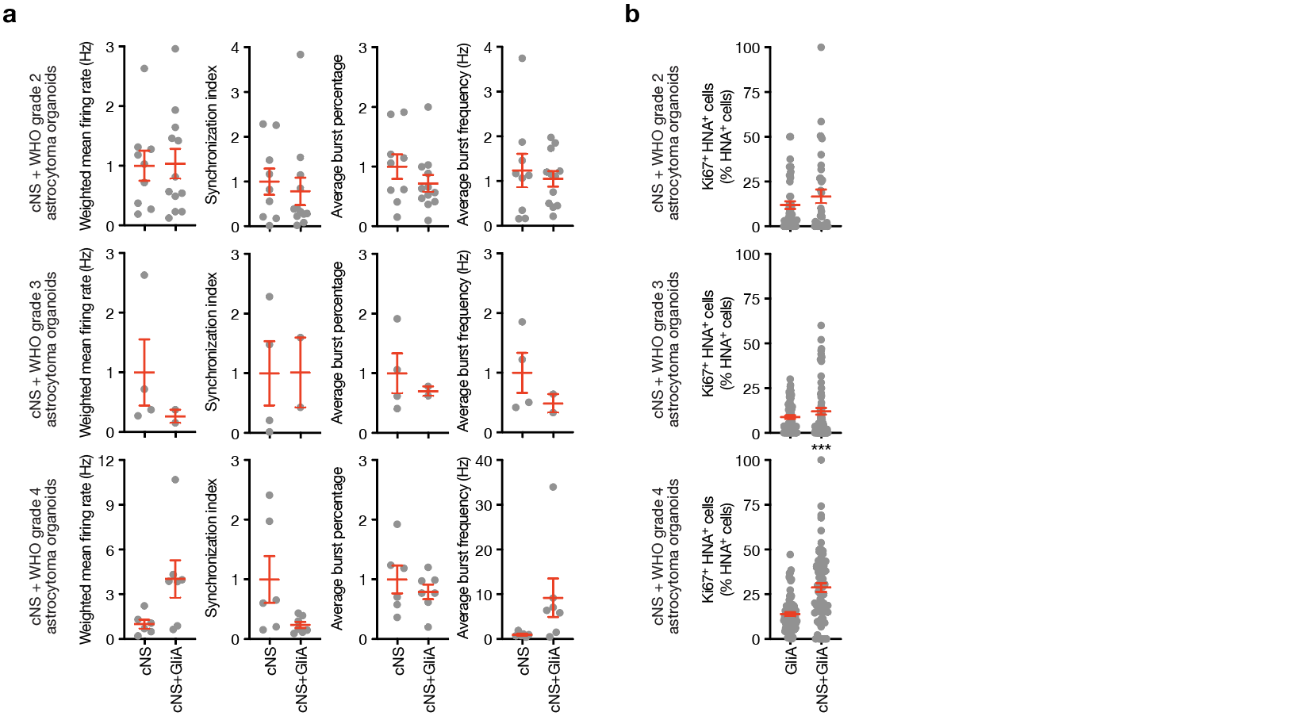Extended Data Fig. 11. Astrocytoma organoid and cortical neurosphere co-culture experiments. a, Quantification of weighted mean firing rate in Hertz (Hz), synchronization index, average burst percentage, and average burst frequency (Hz) from multielectrode array (MEA) cultures of cortical neurospheres (cNS) alone or co-cultured with CNS WHO grade 2, 3, or 4 astrocytoma patient-derived organoids (GliO). Top: n=9 cNS and n=13 cNS + CNS WHO grade 2 GliA co-cultures from three patients. Middle: n=5 cNS and n=2 cNS + CNS WHO grade 3 GliA co-cultures from one patient. Bottom: n=6 cNS and n=7 cNS + CNS WHO grade 4 GliA co-cultures from one patient. b, Quantification of double-positive Ki67⁺ HNA⁺ proliferating cells in GliA alone or in co-culture with cNS. Top: n=45 CNS WHO grade 2 GliA regions from two patients and n=36 patient-matched cNS + GliA regions. Middle: n=67 CNS WHO grade 3 GliA regions from three patients, n=69 patient-matched cNS + GliA regions. Bottom: n=81 CNS WHO grade 4 GliA regions from two patients, n=67 patient-matched cNS + GliA regions. Lines represent means and error bars represent the standard error of the means. Student’s t-tests, *p<0.05, **p<0.01, ***p<0.0001.

