Supplemental Figure 1. Depiction of alternative dimension reduced UMAP embeddings using Harmony (“HARMONY”; approach used in primary manuscript), Joint PCA (“JOINT”), canonical correlation analysis (“CCA”), and reciprocal PCA (“RCPA”) integration approaches. The left UMAP embedding for each integration approach is colorized by unsupervised clustering, as depicted in primary figure 1, and the right embedding is colorized by sample.

Supplemental Figure 2. Representative images illustrating bone marrow specimens at different stages of processing for single-cell transcriptomic analysis, along with flow cytometry gating used for sorting CD34⁺ cells. (a) Histologic evaluation of intact bone marrow tissue (Hematoxylin and Eosin stain, 200x magnification). (b) Cytologic assessment of bone marrow single-cell suspension prior to single-cell sequencing (Wright-Giemsa stain, 500x magnification). Red asterisks indicate early-stage erythroid precursors. (c) Cytologic appearance of sorted CD34+ cells utilized for single-cell sequencing (Wright-Giemsa stain, 500x magnification). (d) Flow cytometry gating strategy for isolation of CD34⁺ cells from whole bone marrow. The top row illustrates the gating workflow: first, doublets were removed using forward scatter area and height parameters. Next, viable cells were selected by excluding propidium iodide-positive events. All cells were then gated while removing debris based on light scatter properties. CD34+MHCII+/- cells (red) were positively selected for downstream analysis. The bottom row highlights the post-sort purity obtained.

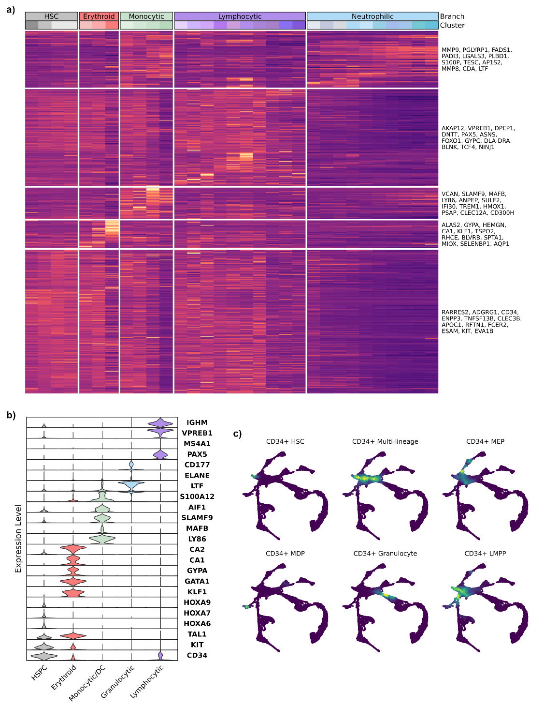
Supplemental Figure 3. Additional plotting associated with Primary Figure 1. (a) Heatmap depicting scaled gene expression of the features that define each of the cell type clusters. The top 12 features that were identified to define each major lineage are listed on the right. (b) Violin plots depicting log normalized expression of canonical markers used to classify hematopoietic stem and progenitor cells and the 4 major cell type lineages. (c) Feature plots depicting the module score enrichment for 6 different cell type gene signatures derived from human bone marrow single-cell RNA sequencing data.
Supplemental Figure 4. UMAP embeddings depicting pseudotime bins used for differential expression analysis and scatter plots log normalized gene expression counts over pseudotime for the (a) erythroid, (b) lymphocytic, and (d) granulocytic lineages. (c) Volcano plots depicting the results of differential expression analysis between common lymphoid progenitors (CLP) and all other cells (top) and between the two CLP subclusters (bottom).

Supplemental Figure 5. Additional plotting associated with Primary Figure 5. (a) UMAP embeddings depicting pseudotime bins used for differential expression analysis within the GMP-granulocytic/monocytic branch point. (b) Line plots depicting smoothed, scaled expression along pseudotime (rescaled to range from 0 [early] to 1 [late]) for early granulocytic-monocytic precursors (GMPs) to late granulocytic precursors (GP, blue) and late monocytic precursors (MP, green). (c) Feature plots depicting log normalized expression of features identified to have peak expression during the transition from GMP to monocytic (top row) or granulocytic (bottom row) lineages.

Supplemental Figure 6. (a) Example flow cytometry gating scheme used to identify granulocyte-monocyte progenitor (GMP; CD34⁺MPO⁺MHCII⁺/⁻CD4⁻ cells), early granulocyte progenitor (Early GP; CD34⁺MPO^{hi}CD4⁻MHCII⁻), late granulocyte progenitor (Late GP; CD34⁺MPO^{lo}CD4⁻MHCII⁻), and neutrophils (CD34⁻MPO^{lo}CD4⁺MHCII⁻). (b) UMAP embedding depicting the divisions of the single-cell RNA sequencing data to compare cell type protein and gene expression. (c) Scatter plot depicting correlation between relative granulocytic cell type abundances as determined by flow cytometry (y-axis) and scRNA-seq (x-axis). (d) Dotplot depicting average, scaled gene expression of features used to characterize granulocyte subtypes.

Supplemental Figure 7. (a) UMAP embeddings depicting pseudotime bins used for differential expression analysis in human (left) and canine (right) granulocytes. (b) Depiction of scaled expression over pseudotime for humans (blue) and dogs (red), as well as log normalized expression in the UMAP embeddings for conserved (CAMP, MMP8, LTF, CXCL8) features.

Supplemental Figure 8. Heatmap depicting smoothed (smoothing spline, df = 4), scaled gene expression of genes determined to be differentially expressed within the granulocytic lineage along pseudotime in either humans (left) or dogs (right). The heatmap depicts human-specific (top) and canine-specific (bottom) genes which were only differentially expressed along granulopoiesis in one of the respective species. Plotting on the right side of the heatmap depicts log normalized expression in UMAP embeddings for select human-specific (PDGFD, SGK1) and canine-specific (GZMB, LY9) features.

