Supplementary material

Table S1. Primers
Name | Sequence (5’-3’) | Target gene | NCBI access number: Region | Reference
GN282 | CAGCAGACGAACTTCCTG | khe | NZ_CP064352.1:c3786054-3785566 | This study
GN283 | CGAGGTTTACGTCTCAAC | khe | NZ_CP064352.1:c3786054-3785566 | This study
GN284 | TTCTCTGCCGTTTCCAA | uidA | CP062774.1:c2776873-2775060 | This study
GN285 | GCTGTCGGCTTTAACCTCT | uidA | CP062774.1:c2776873-2775060 | This study
GN286 | CGAGTGGCGGCATACATC | ehe | CP000653.1:296048-296305 | This study
GN287 | CGCTGGCTCGCAAAATGG | ehe | CP000653.1:296048-296305 | This study
GN315 | GTTGCTGACTCAAGGTCAT | wosA | CP068152.1:3414289-3415251 | This study
GN316 | AATCTAATGGGGGTAGCTC | wosA | CP068152.1:3414289-3415251 | This study
GN317 | GTACTTCGGCTAAGCACAG | pehS | CP056539.1:4185012-4186988 | This study
GN318 | GGTTACCTCATCGAACTGAC | pehS | CP056539.1:4185012-4186988 | This study
GN309 | TCGCCGCATACACTATTCTCAGAATGA | bla_{TEM} | AL513383 | [21]
GN310 | ACGCTCACCGGCTCCAGATTTAT | bla_{TEM} | AL513383 | [21]
GN311 | ATGTGCAGYACCAGTAARGTKATGGC | bla_{CTX-M} | X92506 | [21]
GN312 | TGGGTRAARTARGTSACCAGAAYCAGCGG | bla_{CTX-M} | X92506 | [21]
GN436 | TCGCTAAACTCGAACAGG | bla_{KPC} | AY034847 | [22]
GN437 | TTACTGCCCGTTGACGCCCAATCC | bla_{KPC} | AY034847 | [22]
GN438 | TTGGCCTTGCTGTCCTTG | bla_{NDM} | FN396876 | [22]
GN439 | ACACCAGTGACAATATCACCG | bla_{NDM} | FN396876 | [22]
GN440 | CTATTACTGGCAGGGATCG | bla_{GES} | AF156486 | [22]
GN441 | CCTCTCAATGGTGTGGGT | bla_{GES} | AF156486 | [22]
GN442 | TGTTTTTGGTGGCATCGAT | bla_{OXA-48} | AY236073 | [22]
GN443 | GTAAMRATGCTTGGTTCGC | bla_{OXA-48} | AY236073 | [22]
GN444 | GAGTGGCTTAATTCTCRATC | bla_{IMP} | AJ223604 | [22]
GN445 | AACTAYCCAATAYRTAAC | bla_{IMP} | AJ223604 | [22]
GN446 | GTTTGGTCGCATATCGCAAC | bla_{VIM} | AF317511 | [22]
GN447 | AATGCGCAGCACCAGGATAG | bla_{VIM} | AF317511 | [22]

Table S2. Mobile elements of Tn3-family
Mobile element | Synonym(s) | Transposon | Insertion sequence | Access number | TnpA subgroup | S-recombinase family | Y-recombinase family
Tn3 | TnSwi1, ISSwi1 |  |  | HM769901 | Tn3
ISXc5 | ISXc4, TnXc4 |  |  | Z73593 | Tn3
Tn6454 |  |  |  | CP062794 | Tn3
Tn917 |  |  |  | M11180 | Tn4430
Tn4430 |  |  |  | X07651 | Tn4430
Tn1546 |  |  |  | M97297 | Tn4430
ISSba14 | TnSba14 |  |  | NC_009052 | Tn21
Tn21 |  |  |  | AF071413 | Tn21
Tn4378 |  |  |  | X90708 | Tn21
Tn3434 |  |  |  | AY232820 | Tn163
Tn163 |  |  |  | L14931 | Tn163
ISVsa19 |  |  |  | NC_011314 | IS3000
IS3000 |  |  |  | AF174129 | IS3000
Tn4401b |  |  |  | KT378598 | IS3000
Tn4651 |  |  |  | NC_003350 | Tn4651
ISYps3 | TnYps3 |  |  | NC_011759 | Tn4651
IS882 |  |  |  | NC_005241 | IS1071
IS1071 |  |  |  | M65135 | IS1071
ISBmu13 | ISBusp1 |  |  | NC_007509 | IS1071
*Gray boxes indicate the classification of each mobile element.

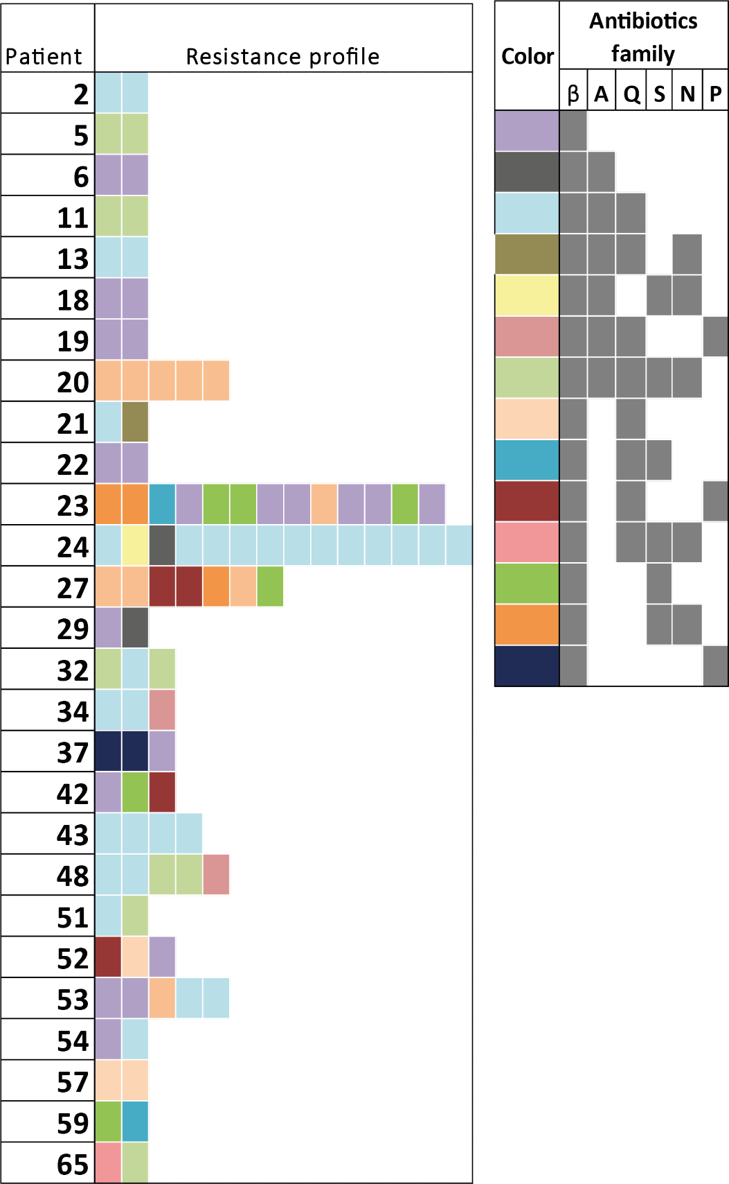

Figure S1. Antibiotic-resistant profiles of patients with multiples Klebsiella pneumoniae isolates harboring bla_{KPC} gene during 2014 to 2016. On the left side are the patient number with two or more KPC-Kp isolates, the colors rectangles indicate the family antibiotic-resistant profile of each isolate according to VITEK® 2 Advanced Expert System ™ results.
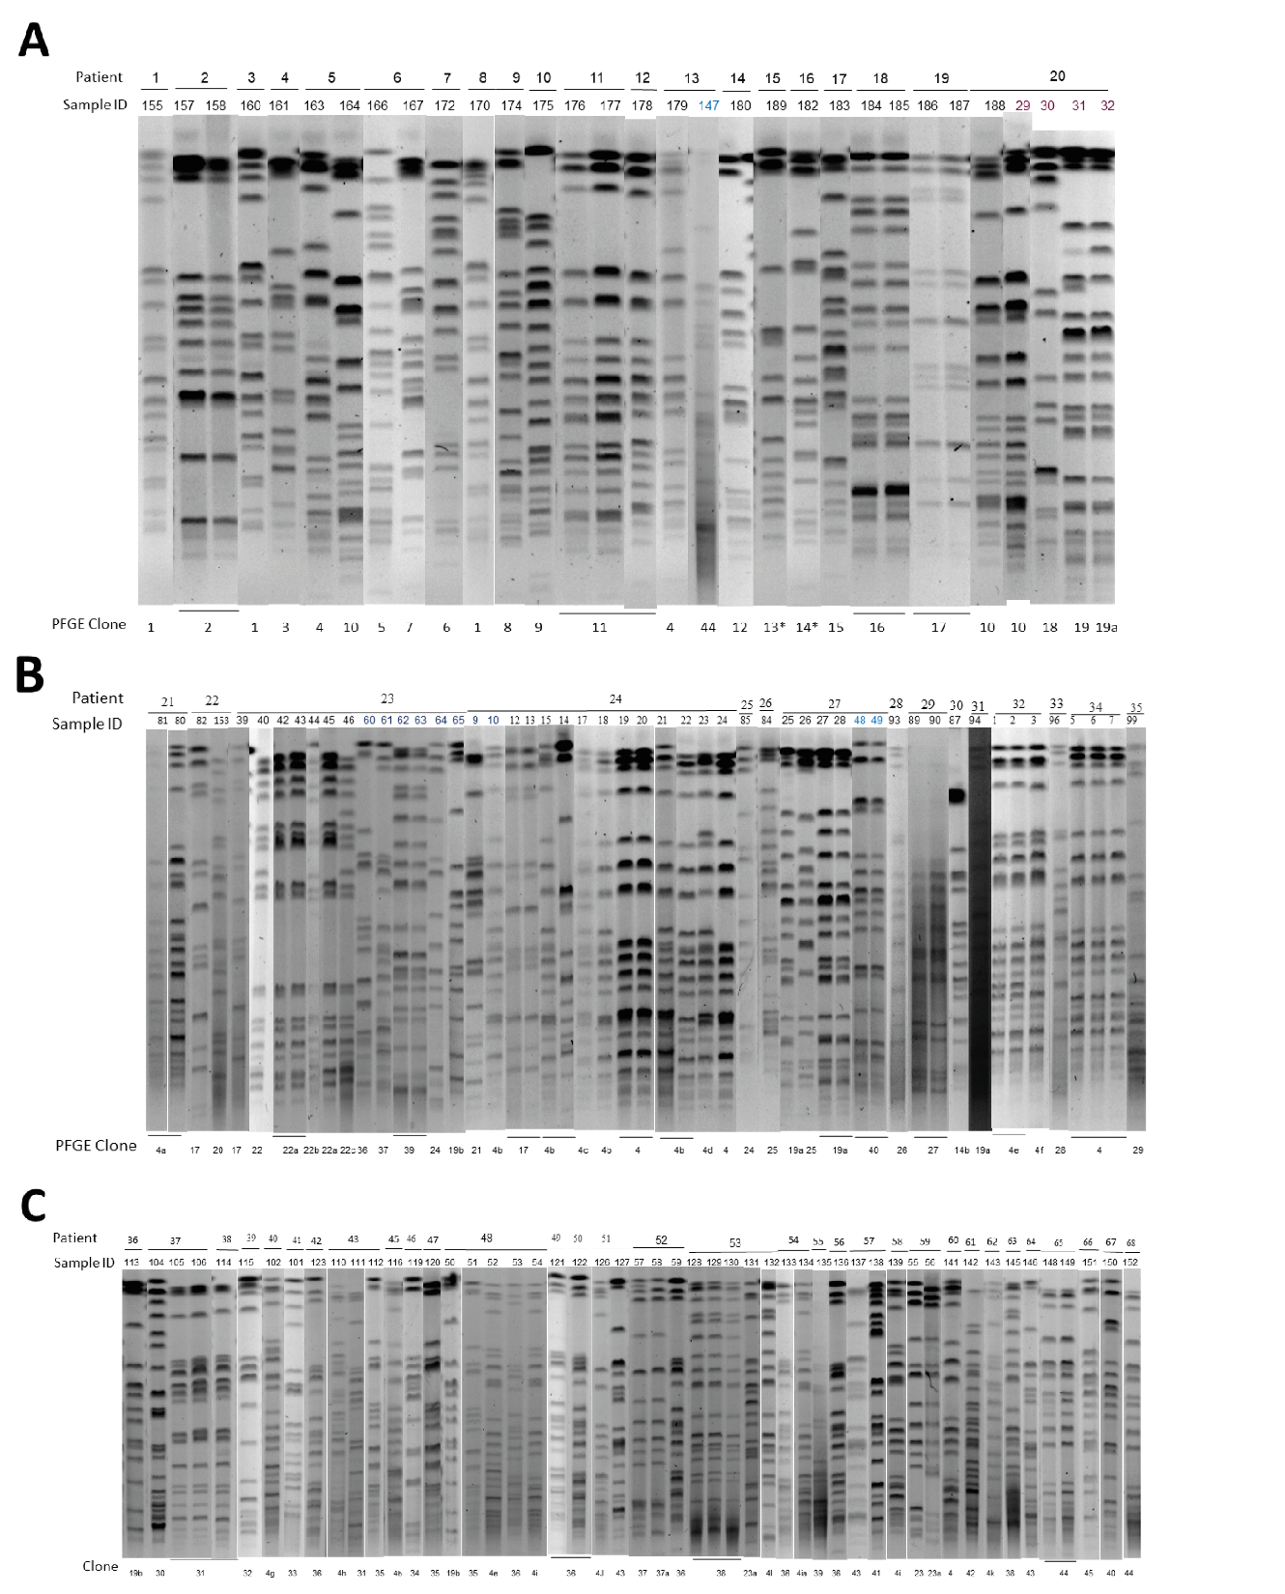
Figure S2. PFGE Clonal distribution by patient of the KPC-Kp isolates recovered in (A) 2014, (B) 2015 and (C) 2016. Each Pulsed-field gel electrophoresis (PFGE) pulsotypes was ordered by patient and date. The first line represents the patient number, second line the sample ID, third line the pulsotype and the last one the PFGE clone. The blue numbers in sample ID represent isolates from 2016 in patients with isolates from previous years.
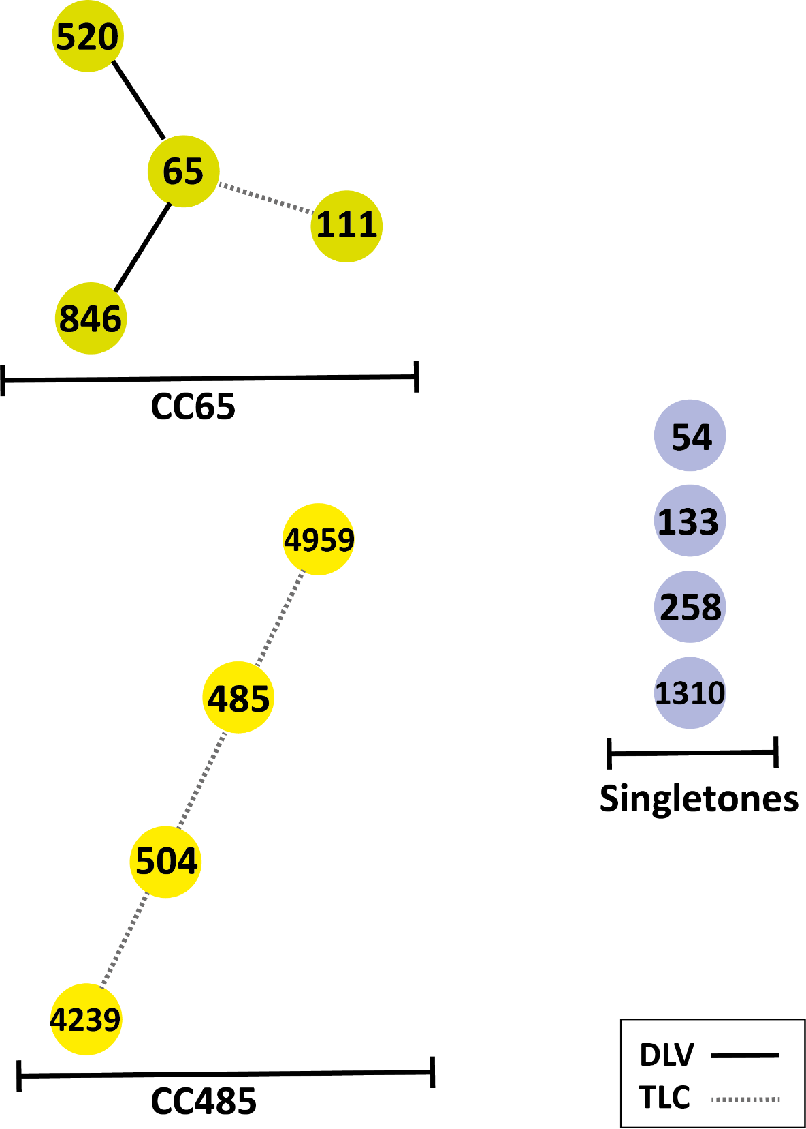
Figure S3. Clonal complexes and singletons of KPC-KP isolates. Each ST was illustrates on color circles, the clonal groups identified by goeBURST analyses had the same circle color, DLVs were grouped in a line and TLVs in a dotted line.
Table S3. Resistome of KPC-Kp clones and KPC-Kv isolate

Klebsiella specie | Isolate (ST) | Contig | DNA molecules | Length (bp) | Circular | Inc group | Resistance genes
K. pneumoniae | 33Kpn9 (846) | 33Kpn9 | Chromosome | 5,464,147 | Yes | - | fosA and oqxAB
K. pneumoniae | 33Kpn9 (846) | p33Kpn9-KPC | Plasmid | 132,884 | Yes | IncFII(K) | bla_{CTX-M}, bla_{OXA-1}, bla_{KPC-2}, aac(6 ')-Ib-cr, drfA14, tetA, and catB3
K. pneumoniae | 33Kpn9 (846) | p33Kpn9-2 | Plasmid | 124,915 | Yes | IncFIB(K) | None
K. pneumoniae | 33Kpn12 ST504) | 33Kpn12 | Chromosome | 5,285,656 | Yes | - | fosA and oqxAB
K. pneumoniae | 33Kpn12 ST504) | p33Kpn12-1 | Plasmid | 116,955 | Yes | IncN | bla_{TEM-1}, bla_{CTX-M-15}, aadA16, aph(6)-Id, aac(6 ')-Ib-cr, drfA27, sul1, sul2 and arr3
K. pneumoniae | 33Kpn12 ST504) | p33Kpn12-KPC | Plasmid | 15,946 | Yes | ColRNAI | bla_{TEM-1} and bla_{KPC-2}
K. pneumoniae | 33Kpn22(ST258) | 33Kpn22 | Chromosome | 5,501,536 | Yes | - | bla_{KPC-3}, fosA and oqxAB
K. pneumoniae | 33Kpn22(ST258) | p33Kpn22-1 | Plasmid | 196,777 | Yes | IncF | catA1
K. pneumoniae | 33Kpn22(ST258) | p33Kpn22-1 | Plasmid | 174,177 | Yes | - | None
K. pneumoniae | 33Kpn22(ST258) | p33Kpn22-1 | Plasmid | 107,862 | Yes | IncFII(Yp) | aac(6')-Ib (two copies) and aac(6')-Ib-cr (two copies)
K. pneumoniae | 33Kpn22(ST258) | p33Kpn22-KPC | Plasmid | 74,766 | Yes | (IncI2 (Δ) | bla_{TEM-1A} and bla_{KPC-3}
K. pneumoniae | 33Kpn22(ST258) | p33Kpn22-1 | Plasmid | 47,425 | Yes | IncR | aac(3)-IV, aac(6')-Ib, aadA1, aadA2b, aph(4)-Ia, cmlA1, aac(6')-Ib-cr and sul3
K. variicola | 33Kva16 (ST182) | 33Kva16-1 | Chromosome | 2,411,593 | No | - | oqxAB, fosA
K. variicola | 33Kva16 (ST182) | 33Kva16-2 | Chromosome | 1,313,960 | No | - | None
K. variicola | 33Kva16 (ST182) | 33Kva16-3 | Chromosome | 428,564 | No | - | bla_{LEN-16}
K. variicola | 33Kva16 (ST182) | 33Kva16-4 | Chromosome | 400,815 | No | - | None
K. variicola | 33Kva16 (ST182) | 33Kva16-5 | Chromosome | 375,057 | No | - | None
K. variicola | 33Kva16 (ST182) | 33Kva16-6 | Chromosome | 330,604 | No | - | None
K. variicola | 33Kva16 (ST182) | 33Kva16-7 | Chromosome | 155,149 | No | - | None
K. variicola | 33Kva16 (ST182) | p33Kva16-1 | Plasmid | 122,204 | Yes | IncFIB(K) | bla_{KPC-2,} aadA16, aac(6 ')-Ib-cr, qnrB6, sul1, drfA27, and arr3
K. variicola | 33Kva16 (ST182) | p33Kva16-KPC | Plasmid | 57,529 | Yes | IncN | None

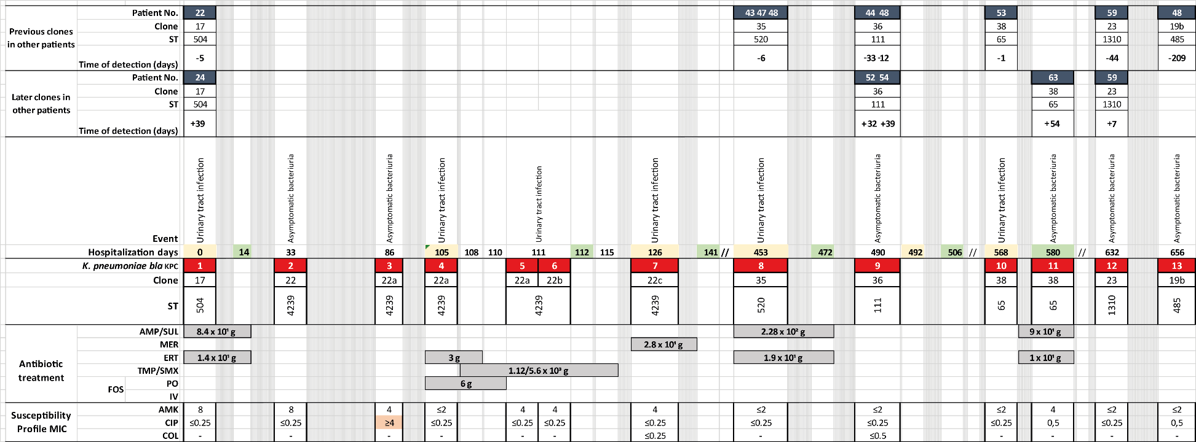
Figure S4. Analysis of the circulation dynamics of KPC-Kp clones of patient number 23 during antibiotic treatment in the hospital stay in 2015 and 2016. The graph illustrates to scale the timeline, highlight in yellow each admission of the patient to the institution and in green the discharges, with a description of the events associated with the KPC -Kp isolates, which are colored red, with their respective MLST. Regarding the susceptibility profile, only the antibiotics to which the isolates were susceptible were illustrated, within the boxes the value in white, and light red of the minimum inhibitory concentrations (MIC) corresponding to the range of the points of inhibition are described. CLSI cutoffs: susceptible, and resistant, respectively. The type of antibiotic used with the cumulative dose in grams and the days of duration of treatment are described in gray boxes. Finally, the time connection with other patients who presented the same clone and the number of days of difference are shown.
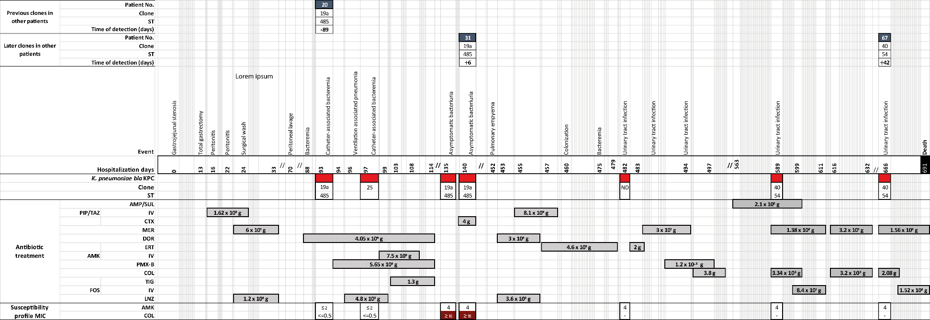

Figure S5. Analysis of the circulation dynamics of KPC-Kp clones of patient number 27 during antibiotic treatment in the hospital stay in 2015 and 2016. The graph illustrates to scale the timeline from the admission of the patient to the institution (day 0) until death (day 691), with a description of the events associated with the KPC -Kp isolates, which are colored red, with their respective MLST. Regarding the susceptibility profile, only the antibiotics to which the isolates were susceptible were illustrated, within the boxes the value in white, and red of the minimum inhibitory concentrations (MIC) corresponding to the range of the points of inhibition are described. CLSI cutoffs: susceptible, and resistant, respectively. The type of antibiotic used with the cumulative dose in grams and the days of duration of treatment are described in gray boxes. Finally, the time connection with other patients who presented the same clone and the number of days of difference are shown.

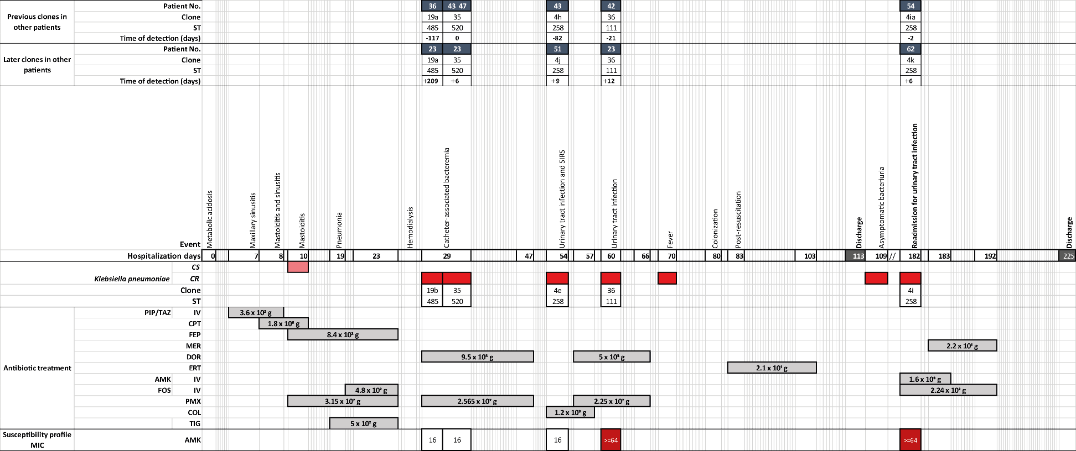
Figure S6. Analysis of the circulation dynamics of KPC-Kp clones of patient number 48 during antibiotic treatment in the hospital stay in 2016. The graph illustrates to scale the timeline, highlight admissions of the patient to the institution and discharges, with a description of the events associated with the KPC -Kp isolates, which are colored red, with their respective MLST. Regarding the susceptibility profile, only the antibiotics to which the isolates were susceptible were illustrated, within the boxes the value in white, and red of the minimum inhibitory concentrations (MIC) corresponding to the range of the points of inhibition are described. CLSI cutoffs: susceptible, and resistant, respectively. The type of antibiotic used with the cumulative dose in grams and the days of duration of treatment are described in gray boxes. Finally, the time connection with other patients who presented the same clone and the number of days of difference are shown.
Table S4. Comparison of the clinical characteristics of the patients who had ST258 isolates

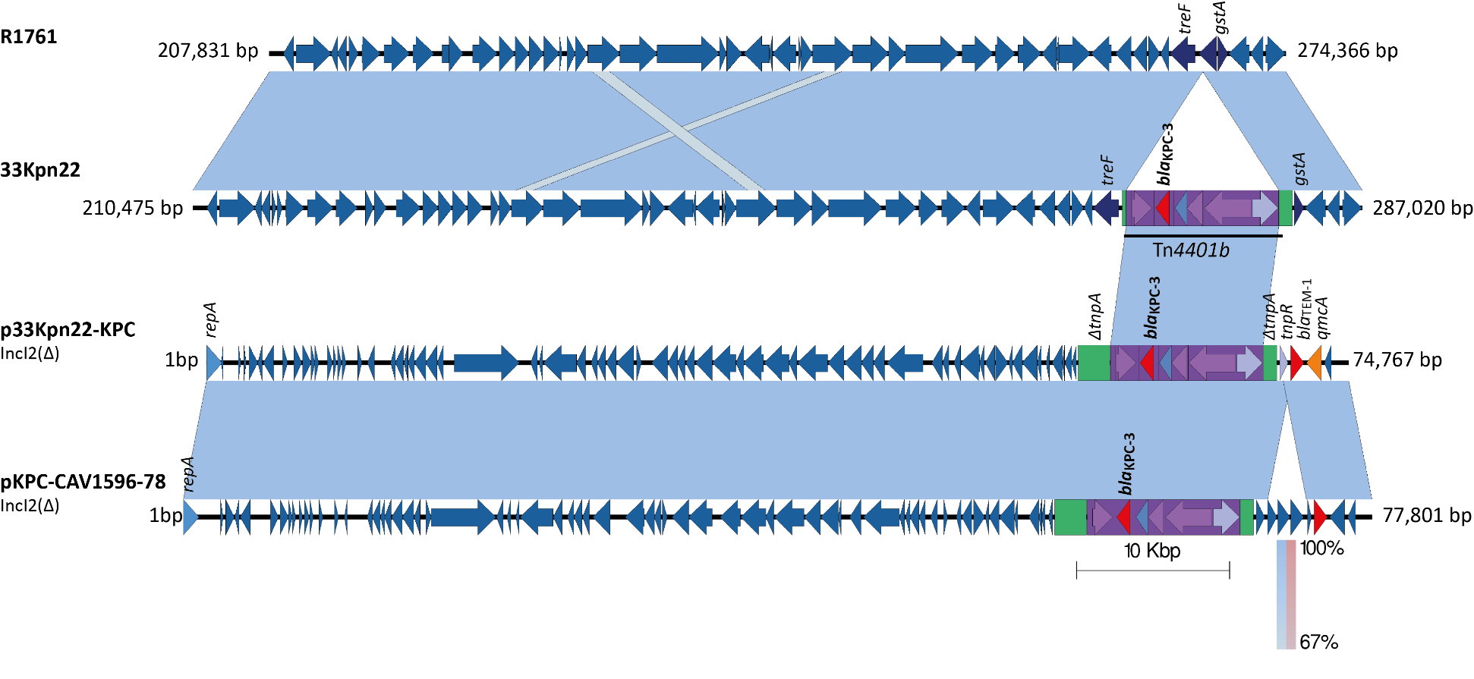
Figure S7. Insertion of the Tn4401b of the IncI2 (Δ) plasmid into the chromosome of Klebsiella pneumoniae 33Kpn22 isolate. The shaded area between the sequences delimits the alignment regions with a percentage identity ≥67%. The blue arrows indicate the open reading frames and, adjacent to the gene of interest, the coding regions for transposases (purple), resolvases (purple), resistance genes (red) are outlined in a purple rectangle to the transposons. The duplication sites (TSDs) generated by the transposition were illustrated and delimited in dotted lines for each mobile genetic element. The graph has a scale line of 10,000 bp.

