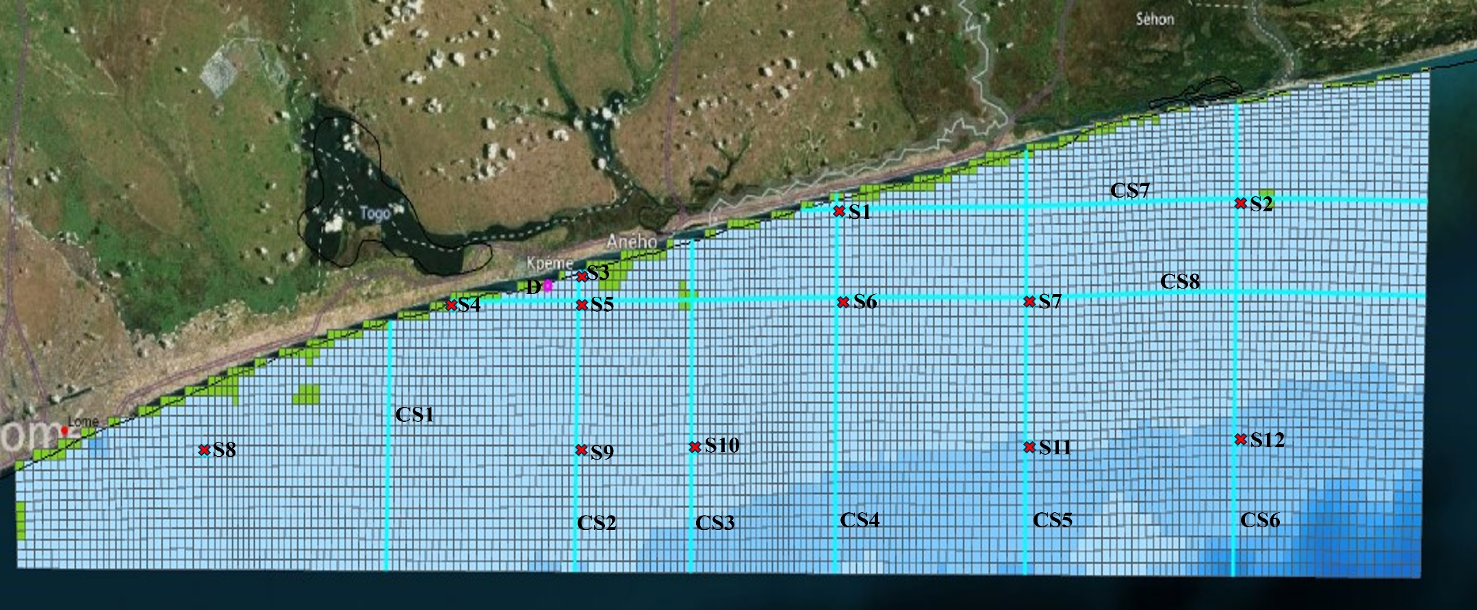
Fig. 33 Observation Station Locations, Cross-Section, and discharge point for the two extensive seasons studied

