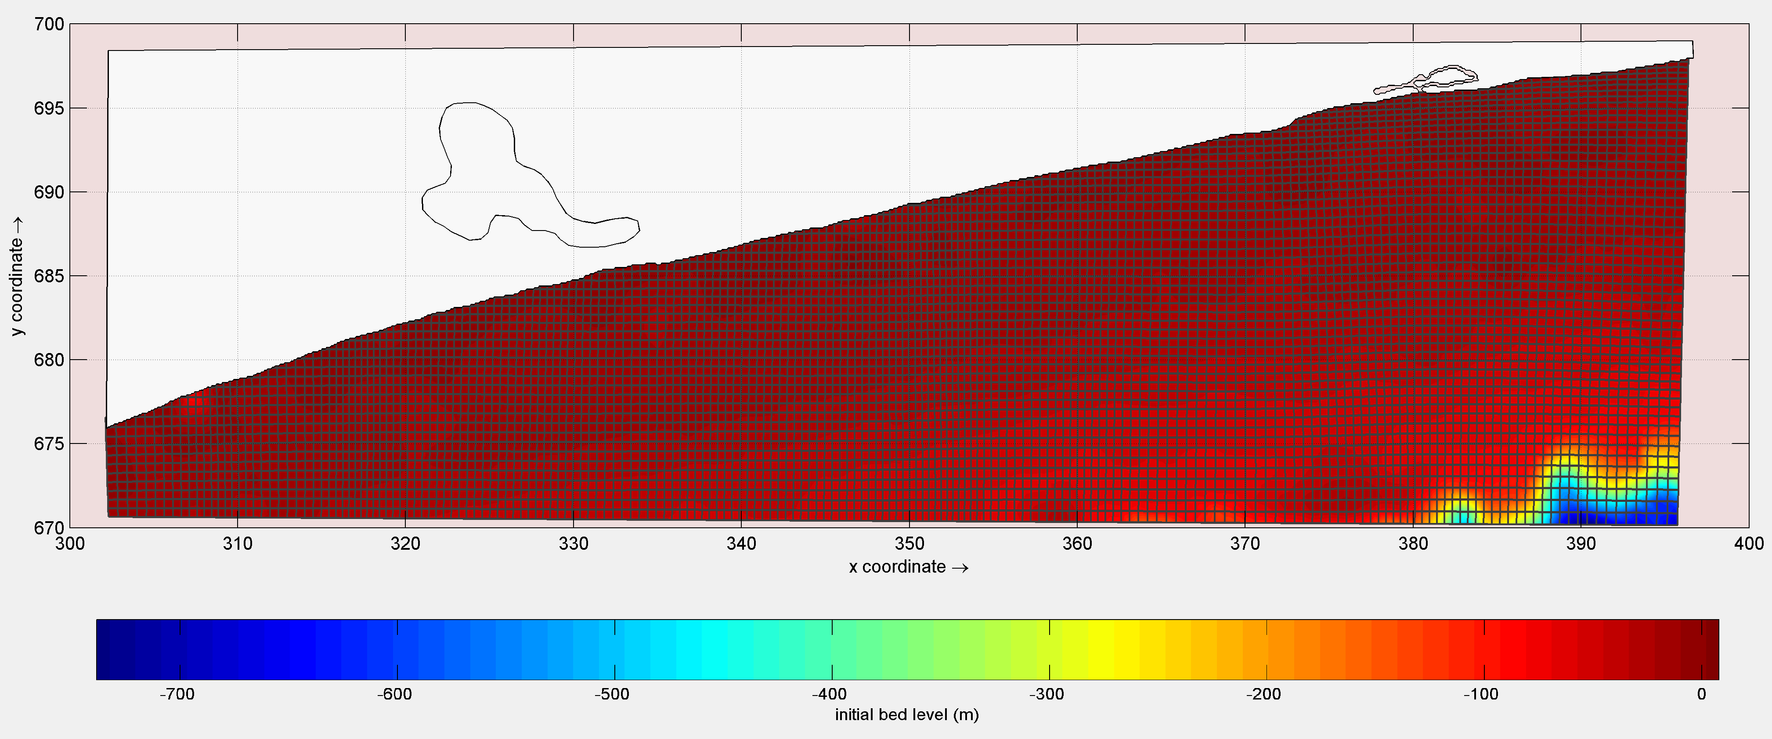
Fig. 31 Mesh configuration and bathymetry of the model for the extended warm season

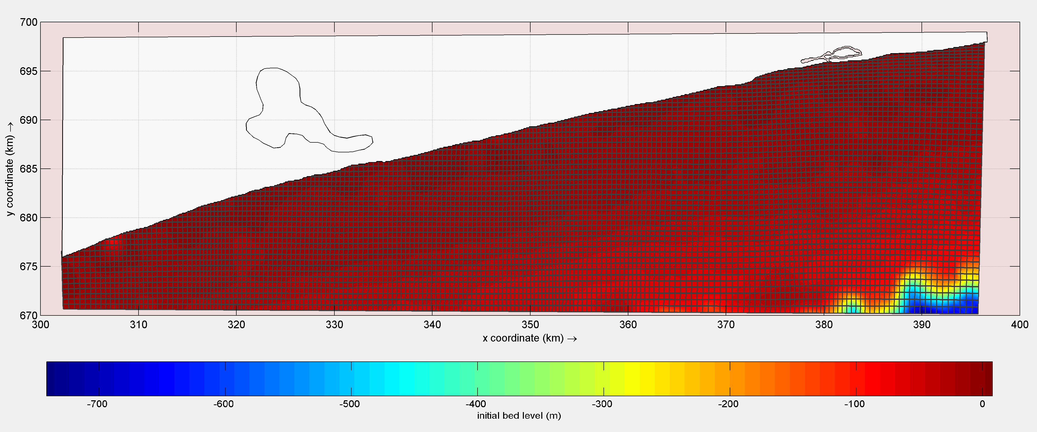
Fig. 32 Mesh configuration and bathymetry of the model for the extensive cold season

