Supplementary Information

Results

Optical genome mapping (OGM)
Optical genome mapping showed changes in various regions of the q12 arm of chromosome 19 (Table 1). OGM in the region spanning 27,904,110-31,334,862 showed that at least one uninterrupted copy of every gene existed. This region encodes genes AC005394.2, UQCRFS1, POP4, C19orf12 and CCNE1. Genomic segments 5 and 6, spanning genes URI1 and ZNF536, were found to be inverted and duplicated and deleted, respectively. Finally, genomic segment 10 encodes TSHZ3 and is deleted. While URI1 has no clear disease association, both ZNF536 and TSHZ3 have been implicated in autism spectrum disorder.

Methods

Imaging

Plates were imaged using the Opera Phenix at 20x magnification with 5 vertical Z-stacks 1um apart to capture both neurites and cell body clusters. Images were analyzed using Perkin Elmer Harmony software to determine live/dead status and confirm neuronal classification. Analysis was based on manual training of an integrated mask program to detect differences between live and dead cells, as well as neuronal or neural precursor cells. Metrics trained for included nuclear size, nuclear roundness and intensity of both DAPI and NeuO fluorescence.

DRUG-seq

Similarity assessment of DMSO wells
To assess similarity of a DMSO well to all the other wells a sequence of Bray Curtis similarity scores were generated for all possible pairs of the well with other wells. Bray Curtis similarity was calculated based on per-gene TPM for both wells. Prior to similarity score calculation, any genes that were expressed in less than 50% of all wells were removed. Similarity score calculation using gene-level TPM was weighted by the fraction of wells the gene was expressed in (Fig S2A).
Using all pairwise similarity, an average similarity score for each well was then calculated using the mean of its similarities to all possible wells. The process was repeated for all available wells and the distribution of similarity scores was used to fit a Gaussian curve. Wells with average similarity scores greater than two standard deviations from the mean of the Gaussian distribution were removed (Fig S2B).

Detection and removal of sparse genes
For each compound/concentration - DMSO pair used for differential expression analysis, a sparsity metric was defined for each gene. The sparsity was calculated as the fraction of wells in which the gene was not detected. The sparsity for each gene follows a trimodal distribution (Figure S3).
A Gaussian mixture model was used to fit the distribution using a mixture of 3 separate Gaussian functions. Genes with a sparsity greater than the mean + standard deviation of the middle Gaussian were removed.

Figures

Figure S1
(A-D) Stepwise analysis of randomly selected vehicle control well section using PerkinElmer Harmony Image Analysis Software; comparison of vehicle control cells to compound treated cells. (A) Live cell imaging of control well demonstrating characteristic staining of nuclei with DAPI (blue) and neurites with NeuO (green) staining at 20x magnification. (B) Live/Dead cell mask trained manually to identify nuclei of live and dead cells using metrics such as nuclear roundness, fluorescence intensity and nuclear area using 5 randomly selected well regions. Color is an artificial mask overlay added post imaging by Harmony software. Nuclei highlighted in green have been identified as live, red identified as dead. Live Cell Fraction (LCF) determined by calculating fraction of live to dead cells as identified by Live/Dead cell mask. (C-D) Randomly selected vehicle control well section (C) and compound treated well (D) showing live neuron staining of nuclei with DAPI (blue) and neurites with NeuO (green) at 20x magnification.
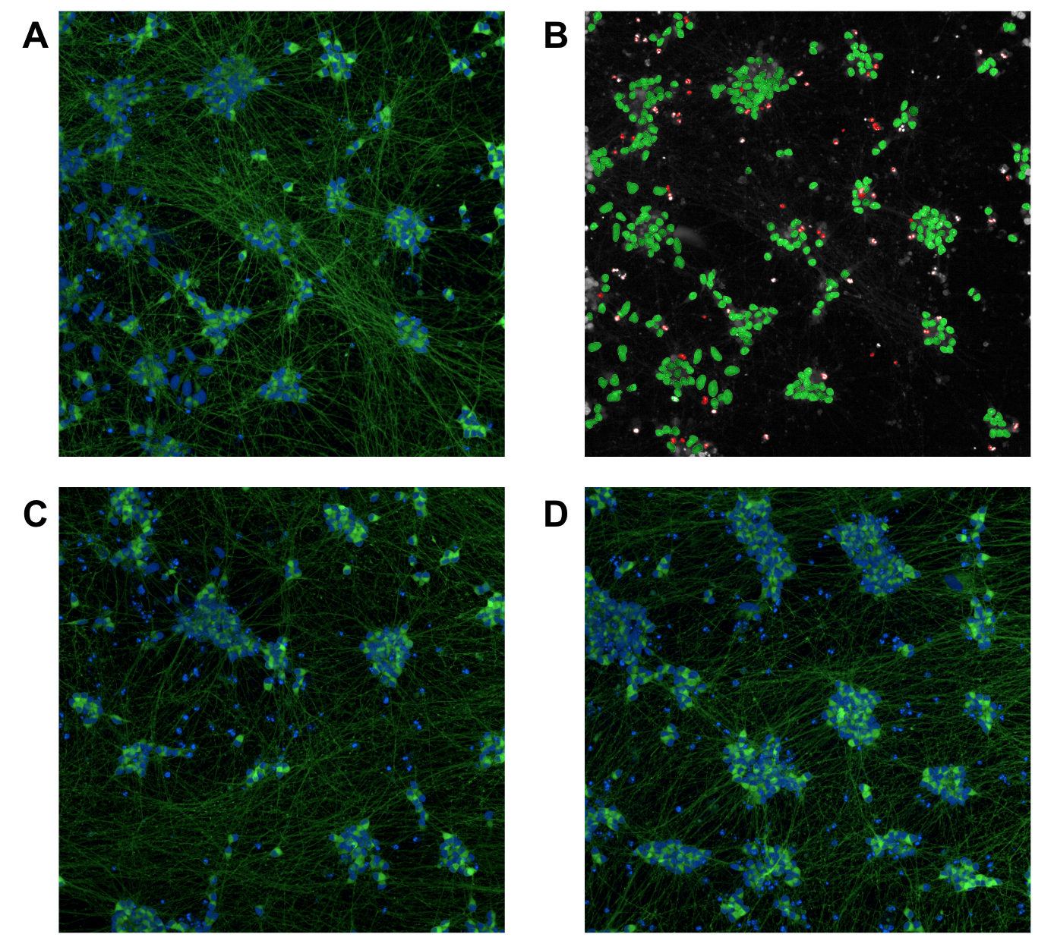

Figure S2
(A) Heatmap showing the Bray-Curtis dissimilarity score of all pairwise well combinations for DMSO treated wells. (B) Kernel density estimation of all mean Bray-Curtis dissimilarity score for each well. Scores closer to 1 signify wells that are more dissimilar to the other DMSO control wells for the batch. Dashed black line shows two standard deviations from the mean of the Gaussian distribution fit used as a cutoff to identify the most similar DMSO wells (mean = 0.229, deviation = 0.014). A total of 24 wells pass having mean Bray-Curtis dissimilarity score < cutoff. Orange line shows the Gaussian fit to the distribution.
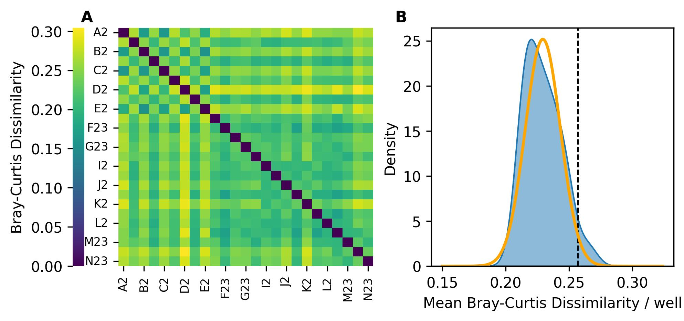

Figure S3
An example histogram showing the distribution of genes as a function of sparsity (Fraction of wells where the gene was undetected) for a single compound/concentration and DMSO pair. The distribution of genes follows a trimodal distribution. A Gaussian mixture of 3 separate Gaussian functions was used to fit the distribution. The leftmost Gaussian fit explains genes with very low sparsity (green curve), i.e. genes that are consistently expressed across all wells. The rightmost Gaussian fit explains genes with very high sparsity (red curve), i.e. genes that are sparsely expressed across the wells. The middle magenta curve represents genes with sparsity between 0.1-0.9. The cutoff (black dashed line) for sparsity is calculated as the mean + standard deviation of the magenta Gaussian function. Genes with sparsity > cutoff are removed from DEA. ~15000 out of a total ~25000 detected genes passed the cutoff.
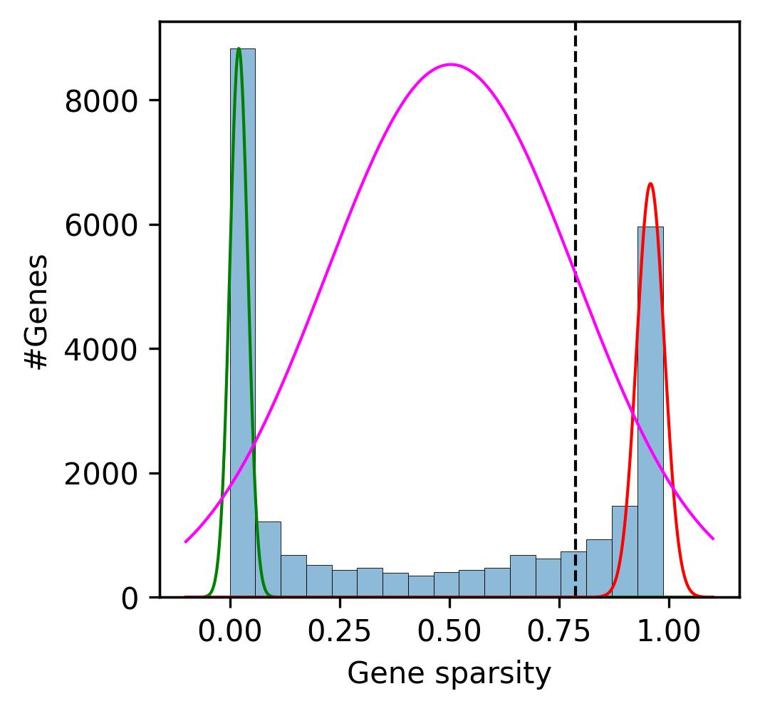

Figure S4
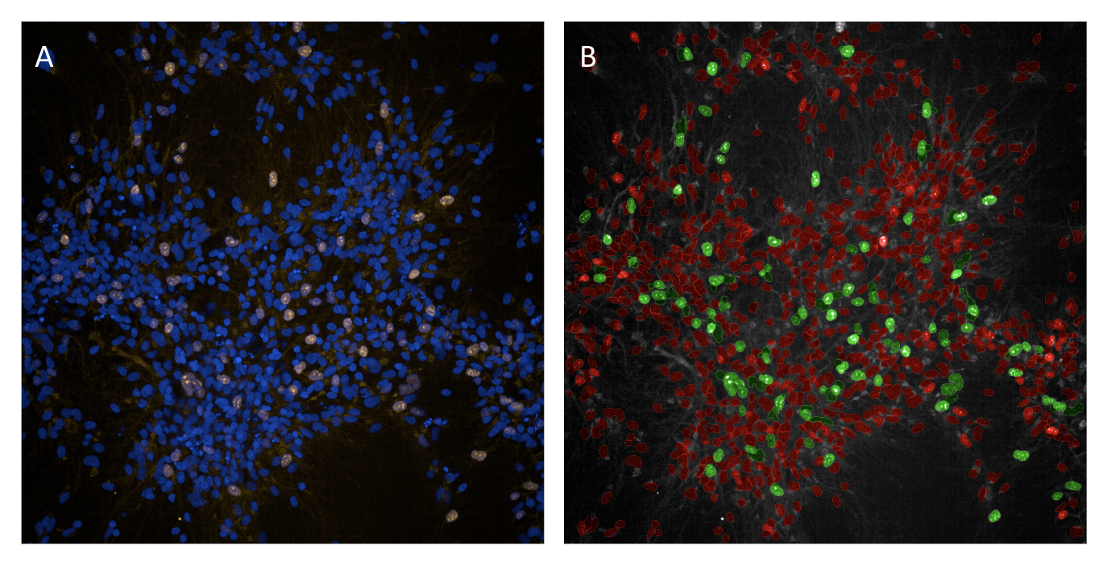
(A) Immunocytochemistry (ICC) image from PerkinElmer Opera Phenix illustrating DAPI-stained nuclei (blue), overlaid with Ki-67 stain (yellow). Ki-67+ nuclei show yellow overlay, contrasting with Ki-67- nuclei, which only show DAPI staining and retain the blue color. Ki-67+ nuclei represent nuclei still capable of undergoing proliferation. The ratio of Ki-67+ to Ki-67- nuclei in a given cell population decreases as Neuron Progenitor Cells (NPCs) undergo neuronal maturation. (B) Manually trained mask in PerkinElmer Harmony image analysis software allows for the distinction between two populations, in this case Ki-67+ and Ki-67- nuclei. Nuclei that only retain the DAPI stain are marked in red as Ki67- nuclei, while nuclei that are Ki-67+ are highlighted in green. Measurements such as fluorescence intensity of both DAPI and Ki-67 are used to train the mask. Adjustments have been made to the mask sensitivity to ensure the most accurate readout of Ki-67- and Ki-67+ nuclei, though some variability is noted. This variability is accounted for by analyzing multiple randomly selected distinct areas (images above are one distinct area within a well) of each well before determining the mean Ki-67+ population for each well, normalized to the number of total live nuclei per well.

Figure S5
Heatmaps showing normalized enrichment score of additional neurogenesis pathways in patient-derived vs. a parental control line as a function of neuron maturation stage (iPSC, NPC, day 7, day 14 and day 20 neurons). Inset numbers show magnitude of normalized enrichment score). Redder and greener colors show lower and higher activity, respectively, in patient-derived compared to a parental control line. The combined p-value for each pathway across the timepoints was calculated using the Fisher Test and all pathways were significant (p-value < 0.05).

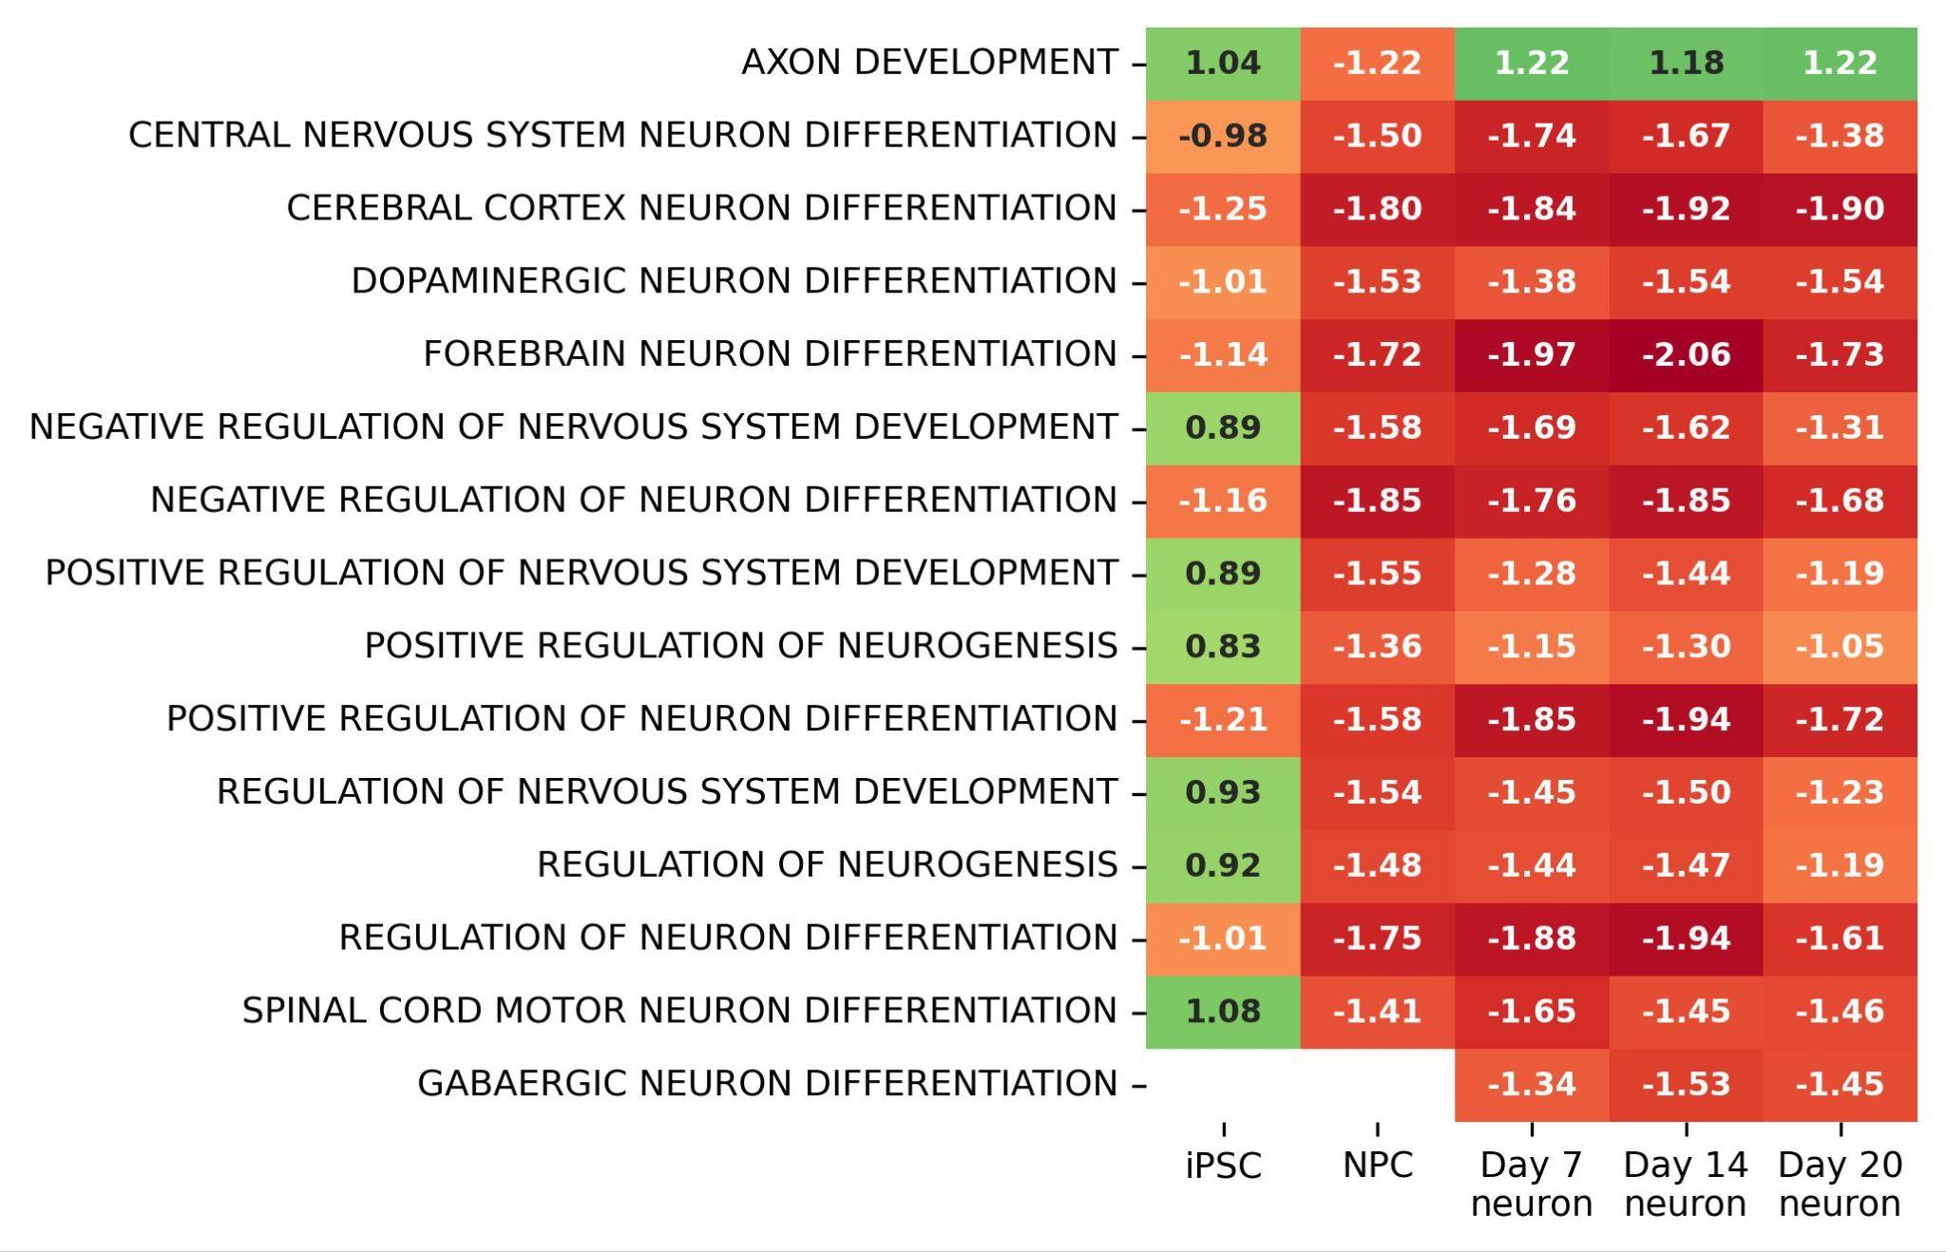

Figure S6
Volcano plots showing regulation of key genes in disease signature pathways in patient-derived (A) iPSC cells (B) day 7 and (C) day 14 neurons compared to a parental control line. Purple and orange points show non-significant and significant fold changes, respectively.
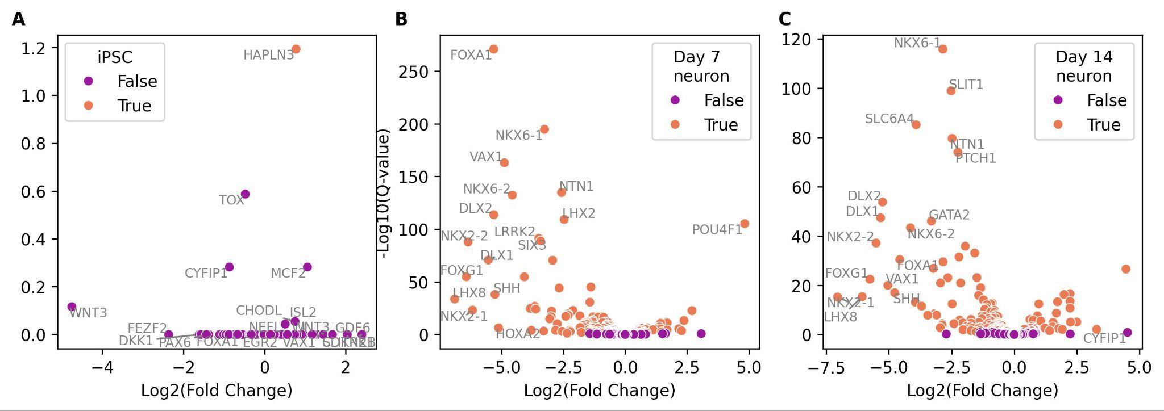

Figure S7
Regulation of relevant pathway sets associated with disease signature and neuronal phenotype of 19q12 autism spectrum disorder as a function of neuron maturation stage. Inset numbers show the magnitude of regulation. Redder and greener colors show lower and higher activity, respectively, in patient-derived compared to a parental control line for (A) neurotransmitter export and trafficking associated with key glutamatergic marker gene SLC17A6 and (B) synapse transmission and organization. A combined p-value for each pathway across timepoints was calculated using the Fisher Test for the individual p-values. Pathways associated with SLC17A6 and synapse transmission all have p-values < 0.05.
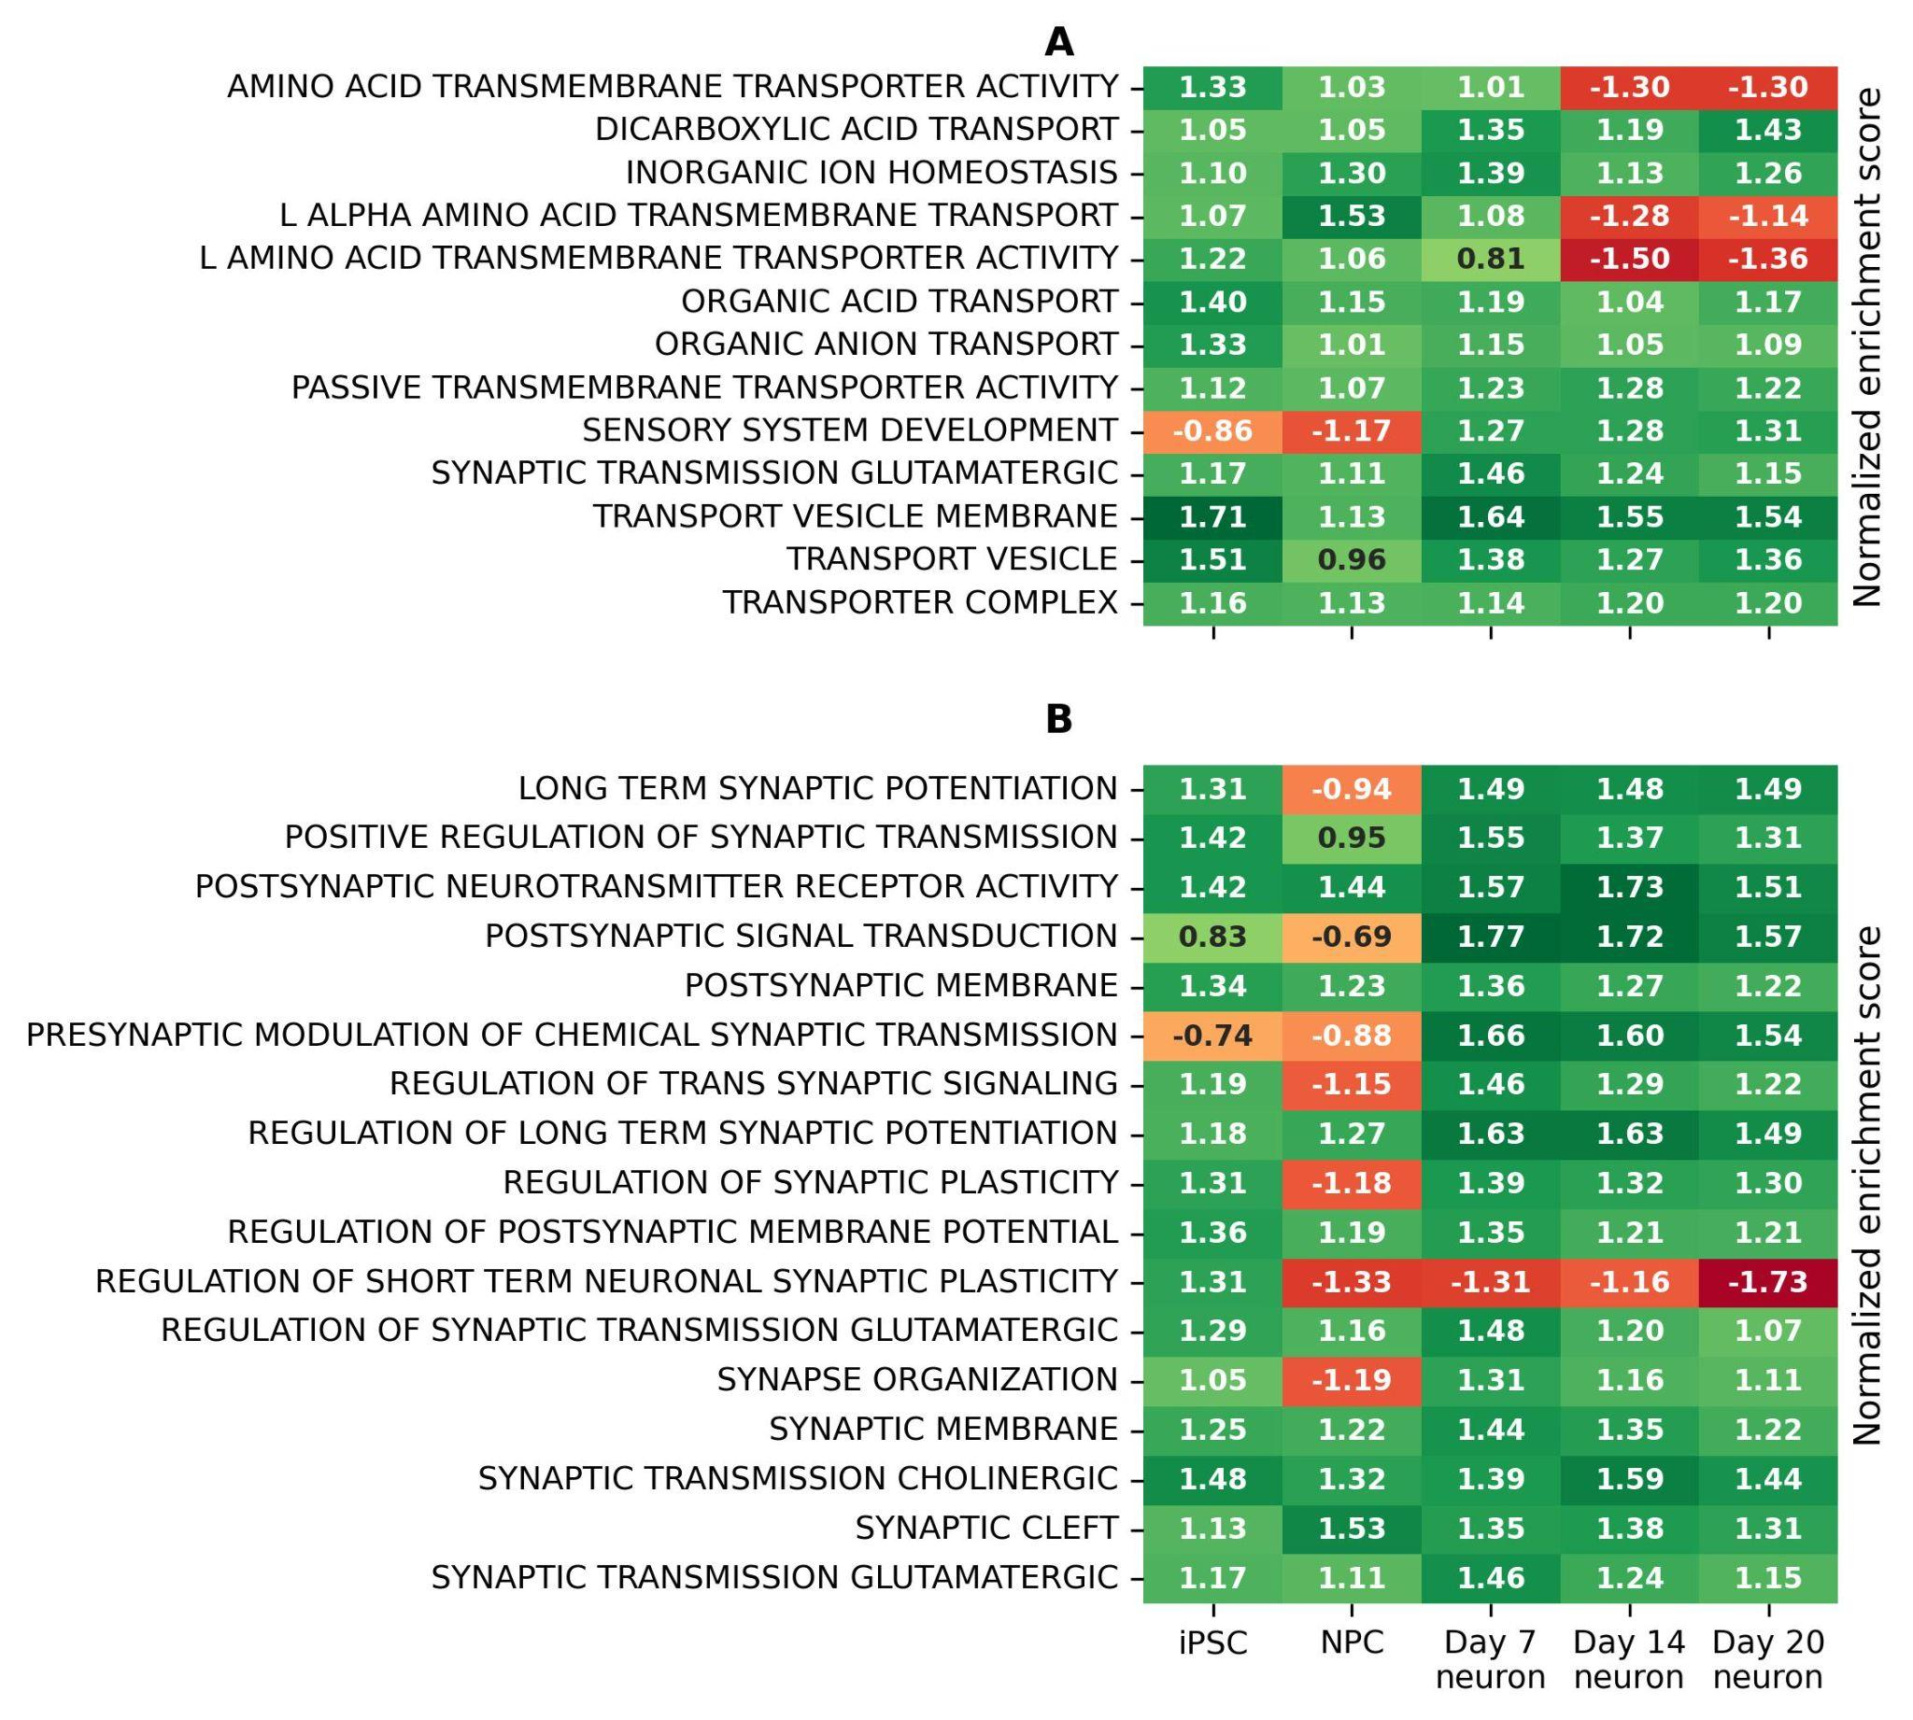

Figure S8
Cytotoxicity profile of Entrectinib in NGN2-derived neurons as a function of compound concentration measured using (A) %dead cells via the lactate dehydrogenase (LDH) assay and (B) live cell fraction using high-content imaging. Dashed line shows baseline values for DMSO-vehicle control treated cells.
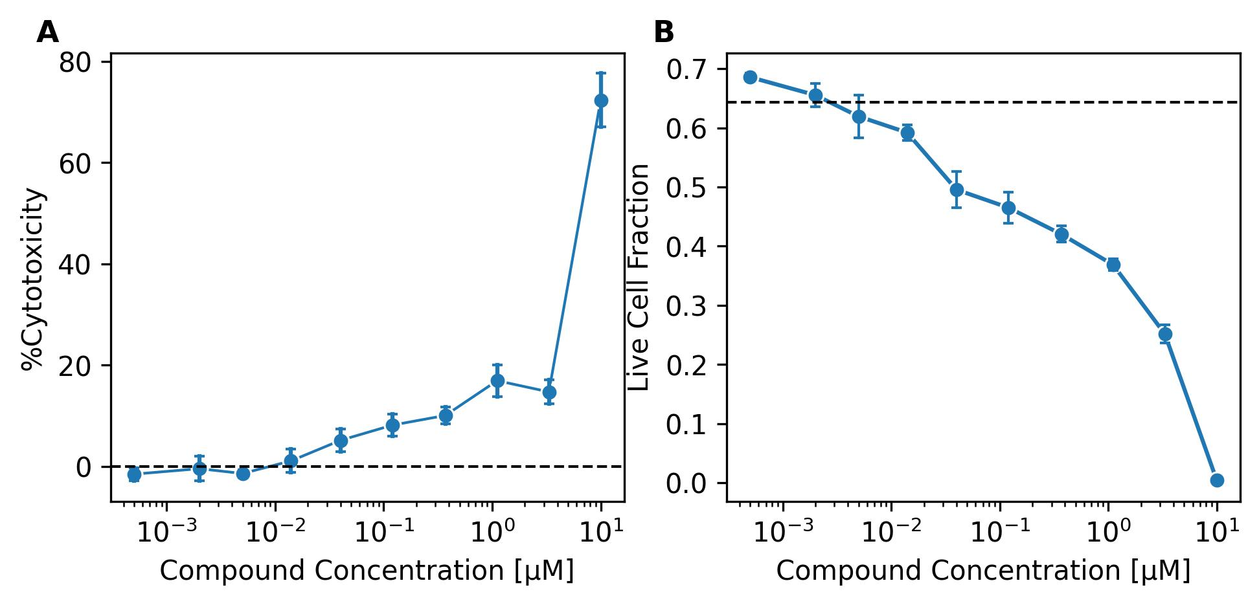

Figure S9
Cosine correlation coefficient calculated using the normalized enrichment scores of signature pathways in table 1 between patient-derived day 20 neurons compared to a parental control line and NGN2-derived neurons treated with Entrectinib compared to DMSO vehicle control. Negative correlations imply reversal of disease signature.
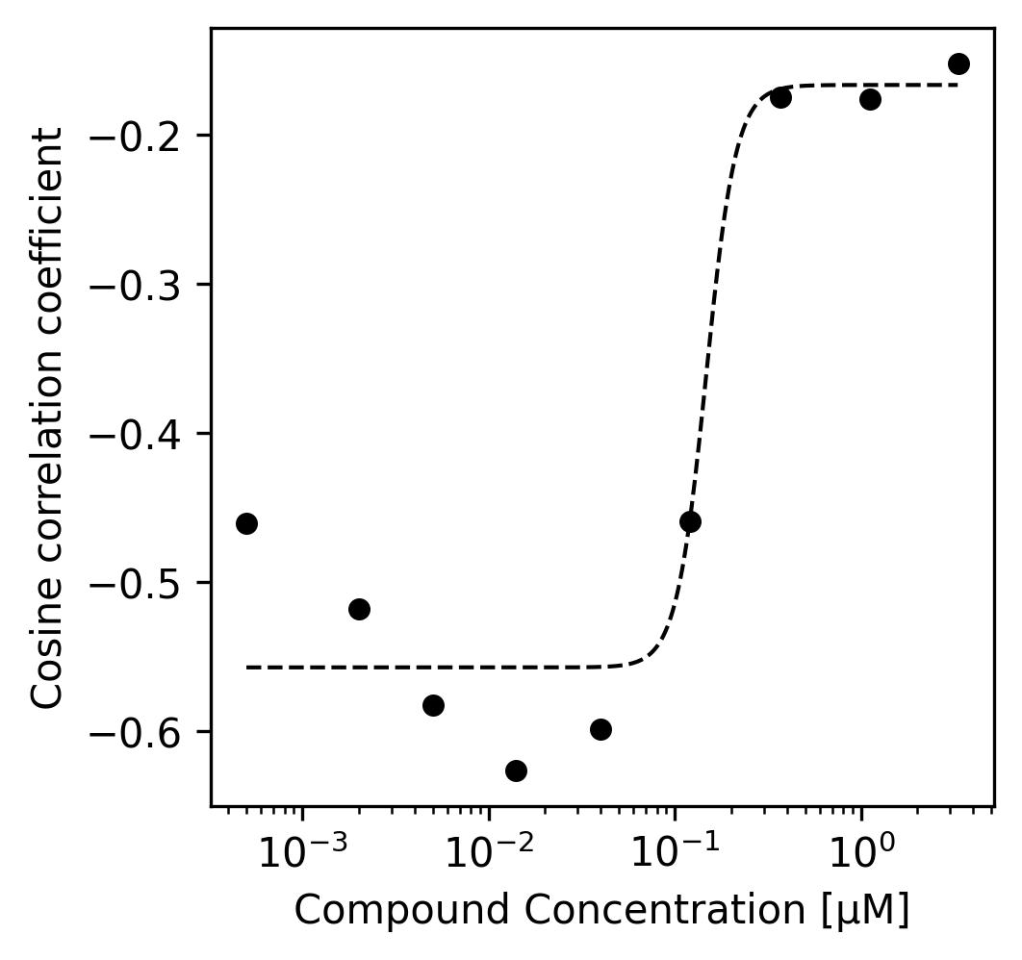

Figure S10
Heatmaps showing normalized enrichment score of (A) neurotransmitter transport and (B) Synaptic transmission/plasticity as a function of compound concentration in nM measured using DRUG-seq. Inset numbers show the magnitude of enrichment scores. Redder and greener colors show lower and higher activity, respectively, in Entrectinib treated vs. DMSO-vehicle control treated NGN2-derived neurons.
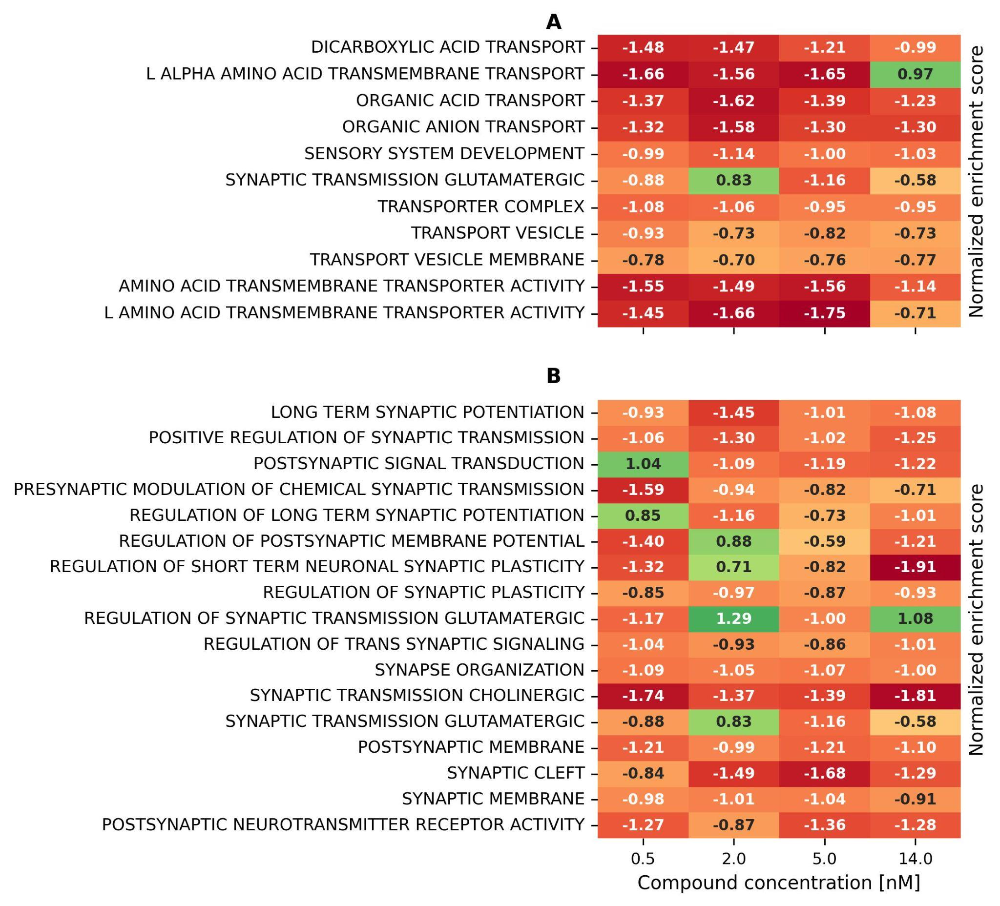

Figure S11
Activity of AMPA receptor signaling pathways (A-B) and BDNF-TrkB signaling pathways (C-D) from (A, C) patient pre-treated whole blood compared to a sibling control, (B, D) 3 (purple) and 6 month post-treatment with Entrectinib compared to a pre-treated control. Hatched and solid lines are non-significant and significant enrichment scores, respectively.
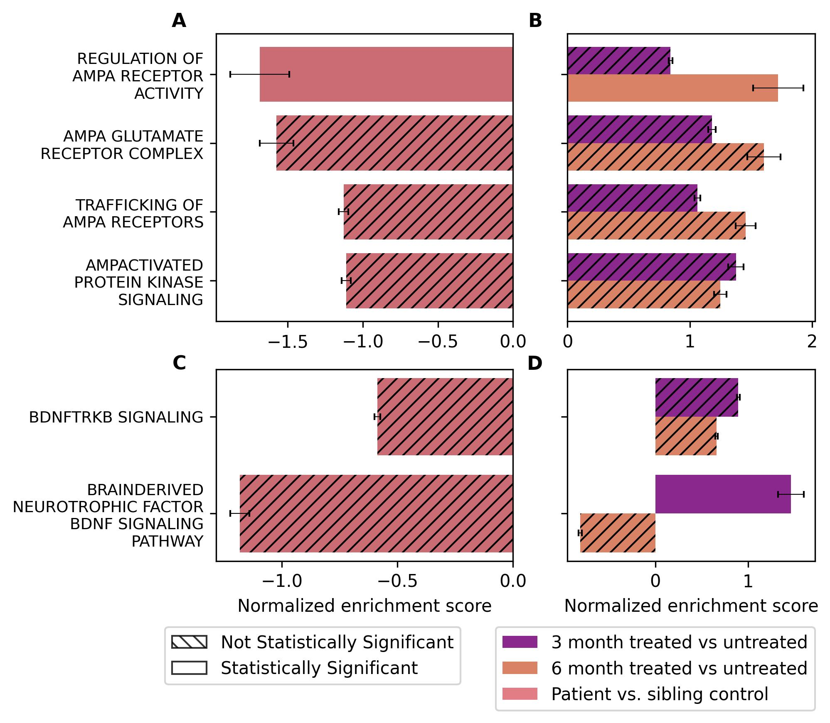

Tables

Table S1
Results from optical genome mapping of the 19q12 region in patient. Gene-level fold changes are based on RNA extracted from frozen lymphocytes from patient vs. sibling.
HGNC Symbol | Structural Change | Gene Start | Gene End | Copy # | Fold Change | Genomic Segment #
AC005394.2 | Deleted | 28435388 | 28727680 | 1 | 1.02 | 1
UQCRFS1 | Inverted and duplicated | 29205320 | 29213151 | 3 | 1.24 | 2 and 3
POP4 | Duplicated | 29606283 | 29617237 | 3 | 1.35 | 4
C19orf12 | Duplicated | 29698886 | 29715789 | 3 | 1.46 | 4
CCNE1 | Duplicated | 29811991 | 29824312 | 3 | 1.9 | 4
URI1 | Inverted and duplicated | 29923644 | 30016612 | 3 | 1.51 | 5
ZNF536 | 5 is inverted duplicated, 6 is deleted | 30224235 | 30713585 | 1 | NA | 5 and 6
TSHZ3 | Deleted | 31149979 | 31349436 | 1 | 0.33 | 10

Table S2
P-values of neurogenesis pathways implicated by root cause genes ZNF536 and TSHZ3 in patient neurons compared to control. Combined p-value for pathway enrichment scores were calculated using the Fisher test for the individual p-values across multiple timepoints.
Pathway | p-value
Regulation of neuron differentiation | 7.72E-15
Regulation of neurogenesis | 2.04E-07
Neuron fate commitment | 8.0E-07
Central nervous system neuron development | 0.000166
Central nervous system neuron differentiation | 1.3E-08

Table S3
P-values of neurotransmitter transport pathways implicated by up-regulation of glutamatergic marker gene SLC17A6 in patient neurons compared to control. Combined p-value for pathway enrichment scores were calculated using the Fisher test for the individual p-values across multiple timepoints.
Pathway | p-value
Amino acid transmembrane transporter activity | 0.031
Dicarboxylic acid transport | 0.027
Inorganic ion homeostasis | 0.000202
L alpha amino acid transmembrane transport | 0.028
L amino acid transmembrane transporter activity | 0.033
Organic acid transport | 0.0075
Organic anion transport | 0.038
Passive transmembrane transporter activity | 0.0033
Sensory system development | 0.0030
Synaptic transmission glutamatergic | 0.023
Transport vesicle membrane | 1.415E-10
Transport vesicle | 2.555E-06
Transporter complex | 0.0109

Table S4
P-values of synoptic transmission and organization pathways implicated by up-regulation of glutamatergic marker gene SLC17A6 and acceleration of neurogenesis in patient neurons compared to control. Combined p-value for pathway enrichment scores were calculated using the Fisher test for the individual p-values across multiple timepoints.
Pathway | p-value
Long term synaptic potentiation | 0.00084
Positive regulation of synaptic transmission | 0.00033
Postsynaptic neurotransmitter receptor activity | 1.44E-05
Postsynaptic signal transduction | 0.00026
Postsynaptic membrane | 0.00041
Presynaptic modulation of chemical synaptic transmission | 0.0030
Regulation of trans synaptic signaling | 3.45E-05
Regulation of long term synaptic potentiation | 0.00031
Regulation of synaptic plasticity | 0.00052
Regulation of postsynaptic membrane potential | 0.0069
Regulation of short term neuronal synaptic plasticity | 0.0086
Regulation of synaptic transmission glutamatergic | 0.0255
Synapse organization | 0.0064
Synaptic membrane | 1.97E-05
Synaptic transmission cholinergic | 0.0017
Synaptic cleft | 0.019
Synaptic transmission glutamatergic | 0.023

Table S5
Top 5 significant neurotransmitter transport pathways in Entrectinib treated wild type NGN2-driven neurons. Combined p-values for pathway enrichment scores were calculated using the Fisher test for the individual p-values across multiple concentrations.
Pathway | p-value
Organic anion transport | 6.679630e-08
Organic acid transport | 1.068493e-06
Amino acid transmembrane transporter activity | 9.396431e-06
L amino acid transmembrane transport | 1.949942e-05
L amino acid transmembrane transporter activity | 2.565775e-05

Table S6
Top 5 significant synaptic plasticity/transmission pathways in Entrectinib treated wild type NGN2-driven neurons. Combined p-values for pathway enrichment scores were calculated using the Fisher test for the individual p-values across multiple concentrations.
Pathway | p-value
Synaptic transmission cholinergic | 0.000058
Synaptic cleft | 0.003050
Regulation of short term neuronal synaptic plasticity | 0.028874
Postsynaptic neurotransmitter receptor activity | 0.034145
Positive regulation of synaptic transmission | 0.046269

Table S7
DAYC-2 scores at pre- and post-treatment evaluations conducted in 2023 and 2025, respectively.

Treatment date | Domain | Raw Score | Standard Score | Age Equivalent | Description
06/2023 | Cognitive | 29 | <50 | 17 month | Extremely Low
01/2025 | Cognitive | 33 | N/A | 23 month | Extremely Low

