Appendix A: Measurement of predictors of CKD within CPCSSN
 | CPCSSN table | Details | LOINC code(s) | ATC code(s) | ICD-9 code(s) | Reference
Demographic variables
Age | Patient | Baseline visit date - date of birth
Sex | Patient
Rurality | Patient | Based on patient home postal code
Health behaviour variables
Smoking | Risk factor | Most recent smoking status reported at or prior to baseline; collected as non-smoker, ex-smoker, ever smoker, and current smoker
Diabetes-related variables
Fasting blood glucose | Laboratory | Most recent before baseline | 14771-0
Baseline HbA1c | Laboratory | Most recent before baseline | 4548-4
HbA1c variation | Laboratory | Coefficient of variation of HbA1c values prior to baseline, calculated as standard deviation/mean, adjusted by the number of measurements by dividing by square root of the ratio of total visits divided by total visits minus 1
Diabetes duration | Disease case | Baseline visit date - First visit with recorded diabetes
Diabetes medication | Medication | Number of diabetes medications used in the last 2 years |  | A10*
Insulin use | Medication | Any use of insulin 2 years prior to baseline |  | A10A*
Non-insulin antihyperglycemic drugs | Medication | Any use of glucose lowering medications (excluding insulin) 2 years prior to baseline |  | A10B*
Anthropometric variables
Weight | Exam | Most recent as recorded in EMR
Body mass index | Exam | Most recent as recorded in EMR or calculated from height and weight
Physical examination variables
Systolic blood pressure | Exam | Most recent as recorded in EMR
Diastolic blood pressure | Exam | Most recent as recorded in EMR
Pulse pressure | Exam | Most recent difference between systolic and diastolic blood pressures
Laboratory variables
Baseline eGFR | Laboratory | Most recent as recorded in EMR | 12195-4
Urinary albumin | Laboratory | Most recent as recorded in EMR | 1754-1
Urinary creatinine | Laboratory | Most recent as recorded in EMR | 14683-7
Urinary ACR | Laboratory | Most recent as recorded in EMR | 32294-1
Serum creatinine | Laboratory | Most recent as recorded in EMR | 14682-9
Triglycerides | Laboratory | Most recent as recorded in EMR | 14927-8
HDL cholesterol | Laboratory | Most recent as recorded in EMR | 14646-4
LDL cholesterol | Laboratory | Most recent as recorded in EMR | 22748-8
Total cholesterol | Laboratory | Most recent as recorded in EMR | 14647-2
Cholesterol-HDL ratio | Laboratory | Most recent as recorded in EMR | 9830-1
Medical history variables
Antihypertensive medication | Medication | Any use of antihypertensive medications 2 years prior to baseline |  | β-blockers, C07 (excluding C07AA04, C07AA07, C07AA12, and C07AG02); renin-angiotensin system inhibitors, C09; diuretics, C03 (excluding C03BA08 and C03CA01); calcium channel blockers, C08; and other antihypertensive drugs, C02 (excluding C02KX01), C10BX03, C01DA02, C04AB01, C05AE03, B01AC09, and G04CA03 |  | [1]
RAS-antagonist | Medication | Any use of reninangiotensin system inhibitors in the last 2 years |  | C09*
Lipid-lowering drugs | Medication | Any use of statins 2 years prior to baseline |  | C10AA, C10AB, and C10AX |  | [2]
Anticoagulants | Medication | Any use of anticoagulant medications 2 years prior to baseline |  | B01A*
Hypertension | Disease case | Any diagnosis prior to baseline |  |  |  | [3]
Dyslipidemia | Billing; Health Condition; Encounter Diagnosis; Medication; Laboratory | Any Cholesterol in LDL (LDLc) test (LOINC: 22748-8) in the Lab table with a result ≥ 3.5 mmol/L OR  Any Cholesterol Total/Cholesterol in HDL Ratio (TCh/HDL) test (LOINC: 9830-1) in the Lab table with a result ≥ 4.3 mmol/L; Any use of ICD 9 272 (Disorders of Lipid Metabolism) | 22748-8; 9830-1 |  | 272
Retinopathy | Disease case | Any diagnosis prior to baseline; use of free text: 'retinopathy' OR 'retinopathie' OR 'rétinopathie' |  |  | 362.0 | [4]
Cerebrovascular disease | Disease case | Any diagnosis prior to baseline |  |  |  | [5]
Atrial fibrillation | Disease case | Any diagnosis prior to baseline
Macrovascular complications | Billing; Health Condition; Encounter Diagnosis | Any diagnosis prior to baseline |  |  | Peripheral vascular disease: 443.9, 441, 785.4, V43.4, 38.48; Cerebrovascular disease: 430-438; Myocardial infarction: 410, 412; Congestive heart failure: 428 | [6]
Cardiovascular disease | Disease case | Any diagnosis prior to baseline |  |  |  | [5]
NeGFR (MDRD), estimated glomerular filtration rate according to MDRD; RAS-antagonist: renin–angiotensin system antagonist.
*: includes all subcodes.
[1] Garies S, Hao S, McBrien K, et al. Prevalence of Hypertension, Treatment, and Blood Pressure Targets in Canada Associated With the 2017 American College of Cardiology and American Heart Association Blood Pressure Guidelines. JAMA Netw Open. 2019;2(3):e190406.
[2] Johnston, I.S., Miles, B., Soos, B. et al. A cross-sectional study evaluating cardiovascular risk and statin prescribing in the Canadian Primary Care Sentinel Surveillance Network database. BMC Prim. Care 23, 128 (2022).
[3] Williamson T, Green ME, Birtwhistle R, et al. Validating the 8 CPCSSN case definitions for chronic disease surveillance in a primary care database of electronic health records. Ann Fam Med. 2014;12(4):367-372. doi:10.1370/afm.1644
[4] Publication forthcoming.
[5] Thomas RD, Kosowan L, Rabey M, Bell A, Connelly KA, Hawkins NM, Casey CG, Singer AG. Validation of a Case Definition to Identify Patients Diagnosed With Cardiovascular Disease in Canadian Primary Care Practices. CJC Open. 2023 Apr 22;5(7):567-576. doi: 10.1016/j.cjco.2023.04.003. PMID: 37496780; PMCID: PMC10366639.
[6] Abu-Ashour W, Twells LK, Valcour JE, Gamble JM. Diabetes and the occurrence of infection in primary care: a matched cohort study. BMC Infect Dis. 2018 Feb 5;18(1):67.

Appendix B: Cohort characteristics for all predictors used by component models
 | N=37,604
Demographic variables
Age (years), mean ± SD | 63.4 ± 12.2
Age group, n (%)
18 to 39 | 1,073 (2.9)
40 to 64 | 18,370 (48.9)
65 and older | 18,161 (48.3)
Sex/gender, n (%)
Male/men | 23,174 (53.0)
Female/women | 20,516 (47.0)
Social and material deprivation, n (%)
1st quintile (least deprived) | 6,564 (17.5)
2nd quintile | 7,521 (20.0)
3rd quintile | 7,032 (18.7)
4th quintile | 7,123 (18.9)
5th quintile (most deprived) | 7,039 (18.7)
Missing | 2,325 (6.2)
Urban residence, n (%) | 29,088 (77.4)
Health behaviour variables
Smoking, n (%)
Not current | 1,111 (3.0)
Non-smoker | 1,080 (2.9)
Ex-smoker | 1,344 (3.6)
Current smoker | 1,417 (3.8)
Missing | 32,652 (86.8)
Diabetes-related variables
Fasting blood glucose (mg/dL), mean ± SD | 136.3 ± 45.5
HbA1c (%), median (first–third quartiles) | 6.7 (6.3–7.4)
Diabetes duration (years), median (first–third quartiles) | 2.8 (1.3–5.1)
Non-insulin antihyperglycemic drugs, n (%) | 21,460 (57.1)
Insulin, n (%) | 4,128 (11.0)
Non-insulin antihyperglycemic drugs or insulin, n (%) | 22,477 (59.8)
Anthropometric variables
Weight (kg), mean ± SD | 91.0 ± 24.9
BMI (kg/m²), mean ± SD | 32.3 ± 7.4
Physical examination variables
Systolic blood pressure (mmHg), mean ± SD | 131 ± 16
Diastolic blood pressure (mmHg), mean ± SD | 76 ± 10
Pulse pressure (mmHg), mean ± SD | 55 ± 14
Laboratory variables
eGFR (mL/min/1.73 m²), mean ± SD | 84 ± 18
Urine albumin (mg/dL), mean ± SD | 3.2 ± 5.9
Urine creatinine (mg/dL), mean ± SD | 127.8 ± 70.7
Urinary ACR (mg/mmol), median (first–third quartiles/IQR) | 1.3 (0.6–2.9)
Serum creatinine (μmol/L), mean ± SD | 73 ± 17
Triglycerides (mmol/L), mean ± SD | 1.7 ± 1.0
LDL cholesterol (mmol/L), mean ± SD | 2.3 ± 0.9
HDL cholesterol (mmol/L), mean ± SD | 1.2 ± 0.3
Total cholesterol (mmol/L), mean ± SD | 4.3 ± 1.1
Cholesterol-HDL ratio, mean ± SD | 3.7 ± 1.2
Medical history variables
Antihypertensive medication, n (%) | 24,855 (66.1)
RAS-antagonist, n (%) | 21,198 (56.4)
Lipid-lowering drugs, n (%) | 21,745 (57.8)
Anticoagulants, n (%) | 7,840 (20.8)
Hypertension, n (%) | 19,121 (50.8)
Dyslipidemia, n (%) | 17,434 (46.4)
Hypertension or dyslipidemia, n (%) | 27,657 (73.5)
Diabetic retinopathy, n (%) | 643 (1.7)
Cerebrovascular disease, n (%) | 1,137 (3.0)
Previous atrial fibrillation, n (%) | 668 (1.8)
Macrovascular complications, n (%) | 3,238 (8.6)
Previous cardiovascular disease, n (%) | 5,631 (15.0)
Comorbidities, n (%)
None | 3,692 (9.8)
One | 9,062 (24.1)
Two | 10,826 (28.8)
Three or more | 14,024 (37.3)
RAS-antagonist: renin–angiotensin system antagonist.

Appendix C: Calibration plots for all ensemble methods
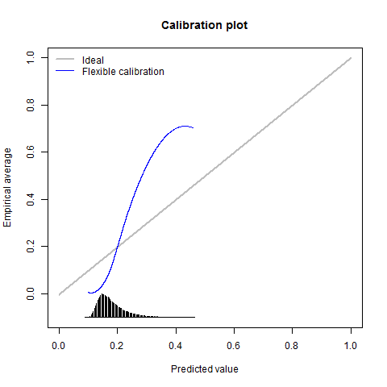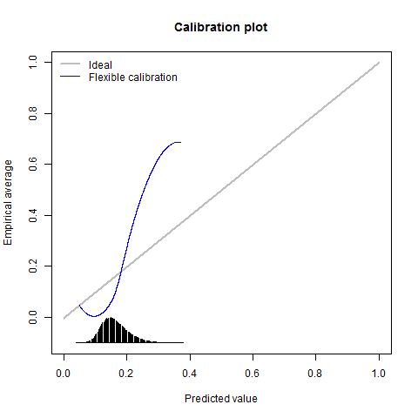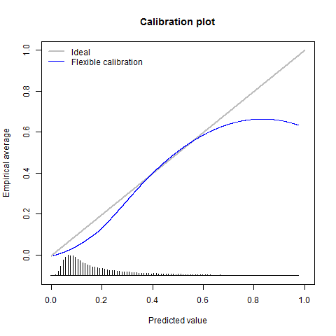
Appendix C1: no weighting/selection; arithmetic mean Appendix C2: no weighting/selection; geometric mean Appendix C3: cohort size weighting; arithmetic mean
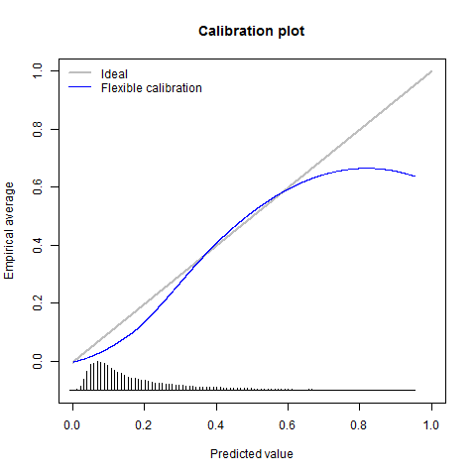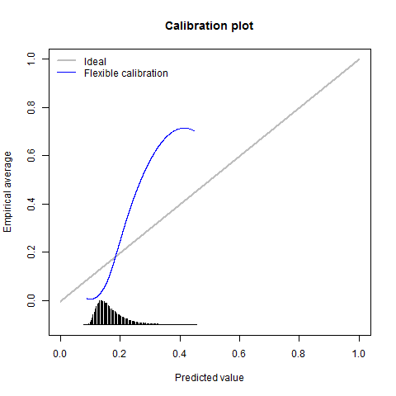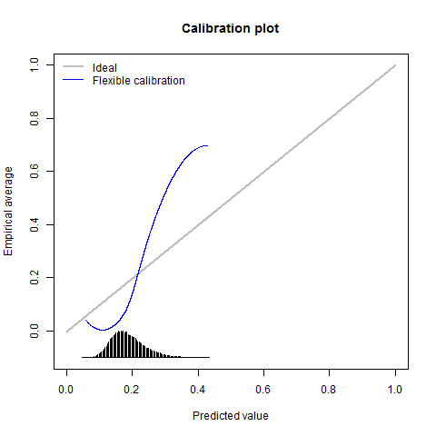
Appendix C4: cohort size weighting; geometric mean Appendix C5: AUROC weighting; arithmetic mean Appendix C6: AUROC weighting; geometric mean
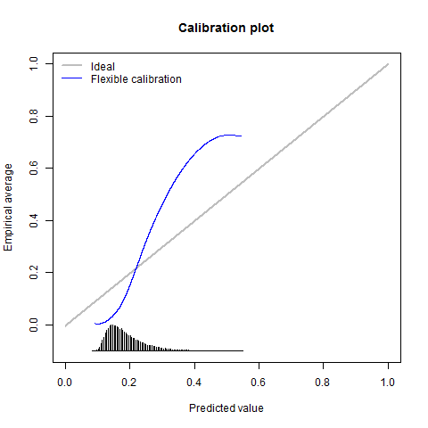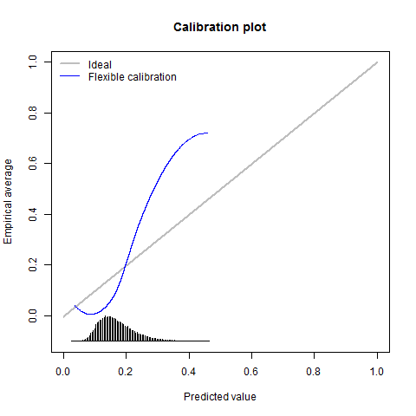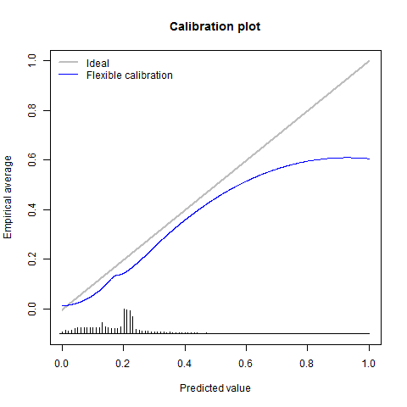
Appendix C7: similarity weighting; arithmetic mean Appendix C8: similarity weighting; geometric mean Appendix C9: similarity; mixture-of-experts (n=1)
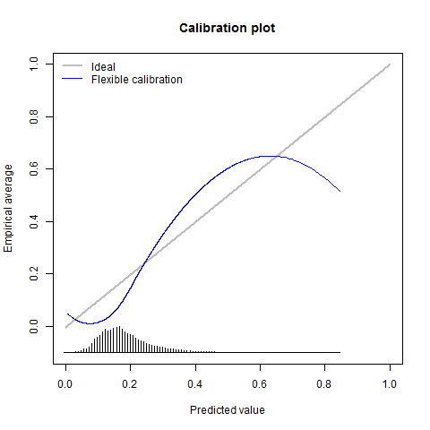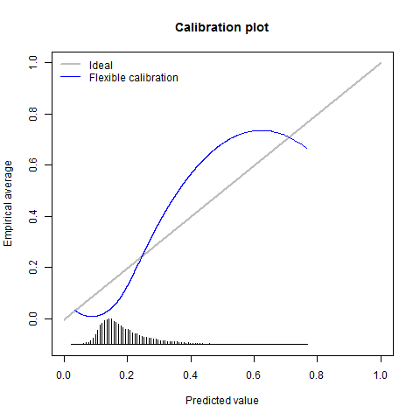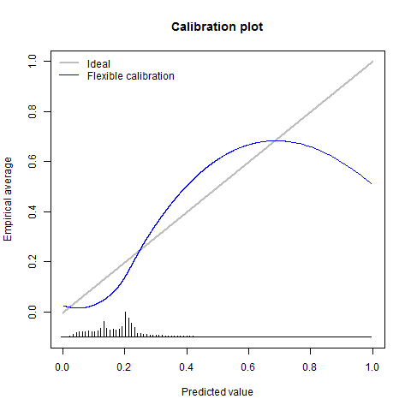

Appendix C10: similarity; mixture-of-experts (n=3) Appendix C11: similarity; mixture-of-experts (n=5). Appendix C12: similarity; median-of-experts (n=3)
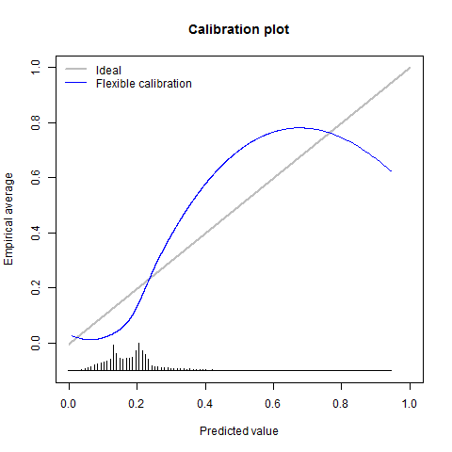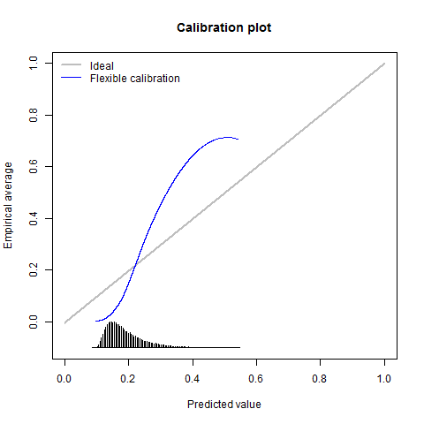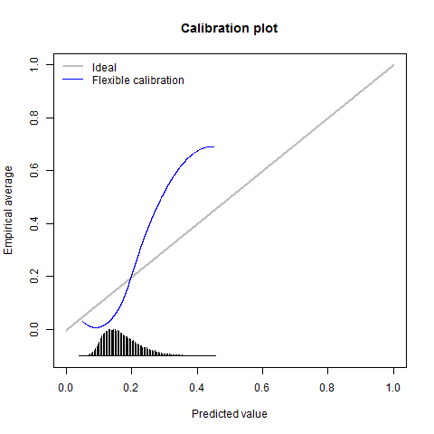
Appendix C13: similarity; median-of-experts (n=5) Appendix C14: age-similarity weighting; arithmetic mean Appendix C15: age-similarity weighting; geometric mean
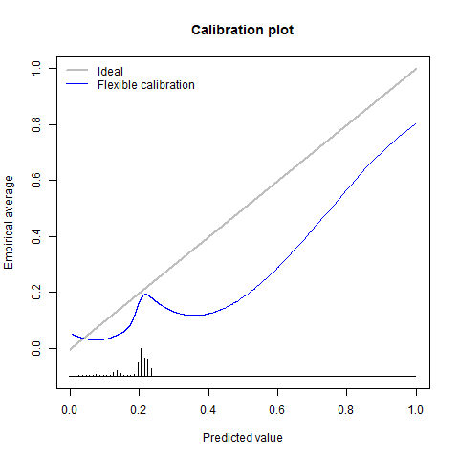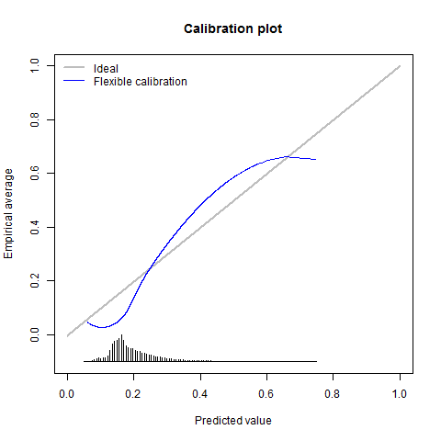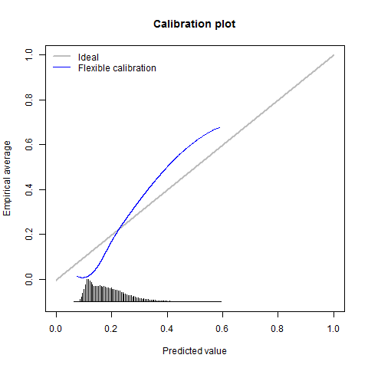
Appendix C16: age-similarity; mixture-of-experts (n=1) Appendix C17: age-similarity; mixture-of-experts (n=3) Appendix C18: age-similarity; mixture-of-experts (n=5)

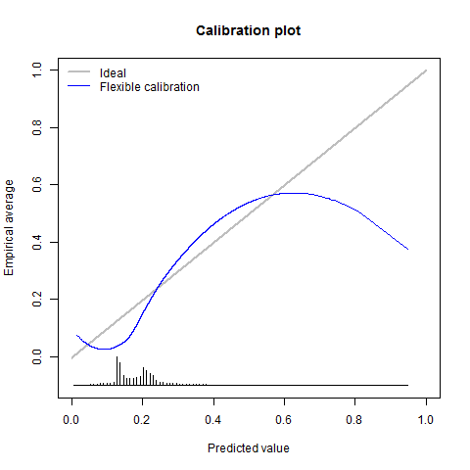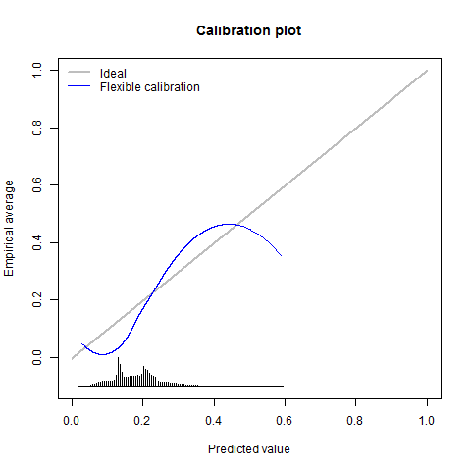
Appendix C19: age-similarity; median-of-experts (n=3) Appendix C20: age-similarity; median-of-experts (n=5)

Appendix D: Performance of ensemble methods for predicting CKD incidence in CPCSSN, by sex/gender.
 | Females/women |  |  |  | Males/men
Averaging or selection processes and corresponding weighting techniques | AUROC | AUPRC | NRI_{>0} | IDI | AUROC | AUPRC | NRI_{>0} | IDI
Best performing component model according to AUROC | 0.825 (0.816 to 0.825) | 0.472 (0.465 to 0.48) | n/a | n/a | 0.829 (0.821 to 0.829) | 0.465 (0.458 to 0.472) | n/a | n/a
No weighting or selection
Arithmetic mean | 0.814 (0.806 to 0.822) | 0.433 (0.426 to 0.44) | -0.051 (-0.065 to  -0.035) | -0.234 (-0.242 to  -0.227) | 0.806 (0.797 to 0.814) | 0.416 (0.409 to 0.422) | -0.268 (-0.281 to  -0.255) | -0.222 (-0.229 to  -0.214)
Geometric mean | 0.815 (0.807 to 0.823) | 0.421 (0.413 to 0.428) | 0.148 (0.133 to 0.163) | -0.243 (-0.252 to  -0.235) | 0.817 (0.809 to 0.825) | 0.42 (0.413 to 0.426) | -0.016 (-0.03 to  -0.001) | -0.228 (-0.236 to  -0.221)
Development cohort size weighting
Arithmetic mean | 0.825 (0.817 to 0.834) | 0.478 (0.47 to 0.485) | -0.314 (-0.327 to -0.300) | -0.011 (-0.011 to  -0.01) | 0.829 (0.821 to 0.837) | 0.467 (0.46 to 0.474) | -0.578 (-0.589 to  -0.566) | -0.01  (-0.01 to  -0.01)
Geometric mean | 0.825 (0.817 to 0.834) | 0.479 (0.472 to 0.487) | -0.048 (-0.062 to  -0.034) | -0.014 (-0.015 to  -0.014) | 0.829 (0.821 to 0.838) | 0.469 (0.462 to 0.476) | -0.335 (-0.347 to  -0.321) | -0.011 (-0.012 to  -0.011)
Development AUROC weighting
Arithmetic mean | 0.819 (0.811 to 0.827) | 0.441 (0.434 to 0.448) | -0.003 (-0.018 to 0.012) | -0.232 (-0.24 to  -0.224) | 0.811 (0.803 to 0.82) | 0.426 (0.419 to 0.432) | -0.193 (-0.205 to  -0.179) | -0.221 (-0.228 to  -0.214)
Geometric mean | 0.816 (0.808 to 0.824) | 0.422 (0.415 to 0.429) | -0.023  (-0.037 to  -0.007) | -0.23  (-0.238 to  -0.222) | 0.819 (0.811 to 0.827) | 0.423 (0.416 to 0.43) | -0.157 (-0.17 to  -0.143) | -0.215 (-0.222 to  -0.207)
Similarity* weighting/selection
Arithmetic mean | 0.817 (0.809 to 0.825) | 0.439 (0.432 to 0.447) | -0.16  (-0.175 to  -0.146) | -0.212 (-0.22 to -0.205) | 0.816 (0.808 to 0.824) | 0.433 (0.426 to 0.44) | -0.394 (-0.406 to  -0.38) | -0.195 (-0.201 to  -0.188)
Geometric mean | 0.819 (0.811 to 0.827) | 0.429 (0.422 to 0.436) | 0.032 (0.018 to 0.045) | -0.213 (-0.22 to  -0.205) | 0.825 (0.817 to 0.833) | 0.437 (0.43 to 0.444) | -0.165 (-0.178 to  -0.151) | -0.191 (-0.199 to  -0.184)
Mixture of experts (n=1) | 0.667 (0.656 to 0.677) | 0.281 (0.274 to 0.287) | -0.109  (-0.125 to  -0.093) | -0.192 (-0.201 to  -0.184) | 0.739 (0.729 to 0.748) | 0.325 (0.318 to 0.331) | -0.38  (-0.395 to  -0.364) | -0.118 (-0.126 to  -0.111)
Mixture of experts (n=3) | 0.786 (0.777 to 0.795) | 0.393 (0.386 to 0.4) | -0.136  (-0.151 to -0.12) | -0.173 (-0.181 to  -0.166) | 0.81 (0.802 to 0.818) | 0.411 (0.405 to 0.418) | -0.389 (-0.403 to  -0.376) | -0.113 (-0.119 to  -0.106)
Mixture of experts (n=5) | 0.815 (0.806 to 0.823) | 0.448 (0.44 to 0.455) | -0.167  (-0.181 to  -0.152) | -0.17  (-0.177 to  -0.163) | 0.822 (0.813 to 0.83) | 0.446 (0.439 to 0.452) | -0.427 (-0.44 to  -0.414) | -0.138 (-0.144 to  -0.132)
Median of experts (n=3) | 0.746 (0.736 to 0.755) | 0.347 (0.34 to 0.354) | -0.103  (-0.119 to  -0.089) | -0.179 (-0.188 to  -0.171) | 0.789 (0.78 to 0.797) | 0.385 (0.379 to 0.392) | -0.444 (-0.459 to  -0.428) | -0.107 (-0.115 to  -0.101)
Median of experts (n=5) | 0.779 (0.77 to 0.787) | 0.385 (0.378 to 0.392) | -0.118  (-0.133 to  -0.101) | -0.172 (-0.18 to  -0.165) | 0.785 (0.776 to 0.794) | 0.39 (0.384 to 0.397) | -0.509 (-0.522 to  -0.496) | -0.142 (-0.149 to  -0.136)
Age-similarity weighting/selection
Arithmetic mean | 0.818 (0.81 to 0.826) | 0.438 (0.43 to 0.445) | -0.166  (-0.18 to -0.152) | -0.21  (-0.217 to  -0.202) | 0.815 (0.806 to 0.823) | 0.423 (0.417 to 0.43) | -0.398 (-0.41 to  -0.385) | -0.193 (-0.2 to -0.186)
Geometric mean | 0.818 (0.81 to 0.826) | 0.427 (0.42 to 0.434) | 0.026 (0.011 to 0.041) | -0.209 (-0.216 to  -0.201) | 0.823 (0.815 to 0.83) | 0.428 (0.422 to 0.435) | -0.173 (-0.187 to  -0.159) | -0.189 (-0.196 to  -0.182)
Mixture of experts (n=1) | 0.577 (0.567 to 0.587) | 0.184 (0.178 to 0.189) | -0.195  (-0.209 to  -0.181) | -0.237 (-0.247 to  -0.228) | 0.633 (0.623 to 0.643) | 0.192 (0.186 to 0.197) | -0.286 (-0.299 to  -0.271) | -0.221 (-0.231 to  -0.213)
Mixture of experts (n=3) | 0.776 (0.766 to 0.786) | 0.382 (0.375 to 0.389) | -0.189  (-0.204 to  -0.175) | -0.184 (-0.191 to  -0.177) | 0.784 (0.775 to 0.793) | 0.374 (0.367 to 0.38) | -0.373 (-0.385 to  -0.359) | -0.126 (-0.133 to  -0.118)
Mixture of experts (n=5) | 0.792 (0.783 to 0.8) | 0.372 (0.365 to 0.38) | -0.133  (-0.147 to  -0.119) | -0.181 (-0.189 to  -0.174) | 0.787 (0.779 to 0.796) | 0.355 (0.348 to 0.361) | -0.322 (-0.335 to  -0.309) | -0.129 (-0.137 to  -0.122)
Median of experts (n=3) | 0.763 (0.754 to 0.773) | 0.354 (0.347 to 0.361) | 0.017 (0.001 to 0.032) | -0.159 (-0.167 to  -0.151) | 0.765 (0.756 to 0.774) | 0.344 (0.337 to 0.351) | -0.207 (-0.221 to  -0.193) | -0.105 (-0.114 to  -0.097)
Median of experts (n=5) | 0.764 (0.755 to 0.773) | 0.331 (0.325 to 0.338) | 0.049 (0.033 to 0.065) | -0.175 (-0.183 to  -0.166) | 0.766 (0.757 to 0.775) | 0.328 (0.321 to 0.334) | -0.17  (-0.185 to  -0.156) | -0.128 (-0.137 to  -0.12)
AUROC: area under the receiver-operating characteristic curve; AUPRC: area under the precision-recall curve; NRI_{>0}: net reclassification index compared to the best performing component model in terms of AUROC; IDI: integrated discrimination improvement compared to the best performing component model in terms of AUROC.
*Similarity of each patient to the development cohort according to age, sex/gender, recorded HbA1c, and BMI.

Appendix E: Performance of ensemble methods for predicting CKD incidence in CPCSSN, by age group
 | 18 to 39 |  |  |  | 40 to 64 |  |  |  | 65 and older
Averaging or selection processes and corresponding weighting techniques | AUROC | AUPRC | NRI_{>0} | IDI | AUROC | AUPRC | NRI_{>0} | IDI | AUROC | AUPRC | NRI_{>0} | IDI
Best performing component model according to AUROC | 0.869 (0.72 to 0.869) | 0.328 (0.3 to 0.356) | n/a | n/a | 0.797 (0.783 to 0.797) | 0.283 (0.276 to 0.289) | n/a | n/a | 0.774 (0.766 to 0.774) | 0.514 (0.506 to 0.521) | n/a | n/a
No weighting or selection
Arithmetic mean | 0.792 (0.616 to 0.967) | 0.244 (0.218 to 0.27) | -0.733 (-0.776 to  -0.692) | -0.243 (-0.35 to  -0.147) | 0.766 (0.752 to 0.78) | 0.214 (0.208 to 0.22) | -0.325 (-0.339 to  -0.312) | -0.192 (-0.205 to  -0.179) | 0.745 (0.737 to 0.753) | 0.467 (0.46 to 0.475) | 0.028 (0.014 to 0.043) | -0.183 (-0.189 to  -0.177)
Geometric mean | 0.829 (0.673 to 0.985) | 0.284 (0.257 to 0.311) | -0.568 (-0.618 to  -0.514) | -0.245 (-0.347 to  -0.132) | 0.788 (0.775 to 0.802) | 0.236 (0.23 to 0.242) | -0.056 (-0.071 to  -0.041) | -0.195 (-0.208 to  -0.183) | 0.747 (0.739 to 0.755) | 0.459 (0.452 to 0.467) | 0.218 (0.202 to 0.231) | -0.194 (-0.201 to  -0.188)
Development cohort size weighting
Arithmetic mean | 0.868 (0.718 to 1) | 0.327 (0.299 to 0.355) | -0.897 (-0.925 to -0.87) | -0.011 (-0.015 to  -0.006) | 0.798 (0.784 to 0.812) | 0.287 (0.28 to 0.293) | -0.619 (-0.629 to  -0.608) | -0.009 (-0.009 to  -0.008) | 0.774 (0.766 to 0.782) | 0.515 (0.508 to 0.523) | -0.26  (-0.274 to  -0.245) | -0.008 (-0.009 to  -0.008)
Geometric mean | 0.87 (0.72 to 1) | 0.331 (0.303 to 0.359) | -0.689 (-0.726 to  -0.646) | -0.012 (-0.018 to  -0.007) | 0.798 (0.784 to 0.813) | 0.29 (0.284 to 0.297) | -0.34  (-0.353 to  -0.326) | -0.01  (-0.011 to  -0.01) | 0.775 (0.767 to 0.782) | 0.516 (0.509 to 0.524) | -0.029 (-0.043 to  -0.015) | -0.011 (-0.011 to  -0.011)
Development AUROC weighting
Arithmetic mean | 0.798 (0.624 to 0.973) | 0.253 (0.227 to 0.28) | -0.696 (-0.741 to  -0.655) | -0.245 (-0.35 to  -0.145) | 0.776 (0.762 to 0.79) | 0.228 (0.222 to 0.234) | -0.257 (-0.272 to  -0.243) | -0.191 (-0.204 to  -0.18) | 0.753 (0.745 to 0.761) | 0.477 (0.47 to 0.484) | 0.087 (0.073 to 0.101) | -0.182 (-0.188 to  -0.176)
Geometric mean | 0.838 (0.692 to 0.984) | 0.321 (0.293 to 0.349) | -0.623 (-0.67 to  -0.577) | -0.231 (-0.337 to  -0.129) | 0.793 (0.78 to 0.806) | 0.243 (0.237 to 0.249) | -0.227 (-0.241 to  -0.212) | -0.185 (-0.197 to  -0.173) | 0.749 (0.741 to 0.757) | 0.461 (0.454 to 0.469) | 0.073 (0.058 to 0.088) | -0.186 (-0.192 to  -0.179)
Similarity* weighting/selection
Arithmetic mean | 0.788 (0.61 to 0.966) | 0.235 (0.21 to 0.261) | -0.754 (-0.791 to  -0.715) | -0.235 (-0.331 to  -0.143) | 0.776 (0.761 to 0.79) | 0.23 (0.224 to 0.236) | -0.425 (-0.437 to  -0.411) | -0.174 (-0.184 to  -0.163) | 0.746 (0.738 to 0.754) | 0.473 (0.466 to 0.48) | -0.112 (-0.127 to  -0.097) | -0.168 (-0.173 to  -0.162)
Geometric mean | 0.821 (0.663 to 0.98) | 0.248 (0.222 to 0.274) | -0.568 (-0.62 to  -0.515) | -0.231 (-0.331 to  -0.126) | 0.795 (0.782 to 0.809) | 0.247 (0.241 to 0.253) | -0.171 (-0.185 to  -0.157) | -0.17  (-0.183 to  -0.158) | 0.75 (0.742 to 0.758) | 0.469 (0.462 to 0.477) | 0.058 (0.044 to 0.073) | -0.172 (-0.178 to  -0.167)
Mixture of experts (n=1) | 0.53 (0.393 to 0.667) | 0.012 (0.006 to 0.019) | -0.455 (-0.513 to  -0.399) | -0.349 (-0.479 to  -0.237) | 0.673 (0.656 to 0.689) | 0.17 (0.165 to 0.175) | -0.206 (-0.224 to  -0.191) | -0.114 (-0.127 to  -0.101) | 0.637 (0.628 to 0.647) | 0.362 (0.355 to 0.369) | -0.242 (-0.256 to  -0.227) | -0.155 (-0.162 to  -0.148)
Mixture of experts (n=3) | 0.689 (0.516 to 0.863) | 0.044 (0.032 to 0.056) | -0.471 (-0.519 to  -0.415) | -0.268 (-0.373 to  -0.159) | 0.758 (0.743 to 0.773) | 0.217 (0.211 to 0.223) | -0.251 (-0.264 to  -0.236) | -0.126 (-0.136 to  -0.116) | 0.708 (0.7 to 0.717) | 0.431 (0.423 to 0.438) | -0.276 (-0.291 to  -0.263) | -0.143 (-0.149 to  -0.137)
Mixture of experts (n=5) | 0.72 (0.525 to 0.914) | 0.088 (0.071 to 0.105) | -0.622 (-0.674 to  -0.571) | -0.25  (-0.354 to  -0.156) | 0.775 (0.76 to 0.79) | 0.245 (0.238 to 0.251) | -0.391 (-0.404 to  -0.379) | -0.146 (-0.156 to  -0.135) | 0.749 (0.74 to 0.757) | 0.479 (0.472 to 0.487) | -0.198 (-0.212 to  -0.185) | -0.134 (-0.139 to  -0.128)
Median of experts (n=3) | 0.653 (0.508 to 0.799) | 0.02 (0.012 to 0.028) | -0.477 (-0.528 to  -0.419) | -0.295 (-0.417 to  -0.185) | 0.728 (0.712 to 0.743) | 0.186 (0.18 to 0.192) | -0.196 (-0.215 to  -0.178) | -0.117 (-0.128 to  -0.105) | 0.681 (0.672 to 0.69) | 0.407 (0.4 to 0.414) | -0.296 (-0.31 to  -0.281) | -0.15  (-0.157 to  -0.142)
Median of experts (n=5) | 0.667 (0.495 to 0.84) | 0.03 (0.019 to 0.04) | -0.493 (-0.544 to  -0.44) | -0.284 (-0.405 to  -0.174) | 0.737 (0.722 to 0.752) | 0.177 (0.172 to 0.183) | -0.381 (-0.396 to  -0.366) | -0.139 (-0.15 to  -0.127) | 0.702 (0.694 to 0.711) | 0.428 (0.421 to 0.435) | -0.266 (-0.281 to  -0.251) | -0.147 (-0.153 to  -0.141)
Age-similarity weighting/selection
Arithmetic mean | 0.781 (0.602 to 0.961) | 0.236 (0.211 to 0.262) | -0.739 (-0.78 to  -0.696) | -0.242 (-0.349 to  -0.143) | 0.778 (0.764 to 0.792) | 0.229 (0.223 to 0.236) | -0.409 (-0.422 to  -0.397) | -0.175 (-0.186 to  -0.163) | 0.739 (0.73 to 0.747) | 0.461 (0.454 to 0.468) | -0.139 (-0.155 to  -0.124) | -0.17  (-0.176 to  -0.164)
Geometric mean | 0.822 (0.668 to 0.975) | 0.3 (0.272 to 0.327) | -0.564 (-0.61 to  -0.515) | -0.24  (-0.35 to  -0.133) | 0.795 (0.781 to 0.808) | 0.249 (0.243 to 0.255) | -0.145 (-0.159 to  -0.132) | -0.171 (-0.182 to  -0.158) | 0.744 (0.736 to 0.752) | 0.46 (0.452 to 0.467) | 0.016 (0.001 to 0.03) | -0.174 (-0.18 to  -0.168)
Mixture of experts (n=1) | 0.619 (0.491 to 0.747) | 0.023 (0.014 to 0.033) | -0.417 (-0.471 to  -0.364) | -0.305 (-0.434 to  -0.182) | 0.56 (0.542 to 0.578) | 0.122 (0.117 to 0.127) | -0.138 (-0.154 to  -0.124) | -0.203 (-0.219 to  -0.187) | 0.521 (0.511 to 0.53) | 0.243 (0.237 to 0.249) | -0.332 (-0.346 to  -0.318) | -0.236 (-0.244 to  -0.228)
Mixture of experts (n=3) | 0.754 (0.649 to 0.86) | 0.06 (0.046 to 0.075) | -0.747 (-0.787 to  -0.707) | -0.294 (-0.428 to  -0.171) | 0.682 (0.663 to 0.7) | 0.185 (0.179 to 0.19) | -0.219 (-0.233 to  -0.204) | -0.16  (-0.173 to  -0.148) | 0.681 (0.672 to 0.69) | 0.393 (0.386 to 0.401) | -0.327 (-0.34 to  -0.313) | -0.164 (-0.171 to  -0.158)
Mixture of experts (n=5) | 0.805 (0.704 to 0.907) | 0.209 (0.185 to 0.234) | -0.571 (-0.62 to  -0.521) | -0.279 (-0.396 to  -0.154) | 0.784 (0.77 to 0.797) | 0.226 (0.22 to 0.232) | -0.115 (-0.129 to  -0.099) | -0.137 (-0.146 to  -0.126) | 0.653 (0.644 to 0.662) | 0.364 (0.357 to 0.371) | -0.332 (-0.345 to  -0.317) | -0.186 (-0.193 to  -0.179)
Median of experts (n=3) | 0.664 (0.527 to 0.801) | 0.046 (0.034 to 0.059) | -0.441 (-0.493 to  -0.392) | -0.283 (-0.411 to  -0.163) | 0.686 (0.669 to 0.703) | 0.15 (0.145 to 0.155) | 0.168 (0.152 to 0.183) | -0.141 (-0.155 to  -0.127) | 0.656 (0.647 to 0.666) | 0.37 (0.363 to 0.377) | -0.322 (-0.336 to  -0.308) | -0.168 (-0.175 to  -0.161)
Median of experts (n=5) | 0.678 (0.534 to 0.821) | 0.117 (0.098 to 0.137) | -0.364 (-0.42 to  -0.307) | -0.285 (-0.412 to  -0.151) | 0.73 (0.714 to 0.745) | 0.167 (0.161 to 0.172) | 0.277 (0.26 to 0.293) | -0.136 (-0.149 to  -0.124) | 0.631 (0.621 to 0.64) | 0.341 (0.334 to 0.348) | -0.329 (-0.344 to  -0.316) | -0.195 (-0.202 to  -0.187)
AUROC: area under the receiver-operating characteristic curve; AUPRC: area under the precision-recall curve; NRI_{>0}: net reclassification index compared to the best performing component model in terms of AUROC; IDI: integrated discrimination improvement compared to the best performing component model in terms of AUROC.
*Similarity of each patient to the development cohort according to age, sex/gender, recorded HbA1c, and BMI.

Appendix F: Performance of ensemble methods for predicting CKD incidence in CPCSSN, by number of comorbidities
 | None |  |  |  | One
Averaging or selection processes and corresponding weighting techniques | AUROC | AUPRC | NRI_{>0} | IDI | AUROC | AUPRC | NRI_{>0} | IDI
Best performing component model according to AUROC | 0.834 (0.814 to 0.834) | 0.461 (0.445 to 0.477) | n/a | n/a | 0.836 (0.823 to 0.836) | 0.491 (0.481 to 0.501) | n/a | n/a
No weighting or selection
Arithmetic mean | 0.816 (0.796 to 0.837) | 0.407 (0.391 to 0.423) | -0.336  (-0.367 to  -0.306) | -0.217  (-0.236 to  -0.198) | 0.814 (0.801 to 0.827) | 0.41 (0.4 to 0.42) | -0.251  (-0.271 to  -0.232) | -0.236  (-0.249 to  -0.224)
Geometric mean | 0.834 (0.815 to 0.852) | 0.419 (0.403 to 0.435) | -0.122  (-0.152 to  -0.091) | -0.222  (-0.241 to  -0.202) | 0.828 (0.816 to 0.84) | 0.409 (0.399 to 0.419) | -0.036  (-0.056 to  -0.015) | -0.243  (-0.255 to  -0.23)
Development cohort size weighting
Arithmetic mean | 0.835 (0.814 to 0.855) | 0.466 (0.45 to 0.482) | -0.581  (-0.606 to  -0.554) | -0.01 (-0.011 to -0.009) | 0.837 (0.824 to 0.85) | 0.493 (0.483 to 0.504) | -0.543 (-0.56 to -0.525) | -0.011  (-0.011 to  -0.01)
Geometric mean | 0.835 (0.815 to 0.855) | 0.467 (0.451 to 0.483) | -0.371 (-0.4 to -0.337) | -0.011 (-0.012 to -0.01) | 0.837 (0.824 to 0.85) | 0.494 (0.483 to 0.504) | -0.29 (-0.308 to -0.271) | -0.013  (-0.014 to  -0.012)
Development AUROC weighting
Arithmetic mean | 0.825 (0.805 to 0.845) | 0.42 (0.404 to 0.436) | -0.276  (-0.308 to  -0.247) | -0.217  (-0.235 to  -0.198) | 0.822 (0.809 to 0.835) | 0.424 (0.414 to 0.434) | -0.198  (-0.219 to  -0.177) | -0.235  (-0.247 to  -0.223)
Geometric mean | 0.837 (0.818 to 0.855) | 0.421 (0.405 to 0.437) | -0.257  (-0.288 to  -0.226) | -0.207  (-0.226 to  -0.188) | 0.831 (0.819 to 0.843) | 0.412 (0.402 to 0.422) | -0.186  (-0.208 to  -0.166) | -0.229  (-0.241 to  -0.216)
Similarity* weighting/selection
Arithmetic mean | 0.824 (0.804 to 0.844) | 0.423 (0.407 to 0.439) | -0.436  (-0.465 to  -0.408) | -0.194  (-0.213 to  -0.176) | 0.82 (0.808 to 0.833) | 0.421 (0.411 to 0.431) | -0.362  (-0.381 to  -0.342) | -0.212  (-0.224 to  -0.201)
Geometric mean | 0.838 (0.82 to 0.856) | 0.431 (0.415 to 0.447) | -0.256  (-0.287 to  -0.224) | -0.187  (-0.205 to  -0.17) | 0.833 (0.821 to 0.845) | 0.421 (0.411 to 0.431) | -0.164  (-0.184 to  -0.145) | -0.208 (-0.22 to -0.197)
Mixture of experts (n=1) | 0.67 (0.644 to 0.697) | 0.268 (0.254 to 0.282) | -0.439 (-0.47 to -0.408) | -0.169  (-0.193 to  -0.149) | 0.683 (0.667 to 0.698) | 0.264 (0.255 to 0.273) | -0.327  (-0.348 to  -0.307) | -0.178  (-0.192 to  -0.164)
Mixture of experts (n=3) | 0.808 (0.788 to 0.829) | 0.398 (0.382 to 0.414) | -0.447  (-0.475 to  -0.42) | -0.134  (-0.152 to  -0.117) | 0.802 (0.789 to 0.816) | 0.388 (0.378 to 0.398) | -0.366  (-0.384 to  -0.347) | -0.153  (-0.164 to  -0.141)
Mixture of experts (n=5) | 0.829 (0.809 to 0.849) | 0.437 (0.421 to 0.453) | -0.458  (-0.488 to  -0.43) | -0.146  (-0.162 to  -0.13) | 0.819 (0.806 to 0.833) | 0.433 (0.423 to 0.443) | -0.383  (-0.402 to  -0.363) | -0.164  (-0.175 to  -0.154)
Median of experts (n=3) | 0.775 (0.753 to 0.797) | 0.366 (0.351 to 0.382) | -0.397  (-0.428 to  -0.365) | -0.132  (-0.153 to  -0.111) | 0.768 (0.754 to 0.782) | 0.335 (0.326 to 0.345) | -0.343  (-0.364 to  -0.32) | -0.154  (-0.167 to  -0.141)
Median of experts (n=5) | 0.786 (0.764 to 0.807) | 0.369 (0.353 to 0.384) | -0.437  (-0.467 to  -0.408) | -0.147  (-0.166 to  -0.129) | 0.779 (0.765 to 0.793) | 0.357 (0.347 to 0.367) | -0.408  (-0.426 to  -0.388) | -0.168 (-0.18 to -0.156)
Age-similarity weighting/selection
Arithmetic mean | 0.826 (0.806 to 0.845) | 0.417 (0.401 to 0.433) | -0.437  (-0.466 to  -0.407) | -0.189  (-0.206 to  -0.171) | 0.821 (0.808 to 0.834) | 0.417 (0.407 to 0.427) | -0.367  (-0.387 to  -0.348) | -0.208 (-0.22 to -0.198)
Geometric mean | 0.838 (0.82 to 0.857) | 0.426 (0.41 to 0.442) | -0.26 (-0.291 to -0.23) | -0.182  (-0.201 to  -0.164) | 0.832 (0.819 to 0.844) | 0.417 (0.407 to 0.427) | -0.166  (-0.186 to  -0.146) | -0.205  (-0.216 to  -0.193)
Mixture of experts (n=1) | 0.641 (0.617 to 0.664) | 0.173 (0.161 to 0.185) | -0.357  (-0.389 to  -0.326) | -0.204  (-0.227 to  -0.183) | 0.612 (0.597 to 0.627) | 0.161 (0.153 to 0.169) | -0.311  (-0.332 to  -0.292) | -0.234  (-0.249 to  -0.22)
Mixture of experts (n=3) | 0.798 (0.776 to 0.819) | 0.37 (0.354 to 0.385) | -0.409  (-0.437 to  -0.378) | -0.134  (-0.152 to  -0.115) | 0.785 (0.77 to 0.799) | 0.348 (0.338 to 0.358) | -0.354  (-0.373 to  -0.335) | -0.158  (-0.171 to  -0.146)
Mixture of experts (n=5) | 0.797 (0.777 to 0.816) | 0.345 (0.33 to 0.361) | -0.386  (-0.414 to  -0.356) | -0.133  (-0.151 to  -0.114) | 0.792 (0.78 to 0.805) | 0.329 (0.319 to 0.338) | -0.309  (-0.329 to  -0.289) | -0.156  (-0.168 to  -0.144)
Median of experts (n=3) | 0.774 (0.752 to 0.796) | 0.332 (0.317 to 0.348) | -0.231  (-0.262 to  -0.2) | -0.107  (-0.128 to  -0.085) | 0.773 (0.759 to 0.786) | 0.314 (0.304 to 0.323) | -0.16 (-0.181 to -0.139) | -0.134  (-0.147 to  -0.12)
Median of experts (n=5) | 0.774 (0.753 to 0.794) | 0.304 (0.289 to 0.319) | -0.185  (-0.216 to  -0.152) | -0.129  (-0.149 to  -0.108) | 0.77 (0.757 to 0.784) | 0.295 (0.286 to 0.304) | -0.117  (-0.139 to  -0.095) | -0.152  (-0.167 to  -0.139)
AUROC: area under the receiver-operating characteristic curve; AUPRC: area under the precision-recall curve; NRI_{>0}: net reclassification index compared to the best performing component model in terms of AUROC; IDI: integrated discrimination improvement compared to the best performing component model in terms of AUROC.
*Similarity of each patient to the development cohort according to age, sex/gender, recorded HbA1c, and BMI.

Appendix F (continued): Performance of ensemble methods for predicting CKD incidence in CPCSSN, by number of comorbidities
 | Two |  |  |  | Three or more
Averaging or selection processes and corresponding weighting techniques | AUROC | AUPRC | NRI_{>0} | IDI | AUROC | AUPRC | NRI_{>0} | IDI
Best performing component model according to AUROC | 0.834 (0.823 to 0.834) | 0.459 (0.45 to 0.469) | n/a | n/a | 0.809 (0.799 to 0.809) | 0.468 (0.459 to 0.476) | n/a | n/a
No weighting or selection
Arithmetic mean | 0.809 (0.798 to 0.82) | 0.41 (0.401 to 0.42) | -0.179  (-0.197 to  -0.162) | -0.233  (-0.243 to  -0.223) | 0.782 (0.773 to 0.792) | 0.424 (0.416 to 0.432) | -0.055  (-0.072 to  -0.039) | -0.214  (-0.222 to  -0.206)
Geometric mean | 0.821 (0.81 to 0.831) | 0.415 (0.405 to 0.424) | 0.047 (0.029 to 0.064) | -0.241  (-0.251 to  -0.229) | 0.792 (0.783 to 0.802) | 0.426 (0.418 to 0.434) | 0.184 (0.168 to 0.2) | -0.223  (-0.231 to  -0.214)
Development cohort size weighting
Arithmetic mean | 0.834 (0.824 to 0.845) | 0.462 (0.452 to 0.471) | -0.466  (-0.482 to  -0.449) | -0.011  (-0.011 to  -0.01) | 0.809 (0.8 to 0.819) | 0.471 (0.463 to 0.479) | -0.352  (-0.366 to  -0.337) | -0.01 (-0.01 to -0.009)
Geometric mean | 0.835 (0.824 to 0.845) | 0.464 (0.454 to 0.473) | -0.21 (-0.228 to -0.192) | -0.013  (-0.014 to  -0.012) | 0.809 (0.8 to 0.819) | 0.473 (0.465 to 0.482) | -0.088  (-0.104 to  -0.073) | -0.012  (-0.013 to  -0.012)
Development AUROC weighting
Arithmetic mean | 0.818 (0.807 to 0.829) | 0.425 (0.416 to 0.435) | -0.116  (-0.134 to  -0.098) | -0.231  (-0.241 to  -0.221) | 0.792 (0.782 to 0.801) | 0.437 (0.429 to 0.445) | 0.013  (-0.004 to 0.029) | -0.213  (-0.221 to  -0.204)
Geometric mean | 0.824 (0.814 to 0.835) | 0.421 (0.412 to 0.43) | -0.11 (-0.126 to -0.09) | -0.227  (-0.237 to  -0.216) | 0.796 (0.787 to 0.805) | 0.43 (0.422 to 0.439) | 0.022 (0.006 to 0.038) | -0.211  (-0.219 to  -0.203)
Similarity* weighting/selection
Arithmetic mean | 0.816 (0.805 to 0.827) | 0.421 (0.411 to 0.43) | -0.297  (-0.316 to  -0.279) | -0.208  (-0.218 to  -0.199) | 0.789 (0.779 to 0.798) | 0.436 (0.428 to 0.445) | -0.181  (-0.198 to  -0.164) | -0.191  (-0.199 to  -0.183)
Geometric mean | 0.826 (0.816 to 0.836) | 0.427 (0.418 to 0.436) | -0.085  (-0.105 to  -0.066) | -0.207  (-0.217 to  -0.196) | 0.799 (0.789 to 0.808) | 0.439 (0.431 to 0.447) | 0.047 (0.031 to 0.063) | -0.191 (-0.2 to -0.183)
Mixture of experts (n=1) | 0.703 (0.69 to 0.716) | 0.28 (0.272 to 0.289) | -0.228  (-0.247 to  -0.207) | -0.16 (-0.172 to -0.149) | 0.712 (0.701 to 0.723) | 0.342 (0.334 to 0.35) | -0.107  (-0.126 to  -0.089) | -0.127  (-0.136 to  -0.117)
Mixture of experts (n=3) | 0.8 (0.789 to 0.811) | 0.387 (0.378 to 0.396) | -0.276  (-0.294 to  -0.259) | -0.146  (-0.155 to  -0.137) | 0.772 (0.762 to 0.782) | 0.402 (0.394 to 0.411) | -0.155  (-0.171 to  -0.138) | -0.131  (-0.138 to  -0.123)
Mixture of experts (n=5) | 0.821 (0.811 to 0.832) | 0.436 (0.427 to 0.446) | -0.321  (-0.338 to  -0.301) | -0.159  (-0.168 to  -0.15) | 0.797 (0.787 to 0.806) | 0.447 (0.439 to 0.455) | -0.201  (-0.217 to  -0.185) | -0.141  (-0.148 to  -0.134)
Median of experts (n=3) | 0.767 (0.756 to 0.779) | 0.354 (0.345 to 0.363) | -0.278  (-0.298 to  -0.255) | -0.146  (-0.157 to  -0.136) | 0.748 (0.737 to 0.758) | 0.377 (0.369 to 0.385) | -0.155  (-0.174 to  -0.136) | -0.131  (-0.139 to  -0.122)
Median of experts (n=5) | 0.781 (0.769 to 0.792) | 0.371 (0.362 to 0.38) | -0.34 (-0.359 to -0.32) | -0.163  (-0.173 to  -0.154) | 0.758 (0.748 to 0.768) | 0.397 (0.389 to 0.405) | -0.229  (-0.248 to  -0.212) | -0.146  (-0.154 to  -0.138)
Age-similarity weighting/selection
Arithmetic mean | 0.816 (0.805 to 0.827) | 0.418 (0.408 to 0.427) | -0.302  (-0.319 to  -0.285) | -0.206  (-0.215 to  -0.196) | 0.788 (0.778 to 0.797) | 0.426 (0.418 to 0.434) | -0.188  (-0.206 to  -0.171) | -0.19 (-0.197 to -0.182)
Geometric mean | 0.825 (0.814 to 0.835) | 0.423 (0.414 to 0.433) | -0.091  (-0.108 to  -0.073) | -0.203  (-0.213 to  -0.194) | 0.796 (0.787 to 0.805) | 0.43 (0.422 to 0.439) | 0.034 (0.018 to 0.05) | -0.189  (-0.197 to  -0.181)
Mixture of experts (n=1) | 0.607 (0.593 to 0.62) | 0.183 (0.176 to 0.19) | -0.255  (-0.274 to  -0.235) | -0.234  (-0.247 to  -0.222) | 0.591 (0.58 to 0.602) | 0.203 (0.196 to 0.21) | -0.16 (-0.178 to -0.143) | -0.219 (-0.23 to -0.209)
Mixture of experts (n=3) | 0.776 (0.763 to 0.789) | 0.365 (0.356 to 0.374) | -0.305  (-0.324 to  -0.287) | -0.157  (-0.167 to  -0.147) | 0.746 (0.736 to 0.757) | 0.363 (0.355 to 0.371) | -0.196  (-0.211 to  -0.18) | -0.148  (-0.157 to  -0.139)
Mixture of experts (n=5) | 0.786 (0.776 to 0.797) | 0.346 (0.337 to 0.355) | -0.238  (-0.256 to  -0.219) | -0.156  (-0.167 to  -0.146) | 0.751 (0.741 to 0.761) | 0.346 (0.338 to 0.354) | -0.138  (-0.156 to  -0.122) | -0.152  (-0.161 to  -0.143)
Median of experts (n=3) | 0.762 (0.75 to 0.775) | 0.337 (0.328 to 0.346) | -0.104  (-0.122 to  -0.083) | -0.134  (-0.145 to  -0.123) | 0.734 (0.723 to 0.744) | 0.346 (0.338 to 0.354) | -0.026  (-0.043 to  -0.009) | -0.129  (-0.138 to  -0.12)
Median of experts (n=5) | 0.763 (0.751 to 0.774) | 0.319 (0.311 to 0.328) | -0.062  (-0.082 to  -0.043) | -0.153  (-0.165 to  -0.141) | 0.73 (0.72 to 0.74) | 0.326 (0.318 to 0.333) | -0.005  (-0.023 to 0.012) | -0.149  (-0.159 to  -0.14)
AUROC: area under the receiver-operating characteristic curve; AUPRC: area under the precision-recall curve; NRI_{>0}: net reclassification index compared to the best performing component model in terms of AUROC; IDI: integrated discrimination improvement compared to the best performing component model in terms of AUROC.
*Similarity of each patient to the development cohort according to age, sex/gender, recorded HbA1c, and BMI.

Appendix G: Performance of ensemble methods for predicting CKD incidence in CPCSSN, by social and material deprivation quintile
 | 1st quintile (least deprived) |  |  |  | 2nd quintile |  |  |  | 3rd quintile
Averaging or selection processes and corresponding weighting techniques | AUROC | AUPRC | NRI_{>0} | IDI | AUROC | AUPRC | NRI_{>0} | IDI | AUROC | AUPRC | NRI_{>0} | IDI
Best performing component model according to AUROC | 0.835 (0.821 to 0.835) | 0.48 (0.468 to 0.492) | n/a | n/a | 0.836 (0.823 to 0.836) | 0.473 (0.462 to 0.485) | n/a | n/a | 0.827 (0.814 to 0.827) | 0.438 (0.427 to 0.45) | n/a | n/a
No weighting or selection
Arithmetic mean | 0.808 (0.793 to 0.822) | 0.431 (0.419 to 0.443) | -0.154 (-0.178 to  -0.131) | -0.234 (-0.247 to  -0.221) | 0.811 (0.798 to 0.825) | 0.429 (0.418 to 0.44) | -0.168 (-0.191 to  -0.146) | -0.233 (-0.245 to  -0.22) | 0.803 (0.789 to 0.817) | 0.385 (0.374 to 0.397) | -0.163 (-0.183 to  -0.143) | -0.227 (-0.24 to  -0.213)
Geometric mean | 0.816 (0.802 to 0.83) | 0.428 (0.415 to 0.44) | 0.075 (0.052 to 0.098) | -0.243 (-0.257 to  -0.23) | 0.823 (0.81 to 0.836) | 0.434 (0.423 to 0.446) | 0.069 (0.046 to 0.091) | -0.241 (-0.252 to  -0.228) | 0.812 (0.799 to 0.825) | 0.384 (0.373 to 0.396) | 0.073 (0.049 to 0.098) | -0.235 (-0.249 to  -0.224)
Development cohort size weighting
Arithmetic mean | 0.835 (0.821 to 0.849) | 0.485 (0.473 to 0.498) | -0.461 (-0.483 to  -0.44) | -0.011 (-0.011 to  -0.01) | 0.836 (0.823 to 0.849) | 0.475 (0.463 to 0.486) | -0.458 (-0.477 to  -0.437) | -0.011 (-0.011 to  -0.01) | 0.828 (0.814 to 0.841) | 0.437 (0.425 to 0.448) | -0.46  (-0.48 to  -0.439) | -0.01  (-0.011 to  -0.01)
Geometric mean | 0.835 (0.821 to 0.849) | 0.488 (0.476 to 0.5) | -0.184 (-0.21 to  -0.159) | -0.013 (-0.014 to  -0.012) | 0.837 (0.824 to 0.849) | 0.476 (0.465 to 0.487) | -0.202 (-0.224 to  -0.181) | -0.013 (-0.014 to  -0.012) | 0.828 (0.814 to 0.841) | 0.439 (0.427 to 0.45) | -0.196 (-0.219 to  -0.173) | -0.013 (-0.013 to  -0.012)
Development AUROC weighting
Arithmetic mean | 0.815 (0.801 to 0.83) | 0.442 (0.43 to 0.454) | -0.095 (-0.12 to  -0.072) | -0.233 (-0.246 to  -0.221) | 0.82 (0.807 to 0.833) | 0.442 (0.43 to 0.453) | -0.106 (-0.131 to  -0.082) | -0.231 (-0.243 to  -0.219) | 0.811 (0.798 to 0.825) | 0.396 (0.385 to 0.407) | -0.095 (-0.117 to  -0.072) | -0.226 (-0.239 to  -0.213)
Geometric mean | 0.818 (0.804 to 0.832) | 0.429 (0.417 to 0.441) | -0.084 (-0.107 to  -0.06) | -0.23  (-0.243 to  -0.217) | 0.827 (0.814 to 0.839) | 0.437 (0.426 to 0.448) | -0.09  (-0.112 to  -0.068) | -0.227 (-0.239 to  -0.215) | 0.814 (0.801 to 0.827) | 0.387 (0.376 to 0.398) | -0.093 (-0.117 to  -0.07) | -0.222 (-0.235 to  -0.209)
Similarity* weighting/selection
Arithmetic mean | 0.814 (0.8 to 0.829) | 0.447 (0.435 to 0.459) | -0.278 (-0.301 to  -0.255) | -0.209 (-0.22 to  -0.198) | 0.817 (0.803 to 0.83) | 0.442 (0.431 to 0.453) | -0.29  (-0.311 to  -0.268) | -0.208 (-0.219 to  -0.196) | 0.811 (0.797 to 0.824) | 0.396 (0.385 to 0.408) | -0.279 (-0.303 to  -0.257) | -0.202 (-0.215 to  -0.19)
Geometric mean | 0.822 (0.808 to 0.836) | 0.444 (0.432 to 0.457) | -0.059 (-0.083 to  -0.033) | -0.209 (-0.221 to  -0.196) | 0.828 (0.815 to 0.84) | 0.447 (0.436 to 0.459) | -0.067 (-0.089 to  -0.045) | -0.206 (-0.217 to  -0.195) | 0.818 (0.806 to 0.831) | 0.396 (0.385 to 0.407) | -0.07  (-0.092 to  -0.046) | -0.201 (-0.215 to  -0.189)
Mixture of experts (n=1) | 0.7 (0.683 to 0.717) | 0.296 (0.285 to 0.308) | -0.261 (-0.287 to  -0.235) | -0.163 (-0.179 to  -0.147) | 0.704 (0.688 to 0.72) | 0.306 (0.295 to 0.316) | -0.241 (-0.266 to  -0.217) | -0.162 (-0.176 to  -0.148) | 0.701 (0.684 to 0.718) | 0.29 (0.279 to 0.3) | -0.23  (-0.254 to  -0.206) | -0.151 (-0.165 to  -0.136)
Mixture of experts (n=3) | 0.796 (0.781 to 0.811) | 0.407 (0.395 to 0.419) | -0.285 (-0.308 to  -0.26) | -0.147 (-0.159 to  -0.136) | 0.798 (0.785 to 0.812) | 0.409 (0.398 to 0.42) | -0.275 (-0.297 to  -0.252) | -0.146 (-0.157 to  -0.135) | 0.795 (0.781 to 0.809) | 0.374 (0.363 to 0.385) | -0.27  (-0.292 to  -0.249) | -0.139 (-0.151 to  -0.126)
Mixture of experts (n=5) | 0.819 (0.805 to 0.833) | 0.455 (0.442 to 0.467) | -0.31  (-0.332 to  -0.286) | -0.159 (-0.17 to  -0.148) | 0.82 (0.807 to 0.834) | 0.458 (0.447 to 0.469) | -0.308 (-0.329 to  -0.286) | -0.158 (-0.169 to  -0.147) | 0.815 (0.801 to 0.828) | 0.412 (0.4 to 0.423) | -0.294 (-0.315 to  -0.273) | -0.152 (-0.162 to  -0.141)
Median of experts (n=3) | 0.766 (0.75 to 0.782) | 0.374 (0.362 to 0.386) | -0.279 (-0.305 to  -0.251) | -0.146 (-0.16 to  -0.132) | 0.769 (0.754 to 0.783) | 0.377 (0.366 to 0.388) | -0.268 (-0.292 to  -0.243) | -0.144 (-0.156 to  -0.131) | 0.764 (0.75 to 0.779) | 0.347 (0.336 to 0.359) | -0.261 (-0.287 to  -0.237) | -0.14  (-0.153 to  -0.127)
Median of experts (n=5) | 0.777 (0.762 to 0.793) | 0.39 (0.378 to 0.402) | -0.329 (-0.353 to  -0.303) | -0.163 (-0.176 to  -0.151) | 0.777 (0.762 to 0.791) | 0.397 (0.386 to 0.408) | -0.339 (-0.361 to  -0.315) | -0.162 (-0.174 to  -0.151) | 0.773 (0.758 to 0.787) | 0.352 (0.341 to 0.363) | -0.32  (-0.344 to  -0.293) | -0.156 (-0.169 to  -0.143)
Age-similarity weighting/selection
Arithmetic mean | 0.813 (0.799 to 0.828) | 0.438 (0.426 to 0.45) | -0.283 (-0.307 to  -0.26) | -0.207 (-0.219 to  -0.195) | 0.818 (0.805 to 0.831) | 0.435 (0.424 to 0.447) | -0.294 (-0.314 to  -0.271) | -0.205 (-0.217 to  -0.193) | 0.809 (0.796 to 0.823) | 0.391 (0.379 to 0.402) | -0.286 (-0.309 to  -0.264) | -0.2  (-0.212 to  -0.188)
Geometric mean | 0.819 (0.806 to 0.833) | 0.437 (0.425 to 0.449) | -0.073 (-0.096 to  -0.049) | -0.206 (-0.218 to  -0.193) | 0.827 (0.814 to 0.839) | 0.443 (0.431 to 0.454) | -0.076 (-0.097 to  -0.053) | -0.202 (-0.214 to  -0.19) | 0.816 (0.803 to 0.829) | 0.392 (0.38 to 0.403) | -0.073 (-0.096 to  -0.049) | -0.198 (-0.21 to  -0.187)
Mixture of experts (n=1) | 0.605 (0.587 to 0.622) | 0.186 (0.177 to 0.196) | -0.26  (-0.283 to  -0.236) | -0.237 (-0.254 to  -0.219) | 0.615 (0.599 to 0.631) | 0.182 (0.173 to 0.191) | -0.249 (-0.271 to  -0.227) | -0.234 (-0.248 to  -0.217) | 0.595 (0.579 to 0.612) | 0.172 (0.164 to 0.181) | -0.246 (-0.269 to  -0.223) | -0.229 (-0.243 to  -0.213)
Mixture of experts (n=3) | 0.768 (0.751 to 0.785) | 0.379 (0.367 to 0.391) | -0.299 (-0.322 to  -0.274) | -0.161 (-0.174 to  -0.147) | 0.785 (0.771 to 0.8) | 0.383 (0.372 to 0.394) | -0.298 (-0.319 to  -0.276) | -0.153 (-0.165 to  -0.14) | 0.766 (0.75 to 0.781) | 0.34 (0.329 to 0.351) | -0.29  (-0.312 to  -0.267) | -0.155 (-0.167 to  -0.141)
Mixture of experts (n=5) | 0.776 (0.762 to 0.791) | 0.359 (0.347 to 0.371) | -0.239 (-0.263 to  -0.216) | -0.162 (-0.176 to  -0.15) | 0.788 (0.775 to 0.801) | 0.359 (0.348 to 0.37) | -0.246 (-0.268 to  -0.225) | -0.155 (-0.169 to  -0.141) | 0.778 (0.764 to 0.792) | 0.329 (0.318 to 0.34) | -0.231 (-0.255 to  -0.207) | -0.153 (-0.166 to  -0.14)
Median of experts (n=3) | 0.752 (0.736 to 0.768) | 0.347 (0.335 to 0.358) | -0.117 (-0.142 to  -0.093) | -0.139 (-0.153 to  -0.123) | 0.772 (0.758 to 0.787) | 0.36 (0.349 to 0.371) | -0.108 (-0.131 to  -0.086) | -0.126 (-0.139 to  -0.111) | 0.748 (0.733 to 0.764) | 0.312 (0.301 to 0.323) | -0.1  (-0.123 to  -0.075) | -0.136 (-0.151 to  -0.122)
Median of experts (n=5) | 0.754 (0.739 to 0.77) | 0.325 (0.314 to 0.337) | -0.078 (-0.103 to  -0.053) | -0.159 (-0.173 to  -0.144) | 0.766 (0.752 to 0.78) | 0.327 (0.316 to 0.337) | -0.078 (-0.101 to  -0.052) | -0.15  (-0.163 to  -0.136) | 0.752 (0.738 to 0.767) | 0.3 (0.29 to 0.311) | -0.068 (-0.092 to  -0.042) | -0.151 (-0.166 to  -0.137)
AUROC: area under the receiver-operating characteristic curve; AUPRC: area under the precision-recall curve; NRI_{>0}: net reclassification index compared to the best performing component model in terms of AUROC; IDI: integrated discrimination improvement compared to the best performing component model in terms of AUROC.
*Similarity of each patient to the development cohort according to age, sex/gender, recorded HbA1c, and BMI.

Appendix G (continued): Performance of ensemble methods for predicting CKD incidence in CPCSSN, by social and material deprivation quintile
 | 4th quintile |  |  |  | 5th quintile (most deprived)
Averaging or selection processes and corresponding weighting techniques | AUROC | AUPRC | NRI_{>0} | IDI | AUROC | AUPRC | NRI_{>0} | IDI
Best performing component model according to AUROC | 0.821 (0.808 to 0.821) | 0.474 (0.462 to 0.485) | n/a | n/a | 0.82 (0.806 to 0.82) | 0.466 (0.455 to 0.478) | n/a | n/a
No weighting or selection
Arithmetic mean | 0.806 (0.792 to 0.819) | 0.416 (0.405 to 0.428) | -0.153  (-0.174 to  -0.13) | -0.224  (-0.237 to  -0.212) | 0.79 (0.775 to 0.804) | 0.405 (0.394 to 0.417) | -0.194  (-0.216 to  -0.169) | -0.23 (-0.241 to -0.217)
Geometric mean | 0.819 (0.806 to 0.832) | 0.421 (0.409 to 0.432) | 0.066 (0.043 to 0.088) | -0.232  (-0.244 to  -0.22) | 0.805 (0.792 to 0.819) | 0.413 (0.402 to 0.425) | 0.03 (0.006 to 0.052) | -0.236  (-0.249 to  -0.223)
Development cohort size weighting
Arithmetic mean | 0.822 (0.808 to 0.836) | 0.479 (0.467 to 0.49) | -0.442  (-0.463 to  -0.419) | -0.01 (-0.011 to -0.01) | 0.821 (0.807 to 0.835) | 0.468 (0.457 to 0.48) | -0.463  (-0.484 to  -0.442) | -0.011  (-0.011 to  -0.01)
Geometric mean | 0.822 (0.809 to 0.836) | 0.479 (0.468 to 0.491) | -0.194  (-0.217 to  -0.171) | -0.013  (-0.013 to  -0.012) | 0.821 (0.807 to 0.835) | 0.471 (0.459 to 0.482) | -0.224  (-0.246 to  -0.201) | -0.013  (-0.014 to  -0.012)
Development AUROC weighting
Arithmetic mean | 0.814 (0.801 to 0.827) | 0.432 (0.42 to 0.443) | -0.087 (-0.11 to -0.066) | -0.223  (-0.235 to  -0.21) | 0.799 (0.785 to 0.813) | 0.421 (0.41 to 0.433) | -0.133  (-0.154 to  -0.111) | -0.228  (-0.241 to  -0.216)
Geometric mean | 0.822 (0.81 to 0.835) | 0.426 (0.415 to 0.438) | -0.077  (-0.099 to  -0.055) | -0.218  (-0.231 to  -0.206) | 0.809 (0.796 to 0.823) | 0.421 (0.409 to 0.432) | -0.124  (-0.147 to  -0.101) | -0.222  (-0.235 to  -0.21)
Similarity* weighting/selection
Arithmetic mean | 0.811 (0.798 to 0.824) | 0.424 (0.413 to 0.436) | -0.276  (-0.298 to  -0.253) | -0.2 (-0.212 to -0.189) | 0.796 (0.782 to 0.81) | 0.417 (0.405 to 0.428) | -0.3 (-0.322 to -0.278) | -0.206  (-0.217 to  -0.194)
Geometric mean | 0.823 (0.811 to 0.836) | 0.431 (0.419 to 0.442) | -0.057  (-0.083 to  -0.034) | -0.198 (-0.21 to -0.186) | 0.811 (0.797 to 0.824) | 0.425 (0.413 to 0.436) | -0.102  (-0.124 to  -0.079) | -0.203  (-0.214 to  -0.189)
Mixture of experts (n=1) | 0.7 (0.684 to 0.717) | 0.299 (0.289 to 0.31) | -0.211  (-0.239 to  -0.186) | -0.154  (-0.168 to  -0.14) | 0.702 (0.685 to 0.718) | 0.307 (0.297 to 0.318) | -0.229  (-0.256 to  -0.205) | -0.15 (-0.164 to -0.136)
Mixture of experts (n=3) | 0.792 (0.778 to 0.806) | 0.385 (0.374 to 0.396) | -0.241  (-0.263 to  -0.219) | -0.142  (-0.153 to  -0.131) | 0.784 (0.77 to 0.799) | 0.385 (0.374 to 0.397) | -0.282  (-0.305 to  -0.261) | -0.144  (-0.155 to  -0.134)
Mixture of experts (n=5) | 0.816 (0.803 to 0.83) | 0.433 (0.421 to 0.444) | -0.292  (-0.315 to  -0.271) | -0.151  (-0.163 to  -0.14) | 0.803 (0.789 to 0.817) | 0.427 (0.416 to 0.439) | -0.325  (-0.349 to  -0.304) | -0.157  (-0.167 to  -0.145)
Median of experts (n=3) | 0.763 (0.748 to 0.777) | 0.349 (0.338 to 0.36) | -0.232  (-0.255 to  -0.205) | -0.143  (-0.156 to  -0.132) | 0.752 (0.737 to 0.767) | 0.352 (0.341 to 0.363) | -0.273  (-0.299 to  -0.248) | -0.147  (-0.159 to  -0.134)
Median of experts (n=5) | 0.777 (0.763 to 0.791) | 0.375 (0.364 to 0.386) | -0.299  (-0.323 to  -0.275) | -0.154  (-0.167 to  -0.142) | 0.769 (0.754 to 0.784) | 0.374 (0.362 to 0.385) | -0.348  (-0.372 to  -0.324) | -0.159  (-0.173 to  -0.147)
Age-similarity weighting/selection
Arithmetic mean | 0.813 (0.8 to 0.826) | 0.421 (0.409 to 0.432) | -0.281  (-0.303 to  -0.26) | -0.197 (-0.21 to -0.185) | 0.797 (0.783 to 0.811) | 0.41 (0.399 to 0.422) | -0.305  (-0.328 to  -0.283) | -0.204  (-0.216 to  -0.192)
Geometric mean | 0.824 (0.811 to 0.836) | 0.426 (0.414 to 0.437) | -0.063  (-0.086 to  -0.039) | -0.195  (-0.206 to  -0.182) | 0.809 (0.796 to 0.823) | 0.419 (0.408 to 0.431) | -0.109  (-0.131 to  -0.086) | -0.2 (-0.212 to -0.188)
Mixture of experts (n=1) | 0.628 (0.612 to 0.643) | 0.195 (0.186 to 0.204) | -0.217  (-0.238 to  -0.194) | -0.218  (-0.233 to  -0.202) | 0.59 (0.573 to 0.606) | 0.185 (0.176 to 0.194) | -0.241  (-0.262 to  -0.217) | -0.231  (-0.248 to  -0.215)
Mixture of experts (n=3) | 0.778 (0.763 to 0.792) | 0.359 (0.347 to 0.37) | -0.254  (-0.276 to  -0.233) | -0.149  (-0.162 to  -0.136) | 0.76 (0.744 to 0.775) | 0.34 (0.329 to 0.351) | -0.292  (-0.314 to  -0.27) | -0.16 (-0.173 to -0.148)
Mixture of experts (n=5) | 0.783 (0.77 to 0.796) | 0.343 (0.332 to 0.354) | -0.199  (-0.222 to  -0.175) | -0.15 (-0.163 to -0.136) | 0.768 (0.754 to 0.782) | 0.323 (0.312 to 0.334) | -0.245  (-0.269 to  -0.221) | -0.159  (-0.172 to  -0.147)
Median of experts (n=3) | 0.766 (0.752 to 0.781) | 0.336 (0.326 to 0.347) | -0.063  (-0.087 to  -0.039) | -0.126  (-0.138 to  -0.112) | 0.747 (0.732 to 0.763) | 0.318 (0.307 to 0.329) | -0.112  (-0.136 to  -0.089) | -0.138  (-0.152 to  -0.124)
Median of experts (n=5) | 0.762 (0.748 to 0.776) | 0.32 (0.309 to 0.331) | -0.028  (-0.052 to  -0.004) | -0.145  (-0.159 to  -0.131) | 0.745 (0.731 to 0.76) | 0.301 (0.29 to 0.311) | -0.07 (-0.096 to -0.046) | -0.155  (-0.169 to  -0.14)
AUROC: area under the receiver-operating characteristic curve; AUPRC: area under the precision-recall curve; NRI_{>0}: net reclassification index compared to the best performing component model in terms of AUROC; IDI: integrated discrimination improvement compared to the best performing component model in terms of AUROC.
*Similarity of each patient to the development cohort according to age, sex/gender, recorded HbA1c, and BMI.

