Supplementary material

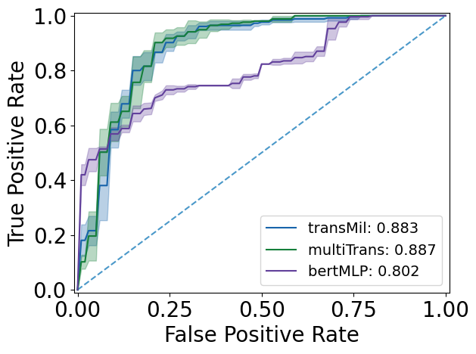
Figure S1. Mean receiver operating characteristic curves with noted AUC of the three ensemble models from the five-fold cross validation tested on the hold-out test set (n=85)

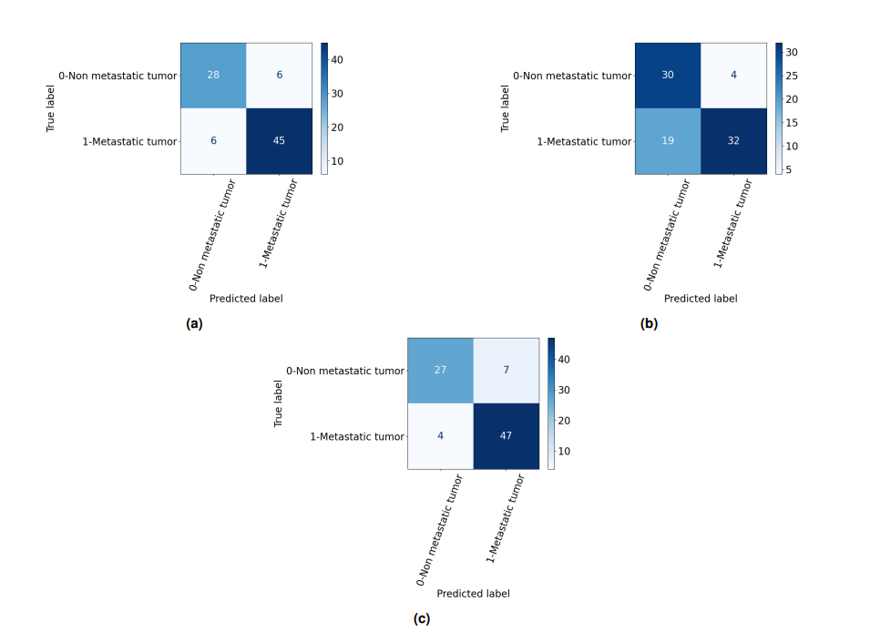

Figure S2. Confusion matrices of (a) TransMIL (b) BertMLP (c) MultiTrans, evaluated on the test set (n=85) at the Youden index.

