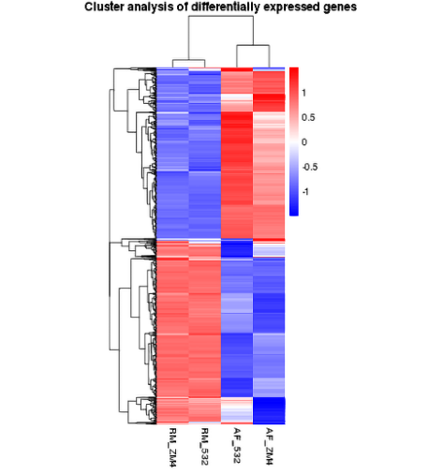

Figure S1 Heatmap clustering analysis of the samples based on log₂ fold change obtained from FPKM data of the DEGs.
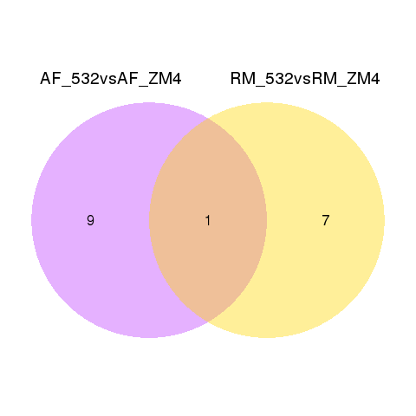
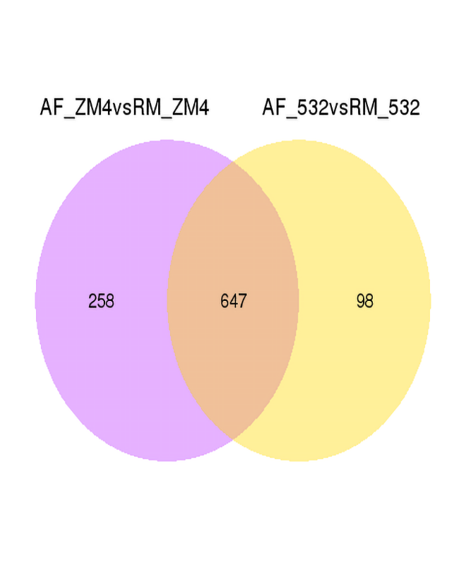
Figure S2 Venn diagram depicting the unique and shared differentially expressed genes between the two Zymomonas mobilis, ZM532 strains, (A) AF_ZM532vsRM_532 (yellow) and its wild type AF_ZM4 vsRM_ZM4 (purple); (B) AF_ZM532vsAF_ZM4 (purple) and RM_ZM532vsRM_ZM4 in response to acetic acid and furfural combine treatments.
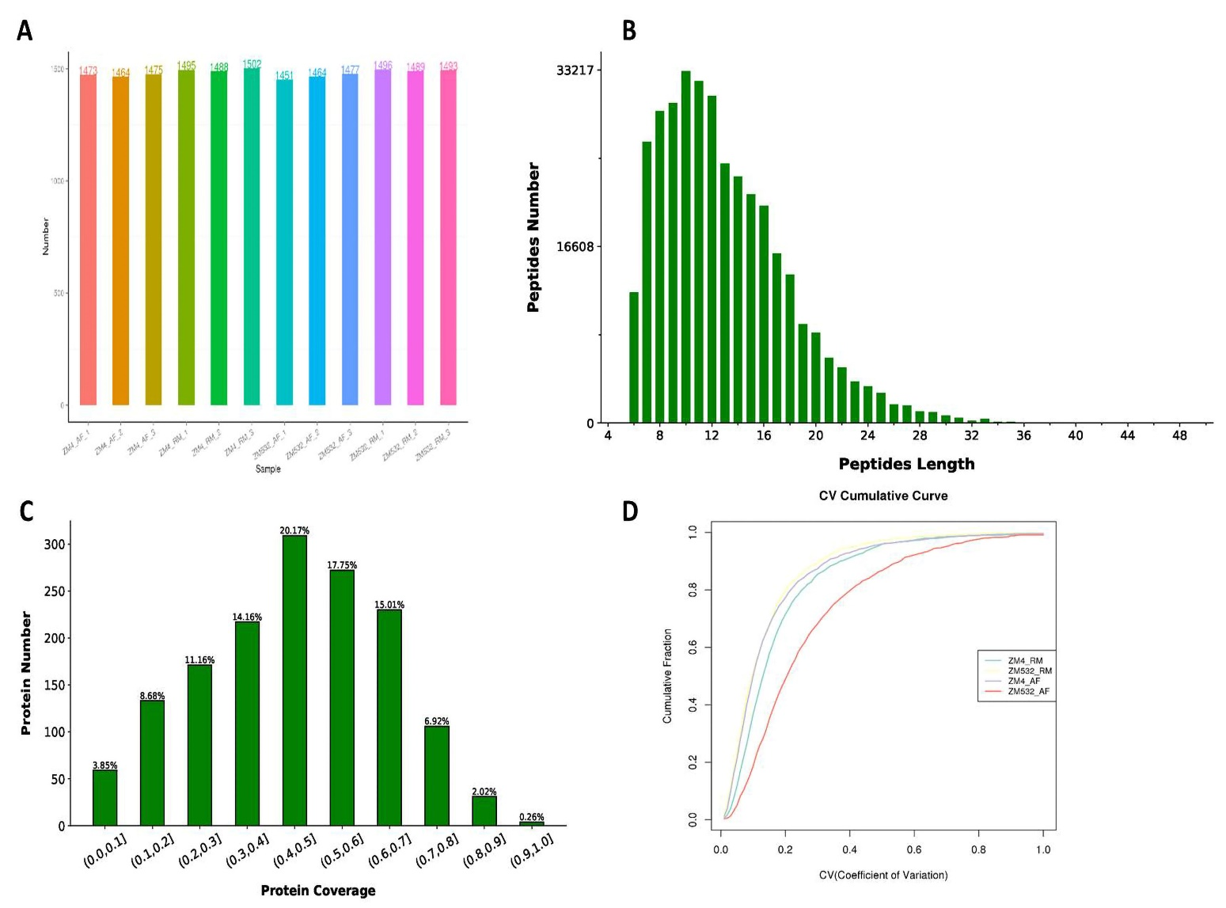

Figure S3 Overview of the quantitative mass spectrometry results (A) Number of proteins identified in each sample; (B) Distribution of peptide length range; (C) Protein molecular weight distribution; (D) Reproducibility between biological replicates.
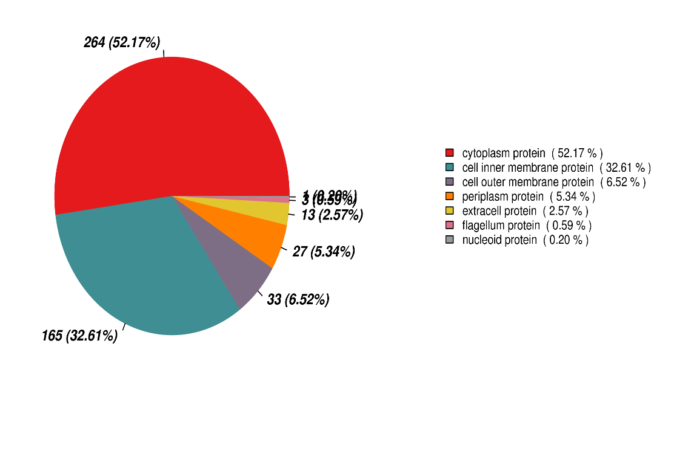
Figure S4 Represented DEPs subcellular localization analysis.
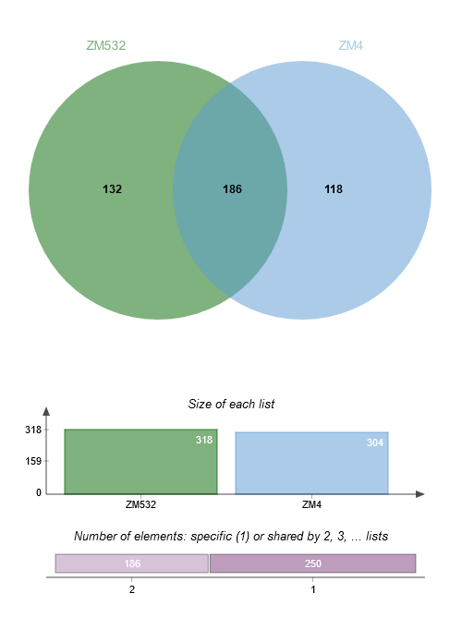

Figure S5 Venn diagram showing the shared and specific (DEP) between ZM4 and ZM532 in response to acetic acid and furfural treatments.
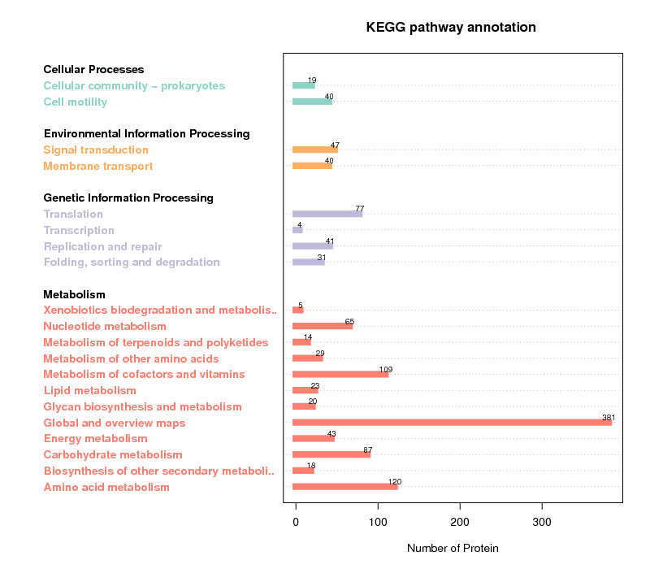
Figure S6 KEGG pathway annotation for Z. Mobilis. The abscissa represents the number of proteins; the pathway categories are shown on the y-axis
A B C

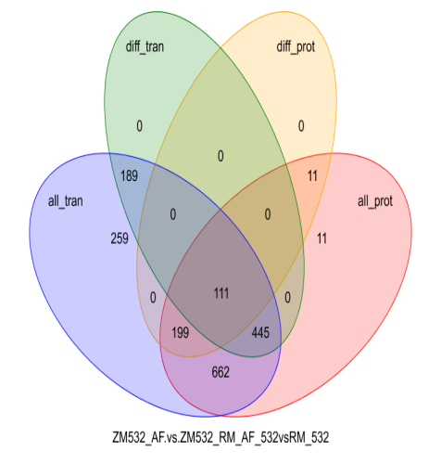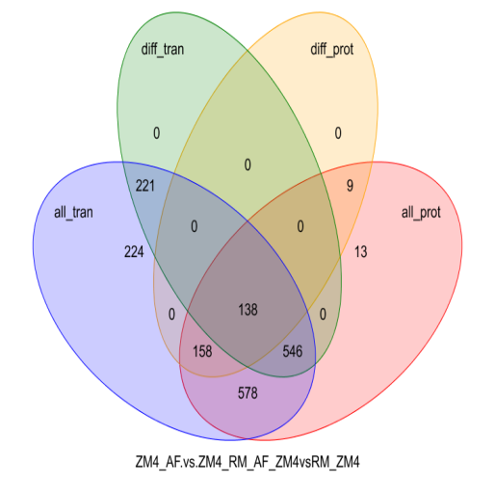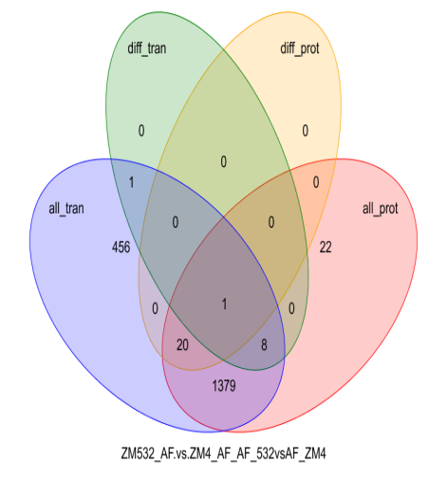
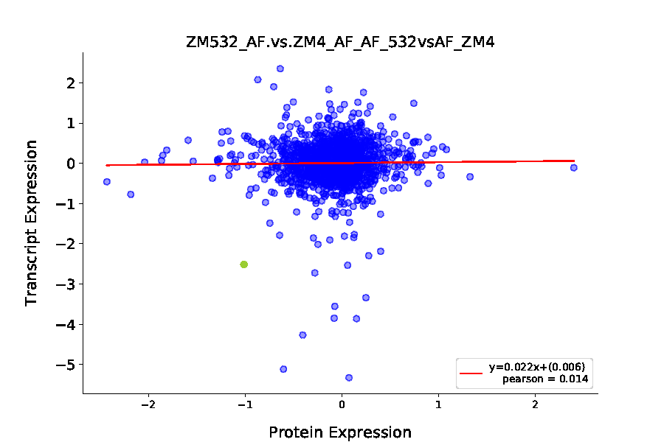
D E F 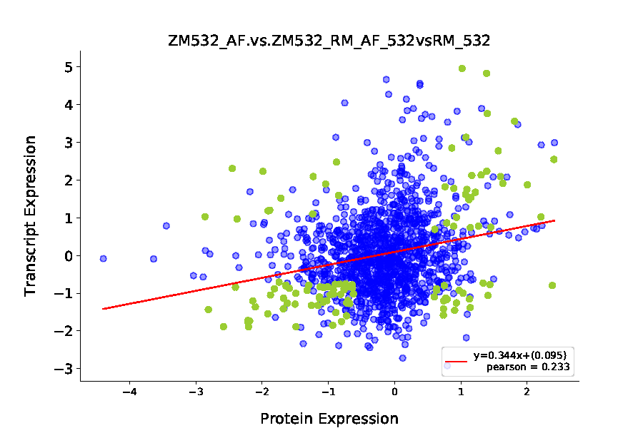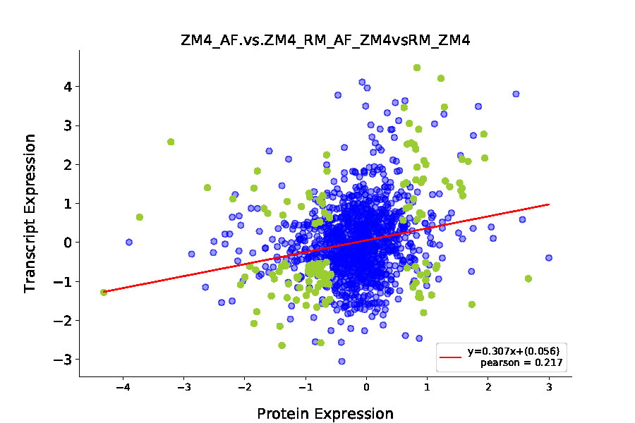
Figure S7 Correlation analysis between transcriptome and proteome. (A-B) The Venn diagram is determined by transcriptome and proteome expression., all the transcripts in our transcriptome data; different_trancripts, differentially expressed transcripts between ZM532_AFvsZM532_RM_AF_532vsRM_532, ZM4_AFvsZM4_RM_AF_ZM4vsRM_ZM4 and ZM532_AFvsZM4_AF_AF_532vsAF_ZM4; different_proteins, distinct expressed proteins between ZM4 and ZM532; all_prot, all the proteins in our proteome data; (C-D) Analysis of correlations between transcriptome and proteome expression levels.
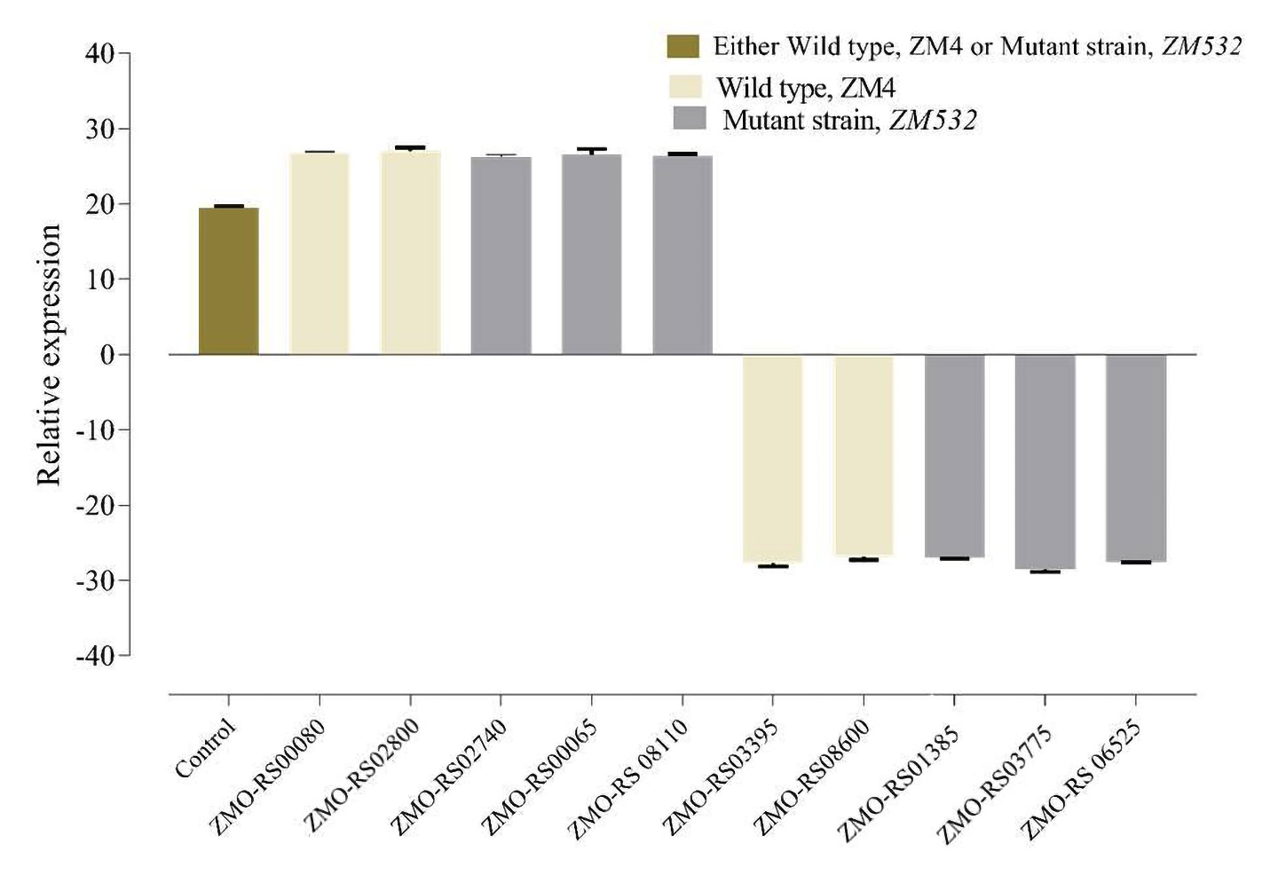
Figure S8 Transcript abundance of 10 selected differentially expressed genes (DEGs) in the two samples (brown bar represents either ZM4 or ZM532 which gave similar expression; gray bar represents expression in the wild type, ZM4; ash bar represents expression in the mutant strain, ZM532. The error bar represents standard error of the three technical repeats
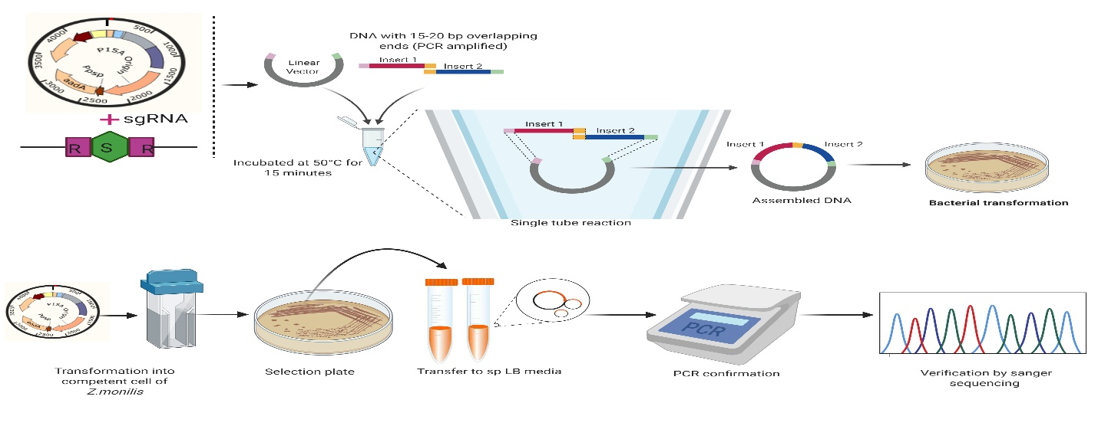
Figure S9 Schematic procedure used in the knock-out of ZM532, ZMO_RS02740 and ZMO_RS06525 in ZM4 and ZM532.

