Appendices Table of Contents
Appendix A. PRISMA 2020 Item Checklist …………...…………………………………….. 56
Appendix B. SWiM Reporting Items …………...……………………………………………. 59
Appendix C. List of Search Terms ...……………….………………………………………… 60
Appendix D. PRISMA Flow Diagram...……………………………………………………… 61
Appendix E. JBI Critical Appraisal Tools...…………………………………………….……. 62

Appendix A: PRISMA 2020 Item Checklist
Section and Topic | Item # | Checklist item | Section where item is reported
TITLE
Title | 1 | Identify the report as a systematic review. | Title
ABSTRACT
Abstract | 2 | See the PRISMA 2020 for Abstracts checklist. | N/A
INTRODUCTION
Rationale | 3 | Describe the rationale for the review in the context of existing knowledge. | Background
Objectives | 4 | Provide an explicit statement of the objective(s) or question(s) the review addresses. | Background
METHODS
Eligibility criteria | 5 | Specify the inclusion and exclusion criteria for the review and how studies were grouped for the syntheses. | Literature Search
Information sources | 6 | Specify all databases, registers, websites, organisations, reference lists and other sources searched or consulted to identify studies. Specify the date when each source was last searched or consulted. | Literature Search
Search strategy | 7 | Present the full search strategies for all databases, registers and websites, including any filters and limits used. | Literature Search
Selection process | 8 | Specify the methods used to decide whether a study met the inclusion criteria of the review, including how many reviewers screened each record and each report retrieved, whether they worked independently, and if applicable, details of automation tools used in the process. | Literature Search
Data collection process | 9 | Specify the methods used to collect data from reports, including how many reviewers collected data from each report, whether they worked independently, any processes for obtaining or confirming data from study investigators, and if applicable, details of automation tools used in the process. | Data Extraction and Analysis
Data items | 10a | List and define all outcomes for which data were sought. Specify whether all results that were compatible with each outcome domain in each study were sought (e.g. for all measures, time points, analyses), and if not, the methods used to decide which results to collect. | Data Extraction and Analysis
Data items | 10b | List and define all other variables for which data were sought (e.g. participant and intervention characteristics, funding sources). Describe any assumptions made about any missing or unclear information. | Data Extraction and Analysis
Study risk of bias assessment | 11 | Specify the methods used to assess risk of bias in the included studies, including details of the tool(s) used, how many reviewers assessed each study and whether they worked independently, and if applicable, details of automation tools used in the process. | Quality Appraisal
Effect measures | 12 | Specify for each outcome the effect measure(s) (e.g. risk ratio, mean difference) used in the synthesis or presentation of results. | N/A
Synthesis methods | 13a | Describe the processes used to decide which studies were eligible for each synthesis (e.g. tabulating the study intervention characteristics and comparing against the planned groups for each synthesis (item #5)). | Data Extraction and Analysis
Synthesis methods | 13b | Describe any methods required to prepare the data for presentation or synthesis, such as handling of missing summary statistics, or data conversions. | Data Extraction and Analysis
Synthesis methods | 13c | Describe any methods used to tabulate or visually display results of individual studies and syntheses. | Data Extraction and Analysis
Synthesis methods | 13d | Describe any methods used to synthesize results and provide a rationale for the choice(s). If meta-analysis was performed, describe the model(s), method(s) to identify the presence and extent of statistical heterogeneity, and software package(s) used. | Data Extraction and Analysis
Synthesis methods | 13e | Describe any methods used to explore possible causes of heterogeneity among study results (e.g. subgroup analysis, meta-regression). | N/A
Synthesis methods | 13f | Describe any sensitivity analyses conducted to assess robustness of the synthesized results. | N/A
Reporting bias assessment | 14 | Describe any methods used to assess risk of bias due to missing results in a synthesis (arising from reporting biases). | Quality Appraisal
Certainty assessment | 15 | Describe any methods used to assess certainty (or confidence) in the body of evidence for an outcome. | Quality Appraisal; Level of Evidence
RESULTS
Study selection | 16a | Describe the results of the search and selection process, from the number of records identified in the search to the number of studies included in the review, ideally using a flow diagram. | Appendix C, Appendix E
Study selection | 16b | Cite studies that might appear to meet the inclusion criteria, but which were excluded, and explain why they were excluded. | Appendix C
Study characteristics | 17 | Cite each included study and present its characteristics. | Appendix E
Risk of bias in studies | 18 | Present assessments of risk of bias for each included study. | Quality Appraisal
Results of individual studies | 19 | For all outcomes, present, for each study: (a) summary statistics for each group (where appropriate) and (b) an effect estimate and its precision (e.g. confidence/credible interval), ideally using structured tables or plots. | Results
Results of syntheses | 20a | For each synthesis, briefly summarise the characteristics and risk of bias among contributing studies. | Results, Discussion
Results of syntheses | 20b | Present results of all statistical syntheses conducted. If meta-analysis was done, present for each the summary estimate and its precision (e.g. confidence/credible interval) and measures of statistical heterogeneity. If comparing groups, describe the direction of the effect. | N/A
Results of syntheses | 20c | Present results of all investigations of possible causes of heterogeneity among study results. | N/A
Results of syntheses | 20d | Present results of all sensitivity analyses conducted to assess the robustness of the synthesized results. | N/A
Reporting biases | 21 | Present assessments of risk of bias due to missing results (arising from reporting biases) for each synthesis assessed. | Discussion
Certainty of evidence | 22 | Present assessments of certainty (or confidence) in the body of evidence for each outcome assessed. | Discussion
DISCUSSION
Discussion | 23a | Provide a general interpretation of the results in the context of other evidence. | Discussion
Discussion | 23b | Discuss any limitations of the evidence included in the review. | Limitations
Discussion | 23c | Discuss any limitations of the review processes used. | Limitations
Discussion | 23d | Discuss implications of the results for practice, policy, and future research. | Discussion
OTHER INFORMATION
Registration and protocol | 24a | Provide registration information for the review, including register name and registration number, or state that the review was not registered. | N/A
Registration and protocol | 24b | Indicate where the review protocol can be accessed, or state that a protocol was not prepared. | N/A
Registration and protocol | 24c | Describe and explain any amendments to information provided at registration or in the protocol. | N/A
Support | 25 | Describe sources of financial or non-financial support for the review, and the role of the funders or sponsors in the review. | N/A
Competing interests | 26 | Declare any competing interests of review authors. | N/A
Availability of data, code and other materials | 27 | Report which of the following are publicly available and where they can be found: template data collection forms; data extracted from included studies; data used for all analyses; analytic code; any other materials used in the review. | Appendices

From: Page MJ, McKenzie JE, Bossuyt PM, Boutron I, Hoffmann TC, Mulrow CD, et al. The PRISMA 2020 statement: an updated guideline for reporting systematic reviews. BMJ 2021;372:n71. doi: 10.1136/bmj.n71

Appendix B: Synthesis Without Meta-analysis (SWiM) Reporting Items
SWiM reporting item | Item description | Section in manuscript where item is reported | Other*
Methods
1 Grouping studies for synthesis | 1a) Provide a description of, and rationale for, the groups used in the synthesis (e.g., groupings of populations, interventions, outcomes, study design) | Appendix H
1 Grouping studies for synthesis | 1b) Detail and provide rationale for any changes made subsequent to the protocol in the groups used in the synthesis | N/A
2 Describe the standardised metric and transformation methods used | Describe the standardised metric for each outcome. Explain why the metric(s) was chosen, and describe any methods used to transform the intervention effects, as reported in the study, to the standardised metric, citing any methodological guidance consulted | N/A
3 Describe the synthesis methods | Describe and justify the methods used to synthesise the effects for each outcome when it was not possible to undertake a meta-analysis of effect estimates | Data Extraction and Analysis
4 Criteria used to prioritise results for summary and synthesis | Where applicable, provide the criteria used, with supporting justification, to select the particular studies, or a particular study, for the main synthesis or to draw conclusions from the synthesis (e.g., based on study design, risk of bias assessments, directness in relation to the review question) | Discussion
SWiM reporting item | Item description | Section in manuscript where item is reported | Other*
5 Investigation of heterogeneity in reported effects | State the method(s) used to examine heterogeneity in reported effects when it was not possible to undertake a meta-analysis of effect estimates and its extensions to investigate heterogeneity | N/A
6 Certainty of evidence | Describe the methods used to assess certainty of the synthesis findings | Discussion
7 Data presentation methods | Describe the graphical and tabular methods used to present the effects (e.g., tables, forest plots, harvest plots).  Specify key study characteristics (e.g., study design, risk of bias) used to order the studies, in the text and any tables or graphs, clearly referencing the studies included | Fig 1: Concept Map of Chronic Cancer Pain Management
Results
8 Reporting results | For each comparison and outcome, provide a description of the synthesised findings, and the certainty of the findings. Describe the result in language that is consistent with the question the synthesis addresses, and indicate which studies contribute to the synthesis | Results  Discussion
Discussion
9 Limitations of the synthesis | Report the limitations of the synthesis methods used and/or the groupings used in the synthesis, and how these affect the conclusions that can be drawn in relation to the original review question | Limitations
PRISMA=Preferred Reporting Items for Systematic Reviews and Meta-Analyses.
*If the information is not provided in the systematic review, give details of where this information is available (e.g., protocol, other published papers (provide citation details), or website (provide the URL)).

Campbell M, McKenzie JE, Sowden A, Katikireddi SV, Brennan SE, Ellis S, Hartmann-Boyce J, Ryan R, Shepperd S, Thomas J, Welch V, Thomson H. Synthesis without meta-analysis (SWiM) in systematic reviews: reporting guideline BMJ 2020;368:l6890 http://dx.doi.org/10.1136/bmj.l6890
Appendix C: List of Search Terms

PubMed
[Title/Abstract]
(Cancer Survivors[Title/Abstract] OR Survivors of Cancer[Title/Abstract] OR Cancer Survivorship[Title/Abstract])
AND
(Pain Management[Title/Abstract] OR Pain Relief[Title/Abstract] OR Pain Control[Title/Abstract] OR Pain Reduction[Title/Abstract] OR Managing Pain[Title/Abstract])
AND
(Barriers[Title/Abstract] OR Obstacles[Title/Abstract] OR Challenges[Title/Abstract] OR Difficulties[Title/Abstract] OR Issues[Title/Abstract] OR Problems[Title/Abstract])

CINAHL
(Cancer Survivors[AB] OR Survivors of Cancer[AB] OR Cancer Survivorship[AB])
AND
(Pain Management[AB] OR Pain Relief[AB] OR Pain Control[AB] OR Pain Reduction[AB] OR Managing Pain[AB])
AND
(Barriers[AB] OR Obstacles[AB] OR Challenges[AB] OR Difficulties[AB] OR Issues[AB] OR Problems[AB])

Scopus
Search Within: Article Title, Abstract, Keywords
(Cancer Survivors OR Survivors of Cancer OR Cancer Survivorship)
AND
(Pain Management OR Pain Relief OR Pain Control OR Pain Reduction OR Managing Pain)
AND
(Barriers OR Obstacles OR Challenges OR Difficulties OR Issues OR Problems)
Embase
(Cancer Survivors[Title/Abstract] OR Survivors of Cancer[Title/Abstract] OR Cancer Survivorship[Title/Abstract])
AND
(Pain Management[Title/Abstract] OR Pain Relief[Title/Abstract] OR Pain Control[Title/Abstract] OR Pain Reduction[Title/Abstract] OR Managing Pain[Title/Abstract])
AND
(Barriers[Title/Abstract] OR Obstacles[Title/Abstract] OR Challenges[Title/Abstract] OR Difficulties[Title/Abstract] OR Issues[Title/Abstract] OR Problems[Title/Abstract])

Appendix D: PRISMA Flow Diagram
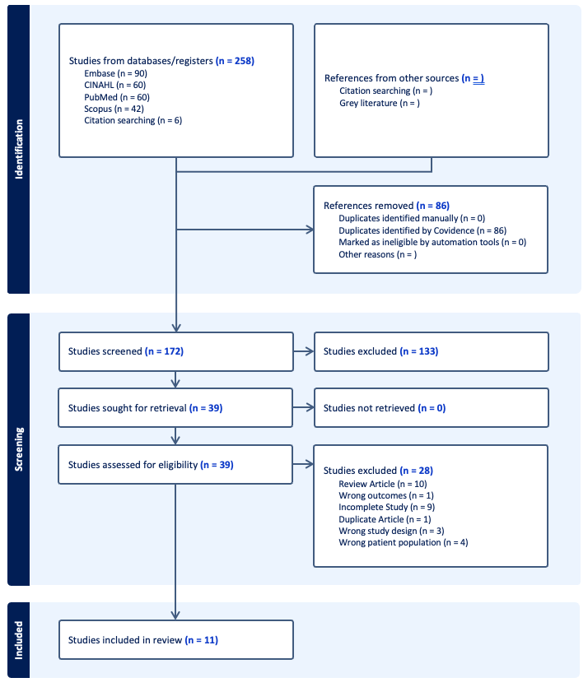

Appendix E: JBI Critical Appraisal Tools
Qualitative Research Appraisal Checklist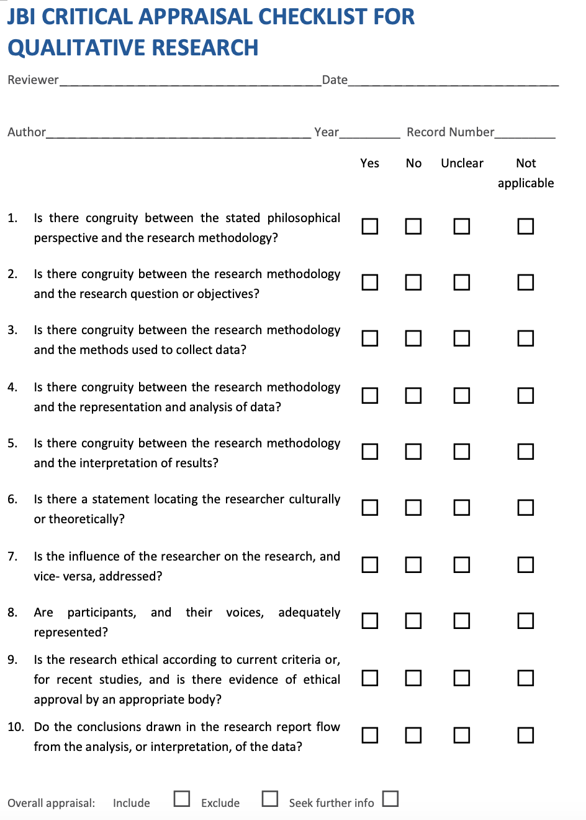

Analytical Cross Sectional Appraisal Checklist
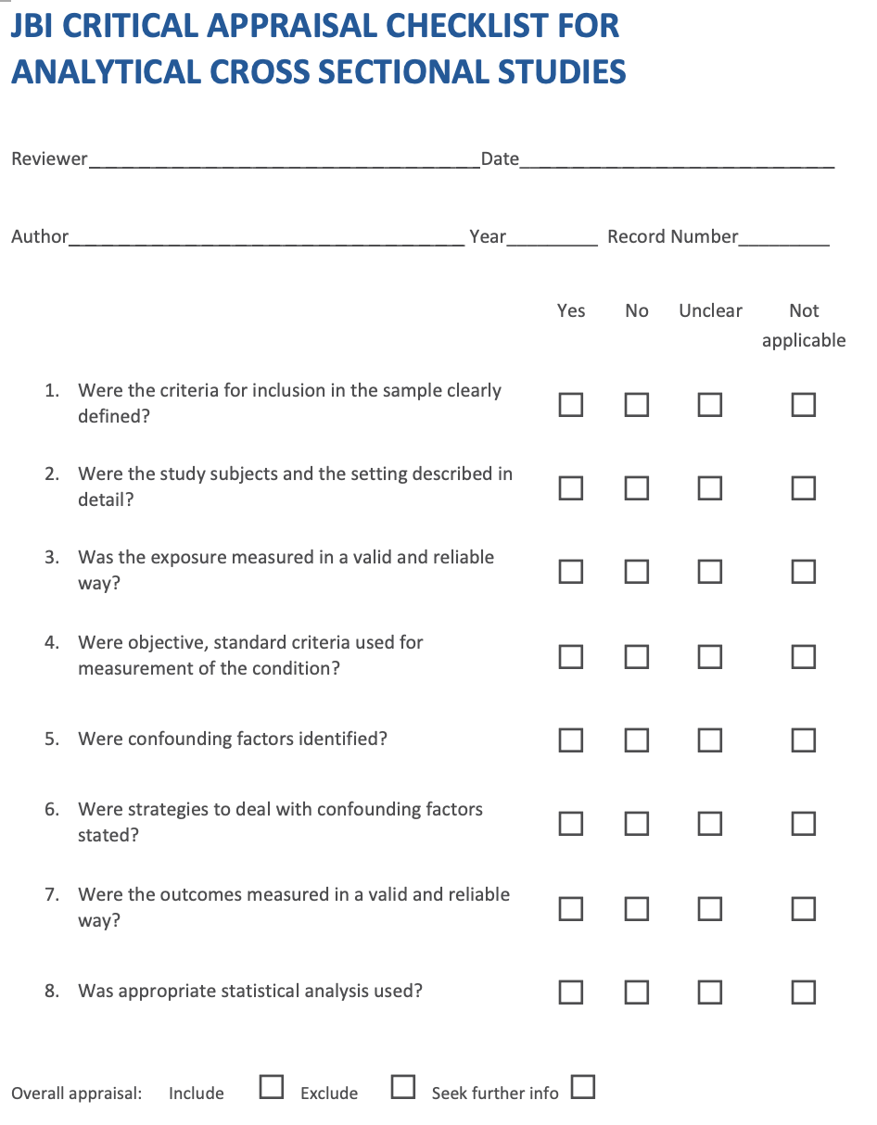

Systematic Review and Research Syntheses Appraisal Checklist
