Supplemental Table 1. Measurement Model Fit Indices across Time Points
Variables | χ²/df | RMSEA |  | CFI
Social Support
BL | 44.1/21 | 0.04 |  | 0.99
FU1 | 35.0/23 | 0.03 |  | 0.99
FU2 | 30.8/22 | 0.04 |  | 0.99
FU3 | 42.5/23 | 0.06 |  | 0.99
Depressive Symptoms
BL | 50.6/23 | 0.04 |  | 0.98
FU1 | 56.1/25 | 0.05 |  | 0.97
FU2 | 54.1/24 | 0.06 |  | 0.97
FU3 | 48.7/23 | 0.07 |  | 0.97
Substance Use Problems
BL | 225.5/77 | 0.05 |  | 0.98
FU1 | 325.5/79 | 0.08 |  | 0.96
FU2 | 228.6/73 | 0.08 |  | 0.97
FU3 | 170.0/70 | 0.08 |  | 0.97
Note. BL = Baseline, FU1 = 6-month follow-up, FU2 = 12-month follow-up, and FU3 = 18-month follow-up.

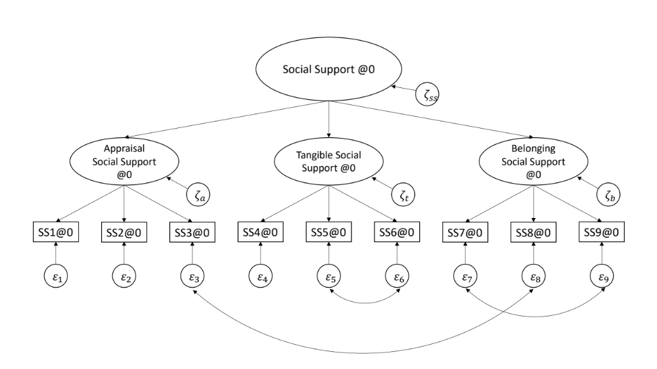
Supplemental Figure 1. Measurement model of social support at baseline. The oval indicates latent variables; the rectangle indicates observed variables (items). SS = social support, @0 = baseline.

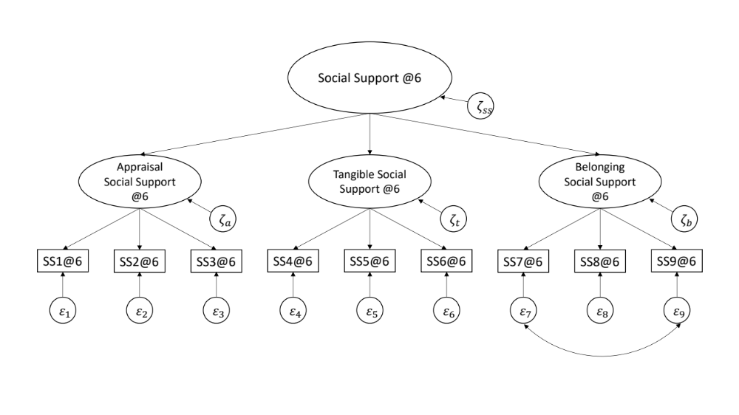
Supplemental Figure 2. Measurement model of social support at 6-month post-baseline. The oval indicates latent variables; the rectangle indicates observed variables (items). SS = social support, @6 = 6-month post-baseline.

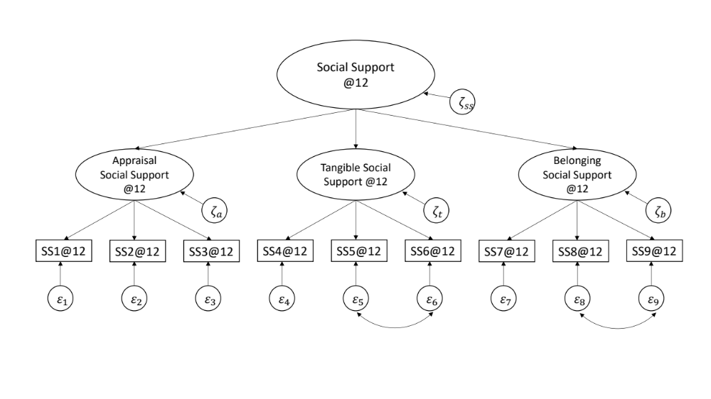
Supplemental Figure 3. Measurement model of social support at 12-month post-baseline. The oval indicates latent variables; the rectangle indicates observed variables (items). SS = social support, @12 = 12-month post-baseline.

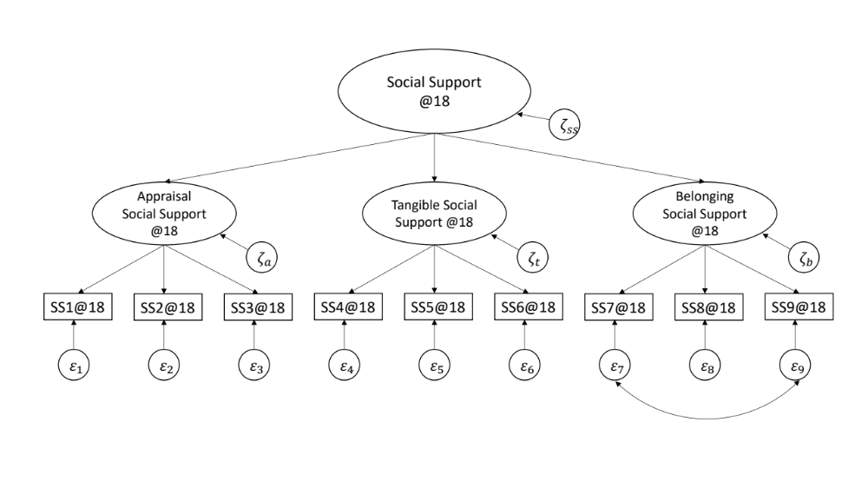
Supplemental Figure 4. Measurement model of social support at 18-month post-baseline. The oval indicates latent variables; the rectangle indicates observed variables (items). SS = social support, @18 = 18-month post-baseline.

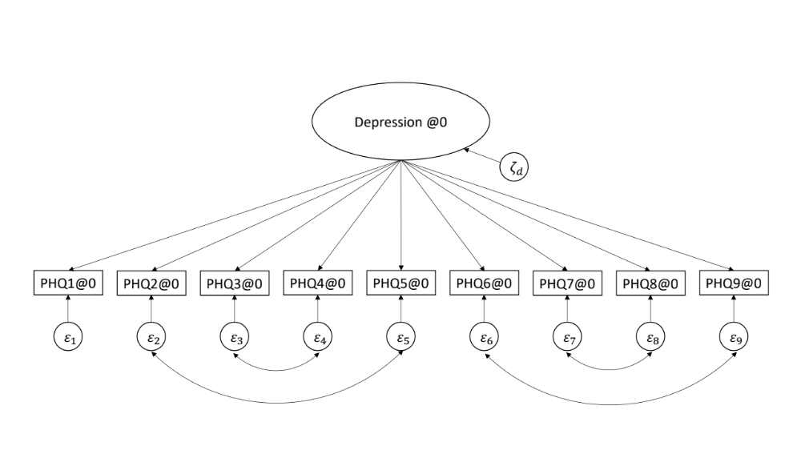
Supplemental Figure 5. Measurement model of depression at baseline. The oval indicates latent variables; the rectangle indicates observed variables (items). PHQ = Patient Health Questionnaire, @0 = baseline.

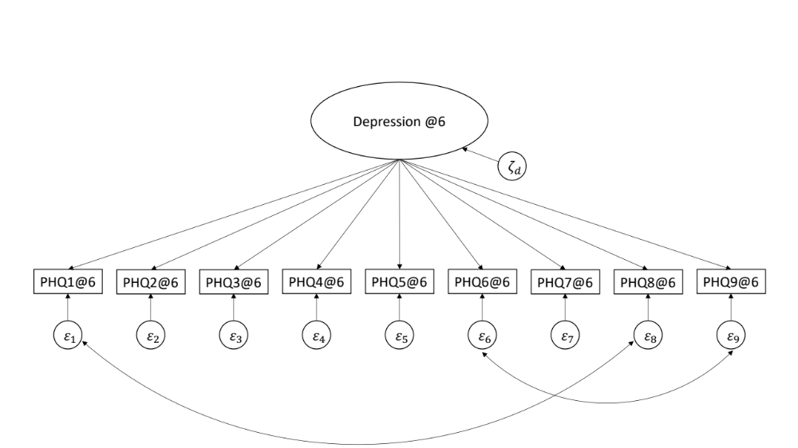
Supplemental Figure 6. Measurement model of depression at 6-month post-baseline. The oval indicates latent variables; the rectangle indicates observed variables (items). PHQ = Patient Health Questionnaire, @6 = 6-month post-baseline.

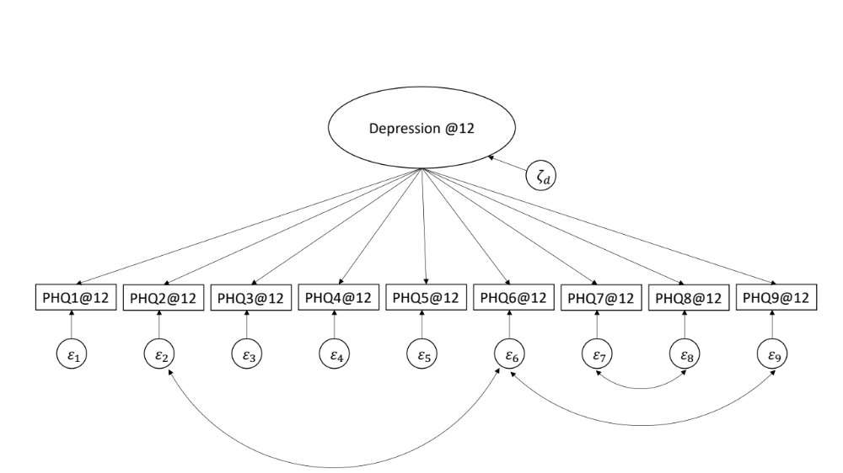
Supplemental Figure 7. Measurement model of depression at 12-month post-baseline. The oval indicates latent variables; the rectangle indicates observed variables (items). PHQ = Patient Health Questionnaire, @12 = 12-month post-baseline.
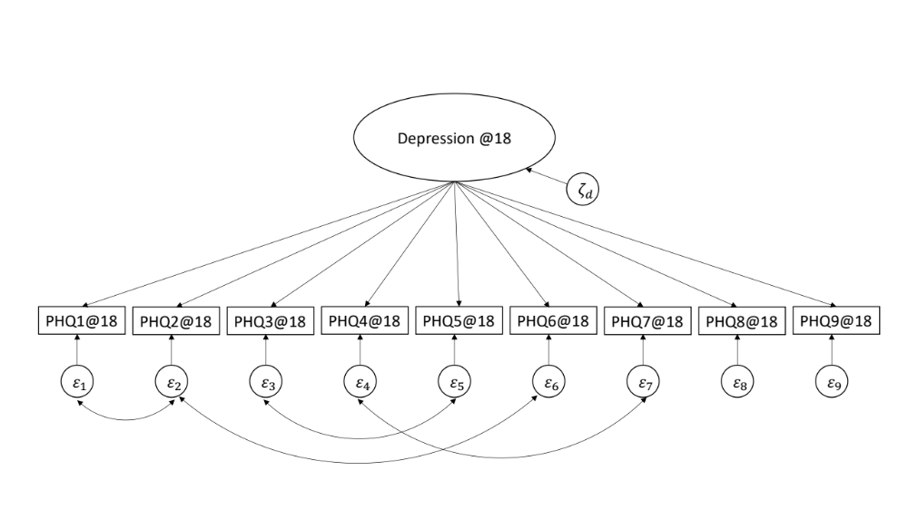
Supplemental Figure 8. Measurement model of depression at 18-month post-baseline. The oval indicates latent variables; the rectangle indicates observed variables (items). PHQ = Patient Health Questionnaire, @18 = 18-month post-baseline.

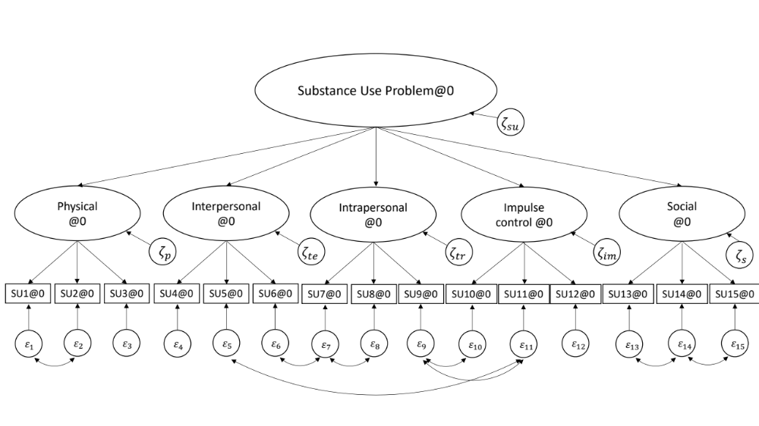
Supplemental Figure 9. Measurement model of substance use problems at baseline. The oval indicates latent variables; the rectangle indicates observed variables (items). SU = substance use problems, @0 = baseline.

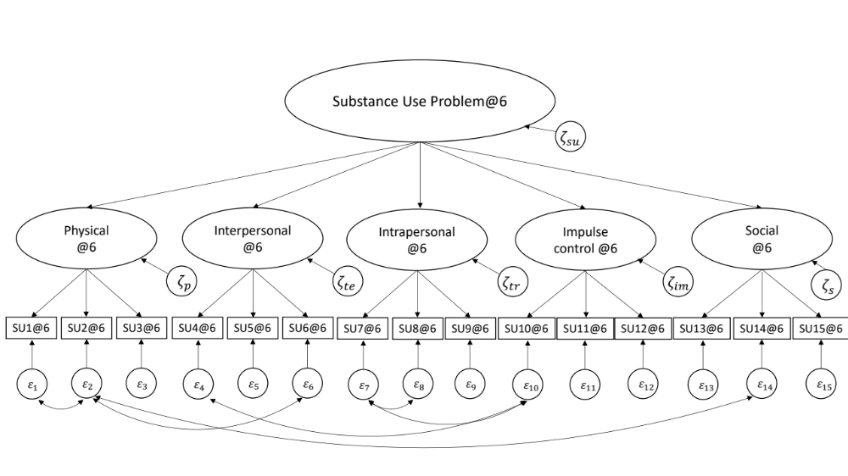
Supplemental Figure 10. Measurement model of substance use problems at 6-month post-baseline. The oval indicates latent variables; the rectangle indicates observed variables (items). SU = substance use problems, @6 = 6-month post-baseline.

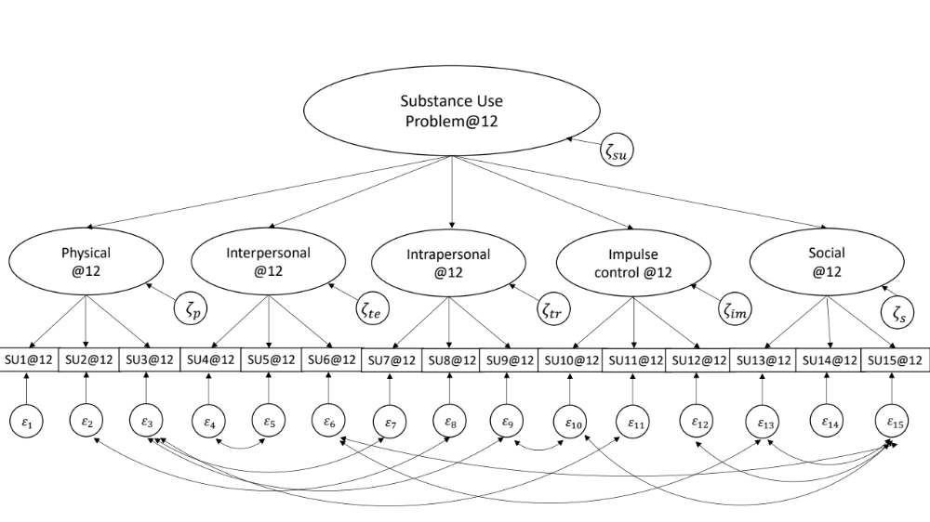
Supplemental Figure 11. Measurement model of substance use problems at 12-month post-baseline. The oval indicates latent variables; the rectangle indicates observed variables (items). SU = substance use problems, @12 = 12-month post-baseline.

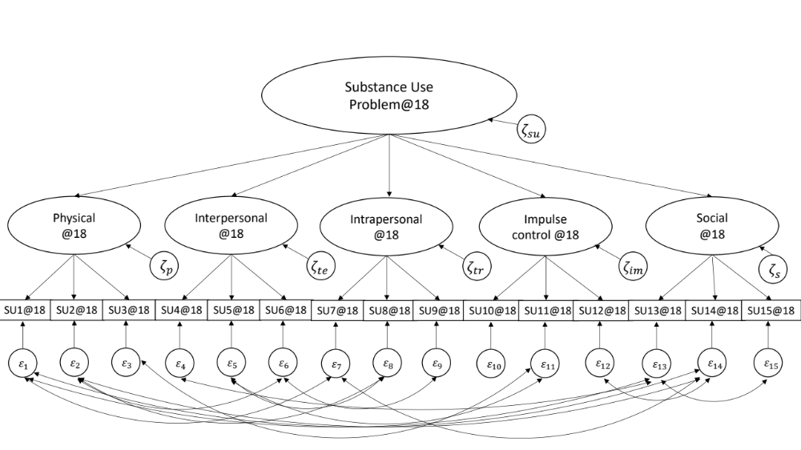
Supplemental Figure 12. Measurement model of substance use problems at 18-month post-baseline. The oval indicates latent variables; the rectangle indicates observed variables (items). SU = substance use problems, @18 = 18-month post-baseline.

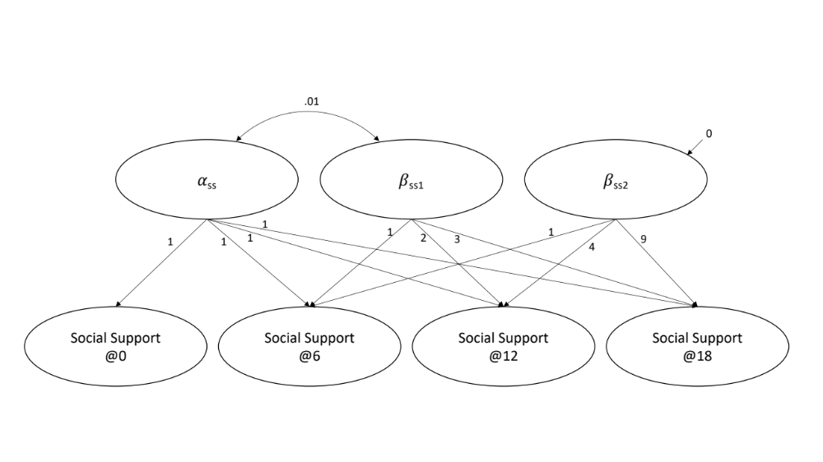
Supplemental Figure 13. Latent growth curve model of social support. The oval indicates latent variables. SS = social support, @0 = baseline, @6 - 18 = 6- to 18-month post-baseline. *p < .05

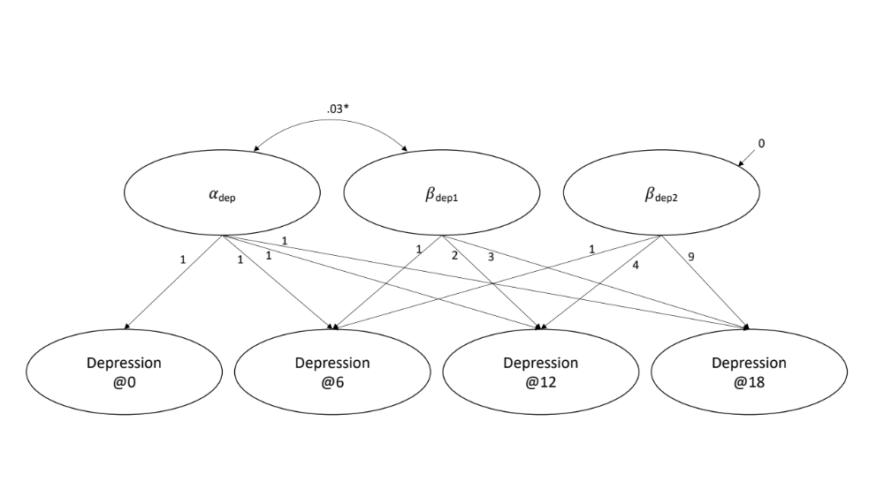
Supplemental Figure 14. Latent growth curve model of depression. The oval indicates latent variables. DEP = depression, @0 = baseline, @6 - 18 = 6- to 18-month post-baseline. *p < .05

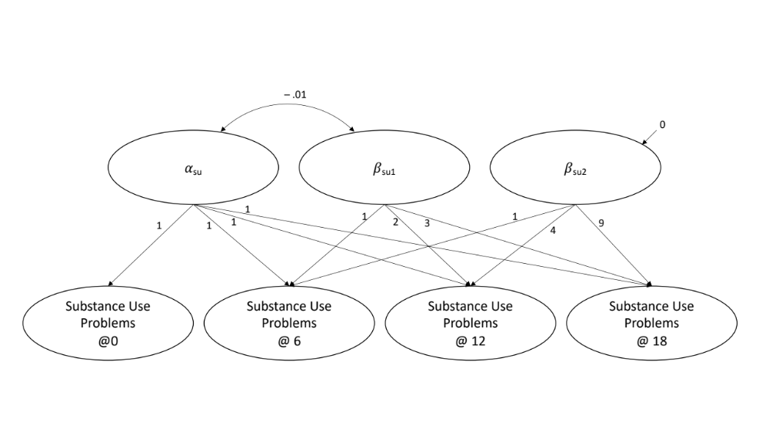
Supplemental Figure 15. Latent growth curve model of substance use problems. The oval indicates latent variables. SU = substance use problems, @0 = baseline, @6 - 18 = 6- to 18-month post-baseline. *p < .05

