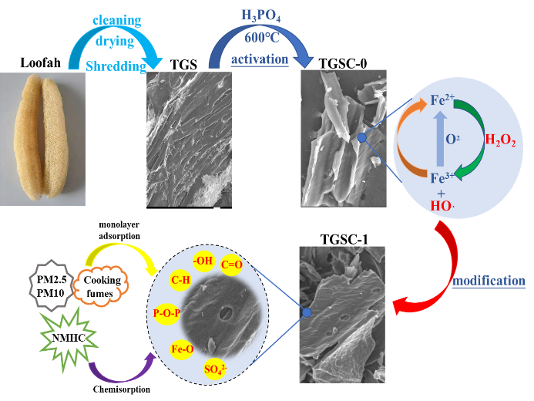
Graphical Abstract
Loofah powder (TGS) was prepared by using natural loofah as the raw material, followed by cleaning and drying, while loofah carbon (TGSC-0) was prepared from TGS by activation with phosphoric acid and carbonization at 600ºC, and TGSC-0 was then further modified by Fenton’s reagent to generate modified loofah carbon (TGSC-1). TGSC-1 exhibited a mesoporous-microporous structure, and the surface was loaded with abundant organic functional groups that can better adsorb pollutants like oils, NMHC, PM2.5, and PM10 that are present in cooking fumes.

