Electronic Supplementary Material

Environmental quality standards for diclofenac derived under the European Water Framework Directive: 3. Marine ecotoxicity
Dean Leverett¹*, Iain Wilson¹, Lucy Kennelly¹, Tom Austin², Cameron Hird^{3,4}, Richard Maunder³, Daniel Hill³, Pete Johnson³
¹ wca Environment Ltd, Brunel House, Volunteer Way, Faringdon, Oxfordshire, SN7 7YR, UK
² Haleon CH SARL, Route de l’Etraz 2, Case Postale 1279, CH-1260 Nyon 1, Switzerland
³ Scymaris Ltd, Freshwater Quarry, Brixham, Devon, TQ5 8BA, UK
⁴ School of Biological and Marine Sciences, University of Plymouth, Drake Circus, Plymouth, Devon, PL4 8AA, UK
* Corresponding author

Material and Methods

Analytical method for the determination of diclofenac sodium in seawater by LC-MS/MS
PREPARATION OF STOCK AND STANDARD SOLUTIONS
Stock solutions of diclofenac and diclofenac-d₄ (internal standards) were prepared in acetonitrile containing 1.0% formic acid. Standard solutions were prepared in 50:50:0.1 (v/v/v) acetonitrile/water/formic acid containing 10 µg/L internal standard.
PROCEDURE FOR SAMPLE PREPARATION
Sea water samples
Sea water samples were prepared by taking 200 mL or 20 mL aliquot of the seawater sample.
Diclofenac-d₄ internal standard (standard in acetonitrile containing 1.0 % formic acid) was added to each sample. Formic acid was added to 0.1% w/w. The samples were then extracted/concentrated by Solid Phase Extraction (SPE).

Solid phase extraction procedure
SPE Cartridge: Agilent Bond Elut C18 500mg, 6 mL
Condition: 5 mL of methanol
Equilibrate: 5 mL of HPLC water
Load Sample: 100 mL of diluted sample
Wash: 5 mL of water
Elute analyte: 2.5 mL of acetonitrile containing 0.1% formic acid (1.5 mL followed by a further 1.0 mL), then add 2.5 mL of LC-MS grade water containing 0.1% formic acid to the extract
During SPE pre-treatment, the flow rate should be low in order to obtain recovery.
An aliquot of the extract was diluted with 50:50 acetonitrile:water (containing 0.1% formic acid) if required prior to analysis by LC-MS/MS.

Sample Introduction and Chromatographic Separation
The following conditions were found to be suitable for the analysis of diclofenac:
Injection volume (µL) 20 µL
Column Poroshell 120 EC C18 (150 x 2.1 mm, 2.7 µm)
Column temperature 30 ^{º}C
Eluent flow rate 200 µL/min
Eluent A 0.1% formic acid in LC-MS grade water
Eluent B 0.1% formic acid in LC-MS grade acetonitrile

Gradient Method:

Time (mins) | A (%) | B (%)
0.00 | 50 | 50
5.00 | 1 | 99
8.00 | 1 | 99
8.01 | 50 | 50
12.00 | 50 | 50

Mass Spectrometer
System: Thermo TSQ Altis/Vanquish Mass Spectrometer
Method Parameters:
Scan type: Selected Reaction Monitoring (SRM)
Source: H-ESI, Negative ion
Collision cell pressure 1.5
Dwell time (ms) 81.13
Q1 Resolution (FWHM) 0.2
Q3 Resolution (FWHM) 1.2

Tune File Parameters:
Sheath gas pressure 25 (Arb)
Auxiliary gas pressure 5.0 (Arb)
Ion sweep gas pressure 1.0 (Arb)
Spray Voltage 2500 (V)
Vaporiser temperature 250 (°C)
Capillary temperature 200 (°C)

Transitions Monitored
Analyte Identification | Typical Retention Time (Minutes) | Ion transitions monitored (m/z) | Collision energy (eV)
Diclofenac | 5.3 | 294 → 250 | 10
Diclofenac | 5.3 | 296 → 252 | 11
Diclofenac-d₄ | 5.3 | 300 → 256 | 11
Quantitation transitions in bold print, confirmation transitions in italic print.
Quantitation and confirmation ion transition data was calculated using the Total Ion Chromatograms (TIC) from the SRM transitions described above.

Analysis of routine parameters, metals and pesticides in seawater supply

Parameter | Seawater Concentration (March 2019)
*pH | 8.03
*Salinity | 34.14
Highest organophosphorous pesticides | <0.01 μg/L
Highest organochlorine pesticides | <0.01 μg/L
Highest PCB | <0.002 μg/L
Aluminium | <40 μg/L
Arsenic | 2.0 μg/L
Boron | 4800 μg/L
Cadmium | <0.03 μg/L
Calcium | 440 mg/L
Cobalt | <10 μg/L
Copper | 0.76 μg/L
Iron | <100 μg/L
Lead | 0.082 μg/L
Magnesium | 1400 mg/L
Manganese | <20 μg/L
Mercury | <0.01 μg/L
Nickel | 0.68 μg/L
Potassium | 420 mg/L
Selenium | <1 μg/L
Silver | <1 μg/L
Sodium | 11000 mg/L
Strontium | 7900 μg/L
Sulphate as SO4 | 2800 mg/L
Vanadium | <20 μg/L
Zinc | 4.0 μg

Paracentrotus lividus test method

Adult P. lividus were sexed prior to the study and exposed to diclofenac sodium under flow-through conditions for 96 hours. The test was run with a dilution water (seawater) control and ten nominal diclofenac concentrations ranging from 0.057 to 2000µg diclofenac sodium/L (Table 1). Test solutions were prepared by mixing stock solutions (prepared in reverse-osmosis water) with 5 µm filtered seawater and were delivered to the test replicates in a flow-through system at a nominal 65 mL/min.
Each replicate tank comprised two male and three female sea urchins. Enough kelp was added to each tank to last the length of the adult exposure. Observations for mortality, abnormal behaviour and appearance were recorded daily.
Following the 96 hour adult exposure phase, the adult sea urchins were removed from the tanks and induced to spawn by injecting 2 mL of 0.5 M potassium chloride into the coelum, through the peristomal membrane surrounding the mouth, on the oral side. An additional 0.5 mL of 0.5 MKCl was injected into seven individual sea urchins where spawning was not induced within 30 minutes of the initial injection. Females were spawned directly into the relevant test solution and males were dry spawned with sperm collected via Pasteur pipette.
Test solutions for the fertilisation phase were prepared using 1µm filtered seawater at the same nominal test concentrations as the adult exposure phase.
Oocytes from the 3 females from each adult exposure replicate tank were pooled together and resuspended at a nominal density of 3000 oocytes/mL. A total of 6x replicate suspensions were prepared for the control (3x replicates from each replicate adult exposure control tank) and a total of 4x replicates per treatment (2x replicates from each replicate adult exposure tank).
Sperm from the two males from each replicate tank was combined and mixed with 1 mL of the relevant test solution. 100 µL of the combined sperm sample was added to each oocyte suspension replicate. Replicates were placed into incubators set at 18±2°C in the dark for 4 hours with continuous orbital rotation of the solutions at 100 rpm.
After 4 hours, two 10 mL samples were taken from each flask. The samples were fixed with neutral buffered formalin (25% of sample volume) to preserve the samples. For each sample, a 1:50 dilution was made with 1 µm filtered seawater and 1 mL of the diluted sample was added to a 1 mL Sedgewick-Rafter counting chamber. The numbers of fertilised and unfertilised oocytes were assessed using light microscopy. A minimum of two counts were made from each 10 mL sample. Additional counts were performed if the total number of oocytes was <100. Successful fertilisation was defined as division of the zygote.
The embryo exposure phase used the same test solutions prepared for the fertilisation phase. Following the 4 hours incubation at the end of the fertilisation phase, a 1 mL sample (nominally 3000 embryos) was added to a 250 mL glass beaker containing 99 mL of the relevant test solution. Each fertilisation replicate seeded an embryo exposure phase replicate, therefore the same level of replication was maintained.
The embryo exposure phase was a 48 hour static test (no renewals) at the same environmental conditions as the adult exposure phase. After 48 hours, each replicate was mixed and two 10 mL samples were taken. The samples were fixed with neutral buffered formalin (25% of sample volume) to preserve the samples. A minimum of two 1 mL subsamples were assessed for each 10 mL sample using a Sedgewick-Rafter counting chamber and light microscopy. Additional counts were performed if the total number of embryos assessed was <50. The number of normal and abnormal embryos were recorded for each sample.
The pH, dissolved oxygen (DO) and salinity of a single replicate tank of the control and each treatment was measured at 0 hours and then daily during the adult exposure phase. The pH, DO and salinity of the excess test solutions was measured at 0 hours during the embryo exposure phase (i.e. fertilisation) and a pooled sample for the control and each treatment at the end of the embryo exposure phase (48 hours). Temperature values during the adult exposure, fertilisation incubation phase and embryo exposure phase were continuously monitored using electronic Max/Min thermometers.
During each phase, the concentrations of diclofenac were measured using the LC-MS/MS method described above. Concentrations were measured in the adult exposure phase on Day -2, Day 0 and at the end of the adult exposure (Day 4). Concentrations were measured in the test solutions used for the fertilisation and embryo exposure phases at the start (0 hours; from excess test solutions) and end (48 hours; from pooled samples) of the embryo exposure phase. Statistical analysis of the fertilisation data and the embryo normality data was undertaken using the CETIS statistical package (version 1.9.4.9).

Psammechinus miliaris test method

Adult P. miliaris were sexed prior to the study and exposed to diclofenac sodium under flow-through conditions for 96 hours. The adult exposure phase was run with a dilution water control and a single nominal test concentration of 20 mg diclofenac sodium/L. To produce the 20 mg/L test solution, a single stock solution was prepared in reverse-osmosis water and mixed with 5 µm filtered seawater and were delivered to the test replicates under a flow-through system at a nominal 25 mL/min flow rate.
Each replicate tank comprised of 2 male and 3 female sea urchins. Enough kelp was added to each tank to last the length of the adult exposure. Observations for mortality, abnormal behaviour and appearance were recorded daily.
Following the 96 hour adult exposure phase, the adult sea urchins were removed from the tanks and induced to spawn by injecting 2 mL of 0.5 M potassium chloride into the coelum, through the peristomal membrane surrounding the mouth, on the oral side. Vigorous shaking was also used to induce spawning. Females were spawned directly into the relevant test solution and males were dry spawned with sperm collected via Pasteur pipette.
Test solutions for the fertilisation phase were prepared 1 µm filtered seawater and included a dilution water (seawater) control and five nominal test concentrations of 1.3 to 20 mg diclofenac sodium/L (Table 1). Two treatments of a nominal diclofenac sodium concentration of 20 mg/L were included in the fertilisation study – the first utilised gametes taken from the adults exposure to 20 mg/L for 96 hours, while a second 20 mg/L used gametes taken from control adults. Gametes for all intermediate concentrations were taken from control adults.
Oocyte suspensions were pooled together from females in the dilution water control and the 20 mg/L treatment, resulting in two oocyte suspensions. Dilutions of the oocyte suspensions were created and counted using a counting chamber on a microscope. The dilutions had densities ranging between 1570 to 1840 eggs/mL. 1 mL of the appropriate diluted oocyte suspension was added to 100 mL of the appropriate treatment solution to produce the test replicates.
Sperm from the males in the dilution water control replicates and the 20 mg/L test concentration replicates was pooled to give two combined sperm samples and mixed with either dilution water or 20 mg/L test solution as appropriate. 100 µL of the combined sperm sample was added to each oocyte suspension replicate. Replicates were placed in an incubator set at 15 ± 2°C in the dark for ~4 hours with continuous orbital rotation of the solutions at 100 rpm.
After 4 hours, a 10 mL sample was taken from each flask. The samples were fixed with neutral buffered formaldehyde solution (5% of sample volume) to preserve the samples. For each 10 mL sample, 1 mL was added to a 1 mL Sedgewick-Rafter counting chamber. The numbers of fertilised and unfertilised oocytes were assessed using light microscopy. Six counts were made from each 10 mL sample. Additional counts were performed if the total number of oocytes was <80. Successful fertilisation was defined as division of the zygote.
The pH, dissolved oxygen (DO), temperature and salinity of a single replicate tank of the control and the 20 mg/L concentration was measured at 0 and 96 hours during the adult exposure phase. The pH, DO and salinity of the excess test solutions was measured at 0 hours during the fertilisation phase. Temperature values during the adult exposure and fertilisation incubation phase were continuously monitored using electronic max/min thermometers.
During each phase, the concentrations of diclofenac were measured using the LC-MS/MS method described above. Concentrations were measured in the adult exposure phase on Day -2, Day 0 and at the end of the adult exposure (Day 4). Concentrations were measured at the start (0 hours) of the fertilisation phase in the excess test solutions. Statistical analysis of the fertilisation data was undertaken using the CETIS statistical package (version 1.9.4.9).

Asterias rubens test method

The study was conducted according to ASTM E1563 Standard Guide (ASTM 2012) with a dilution water (seawater) control and ten nominal diclofenac exposure concentrations ranging from 0.562 to 100 mg diclofenac sodium/L (Table 1). The seawater used to prepare test solutions was further filtered to 1 µm
Five male and five female starfish were removed from the stock tanks and injected with approximately 200 µL of a 1 mM solution of 1 methyladenine into each side of the base of one arm (a total of 400 µL per individual). After 1 hour oocytes and sperm were collected. Each test replicate was seeded with 30 oocytes/mL (3000 oocytes per 100 mL per flask). Sperm was combined and mixed, and then a 5 µL volume added to each test replicate. Flasks were placed into an incubator set at 11 ± 2°C in the dark for 4 hours with continuous orbital rotation of the solutions at 100 rpm.
After 4 hours, one 5 mL sample was taken from each flask. The samples were fixed with 37-41% formaldehyde solution (5% of sample volume) to preserve the samples. Aliquots of the samples were added to a 1 mL Sedgewick-Rafter counting chamber and the numbers of fertilised and unfertilised oocytes assessed using light microscopy. A minimum of three counts were made from each 5 mL sample. Successful fertilisation was defined as formation of the fertilisation membrane, based on images from Carter et al., 2021.
The pH, dissolved oxygen (DO) and salinity of the excess test solutions after test start were measured. Temperature values were continuously recorded in an additional replicate (without gametes) using an electronic monitoring system. The concentrations of diclofenac in the excess test solutions remaining after test start were measured using the LC-MS/MS method described above. Statistical analysis of the fertilisation data was undertaken using the ToxRat solutions statistical package (version 3.3.0).

Arenicola marina test method

Adult lugworms, Arenicola marina, were collected from the wild population at Paignton Beach, Devon, UK, in October 2023, during the spawning season. They were maintained in single-sex tanks using natural sediment from the collection site, under flow through conditions using filtered seawater at 12 ± 2 °C. They were fed with small granular pellets as required.
The test was run using an aqueous-only exposure with a dilution water control and ten nominal test concentrations of 0.01 to 2000 µg diclofenac sodium/L (Table 1). Test solutions were prepared by weighing stock solutions into 1 µm filtered seawater and diluting further with 1 µm filtered seawater as required.
Gametes from three male worms were collected following the initiation of spawning by injection to prevent sperm from being bound together in morulae. Spawning of the males was initiated by the injection of 1 mL 8,11,14-eicosatrienoic acid at 1.3 mg/mL (Pacey and Bentley, 1992), approximately 30 minutes before sperm collection. Sperm from individual males was collected ‘dry’ in a concentrated form as it was released from the nephromixia during spawning and stored on ice for up to 4 hours before use. A subsample of sperm from each male was mixed with seawater and checked for motility. Sperm were observed to have high motility and appeared healthy, so were consequently pooled to create a pooled sperm solution. The pooled sperm suspension was mixed by vigorous shaking for 10 seconds and a 100 µL subsample was diluted 1 in 1000 with 1 µm filtered seawater containing 5 % of 38-41 % formaldehyde solution to immobilise the sperm. The number of sperm in three 1 µm aliquots of this suspension were counted using a Neubaeur Improved Haemocytometer on a microscope to determine the sperm density of the pooled stock.
Gametes from five female worms were collected using a wide-gauge needle to remove the oocytes directly from the coelomic cavity. After allowing to settle and concentrate, oocytes were rinsed to remove excess coelomic fluid by pouring off the overlying water and refilling with fresh seawater multiple times until the solution was colourless, and they were then stored on ice for approximately 1.5 hours before use. The eggs from all five females were assessed as healthy and mature (smooth cell membranes and lack of large germinal vesicles), and consequently combined and mixed by inversion to create a pooled egg suspension. The pooled oocyte suspension was diluted 1 in 100 with 1 µm filtered seawater and the eggs in three homogenous 0.1 mL aliquots were counted using a Sedgewick-Rafter counting chamber on a microscope to determine the oocyte density of the pooled stock.
To start the exposure, the pooled egg suspension was mixed by inversion, and an aliquot was added to each test vessel via pipette to achieve a nominal density of 22.5 eggs/mL in the test replicates. These were exposed for one hour prior to fertilisation. Approximately 5 minutes prior to the initiation of fertilisation, a 5 x 10⁵ sperm/mL intermediate sperm solution was prepared by addition of a subsample of the pooled sperm stock to 100 mL 1 µm filtered seawater. This was mixed by inversion to activate the sperm. Fertilisation was initiated by addition of 2 mL of this intermediate stock to each test replicate to achieve a final sperm concentration of 1 x 10⁴ sperm/mL. Following initiation, the incubator rotation was set to 60 rpm for approximately 10 minutes to increase the instance of egg/sperm interactions. The test vessels were then held in a dark incubator at 12 ± 2 °C for the study duration. The position of the treatments was randomly allocated within the test area.
The study was terminated 2 hours after sperm addition by mixing each replicate with a perforated plunger and taking a 15 mL subsample which was added to a corresponding glass sample vial containing 0.75 mL (5 % sample volume) of 38-41 % formaldehyde solution. These were then mixed by inversion to ensure all embryos were preserved immediately. Subsequently, the number of fertilised and non-fertilised embryos were counted in five subsamples (1 mL volume) for each replicate. A minimum of 100 oocytes were counted for all replicates on a Sedgewick-Rafter grid slide using microscopy. Fertilised oocytes were defined as having intact fertilisation membranes, no discolouration, and obvious polar bodies (Meijer, 1979). Statistical analysis of the fertilisation success data was undertaken using the CETIS statistical package (version 2.1.5.5).
The pH, dissolved oxygen (DO) and salinity of the controls and each treatment were measured at the start of the test, from excess test solutions. Temperature was recorded continuously in a separate vessel, containing dilution water only, using an environmental monitoring system. To establish the concentrations achieved, analysis for diclofenac sodium in the excess test solutions was undertaken using the LC-MS/MS validated method detailed above.

Literature search methodology

Literature searches were conducted regularly as part of a larger project to identify ecotoxicity data for diclofenac, and these were used for the present assessment to identify any long-term ecotoxicity additional data for marine species.
The searches were conducted using the PubMed and Web of Science databases in August and November 2022, February and May 2023, and February 2024. The first search in August 2022 was limited to 2019 onwards, with each subsequent search covering the period from the date of the previous search. The following search terms were used for each search: (diclofenac OR 15307-86-5 OR “2-(2,6-dichloroanilino)phenylacetic acid”) AND (toxicity OR effect) AND (environment OR ecotox* OR aquatic OR soil OR sediment OR mortality OR reproduction OR NOEC OR NOEL OR algae OR fish OR invertebrate OR Daphnia OR crustacean OR avian OR frog OR bird OR “secondary poisoning”).
Some overlap with the period of the EC’s assessment (EC 2022) was applied to identify any additional marine data that may have been published during the assessment phase of the EC’s work (i.e. between the ‘cut-off’ for new data applied in that assessment and the publication of the finalised EQS dossier for diclofenac (EC 2022)).

Results and Discussion
Table S1 Test parameters and EC10/ NOEC thresholds for fertilisation studies with three echinoderms and an annelid worm
Taxonomic Group | Species | Replicates | Replicate volume/ test vessel | Duration | Endpoint | Nominal Concs | Measured Concs | pH range | EC/LC10 | NOEC
Echinoderms | Paracentrotus lividus | 2 per treatment | 12L in glass aquaria | 96 hours | Adult mortality | 0.057, 0.182, 0.582, 1.86, 5.96, 19.1, 61.0, 195, 625 and 2000 μg/L | 0.0533, 0.167, 0.520, 1.61, 5.77, 16.9, 52.7, 176, 568 and 1810 μg/L | 7.95 to 8.14 | >1810 μg/L | 1810 μg/L
Echinoderms | Paracentrotus lividus | 4 per test concentration; 6 for seawater control | 100mL in glass conical flasks | 96 + 4 hours | Fertilisation** | 0.057, 0.182, 0.582, 1.86, 5.96, 19.1, 61.0, 195, 625 and 2000 μg/L | 0.0701, 0.200, 0.694, 2.36, 7.16, 17.4, 59.3, 179, 593 and 1870 μg/L | 8.10 to 8.16 | >1870 μg/L | 1870 μg/L
Echinoderms | Paracentrotus lividus | 4 per test concentration; 6 for seawater control | 99mL in glass beakers | 96 + 48 hours | Embryo-larval development** | 0.057, 0.182, 0.582, 1.86, 5.96, 19.1, 61.0, 195, 625 and 2000 μg/L | 0.0701**, 0.191, 0.615, 2.02, 6.21, 17.1, 58.5, 178, 580 and 1840 μg/L | 8.04 to 8.16 | >1840 μg/L | 1840 μg/L
Echinoderms | Psammechinus miliaris | 2 for 20 mg/L treatment; 4 for seawater control | 12L in glass aquaria | 96 hours | Adult mortality | 20 mg/L | 17.4 mg/L | 7.93 to 7.96 | > 17.4 mg/L | 17.4 mg/L
Echinoderms | Psammechinus miliaris | 4 per test concentration; 6 for seawater control | 100mL in glass beakers | 4 hours | Fertilisation* | 1.3, 2.5, 5.0, 10 and 20 mg/L | 0.979, 1.62, 4.38, 8.57 and 19.4 mg/L | 7.93 to 8.06 | > 19.4 mg/L | 8.57 mg/L
Echinoderms | Psammechinus miliaris | 4 per test concentration; 6 for seawater control | 100mL in glass beakers | 96 + 4 hours | Fertilisation** | 20 mg/L | 19.4 mg/L | 7.93 to 8.06 | NA | < 19.4 mg/L
Echinoderms | Asterias rubens | 4 per test concentration; 6 for seawater control | 100mL in glass conical flasks | 4 hours | Fertilisation | 0.562, 1.00, 1.78, 3.16, 5.62, 10.0, 17.8, 31.6, 56.2 and 100 mg/L | 0.650, 1.07, 2.10, 3.95, 6.48, 11.5, 20.0, 33.0, 58.9 and 113 mg/L | 7.60 to 7.86 | 13.0 mg/L  (6.90 – 24.6 mg/L) | 6.48 mg/L
Annelid Worms | Arenicola marina | 4 per test concentration; 6 for seawater control | 100mL in glass beakers | 3 hours | Fertilisation* | 0.01, 0.05, 0.17, 0.66, 2.52, 9.59, 36.4, 139, 526, 2000 μg/L | 0.0192, 0.0556, 0.144, 0.578, 1.96, 6.78, 27.0, 154, 526, 2340 µg/L | 8.23 to 8.24 | 0.776 μg/L (CLs not calculable) | 0.578 µg/L
* Gametes obtained from unexposed adults
** Gametes obtained from adults exposed for 96 hours to the same nominal concentrations as the fertilisation/ embryo-larval study

Paracentrotus lividus test results and statistical analysis

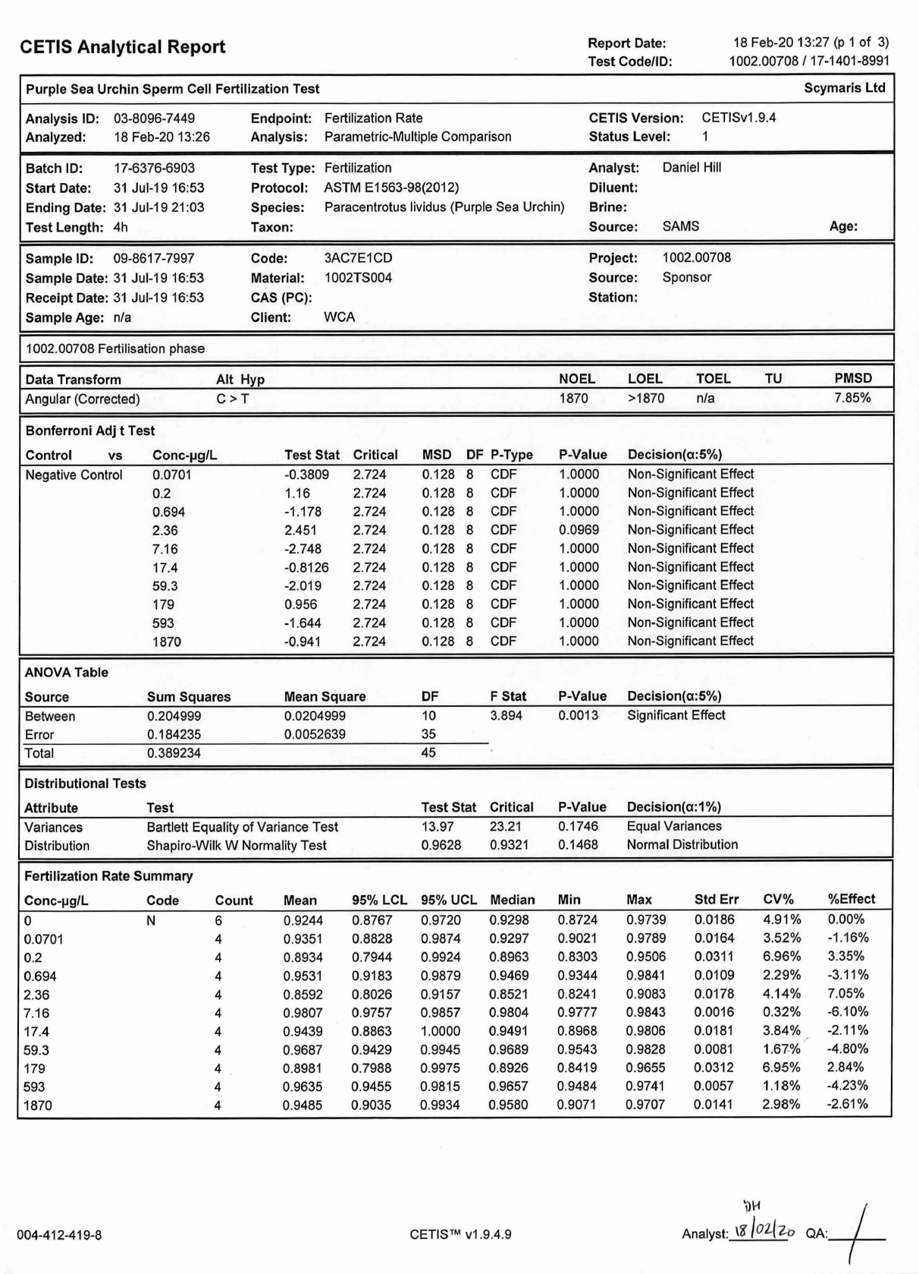

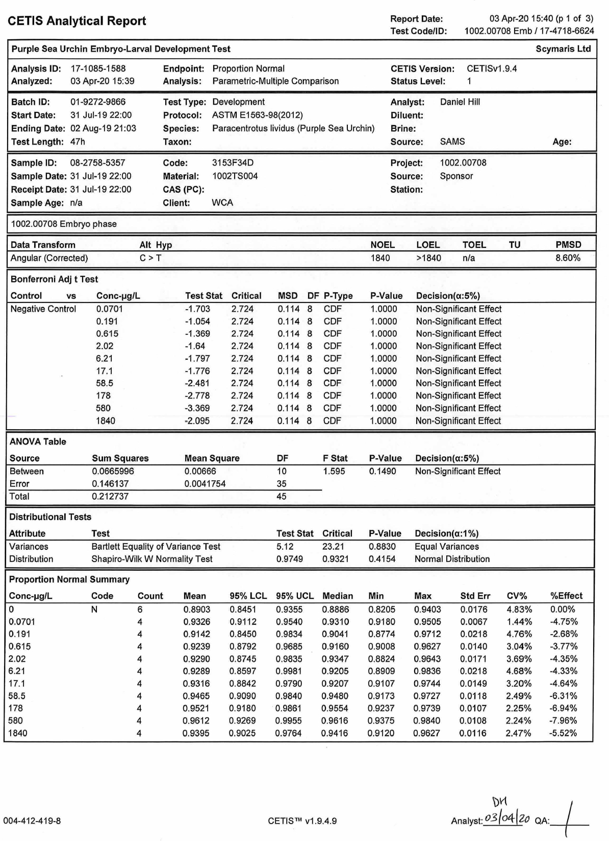

Psammechinus miliaris test results and statistical analysis

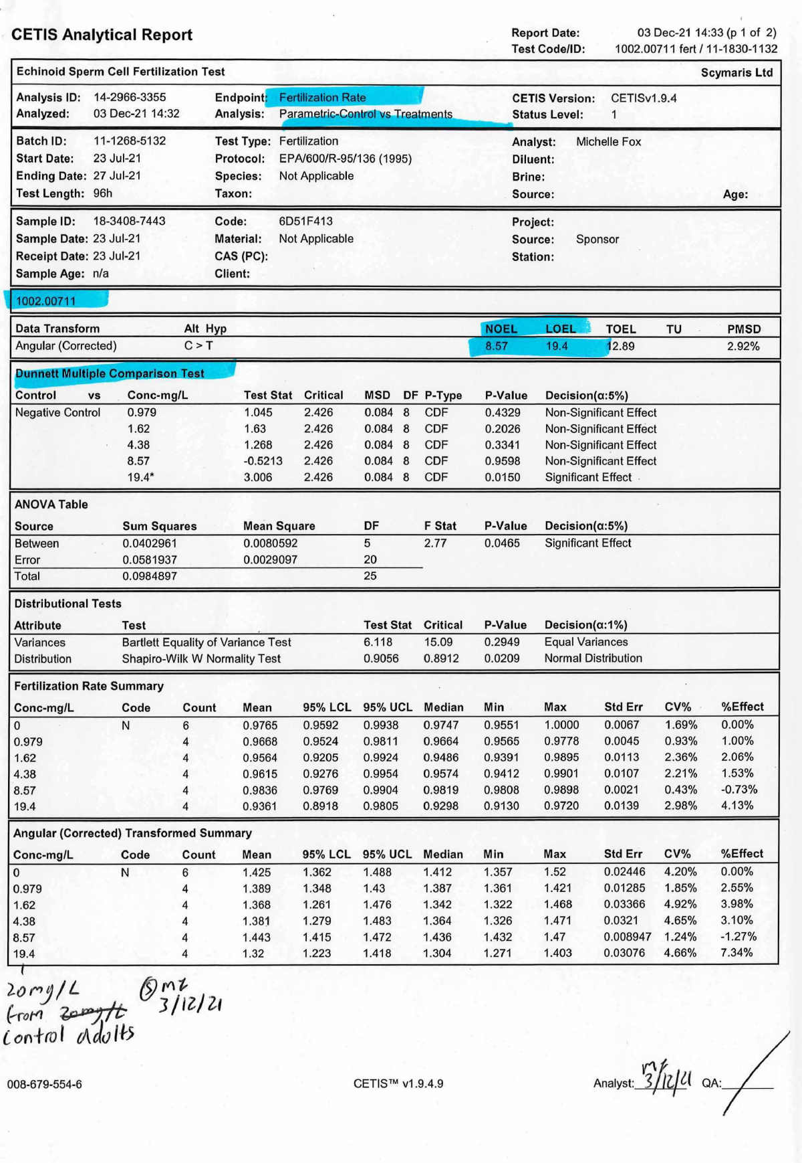

Asteria rubens test results and statistical analysis

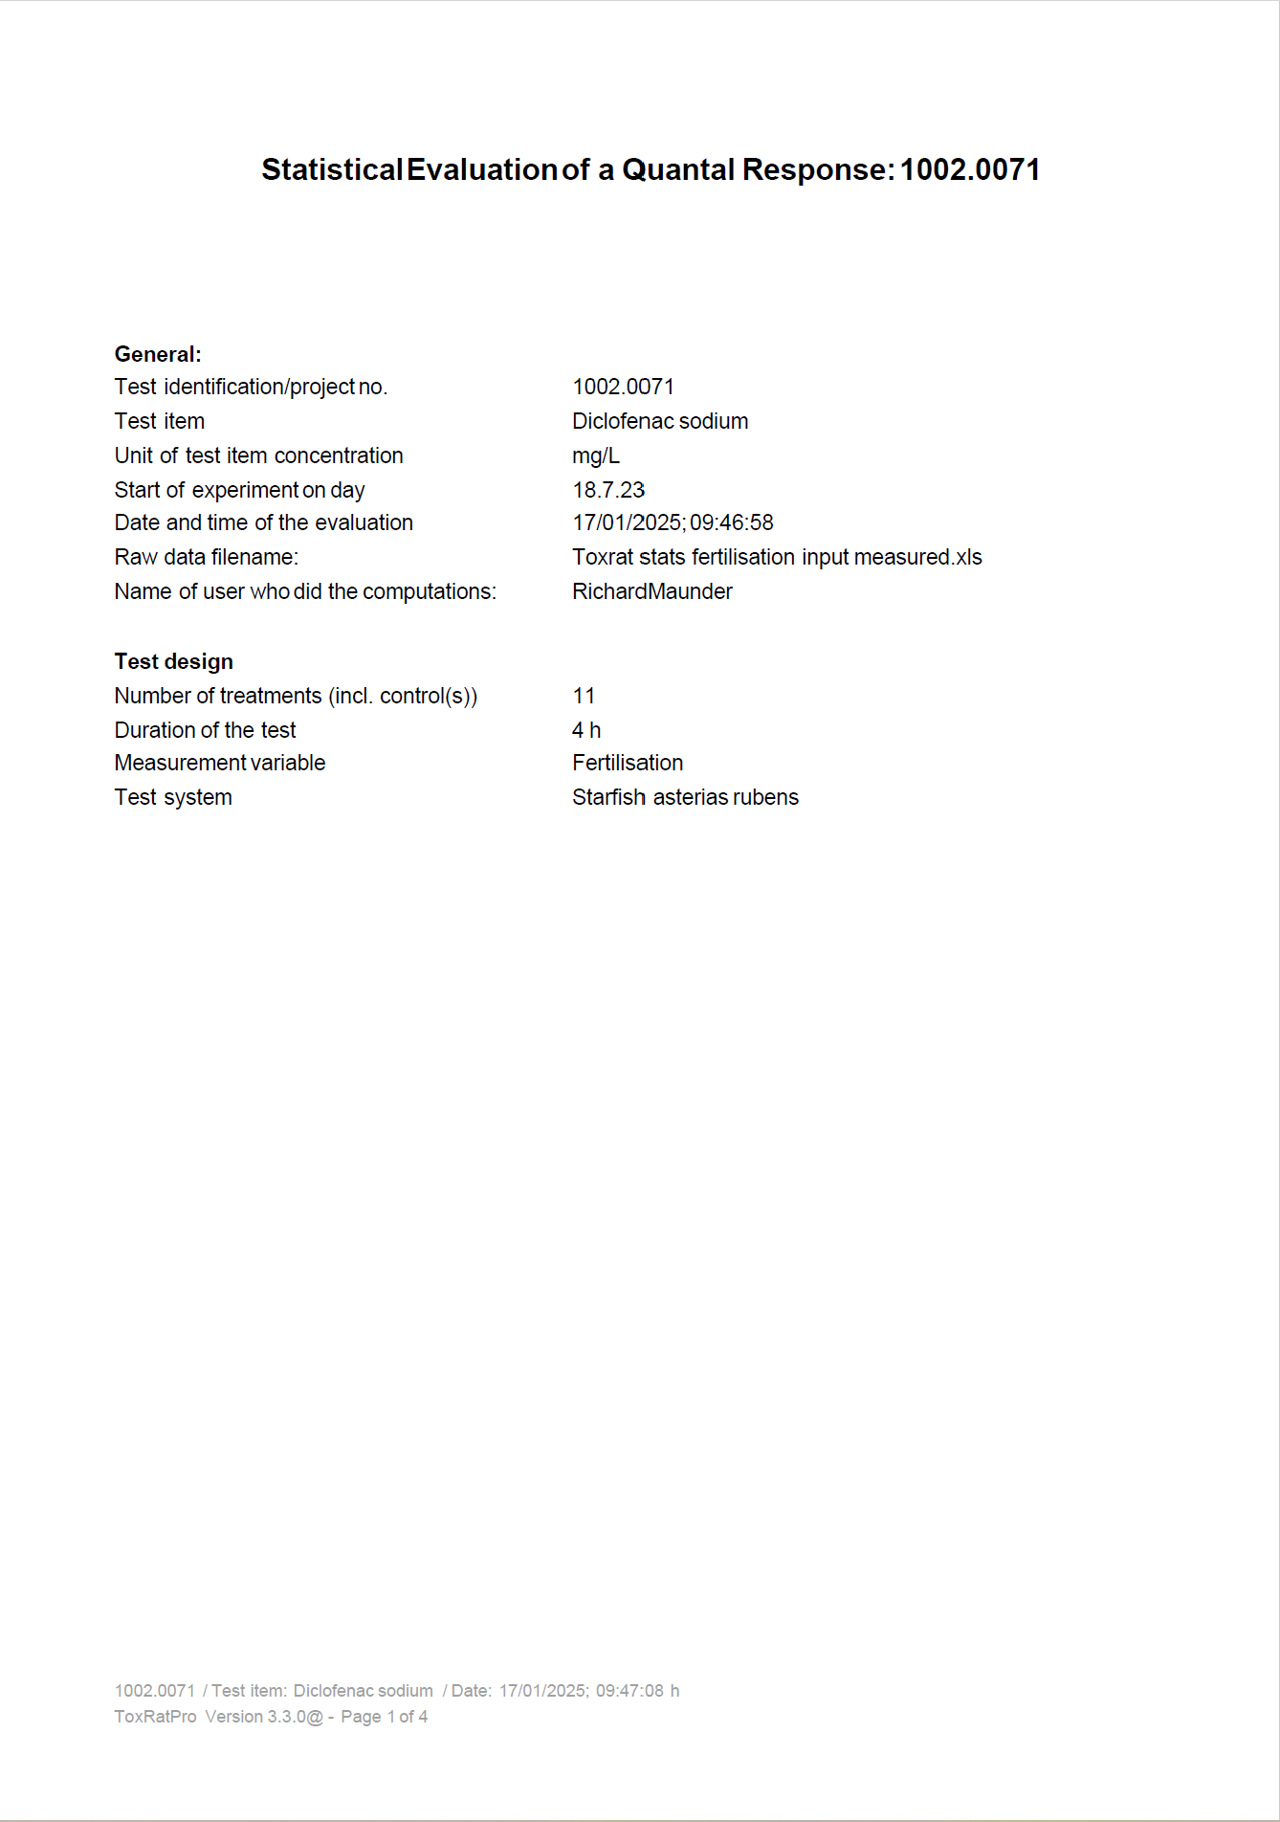
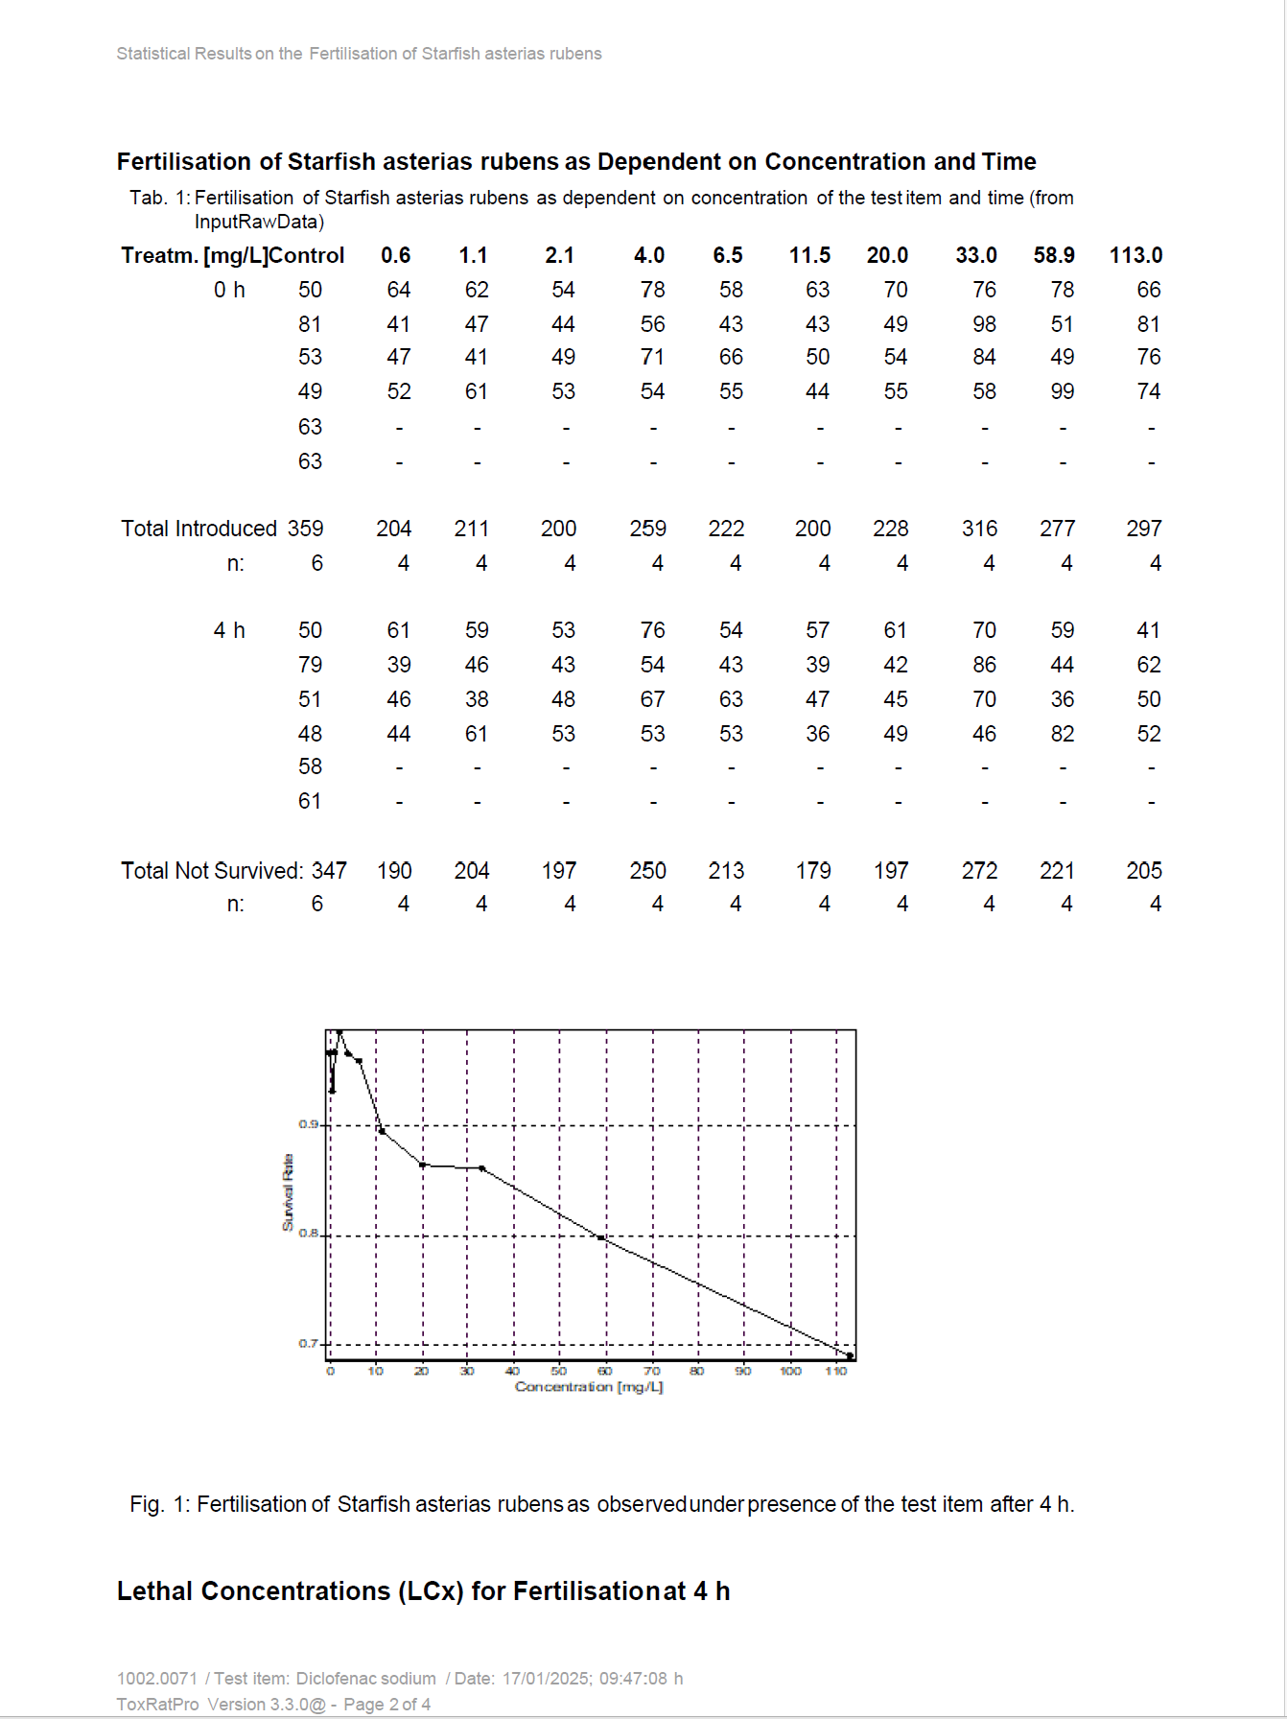

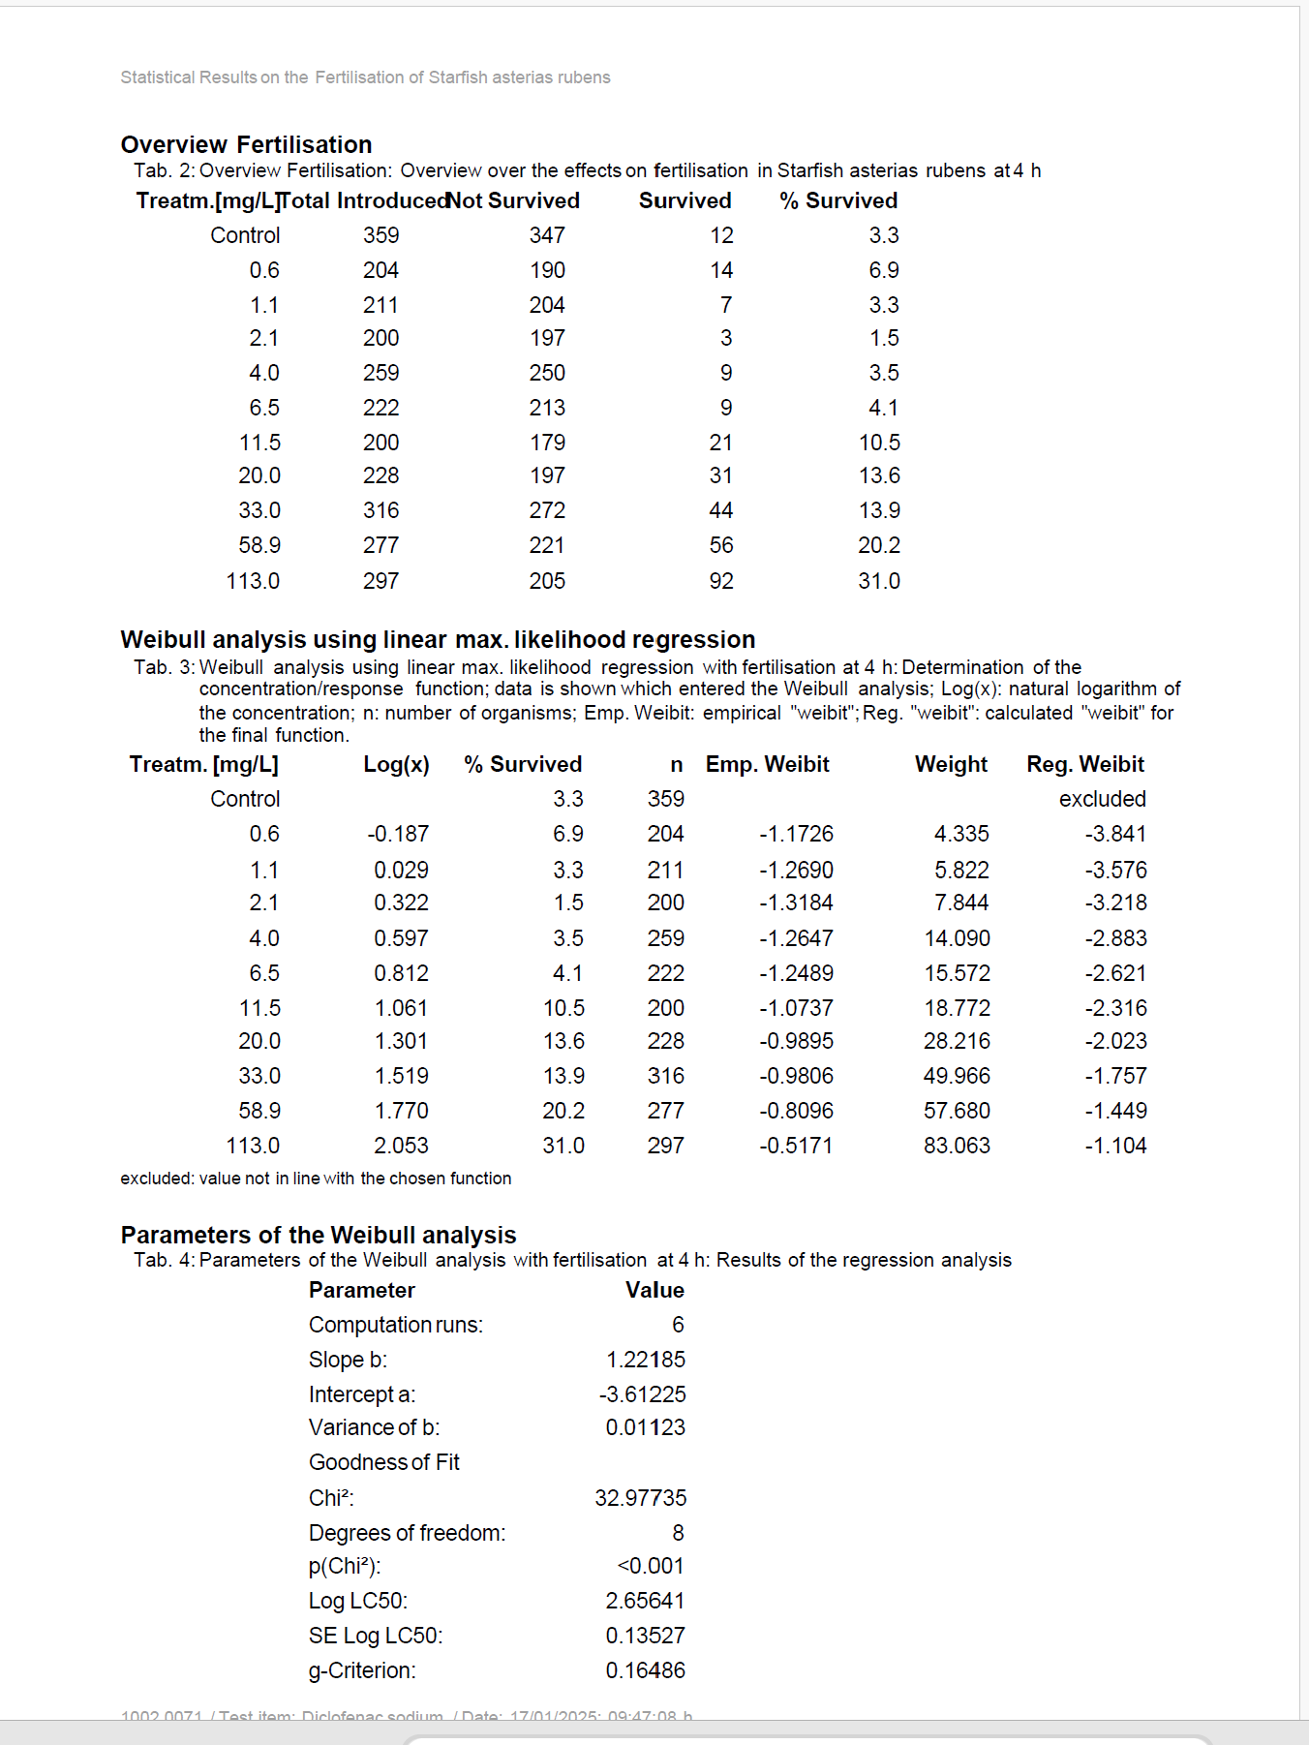

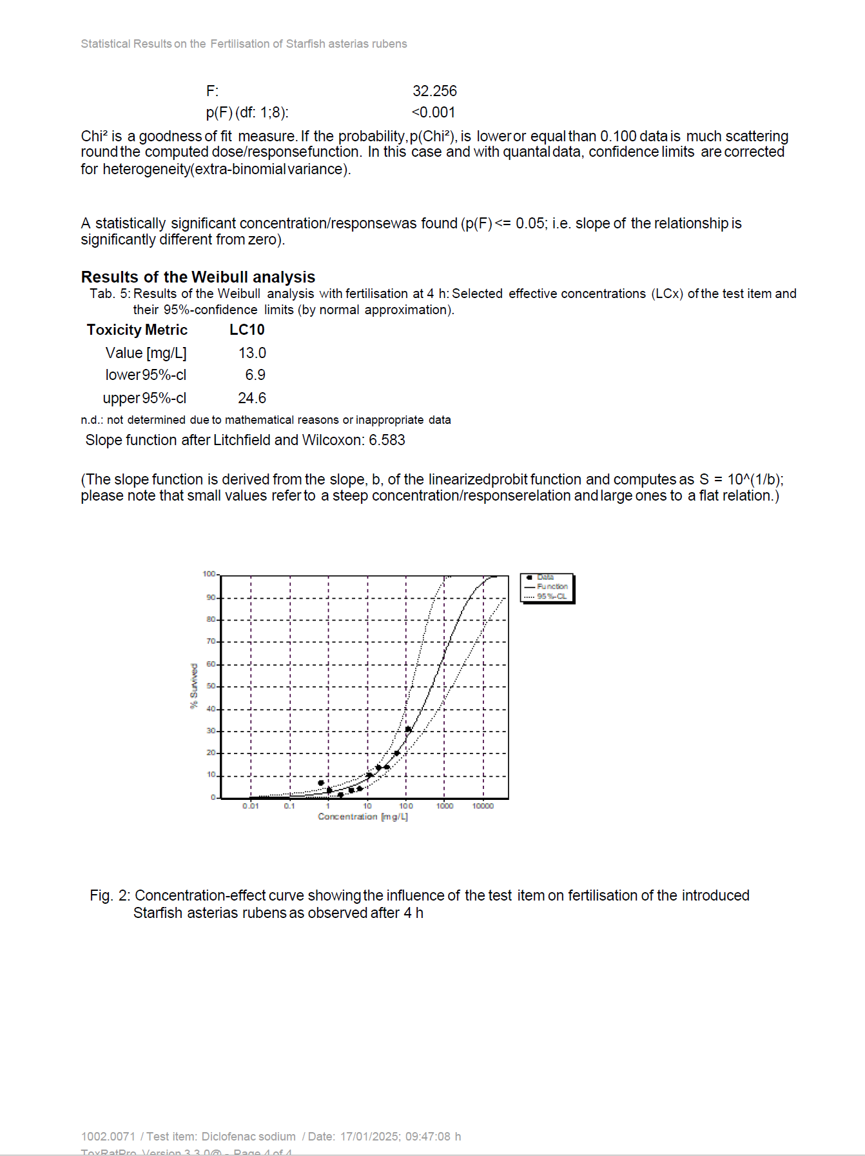

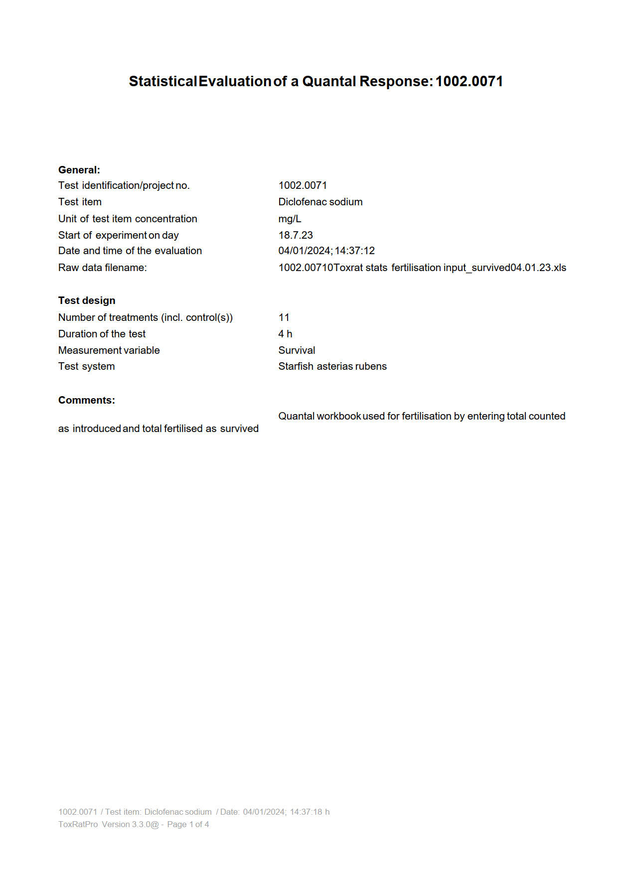

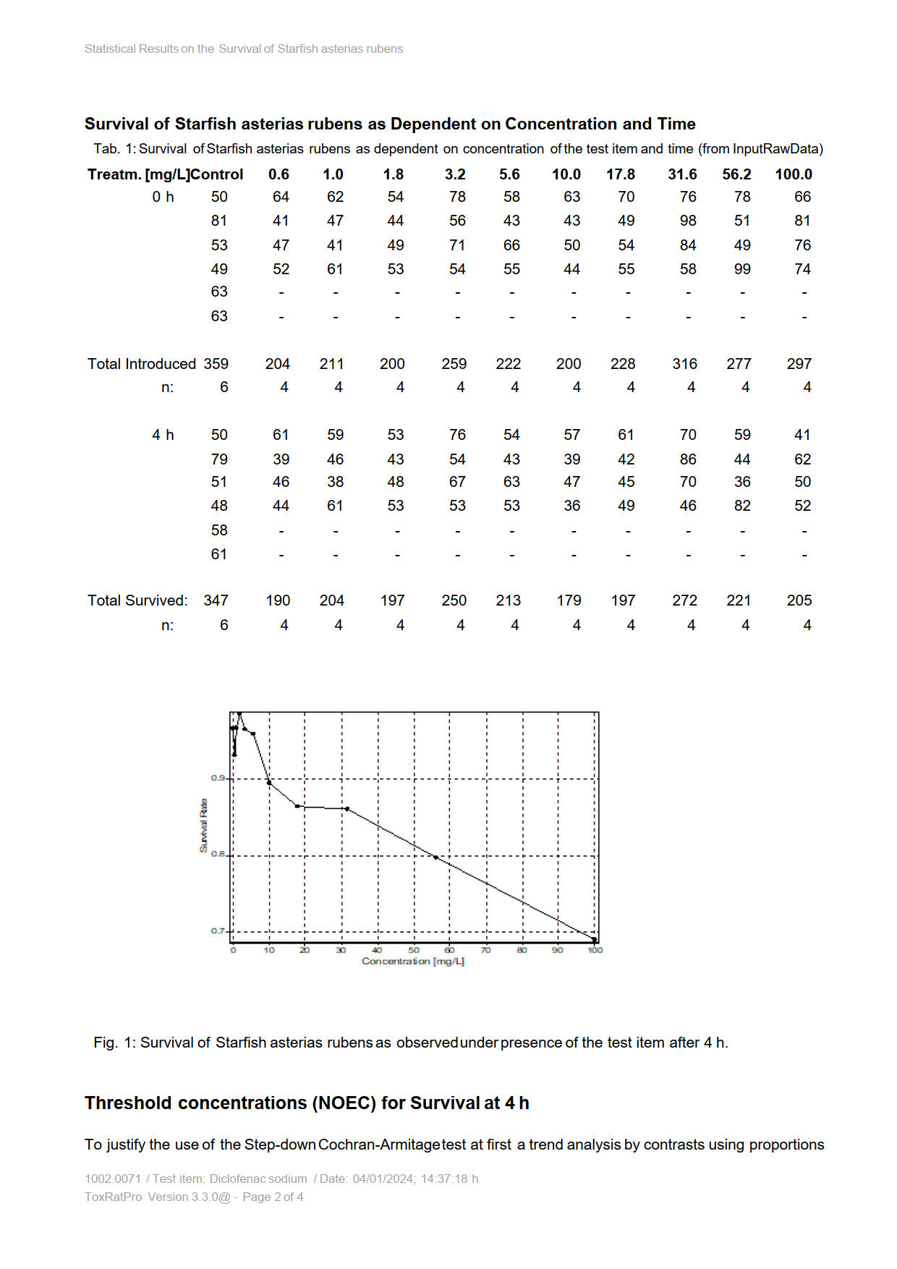
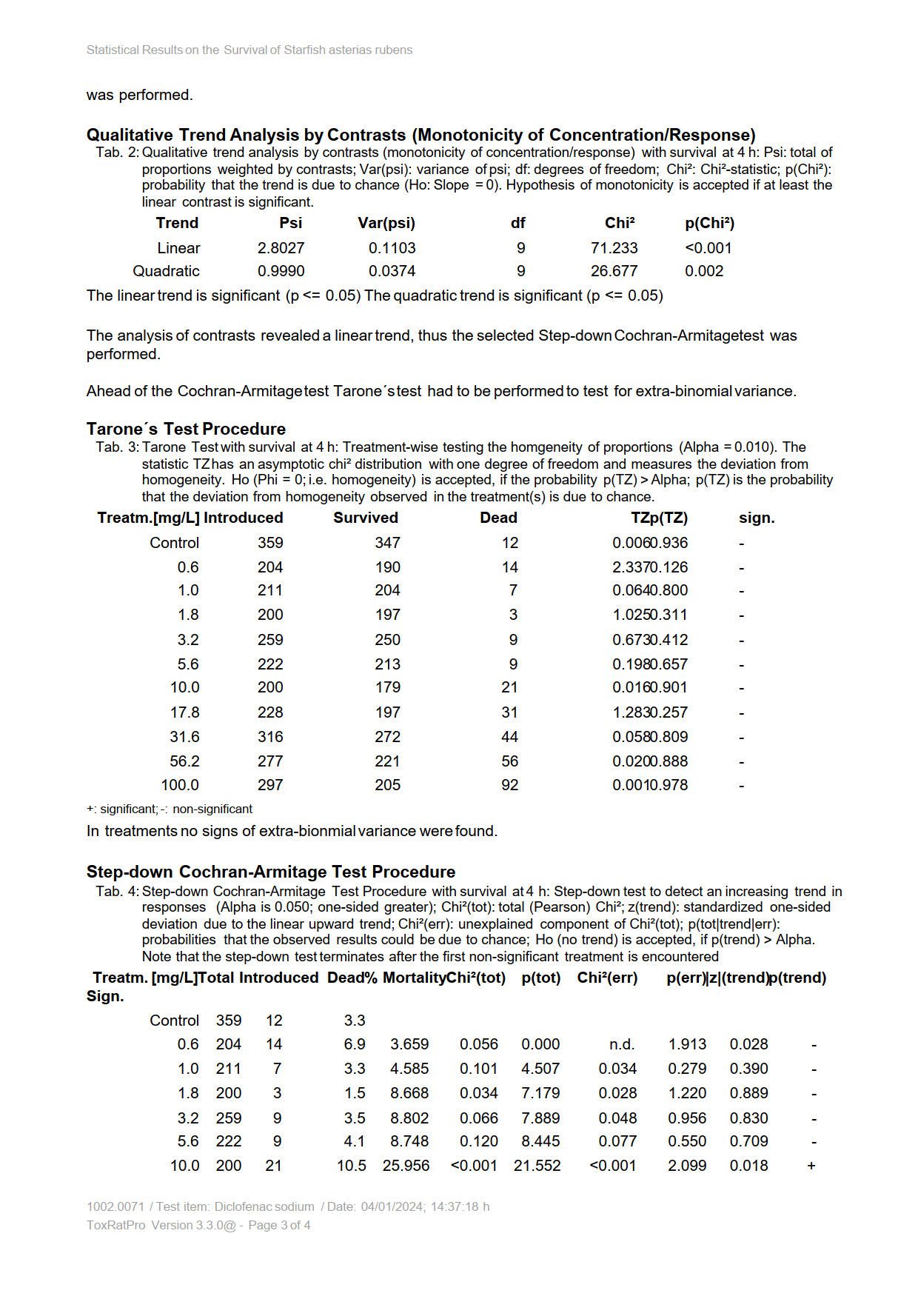
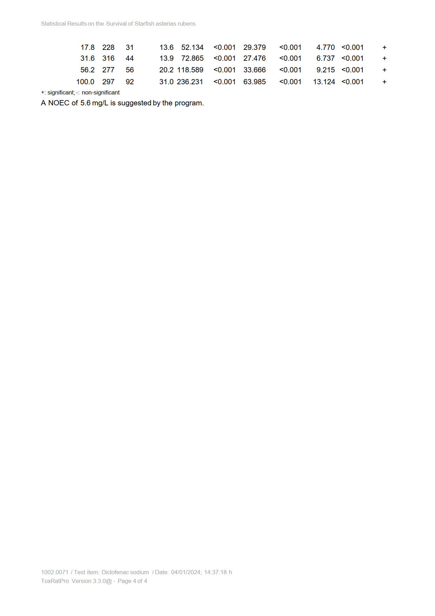

Arenicola marina test results and statistical analysis

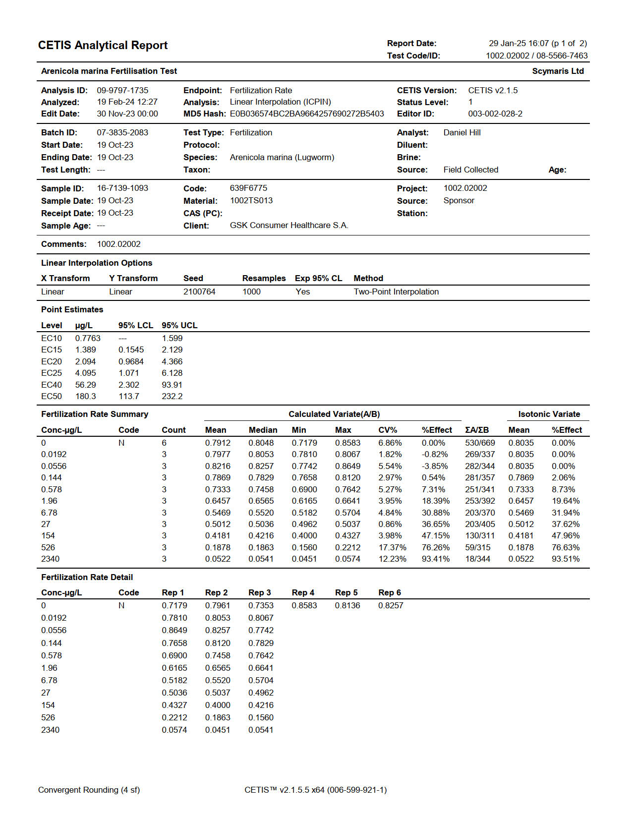

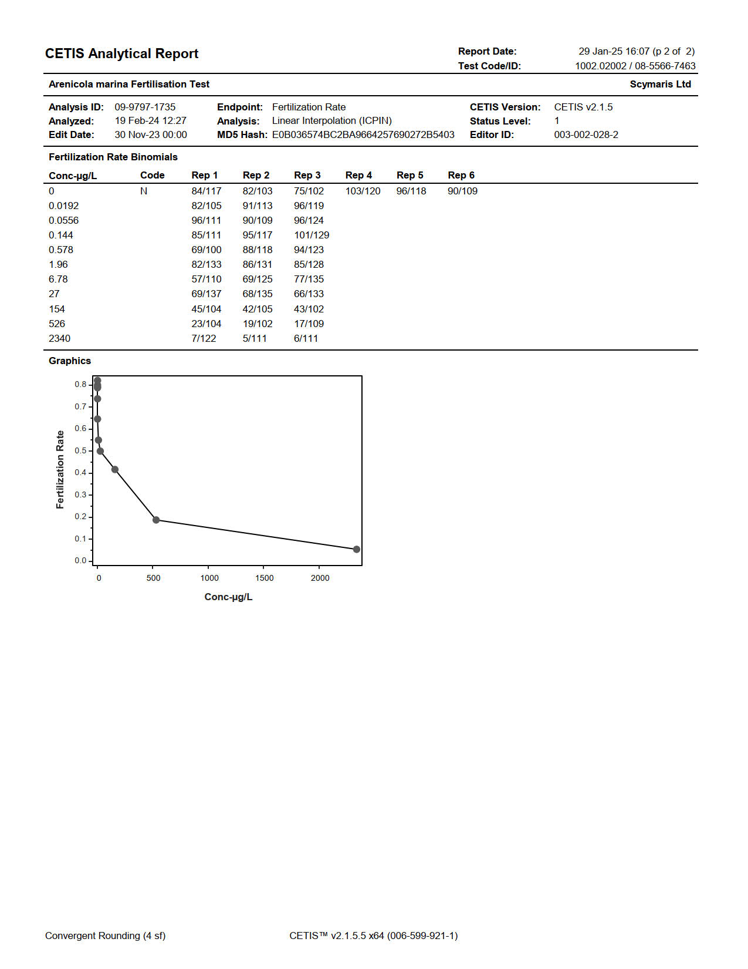

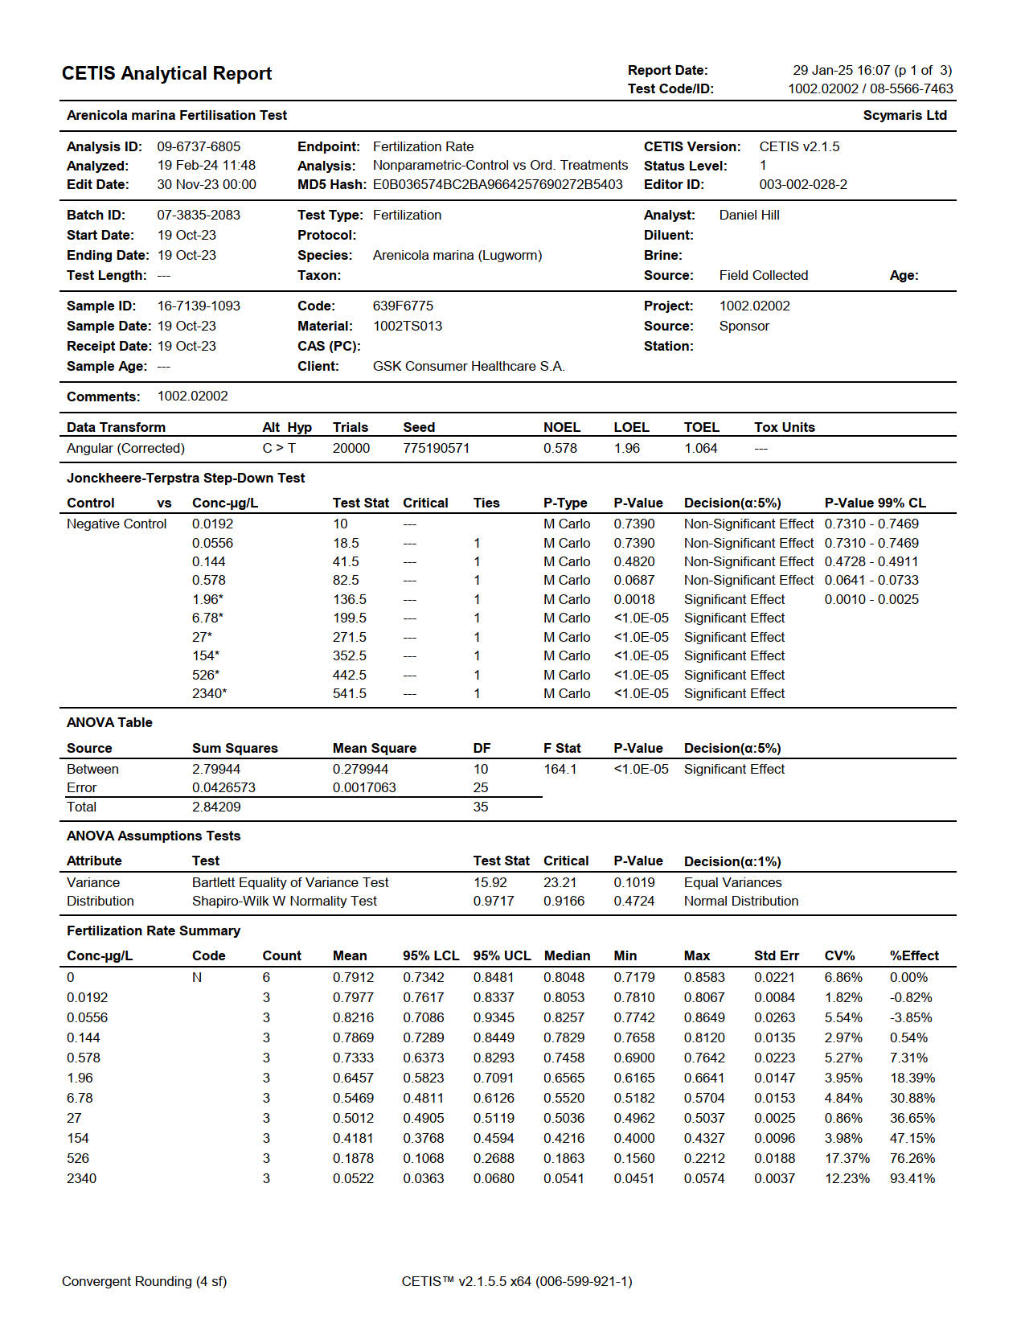

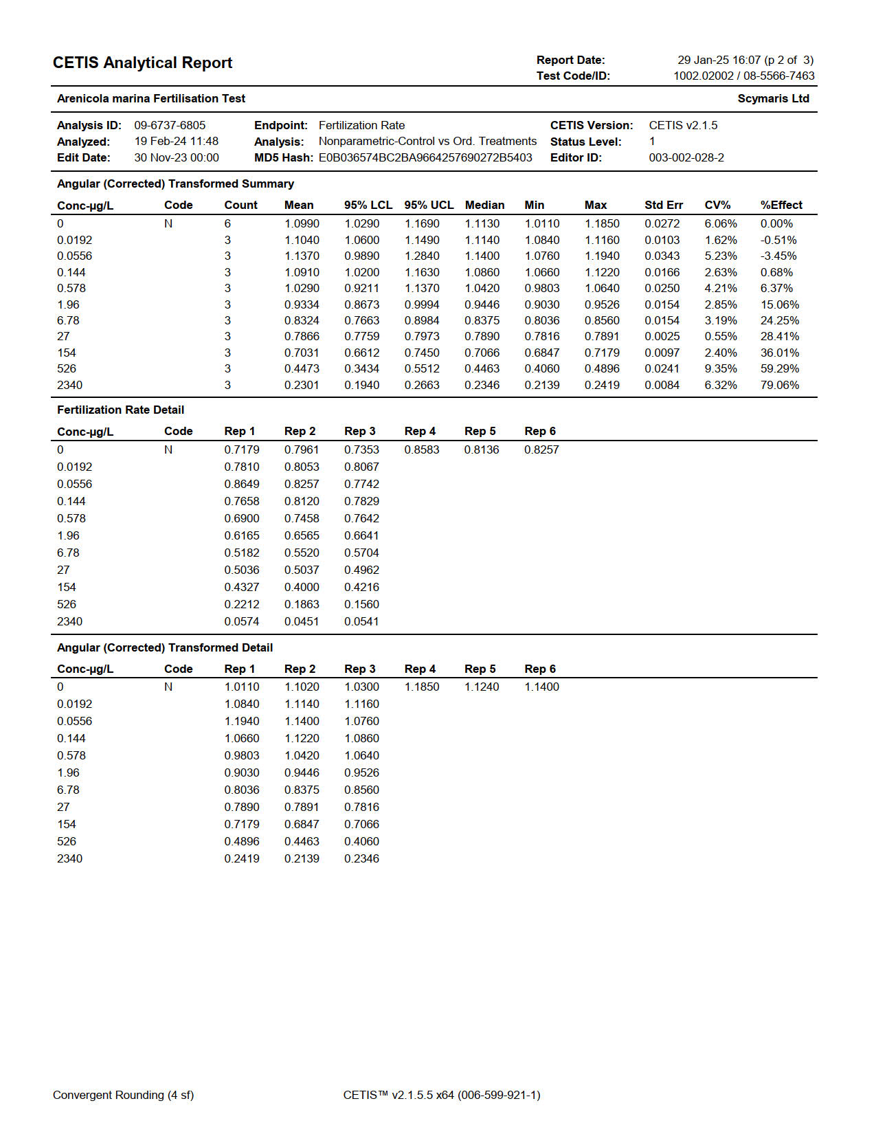

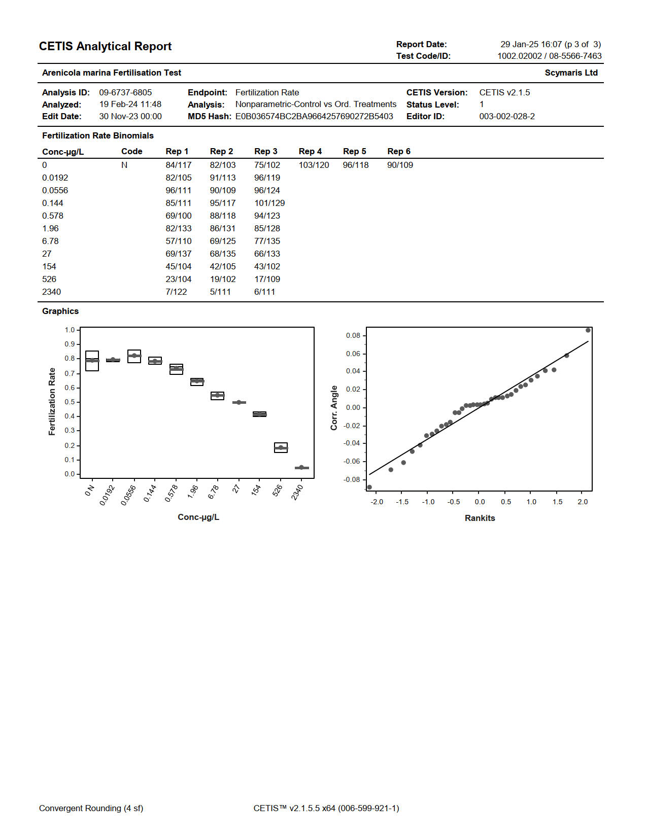

References

ASTM International (2012; updated 2022) Standard Guide for Conducting Short-Term Chronic Toxicity Tests with Echinoid Embryos. ASTM E1563-21a, Book of Standards Volume: 11.06.
European Commission (EC) (2022) Environmental Quality Standard Dossier: Diclofenac. Final Dossier after SCHEER Final Opinion.
Meijer, L. (1979). Hormonal control of oocyte maturation in Arenicola marina L.(Annelida, Polychaeta) II. Maturation and fertilization. Development, Growth & Differentiation, 21(4), pp.315-329.
Pacey, A.A. and Bentley, M.G. (1992). The fatty acid 8,11,14-Eicosatrienoic acid induces spawning in the male Lugworm, Arenicola marina. Journal of Experimental Biology, 173, 165-179.

