Supplementary Note

Sample size selection for training set
We trained the model on samples ranging from 1,000 to 80,000, gradually increasing the sample size and recording the training time. The model performance was tested on 10,000 independent samples. Based on the inflection point in the figure, a sample size of 30,000 was found to achieve 90% predictive accuracy with minimal computational cost (Supplementary Fig. 8a).

Sex difference in BA
Subsequently, we employed the locally weighted scatterplot smoothing (LOESS) method to fit the nonlinear trend between BA and chronological age (CA). Results showed that the BA of various organs in women exhibited nonlinear changes with CA (Supplementary Fig. 8b), with multiple organs reaching a peak around age 55 followed by a slowdown in aging.

Non-linearity adjustment
To address the nonlinear relationship between BA and CA (Supplementary Fig. 8b), we evaluated three detrending methods for BAG estimation: linear regression, locally weighted scatterplot smoothing (LOWESS), and LOESS. We simulated 10 synthetic phenotypes, including five linearly and five non-linearly correlated with CA (Supplementary Fig. 8c), In each iteration, models were trained on nine folds and tested on the remaining fold, with aggregated predictions across all testing folds defined as BA. Deviation measures between BA and CA were calculated using four approaches: the direct difference (dif), residuals from linear regression (delta), LOESS residuals (delta_loess), and LOWESS residuals (delta_lowess). Simulation results demonstrated that LOESS significantly outperformed both linear regression and LOWESS in modeling nonlinear associations (Supplementary Fig. 8d, e). Based on this comparison, we selected LOESS-derived residuals for final CA adjustment in downstream analyses.

Mortality and disease incidence prediction comparison
We examined whether decomposing BAG into CBAG and OSBAG provides additional predictive value for chronic diseases (using 16 diseases as exemplars) by constructing two linear models using different BAG metrics (Supplementary Fig. 9). The first model employed only BAG and the second incorporated both CBAG and OSBAG. Although the improvements were modest overall, 20-fold cross-validation showed that the second model achieved marginally higher AUCs across most diseases in both males (0.631–0.860 vs. 0.625–0.860) and females (0.629–0.864 vs. 0.627–0.862), with these differences reaching statistical significance (paired one-sided t-tests at FDR < 0.001 for males, FDR < 0.04 for females). For instance, in predicting cirrhosis with hepatic system, the second model’s AUC (0.76 in males, 0.75 in females) slightly exceeded the ~0.72 observed using the first models. The incremental gain is not unexpected, yet separating out a common versus an organ-specific factor still provides incremental predictive benefits.

GWASs in sex subgroups
Our sex-stratified GWAS analysis, leveraging a substantially expanded cohort, exhibited high consistency with prior findings reported by Wen et al., except for immune-related BAG (Supplementary Table 37). Critically, we observed no statistically significant divergence in effect sizes between males and females across all phenotypes, supported by three lines of evidence: FDR-corrected Wilcoxon rank-sum p-values > 0.05, Pearson’s correlation coefficients (r) of effect estimates ranging from 0.32 to 0.93, and directional consistency rates between 77.69% and 99.8%. These results collectively validate the robust correction for sex-related confounding in our whole-sample GWAS framework, aligning with methodologies advocated in large-scale studies of sex-specific genetic architecture.

Supplementary Method

Data process
BMI data were derived from Field ID 21001, supplemented by calculating missing values based on height (Field ID 50) and weight (Field ID 21002). Any remaining missing values were imputed using the mean. Ethnicity data (Field ID 21000) utilized only top-level information, and discrepancies in self-reported ethnicity across four questionnaire time points were assigned as missing.
Aging indicators were constructed using a series of indicators referenced in Timmers’s study¹, including Field IDs 2178, 1807, 3526, 1757, and 22192. Healthspan was determined using in-patient hospitalization data (Field ID 41280), with missing values supplemented by self-reported disease onset data (Field ID 87) based on relevant healthspan literature. A frailty index was calculated following the selection of indicators as outlined in Williams’s study².
Chronic disease data were extracted from a list of 15 chronic diseases provided in Tian’s study[37024597], identified using "First Occurrences" data³ (Category 1712). Mortality information (Field ID 40007) and incidence data for obstructive sleep apnea (OSA, ICD-10 G473) were also incorporated.
All quality control (QC) procedures of proteomic data performed in accordance with established protocols described previously⁴.

Association studies
For the GWAS analysis, we performed linear regression using PLINK 2.0⁵ for each aging phenotype, adjusting for potential confounders, including age, dataset status (training/test), sex, age-squared × sex interaction, BMI, genotype measurement batch, ethnic background, UK Biobank assessment center (Field ID 54), and the first 40 genetic principal components. Considering sex differences, we conducted separate analyses for males and females across all 16 aging phenotypes. The covariates were consistent with above GWAS across these subgroup analyses, except for sex variables. We identified genome-wide risk loci for all GWAS summary statistics using FUMA⁶.
The associations between proteins and BAG, CBAG, or OSBAG were analyzed using linear regression⁴. The QC-adjusted protein levels were modeled as the independent variable (X), with BAG, CBAG, or OSBAG as the dependent variable (Y). Covariates including age (Field ID 21003), sex (Field ID 31), BMI, region (Field ID 54), ethnicity, time fasted at blood collection, season of sample collection (classified as summer/autumn and winter/spring), sample age (time from sampling to protein measurement) and smoking statues were adjusted in the analysis⁴. The mean value was employed to impute BMI’s missing values. Statistical significance thresholds were adjusted using the Bonferroni correction to account for multiple testing across 294 proteins and 16 phenotypes (total tests N = 4,704).
Similarly, associations between metabolites and BAG, CBAG, or OSBAG were also analyzed using linear regression⁷. The QC-adjusted metabolite levels were treated as the independent variable (X), with BAG, CBAG, or OSBAG as the dependent variable (Y). Covariates adjusted for this analysis included sex, age, BMI, region (Field ID 54), ethnicity, and NMR batch (Field ID 23650), based on the UK Biobank's NMR metabolomics companion document (https://biobank.ndph.ox.ac.uk/ukb/ukb/docs/nmrm_companion_doc.pdf).

Identification and comparison of genome-wide risk Loci from different GWASs
We followed the same methodology for identifying genome-wide risk loci as in the previous study by Wen et al.⁸. We used FUMA⁶ to identify genome-wide risk loci from the GWAS results of our 16 aging phenotypes. One thing to note, Wen et al. calculated linkage disequilibrium (LD) of SNPs using genotype data from their involved sample to identify independent significant SNPs. We directly utilized the reference cohort provided by FUMA (UKB release 2b 10k European) for LD calculation. Other parameters remained identical to Wen et al.'s study, including the r² threshold for defining independent significant SNPs (≥0.6), the second r² threshold for defining lead SNPs (≥0.6), and the maximum distance between LD blocks to merge into a locus (< 250 kb). When comparing results from different GWASs, we use the same definitions of loci were considered the same if the distance between top lead SNPs was less than 250 kb. For comparing each organ’s GWAS from different groups, we integrated the union list of top lead SNPs from different sets of genome-wide risk loci and compared the consistency of effect sizes, including correlation and concordance of direction. We also assessed differences in statistical significance (P-value) of top lead SNPs across different GWAS, using paired Wilcox test.

LDSC analysis
To compare the different genetic architecture of BAG and CBAG, OSBAG, we evaluate the correspondent genetic association for each organ and the SNP-based heritability (h2) for all phenotypes. It is employed using LDSC⁹ (https://github.com/bulik/ldsc), which ranges from -1 to 1. A complete negative genetic correlation is represented by a value of -1 in the estimate, while a complete positive genetic correlation is represented by a value of 1. To study the inflation effect resulting from a polygenic signal or bias, LDSC investigates the correlation between test statistics and linkage disequilibrium. This approach is not influenced by sample overlap and can evaluate genetic association using GWAS data.

Gene annotation and tissue expression
All candidate genes were annotated based on the position of lead SNPs using Annovar¹⁰. The expression pattern of genes was searched in the Human Protein Atlas (HPA) database¹¹ (https://www.proteinatlas.org/).

Partitioned heritability enrichments
Partitioned heritability enrichments based on 63 cell types (details in Supplementary Table 38) form Roadmap Epigenomics resource^{12,13} for all aging-gap GWAS summary using S-LDSC¹⁴. The details of annotations for all cell types have been described in the other study¹⁵. The annotations for all cell types refer the previous study¹⁶ using S-LDSC¹⁴. For all cell types, we combined all regions with the following annotations from the 15-state chromHMM model: ‘1_TssA’, ‘2_TssAFlnk’, ‘7_Enh’ and ‘6_EnhG’. Each annotation was individually added to the baseline LD model¹⁴. The organ annotation for cell types/tissues was manually annotated and revised by two experts (Supplementary Table 38). We performed SLDSC analysis on above mentioned 69 cell types/tissues and applied strict Bonferroni multiple testing correction for the enrichment p-values (P<0.05/(69×16)). For each organ-BAG and its corresponding CBAG/SBAG phenotypes, when at least one enrichment analysis p-value was significant, we also visualized the other corresponding p-value to facilitate a direct comparison between BAG and CBAG/SBAG. For comparing body-BAG with CBAG, we focus on significant enrichment results for all organs, while for other organs, we focus on significant enrichment results for correspondent organs.

Gene enrichment based on MGI database
Two experts classified the terms of phenotypes provided by the MGI database¹⁷ to align them with the seven organ systems of interest in our study (Supplementary Table 39), raw data download from MGI database (https://www.informatics.jax.org/downloads/reports/HMD_HumanPhenotype.rpt). For the candidate gene sets identified in different GWASs, we performed enrichment analysis using Fisher’s exact test, based on annotations corresponding to the organs after classification. The analysis was implemented using the "fisher.test" function in R.

Quantification of tissue specificity index for genes
We downloaded the gene's RNA expression data across multiple tissues from the Human Protein Atlas (HPA) website (https://www.proteinatlas.org/)¹⁸. We calculated the tissue specificity index τ (tau) following the previous methodology using normalized TPM values (nTPM)¹⁹. The τ index ranges from 0 to 1, where values approaching 1 indicate tissue-specific expression patterns, while values near 0 suggest broad expression across tissues.

Tissue-specificity enrichment analysis of dominant proteins
Four experts classified the terms of “Tissue specificity (RNA)” provided by the HPA website (https://www.proteinatlas.org/)¹⁸ to align them with seven organ systems in our study (Supplementary Table 40). We performed Fisher’s exact test ("fisher.test" in R, CI=0.95) to compare dominant protein associations across phenotypic groups. For CBAG and Body BAG, dominant proteins (defined by T-value thresholds) were tested for enrichment in low tissue-specificity genes. For OSBAG and Organ BAG dominant proteins, we first evaluated their enrichment in tissue-specific genes corresponding to their respective organs (e.g., liver-specific genes for liver-related phenotypes), contrasting against CBAG-dominant proteins as the background control. To compare the enrichment strength between OSBAG and Organ BAG groups, we performed a comparison test on the ORs, where the test statistic was calculated as:
$$Z= \frac{{OR}_{OSBAG}- {OR}_{organ BAG}}{{SE}_{OSBAG}- {SE}_{organ BAG}}$$
with SE derived from the difference between CI_{upper} and CI_{lower} of the OR in Fisher’s test. Two-tailed p-values were computed to assess statistical significance. Bonferroni correction was applied (N_{test}=16).

Pathway enrichment analysis
KEGG, GO and Reactome pathway enrichment analysis was conducted using the R packages clusterProfiler²⁰ and org.Hs.eg.db (version 3.18.0). A total of 2920 proteins were used as the background, and KEGG, GO, Reactome enrichment analysis was performed for proteins identified as CBAG_{vsOSBAG}-dominant and OSBAG_{vsCBAG}-dominant. Pathways with adjusted P-values < 0.05 (using the Benjamini-Hochberg method) were considered significantly enriched.

Mendelian randomization analysis
Mendelian randomization analysis was conducted by the “TwoSampleMR” R package²¹. Prior to MR testing, stringent quality control was performed on the SNP instruments. Firstly, we will delete the overlap SNPs which significant (P < 5ⅹ10⁻⁸) associated with outcome and exposure. Then, we will get two list of lead SNPs by clumping based on position (windows size = +- 250kb) of significant SNPs for outcome and exposure. Additionally, we will supply the detailed p value, beta, effect allele, other allele, sample size, and effect allele frequency for harmonising data. We exclusively selected proteins with three or more instrumental variables (IVs) for subsequent causal analysis. We totally choose three methods including IVW, MR-Egger, and MR-Egger (bootstrap), each has its own advantages. IVW method provides the most statistical power under the assumption that all instruments are valid²². MR-Egger also assesses the horizontal pleiotropy although its statistical power is less than that of IVW²³.
In addition, it should be emphasized that based on pQTL data reported in previous studies²⁴, we conducted Mendelian randomization analysis of protein as exposure and aging as outcome to find causal biomarkers of proteins affecting aging phenotypes. Considering the manual error in st10 of that study, ‘Target UniProt’ has changed from “P29460” to “P29459;P29460” for “5:158773117:G:A:imp:v1” in ‘Variant ID’ of “IL12A_IL12B:P29459_P29460:OID21327:v1” in ‘UKBPPP ProteinID’.
For metabolite levels that are more susceptible, we performed a bidirectional Mendelian analysis of metabolite levels and aging based on the results of a recent super-large metabolite GWAS study²⁵.

Supplementary Figures
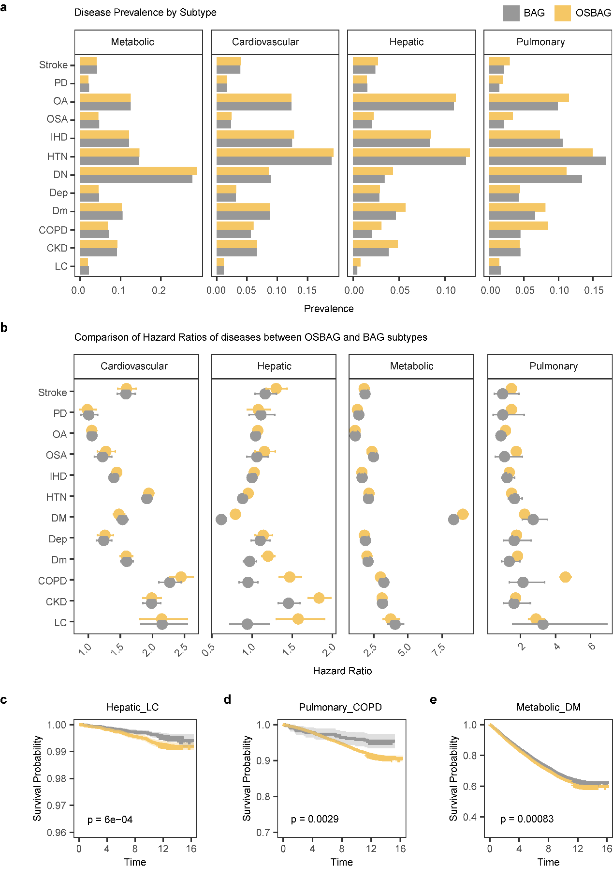
Supplementary Fig. 1 | Aging subtypes in male and clinical disease risk across different aging subtypes. a-b, Comparison of 12 chronic disease prevalence (a) and future disease risk (b) in male extreme agers from metabolic, cardiovascular, hepatic, and pulmonary based on CBAG/OSBAG and BAG-defined aging subtypes (P<2.2×10⁻⁴, Bonferroni-corrected). c, LC-free survival time comparison for hepatic extreme agers in males, using Kaplan-Meier curve. d, COPD-free survival time comparison for pulmonary extreme agers in males. e, DM-free survival time comparison for metabolic extreme agers in males. HTN, hypertensive diseases; IHD, ischemic heart disease; LC, cirrhosis; DM, diabetes; OA, osteoarthritis; OP, osteoporosis; COPD, chronic obstructive pulmonary disease; CKD, chronic kidney disease; OSA, obstructive sleep apnea; BD, bipolar disorder; Dep, depression; Dm, dementia; MS, multiple sclerosis; PD, parkinsonism; SZ, schizophrenia.

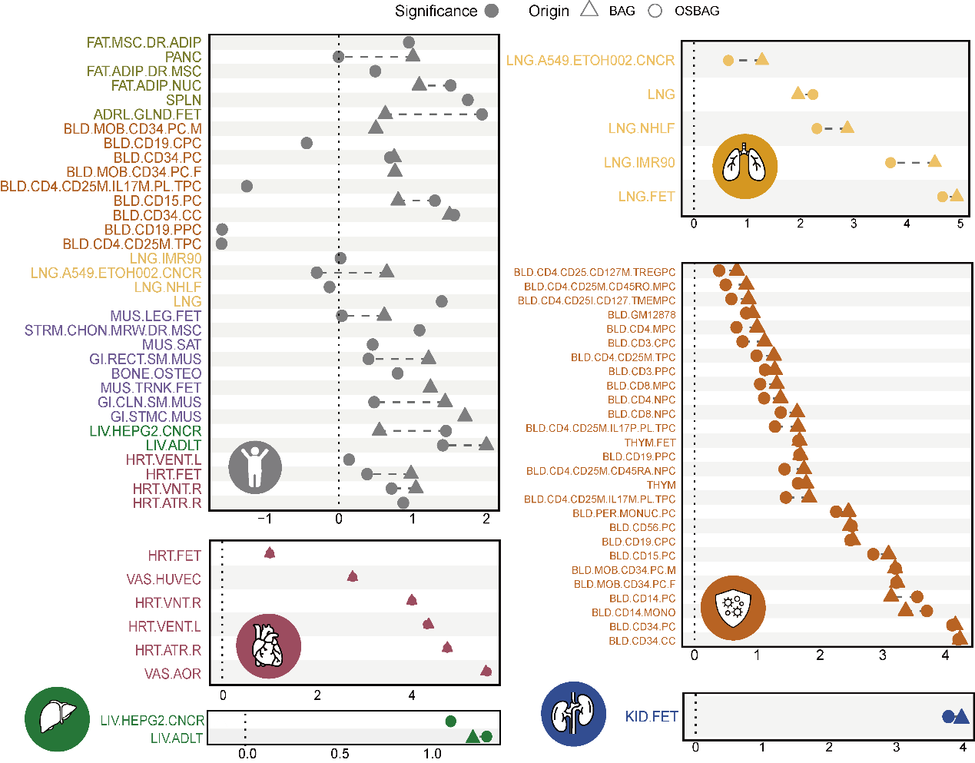

Supplementary Fig. 2 | Partitioned heritability enrichments for CBAG, five organ OSBAG and corresponding BAG GWASs in this study (P<4.5×10⁻⁵, Bonferroni-corrected).
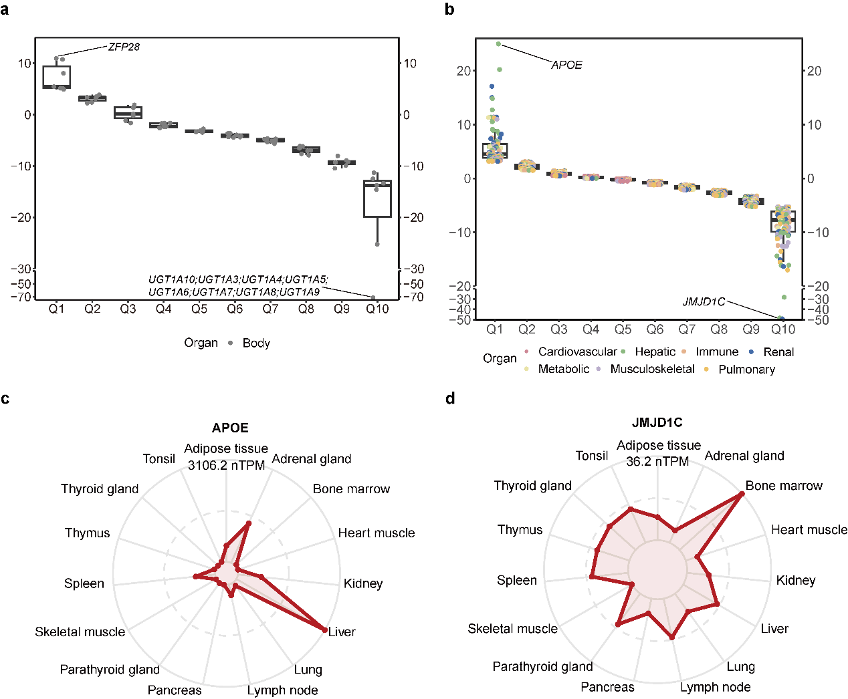

Supplementary Fig. 3 | Differential significance of lead SNPs. a, Difference in −log10(p) between CBAG GWAS versus body BAG GWAS for 69 lead SNPs (one per locus). ZFP28 emerges in the top decile for CBAG, whereas UGT1A gene cluster falls in the opposite extreme decile for BAG. b, Difference in −log10(p) between OSBAG GWAS versus seven organ BAG GWAS for 1,098 lead SNPs (one per locus). APOE emerges in the top decile for hepatic OSBAG, whereas 67 gene cluster falls in the opposite extreme decile for hepatic BAG. Each point represents an SNP annotated by the organ under study (color-coded), and the data are grouped into deciles (Q1-Q10) according to the magnitude of the difference in −log10(p). The boxplots show the distribution of these differences within each decile.
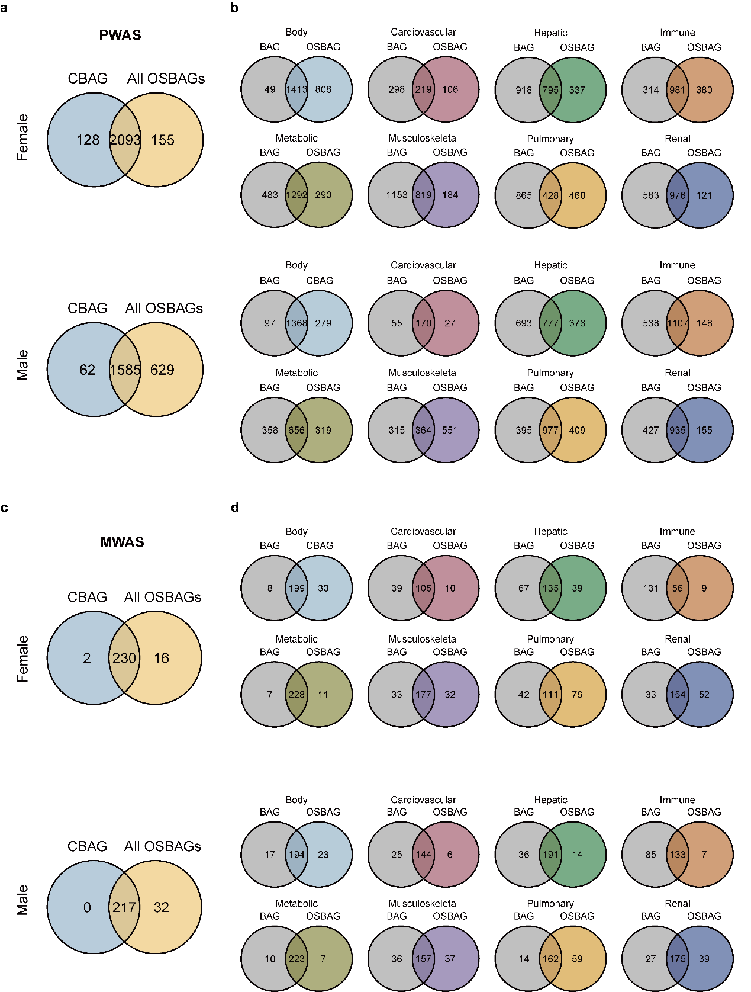

Supplementary Fig. 4 | Comparative overlap of biomarkers associated with CBAG and OSBAG. a, Overlap of proteins significantly associated with CBAG and OSBAG, identified through PWAS. b, Overlap of proteins significantly associated with CBAG and body BAG, each OSBAG and each organ BAG, identified through PWAS. c, Overlap of metabolites significantly associated with CBAG and OSBAG, identified through MWAS. d, Overlap of metabolites significantly associated with CBAG and body BAG, each OSBAG and each organ BAG, identified through MWAS.

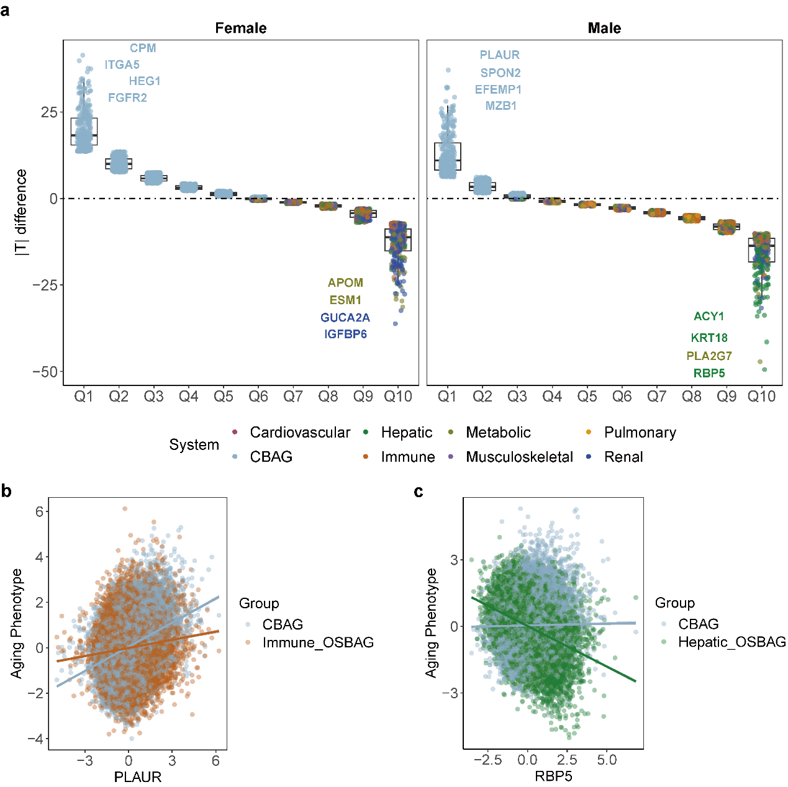
Supplementary Fig. 5 | Protein explanation for CBAG and seven OSBAG in males and females. a, Organ dominance of each protein. The organ category for each protein is defined based on the absolute T values in CBAG and seven OSBAGs. For example, in females, the absolute T value of CPM in CBAG is greater than its absolute T values in any OSBAG, CPM is defined as a CBAG-dominant protein. Similarly, the absolute T value of IGFBP6 in the renal OSBAG is greater than its absolute T values in CBAG and the other 6 OSBAGs, IGFBP6 is defined as a renal OSBAG-dominant protein. b, Correlation of PLAUR levels with CBAG and the immune OSBAG. c, Correlation of RBP5 levels with CBAG and the liver OSBAG.
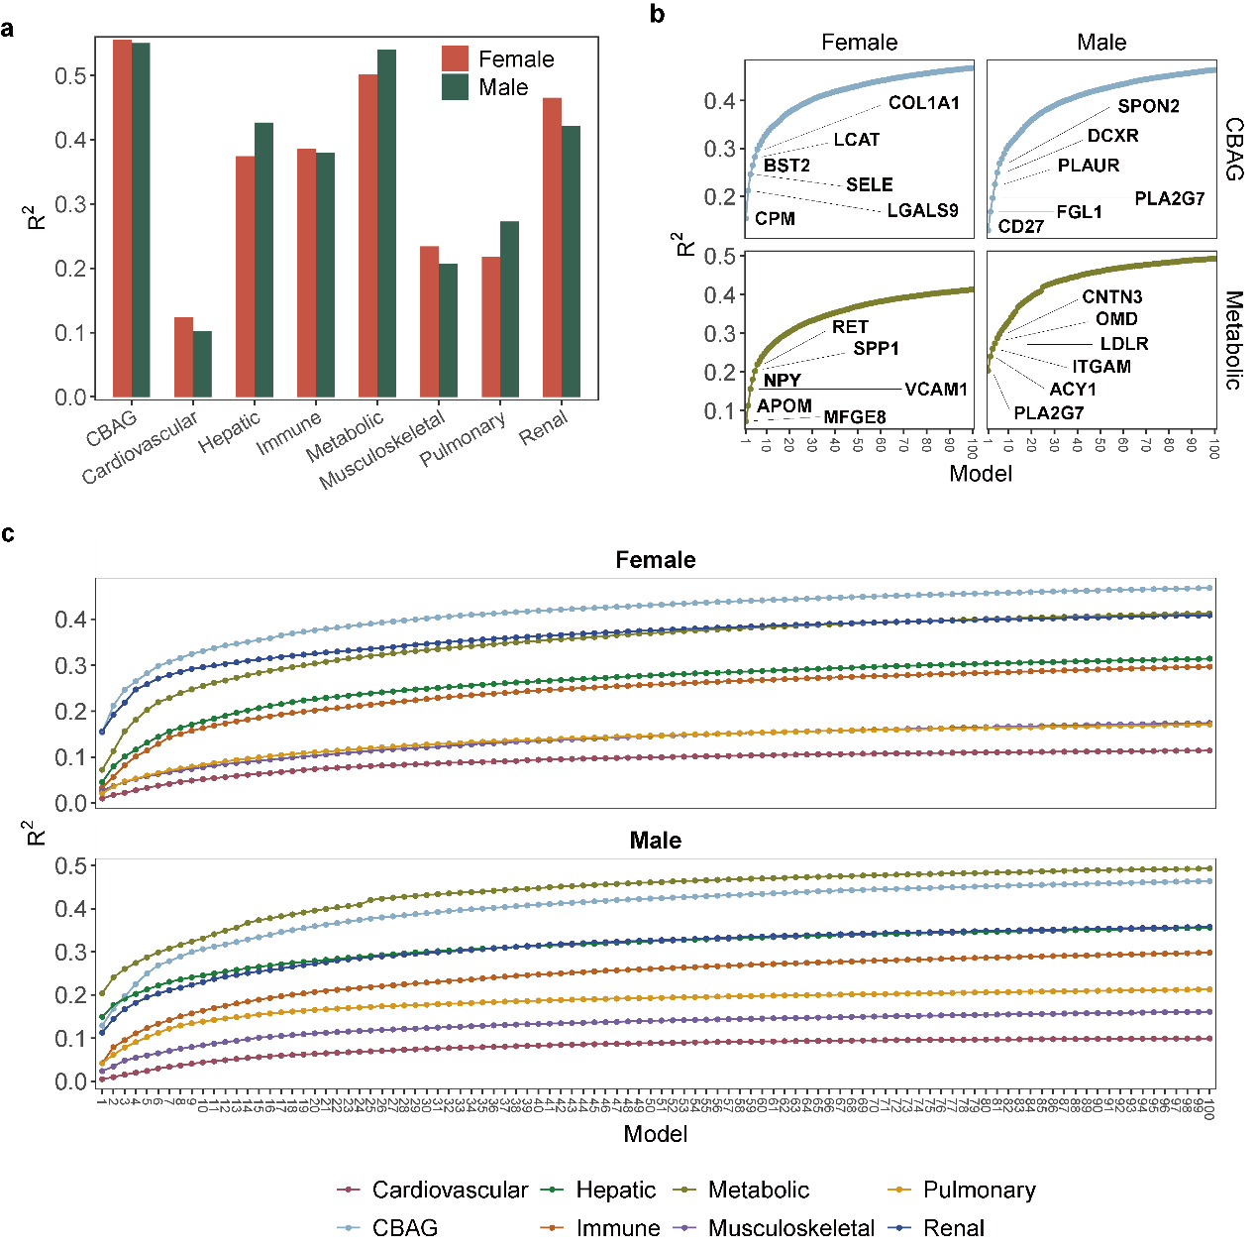

Supplementary Fig. 6 | Proteomic risk score (ProtRS). a, Overall explanatory power of protein biomarkers identified for CBAG and OSBAGs in male and female. b, Cumulative explanatory effects of protein biomarkers for CBAG and metabolic OSBAGs in male and female. The top 6 major contributing proteins are annotated in the plot. c, Cumulative explanatory effect of the top 100 protein markers for CBAG and seven OSBAGs in males and females.

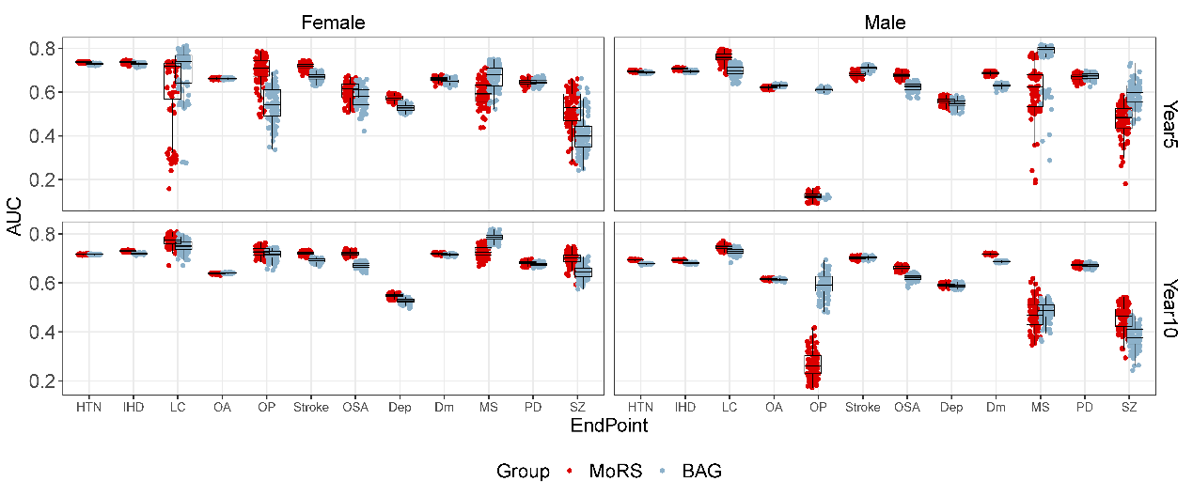
Supplementary Fig. 7 | Comparison of predictive performance between MoRS and CBAG/OSBAG for 5- and 10-year disease incidence of 12 diseases. HTN, hypertensive diseases; IHD, ischemic heart disease; LC, cirrhosis; OA, osteoarthritis; OP, osteoporosis; OSA, obstructive sleep apnea; BD, bipolar disorder; Dep, depression; Dm, dementia; MS, multiple sclerosis; PD, parkinsonism; SZ, schizophrenia.
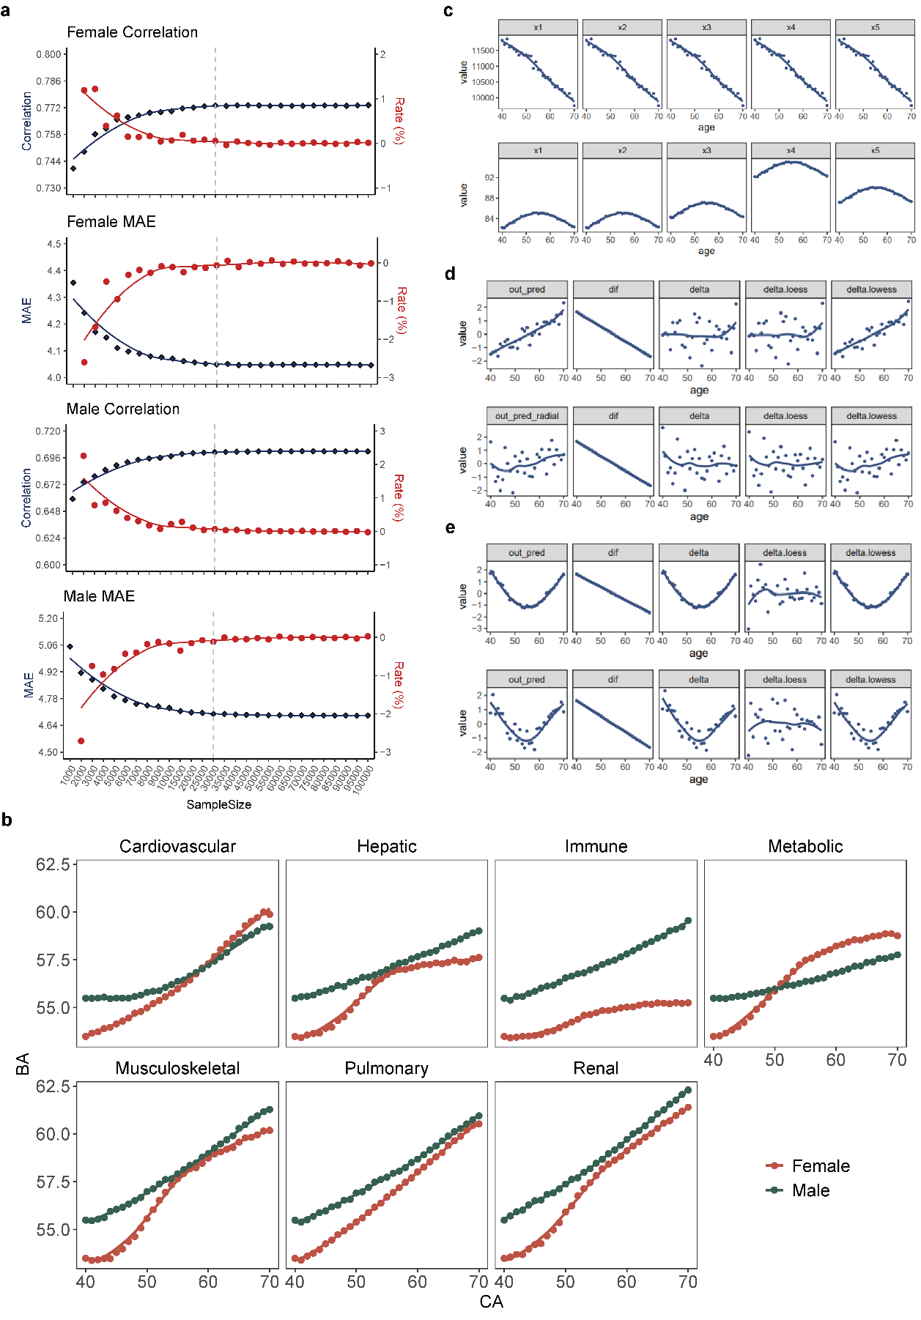
Supplementary Fig. 8 | Training Set Sample Selection and Non-linearity Correction Method Simulation. a, Test set performance (R² and MAE) across different training set sample sizes. b, Trends of BA across age in males and females. Loess fitting is used to estimate the mean BA at each age, with span = 2/3 and window = 1. c, Phenotype simulation: phenotypes linearly correlated with CA (upper) vs. phenotypes non-linearly correlated with CA (lower). d, BA prediction using phenotypes linearly correlated with CA via multiple linear regression (upper) and SVM (lower). Predicted BA: out_pred. BA-CA (dif). Residuals from a linear regression of BA on CA (delta). Residuals from loess (delta_loess). Residuals from lowess (delta_lowess). e, BA prediction using phenotypes non-linearly correlated with CA via multiple linear regression (upper) and SVM (lower), followed by the same process and methods as in c to obtain BA-CA deviation measures. Under non-linear phenotype conditions, only the loess method effectively corrected the non-linearity effect on BA-CA residuals.

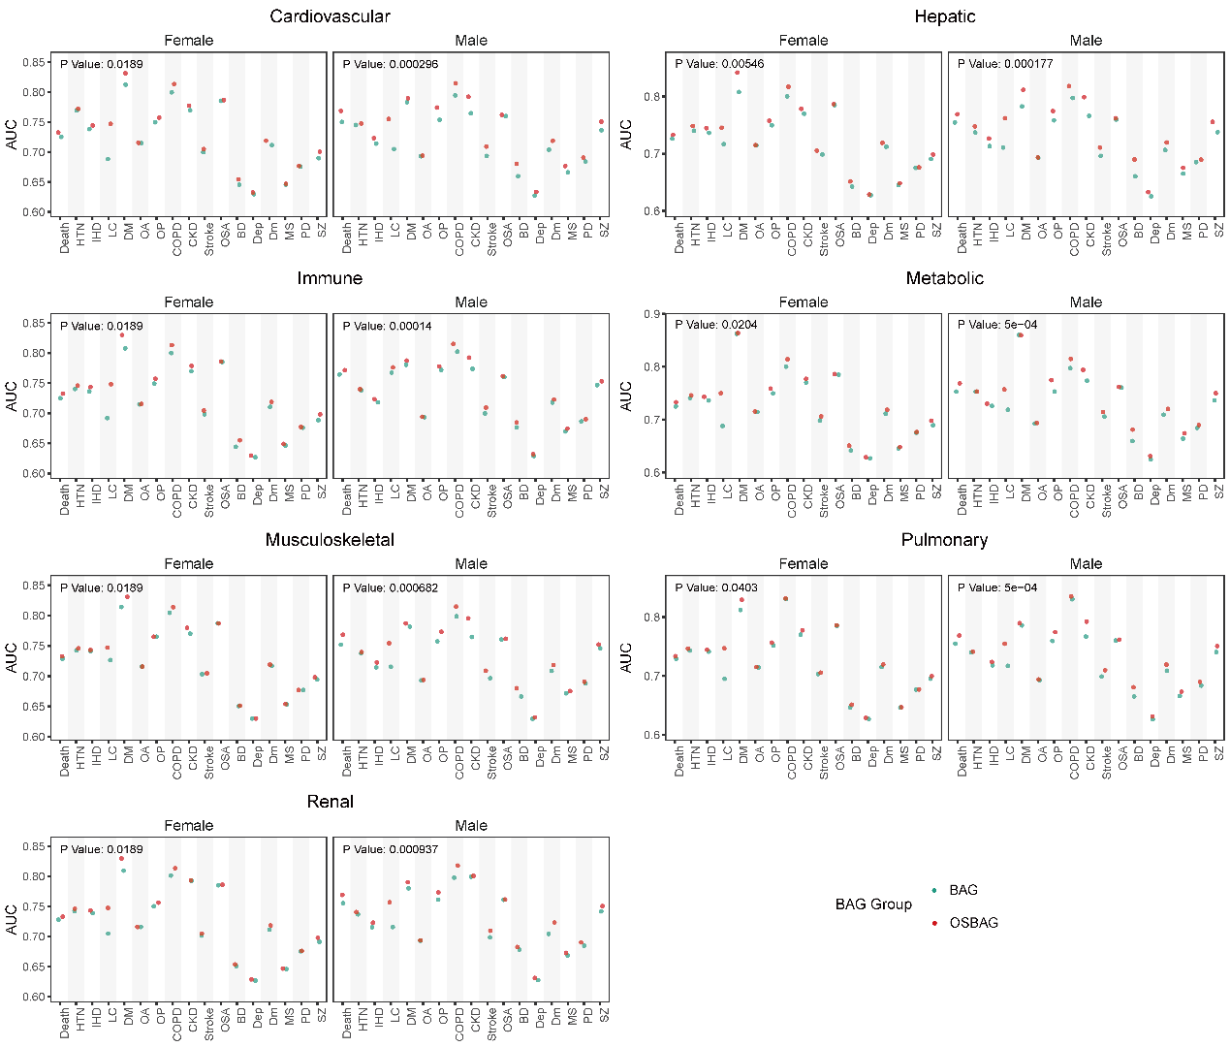
Supplementary Fig. 9 | Inference of mortality and chronic diseases based on BAG and CBAG/OSBAG. Logistic models were applied: BAG (disease/death ~ organ BAG); OSBAG (disease/death ~ CBAG + OSBAG). One-tailed paired t-test p-values are shown (P<7.1×10⁻³). HTN, hypertensive diseases. IHD, ischemic heart disease. LC, cirrhosis. DM, diabetes. OA, osteoarthritis. OP, osteoporosis. COPD, chronic obstructive pulmonary disease. CKD, chronic kidney disease. OSA, obstructive sleep apnea. BD, bipolar disorder. Dep, depression. Dm, dementia. MS, multiple sclerosis. PD, parkinsonism. SZ, schizophrenia.

Reference
1 Timmers, P. et al. Mendelian randomization of genetically independent aging phenotypes identifies LPA and VCAM1 as biological targets for human aging. Nat Aging 2, 19-30 (2022). https://doi.org/10.1038/s43587-021-00159-8
2 Williams, D. M., Jylhava, J., Pedersen, N. L. & Hagg, S. A Frailty Index for UK Biobank Participants. J Gerontol A Biol Sci Med Sci 74, 582-587 (2019). https://doi.org/10.1093/gerona/gly094
3 You, J. et al. Plasma proteomic profiles predict individual future health risk. Nat Commun 14, 7817 (2023). https://doi.org/10.1038/s41467-023-43575-7
4 Deng, Y. T. et al. Atlas of the plasma proteome in health and disease in 53,026 adults. Cell 188, 253-271 e257 (2025). https://doi.org/10.1016/j.cell.2024.10.045
5 Chang, C. C. et al. Second-generation PLINK: rising to the challenge of larger and richer datasets. Gigascience 4, 7 (2015). https://doi.org/10.1186/s13742-015-0047-8
6 Watanabe, K., Taskesen, E., van Bochoven, A. & Posthuma, D. Functional mapping and annotation of genetic associations with FUMA. Nat Commun 8, 1826 (2017). https://doi.org/10.1038/s41467-017-01261-5
7 Yu, Z. et al. Human serum metabolic profiles are age dependent. Aging Cell 11, 960-967 (2012). https://doi.org/10.1111/j.1474-9726.2012.00865.x
8 Wen, J. et al. The genetic architecture of biological age in nine human organ systems. Nat Aging 4, 1290-1307 (2024). https://doi.org/10.1038/s43587-024-00662-8
9 Bulik-Sullivan, B. et al. An atlas of genetic correlations across human diseases and traits. Nat Genet 47, 1236-1241 (2015). https://doi.org/10.1038/ng.3406
10 Wang, K., Li, M. & Hakonarson, H. ANNOVAR: functional annotation of genetic variants from high-throughput sequencing data. Nucleic Acids Res 38, e164 (2010). https://doi.org/10.1093/nar/gkq603
11 Sjostedt, E. et al. An atlas of the protein-coding genes in the human, pig, and mouse brain. Science 367 (2020). https://doi.org/10.1126/science.aay5947
12 Roadmap Epigenomics, C. et al. Integrative analysis of 111 reference human epigenomes. Nature 518, 317-330 (2015). https://doi.org/10.1038/nature14248
13 Luo, Y. et al. New developments on the Encyclopedia of DNA Elements (ENCODE) data portal. Nucleic Acids Res 48, D882-D889 (2020). https://doi.org/10.1093/nar/gkz1062
14 Finucane, H. K. et al. Partitioning heritability by functional annotation using genome-wide association summary statistics. Nat Genet 47, 1228-1235 (2015). https://doi.org/10.1038/ng.3404
15 Li, Y. et al. Combined genome-wide association study of 136 quantitative ear morphology traits in multiple populations reveal 8 novel loci. PLoS Genet 19, e1010786 (2023). https://doi.org/10.1371/journal.pgen.1010786
16 Naqvi, S. et al. Shared heritability of human face and brain shape. Nat Genet 53, 830-839 (2021). https://doi.org/10.1038/s41588-021-00827-w
17 Baldarelli, R. M. et al. Mouse Genome Informatics: an integrated knowledgebase system for the laboratory mouse. Genetics 227 (2024). https://doi.org/10.1093/genetics/iyae031
18 Ponten, F., Jirstrom, K. & Uhlen, M. The Human Protein Atlas--a tool for pathology. J Pathol 216, 387-393 (2008). https://doi.org/10.1002/path.2440
19 Yanai, I. et al. Genome-wide midrange transcription profiles reveal expression level relationships in human tissue specification. Bioinformatics 21, 650-659 (2005). https://doi.org/10.1093/bioinformatics/bti042
20 Sakaue, S. & Okada, Y. GREP: genome for REPositioning drugs. Bioinformatics 35, 3821-3823 (2019). https://doi.org/10.1093/bioinformatics/btz166
21 Hemani, G. et al. The MR-Base platform supports systematic causal inference across the human phenome. Elife 7 (2018). https://doi.org/10.7554/eLife.34408
22 Burgess, S. et al. Guidelines for performing Mendelian randomization investigations: update for summer 2023. Wellcome Open Res 4, 186 (2019). https://doi.org/10.12688/wellcomeopenres.15555.3
23 Bowden, J., Davey Smith, G. & Burgess, S. Mendelian randomization with invalid instruments: effect estimation and bias detection through Egger regression. Int J Epidemiol 44, 512-525 (2015). https://doi.org/10.1093/ije/dyv080
24 Sun, B. B. et al. Plasma proteomic associations with genetics and health in the UK Biobank. Nature 622, 329-338 (2023). https://doi.org/10.1038/s41586-023-06592-6
25 Karjalainen, M. K. et al. Genome-wide characterization of circulating metabolic biomarkers. Nature 628, 130-138 (2024). https://doi.org/10.1038/s41586-024-07148-y

