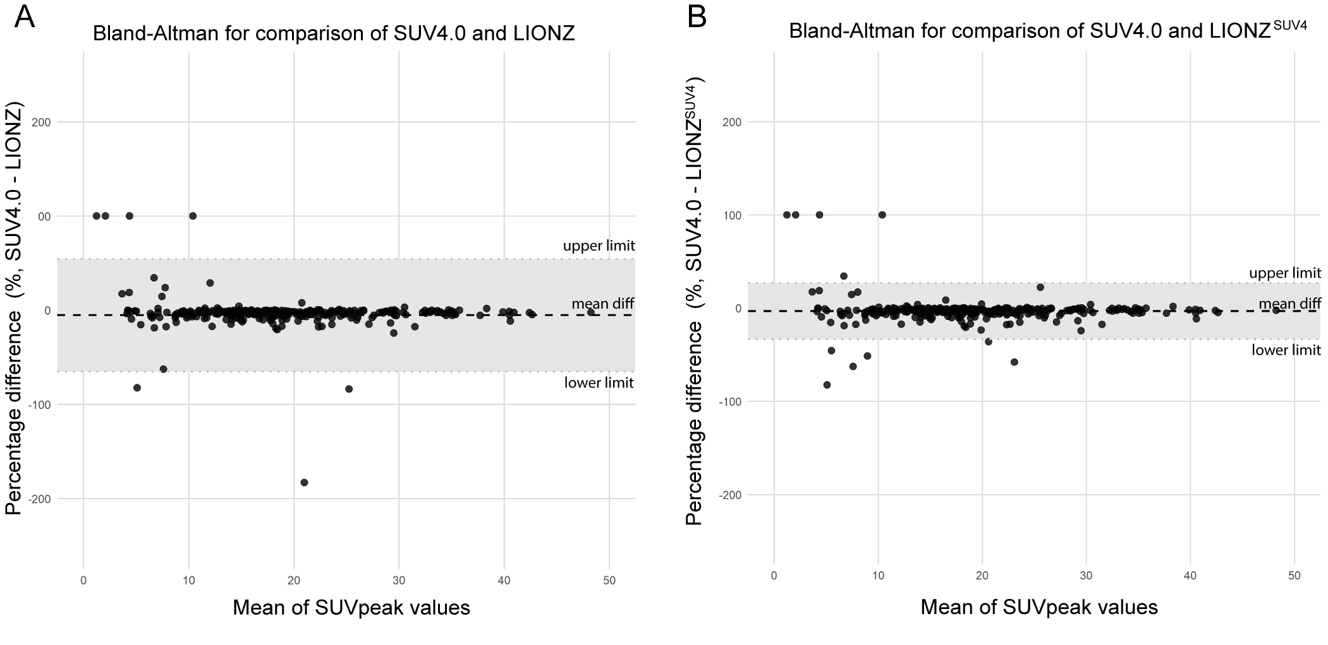
Supplemental Figure 2. Bland-Altman plots for SUVpeak. (A) Bland-Altman plot showing the percentage differences between SUV4.0 and LIONZ. The mean difference is -5.39% (mean diff) with limits of agreement ranging from -65.15% (upper limit) to 54.38% (lower limit). (B) Bland-Altman plot showing the percentage differences between SUV4.0 and LIONZ^{SUV4}. The mean difference is -3.23% (mean diff), with limits of agreement ranging from -33.53% (upper limit) to 27.06% (lower limit). The shaded region represents the range within ±1.96 standard deviations from the mean difference.

