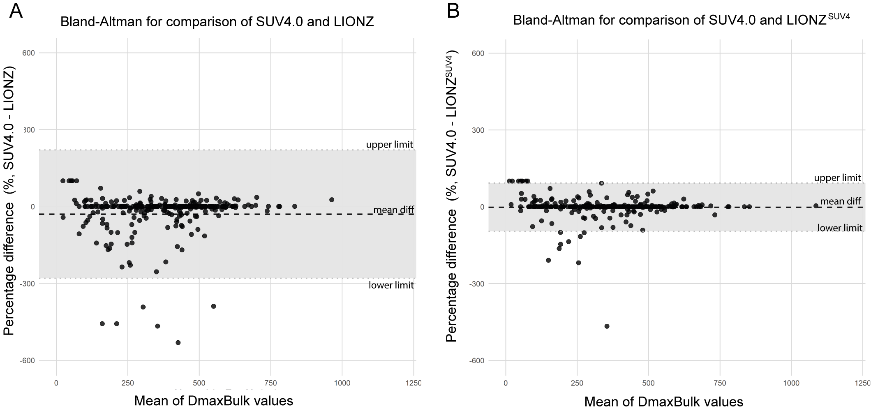
Supplemental Figure 3. Bland-Altman plots for DmaxBulk. (A) Bland-Altman plot showing the percentage differences between SUV4.0 and LIONZ. The mean difference is -29.93% (mean diff) with limits of agreement ranging from -280.63% (upper limit) to 220.78% (lower limit). (B) Bland-Altman plot showing the percentage differences between SUV4.0 and LIONZ^{SUV4}. The mean difference is -1.85% (mean diff), with limits of agreement ranging from -96.24% (upper limit) to 92.54% (lower limit). The shaded region represents the range within ±1.96 standard deviations from the mean difference.

