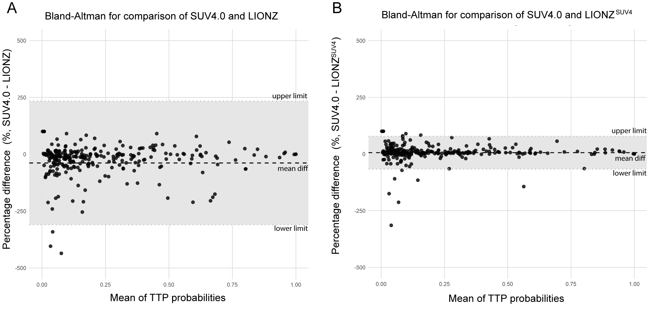
Supplemental Figure 4. Bland-Altman plots for TTP probabilities. (A) Bland-Altman plot showing the percentage differences between SUV4.0 and LIONZ. The mean difference is 5.43% (mean diff) with limits of agreement ranging from -66.94% (upper limit) to 77.8% (lower limit). (B) Bland-Altman plot showing the percentage differences between SUV4.0 and LIONZ^{SUV4}. The mean difference is -38.56% (mean diff), with limits of agreement ranging from -310.48% (upper limit) to 233.37% (lower limit). The shaded region represents the range within ±1.96 standard deviations from the mean difference.

