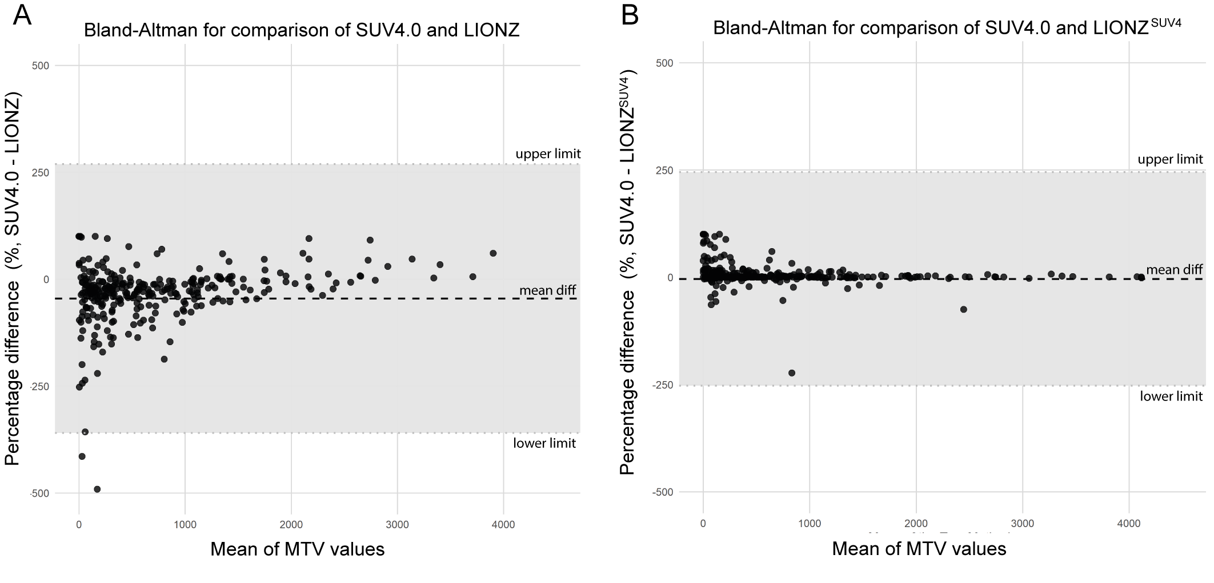
Supplemental Figure 1. Bland-Altman plots for MTV. (A) Bland-Altman plot showing the percentage differences between SUV4.0 and LIONZ. The mean difference is -45.42% (mean diff), with limits of agreement ranging from -359.81% (upper limit) to 268.97% (lower limit). (B) Bland-Altman plot showing the percentage differences between SUV4.0 and LIONZ^{SUV4}. The mean difference is -4.2% (mean diff), with limits of agreement ranging from -253.25% (upper limit) to 244.84% (lower limit). The shaded region represents the range within ±1.96 standard deviations from the mean difference.

