Supplementary Information for

Title
The Origins of Egyptian Civilization: From Cultural Evolution and Cosmic Alignments to Mythological Foundations

Short title
Origins of Egyptian Civilization: Culture, Cosmos and Myths

Authors
Ameline Alcouffe¹ (0000-0002-4273-3291), Sylvie Duchesne¹ (0000-0003-0138-8409), Irina Tupikova² (0000-0002-6795-3645), Nathalie Buchez^{3,4} (0009-0004-9787-2522), Patrice Gérard¹ (0000-0002-6018-6092), Bernard Mathieu⁵, Chahrazed Labba⁶ (0000-0002-7921-273X), Christiane Hochstrasser-Petit⁷ (0000-0001-5283-8743), Alexandre Nominé⁸, Bertrand Ludes⁹ (0000-0002-2415-9708), Alexandre Ribéron¹⁰ (0000-0001-6455-8597), Anne Boyer⁶ (0000-0001-5650-6295), Beatrix Midant-Reynes⁴ (0000-0002-2855-449X), Eric Crubézy*^{1,11} (0000-0001-9417-9053)

¹ University of Toulouse, CAGT (UMR 5288), CNRS, Toulouse, France.
² Lohrmann Observatory, Dresden, Germany.
³ INRAP, Paris, France.
⁴ University of Toulouse, TRACES (UMR 5608), CNRS, Toulouse, France.
⁵ University Paul Valéry, ASM (UMR 5140), CNRS, Montpellier, France.
⁶ University of Lorraine, LORIA (UMR 7503), CNRS, Vandoeuvre-lès-Nancy, France.
⁷ Freelance illustrators, France.
⁸ University of Lorraine, Jean Lamour Institute (UMR 7198), CNRS, Vandoeuvre-lès-Nancy, France.
⁹ University Paris Cité, IFRAE (UMR 8043), CNRS, Paris, France.
¹⁰ University of Toulouse, CRBE (UMR 5300), CNRS, Toulouse, France.
¹¹ IUF; Paris, France.
* Corresponding author: eric.crubezy@univ-tlse3.fr

This PDF file includes:

Human Provenance
Supplementary text S1. Funerary analyses
Supplementary text S2. Description of specific graves or individuals around S 166.
Supplementary text S3. Description of specific graves or individuals around S 837.
Supplementary text S4. Description of specific graves or individuals around S 874.
Supplementary text S5. Artificial Intelligence algorithms results
Supplementary text S6. Phylogeny results
Supplementary text S7. Pyramids texts
Fig. S1 to S13
Table S1 to S3

Other Supplementary Materials for this manuscript include the following:
Data S1 to S3

Human Remains Provenance
Human remains were collected during excavation campaigns directed by E. Crubézy and B. Midant-Reynes from 1990 to 2005. Authenticity and humans remains datation were validated by E. Crubézy, B. Midant-Reynes, S. Duchesne, N. Buchez and S. Hendrickx. The human remains are stored at the Al Miallah excavation depot, 35km south of Luxor (Coordinates: 25°28'26.77 "N; 32°31'26.08). A request can be made to the the Antiquities Service of Egypt's excavations to consult the documents concerning the Adaima site in the referenced depot. This request is made via: IFAO: 37 El-Shaikh Ali Youssef, Al Inshaa WA Al Munirah, El Sayeda Zeinab, Cairo Governorate 4262024, Egypt.
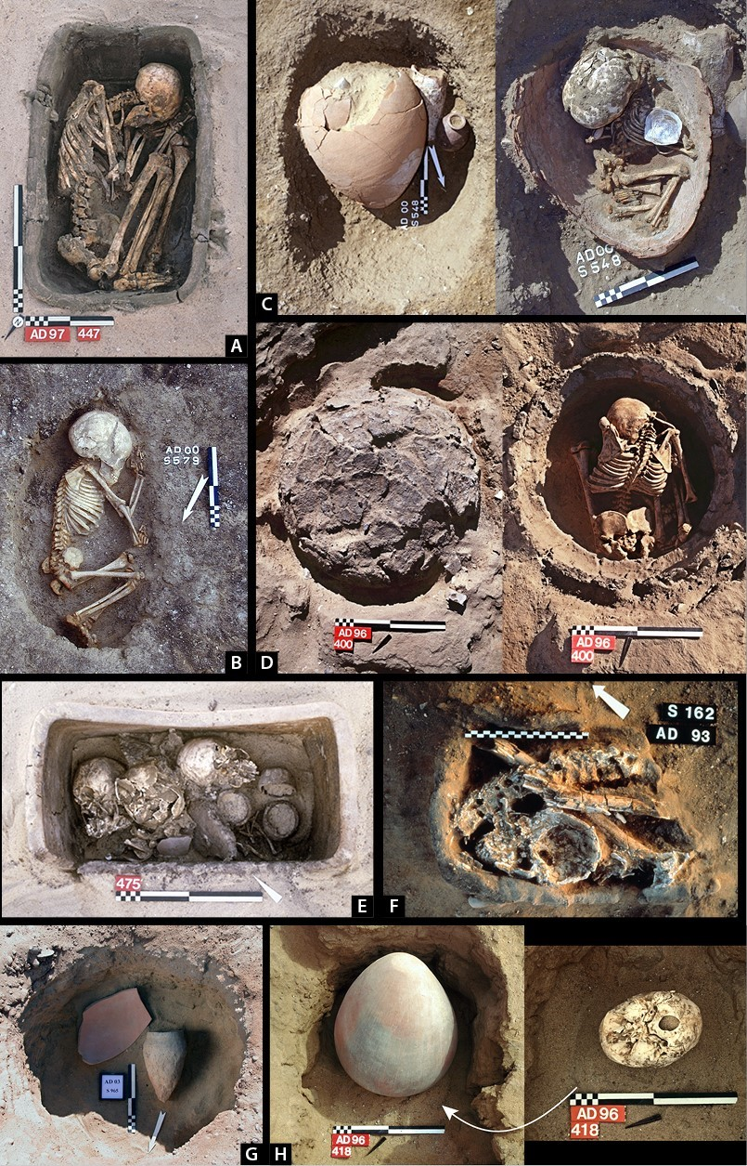
Fig. S1 Typical and/or specific burials in the southern and northern sector of the Eastern Cemetery. (a) S 447, northern sector, adult individual (>30 years). Single inhumation of a woman in a mud coffin closed with a lid made of the same material. The deceased was found in a hypercontracted position, de- posited on her left side. Presumably, the individual was bound and wrapped before being buried. (b) S 579, southern sector, infant individual (1-5 years old). Single inhumation of a child in a simple pit, without a coffin or a jar. The individual was placed and arranged in situ on his/her left side directly in the pit. (c) S 548, southern sector, newborn individual (0-1 year old). Single burial of an infant in a jar. The individual was deposited directly in the jar (in situ arrangement) together with a necklace and a bracelet. A shell was discovered on the right shoulder. (d) S 400, northern sector, infant individual (9-11 years old). The individual was placed in a simple pit in a prostrate kneeling position (in situ arrangement) covered with a mud cap (about 4 cm thick). Third Dynasty. (e) S 475, northern sector, three infant individuals (1-4 years old and 5-9 years old). Secondary burial of three children in a pottery coffin closed with a mud lid. (f) S 162, northern sector, adult secondary burial with body divided into several parts. Third Dynasty. (g) S 965, northern sector, cenotaph. Pit including separate vessel offerings. Their arrangement was the same as in a burial. However, the pit contained no human remains. (h) S 418, northern sector, disembodied skull of a child or an adolescent placed under a jar. The atlas and the axis bones were discovered under the skull

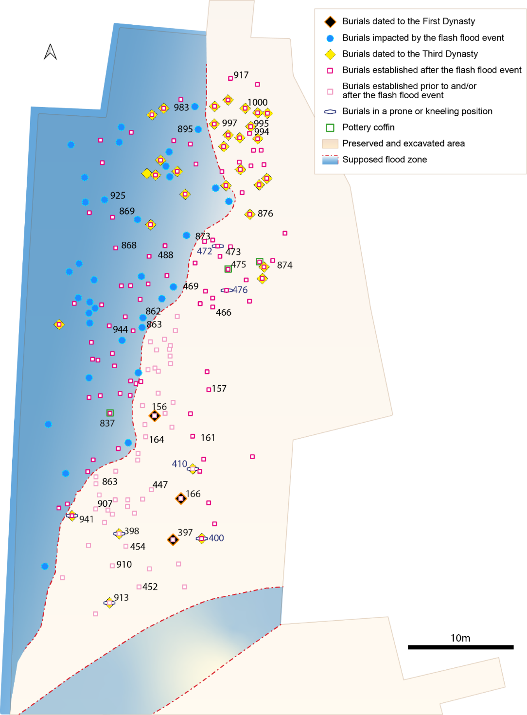
Fig. S2 Adaima, Eastern cemetery, northern sector. Chronology established based on pottery seriation, flash flood events and particular rites associated with certain individuals (burials in a prostrate kneeling position). The extent of the flash flood event (blue area) is indicated by the red dotted line
Supplementary text S1. Funerary analyses
Burial types and demarcating of graves.
It appears that the officiants deposited and arranged most of the bodies (132 out of 184 individuals) in situ. The remaining individuals were brought to the cemetery either in a hypercontracted position (bound or in a bag and/or wrapped in an animal skin) or in a jar (young children). In the northern sector a larger number of individuals (40%) were placed in a hypercontracted position (p = 2.4 ×10-7) – especially during the Third Dynasty – compared to the southern sector (20%). Fifty-one out of the 195 individuals in the northern sector had at least one personal ornament as a grave good and 41 out of these 51 individuals (80%) wore a personal ornament (Fig. S3). Ninety-six out of the 281 individuals in the southern sector were equipped with at least one personal ornament: 77 individuals were associated with personal ornaments either deposited on the body or worn during his/her lifetime. However, in the southern sector the individuals wore a larger number of personal ornaments than in the northern sector and these were of superior quality.
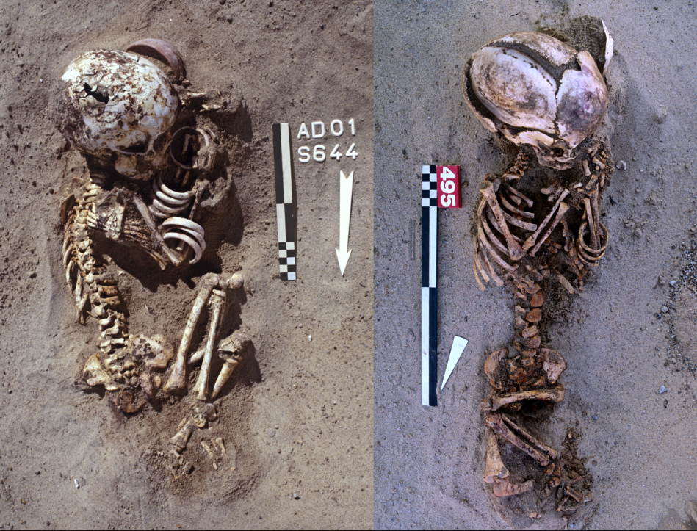
Fig. S3 Personal ornaments. Photographs of infant individuals from the southern sector wearing a set of bracelets (at left: S 644, at right: S 495)

The officiants placed a disembodied skull (burial S 418) under a pot. Apart from this isolated discovery, the deceased were either deposited or arranged in a simple pit (273 cases or 58%), in a jar or in a coffin. Burials in a mud coffin (n = 30) or in a pottery coffin (n = 3) were present in the northern sector. Two wooden coffins were discovered in the northern part of the southern sector – close to a burial that was not counted as a coffin but was covered with several wooden logs. Two additional wooden coffins were found in the northern sector, one at its southern end (S 913, the corners of which were reinforced with mud) and the other at its northern end (S 1000, the walls of which were covered with stucco). Jars (n = 159) and coffins (n = 38) are underrepresented compared to simple pits (p-value < 0.05) and the number of jar burials exceeds the number of burials in a coffin (p-value < 0.05). Amongst the graves, basket burials (n = 23, i.e. seventeen in the southern sector and six in the northern sector) are not very frequent compared to simple pit graves (p-value < 0.05). Only jar burials are age-specific since – except for four out of 159 cases –, the individuals buried in a jar were aged between 0 and 5 years (only one individual over 12 years of age). It could be stated that infants aged between 0 and 1 year were more frequently buried in a jar than in an individual pit or a coffin (p-value = 0.009). No difference was stated between the age groups regarding the burials in a coffin, i.e. 59% of the individuals under 12 years of age and 41% of the individuals over 12 years of age (p-value = 0.11).
Demarcating was identified for 48 tombs (approximately 10%), although this number is a minimum value as the location of tomb S 166 was visible (although there were no traces of postholes). Burial S 397, located south of tomb S 166 and dated to the same period (First Dynasty) was dug in indurated sediment and may have been marked by a post. Burial S 168, as part of the circle of graves surrounding tomb S 166, was associated with postholes detected in the sand around it, near the individual's skull and feet. There were more graves with demarcations in the northern sector (n = 29) than in the southern sector (n = 19) (p-value = 0.02). In the northern sector, immediately prior and during the Third Dynasty, five tombs were demarcated by a large stone that sometimes resembles an unengraved stela (S 874, S893, S 894, S 916, and S 959). One tomb in the southern sector was marked by a small block of stone (S553), a second one (S 800) by a wooden sign (tamarisk burl).

The position of the corpses.
In the southern sector, 66% of the individuals (n = 185) were placed on their left side, which is even a prevailing attitude (n = 76, i.e., 88%) as regards the individuals arranged in situ. In the northern sector, the position on the right side is more or less equivalent to that on the left side (p-value = 0.21). This observation is related to the emergence of the position on the right side, which can be dated shortly prior to the Third Dynasty. Burial S 874 contained an elite woman arranged in situ in a pottery coffin placed on her right side immediately prior to the Third Dynasty. As regards the adults interred in the northern sector, the sex of which could be determined, women were either placed on the left or the right side (n = 4), but not a single male individual was placed on his left side except for the 15-18 years old adolescent (S 954) whose grave was found among the cluster of female burials around tomb S 166. The positions on the right and the left side remain predominant compared to others (p-value = 2.5 × 10-4). Four individuals were placed in a prostrate kneeling position in the northern sector, two around S 874 (S 472 and S 476) and two around S 166 (S 400 and S 410), against only one individual (S 647) in the southern sector (p-value = 0.009). All were placed in an individual pit, facing south or south-east, without any element of the operational sequence of eye-makeup and personal ornaments.
As regards the individuals arranged in situ or in a hypercontracted position, the position of both hands at the level of the head (36%) was the most frequent one in both sectors. Asymmetric positions are equally distributed (10% thorax-head asymmetry, 10% leg-head asymmetry, 12% leg-thorax asymmetry). In cases of arrangements in situ (except for those in jars, although comparisons are possible with S 166 and S 874), S 166 is the only infant individual over ten years old with both hands placed at the chest level. All the other cases (n = 13 in total (12.5%), i.e., two in the northern sector and eleven in the southern sector) were infant individuals aged under ten years. The individual of burial S 874 exhibited an asymmetrical position of the hands with her right hand at the knee level and her left hand at the right elbow level. This position is referred to as “leg-thorax asymmetry” in the dataset (10.7%). This type of asymmetry is specific for infants under ten years of age except for the female burials S 874 and S 469, an individual with epiphyseal dysplasia involving the proximal part of the femur, lying on her right side close to S 874. Three individuals had the same position but were placed on their left side (S 582, S 661, and S 681). The position of S 874 as regards the attitude of the hands and the body is, therefore, unique.

Orientation of the corpse and the face.
The orientations of the head and the feet could be determined for 426 individuals (Fig. S4). As regards the southern sector considered as a whole or differentiating between individuals arranged in situ, in jars or in a hypercontracted position, in most cases, these were oriented to the south-east (143 individuals, i.e., 51%) and to the south (71 individuals, i.e., 20%), the others being more or less distributed in equal shares, except for the orientations to the north-east and the south-west, which are underrepresented in both sectors. When considering the orientations to the north-east, excluding the jar burials, for which the orientations were less respected, there are only two cases: S 397 set in perpendicularly orientation to S 166 (a 90° angle between the two orientations) and S 935 in the circle around S 837. In the northern sector, there is a rebalancing of the different orientations linked to the disappearance of the preferential orientation to the south-east and the south shortly prior the Third Dynasty - a phenomenon well illustrated by the orientations of the individuals arranged in situ. As regards the orientations of the face (n = 232) of the individuals in the southern sector, they looked preferentially towards the west or the north-west (n = 57 and n = 28, i.e., 38% and 19% respectively), whereas in the northern sector, all orientations of the face, except for those to the south or the south-east (8%; p-value = 0.03) are almost represented in equal shares.
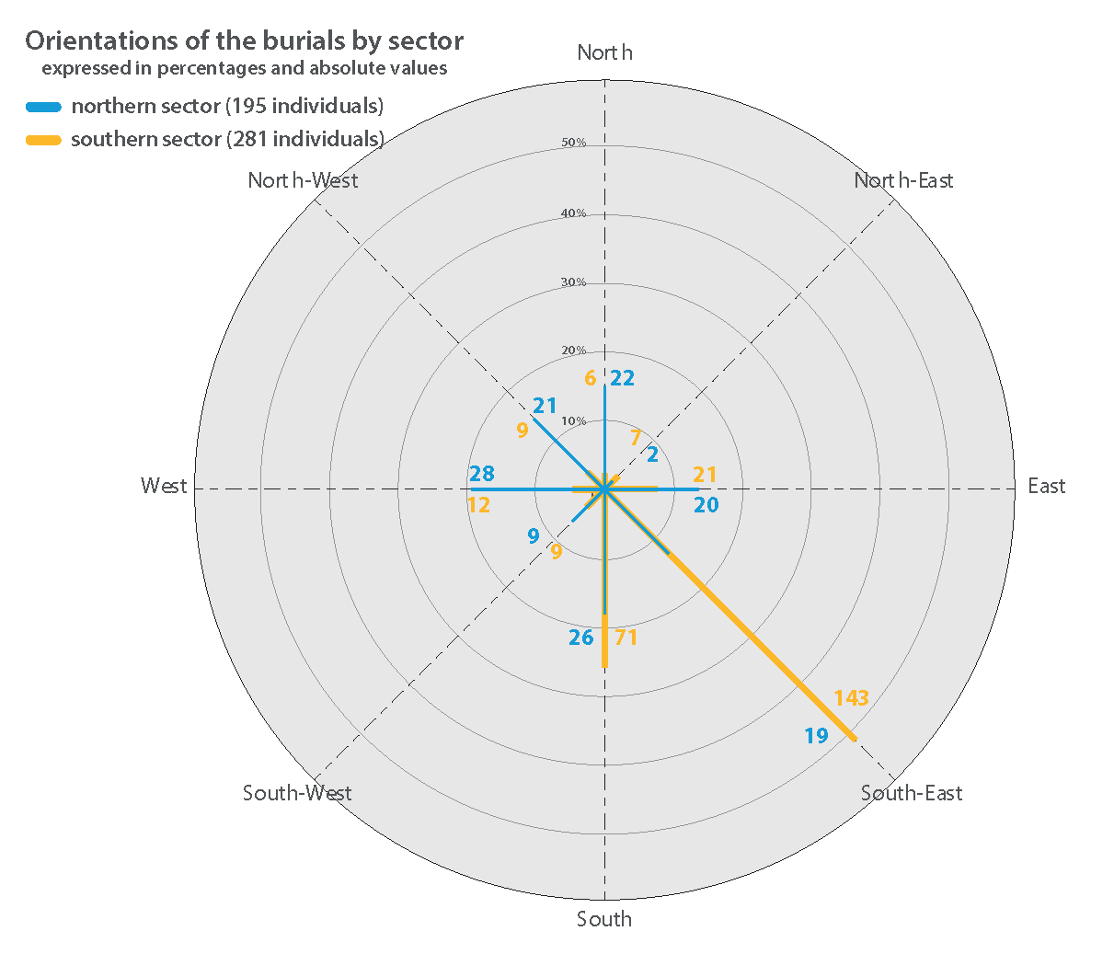
Fig. S4 Orientation of the graves. By sector in percentages (circles) and absolute values (in blue and yellow), which are determined by the head's orientation

As regards the southern sector it could be determined (logistic regressions) that the orientation of the head towards the south and the south-east is related to the position of the body on the left side (α = 0.004) and to the prostrate kneeling position (α < 0.05); to the orientation of the face towards the south-east (α = 0.05) and to the presence of two grave goods (α = 0.1). In the northern sector, these same orientations are associated with personal ornaments, with elements of the operational sequence related to the production of eye-makeup and with pottery, as well as with a position on the left side and a position of the hands at the level of the head or the thorax (α = 0.1). It thus appears that the dominant orientations in the southern sector correspond to a “minimalist” ritual with the body placed on its left side and the deposit of two grave goods. By contrast, in the northern sector, this orientation, which is no longer predominant, was mainly associated with individuals buried with the most elaborate rites of the southern sector (and therefore of an earlier date), notably the hands towards the face or the chest and the presence of elements of the operational sequence of eye-makeup as well as of grave goods. The predominant orientation identified in the southern sector – considered as being an “ancestral tradition” – was the orientation towards the south or the south-east. Consequently, this orientation pattern follows an “ancestral tradition” regarding the individuals in the northern sector.

Actions related to the ritual sequence.
The number of actions does not reveal significant differences (p = 0.5) between both sectors. There is no link between a distinct age class and the presence of several actions, nor are there any actions or rites that are age class-specific. Only jar burials are age-specific (see above), as are some personal ornaments (Baduel 2009; Minotti 2021) and the deposit of feeding bottles (see below). Even the beer jars are not age-specific (associated with four children aged between 0 and 1 year, four children aged between 1 and 5 years and two children aged between 5 and 10 years). The woman buried in S 874 clearly stands out with a sequence of eleven actions, while the area with the most actions is the one centered on S 166. A single action, i.e., the deposit of the body, was identified for 16% (n = 75) of the individuals. Thirty-four per cent (n = 163) and 33% (n = 156) burials were associated with two and three actions, respectively.

Associated artifacts
As a general rule, the artifacts associated with the burials are offerings that accompanied the deceased (Crubézy 2019). A distinction can be made between:
(i) Offerings that are part of a frequently encountered ritual: the elements that fit into this category are those related to the operational sequence of eye-makeup and the deposit of pottery vessels.
– Nineteen per cent (53 out of 281) of the individuals buried in the southern sector and 8.2% (16 out of 195) of the individuals buried in the northern sector were associated with at least one element related to the operational sequence of eye-makeup (p-value = 8.84 × 10-10). There is no association with specific age classes. These elements may be purely symbolic (malachite pigmentation/dust applied on the forehead of a premature baby (S 156) and of a few months’ old infant (S 155) or deposit of a grinding pebble to ground malachite). The child burials usually received only one element but distinct burials in the southern sector were equipped with four elements related to the production sequence of eye-makeup: S 970, a child of two years of age was accompanied by a palette, traces of malachite, a grinding pebble and a bag and S 559, a child aged between 3 and 5 years, was accompanied by two palettes, traces of malachite, and a grinding pebble.
– Deposits of pottery vessels (apart from vessels used as burial containers) can be associated with fine wares and potteries for utilitarian purposes (Buchez Nathalie 2007). Sixty percent (168 out of 281) and 40% (79 out of 195) of the individuals in the southern sector and in the northern sector respectively were associated with at least one vessel (p-value = 3, 49.10-5). In the northern sector display appears through the large number of vessels deposited, which were used in daily life (Buchez Nathalie 2007): S 476 included 32 vessels, S 466 and S 471 each contained 21 vessels; and S 469 was equipped with 16 vessels. These vessels were deposited as grave goods primarily in child burials containing individuals of 1-5 years of age (significant p-value) compared to the age classes 0-1 year and 5-12 years. Sixty-three percent (140 out of 223) of the individuals aged between 1 and 5 years had at least one vessel, compared to 36% (52 out of 144) of the individuals aged between 0 and 1 year and 45% (25 out of 53) of the individuals aged between 5 and 10 years.
– Fifty-six burials were equipped with a vessel type that is qualified as a ‘bottle’ in the typology. These potteries are frequently found in front of or even in contact with the mouth in burials associated with careful rites (Fig. S5). Thirty-nine of these vessels were associated with children aged between 1 and 5 years (63%), 16 (29%) with children aged between 0 and 1 year and 5 (9%) with children aged between 5 and 10 years. These vessels probably were “feeding bottles”. There are only two occurrences in the northern sector (S 934, in the area around S 837 and S 397 set in perpendicularly orientation compared to S 166), typologically differing from those in the southern sector but seemingly with the same function. Thus, in burial S 934, the opening of the feeding bottle was placed in front of the child’s mouth. In addition, this burial contained an ivory boat model (see above).

(ii) The display of goods corresponds to the deposit of valuable items, often arranged on the body but their variability and frequency is not significant (at least to us in the 21st century). Officiants deposited personal ornaments related to adults on the bodies of ten children in the southern sector and of four children in the northern sector. A boat model made from ivory was associated with burial S 934 (Naqada IIID/early Third Dynasty), a child about three years of age placed in a mud coffin. This boat model is a prestige item. All the 29 ivory boat models known for the Predynastic period are dated to Naqada III/Third Dynasty, three of these were found in graves and the other in cult contexts among which 21 objects from the “Main Deposit” found at Hierakonpolis (Vanhulle 2017). Further grave goods, which are rare but were encountered repeatedly in a standardized way seem to be purely symbolic (at least to us in the 21st century) and apparently were reserved for particular rituals. Thus, five children (one in the northern sector, four in the southern sector) were furnished with one or several lumps of mud or of organic matter mixed with mud (fictitious food deposit?).
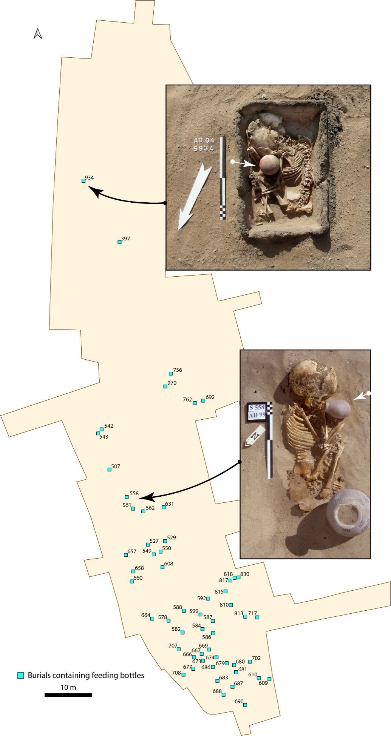
Fig. S5 Map showing the burials associated with feeding bottles. Two examples showing that the feeding bottle was placed in front of the mouth of the infant individuals (S 558 in the southern sector, S 934 in the northern sector)
Analyses according to the age classes
Southern sector, comparing the age group 0 to 5 years to the age group 5 to 12 years:
- The number of personal ornaments is age-dependent (p-value = 0.04, t-test): individuals between 0 and 5 years of age had a more significant number of personal ornaments compared to those aged between 5 and 12 years.
- Hypercontracted positions are associated (p-value = 0.004, Pearson’s chi-squared test) with individuals aged between 0 and 5 years (due to the type of burial).
- A more significant number of children aged between 5 and 12 years were buried in a pit compared to the age group 0 to 5 years (p-value = 0.04, Fisher’s test) since all infant individuals aged between 5 and 12 years were deposited in a pit except for one individual placed in a wooden coffin. Children between 0 and 5 years old were buried in a pit or a jar.

Northern sector, comparing the age group 0 to 5 years to the age group 5 to 12 years:
- Individuals aged between 5 and 12 years were preferentially buried in a pit (p-value = 0.0003, chi-test) compared to burials in a jar or a coffin; those aged from 0 to 5 years were preferentially buried in a pit or a jar (in equal shares) compared to burials in a coffin; (p-value << 0.005, Pearson’s chi-squared test)
- A single pottery item (offerings) in a burial is more frequent among the age group 0 to 5 years. (p-value << 0.05, Fisher’s test)

Northern sector, comparing the age group 0 to 12 years to the age group over 12 years of age:
- Jar burials only concern individuals between 0 and 12 years of age, except for one adult. The difference between burials in wooden coffins is not significant or age-dependent.
- Many vessels (offerings) were associated with individuals over 12 years of age; (p-value = 0.029, Fisher’s test). It should be noted that a large number of potteries means two standard deviations over the mean value of 1.31 vessels per burial, or a minimum of nine vessels per burial).
- There are as many individuals aged under ten years buried in a prostrate kneeling position (n = 2) as there are individuals aged over ten (one adult and one adolescent).

Table S1a Summary of the number of individuals and the number of individuals with complete data
 | South | North | Total
Number of individuals | 280 | 190 | 370
Number of individuals with complete data | 218 | 92 | 310

Table S1b Summary of analyses performed, individuals considered (number) and variables considered (name and details)
Analyses types | Nb of ind. | Nb of variable | Variable detail
Artificial intelligence algorithms | 310  (Complete data only) | 34 | Age class, type of burial, tomb arrangement, body position, body orientation, face orientation, hand position, number of burial-related events, presence or not of ceramics, number of ceramics, presence or not of ornaments, number of ornaments, worn ornaments, deposited ornaments, presence of surface markers, and use of ochre, position of ceramics including 11 localizations, presence or not of a shovel, presence or not of a shell, presence or not of an aspatharia (specific type of shell), presence or not of a pearl, presence or not of a tool, prostate-kneeling position, dismembered individual
Social Network Analysis (SNA) | 92  (North grave and complete data only) | 33  (Without age class) | Type of burial, tomb arrangement, body position, body orientation, face orientation, hand position, number of burial-related events, presence or not of ceramics, number of ceramics, presence or not of ornaments, number of ornaments, worn ornaments, deposited ornaments, presence of surface markers, and use of ochre, position of ceramics including 11 localizations, presence or not of a shovel, presence or not of a shell, presence or not of an aspatharia (specific type of shell), presence or not of a pearl, presence or not of a tool, prostate-kneeling position, dismembered individual
Linear Discriminant  Analyses  (LDA) | 310  (Complete data only) | 16 | Age class, type of burial, tomb arrangement, body position, body orientation, face orientation, hand position, number of burial-related events, presence or not of ceramics, number of ceramics, presence or not of ornaments, number of ornaments, worn ornaments, deposited ornaments, presence of surface markers, and use of ochre
Bayesian | 210  (Exclusion of pot) | 16 | Type of burial, tomb arrangement, body position, body orientation, face orientation, hand position, presence or not of ceramics, number of ceramics, presence or not of ornaments, presence of surface markers, ceramics next to the head, the body, or away from the body, the use of ochre, secondary tombs and dismembered individual
Phylogeny | 21  (10 south, 11 north, only those with a lot of events) | 16
Innovations | 310  (Completed data only) | 17  (Same as phylogeny with number of events in supplement) | Type of burial, tomb arrangement, body position, body orientation, face orientation, hand position, presence or not of ceramics, number of ceramics, presence or not of ornaments, presence of surface markers, ceramics next to the head, the body or besides the body, the use of ochre, secondary tombs and dismembered individual + number of burial-related events

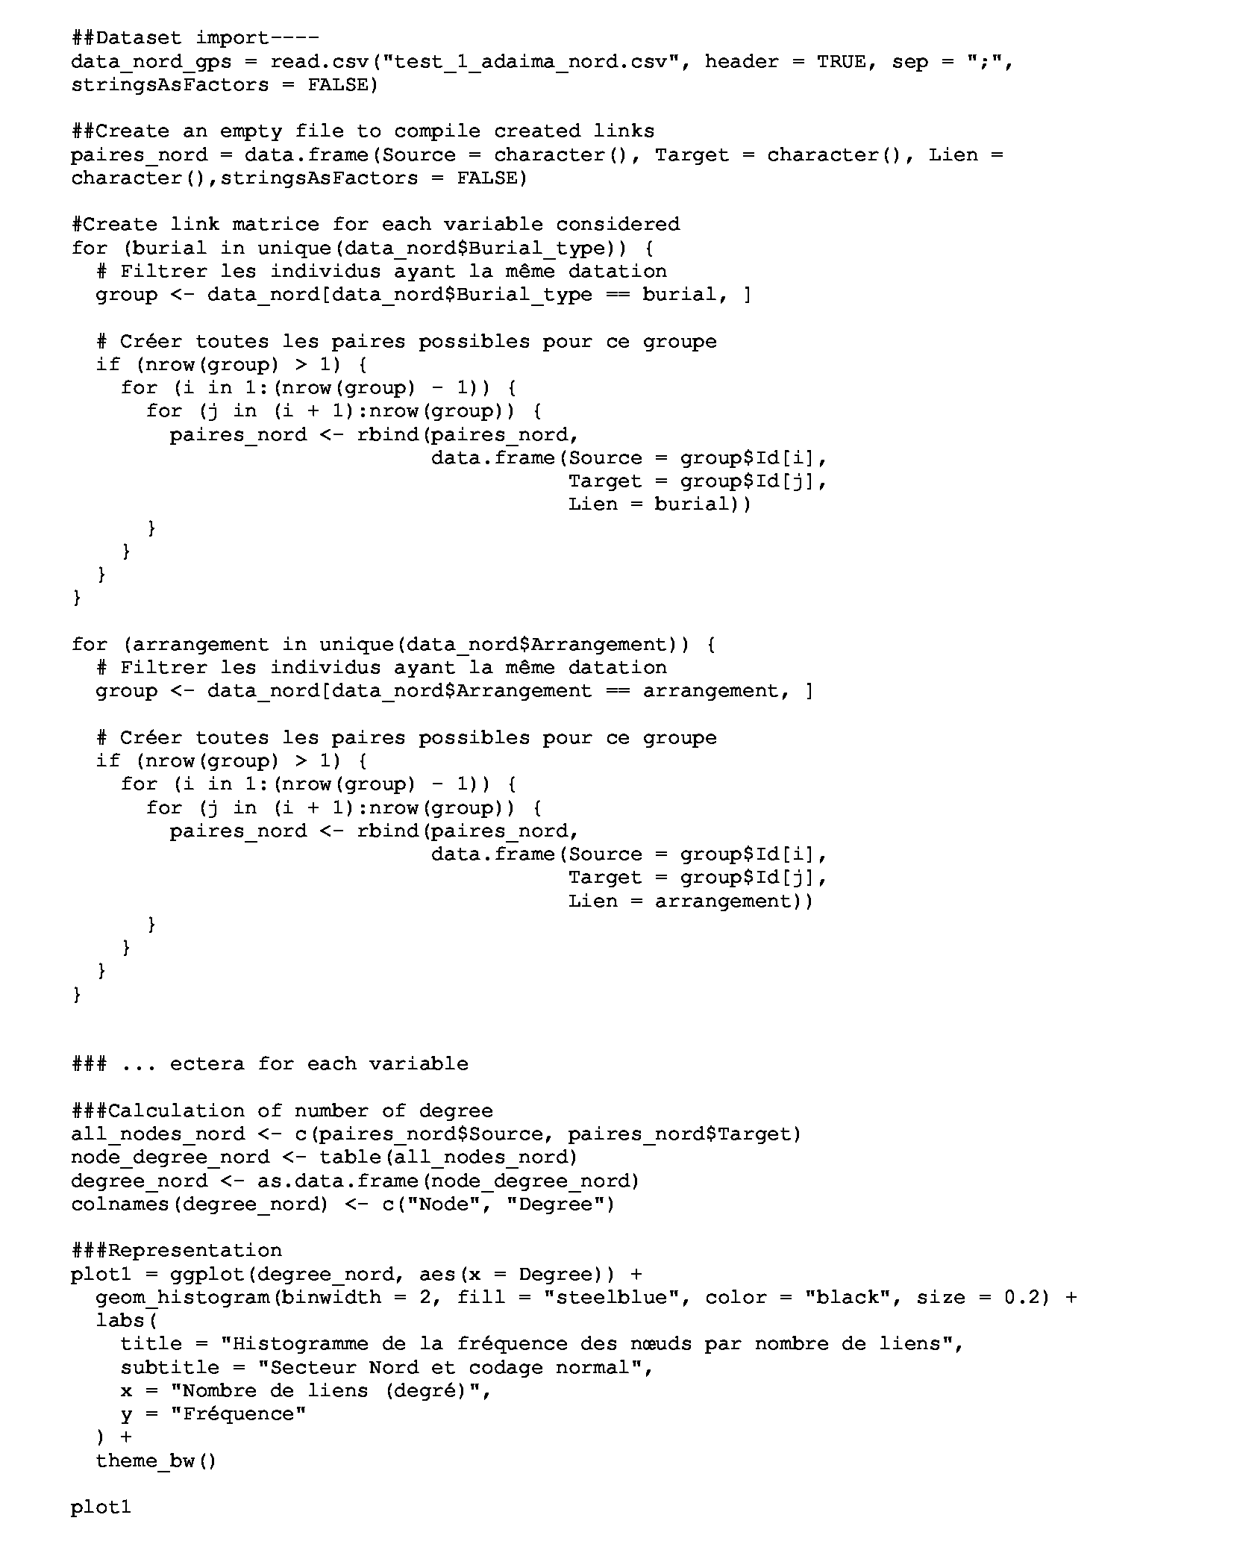
Fig. S6 Script for link matric creation. The code was developed for and with RStudio
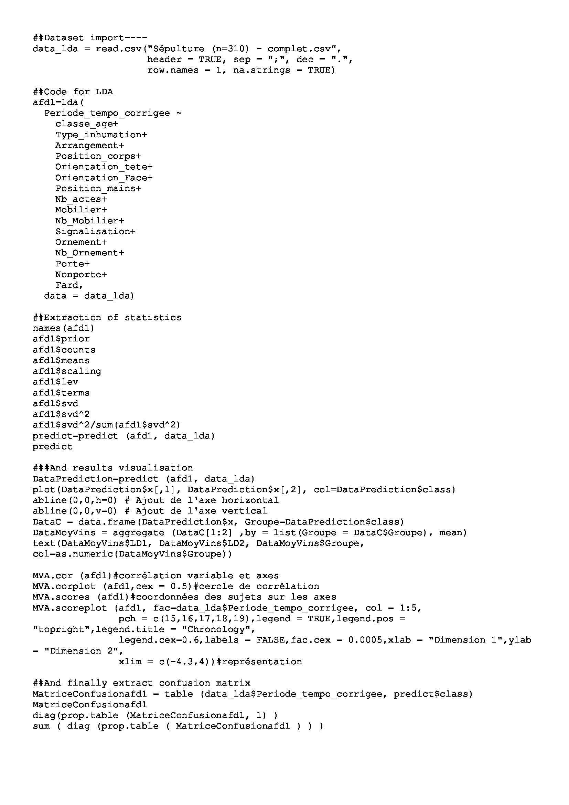
Fig. S7 Script for LDA. The code was developed for and with RStudio

Table S2 Ancestral states for each attribute determined through Bayesian analyses. The probabilities correspond to the probabilities that the attribute state is ancestral. * Three results are inconsistent with our previous observations. Indeed, the ancestral arrangement defined by Bayesian method is hypercontraction. We had previously observed a clear over-representation of individuals arranged directly within the grave (in situ). Individuals in the northern sector were widely deposited in hypercontraction. We will therefore disregard this result in favor of the ancestral state of hypercontraction since the clear evidence of the archaeological report. The absence of funerary material and the absence of ornamentation are defined here as ancestral. We have previously defined that the southern sector was a sector with frequent deposits of grave goods (60%) but in small quantities. In contrast to the northern sector where deposits were less frequent (40%) but when they did occur, they were substantial (up to 32 items). Similarly, for the ornaments, the observation of the evolution of this presence showed us a decrease in the deposits of ornaments during the use of the necropolis. Thus, since these observations, we define the presence of grave goods and ornaments as ancestral characteristics
Character | Features | Bayesian probabilities
Burial type | Pot or coffin  Simple pit | 0.0109  0.9891
Type of arrangement* | In situ (or brought in pot)  Hypercontraction | 0.2672  0.7328
Position of the corpse | Right side  Left side  Other | 0.0490  0.9485  0.0025
Orientation of the corpse | South or South-east  Other | 0.8185  0.1815
Orientation of the face | West or North-west  Other | 0.6837  0.3163
Position of the hands | Head or chest  Legs  Asymmetry | 0.8992  0.0081  0.0927
Number of events in funeral sequence | Less than 2 actions  2,3 or 4 actions  5 or 6 actions  More than 6 actions | 0.0001  0.9918  0.008  0.0002
Presence or absence of grave goods* | No  Yes | 0.7500  0.2500
Number of grave goods | Between 0 and 7  More than 7 grave goods | 0.9997  0.0003
Presence of goods next to the head | No  Yes | 0.9975  0.0025
Presence of goods next to the body | No  Yes | 0.8958  0.1042
Presence of goods away from the body | No  Yes | 0.9118  0.0882
Demarcating of the burial | No  Yes | 0.0106  0.9894
Personal ornaments* | No  Yes | 0.7500  0.2500
Operational sequence of eye-makeup | No  Yes | 0.9991  0.0009
Dismembered individual | No  Yes | 1.0000  0.0000
Secondary burial | No  Yes | 1.0000  0.0000

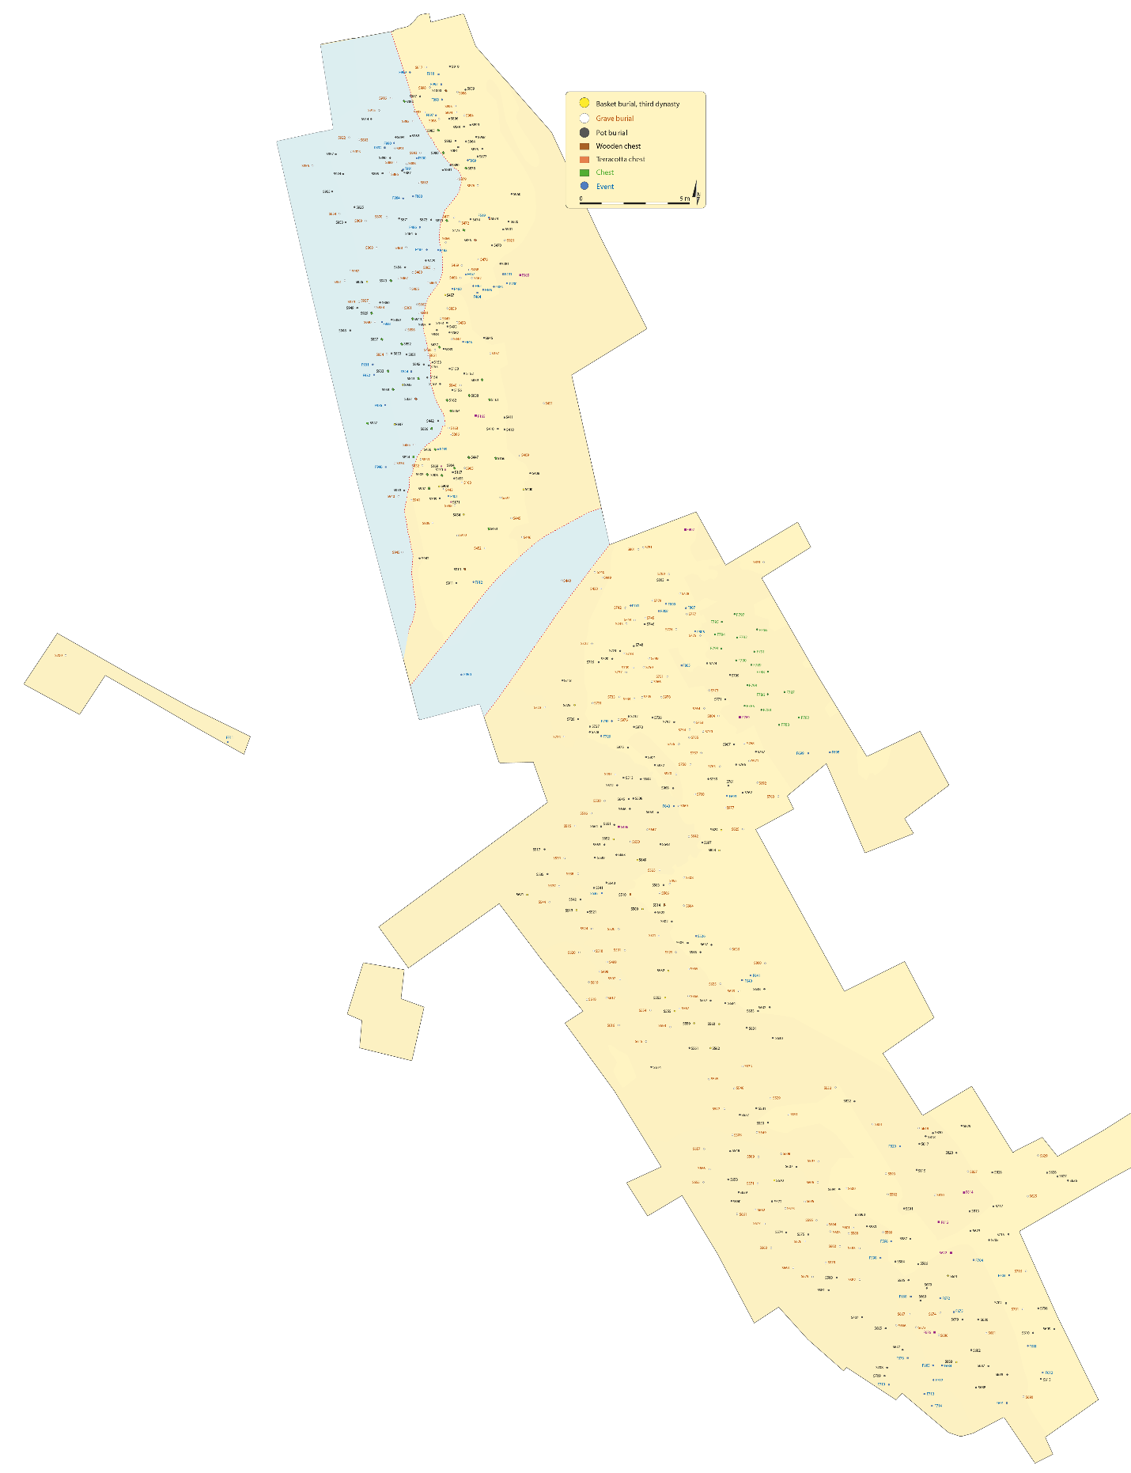
Fig. S8 General map of the Eastern Cemetery. The flash flood event caused by the overflow of the wadi separating the southern and northern sector, which affect the northern sector is represented in blue. Burial S 700, dated to the Naqada IIIA2 period is located at the westernmost point of the Eastern cemetery

Supplementary text S2. Description of specific graves or individuals around S 166
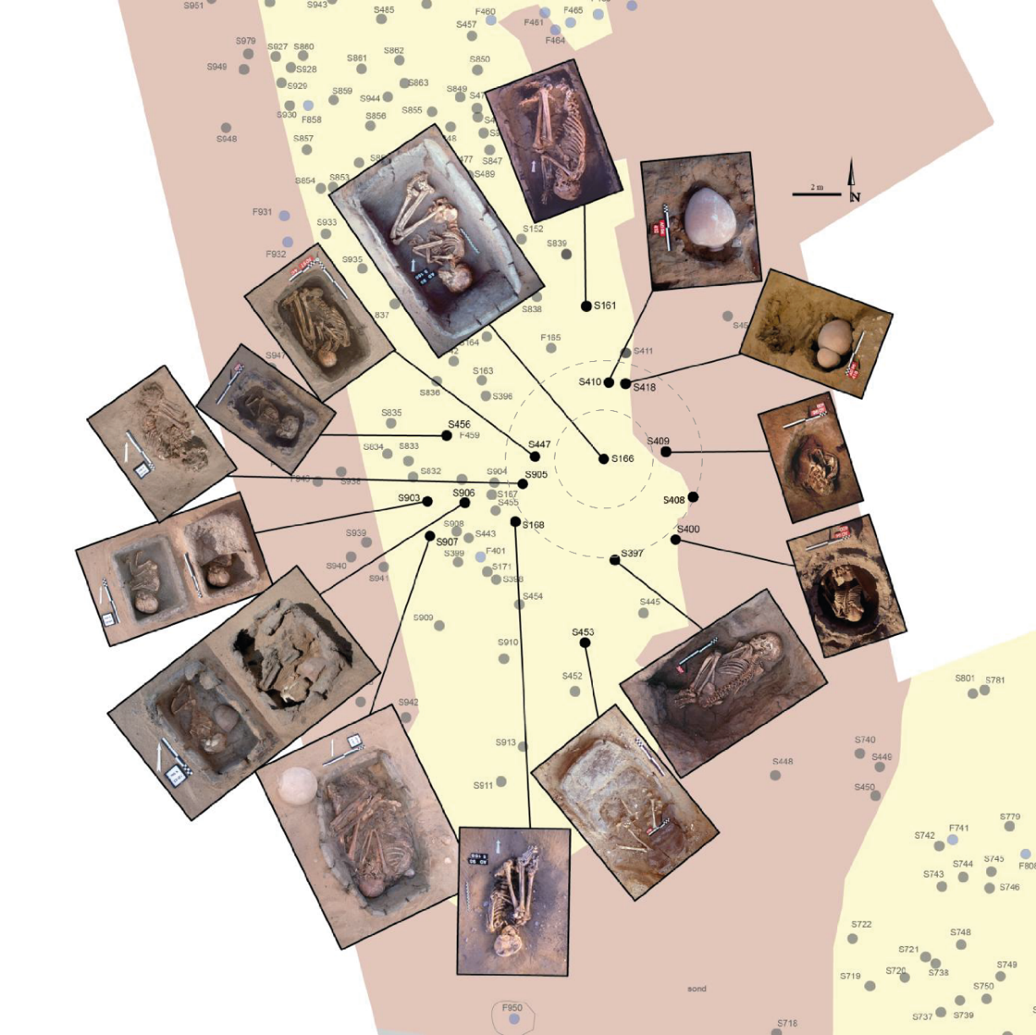
Fig. S9 Dynamic Establishment of the First Circle of Tombs around S 166. The Tomb S 166, the grave of a teenage girl dating to the First Dynasty, could be the first tomb established in this northern sector of the Eastern Cemetery. We dated two other tombs to this period: S 397; the grave of a teenager whose coffin is roughly arranged in an orientation or on an axis perpendicularly to the one of S 166 (oriented SE-NW), i.e., an orientation along the NE-SW axis, and S 168, the grave of a teenager located to the south-south-west of S 166. Tombs S 905, belonging to a child of about seven years old, and S 447, an adult female over 30 years old, were devoid of grave goods and oriented considering the alignment of S 166 so they are associated with this time period. The other tombs in this first circle, located to the north-east part, are significantly later and correspond to the Naqada III D/Third Dynasty: tombs S 410 is located to the north-north-east (newborn), S 418 to the north-east (isolated skull of a child or teenager), S 409 fast precisely to the east (child aged 3 to 4 years), S 408 (between birth and one year old) (no picture available), and S 400 to the south-east (child aged 10 to 11 years). The first dotted circle corresponds to a radius of 2 meters around S 166. and the second to a radius of 4 meters
S 397 belongs to the three burials dated to the First Dynasty. The pit was dug into the red-colored indurated substratum, in which was also dug the pit for the mud coffin of S 166. The coffin of S 397 was set perpendicularly to axis of the coffin of S 166 (oriented SE-NW), i.e., an orientation along the NE-SW axis, and the axis of the body was inclined by 50° degrees relative to the north-south axis to the east. It may be possible that the tomb was demarcated by a wooden post as suggested by a posthole excavated at the bottom of the pit (next to S 166, to which the individual “looked”). There were only these two burials and burial S 156 for some time in this area. S 397 contained an adolescent of 10 to 12 years of age placed in a prone position wrapped in a leather bag, and covered with a mat. It was accompanied by a necklace with two beads and a grinding pebble with ochre was discovered under the head. During the refilling of the pit the officiants deposited a bread mold, a beer jar, a mold, a plate and a small cup and in the upper section a feeding bottle. The grave goods, apart from the feeding bottle, are pretty similar to those associated with burial S 166 and are fairly represented in the southern sector. They are very rare in the northern sector where they represent an earlier tradition. South of the pit, an organic layer may correspond to the remains of a fireplace, the only one identified at the burial site.
S 156 is a burial of a premature individual (fetus seven lunar months gestation) oriented to the south in a jar that was closed with a lump of mud mixed with ashes. Before the burial, an officiant had slathered the stillborn's back or neck using a small piece of malachite humidified on his finger. The corpse was then put in a jar, which was placed in a pit with four miniature vessels deposited on top.
S 453 is a burial in a mud coffin with a cover plate made of the same material which contained the bones of a 5-year-old child. The skeleton was disturbed and the bones in parts were found outside the container. Archaeologists would have evoked looting if it was a ‘wealthy’ burial. However, this is not the case, and in this part of the cemetery, no traces of grave looting were observed at all. Thus, the hypothesis of “bone removal” can be advanced.
S 418 comprises an isolated skull missing the splanchnocranium belonging to a child or an adolescent, covered with a jar. The pit contained a bead next to the first two cervical vertebrae. A bowl was found between the jar and the wall of the pit.
S 161 corresponds to the burial of a female over 30 years old placed in a mud coffin. The officiants had deposited a child’s vertebra fragment on her body.
S 907 is the burial of a woman over 30 years old placed in a mud coffin with a fragment of a massive bracelet in her left hand. Rather than worn at the left arm, this type of bracelet was reserved for children from 0 to 9 years of age (Minotti 2021). The body was in a leather bag; an ochre pebble and a mud seal at the level of the left hand were placed on it. The coffin was closed with a wooden lattice fixed by holes in its corners. The officiants placed a mat on top of the coffin and deposited pieces of malachite against its western wall.
S 906 (premature) and S 903 (aged 3-6 months) were placed in a mud coffin. The coffin of burial S 903 was closed with a bipartite cover plate (unique feature): the upper part with the head was covered in a second stage. S 906 contained a fragment of a red vessel deposited in the grave.
S 400 and S 410 can be dated to the Third Dynasty and were placed in a prostrated kneeling position with a north-eastern orientation.
S 398 and S 913 contained a child aged 8-9 years and a newborn aged between 6 and 12 months respectively, both in a prone position, S 941 contained a child of 4-5 years of age in a prostrate kneeling position.

Supplementary text S3. Description of specific graves or individuals around S 837.
S 934, the burial of a child aged 2-4 years placed in a mud coffin and accompanied by a boat model made of ivory (Fig. S10).
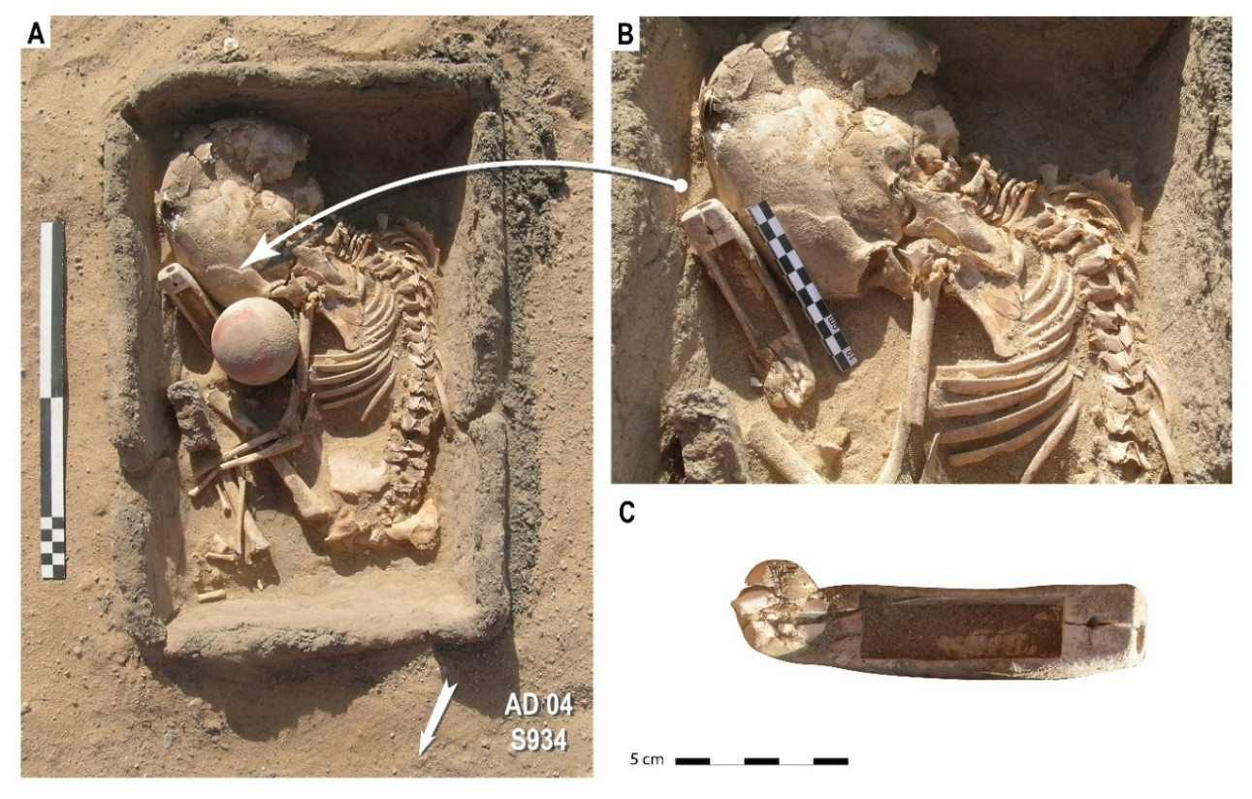
Fig. S10 S 934. Grave of an infant individual placed in a mud coffin accompanied by a boat model made of ivory. (a) First excavation stage. (b) Second excavation stage with baby bottle removed. (c) Boat model made of ivory
S 935, the burial of an infant aged 6-9 months placed on the right side the head pointing to the north-east.
S 836, the burial of an infant individual aged between 12 and 18 months placed in a mud coffin. An oval shaped hole (5 x 4 cm) was initially drilled into the coffin and later closed. Its purpose was to connect the interior of the coffin to the exterior (Fig. S11).
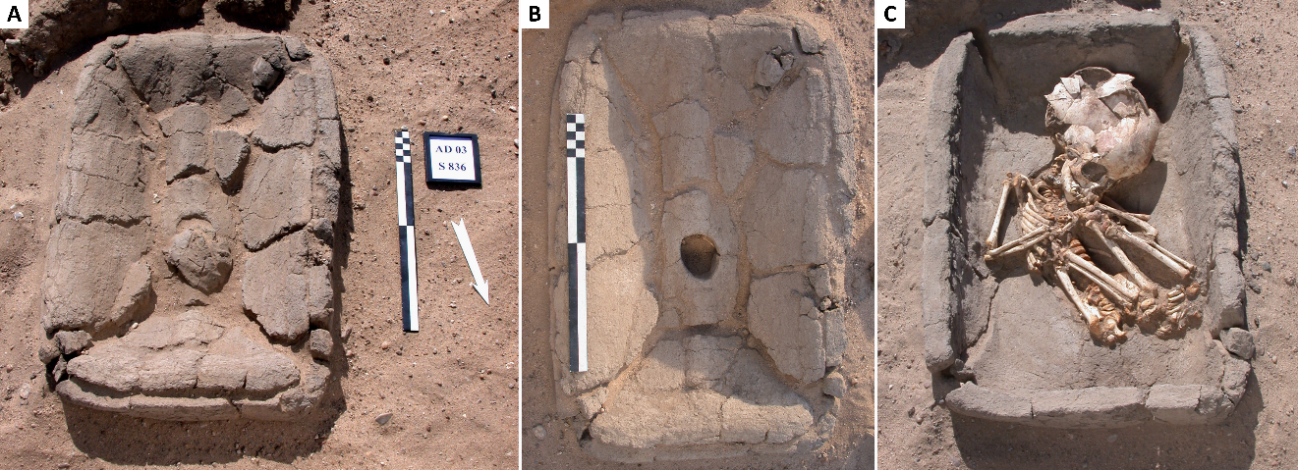
Fig. S11 S 836. Grave of an infant individual placed in a mud coffin with an oval-shaped hole (5 x 4 cm). (a) First excavation stage with the ovel-shaped hole filled. (b) Second excavation stage with the oval-shaped hole emptied. (c) Third excavation stage without the chest cover
S 154, the burial of a newborn in an inverted jar. When the jar which contained the burial was brought to the northern sector and turned over, the body was already decayed (Crubezy Eric Janin Thierry Midant-Reynes Béatrix 2002), as demonstrated by the position of the bones observed inside the pot.
S 162, bone segments of an adult or adolescent in anatomical connection: skull and mandible, thoracic rachis and two lumbar vertebrae, several cervical vertebrae, right hip bone and femur, left femur diaphysis, isolated from each other and grouped together in a mud coffin. The hypothesis was advanced that the officiants handled a dry, mummified body, from which they separated by traction and/or rotation the different segments that failed at the weakest anatomical junctions on specific anatomical units (skull/mandible in particular) and did not intend dislocation (Crubezy Eric Janin Thierry Midant-Reynes Béatrix 2002).
S 155, a secondary burial, contained a dismembered infant aged 3-6 months, placed in a jar next to S 153. The remains of the skeleton are divided in two parts: (i) the skull, the trunk with, on the right side, the humerus, which was severed using a sharp and blunt object, and, on the left side, the upper arm, missing the scapula and the hand, was set against the thorax and the left hip bone and femur, and (ii) the left foot. The absence of the left-hand bones (which are very small in the case of a newborn skeleton) and the attitude of the body are surprising. It can be assumed that the deposit was made once the body had decayed.
Supplementary text S4. Description of specific graves or individuals around S 874.
S 462 contained the bones of an individual aged 12 months in disorder in a well-individualized grave.
In burial S 872, the bones of two children, aged between 5 and 6 years, were found together in a jar. The bones were placed in the pottery in portions (bundles of bones, especially ribs). Anatomical segments, notably the legs, are preserved. As suggested by the position of the bones against the pottery wall, the jar was filled with sand. In the second stage, officiants brought it to the northern sector.
S 475 yielded the complete and well-preserved remains of three children (aged 5 years, 4 years, and 18 months) without anatomical connection, mixed in a pottery coffin (Crubézy 2017). First, the coffin was brought to the cemetery with the children’s remains inside. Second, once in the pit, it was closed with a lid made of mud.
S 466 contained a male individual in a hypercontracted position, laid down on his back, at the bottom of the pit. After the deposit, the officiants partially filled the cavity, and there was a scattering of sherds. As shown by the decomposed and displaced foot of this first individual a second individual was buried in the pit at some distance in time. This individual was an adult woman with a slit throat –incision at the level of the third cervical vertebra – initially placed in a seated position (Crubézy 2017) (Fig. S12)
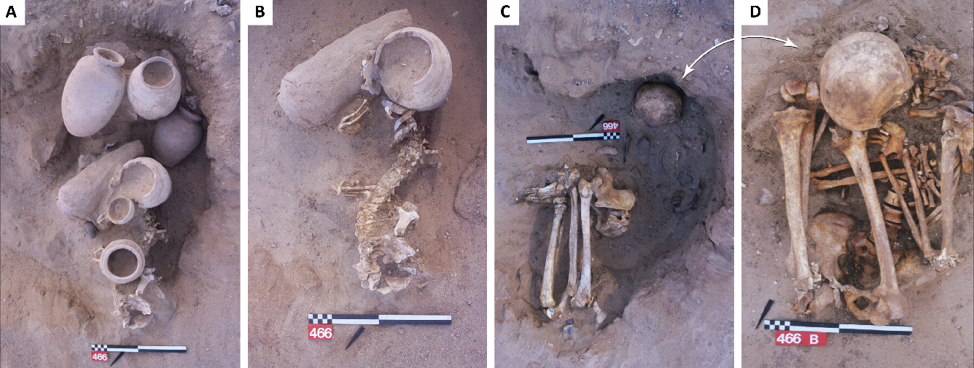
Fig. S12 Grave S 466. (a) Superior view of the grave, the skull of the upper subject is partially destroyed. (b) Excavation of the upper subject. A cervical vertebra shows an incision mark, indicating throat slitting (Ludes and Crubézy 2000). (c) The skull of the lower subject is visible. (d) Lower subject: the man is arranged at the bottom of the pit. (From Crubézy 2017)
S 469, a woman of 20-30 years of age had an epiphyseal dysplasia affecting the femur bones, a form of disability that sometimes resembles dwarfism.
S 472 and S 476, the burials of an adolescent aged 10-20 years and of a male adult aged 20-29 years respectively, which were both placed in a prostrate kneeling position.
S 473 contained a woman over 30 years of age. The fabric was preserved at the level of the ribs and she wore a necklace with a single faience bead. The deceased was deposited on her right side in a mud coffin, covered by a mat and the coffin closed with a mud lid. The upper limbs were bent, her right hand on the face and her left hand on the chest. The lower limbs were hypercontracted on the chest and the feet joint. The still-humid mud coffin was placed in a pit dug into the sand and fit the shape of this latter. Once the coffin closed, two vessels were deposited on the lid at the level of the feet and the pit was filled. The digging of burial S 472 damaged the northern corner of the coffin. Such a case of relative chronology is exceptional in the cemetery.

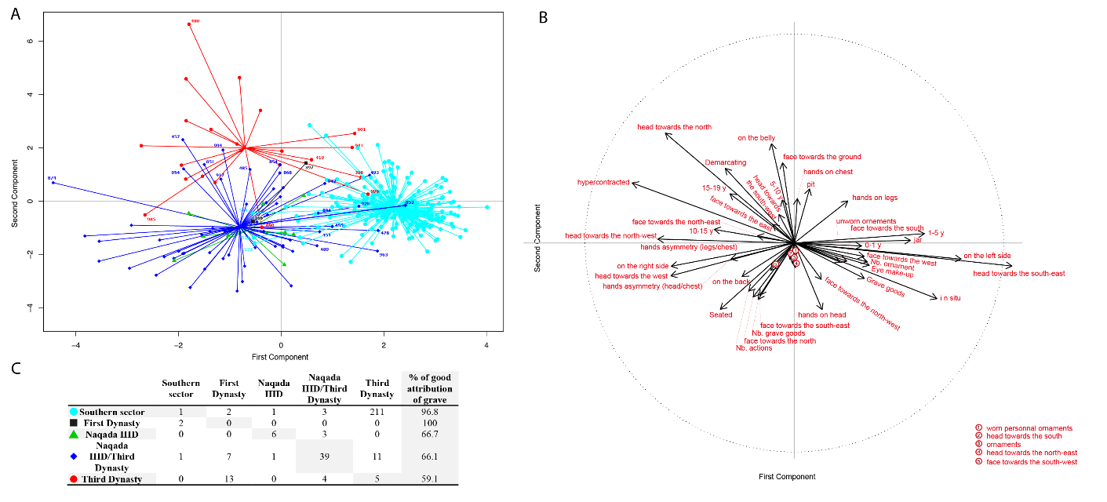
Fig. S13 Linear discriminant analysis (LDA). (a) Graph of individual with the barycenter of each period and annoted individuals who are misattributed to their period. (b) Correlation circle of the attributes. (c) Percentages of correct attributions (global percentage: 87.4 %)

Supplementary text S5. Artificial Intelligence algorithms results
Only three algorithms stood out from the others: RFC, SVM, and GBC, with performances of 81%, 82.5%, and 81.9%, respectively. We determined accuracy by the percentage of error in the algorithm. With 81% accuracy for the RFC for 19% of individuals, the algorithm's prediction of the chronological phase differs from the chronological phase attested on the potteries. The RFC had the highest percentage of correct prediction for individuals buried in the southern sector, at 99.6%, compared with only 33% of those buried in the northern sector (Fig. 9. Main paper). These results suggest an evolution in burial practices from a well-established tradition in the South to a novelty and mixed character in the North.

Supplementary text S6. Phylogeny results
Table S3 Phylogeny results. Each variable used is characterized by three indices: the Consistency Index (CI), the Retention Index (RI), and the Homoplasy Index (HI). The type of transmission is determined by the RI value
Features (n=16) | CI | RI | HI | Transmission type
Burial type | 0,25 | 0,4 | 0,75 | Horizontal
Type of arrangement | 0,5 | 0,5 | 0,5 | Horizontal
Position of the corpse | 0,6 | 0,714 | 0,4 | Vertical
Orientation of the corpse | 0,4 | 0,571 | 0,6 | Vertical
Orientation of the face | 0,5 | 0,6 | 0,5 | Vertical
Position of the hands | 0,5 | 0,625 | 0,5 | Vertical
Presence or absence of grave goods | 0,5 | 0,5 | 0,5 | Horizontal
Number of grave goods | 0,5 | 0 | 0,5 | Horizontal
Presence of goods next to the head | 0,333 | 0,778 | 0,667 | Vertical
Presence of goods next to the body | 0,333 | 0,714 | 0,667 | Vertical
Presence of goods away from the body | 0,333 | 0,714 | 0,667 | Vertical
Demarcating of the burial | 0,2 | 0,2 | 0,8 | Horizontal
Personal ornaments | 0,333 | 0,667 | 0,667 | Vertical
Operational sequence of eye-makeup | 0,167 | 0,286 | 0,833 | Horizontal
Dismembered individual | 0,5 | 0,5 | 0,5 | Horizontal
Secondary burial | 1 | 1 | 0 | Horizontal

In the lower branch, the characteristics linked with the individuals are the following: the presence of personal ornaments, the position of the corpse on the left side and the hands arranged symmetrically at the level of the head or the chest, characters that are more frequently identified in the southern sector compared to the northern sector. The only three subjects from the northern sector are S 906 (a newborn buried in a mud coffin with a bipartite lid, with broken red pottery next to it) and S 155 and S 162 (two secondary burials) with incomplete data. As regards S 906 its presence can be explained by the fact that it is associated with numerous ‘ancestral’ characteristics and moreover with broken red pottery (not considered in the analysis) as is the case for burial S 837 and which seems to be an ‘ancestral’ characteristic. Regarding S 155 and S 162, the fact that we are dealing with a dismembered individual in one case and with a secondary burial in the other made it impossible to indicate the position of the hands, which explains their situation in the result of the analysis.
In the upper branch, the chronological distribution of the individuals from the northern sector indicates that they belong to the latest occupational phase of the cemetery. This is the case for S 874 and S 920, which can be assigned to a transitional cultural phase given that the ancestral characteristics had disappeared and that some of the new characteristics were not yet systematically associated.
In conclusion, among the individuals who present the most significant number of sequences related to the funerary ritual, greater variability can be identified compared to the standard that can be defined in the southern sector and found again in the northern sector, although less frequently. In this sector, in addition to the variability compared to a preceding standard, the rapid evolution of the rites can be stated, notably with outstanding tombs such as S 874 (Naqada IIID/Third Dynasty) and S 400 (Third Dynasty).

Supplementary text S7. Pyramids texts
The occurrence of dismembered and re-arranged corpses is not unique to Adaima and has sparked significant controversy, particularly regarding potential cannibalism. This controversy references the well-known "Cannibal Hymn" from the Pyramid Texts of Pharaohs Unas and Teti (PT, 273-274) and the myth of Osiris, which is prominently featured in the Pyramid Texts. Osiris was a dismembered and reconstituted God, even though his first known representation appears on a fragment originating from the funerary temple of King Djedkarê Isesi in Saqqara (Fifth Dynasty). At that period, Osiris was represented as a male divine figure wearing a long wig (Begelsbacher-Fischer 1981; Eaton-Krauss 1987; Forgeau 2010; Griffiths 1980; Lorton 1985). Concerning these dismembered individuals in the Pyramid Texts, which are the first funerary rituals inscribed dating back to the Fifth Dynasty, it is referred to Osirian relics with mythological allusions (Coulon 2005). The assembling of different parts of the body is a widespread motif in the Pyramid Texts, which is part of a more general theme of the constitution of a new, unalterable body (called djet) for the deceased. It would, therefore not be surprising that some variability existed at the origins of this tradition. However, comparisons can be made between the rites associated with burial S 166 and distinct passages of the Pyramid Texts (Mathieu 2010). Thus, according to B. Mathieu, one could retain (among others) with regard to the reconstitution of the limbs:
– dmḏ ʿ.wt=f jmj.wt štȝw smȝ=f jmj.w Nww rd=f pḥ.wj mdw m Jwnw, : Assembled are his limbs who are in secret, so that he will unite with those who are in Nou, putting an end to the affairs of Heliopolis (= the archaic conflict between Horus and Set) § 318a-c [TP 260].
– šsp=f n=f qs.w=f bjȝ.w ȝw=f n=f ʿ.wt=f j.ḫm.(w)t-skj jmj.wt ẖ.t mw.t Nw.t, He will take his bones of brass, he will lengthen his imperishable limbs which are in the womb of (his) mother Nut: § 530a [TP 325].
– dmḏ qs.w N pn jnq ʿ.wt=f, The bones of this N being assembled, its limbs being united: § 1514b [TP 576].
Concerning the fact that S 166's face was perfectly oriented, we can also note:
– ṯs~n n=k nṯr.w ḥr=k,: The gods tied your face: § 642c [TP 369], § 1805a [TP 638] (incipit).
– sȝq.tj jwf=k ṯs.tj ʿ.wt=k j.sḫʿ.tj jr.tj=k m tp=k, (your two sisters) who joined your flesh, who tied your limbs together, who made your eyes appear on your hea : § 1981b-c [TP 670].
A long-standing issue concerns the possibility of an identification of Osiris and the goddess Isis at an earlier period (Griffiths 1980; Kaplony 1963).
The position of the body on its left side associated with (i) a particular position of the hands (as if they were tied), (ii) the rearranged upper limb and (iii) without the hands being in front of the mouth (the most frequent position in the Predynastic period), can be linked to text passages (Budge 1973; Mercer 1952) evoking that Osiris found himself “on his side” [PT 412, 721a; 442, 819a; 478, 972b; 482, 1008c; 485, 1033b; 532, 1256b; 576, 1500a; 637, 1799b; 677, 2018a; 694, 2144b; 701, 2188a], that Isis and Nephthys ‘collected thy flesh, […] bound together thy limbs’ [PT 670, 1981b-c], and finally that ‘The gods are silent before thee, the Ennead lay their hands upon their mouth’ [PT 246, 254b]. The left side is the one on which Osiris fell and will have to place himself on his right side (§ 730a [TP 412], *1938b [TP N667A] ; § 1047a [TP 487] ; 1002b [TP 482], 1003b [TP 482], *2262d-*2263a [TP *734], 01009b [TP 1009] ; § 1878c [TP 662], 2182b [TP 700] ; (§ 01147b [TP 1147]). The interest of the Adaima site lies in the history of burial S 166. The dismembered and the re-arranged individual was a female adolescent whose funerary rites were subject to many ritual actions (as described below) and with his eyes perfectly oriented towards sunset at winter solstice with the diagonal axis of the coffin oriented towards the heliacal rising of Sirius. The location of her tomb was at the origin of the development of the northern sector of the Eastern Cemetery, and it attracted around it the burials of women, children, relics, and during the Third Dynasty, 200 to 300 years later, the burials of individuals in a prostrate kneeling position (S 400 and S 410) were added around it, which is proof of its continuous respect. Moreover, the association of tomb S 166 with female individuals evokes the passage where, after drifting on the waters, the body of Osiris is searched for and then discovered. The search is carried out by his father Geb, by his sisters Isis and Nephthys (PT 535, 1280a-c), by Horus, or by the ladder-symbol maqet, considered as being associated with the goddess Nut, his mother [PT 478, 972a], and once the body is found, the mourners go into action. These may be the Lady of Pe [PT 258, 309a; 259, 313a] or Isis and Nephthys [PT 482, 1004d; 535, 1281b] also called «the two nurses» [PT 259, 313b]. In the Pyramid Texts, the Isis, the goddess of protection and mother of all gods, who evokes sovereignty and motherhood and is associated with healing and magic (Dunand 2008), is assimilated to the star Sirius, and consequently there will be a connection between young children and the reappearance of Sirius at the 5th epagomenon day, which is the night of the “child who is in the nest”, i.e. the birth of Isis (von Bomhard 1999).
Another direct relationship between the Pyramid Texts and archaeological facts can be established with regard to the rite of “Breaking of the Red Pots” in the elite tomb of the woman buried in S 847. With the tomb 202 of Kom el-Khilgan (Midant-reynes and Buchez 2021), Naqada IIIc/First Dynasty this is indeed the earliest occurrence of the rite of “Breaking of the Red Pots” later described in the Pyramid Texts§ 249b [TP 244] (Assmann 1994). This spell mentioning the breaking of red vessels may provide an explanation for an early presence of this rite as shown by the deposit of a fragment of red pottery in grave S 906, next to the premature baby. Later, the rite will be attested ichnographically at the beginning of the 6th Dynasty, in the tombs of Mereruka and Meryti, and later in the tomb of General Horemheb at Saqqara.
At Adaima, the deposit of ashes and some cases of partial filling of the graves seem to become a more widespread feature for the elite with burial S 874. Some additional cases are of an earlier date. For example, as regards burial S 750 in the southern sector – the only adult deposited in this sector, a woman over 50 years old placed in a leather bag –, ashes were deposited at the level of her forearm and her left hand on the bag, which subsequently was partially covered by silt deposits. The body was then covered with a mat. In the northern sector, during the Naqada IIID/Third Dynasty period, in the case of burial S 980 (an adult over 30 years old), a deposit of ashes and burnt wood could be identified in the north-eastern corner of the tomb; in the case of burial S 994 (a male individual 25-30 years old), ashes were found on his legs (diam. 0.40 m). In addition, as regards burial S 984, a 3-6 months old baby, in the northern sector, of a later date compared to burial S 874, during the Third Dynasty, mud was deposited on the chest and abdomen and ashes on the left foot. A woman over 30 years old in burial S 1000 wrapped in a cloth and laid down in a stuccoed wooden coffin had a deposit of ashes mingled with seeds on her feet. This practice evokes later Egyptians rituals related to the renewal of royal power (Meeks and Favard-Meeks 2014). These rituals took place during the days preceding the annual flooding of the Nile. There was, in particular, the preparation of a cake filled with various mineral and vegetable elements then coated with mud collected from the flooded zone of the fields (Goyon 1972). Through its composition, the object recalls the Osirian simulacra (Meeks and Favard-Meeks 2014). This practice is also reminiscent of the magical rites described for others geographical contexts (more particularly among the Fang people in West Africa), with the preparation of a dump of earth that was mixed with ashes or nails or burnt hair (Allegret 1904).

References cited
Allegret, E. (1904). Les idées religieuses des Fan. Revue de l’histoire des religions, 50, 214–227.
Assmann, J. (1994). Spruch 23 der pyramidentexte undi die ächtung der feinde pharaos. In C. Berger, G. Clerc, & N. Grimal (Eds.), Hommages à Jean Leclant Volume.1, Études pharaoniques (pp. 45–59). Cairo.
Baduel, N. (2009). La mort avant Pharaon. L’archéologue, (100), 6–11.
Begelsbacher-Fischer, B. (1981). Untersuchungen zur Götterwelt des alten Reiches: Im Spiegel der Privatgräber der IV. und V. Dynastie (OBO 37.).
Buchez Nathalie. (2007). Chronologie et transformations structurelles de l’habitat au cours du prédynastique. Apports des mobiliers céramiques funéraires et domestiques du site d’Adaïma (Haute-Egypte). EHESS, Toulouse.
Budge, E. A. (1973). Osiris and the Egyptian Ressurection (V1) (Dover.). New York.
Coulon, L. (2005). Les reliques d’osiris en Egypte ancienne: données générales et particularismes thébains. In P. Borgeaud & Y. Volokhine (Eds.), Les objets de la mémoire. Pour une approche comparatiste des reliques et de leur culte. (Peter Lang., pp. 15–46). Berne.
Crubézy, E. (2017). Adaïma : Volume 3, Demographic and Epidemiological Transitions before the Pharaohs. Le Caire,: Institut français d’archéologie orientale du Caire.
Crubézy, E. (2019). Aux origines des rites funéraires. Voir, cacher, sacraliser. Paris: Odile Jacob.
Crubezy Eric Janin Thierry Midant-Reynes Béatrix. (2002). Adaïma : Volume 2, La nécropole prédynastique. Cairo: IFAO.
Dunand, F. (2008). Isis mère des dieux. Paris: Actes sud.
Eaton-Krauss, M. (1987). The Earliest Representation of Osiris? (VarAeg 3/3.).
Forgeau, A. (2010). Horus-Fils-d’Isis. La jeunesse d’un dieu. (IFAO.). Le Caire.
Goyon, J.-C. (1972). Confirmation du pouvoir royal au Nouvel An ( Brooklyn Museum Papyrus 47 218 50 ). Le Caire: IFAO et Brooklyn Museum.
Griffiths, J. G. (1980). The origins of Osiris and his cult. Studies in the History of Religions.
Kaplony, P. (1963). Die Inschriften der ägyptischen Frühzeit. III (Ägyptolog.). Wiesbaden,: O. Harrassowitz.
Lorton, D. (1985). Considerations on the Origin and Name of Osiris. VarAeg, 113–126.
Mathieu, B. (2010). Mais qui est donc Osiris? Ou la politique sous le linceul de la religion. ENiM, 3(29), 77–107.
Meeks, D., & Favard-Meeks, C. (2014). Les dieux égyptiens. Paris: Fayard.
Mercer, S. . (1952). The Pyramid Texts in Translation and Commentary. New-York: Longman, Greens & Co.
Midant-reynes, B., & Buchez, N. (2021). Kôm el-Khilgan La nécropole prédynastique. IFAO.
Minotti, M. (2021). Adaïma 4 : La parure en contexte funéraire : technique, esthétique et fonction. IFAO, FIFAO (88), 2021.
Vanhulle, D. (2017). Le bateau pré- et protodynastique dans l’iconographie et l’archéologie égyptiennes. Pour une étude analytique et sémiologique de la navigation au 4e millènaire avant J.-C. Volume 1. Université Libre de Bruxelles.
von Bomhard, A. S. (1999). Le Calendrier Égyptien. Une Œuvre d’Éternité. London: Periplus Publishing London Ltd.

Random Forrest Classifier
Support Vector Machine
Gradient Boosting Classifier

