On site discrimination between two closely related commercial strains of Oyster mushroom using a loop-mediated isothermal amplification (LAMP) test.
Johan Baarsª, Viola Kurm^{b}, Bart Scholten^{c}, Yvonne Griekspoor^{b}, Brian Lavrijssenª, Jurre A. Steens^{c}, Marinus J.M. Smuldersª, Arend van Peerª
ª Plant Breeding, Wageningen University & Research, Wageningen, The Netherlands
^{b} Biointeractions and Plant Health, Wageningen University & Research, Wageningen, The Netherlands
^{c} Scope Biosciences BV, Wageningen, The Netherlands
Corresponding author: Johan.Baars@wur.nl

Johan Baars (https://orcid.org/0000-0002-0692-7371), Viola Kurm (https://orcid.org/0000-0003-1261-9778), Bart Scholten (https://orcid.org/0009-0003-4182-5455), Yvonne Griekspoor (https://orcid.org/0009-0004-6520-5733), Brian Lavrijssen (https://orcid.org/0000-0001-9309-1121), Jurre A. Steens (https://orcid.org/0000-0001-9293-7228), Marinus J.M. Smulders (https://orcid.org/0000-0002-8549-6046), Arend van Peer (https://orcid.org/0000-0001-7023-0045)

Author Contributions
Conceptualization: Johan Baars, Viola Kurm, Jurre A. Steens, Marinus J.M. Smulders, Arend van Peer; Methodology: Viola Kurm, Bart Scholten, Yvonne Griekspoor, Brian Lavrijssen; Formal analysis and investigation: Viola Kurm, Bart Scholten , Yvonne Griekspoor, Brian Lavrijssen; Writing - original draft preparation: Johan Baars, Viola Kurm; Writing - review and editing: Johan Baars, Viola Kurm, Bart Scholten, Yvonne Griekspoor, Brian Lavrijssen, Jurre A. Steens, Marinus J.M. Smulders, Arend van Peer

Supplemental data
Supplementary Table 1. Overview of Pleurotus ostreatus varieties that are protected by either plant breeder's rights (PBR) or a plant patent (PP).
Denomination | Geographic region | IP system | Registration no. | Expiration date
SPOPPO | European Union | PBR | 18138 | 31/12/2031
SPOPPO | USA | PP | PP18037 | 07/07/2025
SPOPPO | UK | PBR | 27989 | 17/07/2031
SPOPPO | Israel | PBR | 3209 | 03/03/2037
ALLERPO | European Union | PBR | 18139 | 31/12/2031
ALLERPO | USA | PP | PP32864 | 22/10/2039
ALLERPO | UK | PBR | 27990 | 17/07/2031
Y6 | European Union | PBR | 55073 | 31/12/2045
SY8 | European Union | PBR | 56398 | 31/12/2045
TPLO1 | European Union | PBR | 55070 | 31/12/2045
TPLO1 | UK | PBR | 27988 | 20/04/2045
TPLO4 | European Union | PBR | 55072 | 31/12/2045
TPLO4 | UK | PBR | 27987 | 20/04/2045
TPLO5 | European Union | PBR | 55071 | 31/12/2045
TPLO5 | UK | PBR | 27986 | 20/04/2045
HELIOS | European Union | PBR | 31888 | 31/12/2037
HELIOS | UK | PBR | 27985 | 19/03/2037
Ikaros | European Union | PBR | 31887 | 31/12/2037
Ikaros | UK | PBR | 27984 | 19/03/2037
Fotios | European Union | PBR | 31886 | 31/12/2037
Fotios | UK | PBR | 27983 | 19/03/2037
HOX 1GO | European Union | PBR | 47440 | 31/12/2042
HOX 1GO | Japan | PBR | 23540 | 08/09/2039
Aran | South Korea | PBR | 9206 | 26/09/2042
Baekseon | South Korea | PBR | 8017 | 03/03/2020
Chunhwashim | South Korea | PBR | 6385 | 22/12/2036
Daejang 2ho | South Korea | PBR | 5784 | 25/11/2035
Daejang 3ho | South Korea | PBR | 5785 | 25/11/2035
Dagul | South Korea | PBR | 6383 | 22/12/2036
Dahyun | South Korea | PBR | 8467 | 08/03/2041
Gonji 5ho | South Korea | PBR | 4374 | 11/03/2033
Gonji 7ho | South Korea | PBR | 4751 | 05/01/2034
Gosol | South Korea | PBR | 7520 | 06/02/2039
Hantari | South Korea | PBR | 8464 | 08/03/2041
Heuksol | South Korea | PBR | 7517 | 06/02/2039
Heuksung | South Korea | PBR | 7521 | 06/02/2039
Hwaseong 6ho | South Korea | PBR | 7453 | 01/01/2039
Hwaseong 7ho | South Korea | PBR | 8370 | 13/12/2040
Hwaseong 8ho | South Korea | PBR | 8488 | 30/03/2041
Hwaseong 9ho | South Korea | PBR | 9200 | 12/09/2042
Hwaseong 10ho | South Korea | PBR | 9292 | 09/01/2043
Mongdol | South Korea | PBR | 5242 | 19/01/2035
Sena | South Korea | PBR | 9180 | 16/08/2042
Soltari | South Korea | PBR | 7397 | 25/10/2038
Songnee | South Korea | PBR | 5249 | 19/01/2035
Sootari | South Korea | PBR | 7985 | 13/02/2040
Yasan | South Korea | PBR | 6384 | 22/12/2036
Youngsan | South Korea | PBR | 8728 | 27/09/2041
3015 M | Russian Federation | ? | 73499 | ?
FUNGISEM K-15 | Russian Federation | ? | 42122 | ?
MOSKOVSKAYa | Russian Federation | ? | 49710 | ?
NK 35 | Russian Federation | ? | 31682 | ?
P 77 | Russian Federation | ? | 78500 | ?
P 80 | Russian Federation | ? | 78499 | ?
R 17 | Russian Federation | ? | 69499 | ?
SANTANA RF 336 | Russian Federation | ? | 42382 | ?
Silvan HK-35 | Ukraine | ? | 05274 | ?

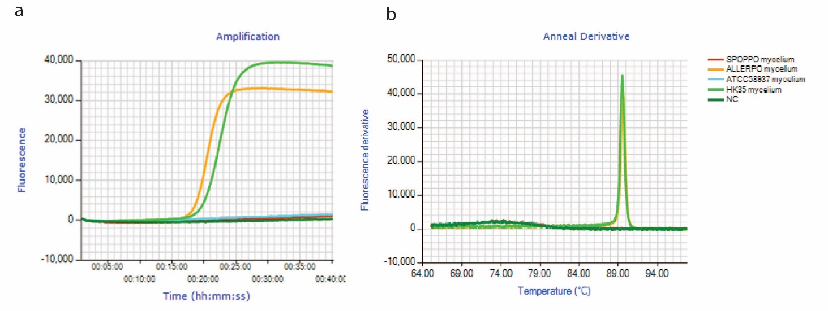
Supplemental Figure 1. a) Amplification curves and b) melting curves of a LAMP assay specific for AQU07 on mycelium of SPOPPO, ALLERPO, ATCC58937 and HK35 and a negative control.
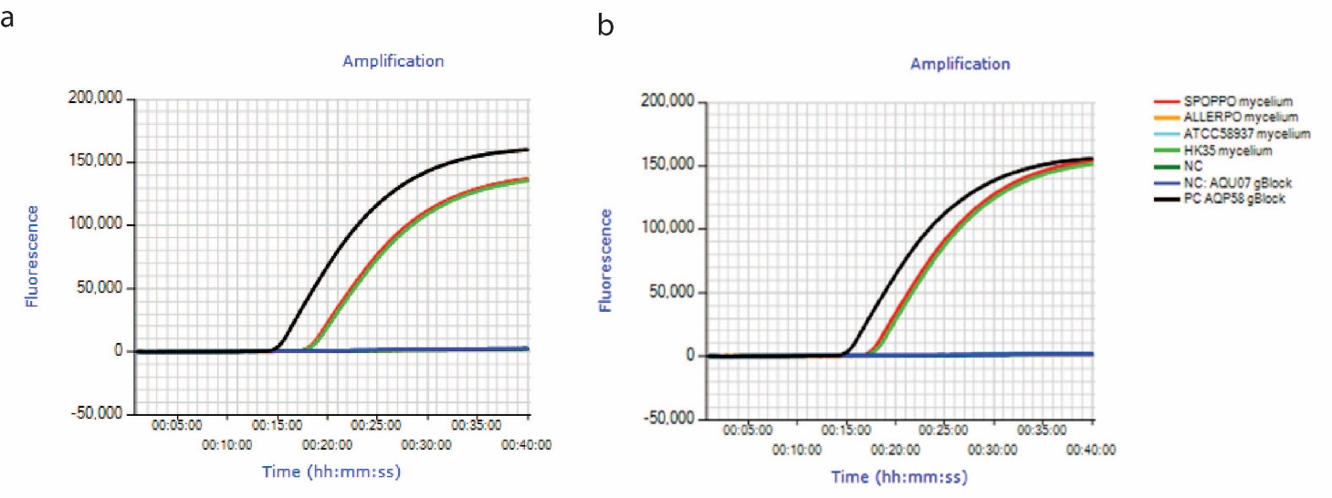
Supplemental Figure 2. Amplification curves of two replicates of a LAMP-CC assay specific for AQP58 on mycelium of SPOPPO, ALLERPO, ATCC58937 and HK35, a negative control, a AQP58 gBlock as a positive control, and the corresponding sequence on AQU07 as a gBlock as a non-template control; a) replicate 1, b) replicate 2.

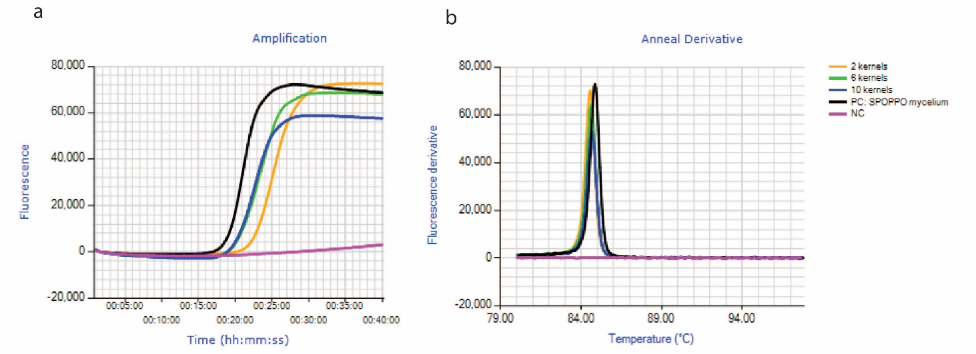
Supplemental Figure 3. a) Amplification curves and b) melting curves of a LAMP assay specific for the msh4-gene on kernels of spawn and SPOPPO-mycelium as a positive control.
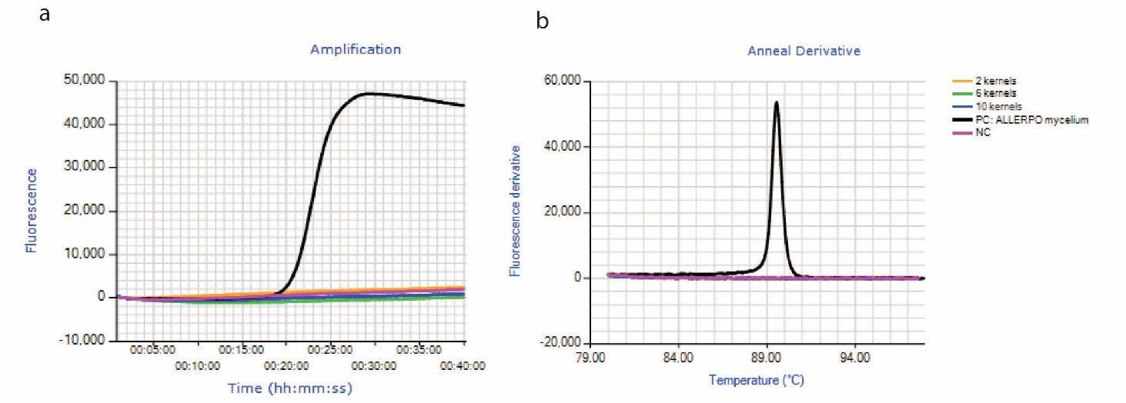
Supplemental Figure 4. a) Amplification curves and b) melting curves of a LAMP assay specific for AQU07 on kernels of spawn and ALLERPO-mycelium as a positive control.

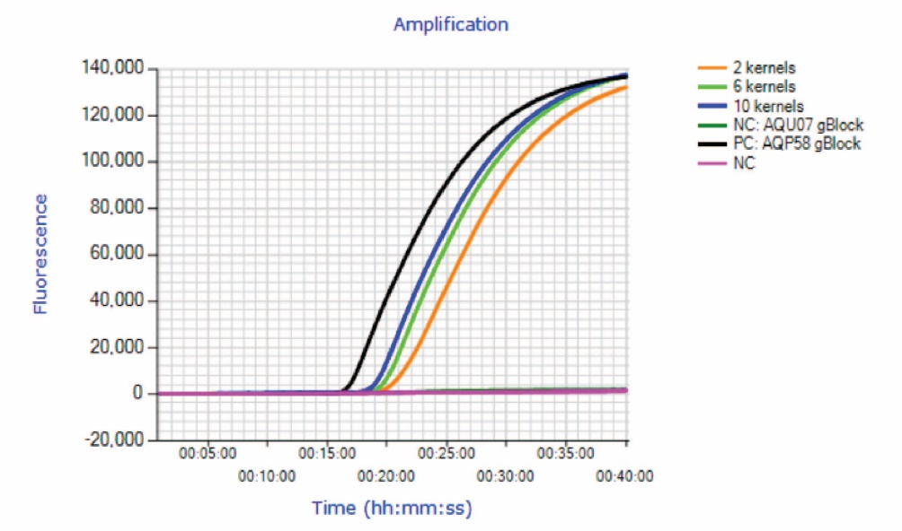
Supplemental Figure 5. Amplification curves of a LAMP-CC assay specific for AQP58 on kernels of spawn and the AQU07 gBlock as a non-template control and the AQP58 gBlock as a positive control.

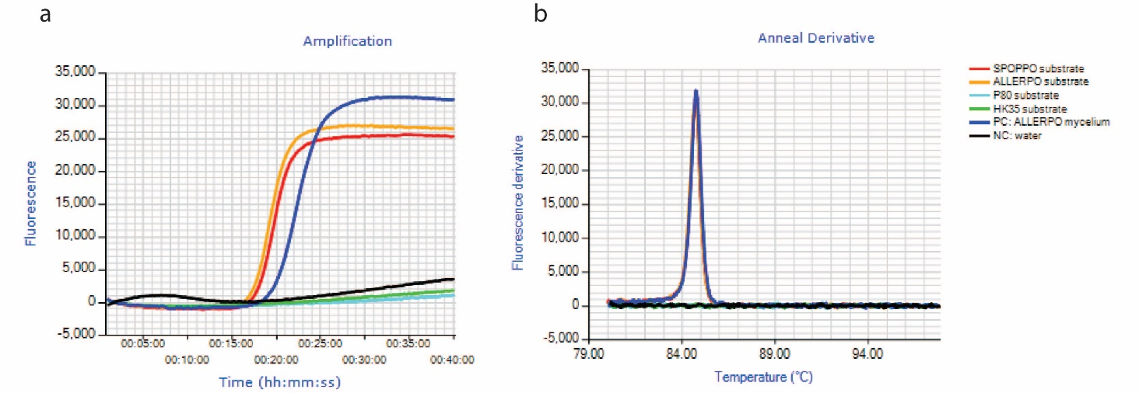
Supplemental Figure 6. a) Amplification curves and b) Melting curves of a MSH4-LAMP assay on substrate colonized by SPOPPO, ALLERPO, P80 and HK35, ALLERPO mycelium extract was used as a positive control.

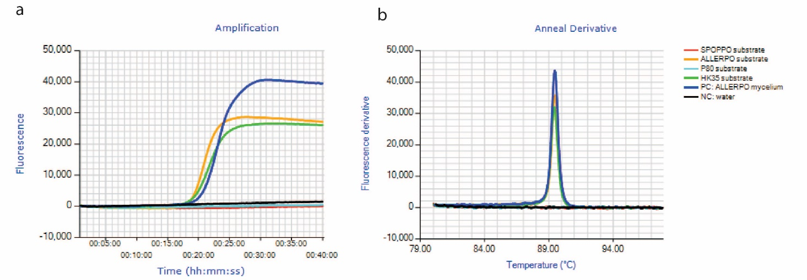
Supplemental Figure 7. a) Amplification curves and b) Melting curves of an AQU07 LAMP assay on substrate colonized by SPOPPO, ALLERPO, P80 and HK35, ALLERPO mycelium extract was used as a positive control.

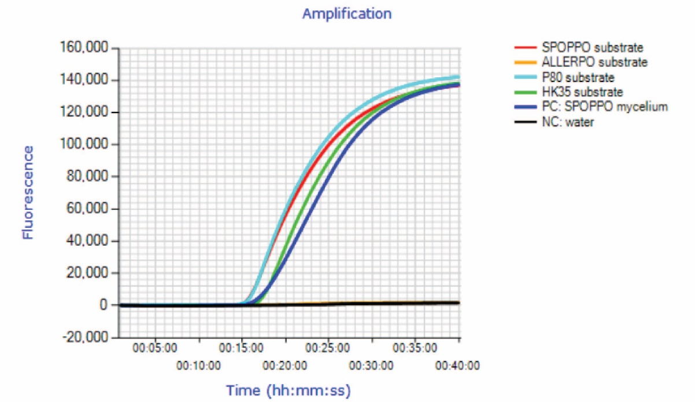
Supplemental Figure 8. Amplification curves of a AQP58 LAMP-CC assay specific for SPOPPO on substrate colonized by SPOPPO, ALLERPO, P80 and HK35, SPOPPO mycelium extract was used as a positive control.

