Supplementary Figures

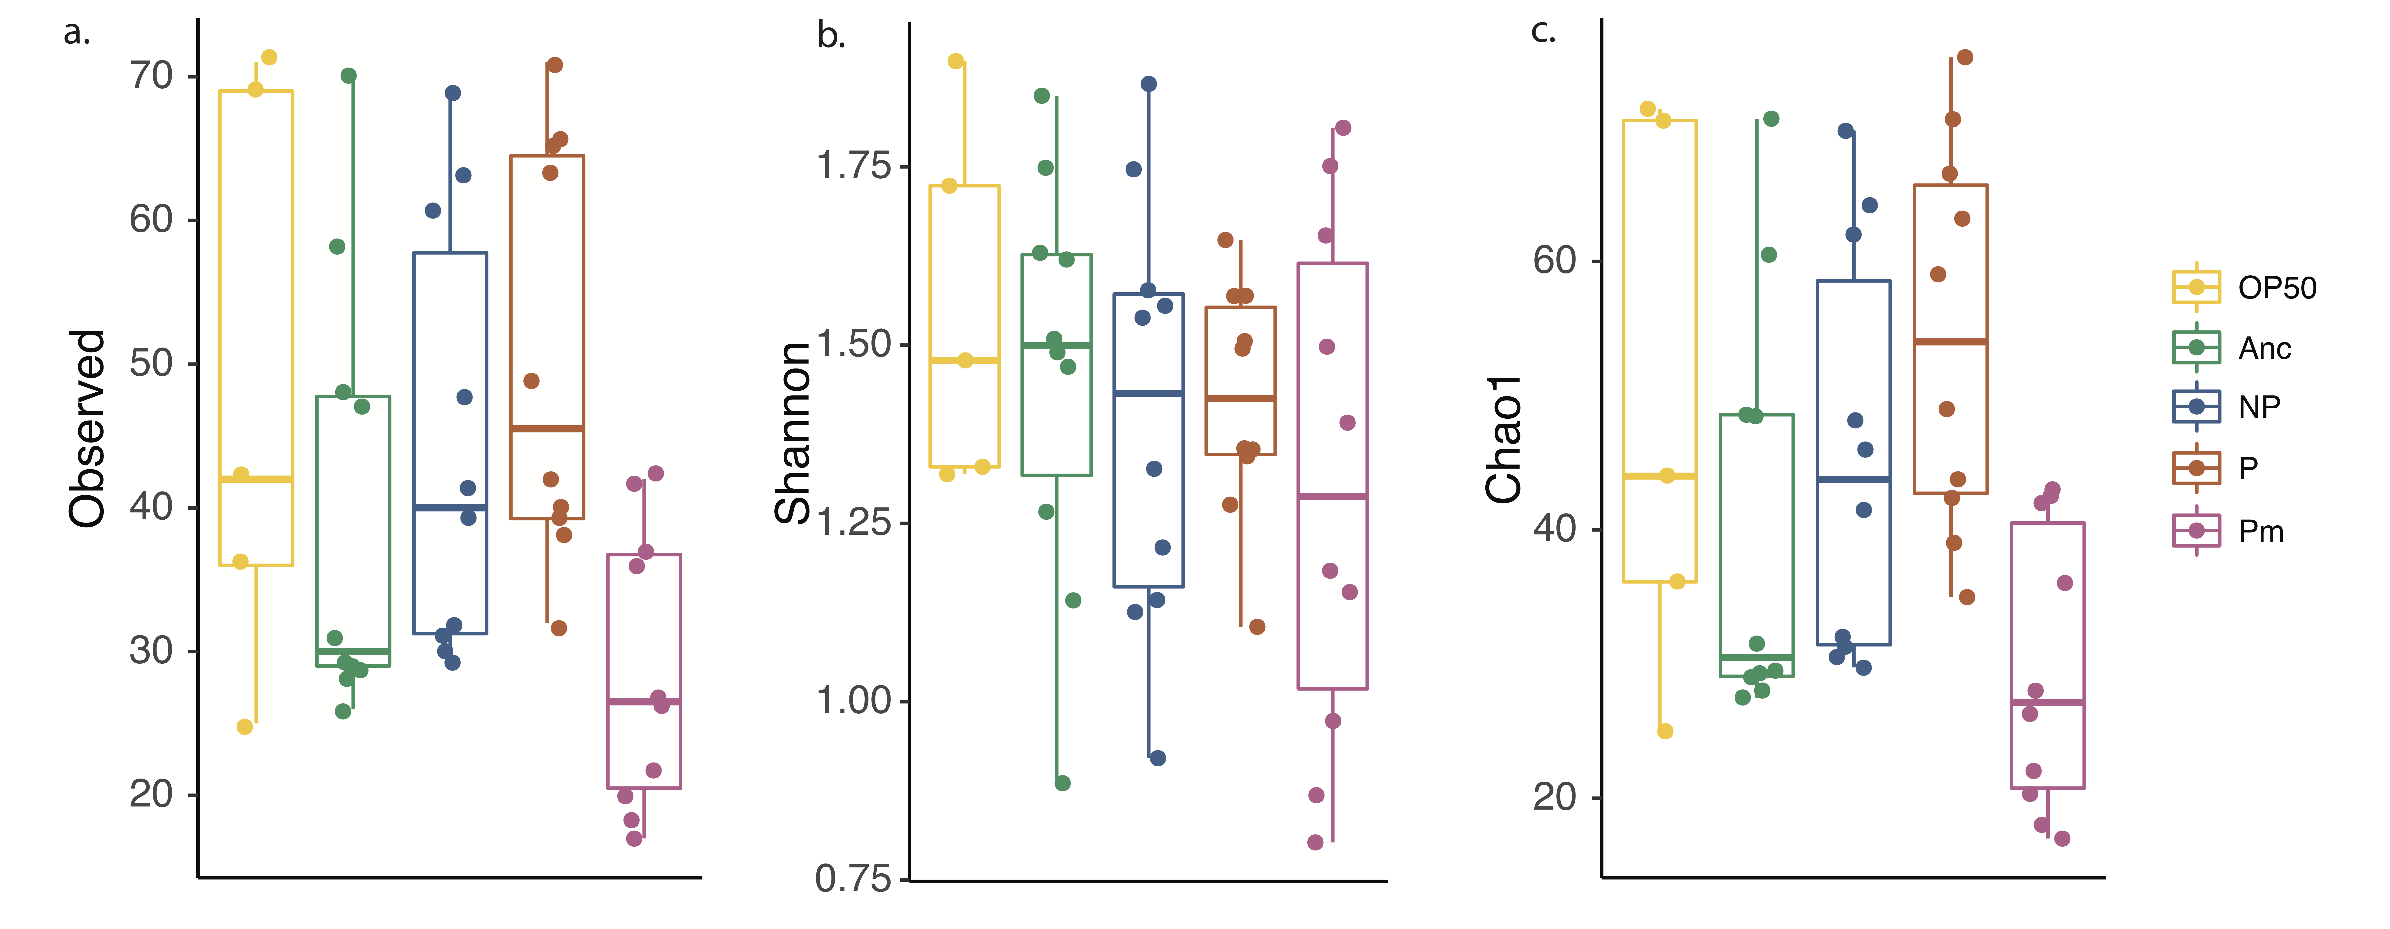

Supplementary Figure 1. Alpha diversity measurements of C. elegans microbiota after compost exposure. Treatments are of different early exposures, prior to compost exposure. a. Observed ribosomal sequence variant measurement. b. Shannon diversity measurements. c. Chao 1 diversity measurement. Plotted with median (line), hinges as first and third quartiles (25th and 75th percentiles), and ends as ranges. Anc = E. faecalis ancestor. NP = E. faecalis single-evolved, n = 10; E. faecalis P = E. faecalis co-colonized evolved, n = 10 Pm = P. mendocina; n = 10; OP50 = E. coli OP50, n = 5. Full ANOVA tables in Supplementary Tables 1-4.

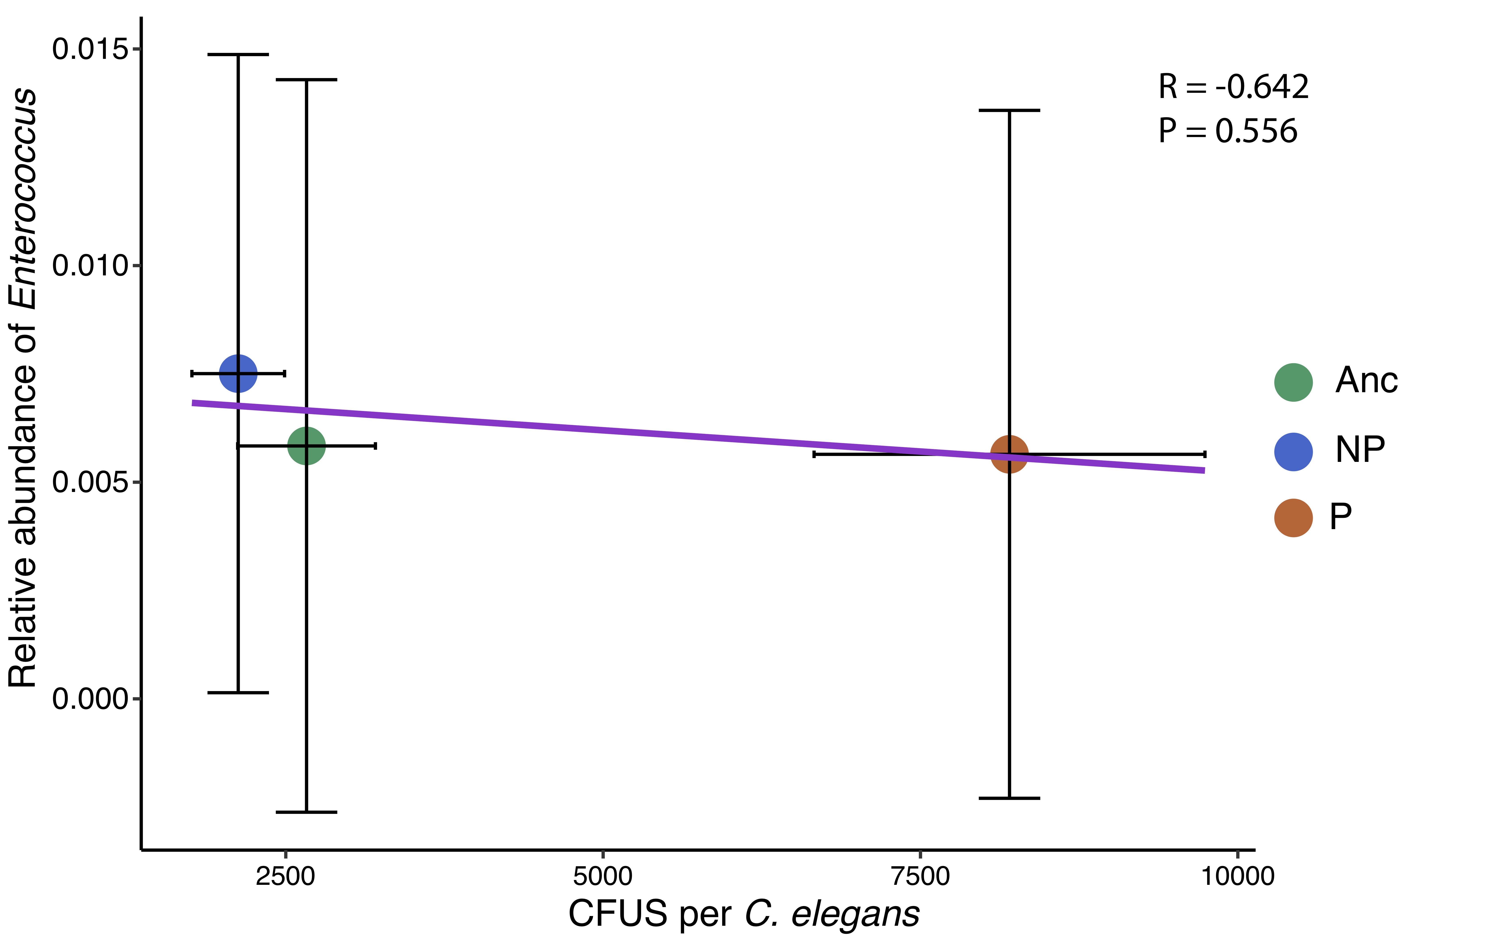

Supplementary Figure 2. E. faecalis CFUs in C. elegans and relative abundance of Enterococcus amongst microbiome. X-axis is C. elegans gut bacterial colony-forming units (CFUs) after exposure to E. faecalis Anc, E. faecalis NP, or E. faecalis P. Y-axis is relative abundance of Enterococcus in C. elegans amongst microbiome. There was no significant correlation between E. faecalis CFUs and Enterococcus relative abundance. Error bars = ± s.e. Anc = E. faecalis ancestor. NP = E. faecalis single-evolved. E. faecalis P = E. faecalis co-colonized evolved.

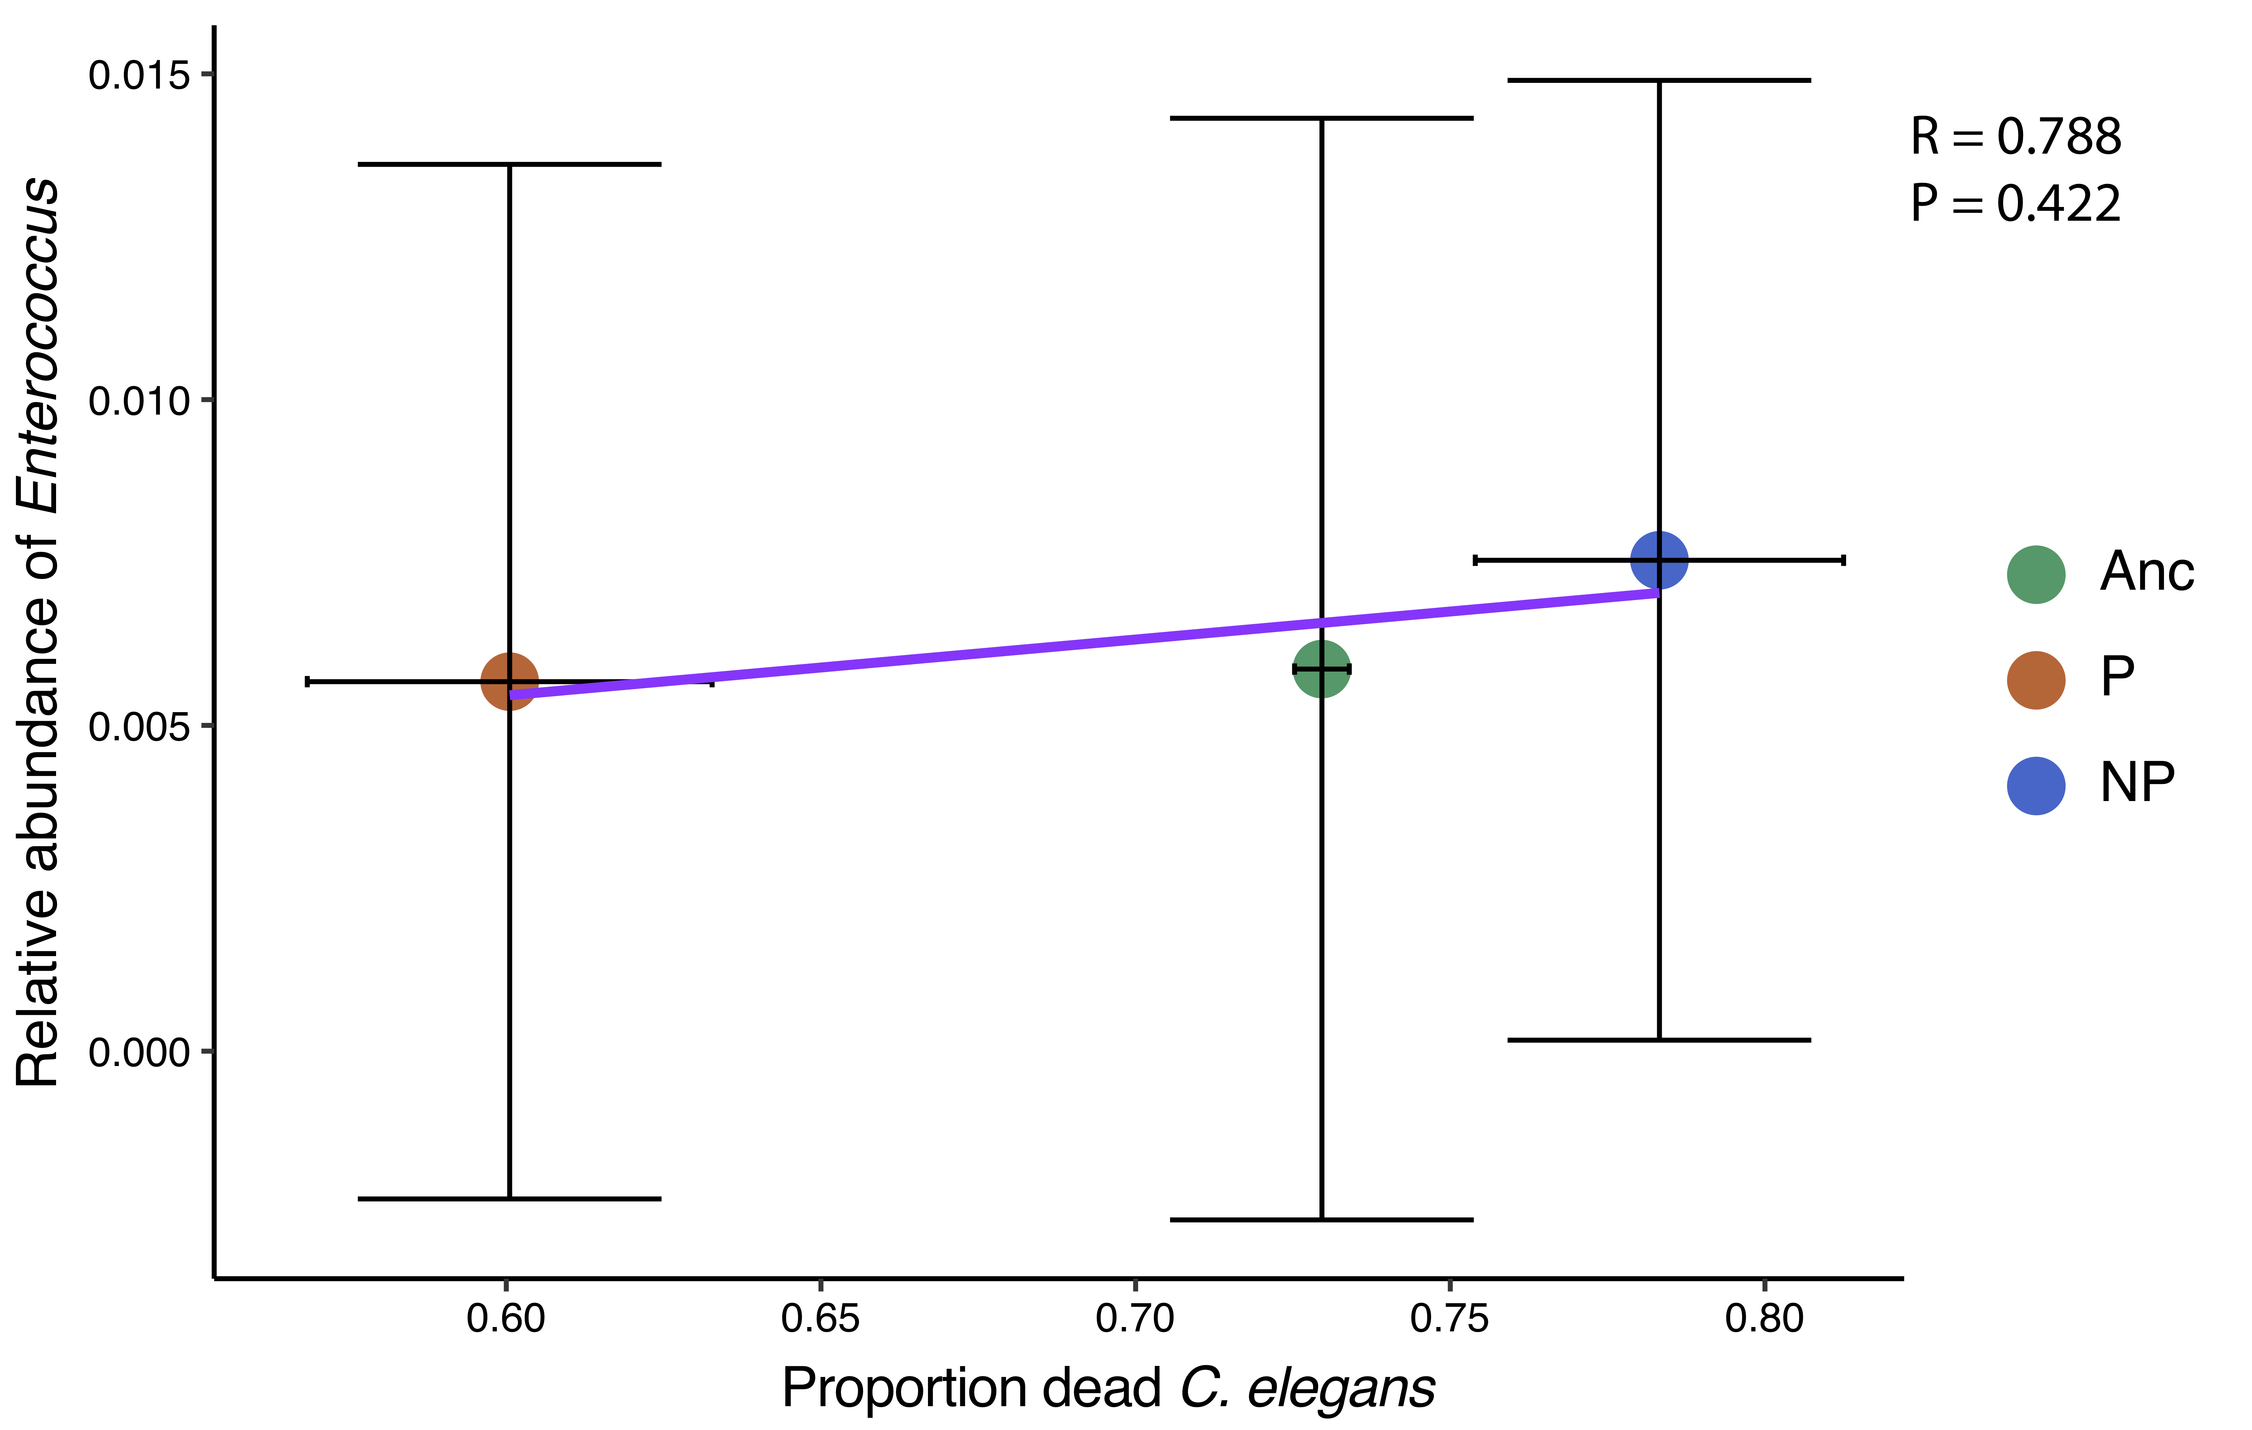

Supplementary Figure 3. Relative abundance of Enterococcus in microbiome and proportion dead C. elegans. X-axis is proportion dead C. elegans after S. aureus exposure. Y-axis is relative abundance of Enterococcus in C. elegans amongst microbiome. There was no significant correlation between E. faecalis CFUs and Enterococcus relative abundance. Error bars = ± s.e. Anc = E. faecalis ancestor. NP = E. faecalis single-evolved. E. faecalis P = E. faecalis co-colonized evolved.

