Appendix A. Supplementary data
Fig. S1 Sequences and phylogenetic analysis of the lycopene epsilon-cyclase genes in Nicotiana tobacum. a Phylogenetic tree and conserved domain analysis of amino acid sequences from Solanaceae species. N. tabacum (Ntε-LCY1), N. tabacum (Ntε-LCY2), Nicotiana sylvestris (Nsyε-LCY), Nicotiana tomentosiformis (Ntomε-LCY), Solanum tuberosum (Stuε-LCY), and Solanum lycopersicum (Slyε-LCY) sequences are shown. b Spatial structures, ligand binding sites, and enzyme active sites of Ntε-LCY2 (497 amino acids) and Ntε-LCY1 (475 amino acids) from N. tobacum predicted with the I-TASSER program.

Fig. S2 Screening gel electrophoresis of homozygous mutants of Ntε-LCY2 and Ntε-LCY1. a ntε-lcy2-1 homozygous mutant line with two rounds of PCR verification. b ntε-lcy2-2 homozygous mutant line with two rounds of PCR verification. c ntε-lcy1-1 homozygous mutant line with two rounds of PCR verification. d ntε-lcy1-2 homozygous mutant line with two rounds of PCR verification. M, DL2000 DNA marker.

Fig. S3 Sequencing verification results of bacterial liquid corresponding to two rounds of PCR reactions for Ntε-LCY2 and Ntε-LCY1 homozygous mutant lines. a Partial peak diagram of WT and two homozygous mutant lines of Ntε-LCY2 (ntε-lcy2-1, ntε-lcy2-2) b Partial peak diagram of WT and two homozygous mutant lines of Ntε-LCY1 (ntε-lcy1-1, ntε-lcy1-2).

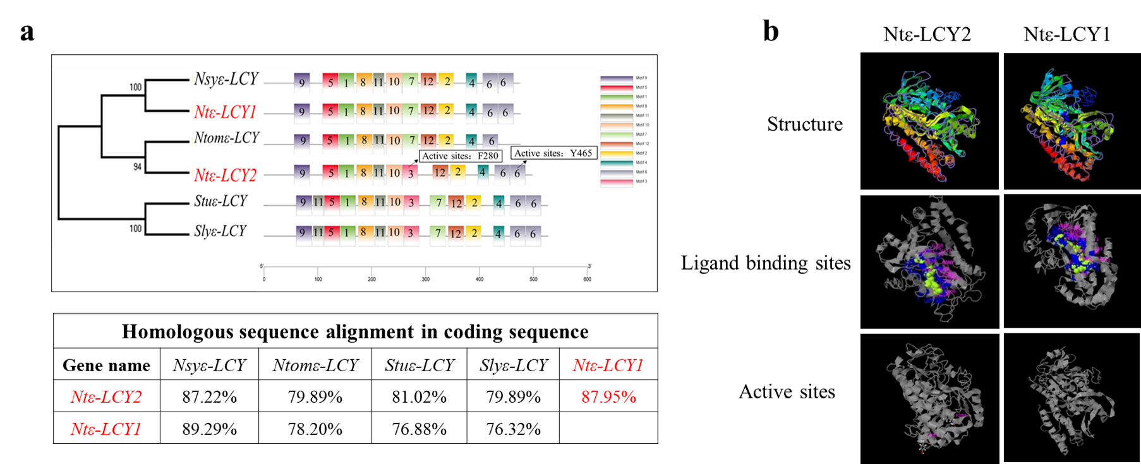

Fig. S1

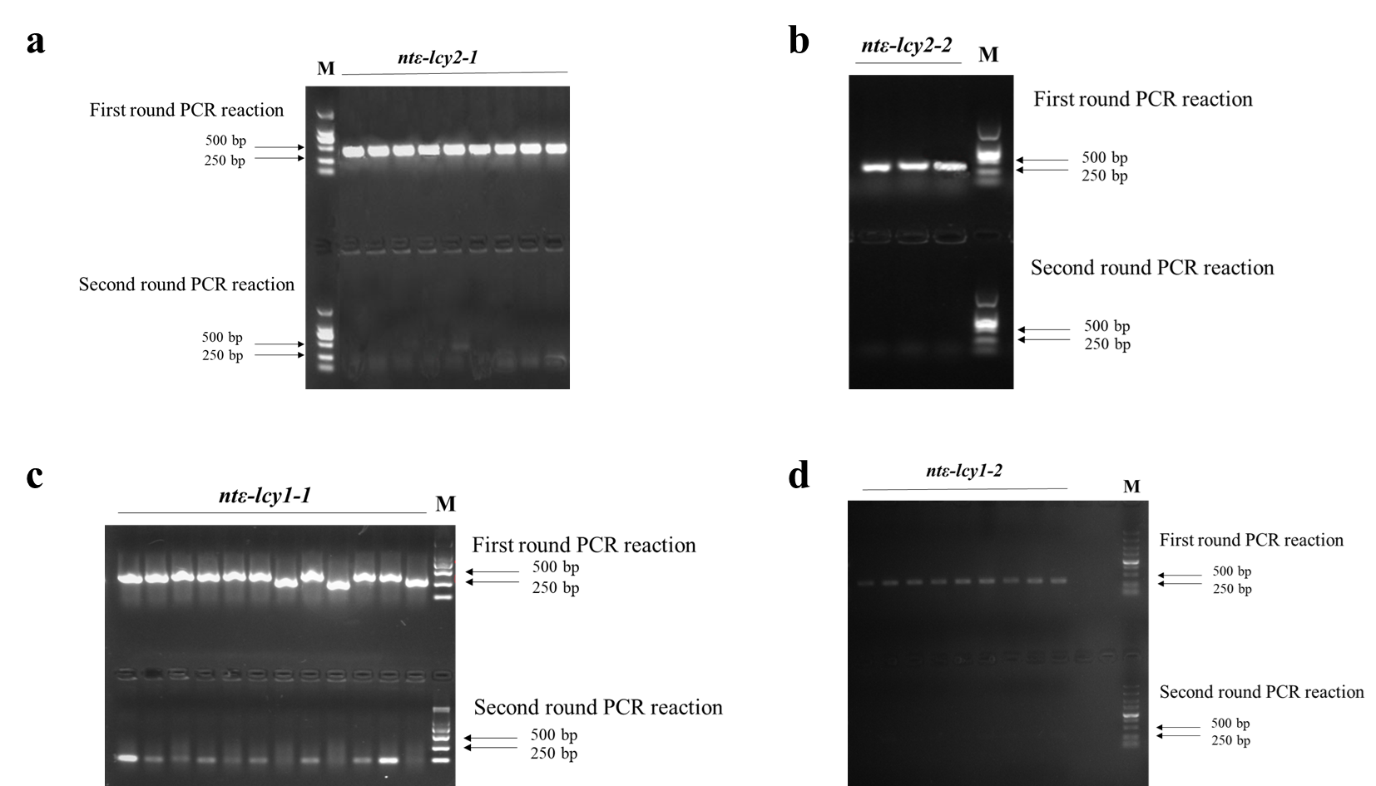
Fig. S2
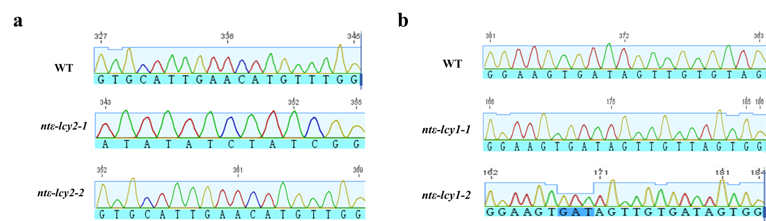

Fig. S3
Appendix A. Supplementary data
Table S1. cis-acting elements in Ntε-LCY gene promoters (3000 bp upstream of the start codon) identified using PlantCARE online software. Important motifs and their functions are shown to highlight similarities and differences among the Ntε-LCY homologs.
Gene | Motif | Function
 | ARE | anaerobic induction
 | MBS | drought inducibility
 | ABRE | abscisic acid responsiveness
 | AE-box | light responsiveness
 | GATA-motif | light responsiveness
Ntε-LCYI & Ntε-LCY2 | G-box | light responsiveness
 | Box 4 | light responsiveness
 | ATCT-motif | light responsiveness
 | GT1-motif | light responsiveness
 | TGACG-motif | MeJA responsiveness
 | CAT-box | meristem expression
 | RY-element | seed-specific regulation
 | TGA-element | auxin-responsive element
 | circadian | circadian control
 | CGTCA-motif | MeJA responsiveness
Ntε-LCY2 | GCN4_motif | endosperm expression
 | GA-motif | light responsiveness
 | TCT-motif | light responsiveness
 | chs-CMA1a | light responsiveness
 | chs-CMA2a | light responsiveness
 | TC-rich repeats | defense and stress responsiveness
 | HD-Zip 1 | differentiation of the palisade mesophyll cells
Ntε-LCY1 | AT1-motif | light responsiveness
 | ACE | light responsiveness
 | G-Box | light responsiveness
 | LTR | low-temperature responsiveness

Table S2. The primers and target sequences used to construct the CRISPR/Cas9 vectors for Ntε-LCY2 and Ntε-LCY1 and identify the resulting mutants.
Primer name | Primer sequence (5' to 3')
Kan-F | CGGCTATGACTGGGCACAACAGACAAT
Kan-R | CTCGGCAGGAGCAAGGTGAGATGAC
Ntε-LCY1-Target | GGAAGTGATAGTTGTGTAG
Ntε-LCY1-F | TTCAAATCATTAGGAAGAAAGAG
Ntε-LCY1-R | ACATACCAAACAGTCAATAAGAA
Ntε-LCY2-Target | GTGCATTGAACATGTTTGG
Ntε-LCY2-F | AACAACAACATCGTGTAATCTC
Ntε-LCY2-R | AAATGGCGACTAACTCTTCC

Table S3. The primers used for quantitative real-time PCR (qRT-PCR) analysis.

Primer name | Primer sequence (5' to 3')
PSY-Q-F | TGTTGGAGAAGATGCCAGAAGAG
PSY-Q-R | ATAAGCAATAGGTAAGGAAATTAGCTTC
PDS-Q-F | ATAAACCCTGACGAGCTTTC
PDS-Q-R | AATATGTTCAACAATCGGCAT
ZDS-Q-F | GAGCATATGCGACAGGATCCCAC
ZDS-Q-R | TGAAATAGGGGAGCTTGATTTCCGC
CRTISO-Q-F | CGTGTACACCGAGAATATGATG
CRTISO-Q-R | GTAGGCGAGAGTCAAGCACTC
β-LCY-Q-F | GATGACAATACAACTAAAGATCTTGATAG
β-LCY-Q-R | CATAAGCTACTTGATATCCAGGAT
ε-LCY1-Q-F | AAAATGCGCCTCCGTACTTG
ε-LCY1-Q-R | CTTGTGGCCAAAGGGTGTTC
ε-LCY2-Q-F | TGGTCATAGGCTGTGGTCCT
ε-LCY2-Q-R | AGAATTGGATCGGCATCGTCA
β-OHase-Q-F | ATGGCCGCCAGCAGAATTTC
β-OHase-Q-R | CTCAATTTTCATTTCAATCTCCTCTGTC
VDE-Q-F | ATGATGCATGGGATGGATATG
VDE-Q-R | CGTTGGAGCTCTTTAAAACCTTC
ZE-Q-F | GTGGTGGGATTGGAGGGTTAGTG
ZE-Q-R | AGGATCTGCTGCAAAGTCATGC
NXS-Q-F | GCCGGGCTCTATTCGACGTGAT
NXS-Q-R | ACTGACTCTACCATATGGTCTTCCCAAAT
26S-RNA-Q-F | GAAGAAGGTCCCAAGGGTTC
26S-RNA-Q-R | TCTCCCTTTAACACCAACGG

