Supplemental Information for
Mapping Full-Stokes Parameters to Metasurface Design via Globally Engineered Disorder
Zhi Cheng, Zhou Zhou, Zhuo Wang, Yue Wang, Changyuan Yu *

Z. Cheng, Y. Wang, C. Yu
Department of Electrical and Electronic Engineering,
the Hong Kong Polytechnic University, Hong Kong SAR, China
changyuan.yu@polyu.edu.hk
Tel: +852 5495 9723

Z. Zhou
Department of Electrical and Computer Engineering, and NUS Graduate School,
National University of Singapore, Singapore 117583, Singapore

Z. Wang
Guangdong Provincial Key Laboratory of Nanophotonic Functional Materials and Devices, School of Optoelectronic Science and Engineering,
South China Normal University 510006, Guangzhou, China

C. Yu
The Hong Kong Polytechnic University Shenzhen Research Institute, Shenzhen, China

Note I: Coupling Between Dominant State of Polarization and Degree of Polarization in diatomic design
Under the weak-coupling regime, the Jones matrix of the diatomic metasurface can be expressed as the sum of each meta-atom’s Jones matrix. This means that arbitrary Jones matrices can be constructed using this approach. The summation process of the Jones matrix elements is illustrated in Fig. S1: the small blue dashed circle represents the unit vector, indicating the complex amplitude of the combined Jones matrix elements. The large blue region, with a modulus of 2, represents the total magnitude of the combined vectors.
The initial combined vector, shown as the green arrow with an amplitude of A1, can be decomposed into two unit vectors. When attempting to adjust A1 to A1'—that is, when trying to change the polarization conversion properties—simply adjusting the surface parameters results in a new combined vector A1' (yellow arrow). However, we observe that the new unit vectors differ substantially from the original ones. This indicates that in the design of diatomic metasurfaces for polarization control, adjustments to polarization conversion properties affect all variables, and modifying just one or a few parameters will not suffice to achieve the desired results.
In other words, practical design requires finding new combinations of meta-atoms and adjusting rotation angles and other parameters to meet the design requirements.
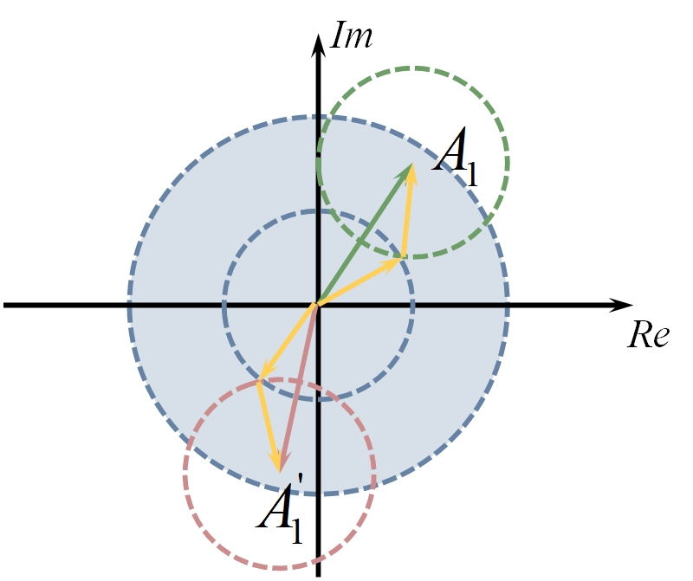
Fig. S1. Phasor diagram of the summation process of Jones matrix elements.
Note II: Derivation of the Jones Matrix for Independent Control of SoP and DoP
Given an arbitrary elliptical polarization state, the states α and β are expressed as:
（S1）
The corresponding conjugate polarization states, α* and β*, are represented as ：
(S2)
We aim to find a Jones matrixes J that either convert (α*, β*) into (α, β) or (α, βe^{iπ}). Thus, we seek：
（S3）
Noting that the Jones matrix for this system, as shown in previous works, must involve a rotation matrix combined with a diagonal matrix, we first rotate the Jones matrix in alignment with the elliptical polarization states, which corresponds to a rotation by ψ-45°：
（S4）
where the matrix D is of the form：
(S5)
Substituting Eq. (S4) into the first Eq. of (S3) yields:
(S6)
It is found that for J₁, the same equation is obtained for both α and β. Since R is an invertible matrix, the above equation can be simplified to:
(S7)
Solving the equations, we get：
(S8)
Thus, the required Jones matrix is:
(S9)
It is easy to see that in order to find a suitable J₂, if the Jones matrix continues to rotate by ψ-45°, substituting Eq. (S4) into the second term of Eq. (S3) yields no solution. Therefore, different rotation angles need to be considered by solving the following system of equations:
(S10)
Where θ = ψ - 45° - ψ₂, with ψ₂ being the rotation angle of J₂. Expanding R(θ) gives the following two sets of equations:
(S11)
By comparing the exponents of the exponential terms on both sides of the equation, the following relationships can be derived:
(S12)
In order for the above equations to hold, d_{i} (i = 1, 2) must satisfy the following conditions:
(S13)
Then we get:
$θ={45}^{∘}+n⋅{90}^{∘}, n∈N$ (S14)
Let θ = -45°，we get ψ₂ = ψ. Thus, we get d₁ = 1 and d₂ = -1, with the Jones matrix in the following form:
(S15)
Thus, the Jones matrix that accounts for the difference conversion between an orthogonal polarization pair can be written as:
(S16)
Note III: The necessity of introducing Disorder compared to Periodic construction
Although it may seem intuitive to use a periodic supercell construction to achieve the Jones matrix presented in Eq. 9 of the main text, several potential issues arise when applying periodic designs to this task. Consider the target polarization conversion parameters stated in the main text, with 2$ψ$ = ${300}^{∘}$, 2$χ$ = ${45}^{∘}$, and DoP = 0.65. The dimensions of the two meta-atoms involved are 320 nm by 650 nm and 600 nm by 250 nm, respectively. One might assume that arranging these meta-atoms uniformly in a supercell, as illustrated in the inset of the Fig. S2(a), would yield the desired result. An 8:3 ratio of meta-atoms is used to approximate the target ratio of 2.743, which is required for the desired DoP control. However, due to the periodic boundary conditions, when the supercell is translated, the meta-atom at the bottom-left corner (meta-atom B) aligns with the meta-atom at the top-right corner of the adjacent supercell. This leads to an excess of meta-atoms B in certain local regions, potentially diminishing the polarization conversion efficiency. This perturbation effect becomes more pronounced when the number of meta-atoms within the supercell is relatively small. In contrast, if the entire disordered metasurface itself were translationally symmetric, the impact of this perturbation would be negligible. Our simulations for this pattern yield a DoP of 0.714, with the azimuthal and elevation angles of the dominant polarization state at -66.31° and 26.56°, respectively. When evaluated using the Euclidean distance between Stokes parameters, the similarity to the target result is 0.76, which falls significantly short of the performance achieved using the disordered metasurface design described in the main text.
An alternative approach might be to arrange the meta-atoms within a two-dimensional crystal lattice, such as a rectangular or hexagonal lattice. This can be done by treating a small group of meta-atoms as a unit cell and placing multiple unit cells at lattice vertices. We provide two such examples in Fig. S2(b) and (c). The design in Fig. S2(b) encounters the same issues as in Fig. S2(a), while the design in Fig. S2(c) generates a quasi-gradient phase along the indicated direction. The white dashed rectangular line represents the larger lattice, while the circular one corresponds to the smaller meta-atom cluster in the Fig. S2(b). The stokes similarity of this design is 0.82. Although the periodic arrangement in the inset of Fig. S2(c) more closely resembles a typical lattice distribution, the strong internal order within the supercell is further enhanced by the periodicity. The arrow in the inset indicates a quasi-phase gradient direction, leading to beam deflection, as confirmed by the far-field intensity shown in Fig. S2(c). The computed similarity of the Stokes parameters for this design is only 0.8. Additionally, the periodic structure leads to pronounced higher-order diffraction effects, as the diffraction fields in the Fig. S2 shown.

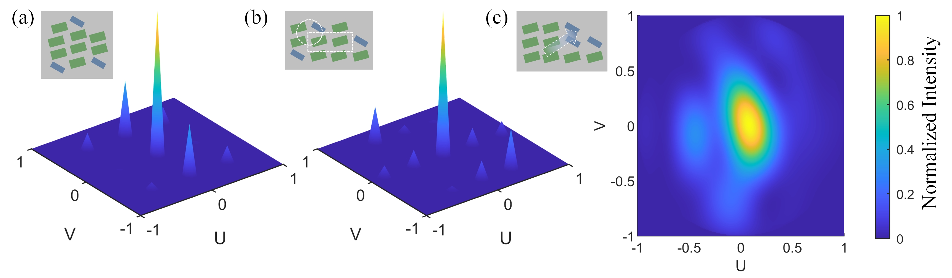
Figure S2. (a-b) Diffraction field of periodic design. (c) Intensity distribution of the far-field. Inset: metasurface arrangements for corresponding design. U and V are the direction cosines.
It is important to note that this discussion does not prove that a disordered metasurface is the only viable solution for achieving this target. Advanced algorithms for periodic design could be developed to address these issues and meet the desired goals. However, directly adopting a disordered design appears to be a more practical approach. Moreover, an appropriate arrangement algorithm (discussed in Note V) is crucial, as it is mathematically impossible to achieve uniform tiling of rectangles with arbitrary proportions and sizes in two dimensions using only simple translations and rotations.
Note IV: Flow chart of the algorithm
Fitness is defined as a measure of how closely the area ratios of different rectangle types within local regions of the plane match their ideal proportions, which are based on the given quantities of each rectangle type. At each step, fitness is evaluated by comparing the actual area distribution in the current region to the ideal, with the goal of minimizing this deviation.
The greedy nature of the algorithm lies in its selection process: at each step, only the placement that provides the maximum local improvement in fitness is chosen, without considering the global impact of this decision. The algorithm focuses on immediate, local uniformity while ignoring potential long-term effects on the overall layout. Additionally, new rectangles are placed along the current outline to prioritize dense packing, further emphasizing the greedy, short-term optimization approach.

Figure S3. The flow chart of the arrangement algorithm.
Note V: Original structural and arrangement parameters for the main text results
We constructed a nanostructure database consisting of rectangular silicon (RI = 3.45 @ 1550 nm) nanopillars on a silica substrate (RI = 1.45 @ 1550 nm). The thickness of the nanopillars is 940 nm, and the period during parameter sweeping is set to 960 nm. The length and width are varied between 200 and 800 nm, as illustrated in Fig. S4. The meta-atoms used to demonstrate the evolution along the latitude on the Poincaré sphere have dimensions of 320 nm by 650 nm and 600 nm by 250 nm. The arrangement data for 2ψ=300∘ is provided in the table S1 and S2. The effective sizes of these meta-atoms are 850 nm by 650 nm and 760 nm by 850 nm, respectively. Table TS1 lists the position coordinates of meta-atoms A, while Table TS2 provides the coordinates for meta-atoms B. For the evolution along the longitude on the Poincaré sphere, the data includes the size parameters for each set of meta-atom combinations at each longitude, which are listed in Table S3. For DoP modulation, the meta-atoms have dimensions of 220 nm by 590 nm and 690 nm by 250 nm, respectively.
The other raw data that support the findings of this study are available from the corresponding author upon reasonable request.
Table S1. Position coordinates of meta-atom with dimensions (320, 650) nm
X | Y | X | Y | X | Y | X | Y | X | Y
425 | 325 | 1275 | 325 | 1185 | 975 | 425 | 1825 | 1275 | 1625
2125 | 1175 | 425 | 2475 | 2275 | 1825 | 3125 | 325 | 575 | 3125
2065 | 2475 | 3125 | 975 | 1425 | 3125 | 2915 | 2475 | 2275 | 3125
1195 | 3775 | 3975 | 1175 | 3885 | 1825 | 3775 | 2475 | 1195 | 4425
4825 | 325 | 2805 | 3975 | 4825 | 975 | 2045 | 4625 | 4735 | 1825
4005 | 3125 | 425 | 5075 | 3655 | 3975 | 1275 | 5275 | 2895 | 4625
5675 | 325 | 4505 | 3775 | 5615 | 1825 | 2885 | 5275 | 1185 | 5925
5615 | 2475 | 5355 | 3325 | 4505 | 4425 | 2035 | 6125 | 6525 | 325
425 | 6575 | 2885 | 5925 | 6525 | 975 | 3735 | 5475 | 6465 | 1625
4585 | 5075 | 6465 | 2275 | 1275 | 6775 | 6205 | 3125 | 2885 | 6575
425 | 7225 | 5445 | 4825 | 4585 | 5725 | 6295 | 3775 | 7315 | 1625
6315 | 4425 | 1335 | 7625 | 2885 | 7225 | 4495 | 6375 | 7165 | 3125
3735 | 7025 | 6295 | 5075 | 8165 | 325 | 2185 | 7875 | 8165 | 975
5345 | 6375 | 8165 | 1625 | 1205 | 8275 | 4585 | 7025 | 8095 | 2275
3035 | 7875 | 6215 | 5725 | 7195 | 4625 | 8095 | 2925 | 2055 | 8525
8045 | 3575 | 6215 | 6375 | 425 | 8925 | 9035 | 1175 | 8085 | 4225
4655 | 7875 | 3415 | 8525 | 8945 | 2675 | 7065 | 6125 | 6195 | 7025
8045 | 4875 | 2115 | 9175 | 4265 | 8525 | 425 | 9575 | 5505 | 7875
2965 | 9175 | 7915 | 5525 | 8935 | 4175 | 9885 | 325 | 1275 | 9825

Table S2. Position coordinates of meta-atom with dimensions (600, 250) nm.
X | Y | X | Y | X | Y | X | Y | X | Y
380 | 1075 | 2080 | 425 | 1230 | 2375 | 3080 | 1725 | 390 | 3875
3930 | 425 | 2000 | 3875 | 3200 | 3225 | 4810 | 2575 | 5630 | 1075
2080 | 5375 | 380 | 5825 | 3700 | 4725 | 5310 | 4075 | 2080 | 6875
3690 | 6225 | 7330 | 425 | 7290 | 2375 | 5410 | 5575 | 400 | 7975
7120 | 3875 | 3850 | 7775 | 7100 | 5375 | 5390 | 7125 | 9030 | 425
1250 | 9025 | 8970 | 1925 | 8900 | 3425 | 7020 | 6875 | 5100 | 8625
8890 | 4925 | 2380 | 9925 | 380 | 10325 | 10400 | 1075 | 8470 | 6275

Table S3. Structure parameters for demonstrating polarization evolution along a longitude on the Poincaré sphere.
2χ | -90 | -67.5 | -45 | -22.5 | 0 | 22.5 | 45 | 67.5 | 90
Meta-atom A (L,W) nm | 470,250 | 240,510 | 340,750 | 560,370 | 550,550 | 360,520 | 320,650 | 240,500 | 250,470
Meta-atom B (L,W) nm | 250,680 | 680,250 | 250,760 | 610,250 | 690,250 | 580,250 | 600,250 | 250,690 | 250,680

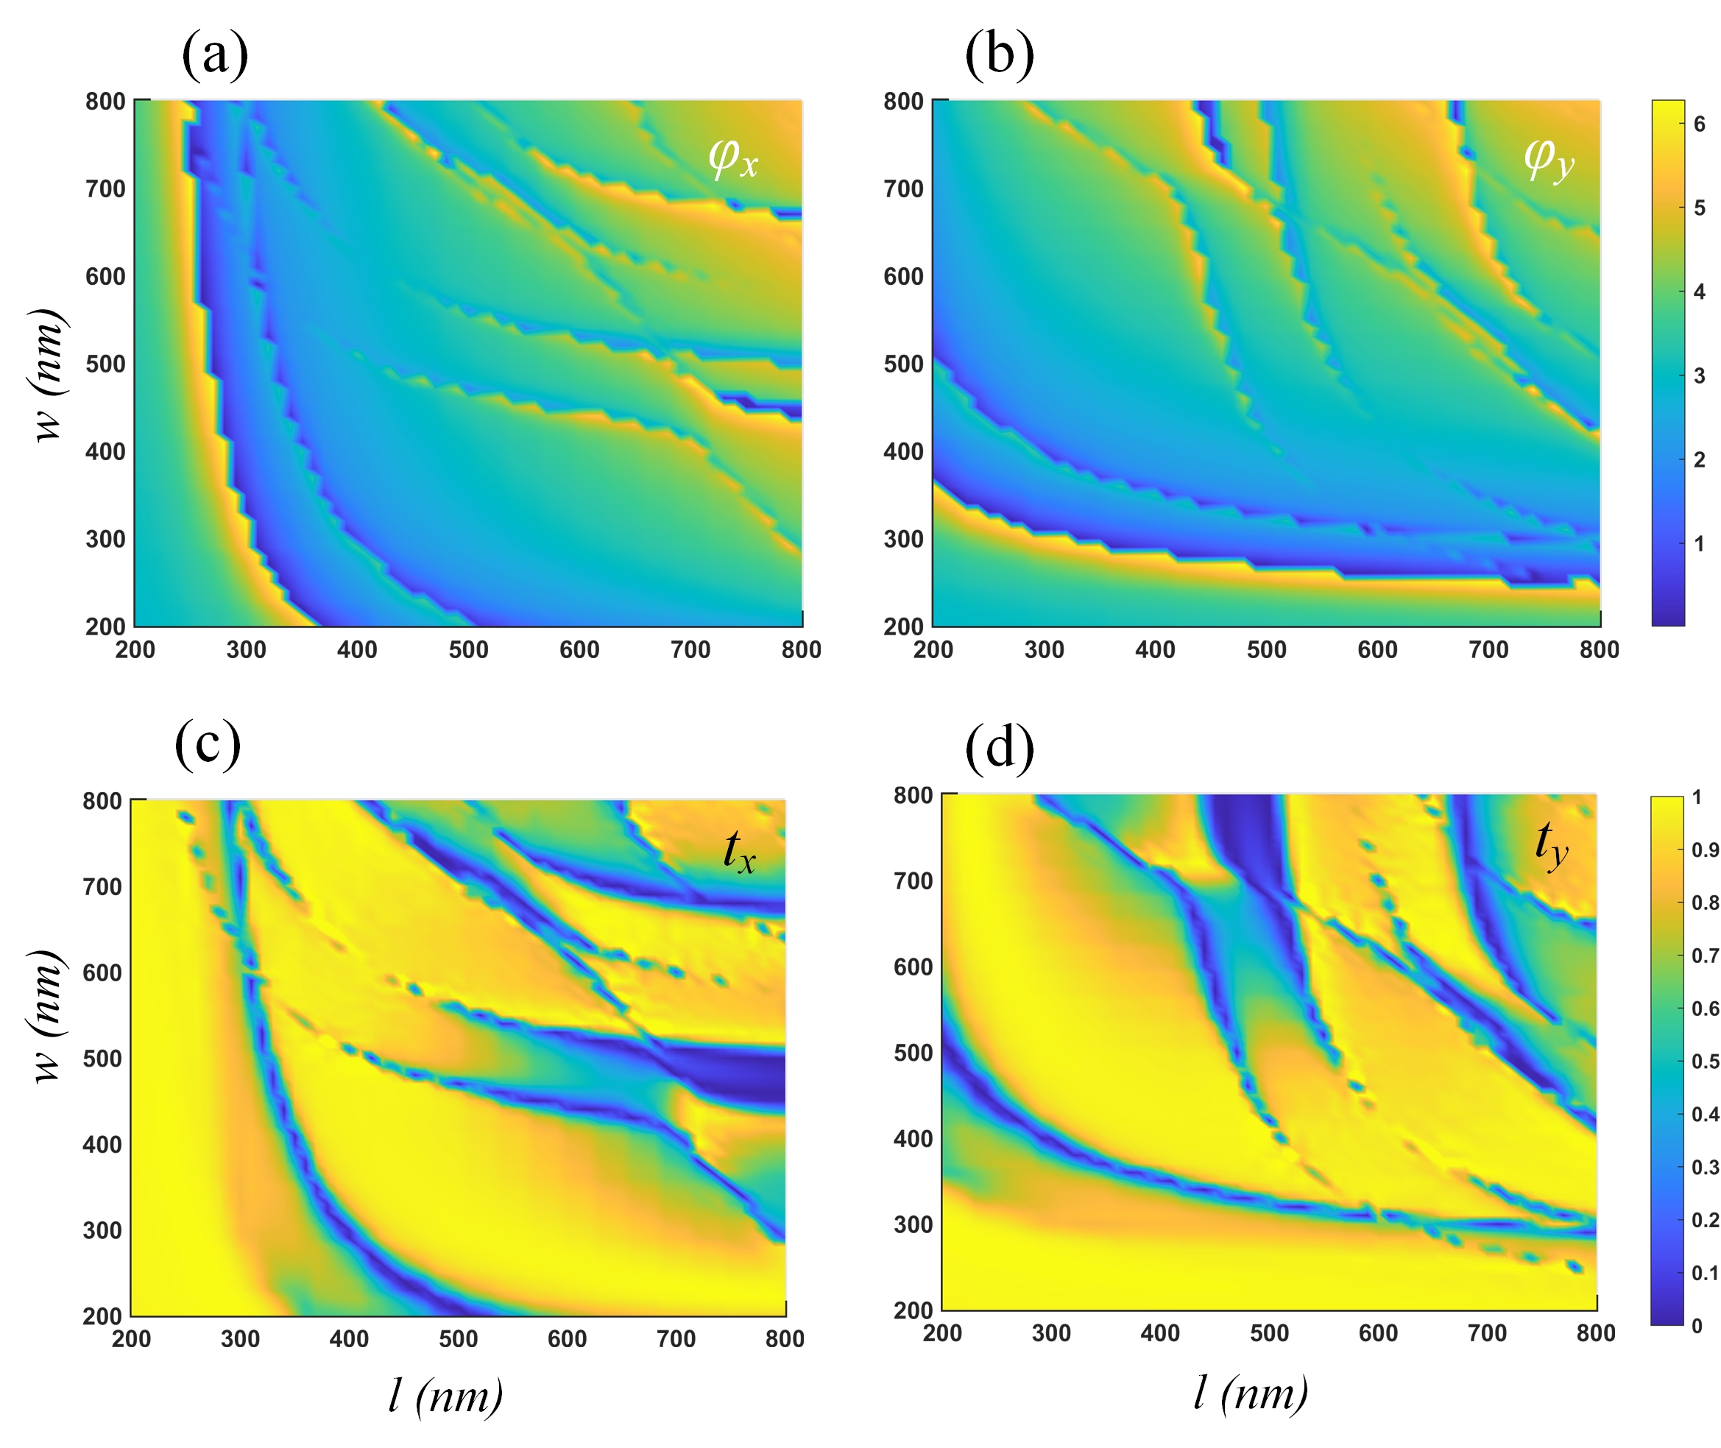
Figure S4 (a-b) Phase delay and (c-d) transmission coefficients with respect to the meta-atoms’ length (l) and width (w) at a wavelength of 1550 nm for x-polarized and y-polarized incident light.
Note VI: Experimental results
The measurement results for all fabricated samples are presented in the Fig. S5. The first and second rows illustrate the evolution of the polarization state along the latitude lines of the Poincaré sphere, corresponding to variations in 2ψ from 0° to 315°. The third row represents the evolution along the longitude lines, covering different polarization states, including linear polarization (LP), elliptical polarization (EP), and right circular polarization (RCP). The fourth row demonstrates the variation in the degree of polarization (DoP), with values of 0.15, 0.4, 0.65, and 0.9.
For each measurement, the inset in the lower right corner of each figure displays the scanning electron microscope (SEM) image of the corresponding fabricated sample, providing a structural reference for the observed polarization characteristics.

Figure S5. Experimental results of all fabricated samples.
Note VII: Forward Method for Implementing Arbitrary Jones Matrices
In addition to the modulation described in the main text, the proposed homogeneous disordered metasurface can be applied to realize arbitrary Jones matrices when M>2. While many previous works ¹⁻⁶ have demonstrated that a diatomic design is sufficient to construct arbitrary Jones matrices for single-layer surfaces, the approach of providing more degrees of freedom (DoFs) offers greater flexibility in the selection of meta-atoms, as well as in other design aspects. For an arbitrary Jones matrix, it can be expressed in the following form:
(S17)
The off-diagonal elements of the matrix are symmetric due to mirror symmetry, which is characteristic of single-layer structures ². By applying a 45-degree rotation, the off-diagonal terms can be rotated into the following configuration:
(S18)
The second term can be interpreted as the Jones matrix of a birefringent meta-atom, with fast and slow axes having phase delays of ϕ₁₂ and ϕ₁₂+π, respectively. The amplitude of J₁₂ can be retrieved after determining the quantity ratio from the first term. Since the second term has the same form as the Jones matrix of a meta-atom, we only need to decompose the first term. To solve for this decomposition, we can construct the following equation:
(S19)
And we can obtain the following system of equations:
(S20)
We can observe that there are four equations with six variables, indicating that the system has an infinite number of solutions. In this case, it is possible to impose initial conditions on the system to obtain a desired solution. For example, by setting ϕ₁₁=ϕ_{x1}=ϕ_{y1}, we get J₁₁ = x + y. The second equation can then be solved analytically, which can be easily visualized using an Argand diagram shown in Fig. S6 (a).
As an example, consider constructing a Jones matrix that converts 45° linearly polarized (LP) light to right circularly polarized (RCP) light. The required Jones matrix for this conversion is:
(S21)
Let x=y and ϕ₁₁=ϕ_{x1}=ϕ_{y1}. We can then solve for the solution as follows:
(S22)
The corresponding meta-atoms have been selected with dimensions of (730, 240), (220, 290), and (250, 650) nm, respectively, with a quantity ratio of 13:13:6. A portion of the arrangement results is shown in Fig. S6 (b). To evaluate the accuracy of the polarization conversion, we employ the fidelity, defined as the inner product between the simulated Jones vector and the target Jones vector. The fidelity achieved in this case exceeds 98%.
This example demonstrates that the proposed metasurface and its corresponding construction algorithm can be extended to various configurations of meta-atom combinations. The flexibility in design allows for greater freedom in selecting meta-atoms, and initial conditions can be adjusted according to specific requirements. This design method, with its increased degrees of freedom, allows for a direct mapping between the metasurface's physical parameters and the desired control targets. As a result, the metasurface can be flexibly designed to achieve precise light field manipulation tailored to specific application requirements.
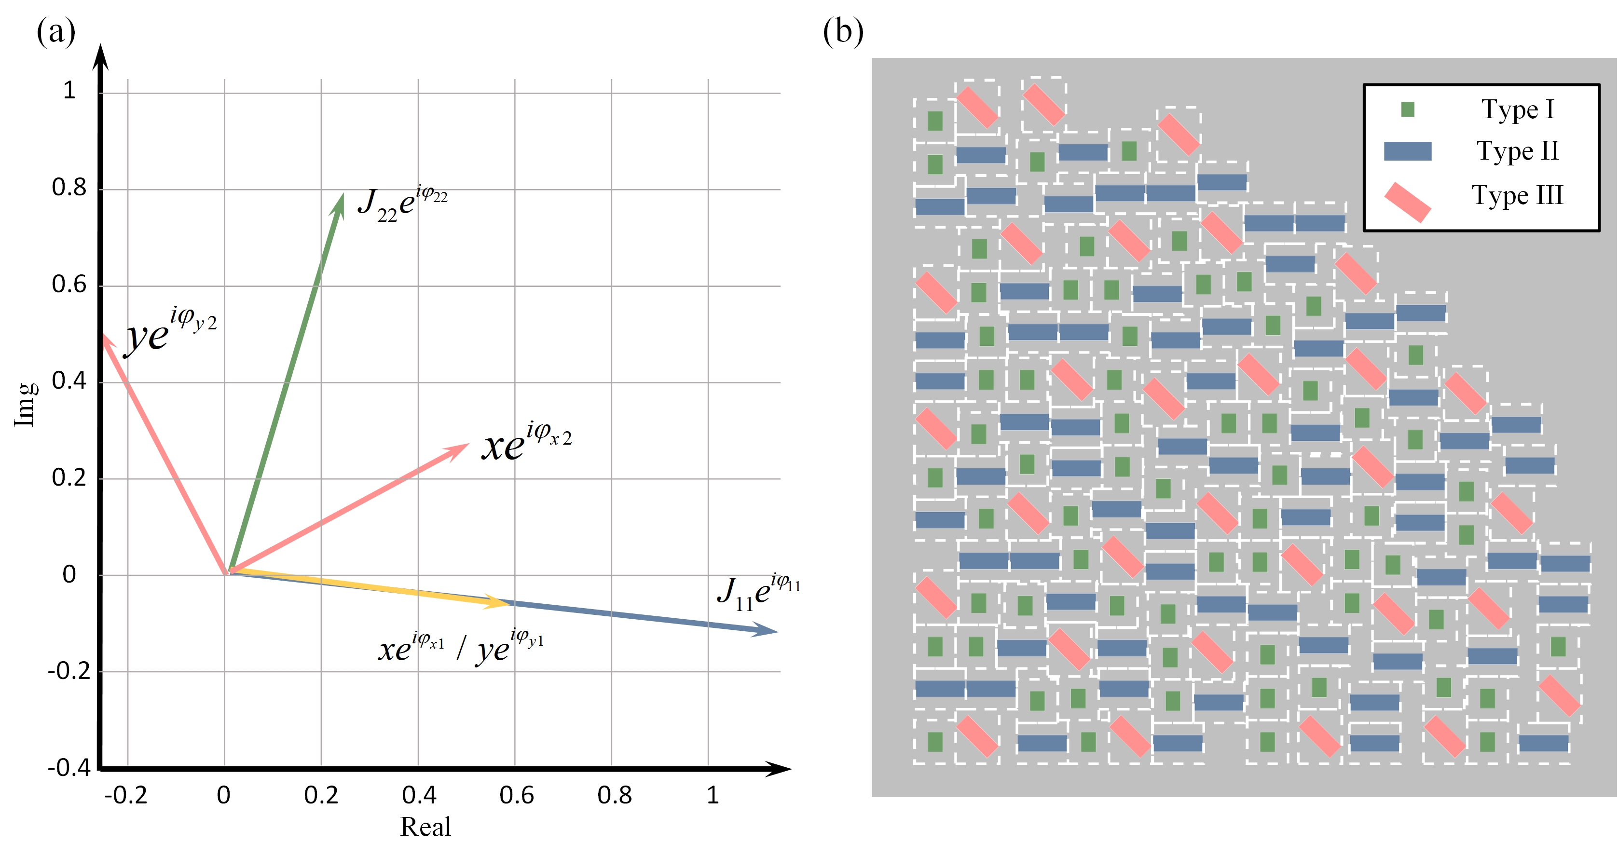
Figure S6. (a) Argand diagram to solve the complex equation (Eq. S20). (b) Metasurface arrangement of the demonstration for the construction of an arbitrary Jones matrix.

References:
1 Overvig, A. C. et al. Dielectric metasurfaces for complete and independent control of the optical amplitude and phase. Light Sci. Appl. 8 (2019). https://doi.org/10.1038/s41377-019-0201-7
2 Bao, Y., Wen, L., Chen, Q., Qiu, C.-W. & Li, B. Toward the capacity limit of 2D planar Jones matrix with a single-layer metasurface. Sci. Adv. 7, eabh0365 (2021).
3 Bao, Y., Weng, Q. & Li, B. Conversion between Arbitrary Amplitude, Phase, and Polarization with Minimal Degrees of Freedom of Metasurface. Laser Photonics Rev. 16, 2100280 (2022). https://doi.org/10.1002/lpor.202100280
4 Wu, T. et al. Dielectric Metasurfaces for Complete Control of Phase, Amplitude, and Polarization. Adv. Opt. Mater. 10, 2101223 (2022). https://doi.org/10.1002/adom.202101223
5 Feng, C. et al. Diatomic Metasurface for Efficient Six‐Channel Modulation of Jones Matrix. Laser Photonics Rev. 17, 2200955 (2023). https://doi.org/10.1002/lpor.202200955
6 Fan, Q. et al. Independent Amplitude Control of Arbitrary Orthogonal States of Polarization via Dielectric Metasurfaces. Phys Rev Lett 125, 267402 (2020). https://doi.org/10.1103/PhysRevLett.125.267402

