PTRAMP, CSS and Ripr form a conserved complex required for merozoite invasion of Plasmodium species into erythrocytes

Benjamin A. Seager^{1,2}, Pailene S. Lim^{1,2}, Keng Heng Lai³, Lionel Brice Feufack-Donfack⁴, Sheena Dass⁶, Xiao Xiao^{1,2}, Nicolai C. Jung^{1,2}, Anju Abraham¹, Matthew J. Grigg^{7,8}, Nicholas M. Anstey^{7,8}, Timothy William^{8,9}, Jetsumon Sattabongkot¹⁰, Andrew Leis^{1,2}, Rhea J. Longley^{1,2,10}, Manoj T. Duraisingh⁶, Jean Popovici^{4,5}, Danny W. Wilson^{3,11,12}, Stephen W. Scally^{1,2‡}, Alan F. Cowman^{1,2‡}

¹ The Walter and Eliza Hall Institute of Medical Research, Parkville 3052, Australia
² University of Melbourne, Melbourne 3010, Australia
³ Research Centre for Infectious Diseases, School of Biological Sciences, The University of Adelaide, Australia 5005
⁴ Malaria Research Unit, Institut Pasteur du Cambodge, Phnom Penh, Cambodia
⁵ Infectious Disease Epidemiology and Analytics G5 Unit, Institut Pasteur, Université Paris Cité, Paris, France
⁶ Department of Immunology and Infectious Diseases, Harvard T.H. Chan School of Public Health, Boston, MA, USA.
⁷ Global and Tropical Health Division, Menzies School of Health Research and Charles Darwin University, Darwin, Northern Territory, Australia.
⁸ Infectious Diseases Society Kota Kinabalu Sabah-Menzies School of Health Research Clinical Research Unit, Kota Kinabalu, Sabah, Malaysia.
⁹ Clinical Research Centre-Queen Elizabeth Hospital, Ministry of Health, Kota Kinabalu, Sabah, Malaysia.
¹⁰ Mahidol Vivax Research Unit, Faculty of Tropical Medicine, Mahidol University, Bangkok 10400, Thailand.
¹¹ Burnet Institute, 85 Commercial Road, Melbourne 3004, Victoria, Australia
¹² Institute for Photonics and Advanced Sensing (IPAS), University of Adelaide, 5005, SA, Australia

‡ Correspondence to:
Alan F. Cowman and Stephen W. Scally
Email: cowman@wehi.edu.au and scally.s@wehi.edu.au

Extended Data
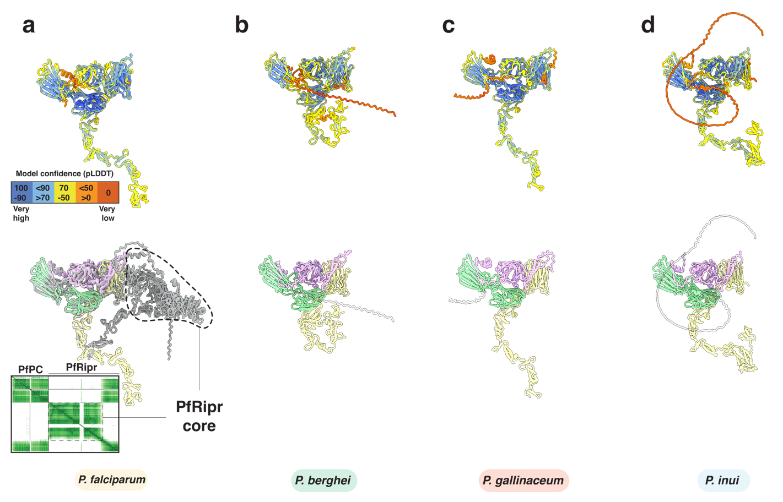
Extended Data figure 1. AlphaFold 3 predicts a PTRAMP, CSS, Ripr complex for all major clades of Plasmodium. a-d. AlphaFold 3 predictions of PTRAMP, CSS and Ripr from several species of Plasmodium. Top row: Models colored by confidence (pLDDT). Bottom row: models colored as follows: PTRAMP (pink), CSS (green) and Ripr (yellow). The prediction for P. falciparum shows the alignment with full length Ripr, where the core forms an ordered structure. Predicted alignment error (PAE) plot is shown as inset. All models have transmembrane domains and signal peptides omitted for clarity.

Extended Data figure 2. Comparison of PvCSS crystal structure with PfCSS structures. a. Binding interface between nanobody D7 and PvCSS. The detail shows the entire interface. PvCSS is grey and the region of D7 binding is shown in pale green, with hydrogen bonds and salt bridges shown in forest green. Regions of D7 involved in the interaction are shown and consist of complementarity determining regions (CDR) and framework regions (FR). Regions of D7 not involved in binding are omitted for clarity. b. Overlay of PfCSS-H2 (H2 in red) and PfCSS-D2 (D2 in blue) crystal structures with PvCSS-PvPTRAMP-D7(D7 in grey) crystal structure. Inset shows PvPTRAMP₄₂₋₅₃ occupies the same region as the CDR3 loop of H2, explaining how it competes with PfPTRAMP binding to PfCSS¹. c. Crystal packing of PvCSS-PvPTRAMP-D7. The asymmetric unit is shown in color (PvCSS in green, PvPTRAMP in pink and D7 in dark grey) and other symmetry related copies in light grey. Red circles show pockets within the crystal lattice that are adjacent to the C-terminal (CT) of PvPTRAMP₄₂₋₅₃ that likely accommodate the GFD and TSR domains of PvPTRAMP.

Extended Data figure 3. The PvPCR complex can be reconstituted in vitro using recombinant proteins. a. Representative SDS-PAGE of recombinant full-length PvRipr. b. Representative biolayer interferometry sensorgram of PvRipr vs PvPC. Data are in yellow and 1:1 model best fit in black. c. Mass distribution plots of PvPC (pink) and PvRipr (yellow) as determined by mass photometry. Histogram data are in color and the Gaussian curve fit in black. d. Size-exclusion chromatography of PvPC (pink), PvRipr (yellow) and PvPCR (grey), with SDS-PAGE results of the co-complexation, showing co-elution of PvPC and PvRipr.

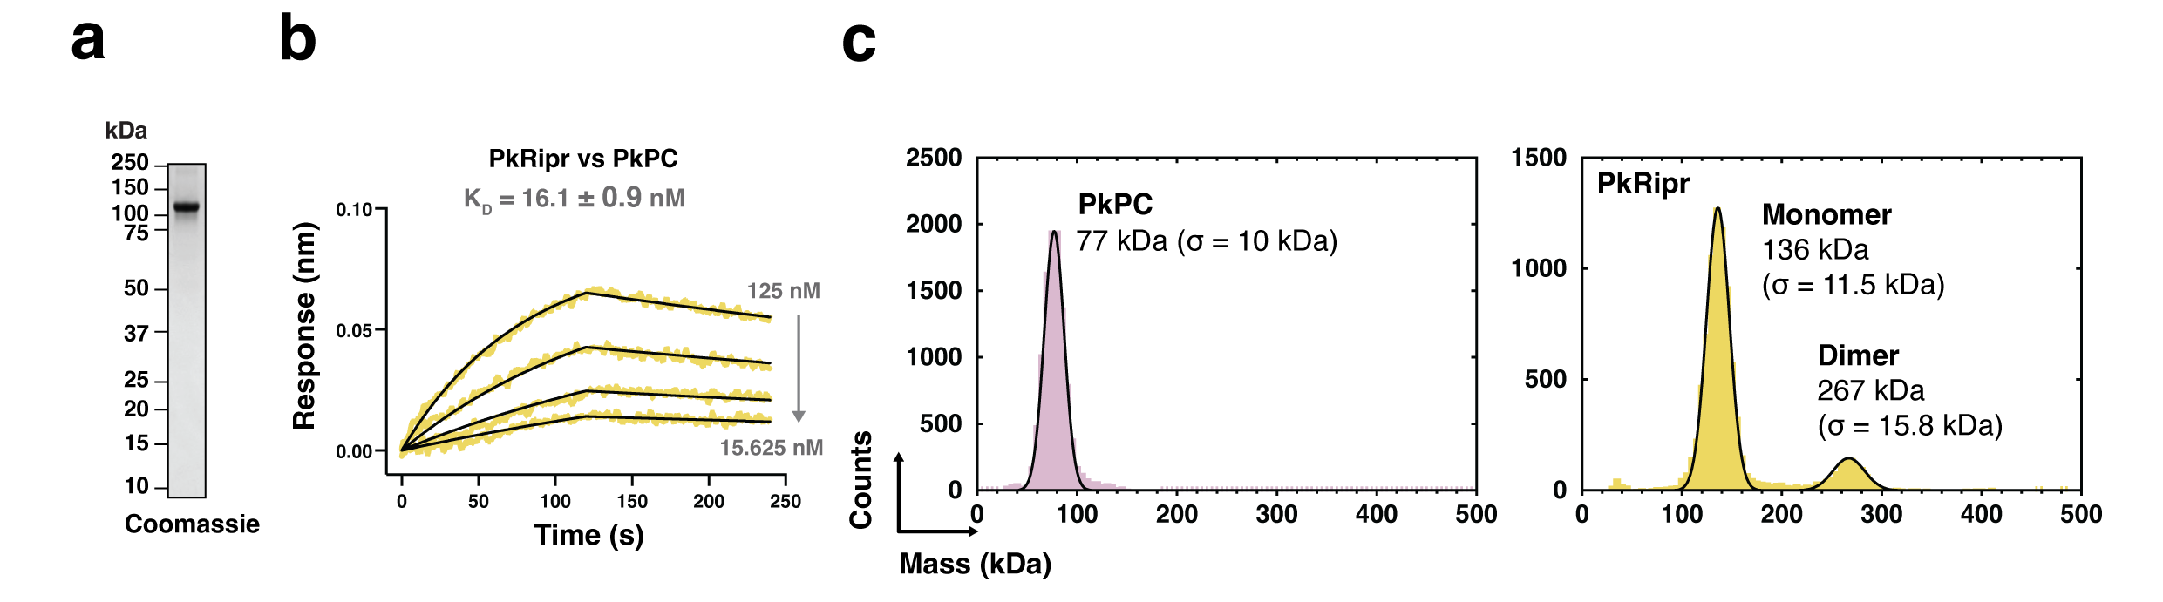
Extended Data figure 4. Biophysical analysis of PkPC and PkRipr. a. SDS-PAGE of recombinant full-length PkRipr. b. Representative biolayer interferometry sensorgram of PkRipr vs PkPC. Data are in yellow and 1:1 model best fit in black. c. Mass distribution plots of PkPC (pink) and PkRipr (yellow) as determined by mass photometry. Histogram data are in color and the Gaussian curve fit in black.
Extended Data figure 5. Biophysical analysis of Ripr truncations. a. SDS-PAGE of recombinant PfRipr truncations and representative biolayer interferometry sensorgrams of Ripr truncations vs PfPC. PfRipr^{tail} and PfRipr^{EGF 9,10,CTD} harbor T966A and S1023A mutations and PfRipr^{CTD} harbors S1023A mutation. b. SDS-PAGE of recombinant PvRipr truncations and representative biolayer interferometry sensorgrams of Ripr truncations vs PvPC. c. SDS-PAGE of recombinant PkRipr truncations and representative biolayer interferometry sensorgrams of Ripr truncations vs PkPC. For all sensorgrams, data are in color and 1:1 model best fit in black where applicable. Schematics of the Ripr truncations are shown above.

Extended Data figure 6. Serological assessment of invasion antigens. Antibody kinetics in longitudinal plasma samples collected from individuals with P. falciparum (yellow), P. vivax (light blue), P. knowlesi (dark blue) infections at three timepoints (current (n=95), week 1 (n=98) and a month (n=98)) on a logarithmic scale. Samples from Volunteer Biospecimen Donor Registry (white, n =28) and Thailand Red Cross (light grey, n = 29) was used to set the sero-positivity cut-off (red dotted line), which is mean of these samples + 2 x standard deviation. Samples from healthy (non-febrile) individuals from Sabah Malaysia (dark grey, n=30) are not included in the sero-positivity calculation as their previous exposure status to any of the Plasmodium species is unknown. Boxplots display the median (horizontal line), interquartile range (IQR) (the box), largest and smallest values (1.25 x IQR, whiskers) and outliers are displayed as points.

Extended Data figure 7. Characterization of anti-PvPC mouse monoclonal antibodies. a. Competition binning of anti-PvPC monoclonal antibodies and PvRipr. b. Representative biolayer interferometry sensorgrams of antibody binding to PvPC, PkPC, and PfPC. Data are in color and 1:1 model best fit in black. c. Table of K_{D} values, in nM, for the curves in b. N.D = not determined

Extended Data figure 8. Characterization of anti-PvRipr mouse monoclonal antibodies. a. SDS-PAGE of recombinant PvRipr^{EGF6-8}. b. Biolayer interferometry sensorgram of PvRipr^{EGF6-8} vs PvPC showing no interaction between the two proteins. c. Competition binning of anti-PvRipr antibodies. d. Representative biolayer interferometry sensorgrams of antibody binding to PvRipr, PkRipr and PfRipr. The anti-PfRipr antibody 1G12 was included as a control ². Data are in color and 1:1 model best fit in black. e. Table of K_{D} values, in nM, for the curves in d. N.D. = not determined.

Extended Data figure 9. Negative stain electron microscopy of PkPCR^{tail}+5B3 Fab shows an elongated structure. a. Size-exclusion chromatography chromatograph of PkPCR^{tail} and PkPCR^{tail}+5B3 Fab. b. Non-reducing SDS-PAGE of peak fractions of purified complexes from a. 5B3 Fab and Ripr^{tail} have approximately the same molecular weight. c. Representative electron micrograph of negatively stained PkPCR^{tail}+5B3 Fab particles. d. Two-dimensional class averages of PkPCR^{tail}+5B3 Fab. White arrows show density attributable to 5B3-Fab.

Extended Data figure 10. PvPC, PkPC and PkPCR do not bind erythrocytes. a. Representative flow cytometry plots of PkPC, PkRipr, and PkPCR incubated with erythrocytes and detected with either anti-PC or anti-Ripr antibodies. PfRh5 was used as a positive control for erythrocyte binding. b. Quantitation of binding events from three independent experiments. Individual experimental replicates are depicted as colored dots, and the mean is shown with standard error of the mean (SEM). c. Representative flow cytometry plots of PvPC and PkPC incubated with reticulocyte enriched cord blood and detected with anti-PC antibody. PvRBP2b was used as a positive control for reticulocyte binding. d. Quantitation double positive binding events of three independent experiments. Individual colored dots represent a replicate performed with a single donor’s blood. Mean is shown with SEM.

Reference List

1. Scally SW, Triglia T, Evelyn C, et al. PCRCR complex is essential for invasion of human erythrocytes by Plasmodium falciparum. Nature Microbiology. 2022/12/01 2022;7(12):2039-2053. doi:10.1038/s41564-022-01261-2
2. Healer J, Wong W, Thompson JK, et al. Neutralising antibodies block the function of Rh5/Ripr/CyRPA complex during invasion of Plasmodium falciparum into human erythrocytes. Cellular Microbiology. 2019;21(7):e13030. doi:10.1111/cmi.13030

