Supplementary material

Table S1. Identification of HLA hot spots by different in silico approach (Hot-spot residues can be defined as those for which alanine mutations have destabilizing effects on ∆∆Gbind of more than 1 kcal/mol)

PDB code: 5WKH
Kfc server results: | Robetta server results: | Hot region results:
HLA residues | ∆∆Gbind HLA residues  (kcal mol⁻¹) | HLA residues
ALA69  GLN72 | GLN62: 1.88  ARG65: 1.29  GLN72: 1.08  GLN155: 3.48  ARG163: 1.33 | ALA69
PDB code: 6RSY
Kfc server results: | Robetta server results: | Hot region results:
HLA residues | ∆∆Gbind HLA residues  (kcal mol⁻¹) | HLA residues
GLN155 | ARG65: 1.38  THR64: 2.04  SER71: 1.27  GLN72: 1.02  HIS74: 1.96  GLU154: 1.97 | ALA69  GLN72  TRP147  VAL152
PDB code: 5EU6
Kfc server results: | Robetta server results: | Hot region results:
HLA residues | ∆∆Gbind HLA residues  (kcal mol⁻¹) | HLA residues
- | LYS66: 1.97  GLN72: 1.43 | GLN72  TRP147  VAL152
PDB code: 5D2L
Kfc server results: | Robetta server results: | Hot region results:
HLA residues | ∆∆Gbind HLA residues  (kcal mol⁻¹) | HLA residues
VAL76 | SER71: 1.13  ARG75: 1.01  SER71: 1.21 | GLN72  VAL76  VAL152
PDB code: 6VRN
Kfc server results: | Robetta server results: | Hot region results:
HLA residues | ∆∆Gbind HLA residues  (kcal mol⁻¹) | HLA residues
- | GLN155: 1.90 | VAL152
PDB code: 6R2L
Kfc server results: | Robetta server results: | Hot region results:
HLA residues | ∆∆Gbind HLA residues  (kcal mol⁻¹) | HLA residues
ALA158  GLU161  THR163 | ARG65: 1.50  GLN155: 1.73  THR163: 1.98 | ALA158  TYR159  GLU161
PDB code: 5ISZ
Kfc server results: | Robetta server results: | Hot region results:
HLA residues | ∆∆Gbind HLA residues  (kcal mol⁻¹) | HLA residues
- | GLN72: 1.62  GLN155: 2.26 | VAL152  TYR159
PDB code: 5JHD
Kfc server results: | Robetta server results: | Hot region results:
HLA residues | ∆∆Gbind HLA residues  (kcal mol⁻¹) | HLA residues
ARG157  ALA158 | GLN72: 1.02  GLN155: 2.01  ARG157: 2.78  GLU161: 1.15  THR163: 2.51 | ARG157  ALA158  TYR159
PDB code: 3O4L
Kfc server results: | Robetta server results: | Hot region results:
HLA residues | ∆∆Gbind HLA residues  (kcal mol⁻¹) | HLA residues
ALA158 | GLN72: 1.28  ARG75: 1.37 | GLN72  ALA158  TYR159  TRP167
PDB code: 5E6I
Kfc server results: | Robetta server results: | Hot region results:
HLA residues | ∆∆Gbind HLA residues  (kcal mol⁻¹) | HLA residues
GLU154  GLN155  ALA158 | GLU63: 1.06  VAL67: 1.51  SER71: 1.55  ALA153: 1.1  GLU154: 1.62  GLN155: 1.3 | VAL152  GLN155  ALA158
PDB code: 5TEZ
Kfc server results: | Robetta server results: | Hot region results:
HLA residues | ∆∆Gbind HLA residues  (kcal mol⁻¹) | HLA residues
LYS146 | LYS146: 1.41  GLN155: 2.73 | TRP147  VAL152
PDB code: 5C07
Kfc server results: | Robetta server results: | Hot region results:
HLA residues | ∆∆Gbind HLA residues  (kcal mol⁻¹) | HLA residues
- | ARG65: 1.42  LYS66: 1.53  GLN72: 2.49  THR73: 1.95  ARG75: 2.21  VAL76: 1.81 | VAL152

Table S2. Hydrogen bonding network formed in the presence of peptide1 to 14 between the PLP and HLA-A3 proteins (only hydrogen bonds were listed that were present at least 10 of the simulation time) (Residue number 1-283 refers to p-HLA complex and residue number 275-283 refers to the PLP immunodominant epitope)
Acceptor | Donor |  | Occupancy  % |  |  | Avg. Distance (Å) |  |  |  |  |  | Avg. Angle
Peptide 1
ARG_273@O | LYS_275@N |  | 17.66 |  |  | 2.8 |  |  |  |  |  | 146.1
SER_4@O | LYS_275@NZ |  | 15.43 |  |  | 2.8 |  |  |  |  |  | 153.9
SER_4@O | LYS_275@NZ |  | 15.11 |  |  | 2.8 |  |  |  |  |  | 154.2
SER_4@O | LYS_275@NZ |  | 14.48 |  |  | 2.8 |  |  |  |  |  | 154.4
GLU_278@OE2 | ILE_277@N |  | 18.65 |  |  | 2.8 |  |  |  |  |  | 148.6
GLU_278@OE1 | ILE_277@N |  | 16.92 |  |  | 2.8 |  |  |  |  |  | 148.9
TYR_171@OH | ILE_277@N |  | 16.59 |  |  | 2.9 |  |  |  |  |  | 160.2
GLU_278@OE2 | TYR_171@OH |  | 43.61 |  |  | 2.6 |  |  |  |  |  | 164.4
GLU_278@OE1 | TYR_171@OH |  | 40.71 |  |  | 2.6 |  |  |  |  |  | 164.7
GLU_278@OE2 | TYR_27@N |  | 27.36 |  |  | 2.8 |  |  |  |  |  | 160.9
GLU_278@OE1 | TYR_27@N |  | 24.90 |  |  | 2.8 |  |  |  |  |  | 160.4
GLU_63@OE1 | TYR_280@OH |  | 50.55 |  |  | 2.7 |  |  |  |  |  | 161.7
GLU_63@OE2 | TYR_280@OH |  | 44.56 |  |  | 2.7 |  |  |  |  |  | 161.2
TYR_280@OH | ASN_66@ND2 |  | 15.80 |  |  | 2.8 |  |  |  |  |  | 160.8
PHE_281@O | TYR_99@OH |  | 13.28 |  |  | 2.7 |  |  |  |  |  | 158.9
ASN_66@O | SER_282@OG |  | 39.01 |  |  | 2.7 |  |  |  |  |  | 160.7
ASP_74@OD1 | LYS_283@NZ |  | 32.88 |  |  | 2.7 |  |  |  |  |  | 157.4
GLN_70@OE1 | LYS_283@N |  | 20.81 |  |  | 2.8 |  |  |  |  |  | 161
ASP_74@OD1 | LYS_283@NZ |  | 19.69 |  |  | 2.7 |  |  |  |  |  | 157.6
ASP_74@OD1 | LYS_283@NZ |  | 19.09 |  |  | 2.7 |  |  |  |  |  | 157.8
THR_73@OG1 | LYS_283@NZ |  | 16.15 |  |  | 2.8 |  |  |  |  |  | 157
ASP_77@OD2 | LYS_283@NZ |  | 14.50 |  |  | 2.7 |  |  |  |  |  | 158
THR_73@OG1 | LYS_283@NZ |  | 13.28 |  |  | 2.8 |  |  |  |  |  | 156.2
THR_73@OG1 | LYS_283@NZ |  | 12.98 |  |  | 2.8 |  |  |  |  |  | 155.8
Peptide 2
LYS_275@O |  | ARG_6@N |  | 64.52 |  |  |  | 2.8 |  |  |  |  | 159.5
ASP_29@OD2 |  | LYS_275@NZ |  | 42.63 |  |  |  | 2.7 |  |  |  |  | 158.8
PRO_210@O |  | LYS_275@NZ |  | 31.79 |  |  |  | 2.8 |  |  |  |  | 154.2
PRO_210@O |  | LYS_275@NZ |  | 21.28 |  |  |  | 2.8 |  |  |  |  | 153.6
ASP_29@OD2 |  | LYS_275@NZ |  | 20.11 |  |  |  | 2.7 |  |  |  |  | 158.3
PRO_210@O |  | LYS_275@NZ |  | 12.11 |  |  |  | 2.8 |  |  |  |  | 156.4
ASP_29@O |  | LEU_276@N |  | 61.53 |  |  |  | 2.8 |  |  |  |  | 161.7
LEU_276@O |  | ASP_29@N |  | 43.53 |  |  |  | 2.8 |  |  |  |  | 147.4
GLU_278@OE1 |  | TYR_280@OH |  | 49.93 |  |  |  | 2.7 |  |  |  |  | 166.7
GLU_278@OE2 |  | TYR_280@OH |  | 30.70 |  |  |  | 2.7 |  |  |  |  | 166.6
GLU_278@OE2 |  | TRP_167@NE1 |  | 24.08 |  |  |  | 2.8 |  |  |  |  | 158.9
GLU_278@OE1 |  | TRP_167@NE1 |  | 21.95 |  |  |  | 2.8 |  |  |  |  | 158.2
TYR_159@OH |  | TYR_280@N |  | 37.31 |  |  |  | 2.8 |  |  |  |  | 156
TYR_280@O |  | ASN_66@ND2 |  | 33.02 |  |  |  | 2.8 |  |  |  |  | 158.9
TYR_280@O |  | GLN_70@NE2 |  | 21.66 |  |  |  | 2.8 |  |  |  |  | 157.5
PHE_281@O |  | TYR_99@OH |  | 19.07 |  |  |  | 2.7 |  |  |  |  | 159
PHE_281@O |  | GLN_70@NE2 |  | 10.35 |  |  |  | 2.8 |  |  |  |  | 154
ASP_74@OD1 |  | LYS_283@NZ |  | 23.20 |  |  |  | 2.7 |  |  |  |  | 156.1
ASP_74@OD1 |  | LYS_283@NZ |  | 22.93 |  |  |  | 2.7 |  |  |  |  | 155.3
ASP_74@OD1 |  | LYS_283@NZ |  | 21.37 |  |  |  | 2.7 |  |  |  |  | 155
LYS_283@OXT |  | TRP_147@NE1 |  | 13.22 |  |  |  | 2.8 |  |  |  |  | 160.6
GLN_70@OE1 |  | LYS_283@N |  | 10.91 |  |  |  | 2.8 |  |  |  |  | 159.5
Peptide 3
SER_4@O |  | LYS_275@N |  |  | 54.01 |  |  |  | 2.8 |  | 160.2
LYS_275@O |  | ARG_6@N |  |  | 51.43 |  |  |  | 2.8 |  | 158.6
ASP_29@OD2 |  | LYS_275@NZ |  |  | 11.81 |  |  |  | 2.7 |  | 159.2
ASP_29@OD2 |  | LYS_275@NZ |  |  | 10.16 |  |  |  | 2.7 |  | 158.7
ASP_29@OD2 |  | LYS_275@NZ |  |  | 10.03 |  |  |  | 2.7 |  | 158.6
ASP_29@O |  | LEU_276@N |  |  | 76.31 |  |  |  | 2.8 |  | 162.3
ILE_277@O |  | THR_279@N |  |  | 12.13 |  |  |  | 2.8 |  | 143.6
GLU_278@OE2 |  | GLU_278@N |  |  | 55.58 |  |  |  | 2.7 |  | 149.3
GLU_278@OE1 |  | ARG_169@NH2 |  |  | 31.65 |  |  |  | 2.7 |  | 160.2
GLU_278@OE1 |  | GLU_278@N |  |  | 20.03 |  |  |  | 2.7 |  | 149.1
THR_279@OG1 |  | PHE_281@N |  |  | 11.98 |  |  |  | 2.9 |  | 156.2
ALA_24@O |  | TYR_280@OH |  |  | 14.97 |  |  |  | 2.7 |  | 160.7
PHE_281@O |  | ASN_66@ND2 |  |  | 13.88 |  |  |  | 2.8 |  | 158.3
SER_282@O |  | TYR_99@OH |  |  | 28.51 |  |  |  | 2.7 |  | 155.5
ALA_69@O |  | SER_282@OG |  |  | 22.57 |  |  |  | 2.7 |  | 160.5
ASP_77@OD1 |  | LYS_283@NZ |  |  | 18.08 |  |  |  | 2.7 |  | 157.7
ASP_74@OD2 |  | LYS_283@NZ |  |  | 15.40 |  |  |  | 2.7 |  | 156.9
ASP_74@OD2 |  | LYS_283@NZ |  |  | 14.99 |  |  |  | 2.7 |  | 157.1
ASP_77@OD1 |  | LYS_283@NZ |  |  | 14.09 |  |  |  | 2.7 |  | 156.8
ASP_74@OD2 |  | LYS_283@NZ |  |  | 13.62 |  |  |  | 2.7 |  | 156.3
THR_73@OG1 |  | LYS_283@N |  |  | 12.47 |  |  |  | 2.9 |  | 159.4
ASP_116@OD2 |  | LYS_283@NZ |  |  | 11.30 |  |  |  | 2.7 |  | 158.9
ASP_116@OD2 |  | LYS_283@NZ |  |  | 10.74 |  |  |  | 2.7 |  | 158.3
ASP_77@OD1 |  | LYS_283@NZ |  |  | 10.32 |  |  |  | 2.7 |  | 157.6
Peptide 4
LYS_275@O |  | ARG_6@N |  |  | 62.33 |  |  |  | 2.8 |  | 160.4
TRP_274@O |  | LEU_276@N |  |  | 48.10 |  |  |  | 2.8 |  | 147.5
GLU_278@O |  | TYR_99@OH |  |  | 81.27 |  |  |  | 2.7 |  | 162.9
GLU_278@OE1 |  | TYR_27@N |  |  | 17.61 |  |  |  | 2.8 |  | 160.1
GLU_278@OE2 |  | TYR_27@N |  |  | 12.14 |  |  |  | 2.8 |  | 159.9
GLU_278@OE2 |  | THR_279@OG1 |  |  | 11.87 |  |  |  | 2.7 |  | 161.8
GLU_278@OE1 |  | THR_279@N |  |  | 10.29 |  |  |  | 2.8 |  | 151.4
TYR_171@OH |  | GLU_278@N |  |  | 10.08 |  |  |  | 2.8 |  | 147.1
THR_279@O |  | TRP_167@NE1 |  |  | 46.41 |  |  |  | 2.8 |  | 151.7
THR_279@OG1 |  | TYR_280@N |  |  | 14.50 |  |  |  | 2.8 |  | 140
TYR_280@O |  | TYR_159@OH |  |  | 57.80 |  |  |  | 2.7 |  | 151.9
GLU_63@OE1 |  | TYR_280@OH |  |  | 11.64 |  |  |  | 2.6 |  | 165.2
LYS_283@O |  | SER_282@OG |  |  | 23.92 |  |  |  | 2.6 |  | 164.7
LYS_283@OXT |  | ARG_114@NH2 |  |  | 61.73 |  |  |  | 2.7 |  | 155.2
LYS_283@OXT |  | ARG_114@NE |  |  | 18.23 |  |  |  | 2.8 |  | 145
ASP_77@OD2 |  | LYS_283@NZ |  |  | 13.87 |  |  |  | 2.7 |  | 155.9
ASP_77@OD2 |  | LYS_283@NZ |  |  | 12.27 |  |  |  | 2.7 |  | 155.7
ASP_77@OD2 |  | LYS_283@NZ |  |  | 11.72 |  |  |  | 2.7 |  | 155.6
ASP_77@OD1 |  | LYS_283@NZ |  |  | 11.04 |  |  |  | 2.8 |  | 154.4
Peptide 5
GLU_212@OE1 |  | LYS_275@NZ |  |  | 23.96 |  |  |  |  | 2.7 | 158.3
GLU_212@OE1 |  | LYS_275@NZ |  |  | 23.51 |  |  |  |  | 2.7 | 158
GLU_212@OE1 |  | LYS_275@NZ |  |  | 21.52 |  |  |  |  | 2.7 | 158
ALA_211@O |  | LYS_275@NZ |  |  | 11.43 |  |  |  |  | 2.8 | 151.4
ALA_211@O |  | LYS_275@NZ |  |  | 10.93 |  |  |  |  | 2.8 | 150.8
ALA_211@O |  | LYS_275@NZ |  |  | 10.35 |  |  |  |  | 2.8 | 150.7
LEU_276@O |  | ARG_6@N |  |  | 12.37 |  |  |  |  | 2.9 | 154.5
GLU_278@O |  | THR_279@OG1 |  |  | 97.72 |  |  |  |  | 2.6 | 160.1
GLU_278@OE1 |  | TYR_27@N |  |  | 47.51 |  |  |  |  | 2.8 | 163.3
GLU_278@OE2 |  | TYR_27@N |  |  | 17.87 |  |  |  |  | 2.8 | 164
GLU_278@OE1 |  | ARG_170@NH2 |  |  | 11.69 |  |  |  |  | 2.7 | 159.4
GLU_278@O |  | TRP_167@NE1 |  |  | 11.03 |  |  |  |  | 2.8 | 152.2
THR_279@O |  | TYR_159@OH |  |  | 38.32 |  |  |  |  | 2.8 | 161.8
THR_279@O |  | TRP_167@NE1 |  |  | 28.72 |  |  |  |  | 2.8 | 151.9
TYR_280@O |  | TYR_7@OH |  |  | 72.24 |  |  |  |  | 2.7 | 159.9
GLU_63@OE2 |  | TYR_280@OH |  |  | 18.32 |  |  |  |  | 2.7 | 164.2
GLU_63@OE1 |  | TYR_280@OH |  |  | 13.40 |  |  |  |  | 2.7 | 164.1
SER_282@OG |  | ASN_66@ND2 |  |  | 13.06 |  |  |  |  | 2.8 | 159.3
LYS_283@O |  | TYR_99@OH |  |  | 83.77 |  |  |  |  | 2.6 | 164
LYS_283@O |  | ARG_114@NH1 |  |  | 80 |  |  |  |  | 2.7 | 162.7
LYS_283@OXT |  | ARG_114@NE |  |  | 62 |  |  |  |  | 2.8 | 156.6
LYS_283@OXT |  | ARG_114@NH1 |  |  | 19.11 |  |  |  |  | 2.7 | 157.1
LYS_283@O |  | ARG_114@NE |  |  | 15.40 |  |  |  |  | 2.8 | 158.2
LYS_283@OXT |  | TYR_99@OH |  |  | 11.43 |  |  |  |  | 2.6 | 163.4
LYS_283@O |  | GLN_70@NE2 |  |  | 10.55 |  |  |  |  | 2.8 | 157.2
Peptide 6
LYS_275@O |  | ARG_6@N |  |  | 23.59 |  |  |  |  | 2.8 | 156.1
GLU_212@OE1 |  | LYS_275@NZ |  |  | 17.61 |  |  |  |  | 2.7 | 156.8
GLU_212@OE1 |  | LYS_275@NZ |  |  | 16.08 |  |  |  |  | 2.7 | 156.3
ASP_29@OD1 |  | LYS_275@NZ |  |  | 12.87 |  |  |  |  | 2.7 | 157.2
ASP_29@OD2 |  | LYS_275@NZ |  |  | 11.35 |  |  |  |  | 2.7 | 160.7
ILE_277@O |  | THR_279@N |  |  | 26 |  |  |  |  | 2.8 | 145.6
GLU_278@OE1 |  | GLU_278@N |  |  | 32.42 |  |  |  |  | 2.8 | 149.4
GLU_278@OE2 |  | GLU_278@N |  |  | 30.71 |  |  |  |  | 2.8 | 148.1
GLU_278@OE2 |  | TYR_27@N |  |  | 11.24 |  |  |  |  | 2.8 | 161.9
GLU_278@OE1 |  | THR_279@OG1 |  |  | 10.18 |  |  |  |  | 2.7 | 162.6
THR_279@OG1 |  | TYR_159@OH |  |  | 33.28 |  |  |  |  | 2.8 | 157
THR_279@O |  | TYR_159@OH |  |  | 27.87 |  |  |  |  | 2.7 | 161.1
GLU_63@OE2 |  | TYR_280@OH |  |  | 10.12 |  |  |  |  | 2.6 | 162.9
PHE_281@O |  | ASN_66@ND2 |  |  | 18.32 |  |  |  |  | 2.8 | 162.6
SER_282@O |  | TYR_99@OH |  |  | 71.51 |  |  |  |  | 2.7 | 162.6
GLU_152@OE1 |  | SER_282@OG |  |  | 14.10 |  |  |  |  | 2.6 | 164.8
LYS_283@OXT |  | ARG_114@NH2 |  |  | 49.66 |  |  |  |  | 2.7 | 160.6
LYS_283@O |  | ARG_114@NH2 |  |  | 41.06 |  |  |  |  | 2.7 | 160.5
GLN_70@OE1 |  | LYS_283@N |  |  | 19.31 |  |  |  |  | 2.8 | 157.6
ASP_74@OD1 |  | LYS_283@NZ |  |  | 19.28 |  |  |  |  | 2.7 | 156.9
ASP_74@OD1 |  | LYS_283@NZ |  |  | 16.66 |  |  |  |  | 2.7 | 156.3
ASP_74@OD1 |  | LYS_283@NZ |  |  | 15.06 |  |  |  |  | 2.7 | 154.9
ASP_77@OD2 |  | LYS_283@NZ |  |  | 11.27 |  |  |  |  | 2.7 | 157.7
Peptide 7
ILE_277@O |  | TYR_99@OH |  |  | 44.52 |  |  |  |  | 2.7 | 160
GLU_278@O |  | TYR_171@OH |  |  | 89.82 |  |  |  |  | 2.7 | 162.7
GLU_278@OE2 |  | THR_279@OG1 |  |  | 78.45 |  |  |  |  | 2.7 | 161.3
GLU_278@O |  | TYR_280@N |  |  | 77.58 |  |  |  |  | 2.8 | 147.8
GLU_278@OE1 |  | TYR_27@N |  |  | 33.14 |  |  |  |  | 2.8 | 163.3
GLU_278@OE1 |  | TYR_7@OH |  |  | 27.20 |  |  |  |  | 2.7 | 160
GLU_278@OE2 |  | TYR_7@OH |  |  | 23 |  |  |  |  | 2.7 | 156.4
GLU_278@OE1 |  | THR_279@OG1 |  |  | 10.32 |  |  |  |  | 2.7 | 162.1
TYR_280@O |  | TYR_159@OH |  |  | 70.85 |  |  |  |  | 2.7 | 156.7
GLU_63@OE2 |  | TYR_280@OH |  |  | 23.56 |  |  |  |  | 2.7 | 164.2
TYR_280@O |  | TYR_99@OH |  |  | 18.57 |  |  |  |  | 2.7 | 159.9
GLU_63@OE1 |  | TYR_280@OH |  |  | 13.79 |  |  |  |  | 2.7 | 163.9
TYR_159@OH |  | PHE_281@N |  |  | 10.21 |  |  |  |  | 2.9 | 152.7
GLN_70@OE1 |  | SER_282@OG |  |  | 13.29 |  |  |  |  | 2.7 | 161
LYS_283@OXT |  | ARG_114@NH2 |  |  | 42.28 |  |  |  |  | 2.7 | 157.1
LYS_283@O |  | ARG_114@NH2 |  |  | 41.65 |  |  |  |  | 2.7 | 157.6
ASP_74@OD1 |  | LYS_283@NZ |  |  | 41.29 |  |  |  |  | 2.7 | 160.5
ASP_77@OD2 |  | LYS_283@NZ |  |  | 37.81 |  |  |  |  | 2.7 | 161.8
ASP_74@OD1 |  | LYS_283@NZ |  |  | 35.62 |  |  |  |  | 2.7 | 160.9
ASP_77@OD2 |  | LYS_283@NZ |  |  | 31.77 |  |  |  |  | 2.7 | 160.6
ASP_74@OD1 |  | LYS_283@NZ |  |  | 20.31 |  |  |  |  | 2.7 | 161.1
ASP_77@OD2 |  | LYS_283@NZ |  |  | 18.25 |  |  |  |  | 2.7 | 161.1
LYS_283@OXT |  | ARG_114@NE |  |  | 15.60 |  |  |  |  | 2.8 | 148
LYS_283@O |  | ARG_114@NE |  |  | 11.63 |  |  |  |  | 2.8 | 147.4
Peptide 8
LYS_275@O | MET_5@N |  | 79.73 |  |  |  | 2.8 |  |  |  |  |  |  | 154
LYS_275@O | ARG_6@N |  | 66.56 |  |  |  | 2.8 |  |  |  |  |  |  | 163.7
ASP_29@OD2 | LYS_275@N |  | 41.43 |  |  |  | 2.8 |  |  |  |  |  |  | 166.7
ALA_211@O | LYS_275@NZ |  | 14.77 |  |  |  | 2.8 |  |  |  |  |  |  | 156.4
ALA_211@O | LYS_275@NZ |  | 14.33 |  |  |  | 2.8 |  |  |  |  |  |  | 155.9
ALA_211@O | LYS_275@NZ |  | 10.93 |  |  |  | 2.8 |  |  |  |  |  |  | 156.9
ASP_29@OD2 | LEU_276@N |  | 12.61 |  |  |  | 2.8 |  |  |  |  |  |  | 152.1
GLU_278@O | TYR_159@OH |  | 92.32 |  |  |  | 2.7 |  |  |  |  |  |  | 161.2
GLU_278@OE2 | THR_279@N |  | 58.54 |  |  |  | 2.8 |  |  |  |  |  |  | 158.7
TYR_99@O | GLU_278@N |  | 18.03 |  |  |  | 2.9 |  |  |  |  |  |  | 161.1
GLU_278@OE1 | THR_279@N |  | 17.95 |  |  |  | 2.8 |  |  |  |  |  |  | 158.5
GLU_63@OE1 | TYR_280@OH |  | 61.09 |  |  |  | 2.6 |  |  |  |  |  |  | 164.8
GLU_63@OE2 | TYR_280@OH |  | 32.24 |  |  |  | 2.6 |  |  |  |  |  |  | 165.3
TYR_99@OH | PHE_281@N |  | 13.25 |  |  |  | 2.9 |  |  |  |  |  |  | 158.4
ASP_74@OD2 | LYS_283@NZ |  | 13.99 |  |  |  | 2.7 |  |  |  |  |  |  | 160.2
ASP_77@OD1 | LYS_283@NZ |  | 12.47 |  |  |  | 2.7 |  |  |  |  |  |  | 159.5
Peptide 9
SER_4@O |  | LYS_275@NZ |  |  | 17.88 |  |  |  |  | 2.8 | 155.4
SER_4@O |  | LYS_275@NZ |  |  | 16.23 |  |  |  |  | 2.8 | 154.9
SER_4@O |  | LYS_275@NZ |  |  | 15.20 |  |  |  |  | 2.8 | 155.5
GLU_212@OE1 |  | LYS_275@NZ |  |  | 14.86 |  |  |  |  | 2.7 | 155.9
GLU_212@OE2 |  | LYS_275@NZ |  |  | 13.10 |  |  |  |  | 2.7 | 156.3
GLU_212@OE2 |  | LYS_275@NZ |  |  | 12.42 |  |  |  |  | 2.7 | 155.4
GLU_212@OE2 |  | LYS_275@NZ |  |  | 12.23 |  |  |  |  | 2.7 | 155.4
GLU_212@OE1 |  | LYS_275@NZ |  |  | 12 |  |  |  |  | 2.7 | 155.9
GLU_212@OE1 |  | LYS_275@NZ |  |  | 10.47 |  |  |  |  | 2.7 | 154.8
ALA_211@O |  | LYS_275@NZ |  |  | 10 |  |  |  |  | 2.8 | 158.4
GLU_278@OE2 |  | TYR_280@OH |  |  | 10.68 |  |  |  |  | 2.7 | 162.7
THR_279@O |  | TYR_99@OH |  |  | 75.07 |  |  |  |  | 2.7 | 156.3
GLU_63@OE2 |  | THR_279@OG1 |  |  | 10.95 |  |  |  |  | 2.6 | 165.5
GLU_63@OE2 |  | TYR_280@N |  |  | 13.81 |  |  |  |  | 2.8 | 157.1
LYS_283@O |  | SER_282@OG |  |  | 57.69 |  |  |  |  | 2.7 | 166.9
LYS_283@OXT |  | ARG_114@NH2 |  |  | 82.68 |  |  |  |  | 2.7 | 159.8
ASP_77@OD2 |  | LYS_283@NZ |  |  | 21.55 |  |  |  |  | 2.7 | 158.3
ASP_77@OD2 |  | LYS_283@NZ |  |  | 19.55 |  |  |  |  | 2.7 | 158.5
ASP_77@OD2 |  | LYS_283@NZ |  |  | 17.67 |  |  |  |  | 2.7 | 158.3
GLN_70@OE1 |  | LYS_283@N |  |  | 15.81 |  |  |  |  | 2.8 | 150.6
ASP_77@OD1 |  | LYS_283@NZ |  |  | 10.71 |  |  |  |  | 2.7 | 159.2
Peptide 10
LYS_275@O | ARG_6@N |  | 31 |  |  |  | 2.8 |  |  |  |  |  |  | 154.5
GLU_212@OE2 | LYS_275@NZ |  | 11.75 |  |  |  | 2.7 |  |  |  |  |  |  | 155.5
GLU_212@OE2 | LYS_275@NZ |  | 11.24 |  |  |  | 2.7 |  |  |  |  |  |  | 156.1
GLU_212@OE2 | LYS_275@NZ |  | 10.22 |  |  |  | 2.7 |  |  |  |  |  |  | 155.8
GLU_278@O | TYR_159@OH |  | 85.88 |  |  |  | 2.7 |  |  |  |  |  |  | 158.7
GLU_278@OE1 | TYR_171@OH |  | 40.55 |  |  |  | 2.6 |  |  |  |  |  |  | 166.6
GLU_278@OE2 | TYR_171@OH |  | 34.84 |  |  |  | 2.6 |  |  |  |  |  |  | 167
GLU_278@OE1 | THR_279@N |  | 22.61 |  |  |  | 2.8 |  |  |  |  |  |  | 147.9
GLU_278@OE2 | THR_279@N |  | 19.30 |  |  |  | 2.8 |  |  |  |  |  |  | 147.3
THR_279@O | PHE_281@N |  | 29.91 |  |  |  | 2.8 |  |  |  |  |  |  | 146.1
TYR_280@OH | TYR_59@OH |  | 27.71 |  |  |  | 2.8 |  |  |  |  |  |  | 160
ASP_74@OD1 | LYS_283@NZ |  | 23.82 |  |  |  | 2.7 |  |  |  |  |  |  | 159.3
ASP_74@OD1 | LYS_283@NZ |  | 17.65 |  |  |  | 2.7 |  |  |  |  |  |  | 158.8
ASP_74@OD1 | LYS_283@NZ |  | 17.60 |  |  |  | 2.7 |  |  |  |  |  |  | 158.9
ASP_77@OD1 | LYS_283@NZ |  | 15.49 |  |  |  | 2.7 |  |  |  |  |  |  | 159.8
ASP_77@OD2 | LYS_283@NZ |  | 13.51 |  |  |  | 2.7 |  |  |  |  |  |  | 159.1
ASP_77@OD1 | LYS_283@NZ |  | 12.91 |  |  |  | 2.7 |  |  |  |  |  |  | 160.3
ASP_77@OD1 | LYS_283@NZ |  | 11.77 |  |  |  | 2.7 |  |  |  |  |  |  | 159.8
ASP_77@OD2 | LYS_283@NZ |  | 11.39 |  |  |  | 2.7 |  |  |  |  |  |  | 158.5
ASP_77@OD2 | LYS_283@NZ |  | 10 |  |  |  | 2.7 |  |  |  |  |  |  | 159.3
Peptide 11
LYS_275@O |  | ARG_6@N |  |  | 53.19 |  |  |  |  | 2.8 | 155.8
ASP_30@OD2 |  | LYS_275@NZ |  |  | 11.90 |  |  |  |  | 2.7 | 158.4
ILE_277@O |  | THR_279@OG1 |  |  | 20.72 |  |  |  |  | 2.8 | 164.2
GLU_278@O |  | TYR_171@OH |  |  | 31.80 |  |  |  |  | 2.7 | 163.3
GLU_278@OE1 |  | TYR_280@OH |  |  | 16.87 |  |  |  |  | 2.7 | 163.2
GLU_278@OE1 |  | TYR_7@OH |  |  | 10.10 |  |  |  |  | 2.6 | 164.3
THR_279@OG1 |  | TYR_159@OH |  |  | 44.26 |  |  |  |  | 2.7 | 161.8
THR_279@O |  | TYR_99@OH |  |  | 41.11 |  |  |  |  | 2.7 | 162.5
TYR_159@OH |  | THR_279@OG1 |  |  | 26.46 |  |  |  |  | 2.8 | 162.3
THR_279@O |  | TYR_159@OH |  |  | 11.73 |  |  |  |  | 2.7 | 163.2
PHE_281@O |  | ARG_114@NH1 |  |  | 19.40 |  |  |  |  | 2.8 | 149.2
PHE_281@O |  | TYR_99@OH |  |  | 18.42 |  |  |  |  | 2.7 | 161.8
LYS_283@OXT |  | SER_282@OG |  |  | 15.22 |  |  |  |  | 2.6 | 164.4
ASP_77@OD2 |  | LYS_283@NZ |  |  | 20.59 |  |  |  |  | 2.7 | 156.7
ASP_77@OD2 |  | LYS_283@NZ |  |  | 20.31 |  |  |  |  | 2.7 | 156.8
ASP_77@OD2 |  | LYS_283@NZ |  |  | 19 |  |  |  |  | 2.8 | 156.2
ASP_116@OD2 |  | LYS_283@NZ |  |  | 15.89 |  |  |  |  | 2.7 | 156.6
ASP_116@OD2 |  | LYS_283@NZ |  |  | 15.65 |  |  |  |  | 2.7 | 156.3
ASP_116@OD2 |  | LYS_283@NZ |  |  | 14.89 |  |  |  |  | 2.7 | 156.6
Peptide 12
ARG_273@O |  | LYS_275@N |  |  | 14.38 |  |  |  |  | 2.8 | 148
ILE_277@O |  | ARG_6@N |  |  | 28 |  |  |  |  | 2.8 | 160.9
ILE_277@O |  | TYR_7@N |  |  | 14.21 |  |  |  |  | 2.8 | 162.6
GLU_278@OE2 |  | TYR_27@N |  |  | 37.93 |  |  |  |  | 2.8 | 160.3
GLU_278@OE1 |  | TYR_27@N |  |  | 35 |  |  |  |  | 2.8 | 161.7
GLU_278@O |  | TYR_7@N |  |  | 30.53 |  |  |  |  | 2.8 | 159.3
GLU_278@OE1 |  | VAL_28@N |  |  | 20.11 |  |  |  |  | 2.8 | 158.4
GLU_278@OE2 |  | VAL_28@N |  |  | 17.91 |  |  |  |  | 2.8 | 159.2
GLU_278@OE1 |  | THR_279@N |  |  | 17.14 |  |  |  |  | 2.8 | 155.5
GLU_278@OE2 |  | THR_279@N |  |  | 13.32 |  |  |  |  | 2.8 | 155.8
TYR_99@O |  | THR_279@OG1 |  |  | 40.56 |  |  |  |  | 2.7 | 163.1
TYR_7@O |  | THR_279@OG1 |  |  | 37.85 |  |  |  |  | 2.7 | 154.1
THR_279@OG1 |  | TYR_99@N |  |  | 11.11 |  |  |  |  | 2.9 | 162.1
TYR_280@O |  | TYR_159@OH |  |  | 69.22 |  |  |  |  | 2.7 | 154.3
GLU_63@OE2 |  | TYR_280@OH |  |  | 23.44 |  |  |  |  | 2.6 | 165.9
GLU_63@OE1 |  | TYR_280@OH |  |  | 18.68 |  |  |  |  | 2.6 | 165.4
TYR_99@O |  | TYR_280@N |  |  | 17.43 |  |  |  |  | 2.9 | 160.6
PHE_281@O |  | ASN_66@ND2 |  |  | 13.55 |  |  |  |  | 2.8 | 152.2
LYS_283@OXT |  | SER_282@OG |  |  | 24.66 |  |  |  |  | 2.7 | 166.3
SER_282@OG |  | ASN_66@ND2 |  |  | 15.27 |  |  |  |  | 2.8 | 160
LYS_283@O |  | ARG_114@NH2 |  |  | 88.65 |  |  |  |  | 2.7 | 153.4
ASP_74@OD2 |  | LYS_283@NZ |  |  | 42.12 |  |  |  |  | 2.7 | 159.3
ASP_77@OD2 |  | LYS_283@NZ |  |  | 39.83 |  |  |  |  | 2.7 | 160.2
LYS_283@O |  | ARG_114@NE |  |  | 35 |  |  |  |  | 2.8 | 146.4
ASP_74@OD2 |  | LYS_283@NZ |  |  | 28.91 |  |  |  |  | 2.7 | 158.9
THR_73@OG1 |  | LYS_283@NZ |  |  | 26.26 |  |  |  |  | 2.8 | 159.6
ASP_77@OD2 |  | LYS_283@NZ |  |  | 25.69 |  |  |  |  | 2.7 | 159.8
ASP_74@OD2 |  | LYS_283@NZ |  |  | 23.85 |  |  |  |  | 2.7 | 159.5
ASP_77@OD2 |  | LYS_283@NZ |  |  | 23.54 |  |  |  |  | 2.7 | 159.9
THR_73@OG1 |  | LYS_283@NZ |  |  | 16.66 |  |  |  |  | 2.8 | 159.6
THR_73@OG1 |  | LYS_283@NZ |  |  | 11.71 |  |  |  |  | 2.8 | 158.5
Peptide 13
LYS_275@O |  | TYR_27@OH |  |  | 73.56 |  |  |  |  | 2.7 | 163.6
GLU_278@O |  | THR_279@OG1 |  |  | 98.19 |  |  |  |  | 2.6 | 161.9
GLU_278@OE1 |  | TYR_7@OH |  |  | 86.16 |  |  |  |  | 2.6 | 165.1
GLU_278@OE2 |  | PHE_33@N |  |  | 81.55 |  |  |  |  | 2.8 | 156
GLU_278@OE2 |  | VAL_34@N |  |  | 24.28 |  |  |  |  | 2.8 | 161
THR_279@OG1 |  | TYR_171@OH |  |  | 53.77 |  |  |  |  | 2.7 | 160.6
GLU_63@OE1 |  | TYR_280@N |  |  | 21.24 |  |  |  |  | 2.8 | 163.7
TYR_280@OH |  | GLN_62@NE2 |  |  | 14.11 |  |  |  |  | 2.8 | 156.6
ASN_66@O |  | SER_282@OG |  |  | 38.30 |  |  |  |  | 2.7 | 162.1
SER_282@O |  | GLN_70@NE2 |  |  | 26.23 |  |  |  |  | 2.8 | 160.9
ASN_66@OD1 |  | SER_282@OG |  |  | 12.98 |  |  |  |  | 2.7 | 160.2
LYS_283@OXT |  | ARG_114@NH2 |  |  | 97.37 |  |  |  |  | 2.7 | 161.3
LYS_283@OXT |  | TYR_99@OH |  |  | 56.92 |  |  |  |  | 2.6 | 162.2
LYS_283@O |  | TYR_99@OH |  |  | 42.01 |  |  |  |  | 2.7 | 163.4
LYS_283@OXT |  | ARG_114@NE |  |  | 17.33 |  |  |  |  | 2.8 | 146.2
ASP_77@OD1 |  | LYS_283@NZ |  |  | 14.12 |  |  |  |  | 2.7 | 155
ASP_116@OD2 |  | LYS_283@NZ |  |  | 12.83 |  |  |  |  | 2.7 | 156.9
ASP_116@OD2 |  | LYS_283@NZ |  |  | 11.88 |  |  |  |  | 2.7 | 156.1
ASP_77@OD2 |  | LYS_283@NZ |  |  | 11.28 |  |  |  |  | 2.7 | 155.5
ASP_77@OD2 |  | LYS_283@NZ |  |  | 10 |  |  |  |  | 2.7 | 155.5
ASP_116@OD1 |  | LYS_283@NZ |  |  | 10 |  |  |  |  | 2.7 | 157.5
Peptide 14
THR_182@OG1 |  | LYS_275@N |  |  | 21.22 |  |  |  |  | 2.8 | 153.1
TRP_274@O |  | LEU_276@N |  |  | 85.78 |  |  |  |  | 2.7 | 151.7
ILE_277@O |  | ARG_6@N |  |  | 46.69 |  |  |  |  | 2.8 | 162.9
GLU_278@O |  | THR_279@OG1 |  |  | 92.74 |  |  |  |  | 2.7 | 160.2
GLU_278@O |  | TYR_171@OH |  |  | 85.61 |  |  |  |  | 2.7 | 163.4
GLU_278@OE2 |  | TYR_27@N |  |  | 32.81 |  |  |  |  | 2.8 | 164.9
GLU_278@OE1 |  | TYR_27@N |  |  | 23.39 |  |  |  |  | 2.8 | 165
ARG_6@O |  | THR_279@N |  |  | 32.20 |  |  |  |  | 2.8 | 149.6
GLU_63@OE1 |  | TYR_280@OH |  |  | 59.66 |  |  |  |  | 2.6 | 162.2
TYR_280@O |  | TRP_167@NE1 |  |  | 32.07 |  |  |  |  | 2.8 | 147
GLU_63@OE2 |  | TYR_280@OH |  |  | 22 |  |  |  |  | 2.6 | 163
ASN_66@OD1 |  | SER_282@N |  |  | 38 |  |  |  |  | 2.8 | 161.6
SER_282@OG |  | LYS_283@N |  |  | 19.41 |  |  |  |  | 2.8 | 140.3
LYS_283@O |  | ARG_114@NH2 |  |  | 40 |  |  |  |  | 2.7 | 153.1
LYS_283@O |  | ARG_114@NE |  |  | 25.52 |  |  |  |  | 2.8 | 149.5
LYS_283@O |  | TYR_99@OH |  |  | 15.72 |  |  |  |  | 2.6 | 165.1
ASP_77@OD1 |  | LYS_283@NZ |  |  | 13.99 |  |  |  |  | 2.7 | 156.5
LYS_283@OXT |  | ARG_114@NH2 |  |  | 11.97 |  |  |  |  | 2.7 | 150.7
LYS_283@OXT |  | ARG_114@NE |  |  | 11.93 |  |  |  |  | 2.8 | 151.1
ASP_77@OD2 |  | LYS_283@NZ |  |  | 10.75 |  |  |  |  | 2.7 | 156.9

Table S3. Percentage of occupancy and average distance (Å) between Peptide 1 to 13 and p-HLA complex active site residues during the 40 ns of MD simulation (only hydrogen bonds were listed that were present at least 10 of the simulation time)
Acceptor  atoms |  |  | Donor  atoms |  |  |  | Occupancy % |  |  |  | Avg. Distance (Å) | Avg. Angle
Peptide 1
THR_163@OG1 |  |  | GLN_11p@NE2 |  |  |  | 50.85 |  |  |  | 2.8 | 156.2
GLU_152@OE1 |  |  | ARG_17p@NH2 |  |  |  | 31.15 |  |  |  | 2.7 | 158.3
ALA_158@O |  |  | GLN_11p@NE2 |  |  |  | 26.51 |  |  |  | 2.8 | 157.8
GLU_152@OE2 |  |  | ARG_17p@NH1 |  |  |  | 24.64 |  |  |  | 2.8 | 159.5
Peptide 2
ALA_150@O |  | GLN_11p@NE2 |  |  | 49.56 |  |  |  | 2.8 |  |  |  | 162.9
GLU_152@OE1 |  | GLN_11p@NE2 |  |  | 36.37 |  |  |  | 2.8 |  |  |  | 164.1
Peptide3
LYS_283@OXT |  |  | ARG_2p@NH1 |  |  |  | 66.1 |  |  |  | 2.7 | 158.9
LYS_283@O |  |  | ARG_2p@NH2 |  |  |  | 57.87 |  |  |  | 2.8 | 157.2
GLU_152@OE1 |  |  | ARG_2p@NH2 |  |  |  | 52.25 |  |  |  | 2.8 | 158.2
GLN_62@O |  |  | TYR_16p@OH |  |  |  | 47.58 |  |  |  | 2.7 | 163
GLU_152@OE2 |  |  | ARG_2p@NE |  |  |  | 37.82 |  |  |  | 2.8 | 159.1
LYS_283@OXT |  |  | ARG_2p@NH2 |  |  |  | 37.56 |  |  |  | 2.8 | 152.8
GLU_152@OE2 |  |  | ARG_2p@NH2 |  |  |  | 37.26 |  |  |  | 2.8 | 157.5
GLU_152@OE1 |  |  | ARG_2p@NE |  |  |  | 29.52 |  |  |  | 2.8 | 157.6
GLU_166@OE2 |  |  | ARG_17p@NH1 |  |  |  | 28.1 |  |  |  | 2.7 | 161.5
GLU_166@OE1 |  |  | ARG_17p@NH2 |  |  |  | 27.49 |  |  |  | 2.7 | 160.5
LYS_283@O |  |  | ARG_2p@NH1 |  |  |  | 22.33 |  |  |  | 2.7 | 156
ALA_150@O |  |  | GLN_6p@NE2 |  |  |  | 20.36 |  |  |  | 2.8 | 162.4
Peptide 4
- |  |  | - |  |  |  | - |  |  |  | - | -
Peptide 5
GLU_58@OE2 | ARG_2p@NH2 |  |  | 62.91 |  |  |  | 2.7 |  |  |  |  | 160.1
GLU_58@OE1 | ARG_2p@NE |  |  | 52.96 |  |  |  | 2.8 |  |  |  |  | 160.9
GLU_58@OE1 | ARG_2p@NH2 |  |  | 34.14 |  |  |  | 2.7 |  |  |  |  | 158.5
GLU_58@OE2 | ARG_2p@NE |  |  | 27.21 |  |  |  | 2.8 |  |  |  |  | 159.3
ASP_77@OD1 | TYR_16p@OH |  |  | 23.61 |  |  |  | 2.6 |  |  |  |  | 164.4
Peptide 6
GLU_55@OE2 | ARG_2p@NH1 |  |  | 27.45 |  |  |  | 2.7 |  |  |  |  | 159.6
GLU_55@OE1 | ARG_2p@NH2 |  |  | 25.10 |  |  |  | 2.8 |  |  |  |  | 160.5
GLN_72@OE1 | TYR_16p@OH |  |  | 20 |  |  |  | 2.7 |  |  |  |  | 164.1
Peptide 7
GLN_11p@OE1 |  | GLN_155@NE2 |  |  |  | 32.46 |  |  |  | 2.8 |  | 160.8
GLU_152@OE1 |  | ARG_17p@NH2 |  |  |  | 47.13 |  |  |  | 2.8 |  | 157.6
GLU_152@OE1 |  | ARG_17p@NH1 |  |  |  | 37.20 |  |  |  | 2.8 |  | 155.2
GLU_152@OE2 |  | ARG_17p@NH2 |  |  |  | 36.29 |  |  |  | 2.8 |  | 157.6
ASN_66@OD1 |  | GLN_14p@NE2 |  |  |  | 36.10 |  |  |  | 2.8 |  | 161.6
GLU_152@OE2 |  | ARG_17p@NH1 |  |  |  | 34.78 |  |  |  | 2.8 |  | 156
GLN_155@OE1 |  | TRP_4p@NE1 |  |  |  | 32.85 |  |  |  | 2.8 |  | 161.3
GLN_72@OE1 |  | TYR_16p@OH |  |  |  | 29.56 |  |  |  | 2.7 |  | 163.1
Peptide 8
LYS_283@OXT |  |  | TYR_16p@OH |  |  |  | 42.25 |  |  |  | 2.6 | 165.1
ALA_158@O |  |  | TRP_8p@NE1 |  |  |  | 33.61 |  |  |  | 2.8 | 151.3
LYS_283@O |  |  | ARG_13p@NH2 |  |  |  | 30.29 |  |  |  | 2.7 | 154.6
LYS_283@OXT |  |  | ARG_13p@NE |  |  |  | 28.72 |  |  |  | 2.8 | 153
LYS_283@OXT |  |  | ARG_13p@NH2 |  |  |  | 28.28 |  |  |  | 2.7 | 152.8
LYS_283@O |  |  | ARG_17p@NH2 |  |  |  | 23.39 |  |  |  | 2.8 | 159.3
LYS_283@OXT |  |  | ARG_17p@NH1 |  |  |  | 21.80 |  |  |  | 2.8 | 160
LYS_283@O |  |  | TYR_16p@OH |  |  |  | 20.84 |  |  |  | 2.6 | 164.3
Peptide 9
PHE_19p@OXT |  |  | ARG_169@NH2 |  |  |  | 30.69 |  |  |  | 2.8 | 162.6
PHE_19p@O |  |  | ARG_169@NH1 |  |  |  | 30.27 |  |  |  | 2.8 | 161.2
SER_282@OG |  |  | TRP_5p@NE1 |  |  |  | 32.97 |  |  |  | 2.8 | 157.3
THR_73@OG1 |  |  | TRP_1p@NE1 |  |  |  | 27.86 |  |  |  | 2.8 | 155.2
Peptide 10
GLU_63@OE1 |  |  | ARG_13p@NH1 |  |  |  | 74.75 |  |  |  | 2.7 | 160.2
THR_163@OG1 |  |  | TRP_5p@NE1 |  |  |  | 60.85 |  |  |  | 2.8 | 158.7
GLU_63@OE2 |  |  | ARG_13p@NH2 |  |  |  | 60 |  |  |  | 2.8 | 158.6
GLU_55@OE1 |  |  | ARG_2p@NH2 |  |  |  | 31.88 |  |  |  | 2.8 | 159.7
THR_73@OG1 |  |  | TYR_16p@OH |  |  |  | 29 |  |  |  | 2.8 | 158.6
GLU_55@OE2 |  |  | ARG_2p@NH2 |  |  |  | 25.15 |  |  |  | 2.8 | 159.1
GLU_55@OE2 |  |  | ARG_2p@NH1 |  |  |  | 24.42 |  |  |  | 2.8 | 159.8
GLU_63@OE1 |  |  | ARG_13p@NH2 |  |  |  | 22.18 |  |  |  | 2.8 | 147.2
GLU_55@OE1 |  |  | ARG_2p@NH1 |  |  |  | 21.20 |  |  |  | 2.8 | 158.4
Peptide 11
PHE_19p@O |  |  | ARG_170@NH2 |  |  |  | 74.81 |  |  |  | 2.8 | 160.5
PHE_19p@OXT |  |  | ARG_170@NH1 |  |  |  | 62.67 |  |  |  | 2.8 | 160.2
PHE_19p@O |  |  | ARG_170@NH1 |  |  |  | 22 |  |  |  | 2.8 | 153
GLN_155@OE1 |  |  | ARG_2p@NE |  |  |  | 51.51 |  |  |  | 2.8 | 153
LYS_283@OXT |  |  | ARG_2p@NH1 |  |  |  | 47.58 |  |  |  | 2.8 | 159.2
GLN_155@OE1 |  |  | ARG_2p@NH2 |  |  |  | 47 |  |  |  | 2.8 | 150.9
LYS_283@O |  |  | ARG_2p@NH2 |  |  |  | 42.84 |  |  |  | 2.8 | 156.4
LYS_283@O |  |  | ARG_2p@NH1 |  |  |  | 38.15 |  |  |  | 2.7 | 158.3
GLU_152@OE2 |  |  | ARG_2p@NH1 |  |  |  | 33.56 |  |  |  | 2.7 | 159.8
GLU_152@OE1 |  |  | ARG_2p@NH1 |  |  |  | 31.85 |  |  |  | 2.7 | 159.2
Peptide 12
GLN_14p@OE1 |  |  | GLN_155@NE2 |  |  |  | 47 |  |  |  | 2.8 | 161.3
GLU_3p@OE2 |  |  | ARG_170@NH1 |  |  |  | 45.52 |  |  |  | 2.8 | 154.5
LYS_10p@O |  |  | GLN_155@NE2 |  |  |  | 34.22 |  |  |  | 2.8 | 161.3
GLU_3p@OE2 |  |  | ARG_170@NH2 |  |  |  | 28.25 |  |  |  | 2.8 | 151.1
GLN_155@O |  |  | GLN_11p@NE2 |  |  |  | 55.71 |  |  |  | 2.8 | 163
GLN_62@OE1 |  |  | TRP_1p@NE1 |  |  |  | 52.96 |  |  |  | 2.8 | 157.6
THR_163@OG1 |  |  | TRP_4p@NE1 |  |  |  | 31.12 |  |  |  | 2.8 | 158.5
Peptide 13
ASP_77@OD1 | TYR_16p@OH |  |  | 42.13 |  |  |  | 2.6 |  |  |  |  | 161.8
GLN_62@OE1 | ARG_2p@NE |  |  | 35.23 |  |  |  | 2.8 |  |  |  |  | 153.5
GLN_62@OE1 | ARG_2p@NH2 |  |  | 28.96 |  |  |  | 2.8 |  |  |  |  | 149.7
ASP_77@OD2 | TYR_16p@OH |  |  | 26.43 |  |  |  | 2.6 |  |  |  |  | 162.9
GLN_155@O | TRP_4p@NE1 |  |  | 21.35 |  |  |  | 2.8 |  |  |  |  | 156.1

A
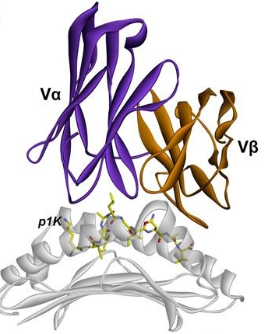
B
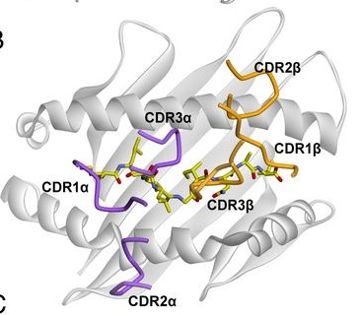
Figure S1. (A) A structural overview of the TCR variable domains in relation to the p-HLA. (B) Position of the CDR loops over the p-HLA complex. This Figure is adapted from reference (Wang, Y., et al., Proceedings of the National Academy of Sciences, 2017. 114(24): p. E4792-E4801.).

S2a
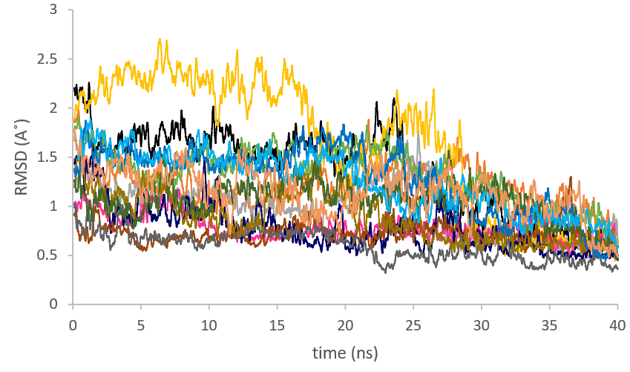
S2b
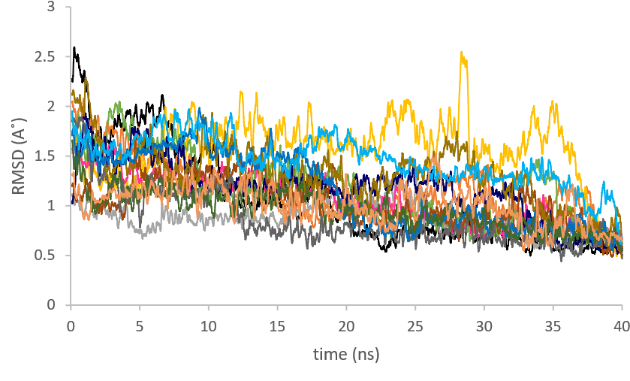
S2c
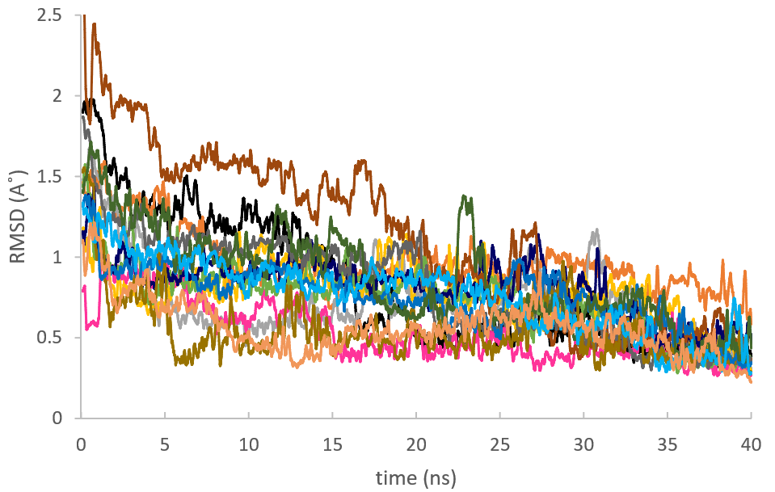

Figure S2. RMSD time plot and RMSD distribution plot of the α₁-helix (S2a), α₂-helix (S2b) and PLP-bound neuroantigen (S2c) of the p-HLA complex.
S3a S3b
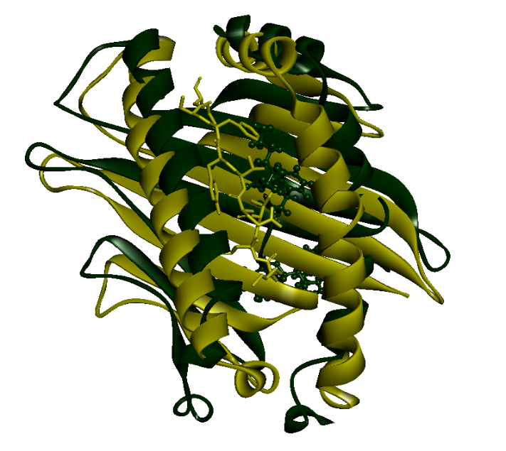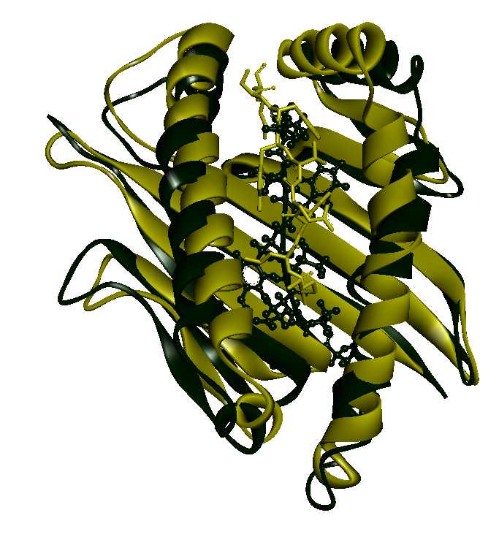
S3c S3d
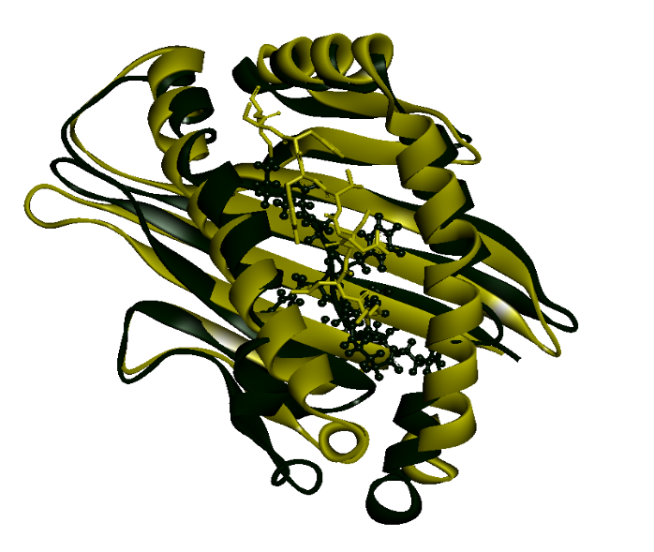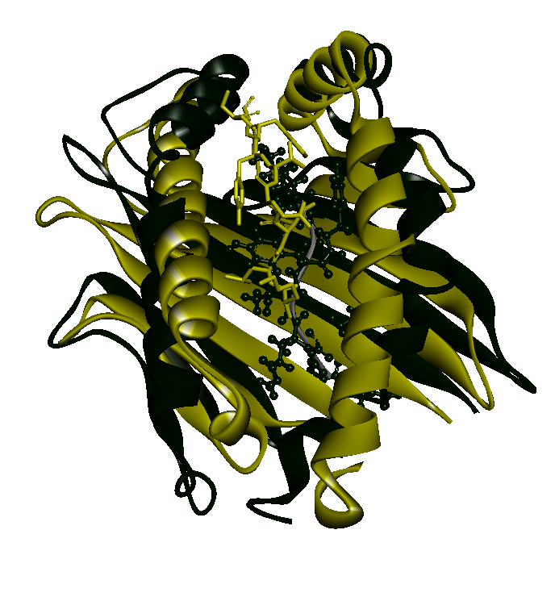
S3e S3f
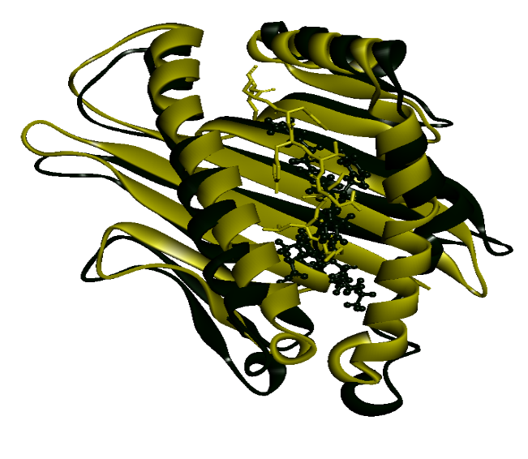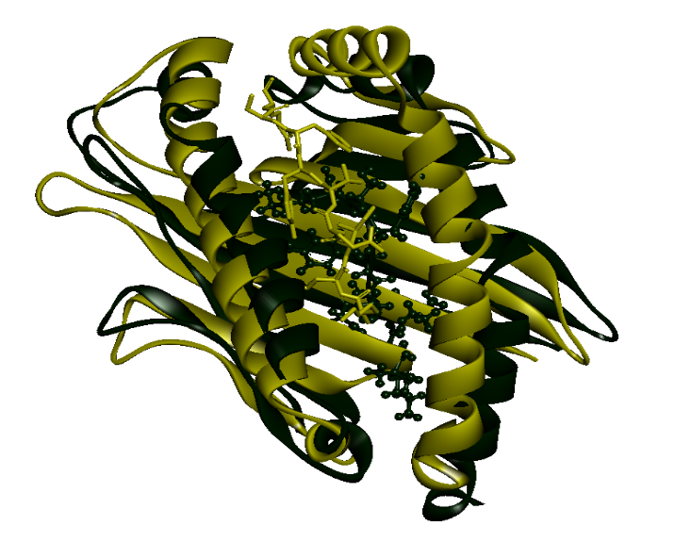
S3g S3h
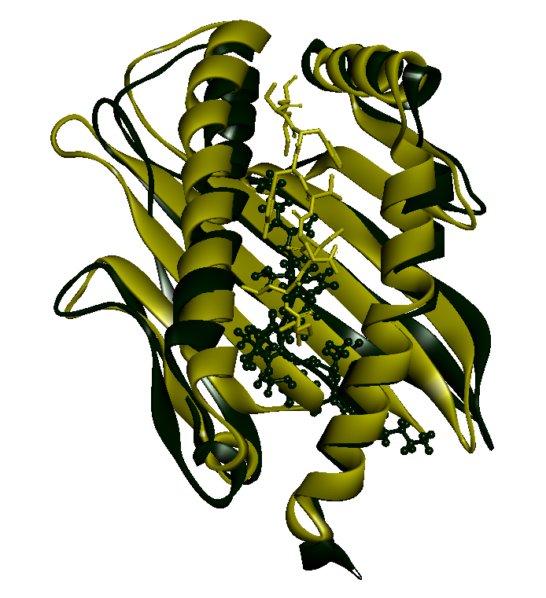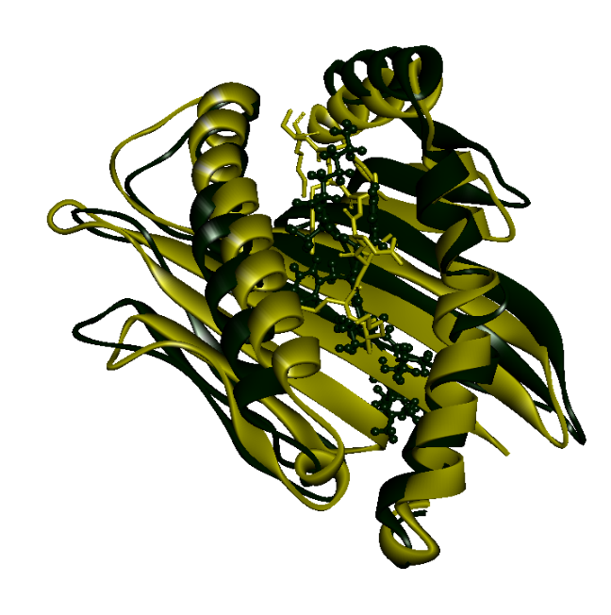
S3i S3j
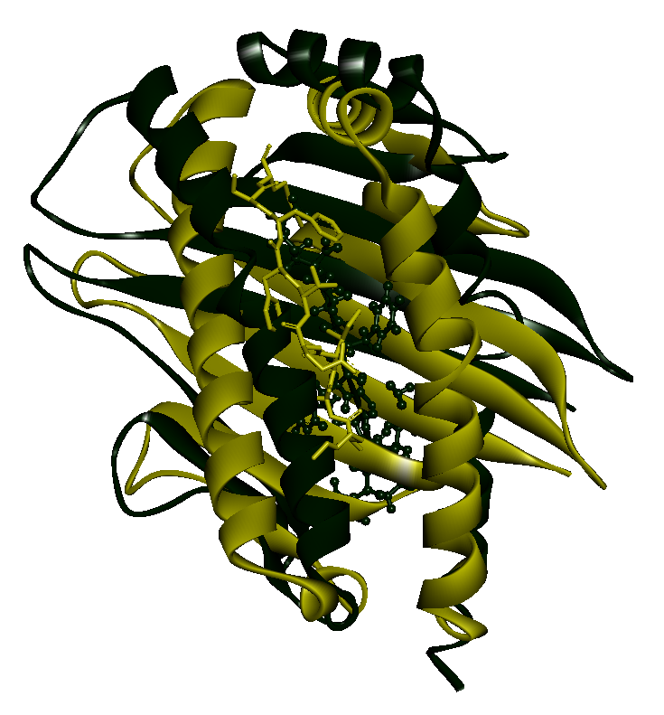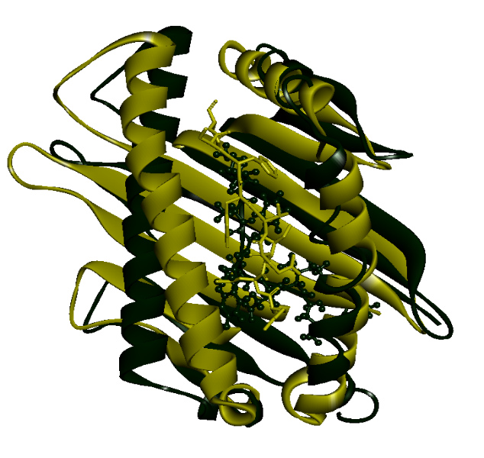
S3k S3l
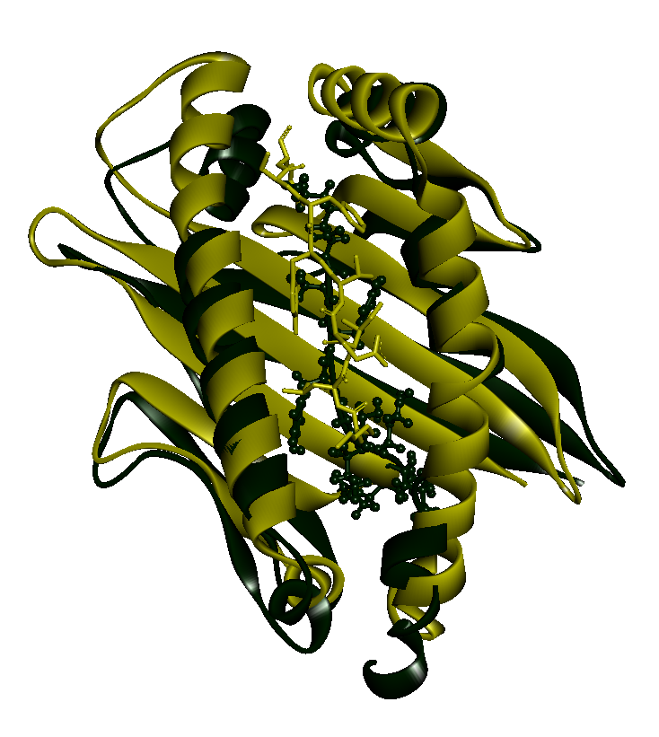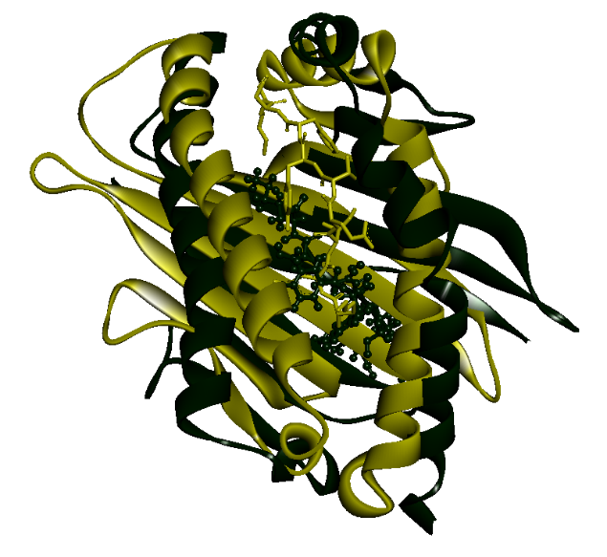
S3m S3n
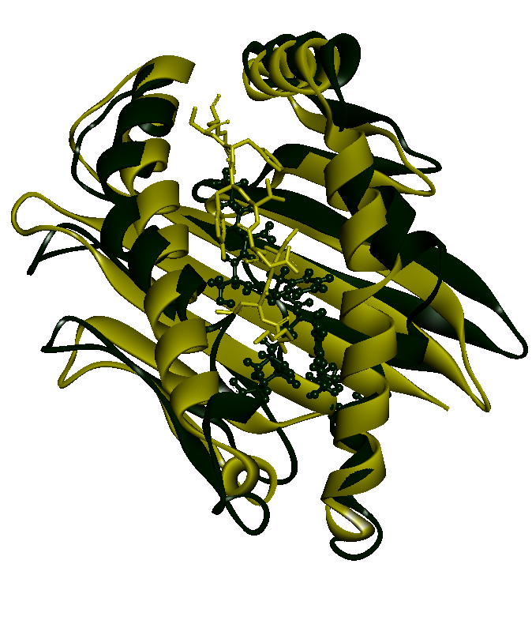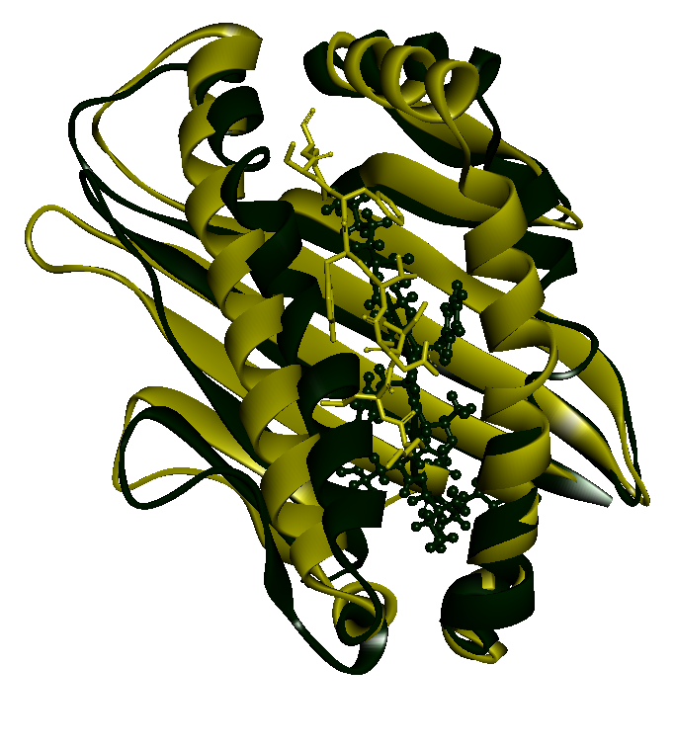
Figure S3. Superimpose structure of p-HLA complex in the peptide-bound (green) and unbound (yellow) state. Figure S3a-S3n: in the presence of peptide1-14, respectively

S4a
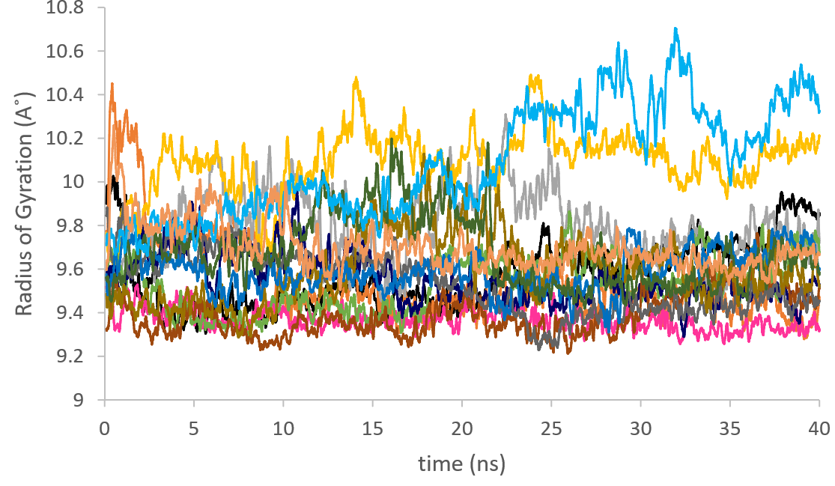

S4b
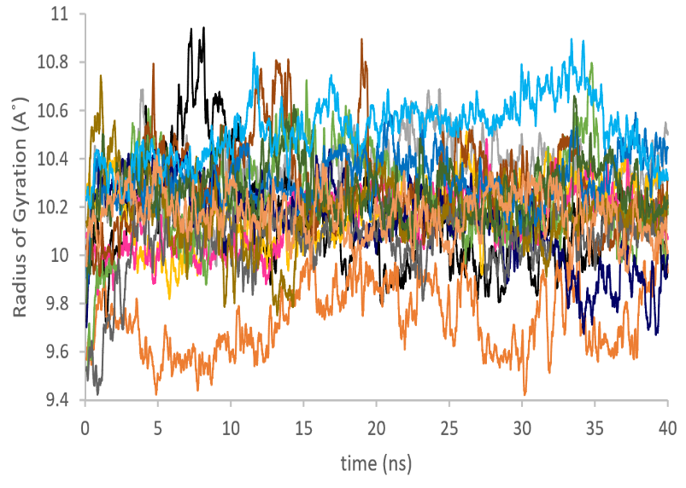
S4c
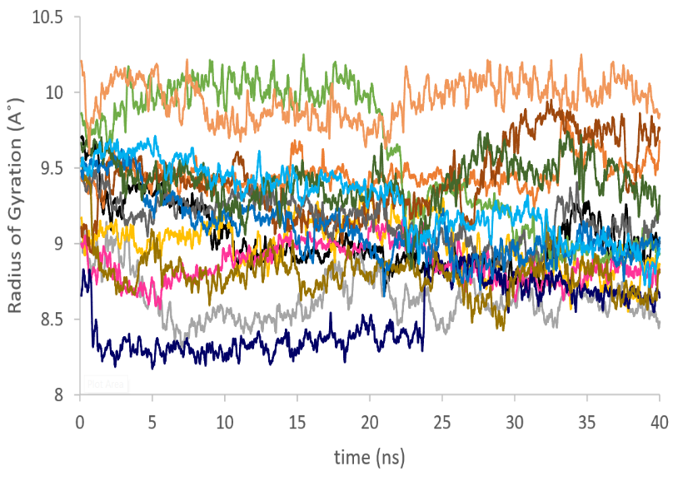
S4d
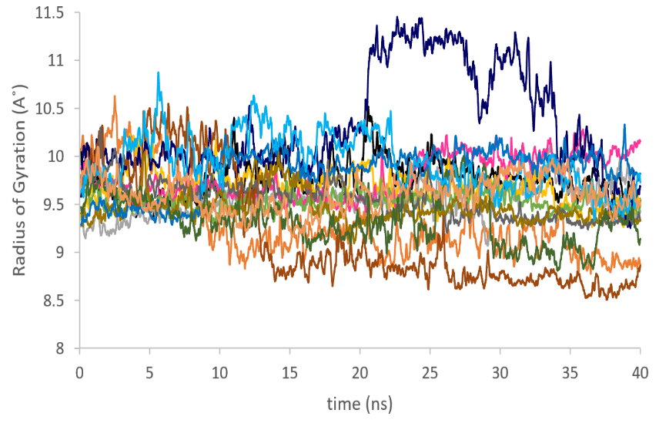
Figure S4. Fluctuation of Rg during simulation time for α₁- helix (S4a), α₂- helix (S4b), PLP neuroantigen (S4c), designed peptide (S4d) during 40 ns of MD simulation

S5a
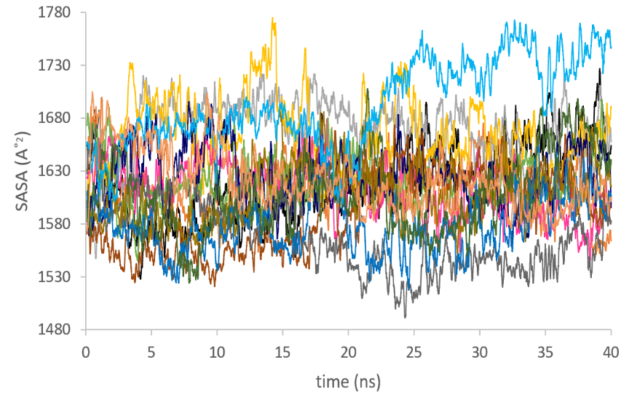
S5b
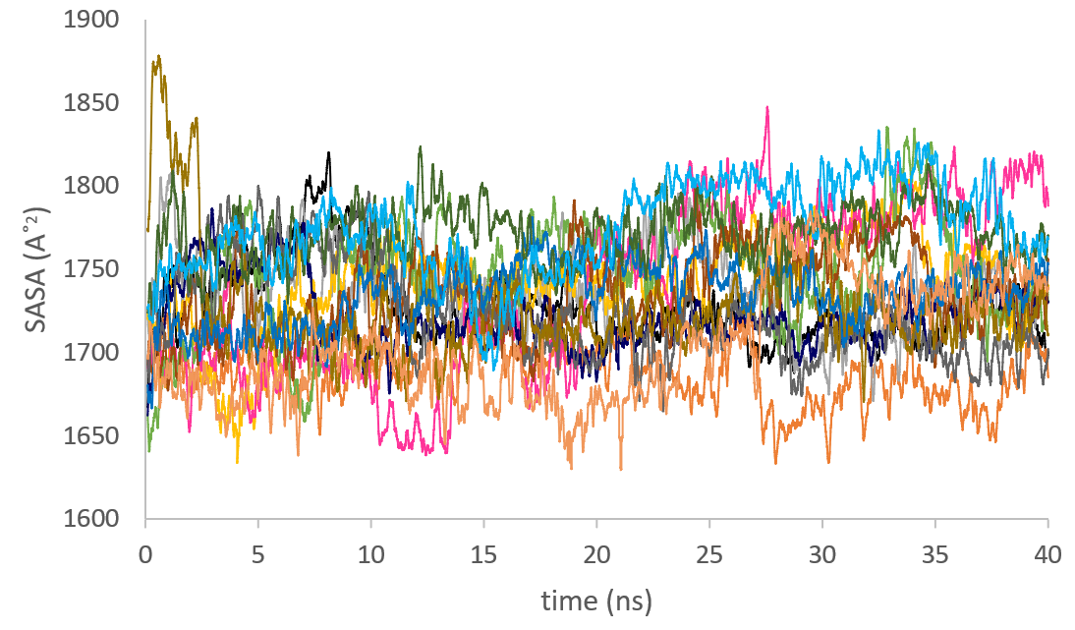
S5C
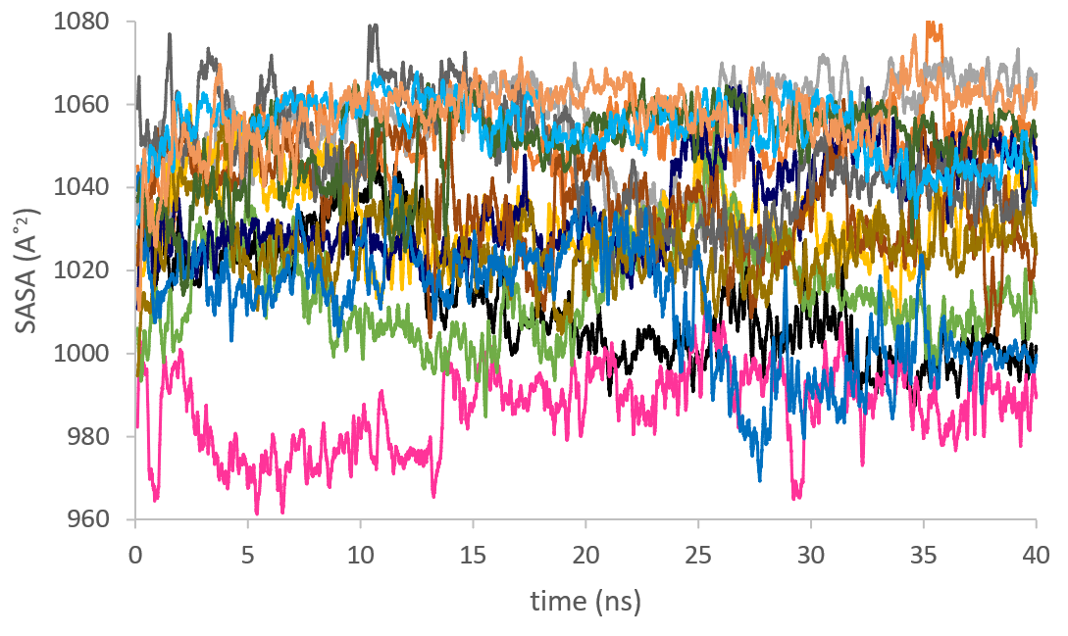

S5d
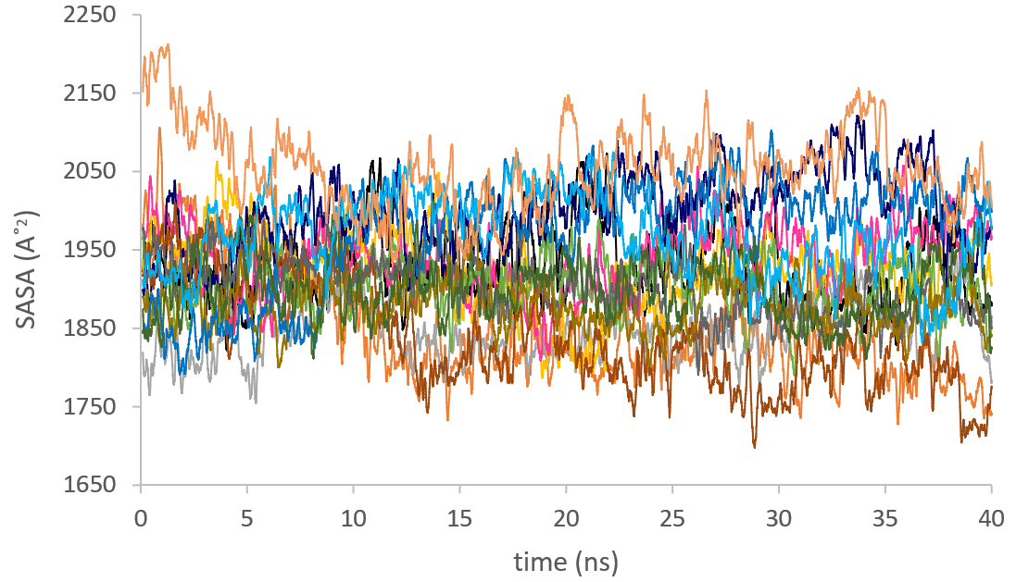
Figure S5. Fluctuation of SASA during simulation time for α₁- helix (S5a), α₂- helix (S5b), PLP neuroantigen (S5c), designed peptide (S5d) during MD simulation.

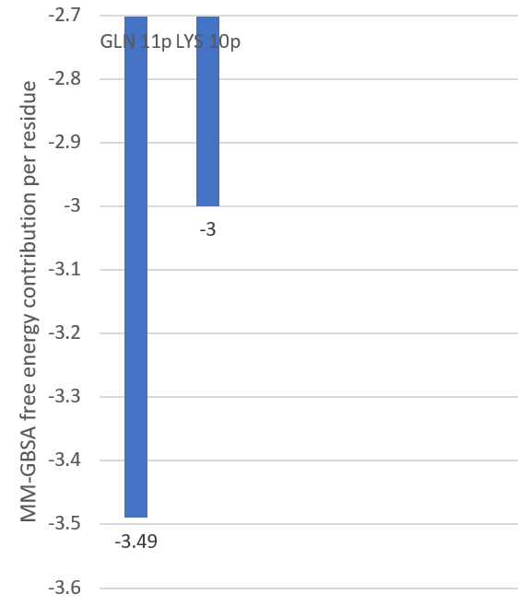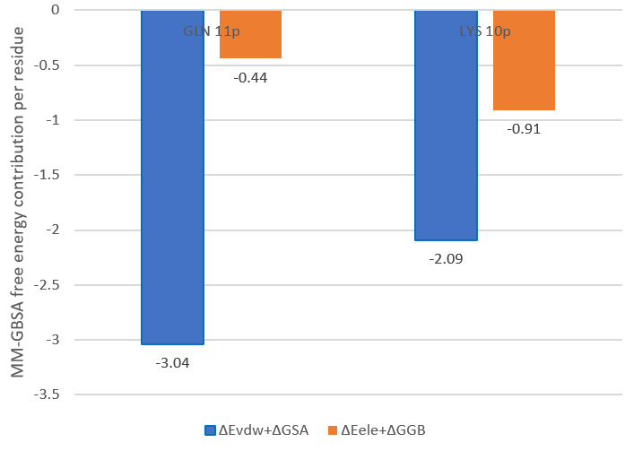
Figure S6. Per-residue energy (kcal/mol) decomposition of binding free energy analysis for peptide 1 to p-HLA complex

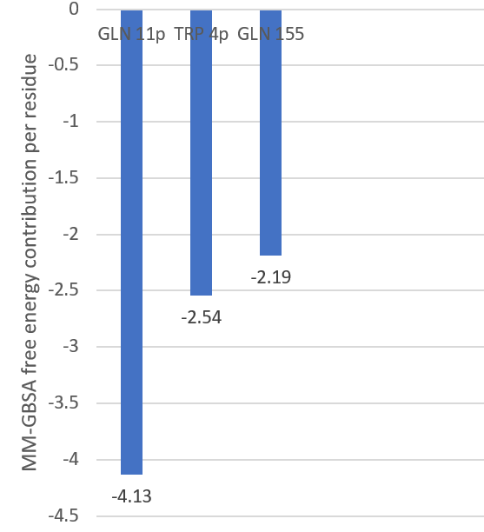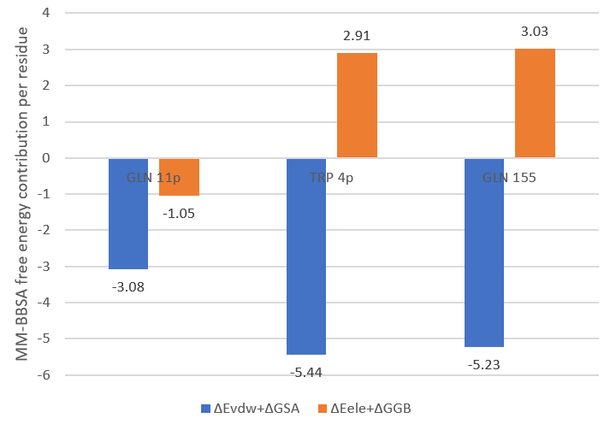
Figure S7. Per-residue energy (kcal/mol) decomposition of binding free energy analysis for peptide 2 to p-HLA complex
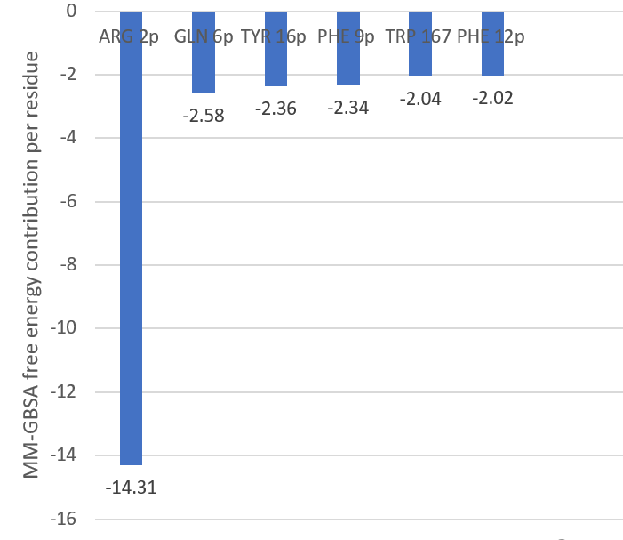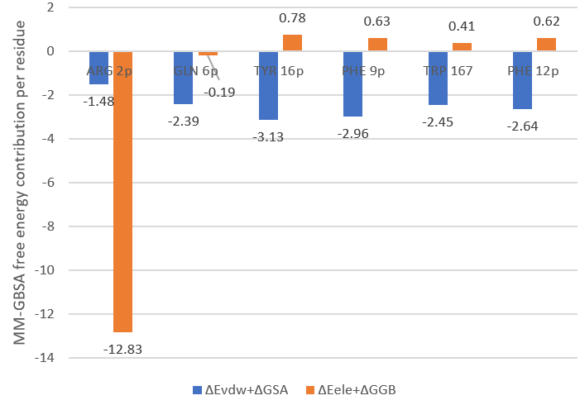
Figure S8. Per-residue energy (kcal/mol) decomposition of binding free energy analysis for peptide 3 to p-HLA complex

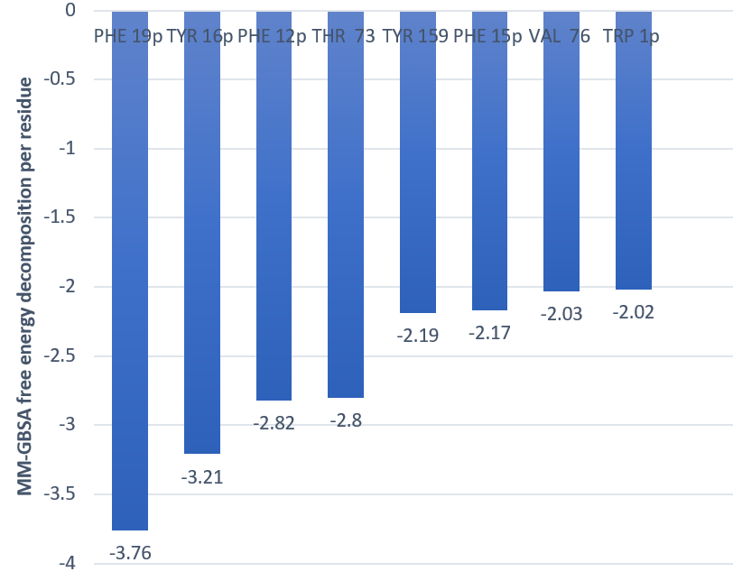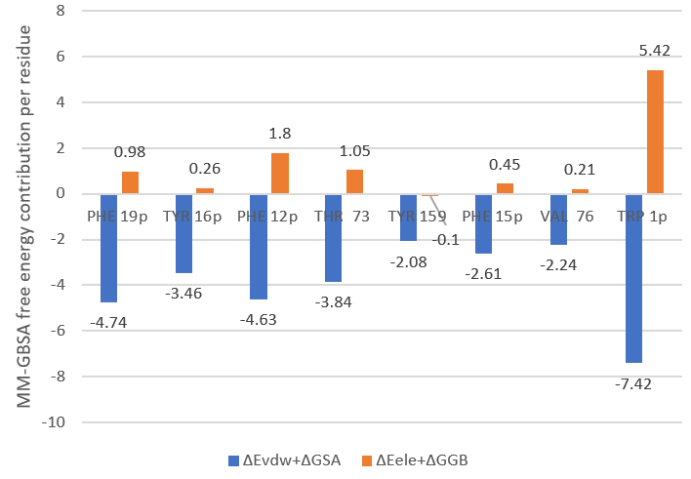
Figure S9. Per-residue energy (kcal/mol) decomposition of binding free energy analysis for peptide 4 to p-HLA complex

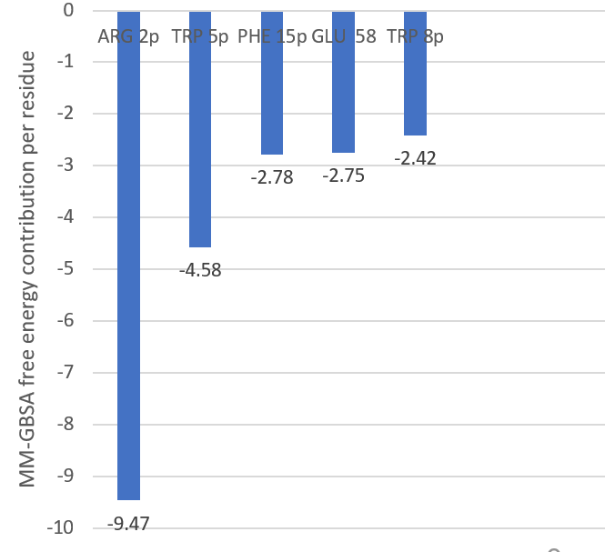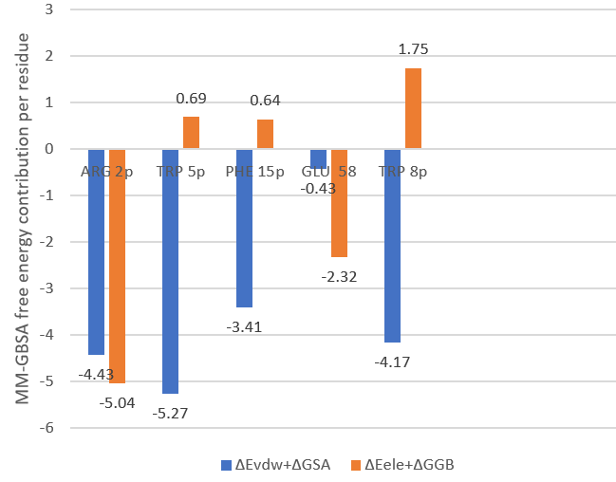
Figure S10. Per-residue energy (kcal/mol) decomposition of binding free energy analysis for peptide 5 to p-HLA complex
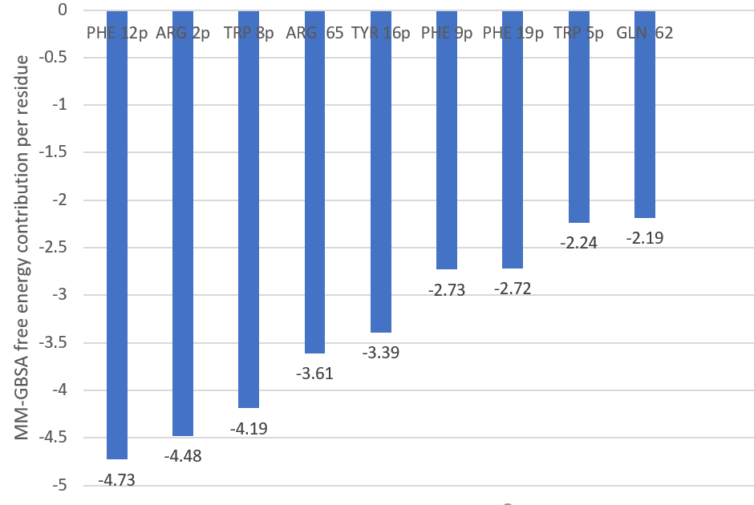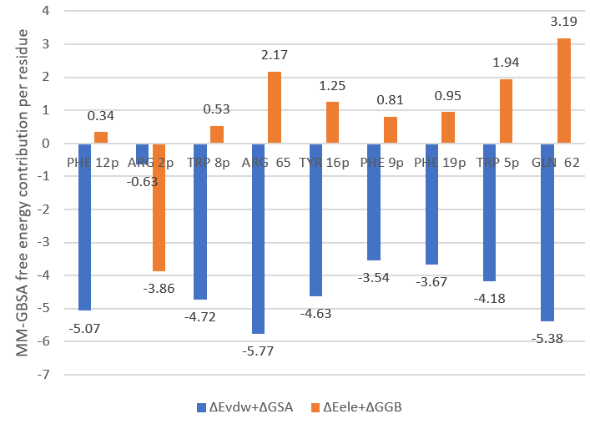
Figure S11. Per-residue energy (kcal/mol) decomposition of binding free energy analysis for peptide 6 to p-HLA complex
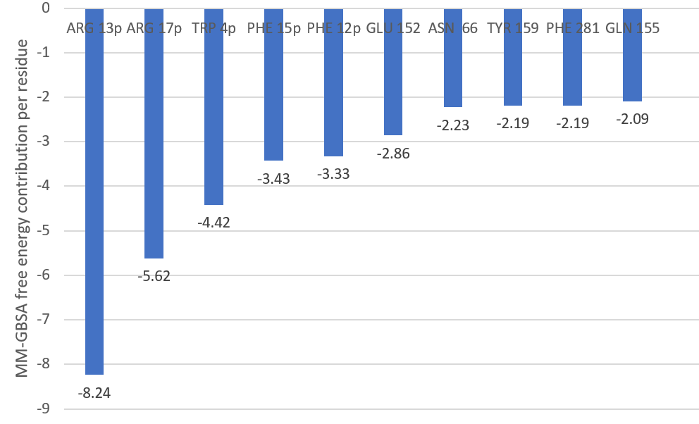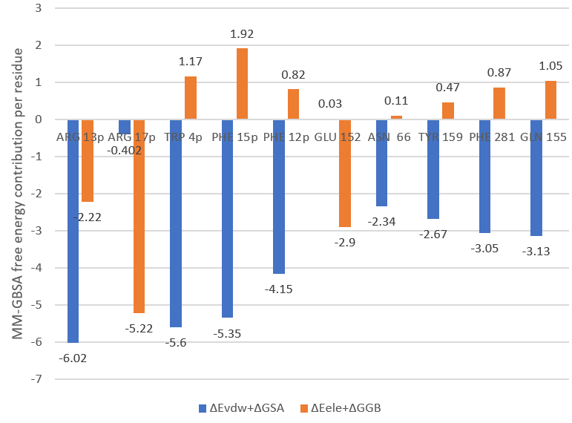
Figure S12. Per-residue energy (kcal/mol) decomposition of binding free energy analysis for peptide 7 to p-HLA complex
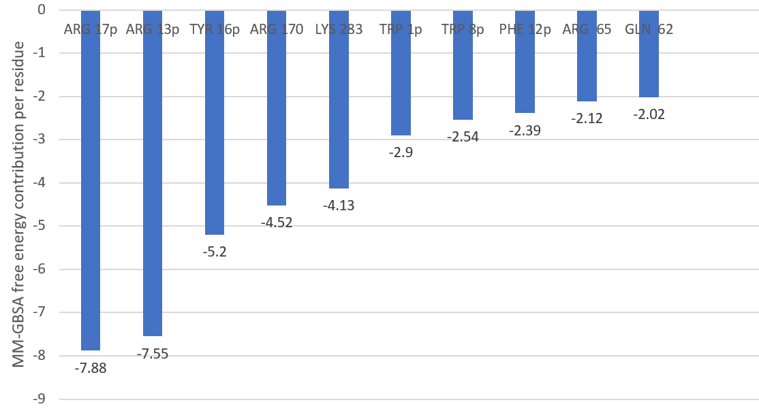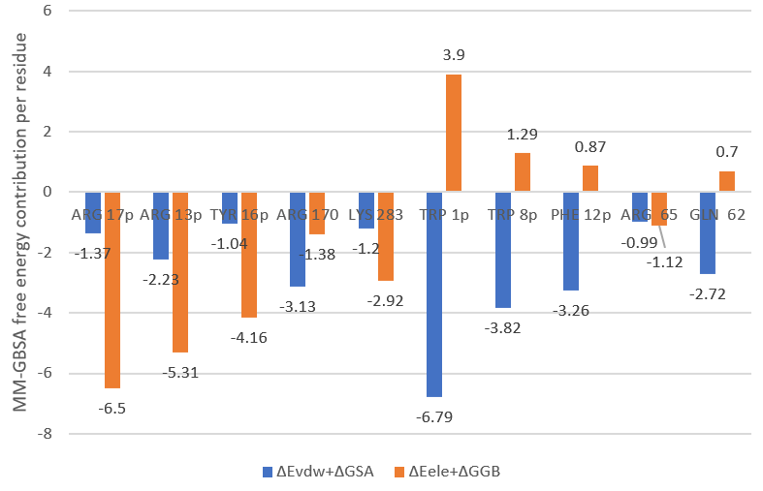
Figure S13. Per-residue energy (kcal/mol) decomposition of binding free energy analysis for peptide 8 to p-HLA complex
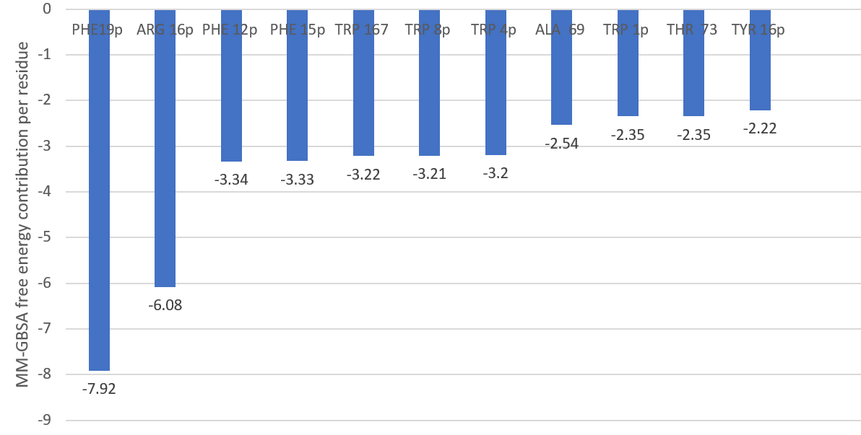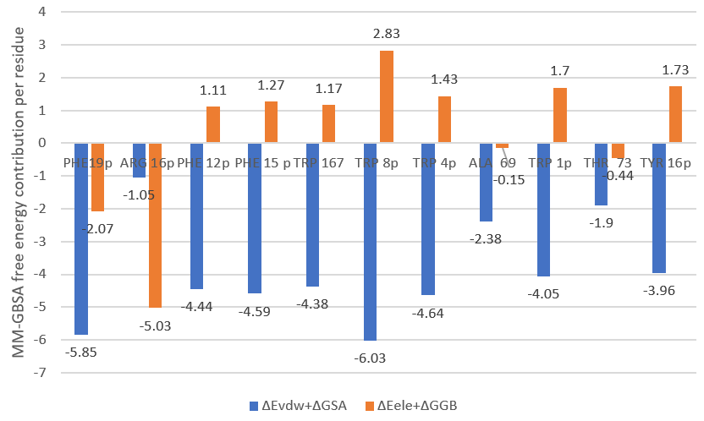
Figure S14. Per-residue energy (kcal/mol) decomposition of binding free energy analysis for peptide 9 to p-HLA complex
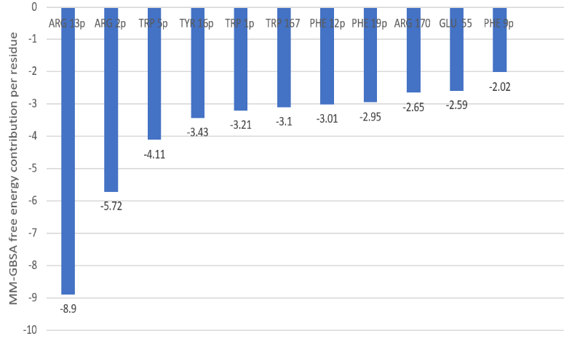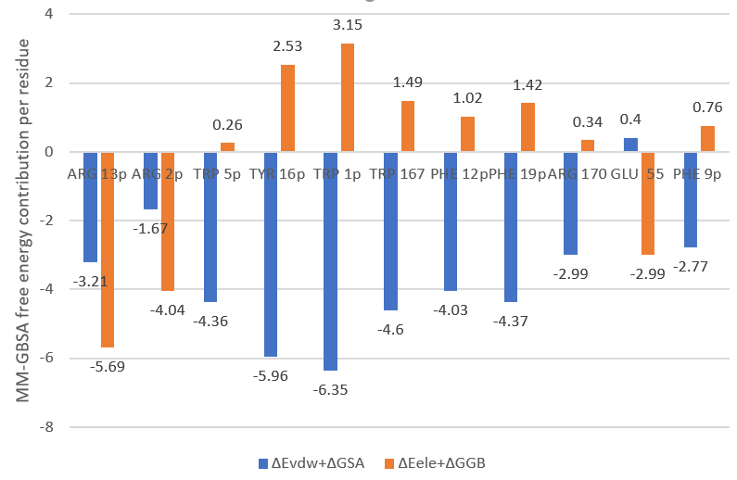
Figure S15. Per-residue energy (kcal/mol) decomposition of binding free energy analysis for peptide 10 to p-HLA complex
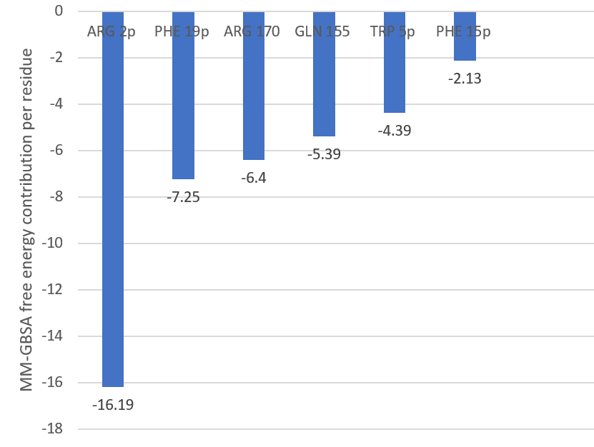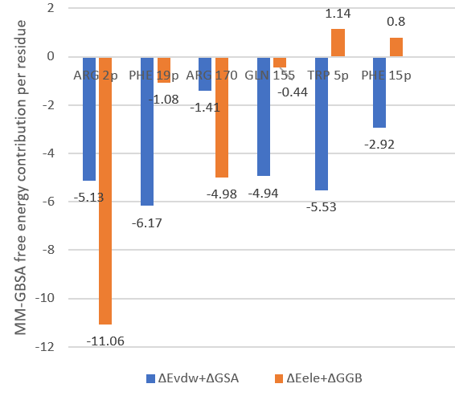
Figure S16. Per-residue energy (kcal/mol) decomposition of binding free energy analysis for peptide 11 to p-HLA complex
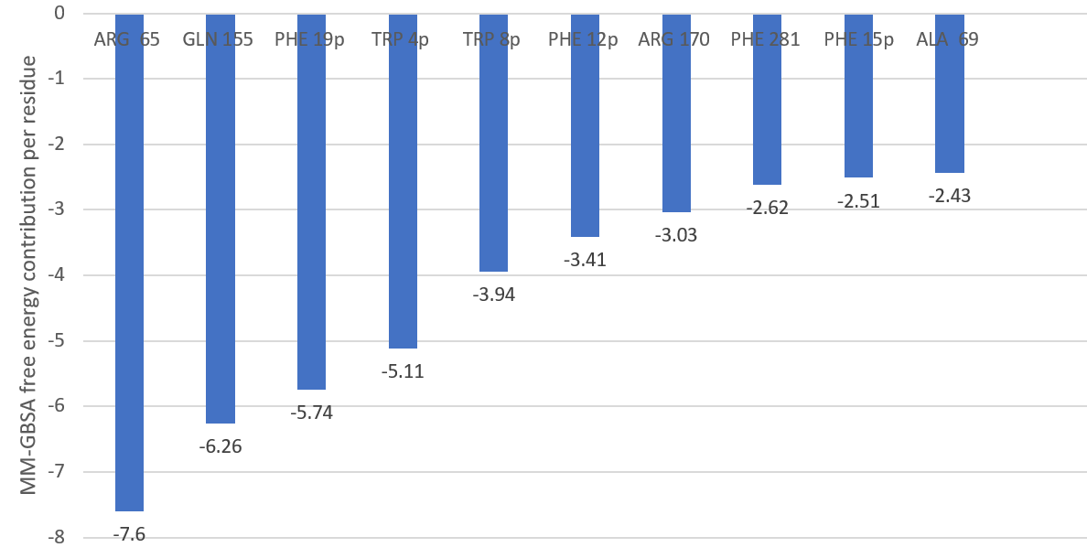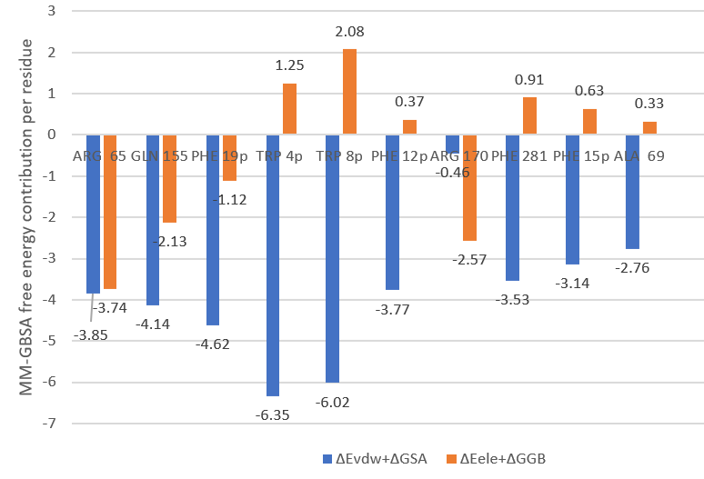
Figure 17. Per-residue energy (kcal/mol) decomposition of binding free energy analysis for peptide 12 to p-HLA complex
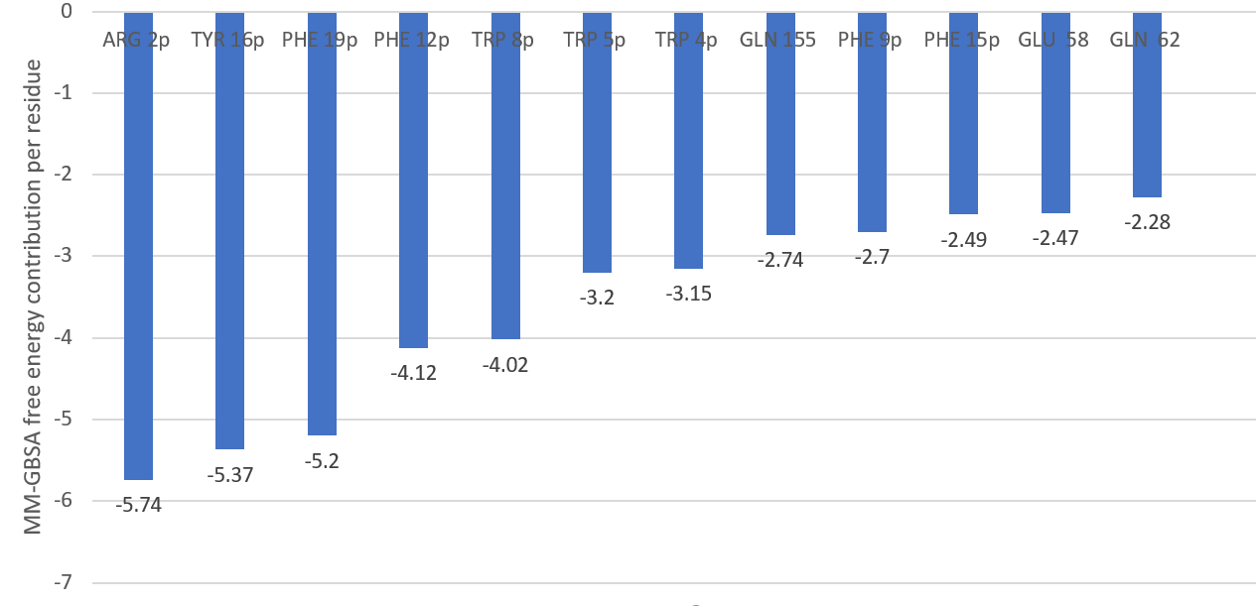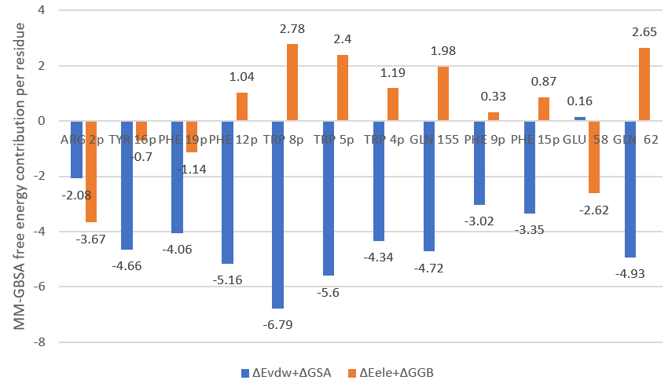
Figure S18. Per-residue energy (kcal/mol) decomposition of binding free energy analysis for peptide 13 to p-HLA complex

