Supplementary information

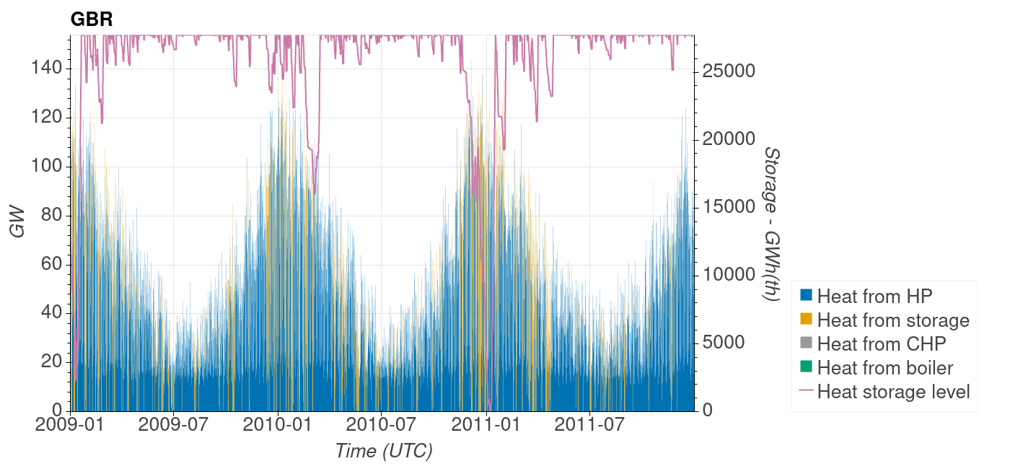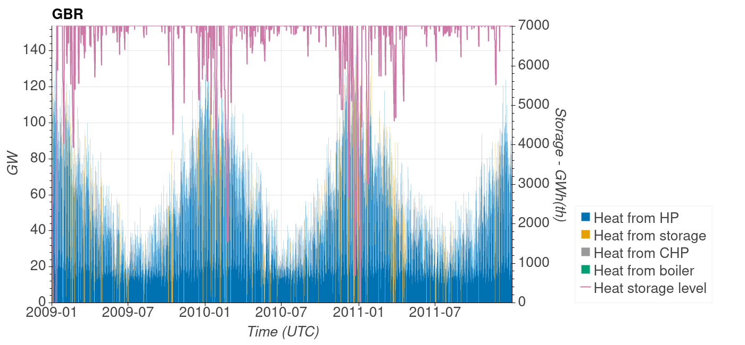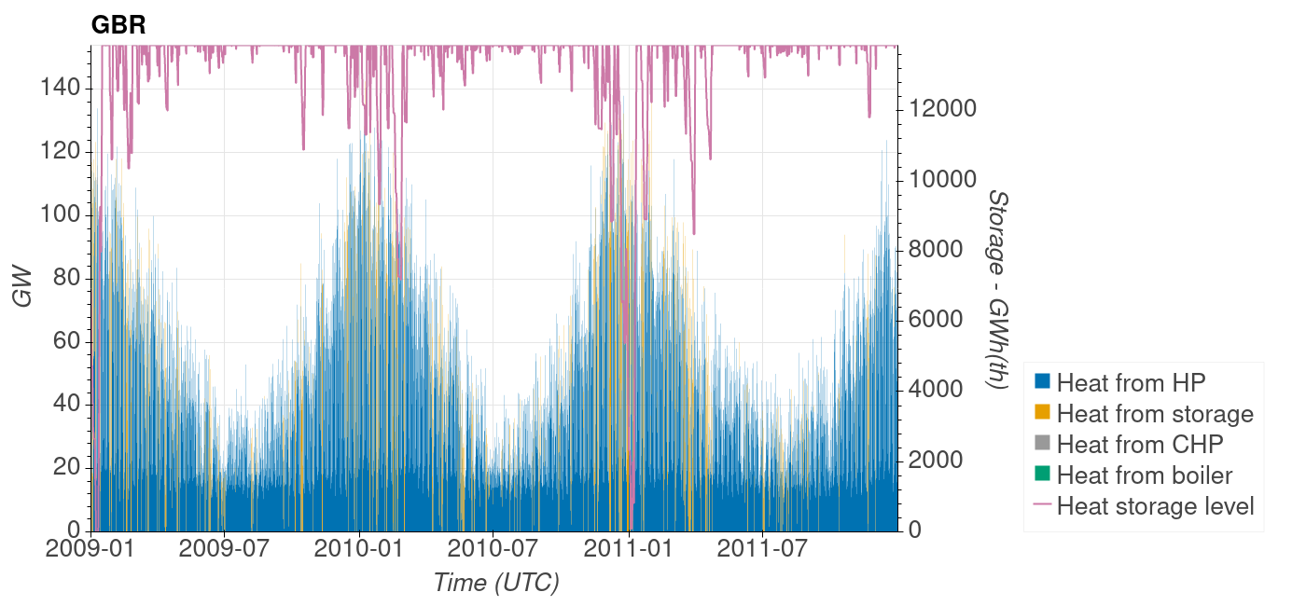
DH GenHi
DH
DH GenLo
Supplementary Figure 1 | Hourly storage level and delivered heat. Top, DH GenHi scenario with 33% more wind and solar capacities, and 50% less storage size than the core DH architecture. Middle, core DH architecture. Bottom, DH GenLo scenario with 33% less wind and solar capacity, and 100% more storage then the core DH architecture.

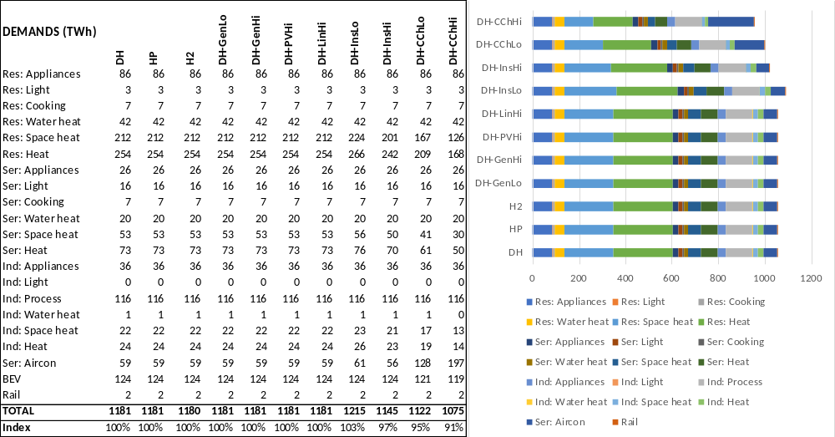
Supplementary Figure 2 | End use energy demands (i.e. final energy consumption) in 2010 for each scenario. Res: Residential; Ser: Services; Ind: Industry; Aircon: air conditioning; BEV: battery electric vehicles; Index: ratio of TOTAL for a given scenario to TOTAL for the core DH scenario.

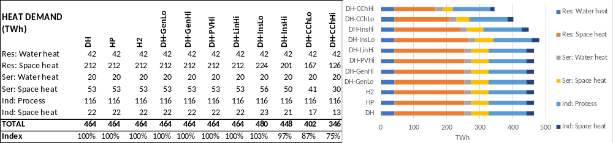
Supplementary Figure 3 | Annual heat demand in 2010. Res: Residential; Ser: Services; Ind: Industry; Index: ratio of TOTAL for a given scenario to TOTAL for the core DH scenario.

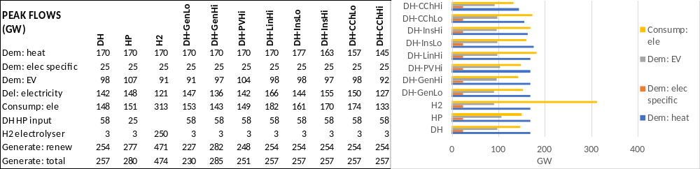
Supplementary Figure 4 | Peak flows in 2010. Dem: energy demand; Elec specific: electricity only; EV: electric vehicles; Del: delivered; “Consump: ele”: electricity consumption; DH HP input: electricity input to district heating heat pumps.

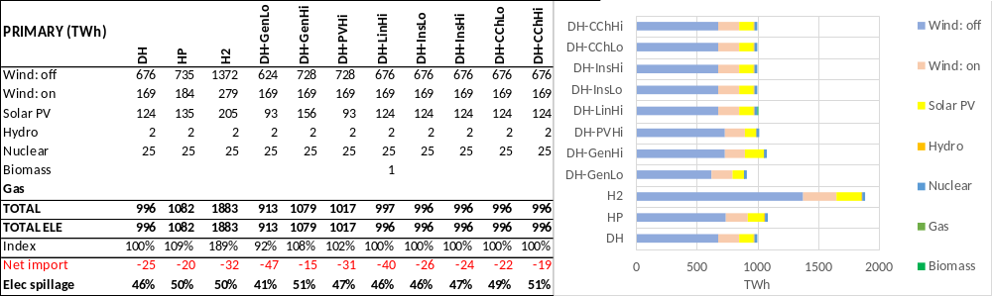
Supplementary Figure 5 | Primary energy supply in 2010. Index: ratio of TOTAL for a given scenario to TOTAL for the core DH scenario; Net import: import minus export.

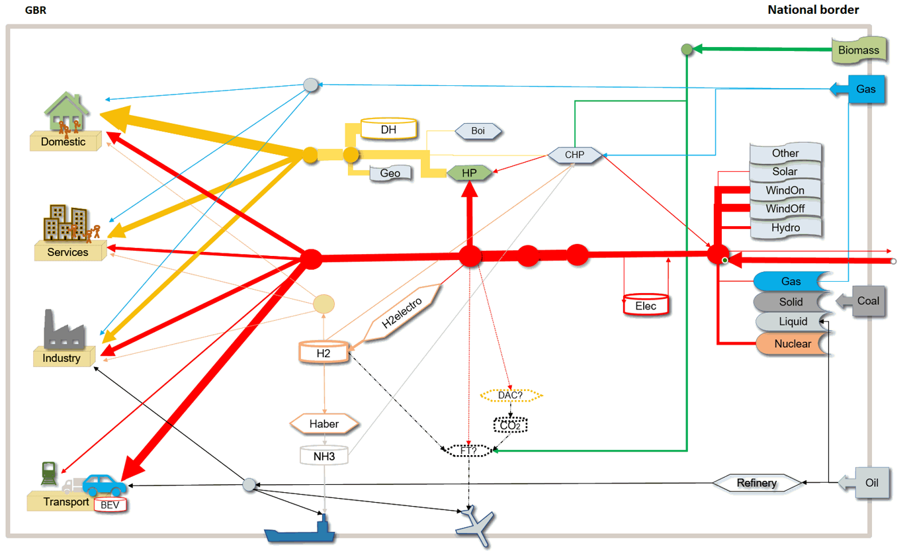

Supplementary Figure 6 | Diagram of the energy system of a node. Example of the GBR node. The arrows extending outside the box (which represents the national border) indicate interconnection flows. Aviation, biofuel supply, and carbon capture (dotted shapes) are not yet included in ESTIMO.

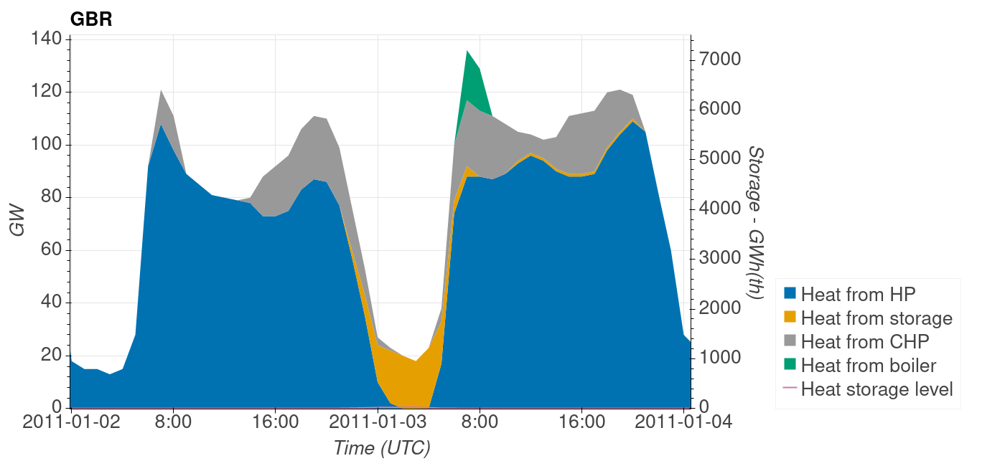
Supplementary Figure 7 | Example of the hourly heat supply from district heating over two days.

Supplementary Table 1 | Electricity consumption in 2010. Res: Residential; Ser: Services; Ind: Industry; Index: ratio of TOTAL for a given scenario to TOTAL for the core DH scenario.
Electricity consumption (TWh) | DH | HP | H2 | DH-GenLo | DH-GenHi | DH-PVHi | DH-LinHi | DH-InsLo | DH-InsHi | DH-CChLo | DH-CChHi
Battery EVs | 124 | 124 | 124 | 124 | 124 | 124 | 124 | 124 | 124 | 121 | 119
Rail | 5 | 5 | 5 | 5 | 5 | 5 | 5 | 5 | 5 | 5 | 5
Delivered in Res | 144 | 174 | 144 | 144 | 144 | 144 | 144 | 145 | 143 | 139 | 136
Delivered in Ser | 70 | 78 | 70 | 70 | 70 | 70 | 70 | 70 | 69 | 68 | 68
Delivered in Ind | 58 | 75 | 58 | 58 | 58 | 58 | 58 | 58 | 58 | 57 | 56
DH heat pumps | 95 | 41 |  | 98 | 93 | 94 | 94 | 98 | 91 | 82 | 69
H2 electrolysis | 1 | 1 | 484 | 1 | 1 | 1 | 1 | 1 | 1 | 1 | 1
Grid store loss | 2 | 3 | 2 | 5 | 2 | 3 | 4 | 3 | 2 | 2 | 2
Transmission loss | 36 | 36 | 62 | 36 | 36 | 36 | 36 | 36 | 35 | 34 | 33
Interconnector loss | 1 | 1 | 1 | 2 | 1 | 1 | 2 | 1 | 1 | 1 | 1
Total | 536 | 538 | 951 | 543 | 533 | 536 | 538 | 542 | 531 | 511 | 490
Index to DH | 100% | 116% | 205% | 117% | 115% | 115% | 116% | 117% | 114% | 110% | 105%

Supplementary Table 2 | Annual system costs. Consumer conversion: heat pumps and boilers; DH conversion: heat pumps, CHPs, boilers; Index: ratio of TOTAL for a given scenario to TOTAL for the core DH scenario.
Total G£/a | DH | HP | H2 | DH-GenLo | DH-GenHi | DH-PVHi | DH-LinHi | DH-InsLo | DH-InsHi | DH-CChLo | DH-CChHi
Consumer conversion | 9.8 | 23.0 | 16.2 | 9.8 | 9.8 | 9.8 | 9.8 | 9.8 | 9.8 | 9.8 | 9.8
DH conversion | 9.6 | 4.1 |  | 9.6 | 11.8 | 9.6 | 15.1 | 15.9 | 9.2 | 8.8 | 8.4
DH store & network | 13.2 | 5.4 |  | 17.2 | 11.3 | 13.2 | 11.6 | 13.2 | 13.2 | 13.2 | 13.2
H2 electrolyser | 0.1 | 0.1 | 11.7 | 0.1 | 0.1 | 0.1 | 0.1 | 0.1 | 0.1 | 0.1 | 0.1
H2 store & network |  |  | 9.2
Ammonia prod & storage | 0.1 | 0.1 | 0.1 | 0.1 | 0.1 | 0.1 | 0.1 | 0.1 | 0.1 | 0.1 | 0.1
Elec storage | 8.9 | 11.7 | 8.8 | 17.8 | 4.4 | 8.9 | 4.4 | 8.9 | 8.9 | 8.9 | 8.9
Elec network | 4.9 | 7.9 | 8.1 | 4.4 | 5.4 | 4.6 | 4.9 | 4.9 | 4.9 | 4.9 | 4.9
Nuclear | 2.6 | 2.6 | 2.6 | 2.6 | 2.6 | 2.6 | 2.6 | 2.6 | 2.6 | 2.6 | 2.6
Renewables | 24.1 | 26.3 | 45.9 | 22.2 | 26.1 | 24.6 | 24.1 | 24.1 | 24.1 | 24.1 | 24.1
Trade | -0.7 | -0.6 | -1.0 | -1.4 | -0.5 | -0.9 | -1.2 | -0.8 | -0.7 | -0.6 | -0.6
TOTAL exc. BEV | 73.5 | 81.2 | 102.6 | 83.8 | 71.7 | 73.7 | 72.9 | 79.7 | 73.0 | 72.7 | 72.3
Index to DH | 100% | 111% | 140% | 114% | 98% | 100% | 99% | 109% | 99% | 99% | 98%

Supplementary Table 3 | Capital and O&M system costs.
 | DH | HP | H2 | DH-GenLo | DH-GenHi | DH-PVHi | DH-LinHi | DH-InsLo | DH-InsHi | DH-CChLo | DH-CChHi
Capital G£ | 727 | 799 | 1045 | 819 | 715 | 728 | 720 | 783 | 723 | 720 | 716
Cap. Annuitised G£/a | 48 | 54 | 69 | 56 | 47 | 48 | 47 | 52 | 48 | 48 | 47
O&M G£/a | 25 | 27 | 34 | 28 | 25 | 26 | 26 | 28 | 25 | 25 | 25
Total G£/a | 73 | 81 | 103 | 84 | 72 | 74 | 73 | 80 | 73 | 73 | 72
O&M %total G£/a | 35% | 34% | 33% | 34% | 35% | 35% | 35% | 35% | 35% | 35% | 35%

Supplementary Table 4 | System costs allocated to heat supply. “Heat: direct costs” includes the conversion technologies; “Primary for heat” represents the share of primary energy supply used to meet heat demand.
Total G£/a | DH | HP | H2 | DH-GenLo | DH-GenHi | DH-PVHi | DH-LinHi | DH-InsLo | DH-InsHi | DH-CChLo | DH-CChHi
Heat: direct costs | 33 | 33 | 31 | 37 | 33 | 33 | 37 | 39 | 32 | 32 | 32
Primary for heat | 14 | 15 | 52 | 16 | 14 | 14 | 13 | 15 | 14 | 13 | 11
Total heat cost | 47 | 48 | 83 | 53 | 47 | 47 | 50 | 54 | 46 | 45 | 43
 | 100% | 101% | 175% | 112% | 99% | 100% | 106% | 114% | 98% | 95% | 90%
Heat Cost % total | 64% | 59% | 80% | 63% | 65% | 64% | 68% | 68% | 63% | 61% | 59%
Heat demand | 464 | 464 | 464 | 464 | 464 | 464 | 464 | 480 | 448 | 402 | 346
Heat cost | 10 | 10 | 18 | 11 | 10 | 10 | 11 | 11 | 10 | 11 | 12
 | 100% | 101% | 175% | 112% | 99% | 100% | 106% | 110% | 102% | 109% | 121%
Remainder | 58.5 | 66.5 | 89.6 | 64.9 | 56.5 | 58.7 | 54.0 | 58.5 | 58.5 | 58.5 | 58.5
Ele for heat | 131.5 | 122.8 | 548.2 | 135.9 | 129.4 | 130.8 | 130.9 | 137.0 | 125.9 | 110.1 | 91.4
% ele for heat | 25% | 23% | 58% | 25% | 24% | 24% | 24% | 25% | 24% | 22% | 19%

Supplementary Note 1. Technology attributes
Data for the principal technologies are set out in the Supplementary Table 5, with the majority of these extracted from the Danish Technology Catalogue (source: Danish Energy Agency). The installed efficiencies of all technologies are assumed constant, except for heat pumps and electricity transmission, where efficiency varies with power flow. For heat pumps, the efficiency is the fraction of the Carnot efficiency. The capital costs and efficiencies of most technologies are assumed to have economies of scale. Capital costs are projected for 2050 (using Danish Energy Agency data), but these, particularly for solar, wind and batteries, are necessarily speculative. Nuclear construction, operation, decommissioning and waste handling costs are obscure, since a proportion of these are borne publicly (e.g. insurance) and are not expressed as market costs. The simulated scenarios have a nuclear capacity limited to Hinkley C.

Supplementary Table 5 | Attributes of the main technologies modelled in ESTIMO.
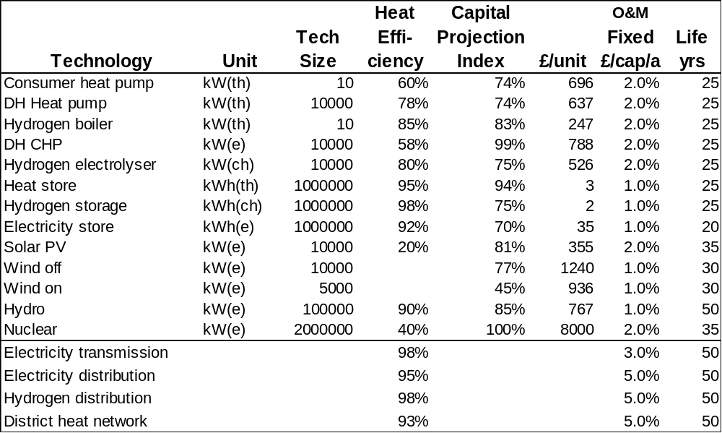

The requirements and costs of new or upgraded district heating, hydrogen and electricity networks basically depend on network lengths and peak flows (Supplementary Figure 8). Distribution network costs for the UK are calculated with an estimated cost per consumer, which increases with percentage (share) of connected consumers, to simply reflect decreasing consumer spatial density; costs depend on factors including existing network capacities and the exigencies of underground conditions across settlements. Electricity high voltage transmission capacity depends on peak flows, which are largely determined by the installed generation capacity; the approach here is to assign a cost in £/kWe. The future O&M costs of networks are also uncertain but are likely to reduce per energy transmitted due to automation.
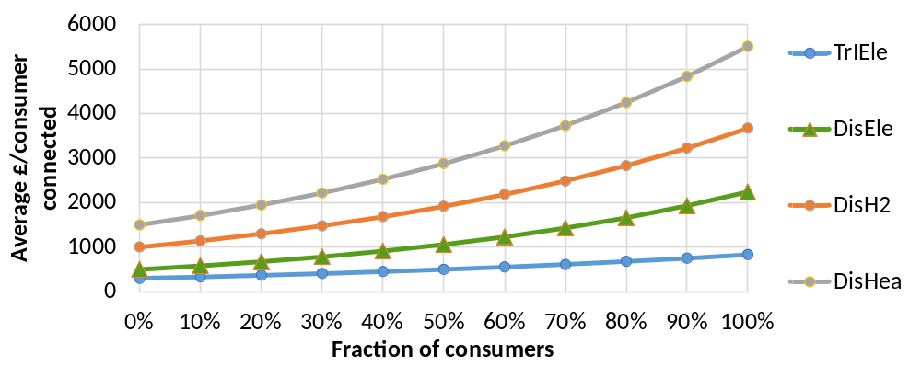
Supplementary Figure 8 | Network costs. Network cost per consumer connected for electricity transmission (TrIEle), distribution (DisEle), hydrogen (DisH2), heat (DisHea).

Supplementary Note 2. Implications for the energy system transition
Assuming that the systems are built over a period of 30 years (say 2020-2050) and that there will be 40 M domestic and other consumers, the average required rates of implementation may be calculated. The rates of retirement of existing components and their replacement with low emission technologies is complex to determine. The actual rates of implementation year on year will depend on consumer choice, and how fast production and installation capacities of the different components can be ramped up with labour training, investment and so on. The modelling of implementation is not included in ESTIMO.
There will be meteorology periods where there are residual emissions. It may be that low cost back-up (e.g. DH CHPs) will supply in such periods. For example, 150 GW of OGT using natural or perhaps biogas might cost about 1.5 G£/a, or less than 5% of total system cost. The emissions from this might be balanced by DACS. Increased long distance trading will reduce this problem.
In general, it is hard to force change to privately owned systems because objectionable, coercive regulation may be required, and because of disruption, and because consumers may have to make capital investments in heat pumps or boilers, as opposed to paying annual energy bills incorporating investment costs. The past decades of slow building efficiency retrofit exemplify the difficulties. Forcing change from fossil to electric vehicles is rather easier because of the fast turnover of vehicles and because EV costs are converging on fossil vehicles, though it will require charging infrastructure.
Primary vs consumer. In contrast, it is easier to rapidly implement public system primary components such as wind and solar farms through regulation and incentives such that renewable generation has grown to 37% of total (2019) to exceed fossil in just a decade or so.
It is notable that in Europe about 25% of heating is District Heating (840 TWh)¹ and 10% heat pumps (11.8 million units in 2018)², whereas the application of hydrogen boilers and networks is very small.
District heating and hydrogen distribution networks will be installed on an area by area basis. Hydrogen networks will largely adapt existing gas networks and so existing gas consumers will have to switch their gas equipment by area, assuming they do not switch to electric heating. District heating networks would be installed alongside gas networks so consumers can individually choose whether or not to connect. However, the economics of hydrogen and district heating degrade with a reducing fraction of consumers connected, even though low temperature district heating using plastic pipes may be still cost-effective in low heat load areas. The widespread adoption of consumer heat pumps will increase the peak electricity demand on the electricity distribution network, and this will require reinforcement. The extent reinforcement will be required will also depend on electric vehicle uptake and charging infrastructure and strategies, and on consumer side storage. One trajectory would be to replace gas boilers as they ‘die’ with reversible heat pumps, and then later replace the heat pumps with a connection to DHC as and if it becomes available. The advantage of this is that boiler life is typically less than 15 years and so much fossil heating could be replaced within 20 years or so given heat pump installation capacity.

References
1. Fahl, U. & Dobbins, A. District heating in Europe: Opportunities for energy savings, business, and jobs. Opportunities for energy savings, business, and jobs. in Europe’s Energy Transition: Insights for Policy Making 249–259 (Elsevier, 2017). doi:10.1016/B978-0-12-809806-6.00029-8.
2. European Heat Pump Association. Market Data. https://www.ehpa.org/market-data.

