Substantial increases in future precipitation extremes – insights from a large ensemble of downscaled CMIP6 models
Rohan Eccles¹*, Jozef Syktus², Ralph Trancoso^{1,2}, Sarah Chapman^{1,2}, Conrad Wasko³, Jason P. Evans^{4,5}, Marcus Thatcher⁶, Giovanni Di Virgilio^{5,7}, Christian Stassen⁸
¹ Climate Projections and Services, Queensland Treasury, Queensland Government, Brisbane, Australia
² School of The Environment, The University of Queensland, Brisbane, Australia
³ School of Civil Engineering, The University of Sydney, Sydney, NSW, Australia
⁴ Climate Change Research Centre, School of Biological, Earth and Environmental Sciences, University of New South Wales, Sydney, Australia
⁵ Australian Research Council Centre of Excellence for Weather of the 21st Century, University of New South Wales, Sydney, Australia
⁶ CSIRO Environment, Melbourne, VIC, Australia
⁷ Climate & Atmospheric Science, NSW Department of Climate Change, Energy, the Environment and Water, Sydney, Australia
⁸ Bureau of Meteorology, Melbourne, Australia

Supplementary Material
This supplementary material contains Figure S1 to Figure S2 and Table S1 to Table S4.

Ensemble evaluation
Table S1. Percent bias of the mean precipitation over capital city regions for each of the model ensembles compared to AGCD for 1981-2020. Mean Absolute Percentage Error (MAPE) biases are presented for all capital city areas and across Australia as a whole.
Region | CMIP6 | QldFCP-2 | CCAM-ACS | BARPA-ACS | NARCliM2
ACT | 2.0 | -25.8 | 2.4 | -3.0 | -8.6
Adelaide | -26.4 | -20.8 | -1.9 | 12.5 | -37.1
Brisbane | 4.8 | 5.8 | 11.1 | 9.6 | -11.9
Darwin | -9.4 | -31.2 | -2.9 | -12.5 | -29.7
Hobart | 24.3 | -28.0 | -5.4 | -16.0 | -15.9
Melbourne | -6.6 | -17.2 | -5.9 | 6.9 | -27.0
Perth | -36.2 | -47.4 | -17.9 | -13.4 | -42.6
Sydney | -6.1 | -23.7 | 1.7 | 2.7 | -16.4
MAPE capital cities | 14.5 | 25.0 | 6.1 | 9.6 | 23.6
MAPE Australia | 23.1 | 18.8 | 30.8 | 16.4 | 20.9

Table S2. Percent bias of the 99th percentile precipitation over capital city regions for each of the model ensembles compared to AGCD for 1981-2020. Mean Absolute Percentage Error (MAPE) biases are presented for all capital city areas and across Australia as a whole.
Region | CMIP6 | QldFCP-2 | CCAM-ACS | BARPA-ACS | NARCliM2
ACT | -19.3 | -15.7 | 7.9 | -3.2 | -7.9
Adelaide | -26.7 | -5.9 | 9.7 | 4.3 | -26.0
Brisbane | -15.0 | 1.3 | 9.6 | 8.1 | -10.0
Darwin | -15.2 | -28.1 | 2.8 | -16.6 | -17.1
Hobart | -26.7 | -28.2 | -9.0 | -5.3 | -12.9
Melbourne | -15.8 | -4.9 | 6.4 | 2.7 | -15.9
Perth | -37.1 | -29.9 | -0.5 | -5.5 | -31.2
Sydney | -21.7 | -13.7 | 7.1 | 2.4 | -8.2
MAPE capital cities | 22.2 | 16.0 | 6.6 | 6.0 | 16.1
MAPE Australia | 14.6 | 22.5 | 19.5 | 13 | 21.3

Table S3. Percent bias of the 99.7th percentile precipitation over capital city regions for each of the model ensembles compared to AGCD for 1981-2020. Mean Absolute Percentage Error (MAPE) biases are presented for all capital city areas and across Australia as a whole.
Region | CMIP6 | QldFCP-2 | CCAM-ACS | BARPA-ACS | NARCliM2
ACT | -22.8 | -7.8 | 13.5 | 0.4 | -6.8
Adelaide | -19.6 | 3.1 | 19.9 | 7.3 | -16.9
Brisbane | -22.7 | 7.4 | 14.8 | 16.5 | -4.3
Darwin | -15.9 | -6.1 | 21.7 | 2.0 | 1.2
Hobart | -34.6 | -24.4 | -10.8 | 0.8 | -11.9
Melbourne | -14.5 | 2.1 | 16.4 | 6.2 | -8.3
Perth | -35.7 | -21.3 | 5.4 | -1.4 | -25.5
Sydney | -27.9 | -5.7 | 11.6 | 5.8 | -1.3
MAPE capital cities | 24.2 | 9.7 | 14.3 | 5.0 | 9.5
MAPE Australia | 14.8 | 19.7 | 26.4 | 14.2 | 13.2

Changes across Australia
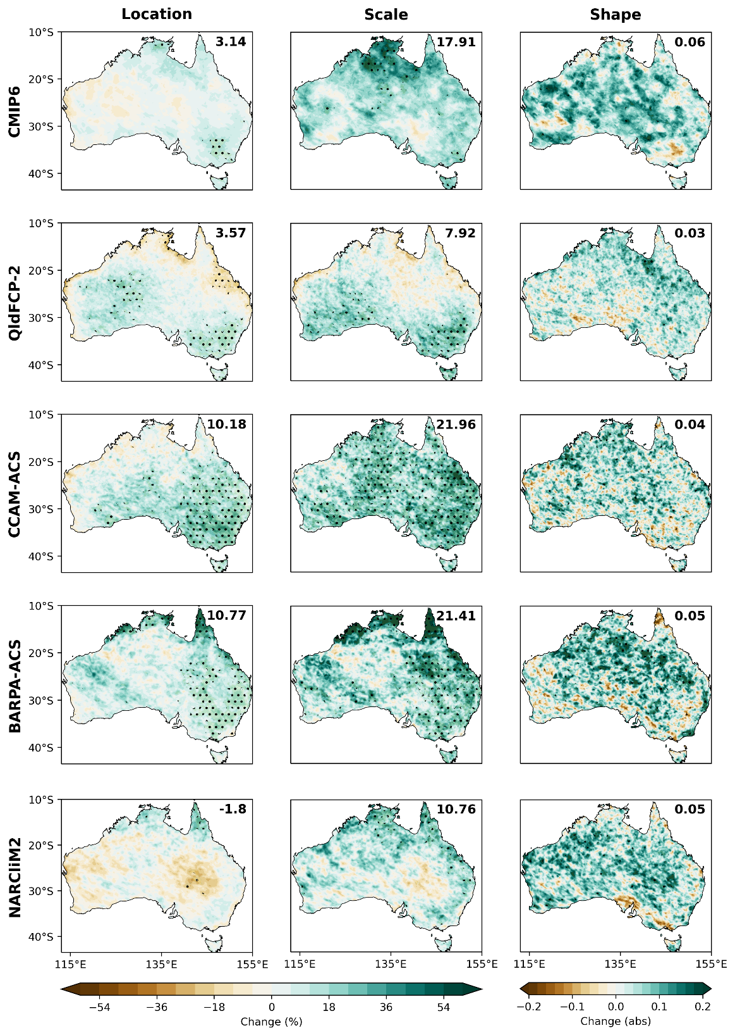
Figure S1. Comparison of ensemble median change to the location, scale, and shape parameters by the end of the century (2071-2100) compared to the reference period (1981-2010) under SSP370. Highlighted values show the average changes over Australia in percent from the multi-model median, stippling shows where the signal-to-noise ratio > 1.0.

Changes to Capital Cities
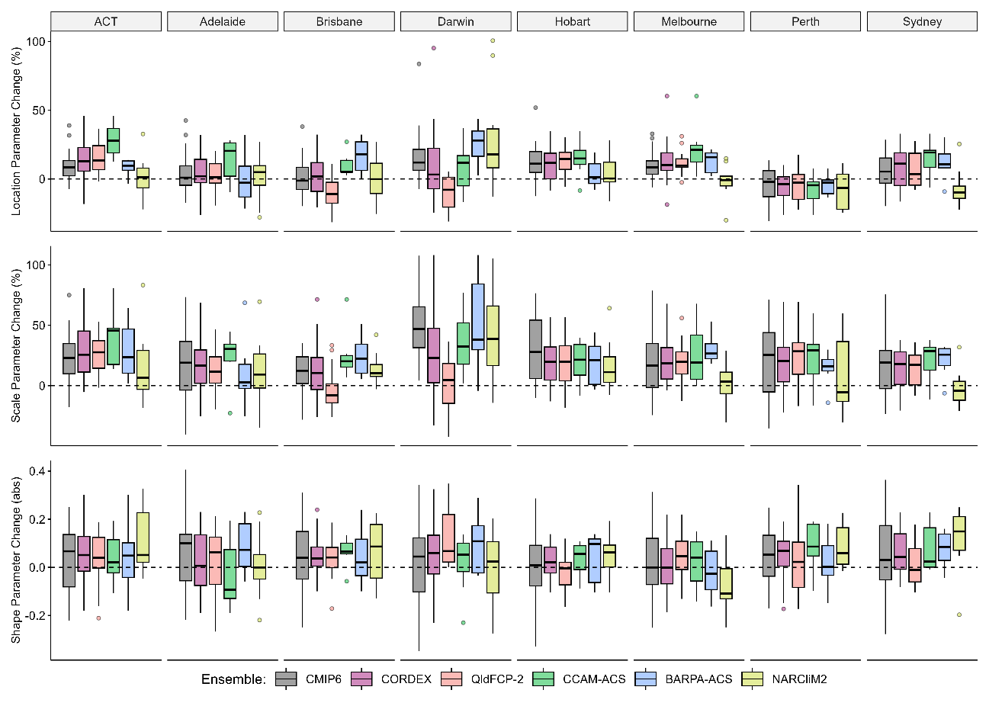
Figure S2. Changes to the location, scale, and shape parameters by the end of the century (2071-2100) compared to the reference period (1981-2010) under SSP370. Boxplots show variability in projected changes within greater capital city regions from each of the model ensembles.

Table S4. Summary of the median and range (10th to 90th percentile) of changes to mean and extreme precipitation per degree of global warming (%/K) from downscaled and host models for Australian greater capital city regions.
City | Model Type | Mean | 99th percentile | 99.7th percentile | 1 in 10 AEP | 1 in 50 AEP | 1 in 100 AEP
ACT | Downscaled | -0.7  (-5.8 - 5.7) | 1.9  (-1.8 - 6.4) | 4  (-1.4 - 8.7) | 6.5  (1 - 12.3) | 8.7  (0.5 - 16.6) | 9.3  (-0.3 - 19)
ACT | Host | -0.9  (-5.2 - 3.2) | 2.5  (-1.7 - 5.2) | 2.5  (-0.6 - 6.5) | 4.9  (0.4 - 8.4) | 6.8  (-2.2 - 12) | 8.2  (-4.1 - 15.7)
Adelaide | Downscaled | -4.5  (-11 - 2.8) | -0.4  (-6.5 - 4.8) | 2  (-4.4 - 6.7) | 3.4  (-4 - 8.3) | 4.2  (-5.1 - 12.5) | 4  (-5.9 - 15.5)
Adelaide | Host | -5  (-7.5 - 0.3) | -0.1  (-6 - 5.9) | 1.1  (-2.6 - 9.2) | 4.3  (-3.4 - 12.4) | 7  (-5.3 - 19.2) | 9  (-6.1 - 21.9)
Brisbane | Downscaled | -1.2  (-6.3 - 4.2) | -0.8  (-7.4 - 3.8) | 0.4  (-7 - 5.2) | 3.6  (-4.4 - 11) | 6.5  (-4.3 - 15.1) | 7.6  (-5 - 17.8)
Brisbane | Host | -1.6  (-6.5 - 3.3) | -0.7  (-4.4 - 4.8) | 0.7  (-3.8 - 6.6) | 2.4  (-2.2 - 8.6) | 3.6  (-4.9 - 14.4) | 3.7  (-8 - 17.2)
Darwin | Downscaled | 0.5  (-5.9 - 5.6) | 1.3  (-5.4 - 7.1) | 3.7  (-6 - 11.6) | 7.7  (-2.2 - 14.7) | 9.2  (-2.5 - 20.8) | 11.9  (-2.6 - 24.6)
Darwin | Host | -0.2  (-6.9 - 3.8) | 2.7  (-0.6 - 6.9) | 5.3  (2.8 - 10) | 8.8  (3.5 - 13.6) | 11.3  (3.5 - 19.1) | 12.2  (3.4 - 21.3)
Hobart | Downscaled | -1.8  (-5.9 - 2.6) | 0.8  (-3.9 - 4.4) | 2.7  (-2.2 - 6.4) | 3.8  (-0.3 - 10) | 5  (-2.3 - 12.7) | 5.5  (-3.6 - 14.2)
Hobart | Host | -0.5  (-2.6 - 2.7) | 3.5  (-0.8 - 6.3) | 4.1  (-0.7 - 6.9) | 4.8  (0 - 10.7) | 4.3  (0.6 - 14) | 5.1  (-0.2 - 15.3)
Melbourne | Downscaled | -2.6  (-7.3 - 2.3) | 1.8  (-2.2 - 5.8) | 3.2  (-1.5 - 6.7) | 3.8  (-1 - 10.4) | 3.6  (-3.5 - 14.6) | 3.4  (-5.9 - 16.8)
Melbourne | Host | -3.6  (-6.1 - 0.2) | 1.9  (-1.8 - 4.9) | 3.1  (-0.8 - 7) | 2.3  (-1.2 - 10.2) | 4.4  (-1.7 - 13.6) | 5  (-2.9 - 14.2)
Perth | Downscaled | -9.3  (-15.5 - -4.4) | -4.6  (-11 - -0.1) | -2.2  (-8 - 2) | 1.7  (-4.7 - 9.6) | 3.7  (-3.4 - 15.5) | 4.4  (-4.9 - 17.9)
Perth | Host | -9.4  (-12.3 - -5.2) | -4  (-8.6 - -1.5) | -0.2  (-6.4 - 2.4) | 3.6  (-5.1 - 9) | 5.7  (-5.7 - 14.5) | 6.3  (-6.3 - 18.1)
Sydney | Downscaled | 0.6  (-4.1 - 6) | -0.4  (-5.1 - 4.5) | 1.7  (-3.2 - 6.2) | 4  (-2.3 - 9.6) | 6.4  (-1.9 - 14.4) | 7.3  (-1.7 - 17)
Sydney | Host | -1.2  (-4 - 3.2) | 0.6  (-3 - 3.6) | 2.5  (-1.8 - 5.2) | 3.4  (-1.6 - 8.7) | 4.2  (-2 - 10.7) | 5.7  (-2.2 - 13.8)

