Smoking, opioids and stagnation of survival among US Whites of low education

Supplementary Appendix
Table of Contents

Extended Data Table 1. Definitions of Causes of death defined by ICD-9 and ICD-10 codes |  | 3
Extended Data Table 2. Pooled Hazard Ratios (HR) for smoking and cause-specific mortality in three prospective studies by sex, causes and education level, and reduction in the log HR with adjustment for known confounders |  | 4
Extended Data Table 3. Pooled lung cancer mortality rates (per 100,000) in three prospective studies in current and never smokers by education level and during the earlier and later periods of observation |  | 5
Extended Data Table 4. Age-adjusted* all-cause mortality rates (per 100,000) and cause-specific contribution to mortality in Whites† aged 30-64 and 65-79 by sex and education from 1989-2009 and 2010-2019 |  | 6
Exended Data Table 5. Five- and thirty-year averages of population, death, age-adjusted* mortality rates, and 15-year risks† of death by year and education for those aged 15-29, 1989-2019 |  | 7
Extended Data Table 6. Comparisons of probability of death at ages 15-79 among US Whites by education and selected other countries, 1989-93 vs. 2015-19 both sexes combined |  | 8
Extended Data Table 7. Sample characteristics of US NHIS, Canada CCHS and UK Biobank and variables used |  | 9
Extended Data Figure 1. Two-year moving average of age-standardized* all-cause mortality rates in Whites† at ages 15-29 by years of education, 1989-2023 |  | 10
Extended Data Figure 2. Two-year moving average of cause-specific age-adjusted* mortality rates for selected causes in White† men and women aged 15-29 by years of education, 1989-2019 |  | 11
Supplementary Information |  | 12-13
STROBE statement |  | 14-19
Data Sharing Statement |  | 20

Extended Data Table 1. Definitions of Causes of death defined by ICD-9 and ICD-10 codes
Causes (* are those attributable to smoking) | ICD-9 (1990-1998) |  | ICD-10 (1999-2020)
Causes (* are those attributable to smoking) | Diagnosis | External Cause of Injury | Underlying Cause | Contributing Cause
Lung Cancer* | 162 |  | C33-C34
Cancers* |  |  | C00-C97
Respiratory disease* | 034.0, 460-519 |  | J00-J99
Vascular disease* | 390-459 |  | I00-I99
Opioids | 965.00-965.02, 965.09 | E850.0-E850.2 | X40-X44, X60-X64, X85, Y10-Y14 | T40.0-T40.4, T40.6 (subset of those where underlying cause was opioid deaths)
Chronic liver disease and cirrhosis | 571 |  | K70, K73-K74
Suicide |  | E950-959 | *U03, X60-X84, Y87.0
Assault |  | E960-E978 | *U01-*U02, X85-Y09, Y87.1
Accidental falls |  | E880-E888 | W00-W19
Accidental poisoning (excluding opioids) |  | E850-E869, minus opioids | X40-49, minus opioids
Motor vehicle accidents |  | E810-E825 | V02-V04, V09.0, V09.2, V12-V14, V19.0-V19.2, V19.4-V19.6, V20-V79, V80.3-V80.5,V81.0-V81.1, V82.0-V82.1, V83-V86, V87.0-V87.8, V88.0-V88.8, V89.0, V89.2
All external causes |  | E800-E999 | V01-Y89

Extended Data Table 2. Pooled Hazard Ratios (HR) for smoking and cause-specific mortality in three prospective studies by sex, causes and education level, and reduction in the log HR with adjustment for known confounders
 |  | Men |  |  |  | Women
Cause | Education  in years | No. of death  never/  current | HRs (95% CI) |  | Log HR reduction  % | No. of death  never/  current | HRs (95% CI) |  | Log HR  reduction  %
Cause | Education  in years | No. of death  never/  current | Adjusted for age | Adjusted for age, drink and BMI |  |  | Adjusted for age | Adjusted for age, drink and BMI
Vascular disease | 0-11 | 722 / 905 | 2.59 (1.93-3.47) | 2.72 (2.09-3.53) | -5.1% | 779 / 414 | 2.90 (2.06-4.07) | 3.05 (2.33-4.00) |  | -4.7%
Vascular disease | 12 | 455 / 496 | 2.49 (2.03-3.06) | 2.55 (2.05-3.16) | -2.6% | 465 / 269 | 2.84 (2.42-3.33) | 3.10 (2.63-3.66) |  | -8.4%
Vascular disease | 13+ | 857 / 590 | 2.85 (2.43-3.33) | 2.92 (2.40-3.55) | -2.3% | 622 / 261 | 2.92 (2.40-3.55) | 3.17 (2.66-3.78) |  | -7.7%
Cancer | 0-11 | 1181 / 1432 | 3.03 (2.74-3.35) | 2.98 (2.59-3.45) | 1.5% | 2019 / 1055 | 2.90 (2.30-3.66) | 2.97 (2.35-3.74) |  | -2.2%
Cancer | 12 | 800 / 827 | 2.95 (2.30-3.79) | 2.95 (2.26-3.85) | 0.0% | 948 / 647 | 3.10 (2.49-3.87) | 3.12 (2.54-3.84) |  | -0.6%
Cancer | 13+ | 1494 / 953 | 3.22 (2.18-4.76) | 3.19 (2.15-4.73) | 0.8% | 1871 / 670 | 2.56 (2.09-3.13) | 2.58 (2.12-3.14) |  | -0.8%
Lung cancer | 0-11 | 56 / 524 | 19.79 (13.28-29.51) | 17.63 (9.57-32.50) | 3.9% | 109 / 461 | 23.77 (19.37-29.17) | 23.16 (18.84-28.47) |  | 0.8%
Lung cancer | 12 | 33 / 233 | 17.18 (12.19-24.21) | 17.04 (12.07-24.07) | 0.3% | 48 / 188 | 18.55 (13.53-25.44) | 18.63 (13.53-25.67) |  | -0.1%
Lung cancer | 13+ | 51 / 245 | 19.66 (14.53-26.61) | 19.70 (14.52-26.73) | -0.1% | 95 / 210 | 14.86 (11.57-19.09) | 13.99 (10.86-18.01) |  | 2.2%
Respiratory disease | 0-11 | 174 / 341 | 3.72 (2.20-6.29) | 3.72 (2.22-6.24) | 0.0% | 205 / 252 | 8.04 (6.64-9.72) | 7.83 (6.44-9.52) |  | 1.3%
Respiratory disease | 12 | 73 / 162 | 6.23 (4.67-8.31) | 5.85 (4.35-7.85) | 3.4% | 108 / 139 | 6.97 (4.74-10.23) | 7.17 (4.91-10.47) |  | -1.5%
Respiratory disease | 13+ | 136 / 170 | 5.56 (4.23-7.31) | 5.76 (4.03-8.24) | -2.1% | 123 / 152 | 7.82 (4.02-15.22) | 8.00 (4.37-14.63) |  | -1.1%
All causes | 0-11 | 3166 / 3624 | 2.40 (1.80-3.21) | 2.40 (1.80-3.21) | 0.0% | 4580 / 2307 | 2.75 (2.02-3.74) | 2.82 (2.13-3.74) |  | -2.5%
All causes | 12 | 2063 / 2177 | 2.48 (2.20-2.78) | 2.47 (2.20-2.78) | 0.4% | 2620 / 1529 | 2.70 (2.45-2.97) | 2.81 (2.54-3.11) |  | -4.0%
All causes | 13+ | 3813 / 2566 | 2.85 (2.30-3.55) | 2.85 (2.26-3.60) | 0.0% | 3901 / 1583 | 2.66 (2.49-2.84) | 2.76 (2.53-3.01) |  | -3.8%

Notes: *The studies included are the US National Health Interview Study (NHIS), the Canadian Community Health Survey and the UK Biobank.

Extended Data Table 3. Pooled lung cancer mortality rates (per 100,000) in three prospective studies in current and never smokers by education level and during the earlier and later periods of observation
 | Men | Lung cancer mortality rates per 100,000 by smoking status (number of deaths) |  |  |  |  |  |  | Women |  | Lung cancer mortality rates per 100,000 by smoking status (number of deaths)
Education (years) | No. of lung cancer deaths/ population | Current | Never |  |  |  |  | No. of lung cancer deaths/ population |  | Current |  | Never
Education (years) | No. of lung cancer deaths/ population |  | All | Early | Late |  |  |  |  |  |  | All | Early | Late
0-11 | 580 / 58660 | 213.1 (524) | 10.9 (56) | 13.7 (25) | 9.4 (31) |  |  |  | 570 / 89473 | 213.8 (461) |  | 11.4 (109) | 8.3 (28) | 13.1 (81)
12 | 266 / 43536 | 111.4 (233) | 8.2 (33) | 7.5 (9) | 8.5 (24) |  |  |  | 236 / 53345 | 100.8 (188) |  | 8.3 (48) | 7.9 (13) | 8.5 (35)
13+ | 296 / 91544 | 83.3 (245) | 5.1 (51) | 7.7 (22) | 4.1 (29) |  |  |  | 305 / 112082 | 81.3 (210) |  | 7.2 (95) | 7.1 (27) | 7.2 (68)
All | 1142 / 193740 | 133.8 (1002) | 7.3 (140) | 9.5 (56) | 6.3 (84) |  |  |  | 1111 / 254900 | 130.1 (859) |  | 8.8 (252) | 7.7 (68) | 9.3 (184)

Note: *The studies included are the US National Health Interview Study (NHIS), the Canadian Community Health Survey (CCHS) and the UK Biobank. The early/late periods were as follows: US NHIS: Early 1997-2001 Late: 2002-06; CCHS: Early 2001-11, Late 2012-22; UK Biobank: Early 2006-13, Late 2014-21

Extended Data Table 4. Age-adjusted* all-cause mortality rates (per 100,000) and cause-specific contribution to mortality in Whites† aged 30-64 and 65-79 by sex and education from 1989-2009 and 2010-2019
Age group | Sex | Education Level | Excess deaths in thousands |  |  | Contribution (%) to excess deaths, 1989-2019
 |  |  |  |  |  | Smoking / Opioid / Cirrhosis / External / Other
Age group | Sex | Education Level | 1989-2019 | 1989-2009 | 2010-2019 | 1989-2009 | 2010-2019
Age 30-64 | Men | 0-11 years | 495 | 273 | 221 | 52 / 3 / 3 / 11 / 30 | 52 / 7 / 3 / 13 / 25
Age 30-64 | Men | 12 years | 829 | 430 | 399 | 54 / 4 / 2 / 10 / 31 | 39 / 10 / 2 / 13 / 36
Age 30-64 | Women | 0-11 years | 291 | 161 | 130 | 47 / 4 / 2 / 10 / 38 | 41 / 7 / 3 / 10 / 38
Age 30-64 | Women | 12 years | 515 | 267 | 248 | 49 / 4 / 1 / 9 / 38 | 34 / 10 / 3 / 13 / 40
Age 65-79 | Men | 0-11 years | 849 | 545 | 304 | 60 / 0 / 1 / 2 / 38 | 55 / 0 / 1 / 3 / 41
Age 65-79 | Men | 12 years | 694 | 371 | 323 | 69 / 0 / 0 / 1 / 30 | 53 / 0 / 1 / 2 / 44
Age 65-79 | Women | 0-11 years | 720 | 461 | 259 | 68 / 0 / 1 / 1 / 30 | 64 / 0 / 1 / 2 / 33
Age 65-79 | Women | 12 years | 943 | 527 | 416 | 78 / 0 / 0 / 1 / 20 | 69 / 0 / 1 / 2 / 27

Notes: * Mortality rates adjusted to 2000 US standard population. † Non-Hispanic White. ‡ Excludes deaths caused by opioids. § Results after 2019 not graphed due to COVID.

Exended Data Table 5. Five- and thirty-year averages of population, death, age-adjusted* mortality rates, and 15-year risks† of death by year and education for those aged 15-29, 1989-2019

Group/year and level of education | Population / Death (in millions) |  |  |  | Rates* per 100,000 population |  |  |  | Risk of death 15 to 29 years |  |  |  | Absolute gap in risks
Group/year and level of education | Low  (0-11 years) | Middle (12 years) | High  (13+ years) | Low |  | Middle | High | Low |  | Middle | High | between Middle and High |  | between Low and High
Whites‡ only (67% of total population, 1989-2019)
1989-1993 | 12 / 0.01 | 15 / 0.01 | 15 / 0.01 | 122 |  | 92 | 57 | 2% |  | 1% | 1% | 1% |  | 1%
2015-2019 | 9 / 0.01 | 8 / 0.01 | 18 / 0.01 | 283 |  | 161 | 51 | 4% |  | 2% | 1% | 2% |  | 4%
2020-2023 | 8 / 0.01 | 9 / 0.02 | 17 / 0.01 | 380 |  | 164 | 47 | 6% |  | 2% | 1% | 2% |  | 5%
Non-Whites (33% of total population, 1989-2019)
1989-1993 | 7 / 0.01 | 5 / 0.01 | 4 / <0.01 | 130 |  | 124 | 77 | 2% |  | 2% | 1% | 1% |  | 1%
2015-2019 | 8 / 0.01 | 9 / 0.01 | 13 / 0.01 | 201 |  | 119 | 47 | 3% |  | 2% | 1% | 1% |  | 2%
2020-2023 | 8 / 0.01 | 10 / 0.02 | 13 / 0.01 | 362 |  | 165 | 55 | 5% |  | 2% | 1% | 2% |  | 5%
All races and ethnicities
1989-1993 | 19 / 0.02 | 20 / 0.02 | 18 / 0.01 | 125 |  | 100 | 61 | 2% |  | 1% | 1% | 1% |  | 1%
2015-2019 | 17 / 0.01 | 17 / 0.03 | 31 / 0.02 | 227 |  | 139 | 49 | 3% |  | 2% | 1% | 1% |  | 3%
2020-2023 | 16 / 0.02 | 18 / 0.03 | 30 / 0.02 | 364 |  | 164 | 51 | 5% |  | 2% | 1% | 2% |  | 5%
30-year averages (1989-2019)
Whites | 10 / 0.01 | 10 / 0.01 | 17 / 0.01 | 193 |  | 133 | 47 | 3% |  | 2% | 1% | 1% |  | 2%
Non-Whites | 8 / 0.01 | 7 / 0.01 | 8 / <0.01 | 156 |  | 128 | 53 | 2% |  | 2% | 1% | 1% |  | 2%
All | 19 / 0.02 | 16 / 0.02 | 25 / 0.01 | 167 |  | 129 | 48 | 3% |  | 2% | 1% | 1% |  | 2%

Notes: * Mortality rates adjusted to 2000 US standard population. † The 15-year smoking-attributable risk of death is 1-exp(-∑_{p} 15R_{p}/100 000), where R_{p} is the 5-year age-specific all-cause mortality rate for the 15 years (15-19, 20-24, 25-29). ‡ Non-Hispanic whites; § In 2021, the 15-year risk of death for someone aged 15-29 is 0.6% in Canada and 4% in low-income countries, calculated using population and death estimates from UN Population Division.²
Extended Data Table 6. Comparisons of probability of death at ages 15-79 among US Whites by education and selected other countries, 1989-93 vs. 2015-19 both sexes combined

Country/education) |  | 1989-93 | 2015-19 | Absolute improvement as % | Relative improvement 2015-19 vs 1989-93
US Whites by years of education | 0-11 | 44 | 74 | -30 | -69%
US Whites by years of education | 12 | 45 | 52 | -7 | -15%
US Whites by years of education | 13+ | 37 | 30 | 7 | 18%
US: all races and education groups |  | 51 | 41 | 11 | 22%
Australia |  | 51 | 29 | 22 | 43%
Austria |  | 52 | 34 | 18 | 35%
Belgium |  | 53 | 35 | 18 | 34%
Canada |  | 48 | 33 | 15 | 32%
France |  | 47 | 31 | 16 | 34%
Germany |  | 53 | 36 | 17 | 32%
Japan |  | 41 | 27 | 14 | 34%
Netherlands |  | 50 | 33 | 17 | 33%
Sweden |  | 47 | 31 | 16 | 34%
Switzerland |  | 45 | 28 | 17 | 38%
United Kingdom |  | 55 | 35 | 20 | 36%
Average of non-US countries |  | 49 | 32 | 17 | 35%
Notes: *US Whites’ probability of death is calculated as the 65-year risks of deaths using the average of age-specific mortality rates. Probability of survival of the whole of the US and non-US countries is calculated based on life tables from United Nations Population Division.² † In the high-education group in US Whites, the probability of death is comparable to that of France, Sweden, and Switzerland, and bettered only by Japan. However, the absolute improvement in probability of death is only 7 percentage points among US Whites, which is lower than the selected non-US countries.
Extended Data Table 7. Sample characteristics of US NHIS, Canada CCHS and UK Biobank and variables used
 | US NHIS | Canada CCHS | UK Biobank
Age | 30-79 | 30-79 | 40-73
Race | White (100% in this sub-study) | White (83.7%) Asian (8.4%) Black (1.9%) Other (6.0%) | White (93.3%) Asian (2.8%) Black (2.0%) Others (1.9%)
Survey years | 1997-2018 | 2000-2014 | 2006-2010
Mortality follow-up years | 1997-2019 (*lung cancer 1997-2006) | 2000-2022 | 2006-2021
No. Subject (men/women) | 83053/100091 | 27894/34991 | 125157/170028
No. Death (men/women) | 5682/6127 | 2451/2472 | 9276/7921

Variable definitions for hazard analysis
Variables | Form | Categories | Definition
age | continuous
drink | categorical (4 group) | Never / Former / infrequent and light / moderate and heavy | infrequent and light (≤3 times/week);  moderate and heavy (>3 times/week)
Body mass index (BMI) | categorical (3 group) | <25 / 25-<30 / 30+ | underweight or healthy weight (BMI < 25);  overweight but not obese (25 ≤ BMI < 30);  obese (BMI ≥ 30)

Notes: * For ICD-9 codes specifying death caused by opioids, the record may have an N code in the Diagnosis column or an E code in the External Cause of Injury column. For ICD-10 codes specifying death caused by opioids, the record need to have an Underlying Cause code and a Contributing Cause code from the ones listed in each column. Definition of opioid-related deaths based on “Using International Classification of Diseases (ICD) Codes to Assess Opioid-Related Overdose Deaths. Substance Abuse and Mental Health Services Administration; 2018.” † For hazard analysis, former smokers who quit within 5 years before death are defined as current smokers. Hazard analysis excludes former smokers, those with a history of vascular disease, cancer or respiratory disease, or those with missing causes of death, years of education, smoking status, drinking status and BMI. We excluded individuals with missing smoking status, history of chronic disease (diabetes, hypertension, vascular disease, and respiratory disease), education level, BMI and alcohol status. In these survival analyses, we censored individuals according to the date of death or the end of follow-up, whichever came first. ‡ Deceased with missing education are excluded from analysis.

Extended Data Figure 1. Two-year moving average of age-standardized* all-cause mortality rates in Whites† at ages 15-29 by years of education, 1989-2023
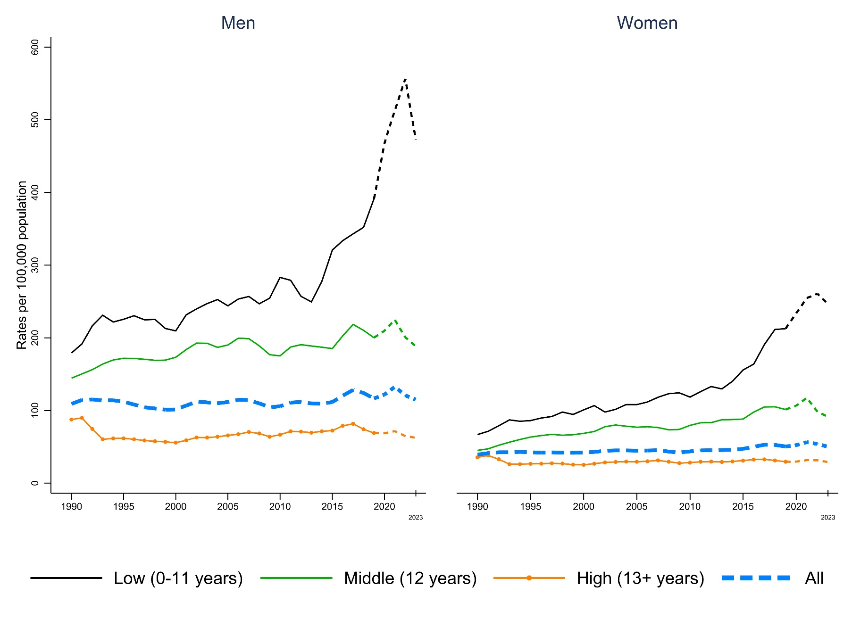
Notes: * Mortality rates adjusted to 2000 US standard population. † Non-Hispanic Whites ‡ Mortality affected by COVID-19 pandemic in dotted line. § Of 66,015,833 deaths, 1% occurred in men and 0.4% in women aged 15-29. ‖ Median age of deaths is 27 in men and the same in women. ¶ For men aged 15-29 with 0-11, 12, and 13+ years of education, the average annual rates of reduction (AARRs) are -2% (i.e. a 2% increase in mortality), -1% and -0.5%, respectively. For women in the same age group, the AARRs are -3%, -2% and -0.2%.
Extended Data Figure 2. Two-year moving average of cause-specific age-adjusted* mortality rates for selected causes in White† men and women aged 15-29 by years of education, 1989-2019
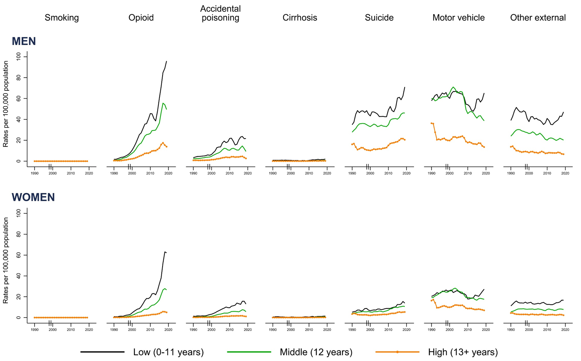
Notes: * Mortality rates adjusted to 2000 US standard population. † Non-Hispanic White. ‡ Excludes deaths caused by opioids. ‖ Change from ICD-9 to ICD-10 in 1999.

SUPPLEMENTARY INFORMATION

Opioid deaths
Either the ICD-9 diagnosis or external cause of injury codes could specify opioid deaths. In ICD-9, because both the nature of injury and external causes of injury codes encompasses the same range (nature of injury 800-999, external cause of injury E000-E999), the last digit (i.e. the 7th) of the entity codes is a 0 or 1 flag variable with 1 representing the nature of injury code. In the ICD-10, both the underlying cause and contributing cause codes were necessary to define opioid deaths.

The indirect method used for smoking-attributable deaths
The smoking impact ratio (SIR) numerator is the difference between the annual age-specific lung cancer death rates using the National Death Index¹ and the reference lung cancer death rates for nonsmokers (see main methods). The denominator is the difference between the smokers’ and nonsmokers’ reference lung cancer death rates. This difference eliminates the shared reasons among smokers and nonsmokers for developing lung cancer. Thus, the SIR represents lung cancer deaths caused solely by smoking. While it is mathematically possible for SIR to be less than zero or greater than 1, we bounded SIR between 0 and 1, with 0 representing smoking having nothing to do with the mortality and 1 representing smoking completely contributes to death in this group.

SIR = (C-N)/(S-N)
C = age-specific lung cancer death rates from NDI
S = reference smokers’ lung cancer death rates from the ACS-CPS II (Appendix. Peto et al., 1992)
N = reference nonsmokers’ lung cancer death rates from the ACS-CPS II (Appendix. Peto et al., 1992)

The excess risk of death from smoking incorporates both the SIR and the risk ratios derived from the ACS-CPS II.

Excess risk of death from smoking = [SIR(RR-1)]/2

The proportional of smoking attributable deaths directly follows from the excess risks.

Proportion of smoking attributable death (PSAD) = excess risk / (1+ excess risk)

Multiplying the PSAD with age-specific mortality rates, and we have the age-specific smoking-attributable mortality rates.
Age-specific smoking attributable death rate = age-specific death rate * PSAD

We applied the usual standardization to obtain age-standardized smoking-attributable mortality rates, using the US 2000 standard population.

Because we examine smoking-attributable mortality by education among whites, we assumed that the age- and sex-stratified death rates and ratios derived from the ACS-CPS II were applicable to US whites and the low-, middle- and high-education groups. Assuming the national-level rates and risk ratios apply to whites only may be reasonable because whites are the majority of the US population. However, the same assumption for education attainment may overestimate smoking-attributable morality in high-education groups and underestimate deaths from smoking in the middle- and low-education groups because the level of overall mortality is higher than the high-education group but lower than the middle- and low-education groups (Figure 1).

Average annual rate of reduction (AARR) for excess mortality
The AARR is calculated using AARR = 1-exp(beta), where beta is the coefficient from the linear regression with the dependent variable being the difference between logs of the current year and the base year and independent variable being log age-adjusted mortality rates.²

STROBE Statement
 | Item No. | Recommendation | Relevant text from manuscript (page no.)
Title and abstract | 1 | (a) Indicate the study’s design with a commonly used term in the title or the abstract | Smoking, opioids and stagnation of survival among US Whites of low education (1)
Title and abstract | 1 | (b) Provide in the abstract an informative and balanced summary of what was done and what was found | Adult survival among non-Hispanic Whites (“Whites”) in the United States (US) has stagnated in recent decades, particularly among Whites with lower levels of education. We examined national mortality and population data to quantify the impact of smoking-attributable diseases, opioids, and other causes on survival between ages 30 and 79 from 1989 to 2023, stratified by education levels: ≤11 years (low), 12 years (middle), and ≥13 years (high). (1)  Absolute mortality rates widened sharply between the low- and middle-education groups and the high-education group. By 2023, the probability of death at 30-79 years was 30% for high-education Whites, compared to 78% for low-education Whites, accentuated by the COVID pandemic from 2020-22. From 1989 to 2019, smoking-attributable mortality rose substantially among low-education Whites but declined in middle- and high-education groups. Opioid mortality surged across all education levels at ages 30-64, especially after 2010. Among the 5.3 million excess premature deaths observed in low- and middle-education groups from 1989 to 2019, 58% were attributable to smoking. At ages 30-64, opioids caused 4% of the excess deaths from 1989 to 2009, rising to 9% from 2010 to 2019. Smoking remains a primary driver of stagnating survival among US Whites. Public health action on smoking, opioids and other diseases is achievable. (1)
Introduction
Background/rationale | 2 | Explain the scientific background and rationale for the investigation being reported | A proper understanding of the stagnation in US adult survival requires consideration of three key features of American society. First, there are significant differences in mortality rates and trends by race. Non-Hispanic White (hereafter 'White') populations constituted approximately 80% of the US population in 1990 and 60% in 2020. This group exhibits the most stagnation in survival. By contrast, overall survival has improved among African Americans and in Hispanics (partly due to the in-migration of healthier Hispanics). Second, despite declines in smoking prevalence across all education groups and in overall smoking-attributable deaths, smoking still accounted for about one in six of all adult deaths in 2020. Third, until about 2013 a significant proportion of the population below age 65, the eligibility age for Medicare—lacked health insurance. (2)
Objectives | 3 | State specific objectives, including any prespecified hypotheses | We examine trends in overall and cause-specific mortality from 1989 to 2023 among individuals aged 30–64 and 65–79, stratified by age, sex, and education levels: ≤11 years (low), 12 years (middle), and ≥13 years (high). We also quantify excess deaths in the two lowest education groups. We assess the contribution of smoking-attributable deaths to educational differences in mortality using a well-established method that links absolute lung cancer rates to other causes of death made more common by smoking for each educational strata. Additionally, we quantify the contribution of specific conditions—opioids, accidental poisoning, cirrhosis, suicide, injuries and other external causes—to these educational differences using medically certified death data. (2-3)
Methods
Study design | 4 | Present key elements of study design early in the paper | The study included the entire US white population from 1989 to 2022. (11)
Setting | 5 | Describe the setting, locations, and relevant dates, including periods of recruitment, exposure, follow-up, and data collection | We used US national mortality data, which since 1989 capture education level of the deceased. We obtained underlying population by age, sex, and education level from the Current Population Survey (CPS). (11)
Participants | 6 | (a) Give the eligibility criteria, and the sources and methods of selection of participants. Describe methods of follow-up | We used age 80 as the upper age in our analyses as this exceeds the most recent median life expectancy in the US. (11)  We exclude 2M White decedents aged 15-79 with unknown education level between 1989 and 2022. (11)
Participants | 6 | (b) For matched studies, give matching criteria and number of exposed and unexposed | NA
Variables | 7 | Clearly define all outcomes, exposures, predictors, potential confounders, and effect modifiers. Give diagnostic criteria, if applicable | We defined our “middle-age” group as 30 to 64 years to allow sufficient time for most individuals to complete college education. We used the Medicare-eligibility age of 65 years as a lower cutoff for the elderly age group because Medicare has covered nearly all US elderly since the 1960s, and insurance coverage may alter mortality risks. (11)  We defined Whites as non-Hispanic. The death certificates indicated decedents’ years of education completed at the time of death. We examined three education levels: ≤11 years (hereafter “low-education” group), 12 years (“middle-education” group) and ≥13 years (“high-education” group). (11)  During our study period, nearly 100% of deaths were medically-certified with causes assigned according to the International Classification of Diseases (ICD) 9th (to 1998) and 10th (1999 onward) editions. (11)  Supplementary Appendix: Extended Data Table 7.
Data sources/ measurement | 8* | For each variable of interest, give sources of data and details of methods of assessment (measurement). Describe comparability of assessment methods if there is more than one group | See no. 5.  The National Death Index (NDI) includes automated methods to correct for occasional mistakes in death certification, such as confusing mode with underlying cause of death. (11)  […] using data from the US National Health Interview Survey (NHIS) linked to the NDI (1997-2004), the United Kingdom Biobank (2006-2010), and the Canadian Community Health Survey (2000-2014). (13)
Bias | 9 | Describe any efforts to address potential sources of bias | We examined whether potential confounding with smoking was greater in lower education groups and if this differed across lung and other cancers, and vascular or respiratory diseases. Using Cox-proportional hazard models, we quantified the hazard ratios (HRs) for each major disease smoker: never smoker HRs by education using data from the US National Health Interview Survey (NHIS) linked to the NDI (1997-2004), the United Kingdom Biobank (2006-2010), and the Canadian Community Health Survey (2000-2014). Use of these three prospective studies, which are broadly similar in demographic structure and smoking patterns, produces estimates which are less variable than those derived from the NHIS alone. (13)
Study size | 10 | Explain how the study size was arrived at | NA
Quantitative variables | 11 | Explain how quantitative variables were handled in the analyses. If applicable, describe which groupings were chosen and why | See no. 7.
Statistical methods | 12 | (a) Describe all statistical methods, including those used to control for confounding | The risk of death at ages 30-79 applies a uniform averaging of the age-specific rates (Rp, per 100,000 population) for the ten 5-year age groups (30-34, 35-39,…, 75-79). The risk of death between ages 30-79 years is thus 1-exp(-50 Rp/100,000). Risks are not subject to variation in the population composition of any given year. We applied comparable approaches for risks of death at ages 15-29 years. (12)  The main analyses defined excess mortality as the difference between the cumulative deaths that occurred between 1989 and 2019 in low- and middle-education groups compared to deaths that would have occurred had these groups experienced the average annual rate of reduction (AARR) in mortality of the high-education group, using an average of three annual death rates in 1989-1991 to improve statistical stability of the baseline. (12)  […]indirect methods developed by Peto and colleagues can provide estimates of smoking-attributable deaths by scaling age-specific death rates for lung cancer to various other diseases in each education stratum. (4)  Supplementary Appendix: Supplementary Information (p12-13)
Statistical methods | 12 | (b) Describe any methods used to examine subgroups and interactions | NA
Statistical methods | 12 | (c) Explain how missing data were addressed | See no. 6.
Statistical methods | 12 | (d) If applicable, explain how loss to follow-up was addressed | NA
Statistical methods | 12 | (e) Describe any sensitivity analyses | NA
Results
Participants | 13* | (a) Report numbers of individuals at each stage of study—e.g. numbers potentially eligible, examined for eligibility, confirmed eligible, included in the study, completing follow-up, and analyzed | From 1989 (when education level became available on US death certificates) to 2023, 47 million (M) deaths with known education status occurred at ages 15–79 years in the US, of which 19M occurred at ages 30–64, and 26M occurred at 65–79 years. We focus on individuals aged 30 or older, as most adults have completed their lifetime education by this age. Among the 43M who died at ages 30-79, 76%, or 34M, were White, while Whites constituted approximately two-thirds of the US population over the two decades. (3)  Of the 34M Whites aged 30–79 who died from 1989 to 2019 with known education status, 21% were in the low-education group, 45% were in the middle-education group, and 34% were in the high-education group. In comparison, among Whites aged 30 and older in the 2021 US Census, 6% of the population was in the low-education group, 27% in the middle-education group, and 67% in the high-education group. Additionally, 58% of deaths occurred in men and 42% in women. (4)
Participants | 13* | (b) Give reasons for non-participation at each stage | NA
Participants | 13* | (c) Consider use of a flow diagram | NA
Descriptive data | 14* | (a) Give characteristics of study participants (e.g. demographic, clinical, social) and information on exposures and potential confounders | Table 1,  Supplementary Appendix: Extended Data Tables 2-3
Descriptive data | 14* | (b) Indicate number of participants with missing data for each variable of interest | NA
Descriptive data | 14* | (c) Summarize follow-up time (e.g., average and total amount) | NA
Outcome data | 15* | Report numbers of outcome events or summary measures over time | Table 1
Main results | 16 | (a) Give unadjusted estimates and, if applicable, confounder-adjusted estimates and their precision (e.g., 95% confidence interval). Make clear which confounders were adjusted for and why they were included | Figures 1-5,  Supplementary Appendix: Extended Data Tables 4-5
Main results | 16 | (b) Report category boundaries when continuous variables were categorized | See no. 7.  Supplementary Appendix: Extended Data Table 7
Main results | 16 | (c) If relevant, consider translating estimates of relative risk into absolute risk | NA
Other analyses | 17 | Report other analyses done—e.g. analyses of subgroups and interactions, and sensitivity analyses | Supplementary Appendix: Extended Data Tables 2-3,  Supplementary Appendix: Extended Data Figures 1-2
Discussion
Key results | 18 | Summarize key results with reference to study objectives | The lack of progress in reducing deaths at uniform rates of progress across education groups equates to approximately 5.3M excess deaths among low- and middle-education Whites over three decades. (8)  Our analysis demonstrates that smoking (which as a strongly addictive substance will also be influenced by economic or social despair) has played a large and significantly under-estimated role in the stagnation of survival over the past three decades, accounting for approximately half of the social inequalities in mortality in the US—a proportion similar to that observed in other countries. Notably, unlike the decline in smoking-related deaths, high-education groups experienced rising mortality from opioid poisoning, cirrhosis, and external causes in middle age. Thus, the presumed protective effect of higher education may not have been sufficient to counter the mass marketing of highly potent synthetic opioids after 2010. While opioid poisoning, cirrhosis, and external causes contributed notably and similarly to the stagnation in survival at ages 30–64 during the last decade, smoking remained the dominant factor at these ages and played an even larger role in excess deaths among lower-education groups at ages 65–79. Reductions in smoking-related deaths during this period would result primarily from smoking cessation, with some additional impact from reduced uptake. (8-9)
Limitations | 19 | Discuss limitations of the study, taking into account sources of potential bias or imprecision. Discuss both direction and magnitude of any potential bias | First, the indirect method used to estimate smoking-attributable mortality requires assumptions about the relationship between absolute lung cancer rates and smoker-to-non-smoker relative risks for other diseases. We found little evidence from large prospective studies that we overestimated smoking-related mortality in lower-education groups or that the method has become biased over time, given the stability of HRs for various diseases and the mostly stable never-smoker lung cancer rates. (10)  Second, misreporting of education levels is possible, particularly in cases where individuals report completing 12 years of schooling without having actually done so. (10)  Third, there is likely misclassification of causes of death in the National Death Index, which could inflate smoking-attributable death rates for some conditions while lowering them for others, though it would not affect all-cause mortality. Similarly, our definition of opioid mortality may underestimate suicides as the underlying cause of death. We based our excess death estimates on the average annual rate of reduction in the highest-education group. (10)  Fourth, the rapid decline in the low-education population may suggest that the remaining individuals in this group today differ from those 30 years ago. However, this group may have additional determinants (such as subtle advantages in effective health insurance coverage, even among those who are insured) that are not easily generalizable to other education groups. (10)
Interpretation | 20 | Give a cautious overall interpretation of results considering objectives, limitations, multiplicity of analyses, results from similar studies, and other relevant evidence | In summary, smoking remains the primary driver of stagnated survival among White US adults, particularly in lower-education groups, while opioid-related and other external causes have increased over the past decade. Coordinated public health, fiscal, and regulatory actions could address these determinants and improve overall survival. (11)
Generalizability | 21 | Discuss the generalizability (external validity) of the study results | NA. Our results are generalizable to US whites.
Other information
Funding | 22 | Give the source of funding and the role of the funders for the present study and, if applicable, for the original study on which the present article is based | External funding is from Canadian Institutes of Health Research (FDN-154277). (10)

Data Sharing Statement

The data that support the findings of this study are openly available.

The US death records data are available in the Vital Statistics Online Data Portal at https://www.cdc.gov/nchs/data_access/vitalstatsonline.htm#Mortality_Multiple. The population data are available in the Annual Social and Economic Supplements of the Current Population Survey at https://www.census.gov/data/datasets/time-series/demo/cps/cps-asec.html. The reference death rates by causes and smoking history are available in the appendix of Peto et al. (1992) at https://doi.org/10.1016/0140-6736(92)91600-D. The risk ratios by causes and smoking history are available in Table 12.3 of the US Surgeon General’s Report (2014) at https://www.cdc.gov/tobacco/sgr/50th-anniversary/index.htm. For the results from the Cox-proportional hazard models, the National Health Interview Survey linked mortality data are available at https://www.cdc.gov/nchs/data-linkage/mortality-public.htm. Data from the Canadian Community Health Survey are available at https://www23.statcan.gc.ca/imdb/p2SV.pl?Function=getSurvey&Id=1531795. Data from the United Kingdom Biobank are available at https://www.ukbiobank.ac.uk/.

The Stata and SAS codes that support the findings of this study are available from the first author, XT, upon request.

1. National Center for Health Statistics. About the National Death Index. 2/5/2021 2021. https://www.cdc.gov/nchs/ndi/about.htm (accessed 10/17 2022).
2. Technical Note: How to calculate average annual rate of reduction (AARR) of underweight prevalence. UNICEF 2007.

