Table 1. Listing of the nine fMRI sessions involving baseline pain aggravation epochs, including the mask/plates used, the approximate locations on the face/head locations stimulated, and the effect on pain modulations (aggravation, relief, or sham). In total, 35 epochs entailed aggravating baseline pain, 18 epochs entailed partial relief, and 17 epochs had no effect on modulating pain. Light gray cells highlight a minor discrepancy in the degree of pain rating across sessions that used the same face mask, likely due to precise fitting of the mask together with head placement and padding within the MRI headcoil.
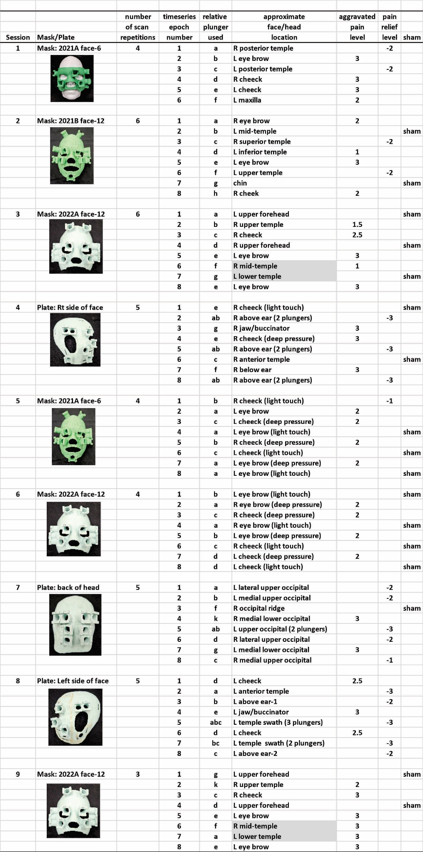
Table 2. Group activation centroids in Talairach (AFNI) coordinate space for t-test cortical ROI foci from collective fMRI datasets (corresponding with Fig. 2C-F), depicting brain regions significantly activated when aggravating baseline chronic headache pain relative to sham conditions. See text for other details.

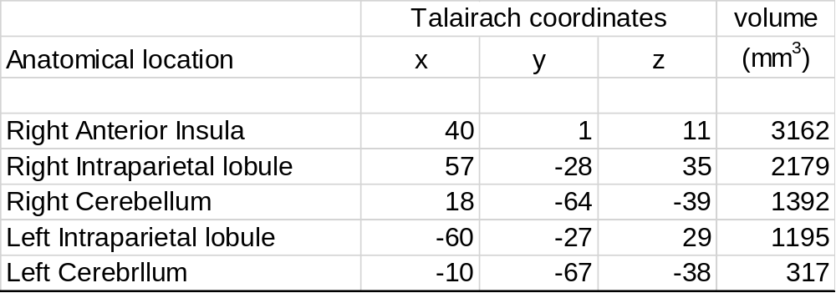

Table 4. Mean path coefficients and significance level for each connection from SVAR effective connectivity analysis of the aggravated baseline pain network plus PAG upon grouping five separate rsfMRI scanning session datasets. * = uncorrected; **p < 0.01 Bonferroni corrected. See text and corresponding Figure 4A for other details.
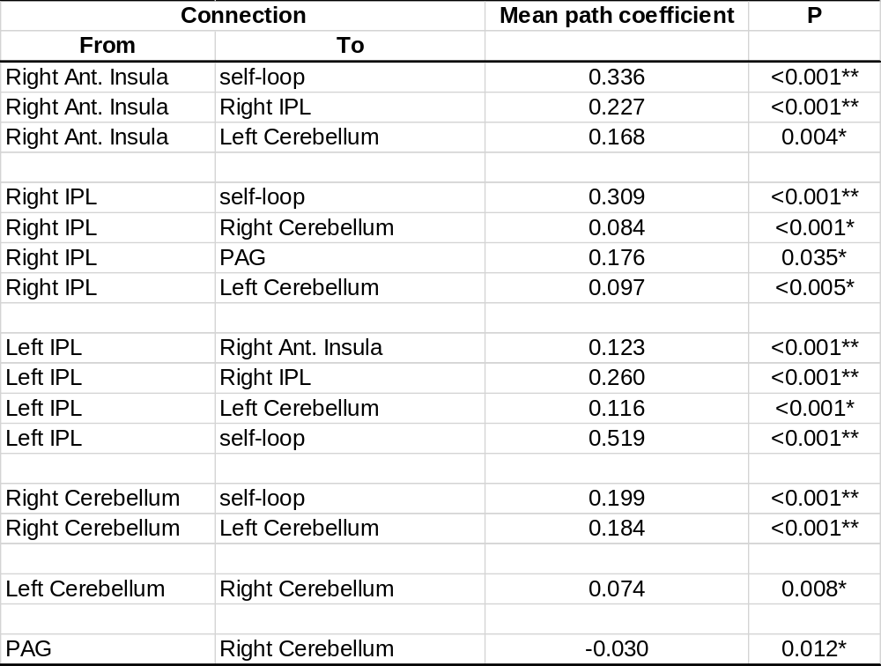

Table 5. Path coefficients and significance level for each connection from SVAR effective connectivity analysis comparing two separate rsfMRI sessions occurring on days in which the participant reported a relatively greater degree of baseline chronic headache pain. *p < 0.05, uncorrected; **p < 0.03 Bonferroni corrected. Refer to text and corresponding Figure 4B for other details.

