Supplementary material for
Inhibition of Rac1 attenuated propofol-induced neurotoxicity in the hippocampal dentate gyrus in developing mice
Yuan Li^{a,b†}, Haifeng Duan^{c†}, Qi Wangª, Yi Linª, Zhoujing Yangª, Zhiru Wang^{d}, Yingwei Wangª, Kai Wei^{a*}, Daojie Xu^{a*}
ªDepartment of Anesthesiology, Huashan Hospital, Fudan University, Shanghai, China.
^{b}Department of Anesthesiology, Renmin Hospital, Wuhan University, Hubei, China.
^{c}Department of Anesthesiology, Zhongnan Hospital, Wuhan University, Hubei, China.
^{d}Key Laboratory of Brain Functional Genomics-Ministry of Education, School of Life Science, East China Normal University, Shanghai, China
†These authors share first authorship
*Corresponding author:
Kai Wei
Address: Department of Anesthesiology, Huashan Hospital, Fudan University, Shanghai 200040, China. Tel.: 159-2734-5535. E-mail address: wei-kai-cool@163.com. ORCID ID: 0000-0001-9207-5138
Daojie Xu
Address: Department of Anesthesiology, Huashan Hospital, Fudan University, Shanghai 200040, China. Tel.: 159-0178-7886. E-mail address: xudaojie@fudan.edu.cn. ORCID ID: 0009-0007-4341-9062

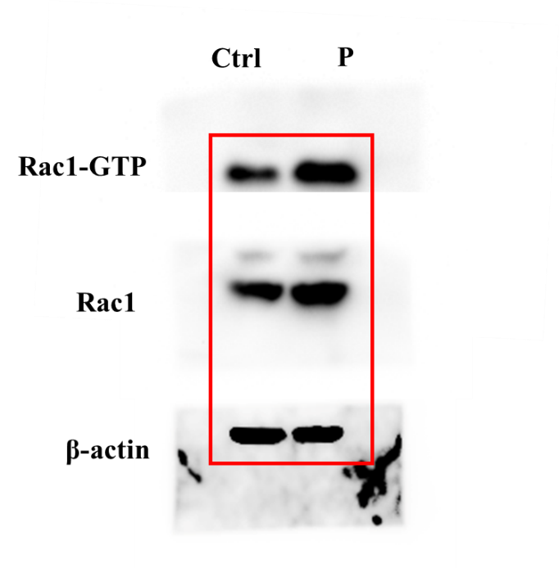

Figure S1. Full and unprocessed western blot images corresponding to Figure 3A, the square refers to the blots cited in the main article.
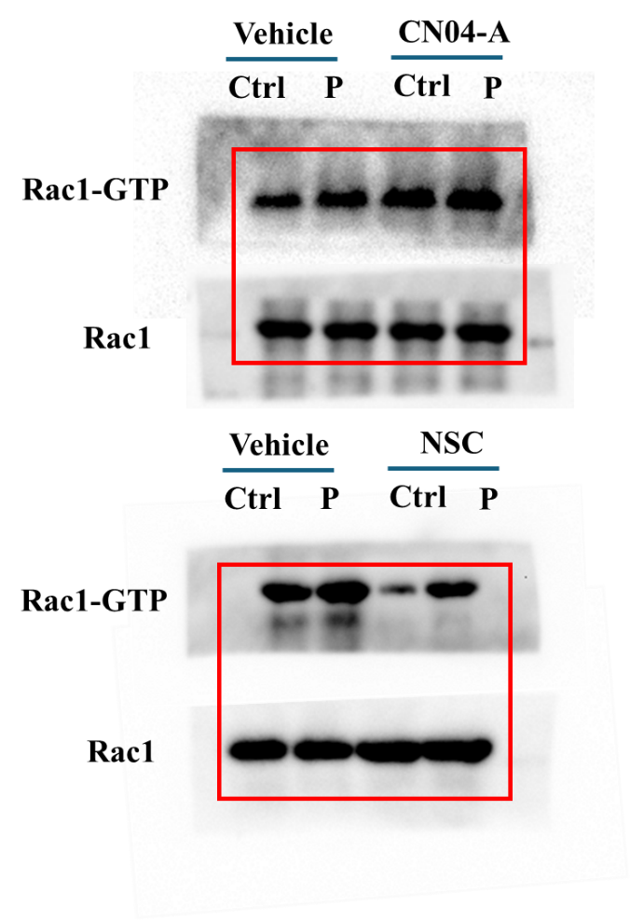

Figure S2. Full and unprocessed western blot images corresponding to Figure 4 A, C, the square refers to the blots cited in the main article.

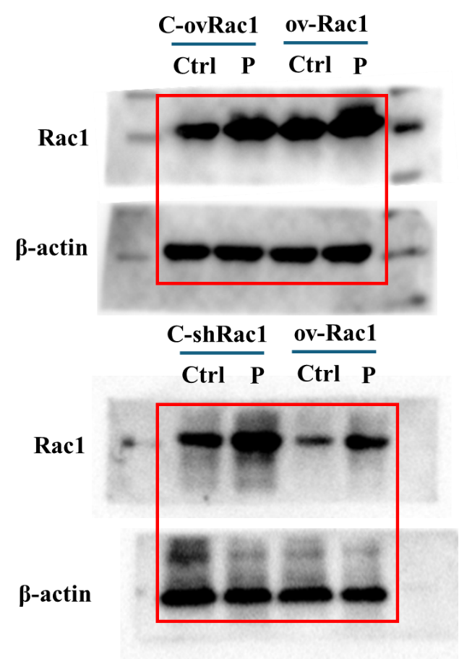

Figure S3. Full and unprocessed western blot images corresponding to Figure 5 A, C, the square refers to the blots cited in the main article.
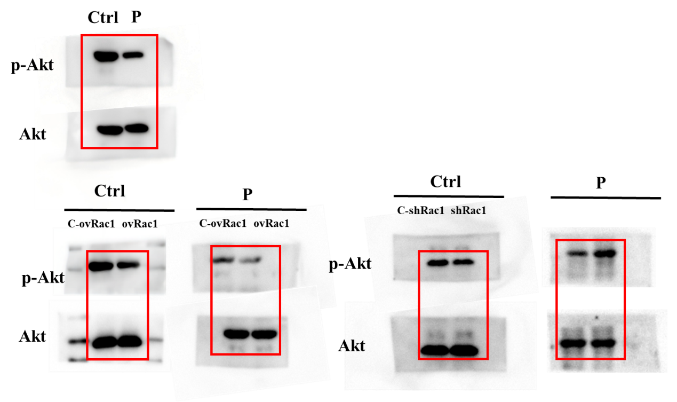

Figure S4. Full and unprocessed western blot images corresponding to Figure 7A, C, F. the square refers to the blots cited in the main article.

