Title of Manuscript
One-step electrodeposition prepared MoS₂ composed Ni₃S₂/Ni(OH)₂ nanosheets as high efficient and stable metal sulfide catalyst for hydrogen precipitation in alkaline solutions
Corresponding Author and Cu-authors:
Shunming Li^{a,1} ， Pengyu Huª，Jingzong Quª，Jie Zhou^{a,b}，Zibo Wangª，Yanan Wangª，Tao Sun^{a,}*，Anran Chen^{a,}*
^{a.} International Joint Research Center of China for Optoelectronic and Energy Materials, School of Materials and Energy, Yunnan University, Kunming, Yunnan 650091, China
^{b.} Ningbo Institute of Materials Technology and Engineering, Chinese Academy of Sciences, Ningbo 315201, China;
*Correspondence: Tao Sun: taosun8805@163.com, Anran Chen: 20170027@ynu.edu.cn

Synopsis Figure:

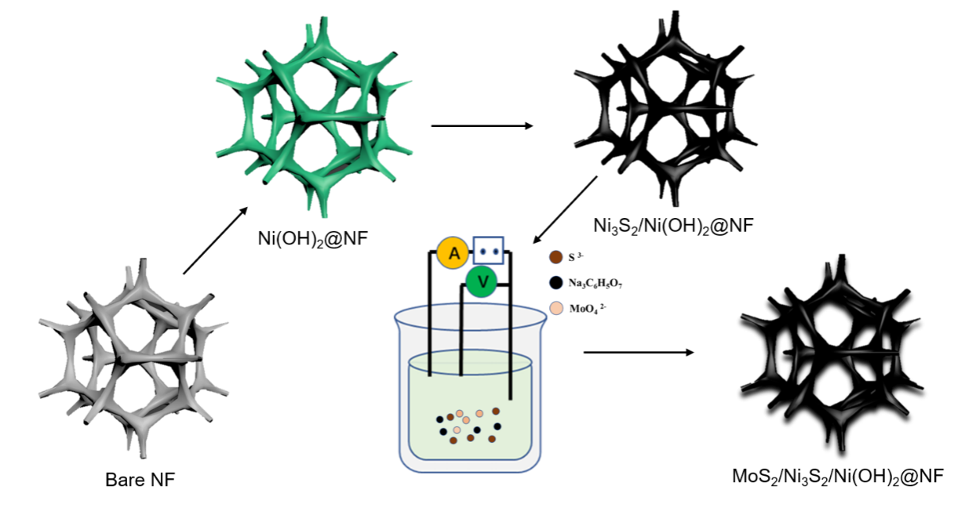
Figure 1 Schematic diagram of MoS₂/Ni₃S₂/ Ni (OH)₂@NF preparation

