Supplementary materials:
Figure 1s: Manual measurement of the anastomotic tensile strength and breaking point.
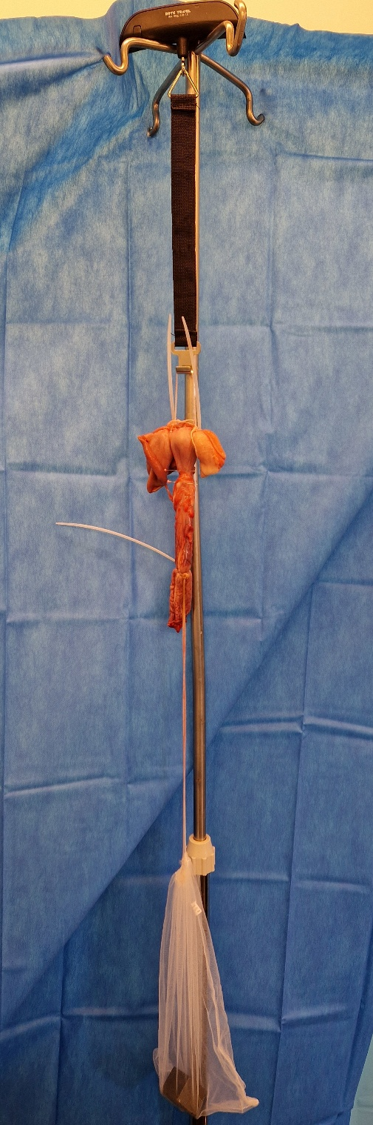
The anastomosis was mounted in a vertical position, the gastric segment at the top and the jejunal segment at the bottom. A net was mounted on to the jejunal segment of the anastomosis. Weights were progressively added to the net in order to increase the stretching force on the anastomosis, starting with a weight of 500g (4.9 N). The anastomotic tensile strength was tested by progressively applying traction force by adding 50g (0.45 N) every two minutes until rupture of the anastomotic tissue.

Figure 2s : Efron’s enhanced bootstrap method with 80 random replication

 | DTOG | WEST
Percent frequency IC 95% | [0.1818 ;0.6818] | [0.3182 ; 0.8182]
Bias | -0.0023 | 0.0023

Figure 3s: Image of the two LAMS impact each other after the LAMS-in-LAMS technique without interposition tissue
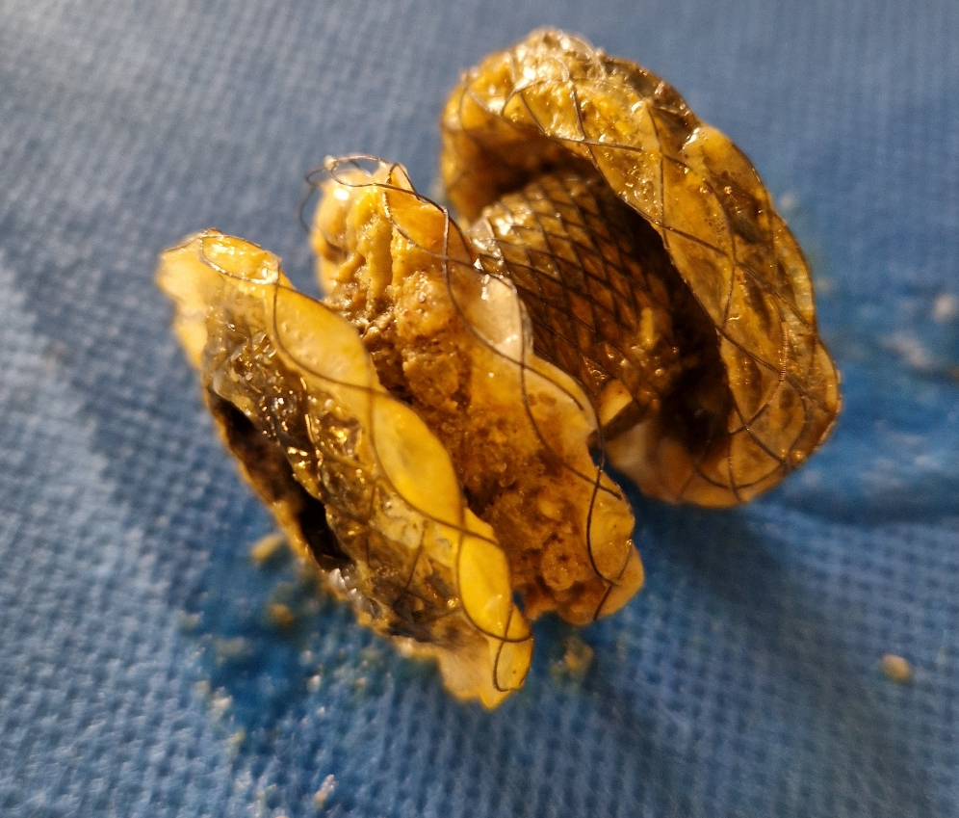
Figure 4s: Microscopic view after Hematoxylin Eosin stain of the gastro-jejunal anastomosis. (+: jejunal tissue , *: gastric tissue , &: fibrotic tissue)
