Supplementary Materials
Supplementary Methods
Inclusion and exclusion criteria
To be included in the study, participants had to be between 15 and 40 years old with sufficient language skills for participation and had to have the capacity to give their informed consent. Exclusion criteria were the following: an IQ below 70, current or past head trauma with loss of consciousness (> 5 minutes), current or past known neurological or somatic disorders that could potentially affect structure or functioning of the brain, current or past alcohol dependence, polysubstance dependence within the past 6 month or medical indications against MRI. Recent-onset depression (ROD) and Recent-onset psychosis (ROP) criteria were assessed by the structured clinical interview for DSM-IV disorders (SCID) (1). ROP patients were included if they had a psychotic episode according to the DSM-IV-TR (Diagnostic and Statistical Manual of Mental Disorders, Text Revision) criteria for a lifetime affective and nonaffective psychotic episode within the past 3 months. In accordance with that ROD patients had to fulfill the DSM-IV-TR criteria for a lifetime major depressive episode within the past 3 months. For both groups the onset of the disease had to be within the last 24 months. Furthermore, ROD as well as ROP subjects were excluded if they were on an antipsychotic medication for longer than 90 days or above the minimum dosage of the first-episode psychosis range of DGPPN S3 Guidelines (2). To be included in the clinical high-risk for psychosis (CHR-P) group, participants either needed to fulfill ultra-high-risk criteria, which were assessed by the Structured Interview for Psychosis-Risk Syndromes (3) or the cognitive disturbances (COGDIS) criteria, assessed by the Schizophrenia Proneness Instrument (SPI-A) (4); in addition to the antipsychotic medication related exclusion criterion described above, an antipsychotic medication for more than 30 days (cumulative number of days) at or above the same minimum dosage range let to exclusion.
Additional exclusion criteria for healthy controls (HC) were Current or past DSM-IV-TR Axis-I disorder (not including nicotine dependency); CHR-P criteria positive (life time); Intake of psychopharmacological substances or illegal drugs for more than 5 days per year and/or during the past month prior examination; Affective or non-affective psychosis or major affective disorder (Major Depressive Disorder, Bipolar Disorder) of 1° relatives* (defined by treatment or diagnosis), if not due to a secondary medical condition.
Cognitive Domain Calculation
We calculated five cognitive domains similar to the MATRICS Consensus Cognitive Battery (MCCB) (5,6) and a global cognition score based on individual scores of the cognitive tests that were assessed. For the social cognition domain we calculated the scaled sum of the correctly identified emotions in the Diagnostic Analysis of Non-Verbal Accuracy (7) test. Working memory was calculated as the scaled average of the correct trials in the backward and forward digit span test (subtest of the Wechsler Adult Intelligence Scale) (8). For the speed of processing domain the scaled number of correctly named words in the semantic verbal fluency task (9) was subtracted from the scaled execution time of the Trail Making Test A (10) and the scaled number of correct digit-symbol substitutions (digit-symbol substitution task) (8) was added. This was then divided by three. We calculated attention as the scaled difference between number of correct answers and the number of errors in the continuous performance test - identical pairs (11). For the verbal learning score the scaled sum of trial 1 to 5 of the Rey Auditory Verbal Learning Task (12) was calculated. Global cognition was calculated as the average of the scaled values across the five domains. Scaling was performed over all subjects including HC. We corrected for confounding effects of age, sex, site and years of education as done before (13). Regression models based on HC were built for every cognition domain using age, sex, site and years of education as predictors. These models were then applied to the patient data and residuals were used for further analysis.

MRI preprocessing
For preprocessing the Statistical Parametric Mapping software (SPM, version 12-6685; http://www.fil.ion.ucl.ac.uk/spm) and the Resting State fMRI data analysis Toolkit (REST, version 1.8; http://www.restfmri.net/) were used. The first 8 volumes were discarded, and images were slice-time corrected and realigned to the first volume. The functional maps were co-registered to the T1-weighted images, resliced, and normalized to the common Montreal Neurological Institute space. Furthermore, white matter, cerebrospinal fluid and the Friston 24 motion parameters, comprising translation and rotation in three directions, temporal derivatives and their quadratic terms (14), were regressed out as covariates. Finally, Smoothing was applied, motion was corrected using time series de-spiking, and scans were detrended. For our analysis participants with a mean framewise displacement over 0.50 mm for more than 38.5% of volumes were excluded.
Correction for site differences via ComBat
ComBat is a procedure originally developed for correcting batch effects in gene expression data, using an empirical bayesian framework. Recently, ComBat has been successfully used to account for potentially confounding site-effects in MRI data in over 50 studies (15). We used Munich as a reference site, as it was the site with the highest number of study participants. While correcting for site effects, ComBat allows for specification of variables whose variance should be preserved. To ensure that differences due to biological variation are maintained, we chose to preserve the variance in age and sex. We trained ComBat on HC subjects and the derived estimates were then applied to the patient data using the implementation neuroHarmonize (16).
Supplementary Tables
Supplementary Table 1
Neuroimaging acquisition parameters for the structural MRI data across the different PRONIA sites. Adapted with minimal modifications from Koutsouleris et al. (2018) (3)/ Buciuman et al. (2023) (17)
Site | Scanner model | Field strength | Flip Angle | Coil Channels | Voxel size (mm) | TR (ms) | TE (ms) | FOV (mm) | Slices
Munich | Philips Ingenia | 3T | 8 | 32 | 0.97 x 0.97 x 1 | 9.5 | 5.5 | 250 x 250 | 190
Milan | Philips Achieva Intera | 1.5T | 12 | 8 | 0.93 x 0.93 x 1 | Shortest (8.1) | Shortest (3.7) | 240 x 240 | 170
Cologne | Philips Achieva | 3T | 8 | 8 | 0.97 x 0.97 x 1 | 9.5 | 5.5 | 250 x 250 | 190
Basel | SIEMENS Verio | 3T | 8 | 12 | 1 x 1 x 1 | 2000 | 3.4 | 256 x 256 | 176
Birming-ham | Philips Achieva | 3T | 8 | 32 | 1 x 1 x 1 | 8.4 | 3.8 | 288 x 287 | 175
Udine | Philips Achieva | 3T | 12 | 8 | 0.93 x 0.93 x 1 | Shortest (8.1) | Shortest (3.7) | 240 x 240 | 170
Münster | SIEMENS Prisma fit | 3T | 8 | 12 | 1 x 1 x 1 | 2130 | 2.3 | 256 x 256 | 192
Turku | Philips Ingenuity | 3T | 7 | 32 | 1 x 1 x 1 | 8.1 | 3.7 | 256 x 256 | 176
Note. TR = repetition time; TE = echo time; FOV = field of view.
Supplementary Table 2
Neuroimaging acquisition parameters for the resting-state functional MRI data across the different PRONIA sites. Adapted with minimal modifications from Buciuman et al. (2023)
Site | Scanner model | Field strength | Flip Angle | Coil Channels | Voxel size (mm) | TE (ms) | FOV (mm) | Slices | Slice order
Munich | Philips Ingenia | 3T | 90 | 32 | 2.88 x 2.88 x 3 | 30 | 230 x 230 | 53 | Ascending
Milan | Philips Achieva Intera | 1.5T | 90 | 8 | 3 x 3 x 3 | 32 | 240 x 240 | 45 | Interleaved
Cologne | Philips Achieva | 3T | 90 | 8 | 2.88 x 2.88 x 3 | 30 | 230 x 230 | 53 | Ascending
Basel | SIEMENS Verio | 3T | 82 | 12 | 2.98 x 2.98 x 3 | 28 | 256 x 256 | 34 | Interleaved
Birming-ham | Philips Achieva | 3T | 85 | 32 | 3 x 3 x 3 | 34.5 | 240 x 240 | 52 | Interleaved
Udine | Philips Achieva | 3T | 90 | 8 | 3 x 3 x 3 | 32 | 240 x 240 | 45 | Interleaved
Münster | SIEMENS Prisma fit | 3T | 90 | 12 | 3 x 3 x 3 | 26 | 256 x 256 | 51 | Interleaved
Turku | Philips Ingenuity | 3T | 90 | 32 | 3 x 3 x 3 | 30 | 240 x 240 | 53 | Interleaved
Note. TR = repetition time; TE = echo time; FOV = field of view.

Supplementary Table 3
Receptors included in receptor expression analysis
Neurotransmitter system | receptors
acetylcholine | VAChT, (18–20), M1 (21), a4b2 (22)
dopamine | D2 (23–27), DAT (28,29), D1 (30)
cannabinoid | CB1 (31,32)
opioid | KOR (33), MOR (34,35)
glutamate | mGlur5 (20,36,37) , NMDA (20)
serotonin | 5Ht1a (38,39), 5Ht1b (38–40), 5HTT (38,39,41), 5Ht2a (38,39), 5Ht6 (42), 5Ht4 (39)
GABA | GABAa (28,43), GABAa alpha 5 subunit (44)
norepinephrene | NET (45,46)
histamine | H3 (47)

Supplementary Figures
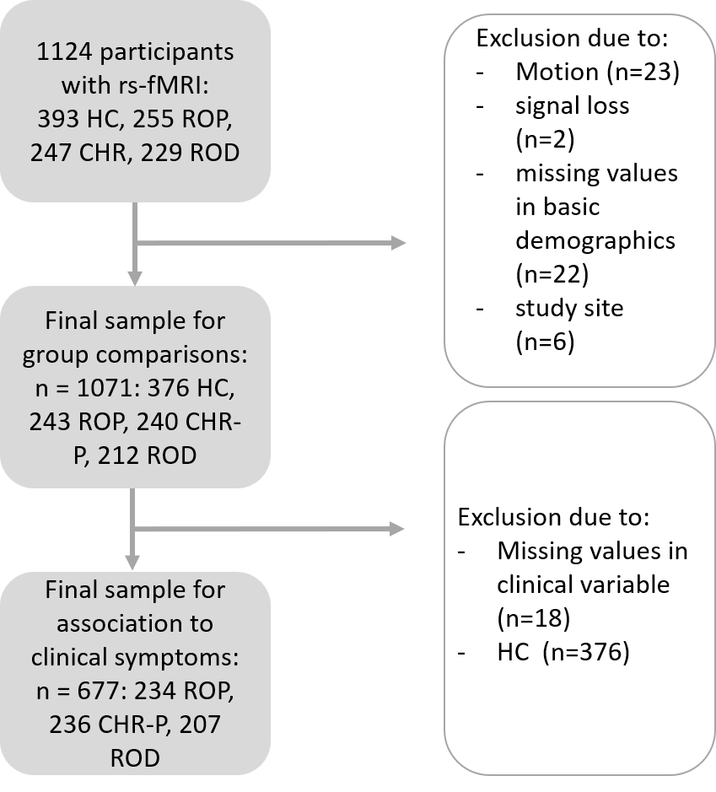
Supplementary Figure 1. Flow chart of exclusion of cases.

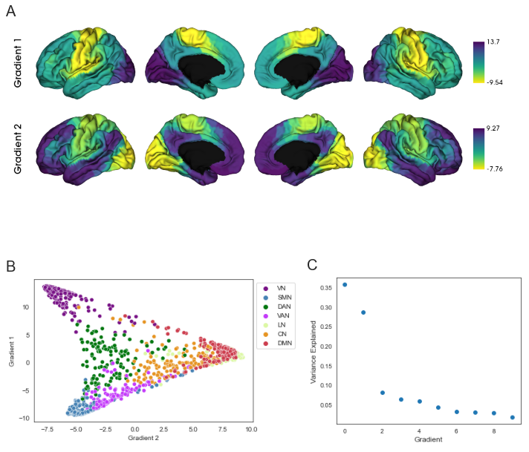
Supplementary Figure 2. Reference gradients derived from mean FC healthy subjects. (A) Spatial topography of first and second gradient. (B) Gradient scores in the two-dimensional gradient space. (C) Variance explained by gradients. VN = visual network; SMN = somatomotor network; DAN = dorsal attention network; VAN = salience ventral attention network; LN = limbic network; CN = control network; DMN = default mode network.

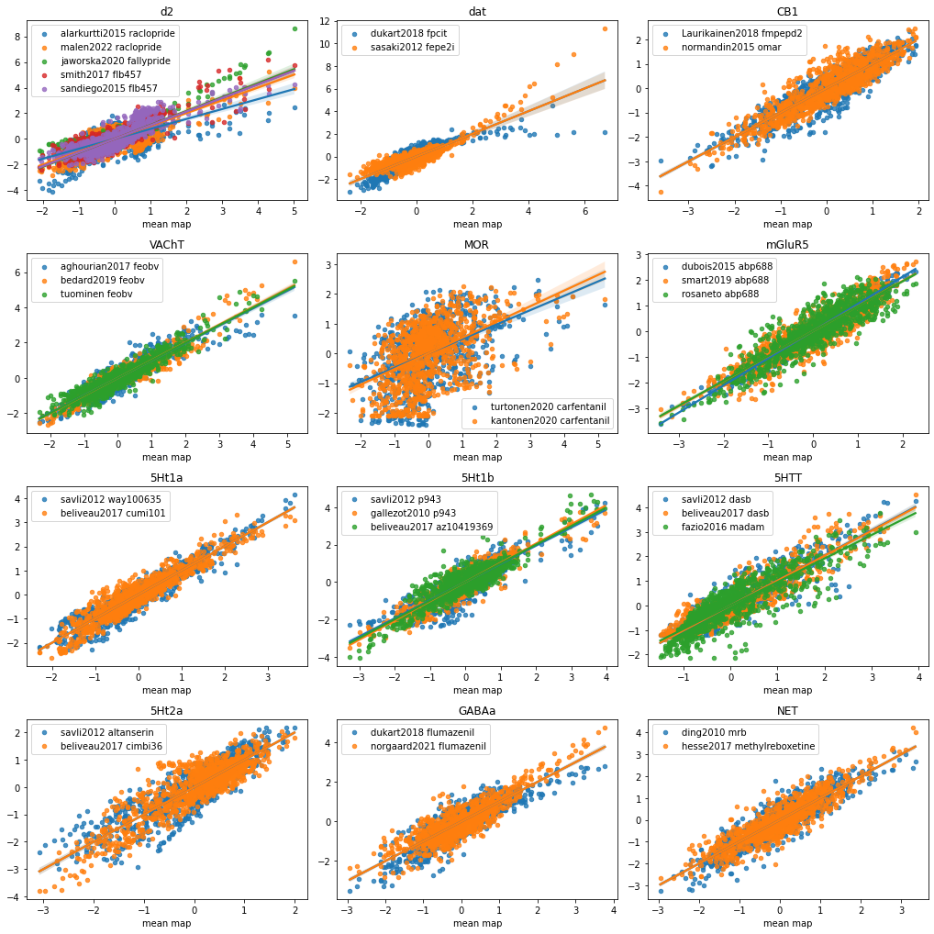
Supplementary Figure 3. Correlations of mean receptor maps with single datasets. Maps of the same neurotransmitter were averaged into a single mean neurotransmitter map. Each map is highly correlated with the mean map. Names indicate the dataset and the used tracer.

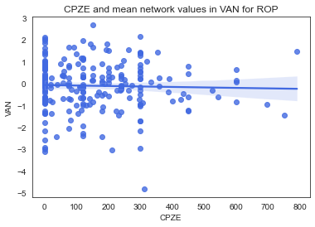
Supplementary Figure 4. Correlation of CPZE and mean VAN values for ROP. r = -.04, p = .581; 7 patients were excluded for this analysis because of depot medication.

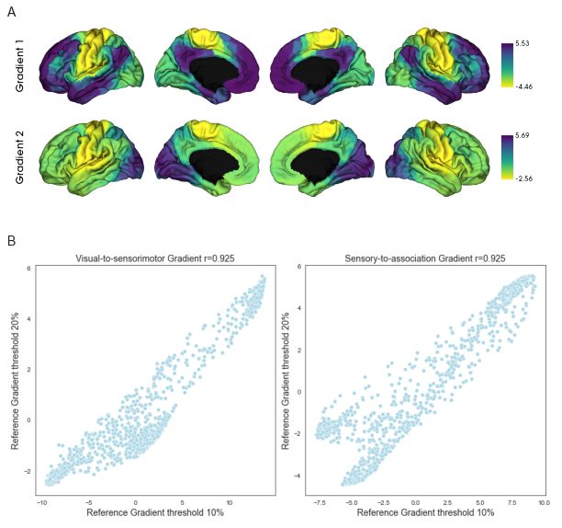
Supplementary Figure 5. Similarity of reference gradients with different thresholds. (A) Spatial topography of first and second gradient computed with a threshold of retaining the 20% strongest connections of the functional connectivity matrix before computing the affinity matrix. (B) Correlations of gradients with 10% and 20% thresholds. Reference gradients computed with the 20% threshold are switched in their order, but visual-to-sensorimotor gradients and sensory-to-association gradients show a high correspondence.

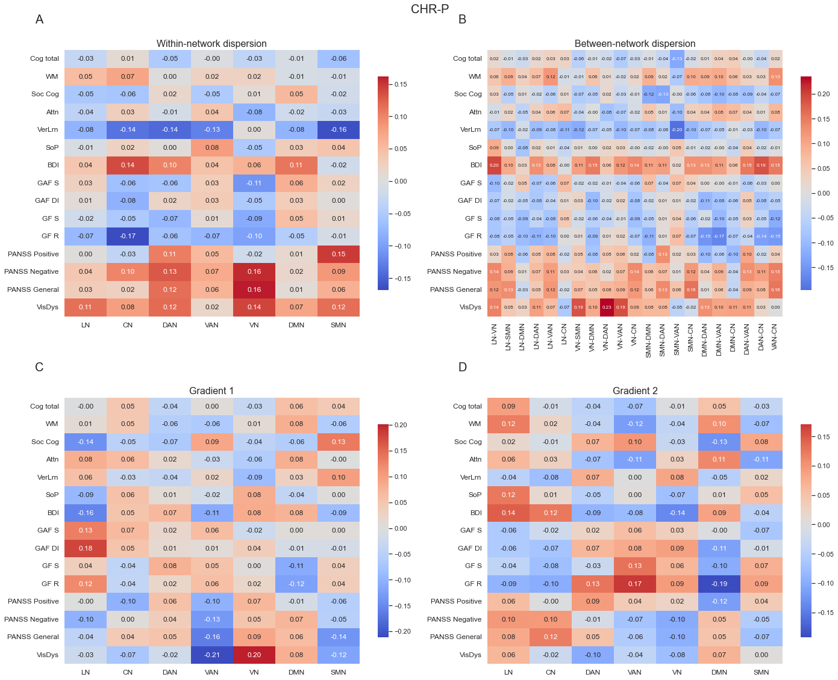
Supplementary Figure 6. Association of clinical variables with gradient measures for CHR-P patients. Asterisks indicate significant correlations after FDR-correction; * p_{FDR} < .05. (A) Correlations of within-network dispersion with clinical variables. (B) Correlations of between-network dispersion with clinical variables. (C) Correlations of mean-network values of gradient 1 with clinical variables. (D) Correlations of mean-network values of gradient 2 with clinical variables. Attn = attention; BDI = Becks Depression Inventory; CN = control network; Cog total = cognition total score; DAN = dorsal attention network; DMN = default-mode network; GAF DI = Global Assessment of Functioning Disability; GAF S = Global Assessment of Functioning Symptoms; GF R = Global Functioning Role Scale; GF S = Global Functioning Social Scale; LN = limbic network; Soc Cog = social cognition; SoP = speed of processing; SMN = somatomotor network; VAN = ventral attention network; VerLrn = verbal learning; VisDys = visual dysfunctions; VN = visual network; WM = working memory.

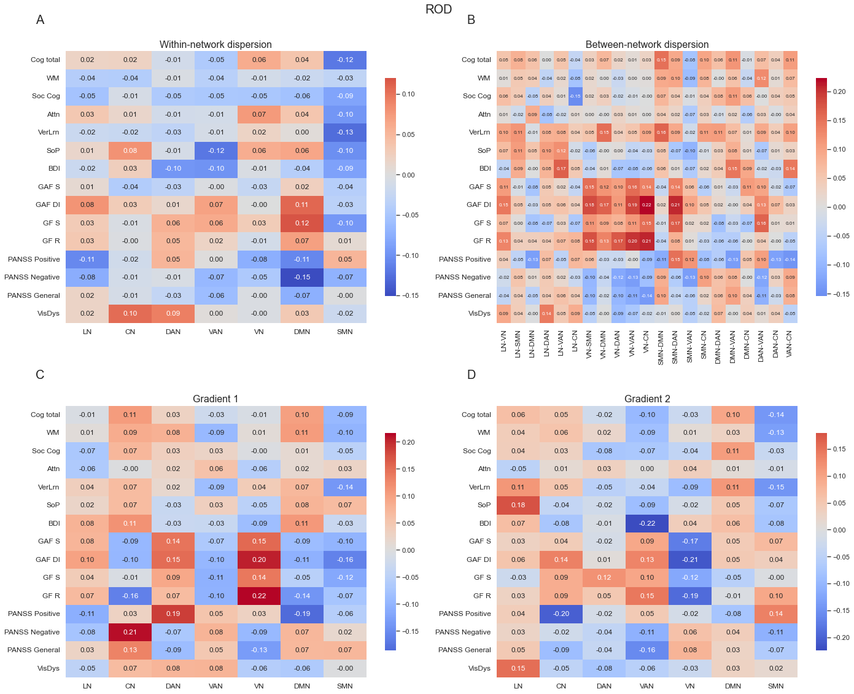
Supplementary Figure 7. Association of clinical variables with gradient measures for ROD patients. Asterisks indicate significant correlations after FDR-correction; * p_{FDR} < .05. (A) Correlations of within-network dispersion with clinical variables. (B) Correlations of between-network dispersion with clinical variables. (C) Correlations of mean-network values of gradient 1 with clinical variables. (D) Correlations of mean-network values of gradient 2 with clinical variables. Attn = attention; BDI = Becks Depression Inventory; CN = control network; Cog total = cognition total score; DAN = dorsal attention network; DMN = default-mode network; GAF DI = Global Assessment of Functioning Disability; GAF S = Global Assessment of Functioning Symptoms; GF R = Global Functioning Role Scale; GF S = Global Functioning Social Scale; LN = limbic network; Soc Cog = social cognition; SoP = speed of processing; SMN = somatomotor network; VAN = ventral attention network; VerLrn = verbal learning; VisDys = visual dysfunctions; VN = visual network; WM = working memory.

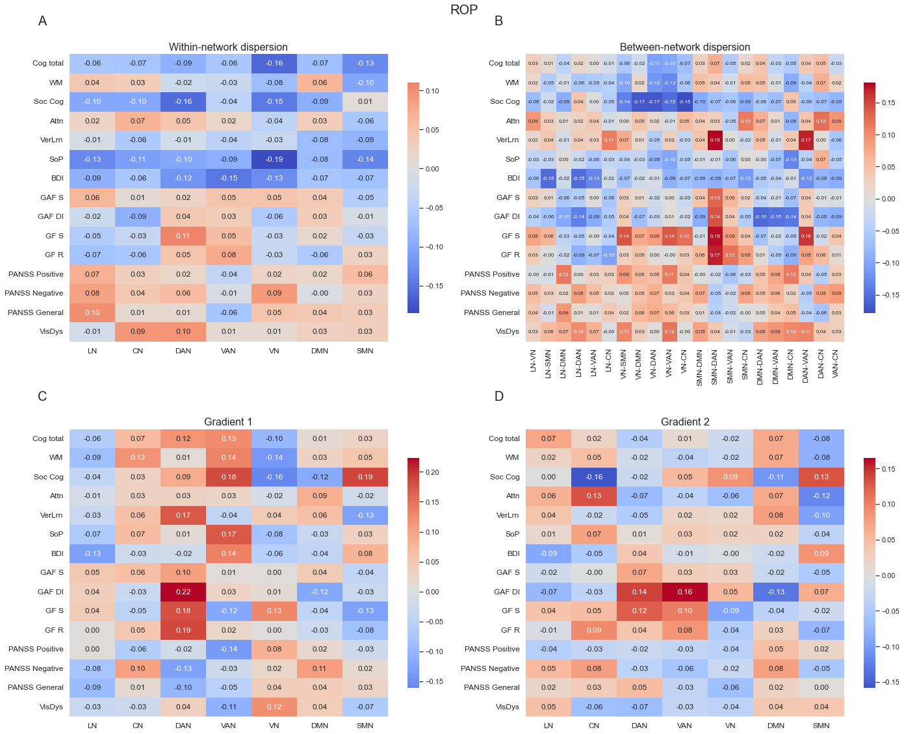
Supplementary Figure 8. Association of clinical variables with gradient measures for ROP patients. Asterisks indicate significant correlations after FDR-correction; * p_{FDR} < .05. (A) Correlations of within-network dispersion with clinical variables. (B) Correlations of between-network dispersion with clinical variables. (C) Correlations of mean-network values of gradient 1 with clinical variables. (D) Correlations of mean-network values of gradient 2 with clinical variables. Attn = attention; BDI = Becks Depression Inventory; CN = control network; Cog total = cognition total score; DAN = dorsal attention network; DMN = default-mode network; GAF DI = Global Assessment of Functioning Disability; GAF S = Global Assessment of Functioning Symptoms; GF R = Global Functioning Role Scale; GF S = Global Functioning Social Scale; LN = limbic network; Soc Cog = social cognition; SoP = speed of processing; SMN = somatomotor network; VAN = ventral attention network; VerLrn = verbal learning; VisDys = visual dysfunctions; VN = visual network; WM = working memory.

References
1. First MB, Gibbon M. The Structured Clinical Interview for DSM-IV Axis I Disorders (SCID-I) and the Structured Clinical Interview for DSM-IV Axis II Disorders (SCID-II). In: Comprehensive handbook of psychological assessment, Vol 2: Personality assessment. Hoboken, NJ, US: John Wiley & Sons, Inc.; 2004. p. 134–43.
2. http://www.dgppn.de/fileadmin/user_upload/_medien/download/pdf/kurzversion-leitlinien/s3-praxisleitlinienbd1-schizophrenie.pdf [Internet]. [cited 2013 Dec 4]. Available from: http://www.dgppn.de/fileadmin/user_upload/_medien/download/pdf/kurzversion-leitlinien/s3-praxisleitlinienbd1-schizophrenie.pdf
3. McGlashan TH, Miller TJ, Woods SW, Hoffman RE, Davidson L. Instrument for the Assessment of Prodromal Symptoms and States. In: Miller T, Mednick SA, McGlashan TH, Libiger J, Johannessen JO, editors. Early Intervention in Psychotic Disorders [Internet]. Dordrecht: Springer Netherlands; 2001 [cited 2024 Apr 4]. p. 135–49. Available from: http://link.springer.com/10.1007/978-94-010-0892-1_7
4. Schultze-Lutter F, Addington J, Ruhrmann S, Klosterkötter J. Schizophrenia proneness instrument, adult version (SPI-A). Rome Giovanni Fioriti. 2007;
5. Kern RS, Nuechterlein KH, Green MF, Baade LE, Fenton WS, Gold JM, et al. The MATRICS Consensus Cognitive Battery, Part 2: Co-Norming and Standardization. Am J Psychiatry. 2008 Feb;165(2):214–20.
6. Nuechterlein KH, Green MF, Kern RS, Baade LE, Barch DM, Cohen JD, et al. The MATRICS Consensus Cognitive Battery, Part 1: Test Selection, Reliability, and Validity. Am J Psychiatry. 2008 Feb;165(2):203–13.
7. Nowicki S, Duke MP. Individual differences in the nonverbal communication of affect: The diagnostic analysis of nonverbal accuracy scale. J Nonverbal Behav. 1994 Mar;18(1):9–35.
8. Wechsler D. Manual for the Wechsler Adult Intelligence Scale. Oxford, England: Psychological Corp.; 1955. vi, 110 p. (Manual for the Wechsler Adult Intelligence Scale.).
9. Ruff R. Benton controlled oral word association test: Reliability and updated norms. Arch Clin Neuropsychol. 1996;11(4):329–38.
10. Tombaugh T. Trail Making Test A and B: Normative data stratified by age and education. Arch Clin Neuropsychol. 2004 Mar;19(2):203–14.
11. Eliason MJ, Richman LC. The Continuous Performance Test in Learning Disabled and Nondisabled Children. J Learn Disabil. 1987 Dec;20(10):614–9.
12. Schmidt M. Rey auditory verbal learning test. Western Psychological Services Los Angeles; 1996.
13. Wenzel J, Haas SS, Dwyer DB, Ruef A, Oeztuerk OF, Antonucci LA, et al. Cognitive subtypes in recent onset psychosis: distinct neurobiological fingerprints? Neuropsychopharmacology. 2021 Jul;46(8):1475–83.
14. Satterthwaite TD, Elliott MA, Gerraty RT, Ruparel K, Loughead J, Calkins ME, et al. An improved framework for confound regression and filtering for control of motion artifact in the preprocessing of resting-state functional connectivity data. NeuroImage. 2013 Jan;64:240–56.
15. Bayer JMM, Thompson PM, Ching CRK, Liu M, Chen A, Panzenhagen AC, et al. Site effects how-to and when: An overview of retrospective techniques to accommodate site effects in multi-site neuroimaging analyses. Front Neurol. 2022 Oct 31;13:923988.
16. Pomponio R, Erus G, Habes M, Doshi J, Srinivasan D, Mamourian E, et al. Harmonization of large MRI datasets for the analysis of brain imaging patterns throughout the lifespan. NeuroImage. 2020 Mar;208:116450.
17. Buciuman MO, Oeztuerk OF, Popovic D, Enrico P, Ruef A, Bieler N, et al. Structural and Functional Brain Patterns Predict Formal Thought Disorder’s Severity and Its Persistence in Recent-Onset Psychosis: Results From the PRONIA Study. Biol Psychiatry Cogn Neurosci Neuroimaging. 2023 Dec;8(12):1207–17.
18. Aghourian M, Legault-Denis C, Soucy JP, Rosa-Neto P, Gauthier S, Kostikov A, et al. Quantification of brain cholinergic denervation in Alzheimer’s disease using PET imaging with [18F]-FEOBV. Mol Psychiatry. 2017 Nov;22(11):1531–8.
19. Bedard MA, Aghourian M, Legault-Denis C, Postuma RB, Soucy JP, Gagnon JF, et al. Brain cholinergic alterations in idiopathic REM sleep behaviour disorder: a PET imaging study with 18F-FEOBV. Sleep Med. 2019 Jun;58:35–41.
20. Hansen JY, Shafiei G, Markello RD, Smart K, Cox SML, Nørgaard M, et al. Mapping neurotransmitter systems to the structural and functional organization of the human neocortex. Nat Neurosci. 2022 Nov;25(11):1569–81.
21. Naganawa M, Nabulsi N, Henry S, Matuskey D, Lin SF, Slieker L, et al. First-in-Human Assessment of¹¹ C-LSN3172176, an M1 Muscarinic Acetylcholine Receptor PET Radiotracer. J Nucl Med. 2021 Apr;62(4):553–60.
22. Hillmer AT, Esterlis I, Gallezot JD, Bois F, Zheng MQ, Nabulsi N, et al. Imaging of cerebral α4β2* nicotinic acetylcholine receptors with (−)-[18F]Flubatine PET: Implementation of bolus plus constant infusion and sensitivity to acetylcholine in human brain. NeuroImage. 2016 Nov;141:71–80.
23. Malén T, Karjalainen T, Isojärvi J, Vehtari A, Bürkner PC, Putkinen V, et al. Atlas of type 2 dopamine receptors in the human brain: Age and sex dependent variability in a large PET cohort. NeuroImage. 2022 Jul;255:119149.
24. Sandiego CM, Gallezot JD, Lim K, Ropchan J, Lin S fei, Gao H, et al. Reference Region Modeling Approaches for Amphetamine Challenge Studies with [¹¹ C]FLB 457 and PET. J Cereb Blood Flow Metab. 2015 Apr;35(4):623–9.
25. Smith CT, Crawford JL, Dang LC, Seaman KL, San Juan MD, Vijay A, et al. Partial-volume correction increases estimated dopamine D2-like receptor binding potential and reduces adult age differences. J Cereb Blood Flow Metab. 2019 May;39(5):822–33.
26. Jaworska N, Cox SML, Tippler M, Castellanos-Ryan N, Benkelfat C, Parent S, et al. Extra-striatal D2/3 receptor availability in youth at risk for addiction. Neuropsychopharmacology. 2020 Aug;45(9):1498–505.
27. Alakurtti K, Johansson JJ, Joutsa J, Laine M, Bäckman L, Nyberg L, et al. Long-Term Test–Retest Reliability of Striatal and Extrastriatal Dopamine D_{2/3} Receptor Binding: Study with [¹¹ C]Raclopride and High-Resolution PET. J Cereb Blood Flow Metab. 2015 Jul;35(7):1199–205.
28. Dukart J, Holiga Š, Chatham C, Hawkins P, Forsyth A, McMillan R, et al. Cerebral blood flow predicts differential neurotransmitter activity. Sci Rep. 2018 Mar 6;8(1):4074.
29. Sasaki T, Ito H, Kimura Y, Arakawa R, Takano H, Seki C, et al. Quantification of Dopamine Transporter in Human Brain Using PET with¹⁸ F-FE-PE2I. J Nucl Med. 2012 Jul;53(7):1065–73.
30. Kaller S, Rullmann M, Patt M, Becker GA, Luthardt J, Girbardt J, et al. Test–retest measurements of dopamine D1-type receptors using simultaneous PET/MRI imaging. Eur J Nucl Med Mol Imaging. 2017 Jun;44(6):1025–32.
31. Laurikainen H, Tuominen L, Tikka M, Merisaari H, Armio RL, Sormunen E, et al. Sex difference in brain CB1 receptor availability in man. NeuroImage. 2019 Jan;184:834–42.
32. Normandin MD, Zheng MQ, Lin KS, Mason NS, Lin SF, Ropchan J, et al. Imaging the Cannabinoid CB1 Receptor in Humans with [¹¹ C] OMAR: Assessment of Kinetic Analysis Methods, Test–Retest Reproducibility, and Gender Differences. J Cereb Blood Flow Metab. 2015 Aug;35(8):1313–22.
33. Vijay A, Cavallo D, Goldberg A, De Laat B, Nabulsi N, Huang Y, et al. PET imaging reveals lower kappa opioid receptor availability in alcoholics but no effect of age. Neuropsychopharmacology. 2018 Dec;43(13):2539–47.
34. Kantonen T, Karjalainen T, Isojärvi J, Nuutila P, Tuisku J, Rinne J, et al. Interindividual variability and lateralization of μ-opioid receptors in the human brain. NeuroImage. 2020 Aug;217:116922.
35. Turtonen O, Saarinen A, Nummenmaa L, Tuominen L, Tikka M, Armio RL, et al. Adult Attachment System Links With Brain Mu Opioid Receptor Availability In Vivo. Biol Psychiatry Cogn Neurosci Neuroimaging. 2021 Mar;6(3):360–9.
36. DuBois JM, Rousset OG, Rowley J, Porras-Betancourt M, Reader AJ, Labbe A, et al. Characterization of age/sex and the regional distribution of mGluR5 availability in the healthy human brain measured by high-resolution [11C]ABP688 PET. Eur J Nucl Med Mol Imaging. 2016 Jan;43(1):152–62.
37. Smart K, Cox SML, Scala SG, Tippler M, Jaworska N, Boivin M, et al. Sex differences in [11C]ABP688 binding: a positron emission tomography study of mGlu5 receptors. Eur J Nucl Med Mol Imaging. 2019 May;46(5):1179–83.
38. Savli M, Bauer A, Mitterhauser M, Ding YS, Hahn A, Kroll T, et al. Normative database of the serotonergic system in healthy subjects using multi-tracer PET. NeuroImage. 2012 Oct;63(1):447–59.
39. Beliveau V, Ganz M, Feng L, Ozenne B, Højgaard L, Fisher PM, et al. A High-Resolution In Vivo Atlas of the Human Brain’s Serotonin System. J Neurosci. 2017 Jan 4;37(1):120–8.
40. Gallezot JD, Nabulsi N, Neumeister A, Planeta-Wilson B, Williams WA, Singhal T, et al. Kinetic Modeling of the Serotonin 5-HT_{1B} Receptor Radioligand [¹¹ C]P943 in Humans. J Cereb Blood Flow Metab. 2010 Jan;30(1):196–210.
41. Fazio P, Schain M, Varnäs K, Halldin C, Farde L, Varrone A. Mapping the distribution of serotonin transporter in the human brainstem with high-resolution PET: Validation using postmortem autoradiography data. NeuroImage. 2016 Jun;133:313–20.
42. Radhakrishnan R, Nabulsi N, Gaiser E, Gallezot JD, Henry S, Planeta B, et al. Age-Related Change in 5-HT₆ Receptor Availability in Healthy Male Volunteers Measured with¹¹ C-GSK215083 PET. J Nucl Med. 2018 Sep;59(9):1445–50.
43. Nørgaard M, Beliveau V, Ganz M, Svarer C, Pinborg LH, Keller SH, et al. A high-resolution in vivo atlas of the human brain’s benzodiazepine binding site of GABAA receptors. NeuroImage. 2021 May;232:117878.
44. Lukow PB, Martins D, Veronese M, Vernon AC, McGuire P, Turkheimer FE, et al. Cellular and molecular signatures of in vivo imaging measures of GABAergic neurotransmission in the human brain. Commun Biol. 2022 Apr 19;5(1):372.
45. Hesse S, Becker GA, Rullmann M, Bresch A, Luthardt J, Hankir MK, et al. Central noradrenaline transporter availability in highly obese, non-depressed individuals. Eur J Nucl Med Mol Imaging. 2017 Jun;44(6):1056–64.
46. Ding YS, Singhal T, Planeta-Wilson B, Gallezot JD, Nabulsi N, Labaree D, et al. PET imaging of the effects of age and cocaine on the norepinephrine transporter in the human brain using (S,S)-[¹¹ C]O-methylreboxetine and HRRT. Synapse. 2010 Jan;64(1):30–8.
47. Gallezot JD, Planeta B, Nabulsi N, Palumbo D, Li X, Liu J, et al. Determination of receptor occupancy in the presence of mass dose: [¹¹ C]GSK189254 PET imaging of histamine H₃ receptor occupancy by PF-03654746. J Cereb Blood Flow Metab. 2017 Mar;37(3):1095–107.

