Graphical Abstract

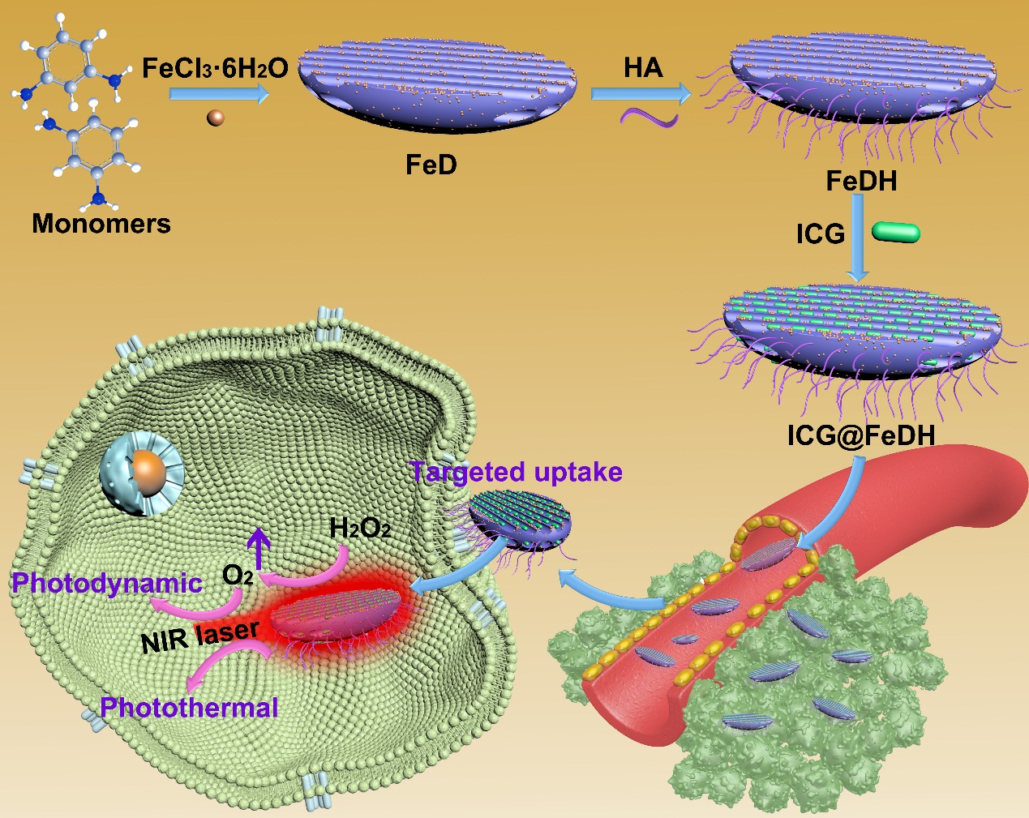
The preparation of organic polymer-based nanoagent for targeted and oxygen-evolved combinational phototherapy of tumor.

