Hyaluronic acid modified covalent organic polymers for efficient targeted and oxygen-evolved phototherapy
Fangpeng Shu^{1#}, Taowei Yang^{2#}, Xuefeng Zhang⁴, Wenbin Chen², Kaihui Wu², Junqi Luo², Xumin Zhou², Guochang Liu³*, Jianming Lu²*, Xiangming Mao²*.

¹ Department of Urology, Guangzhou Women and Children's Medical Center, Guangzhou Medical University, and Department of Urology, Zhujiang Hospital of Southern Medical University, Guangzhou, China.
² Department of Urology, Zhujiang Hospital of Southern Medical University, Guangzhou, China.
³ Department of Urology, Guangzhou Women and Children's Medical Center, Guangzhou Medical University, Guangzhou, China.
⁴ Department of Urology, First Affiliated Hospital of Soochow University, 899 Pinghai Road, Suzhou, 215031, China

# These authors contribute equally to this work.

Corresponding author: Prof. Xiangming Mao (mxm631221@126.com)
Prof. Jiangming Lu (Louiscfc8@gmail.com)
Prof. Guochang Liu (starbless2003@126.com)

Calculation of photothermal conversion efficiency
The photothermal conversion efficiency is calculated according to previously reported method^{1,2}:
$\sum_{i}{m_{i}C_{i}\frac{dT}{dt}}=Q_{NC}+Q_{sys}-Q_{out}$ (1)
Where m and C are the mass and heat capacity of water, respectively, T is the solution temperature, Q_{NC} is the energy absorbed by ICG@FeDH and ICG@FeD, Q_{sys} is the energy imputed by the pure water system, and Q_{out} is heat dissipation of the system.
The heat absorbed (Q_{NC}) by ICG@FeDH and ICG@FeD can be shown as:
$Q_{NC}=I(1-10^{-A_{808}})η$ (2)
Where I is incident laser power in W, is the photothermal conversion efficiency, and A₈₀₈ indicates the absorbance of the ICG@FeDH and ICG@FeD at 808 nm.
Q_{out} is linear with system temperature, as expressed as:
$Q_{out}=hS(T-T_{surr})$ (3)
Where h is heat transfer coefficient, S is the surface area of the container, and T_{surr} is ambient temperature of the surroundings.
When the system reaches a steady state temperature (T_{max}), the heat input and output are balanced:
$Q_{NC}+Q_{sys}=Q_{out}=hS(T_{max}-T_{suur})$ (4)
After the laser is removed, the Q_{NC} + Q_{sys} = 0, reducing the Eq. (1)
$\sum_{i}{m_{i}}C_{i}\frac{dT}{dt}=-Q_{out}=-hS(T-T_{surr})$ (5)
Rearranging the Eq. (5) would give
$dt=-\frac{\sum_{i}{m_{i}C_{i}}}{hS}\frac{dT}{(T-T_{surr})}$ (6)
And integrating, give the expression
$t=-\frac{\sum_{i}{m_{i}C_{i}}}{hS}\ln{\frac{T-T_{surr}}{(T_{max}-T_{suur})}}$ (7)
A system time constant τ_{s} is defined as:
$τ_{s}=-\frac{\sum_{i}{m_{i}C_{i}}}{hS}$ (8)
And θ is introduced using the maximum system temperature, T_{max}
$θ=\frac{T-T_{surr}}{(T_{max}-T_{suur})}$ (9)
Substituting Eq. (8) and (9) giving:
$t=-τ_{s}\ln{θ}$ (10)
Therefore, the time constant for heat transfer from the system τ_{s} can be determined by applying the linear time data from the cooling period vs. negative natural logarithm of driving force temperature (θ)
Since Q_{sys} can be obtained directly as
$Q_{sys}=hS(T_{max,{H_{2}}O}-T_{surr})$ (11)
Eq. (4) can be given as:
$Q_{NC}=I(1-10^{-A_{808}})η=hS(T_{max}-T_{max,{H_{2}}O})$ (12)
Also
$hS=-\frac{\sum_{i}{m_{i}C_{i}}}{τ_{s}}$ (13)
Finally, for ICG@FeDH, the τ_{s} is determined to be 335.17 s. m is 0.5 g and C is 4.2 J/g, hS can be calculated to be -0.006265 W/ºC. Substituting I = 1.0 W/cm², A₈₀₈ = 0.483, respectively, and T_{max} - T_{surr} = 44.2 - 23=21.2 ºC into Eq. (12), the photothermal conversion efficiency can be determined to be 19.7%.
Finally, for ICG@FeDH, the τ_{s} of ICG@FeDH is determined to be 335.42 s. m is 0.5 g and C is 4.2 J/g, hS can be calculated to be -0.006261 W/ºC. Substituting I = 1.0 W/cm², A₈₀₈ = 0.476, and T_{max} - T_{surr} = 43.2 – 22.5=20.7 ºC into Eq. (12), the photothermal conversion efficiency can be determined to be 19.5%.

References
[1] D. K. Roper, W. Ahn and M. Hoepfner, J. Phys. Chem. C, 2007, 111, 3636-3641.
[2] X. W. Wang, X. Y. Zhong, H. L. Lei, Y. H. Geng, Q. Zhao, F. Gong, Z. J. Yang, Z. L. Dong, Z. Liu and L. Cheng, Chem. Mater. 2019, 31, 6174-6186.

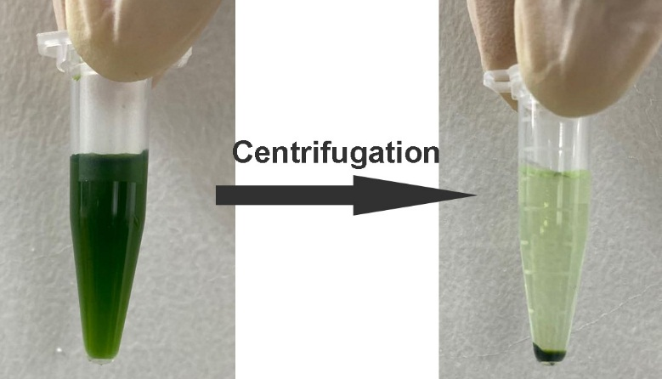
Figure S1. The photographs of ICG@FeDH dispersion (left) before and (right) after high-speed centrifugation. The loaded ICG is precipitated together with FeDH and no obvious green color can be observed in supernatant solution, indicating the efficient loading of ICG.

Figure S2. Size distribution of ICG@FeDH measured by DLS. The size distribution of ICG@FeDH shows no abnormal change in comparison to bare FeDH, implying that the loading of ICG would not affect the colloidal stability of FeDH.

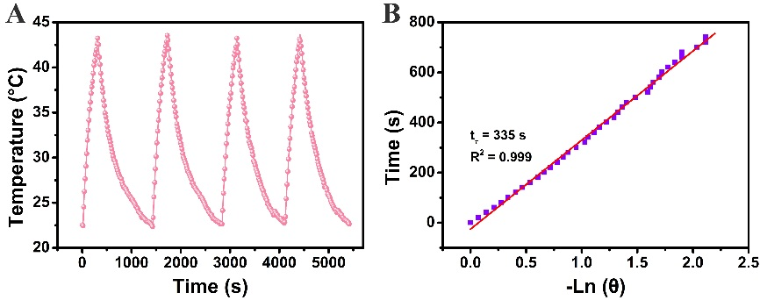
Figure S3. (A) Temperature change of ICG@FeD dispersions exposed to photothermal heating and natural cooling cycles under 808 nm laser irradiation. (B) Measurement of photothermal conversion efficiency of ICG@FeD at 808 nm.

Figure S4. The fluorescence intensity changes of SOSG at 525 nm with increasing irradiation time.

Figure S5. Quantification of HIF-α expression in tumor slices from different groups. **P<0.01.

