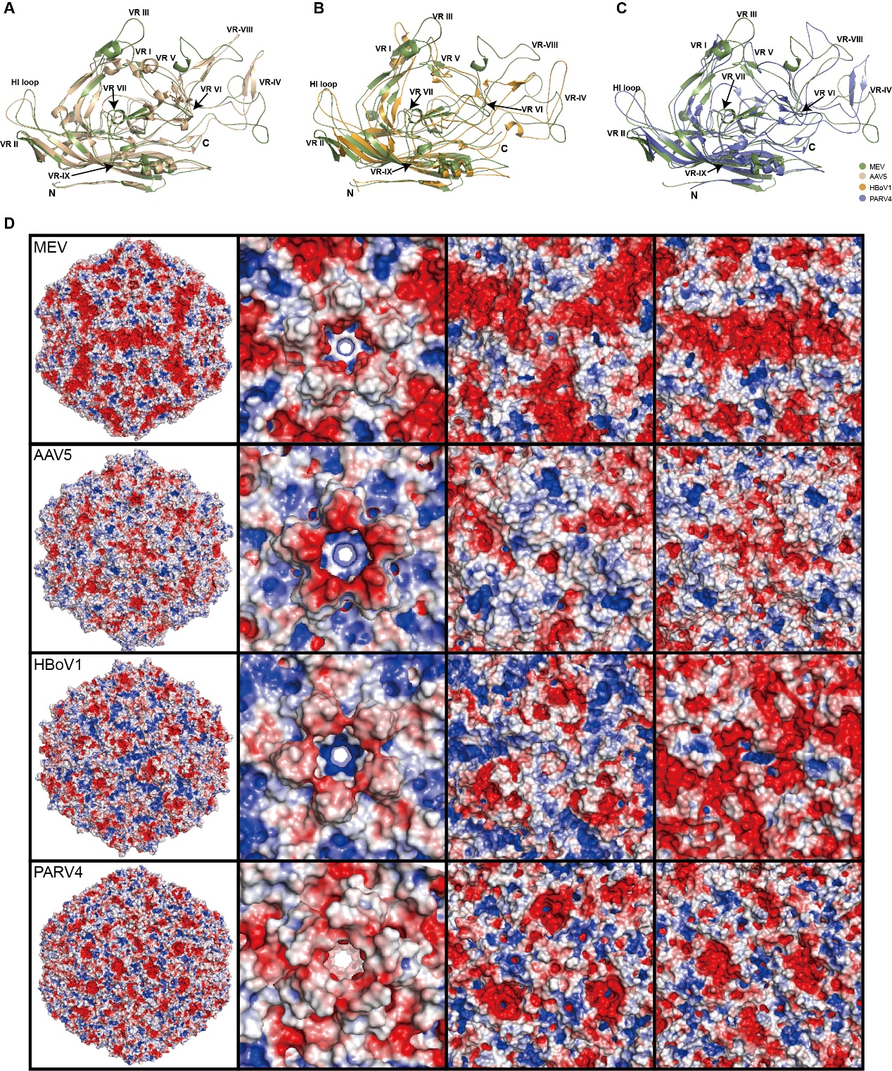
Figure S1 Structural comparison of MEV and other Parvovirinae members. (A) Superposition of MEV and AAV5 capsid structures, highlighting the variable region, N-terminus, and C-terminus. (B) Superposition of MEV and HBoV1 capsid structures. (C) Superposition of MEV and PARV4 capsid structures. (D) Comparison of surface electrostatic potentials among MEV, AAV5, HBoV1, and PARV4.

