Supplementary Information

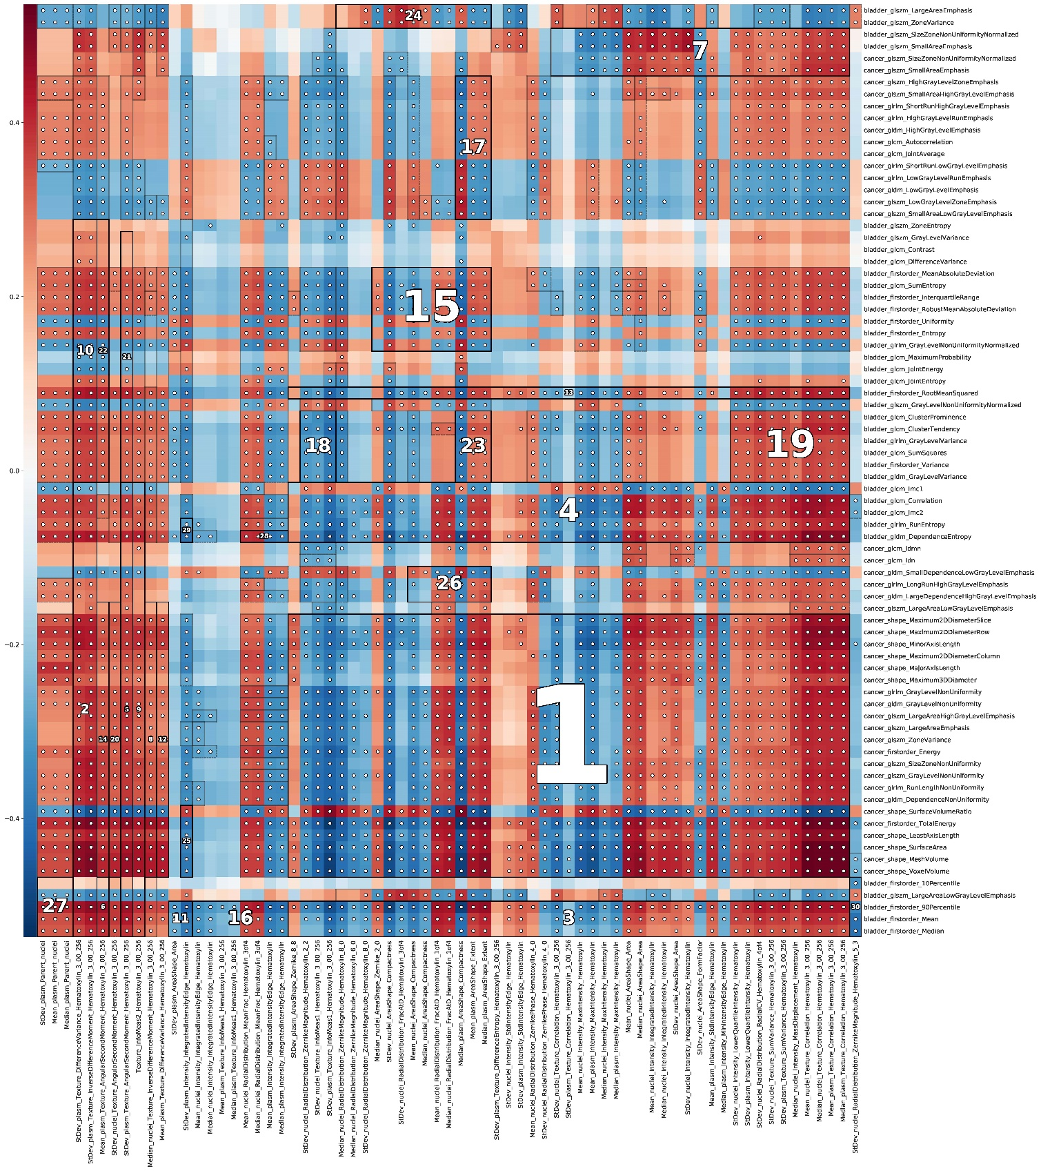
Supplementary Figure

Fig. S1 Densely associated blocks identified by HAllA. The white dot means statistical significance (P < 0.05) of the related feature pairs.

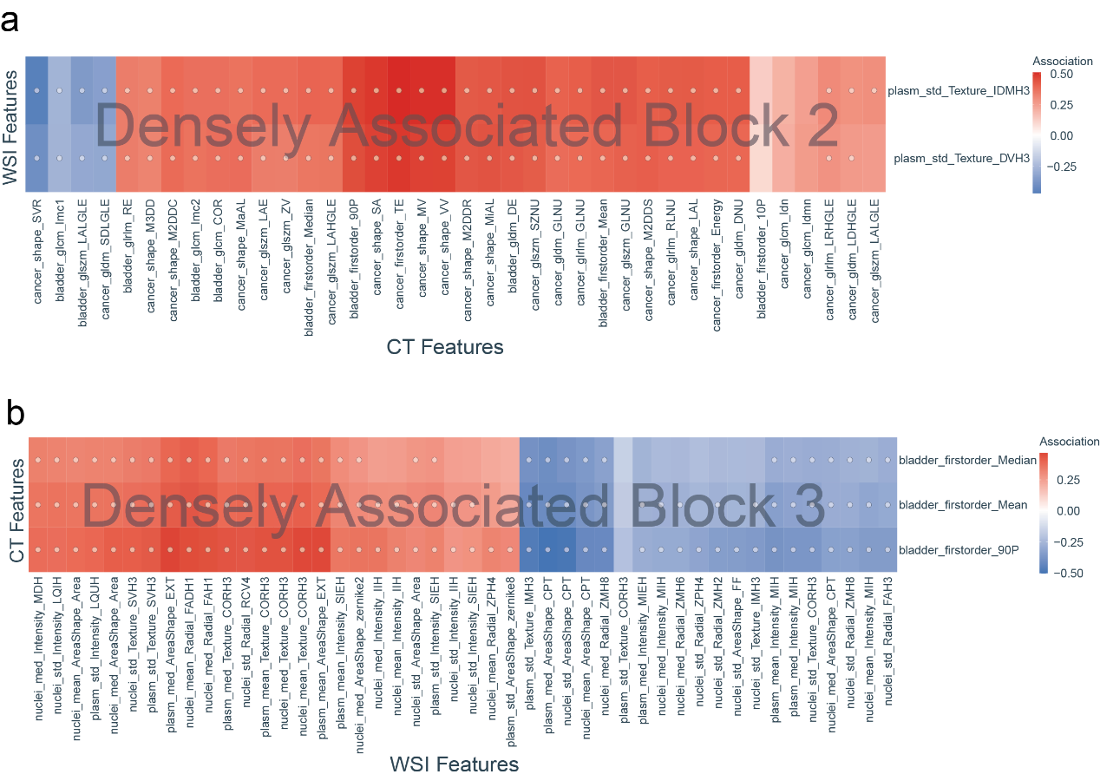

Fig. S2 Heatmap of Densely associated block 2 and 3 identified by HAllA. The white dot means statistical significance (P < 0.05) of the related feature pairs.

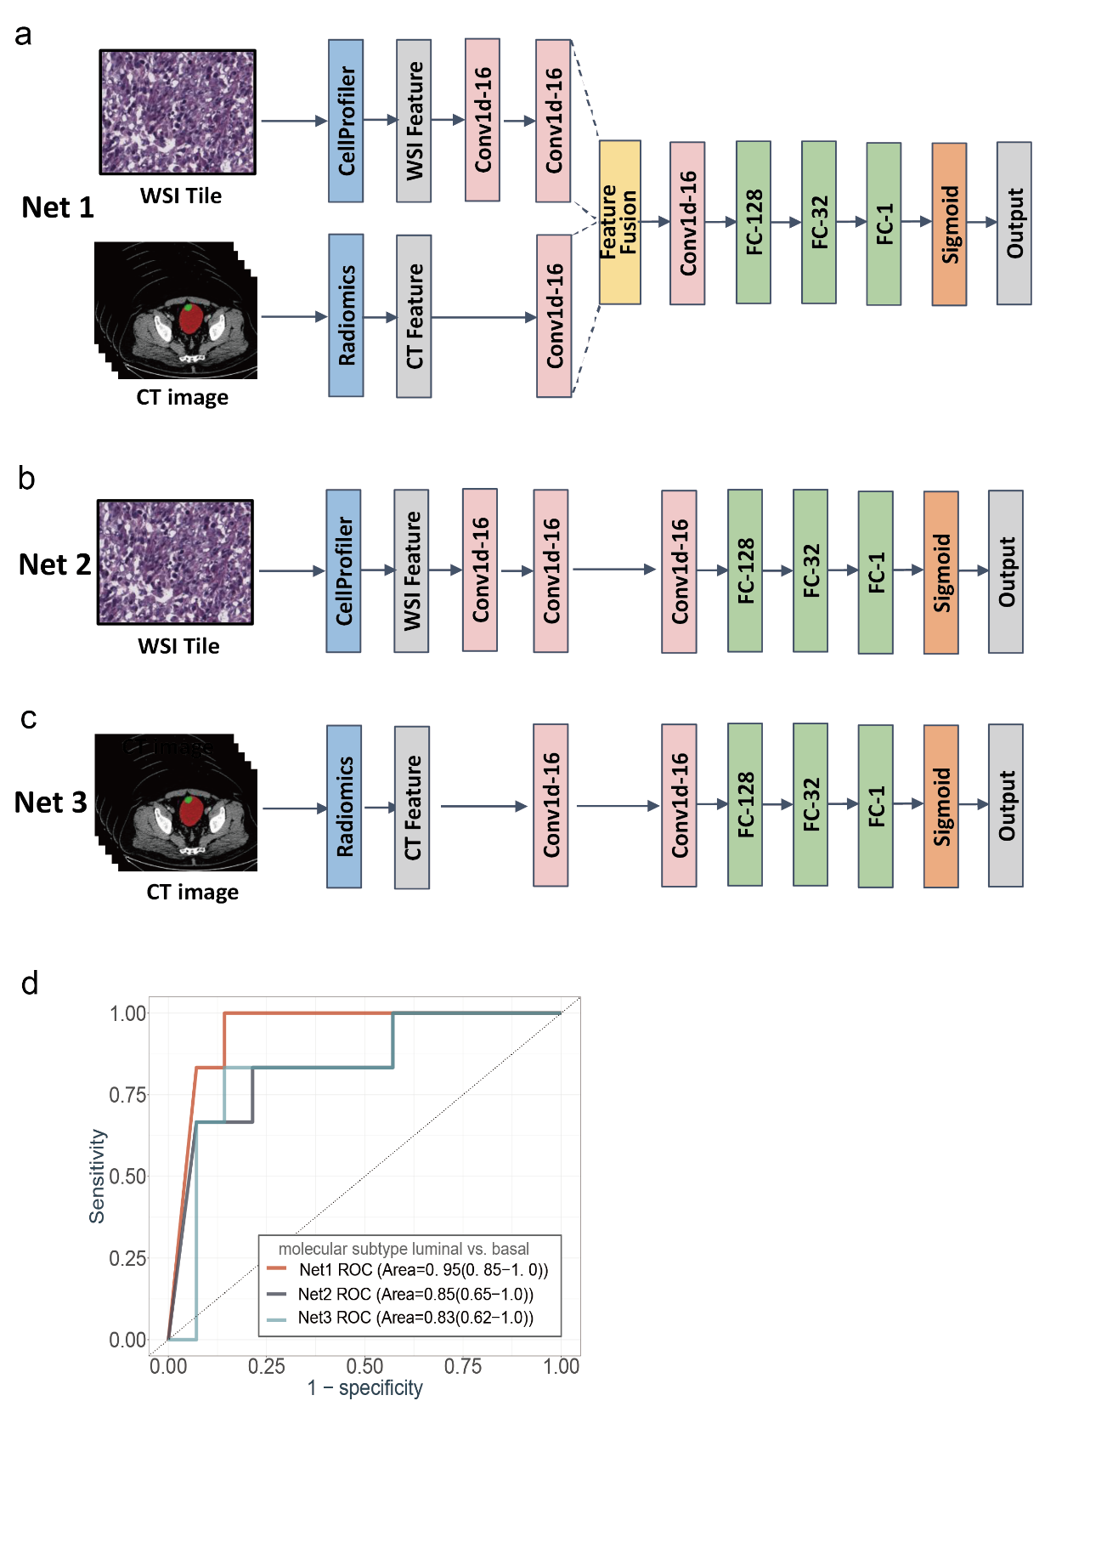

Fig. S3 Comparison of three proposed neural networks in luminal/basal molecular subtype prediction. (a) The diagram of the neural network with fused features of WSI and CT. (b) The diagram of the neural network with WSI features. (c) The diagram of the neural network with CT features. (d) Receiver operating characteristic (ROC) curve of the three proposed neural networks for luminal/basal molecular subtype prediction in testing set (20 cases). Net1 stands for the neural network in (a), Net2 stands for the neural network in (b), and Net3 stands for the neural network in (c). The AUC is evaluated at the 95% confidence interval. The Net1 reached the best performance among these three classification networks.

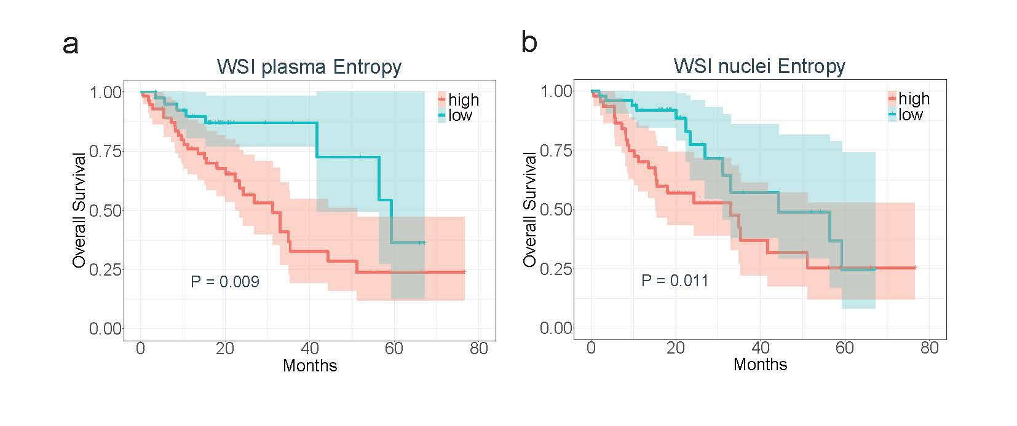
Fig. S4 Kaplan-Meier survival plot of Shannon entropy of WSI feature. (a) Survival distribution of two groups with high and low plasma entropy. (b) Survival distribution of two groups with high and low nuclei entropy.

